WebSphere

WAS - Websphere Application Server

<https://www.ibm.com/cloud/blog/websphere-trial-options-and-downloads>

Single developer use: As a developer, you can download any edition of either traditional WebSphere or WebSphere Liberty and use it for free for development purposes, as long as it is used on a single-developer machine (e.g., the "desktop" can be physical or virtual). There is no formal support from IBM.

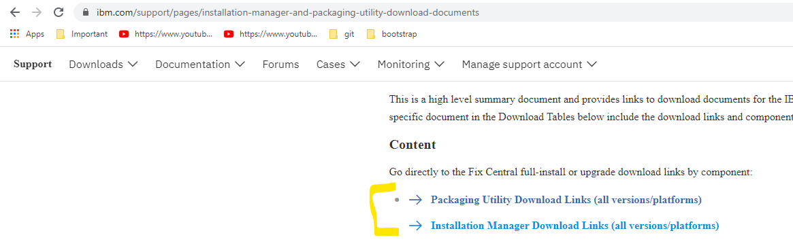

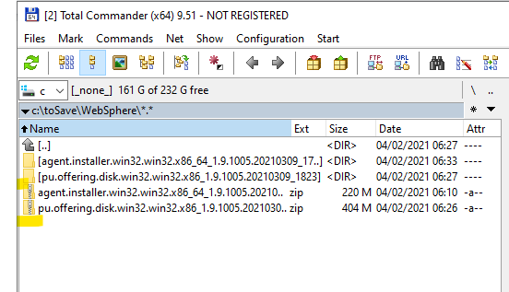

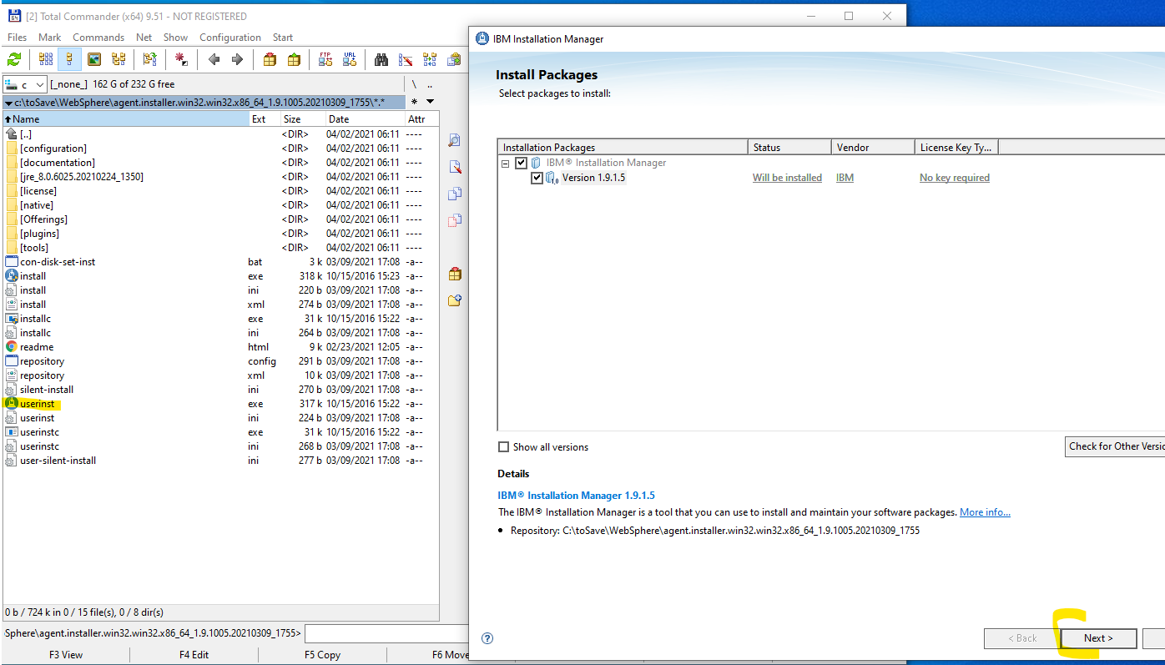

C:\Users\gf\IBM\Installation Manager\eclipse

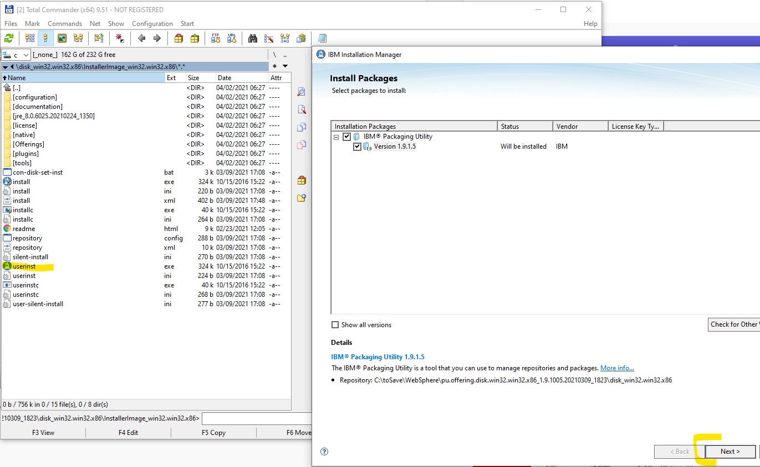

C:\Users\gf\IBM\Shared

C:\Users\gf\IBM\PackagingUtility

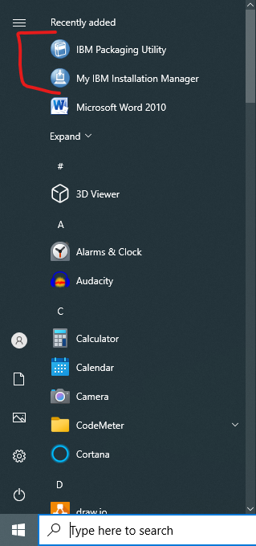

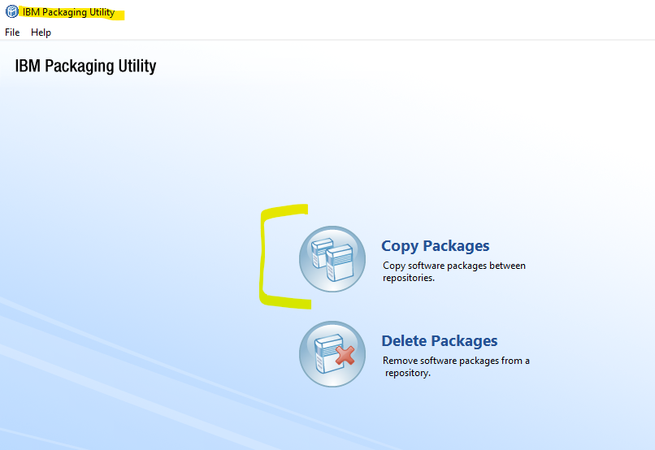

Google: websphere application server repository url for 8.5

<https://www.ibm.com/docs/en/was/8.5.5?topic=installing-online-product-repositories-websphere-application-server-offerings>

IBM WebSphere Application Server Network Deployment Trial

<https://www.ibm.com/software/repositorymanager/com.ibm.websphere.NDTRIAL.v85>

IBM WebSphere Application Server for Developers

https://www.ibm.com/software/repositorymanager/com.ibm.websphere.DEVELOPERS.v85

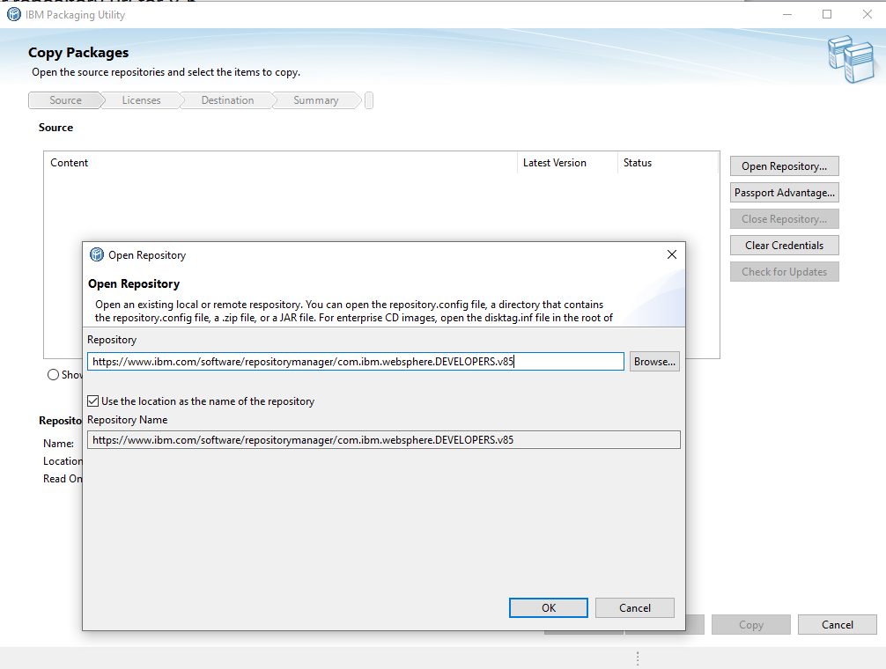

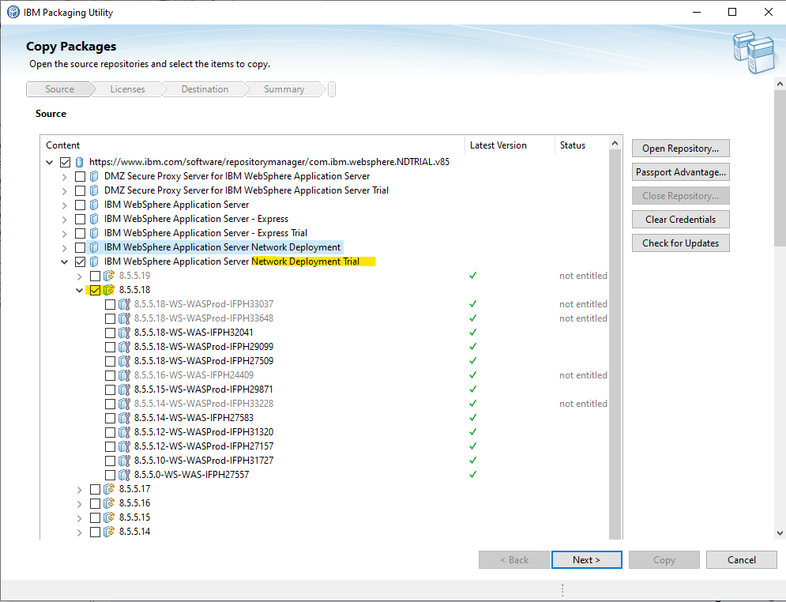

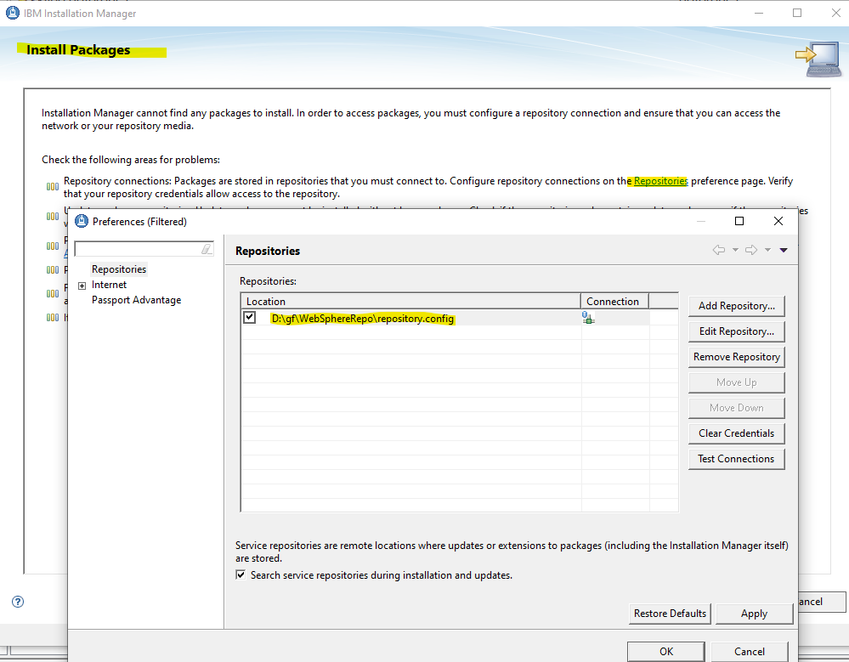

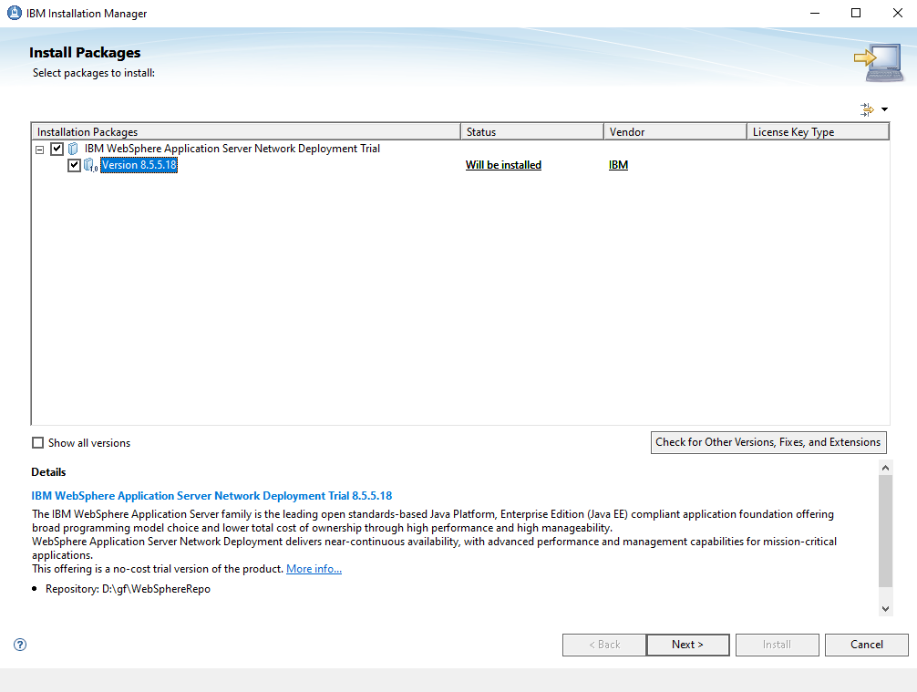

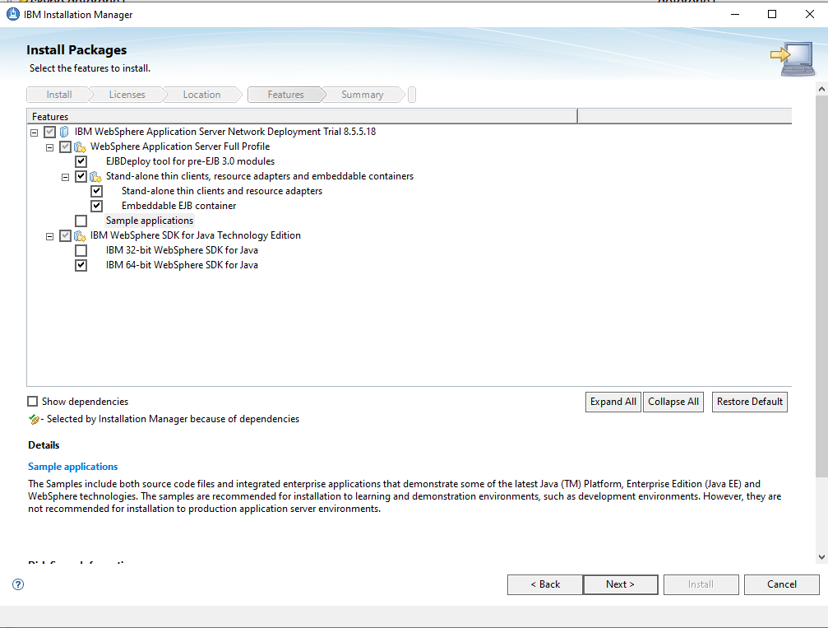

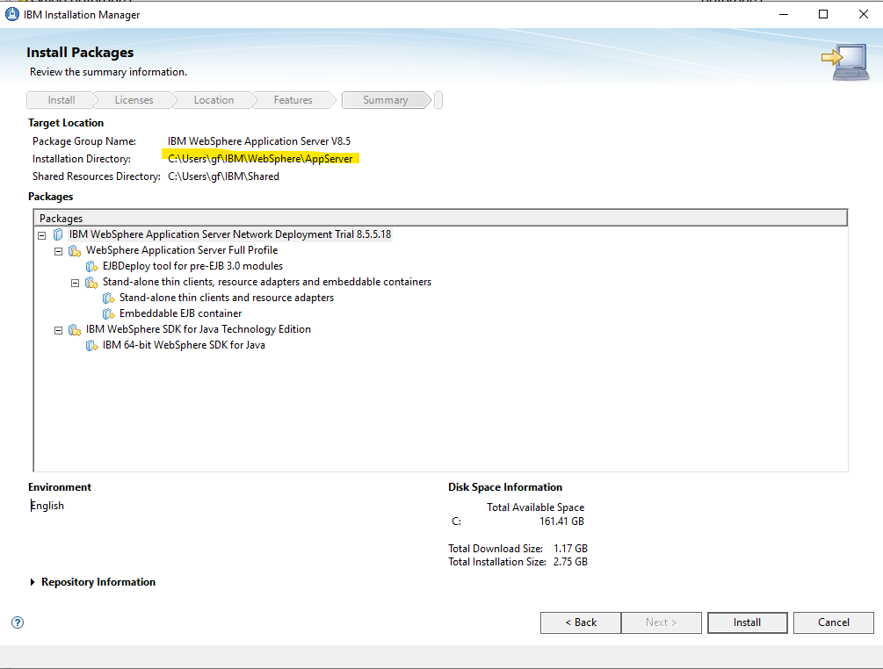

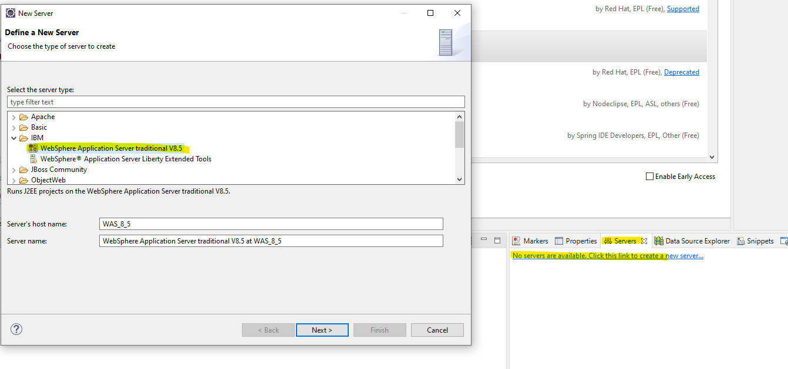

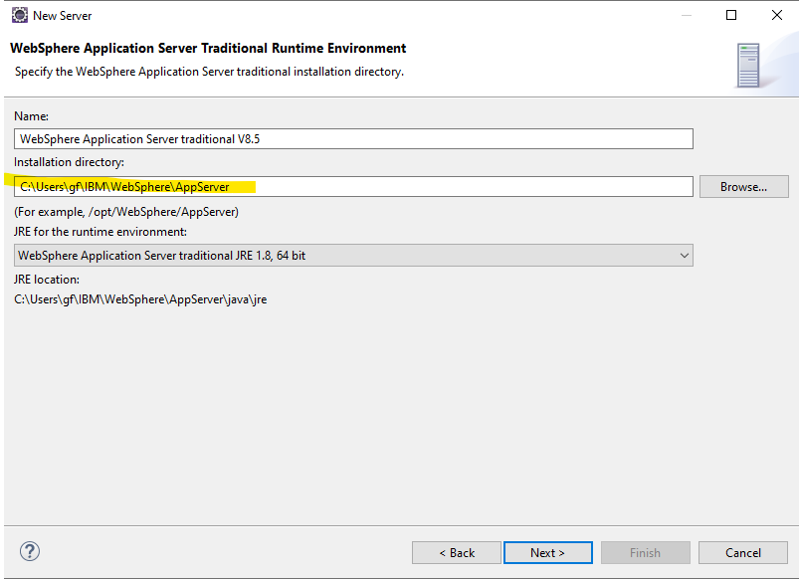

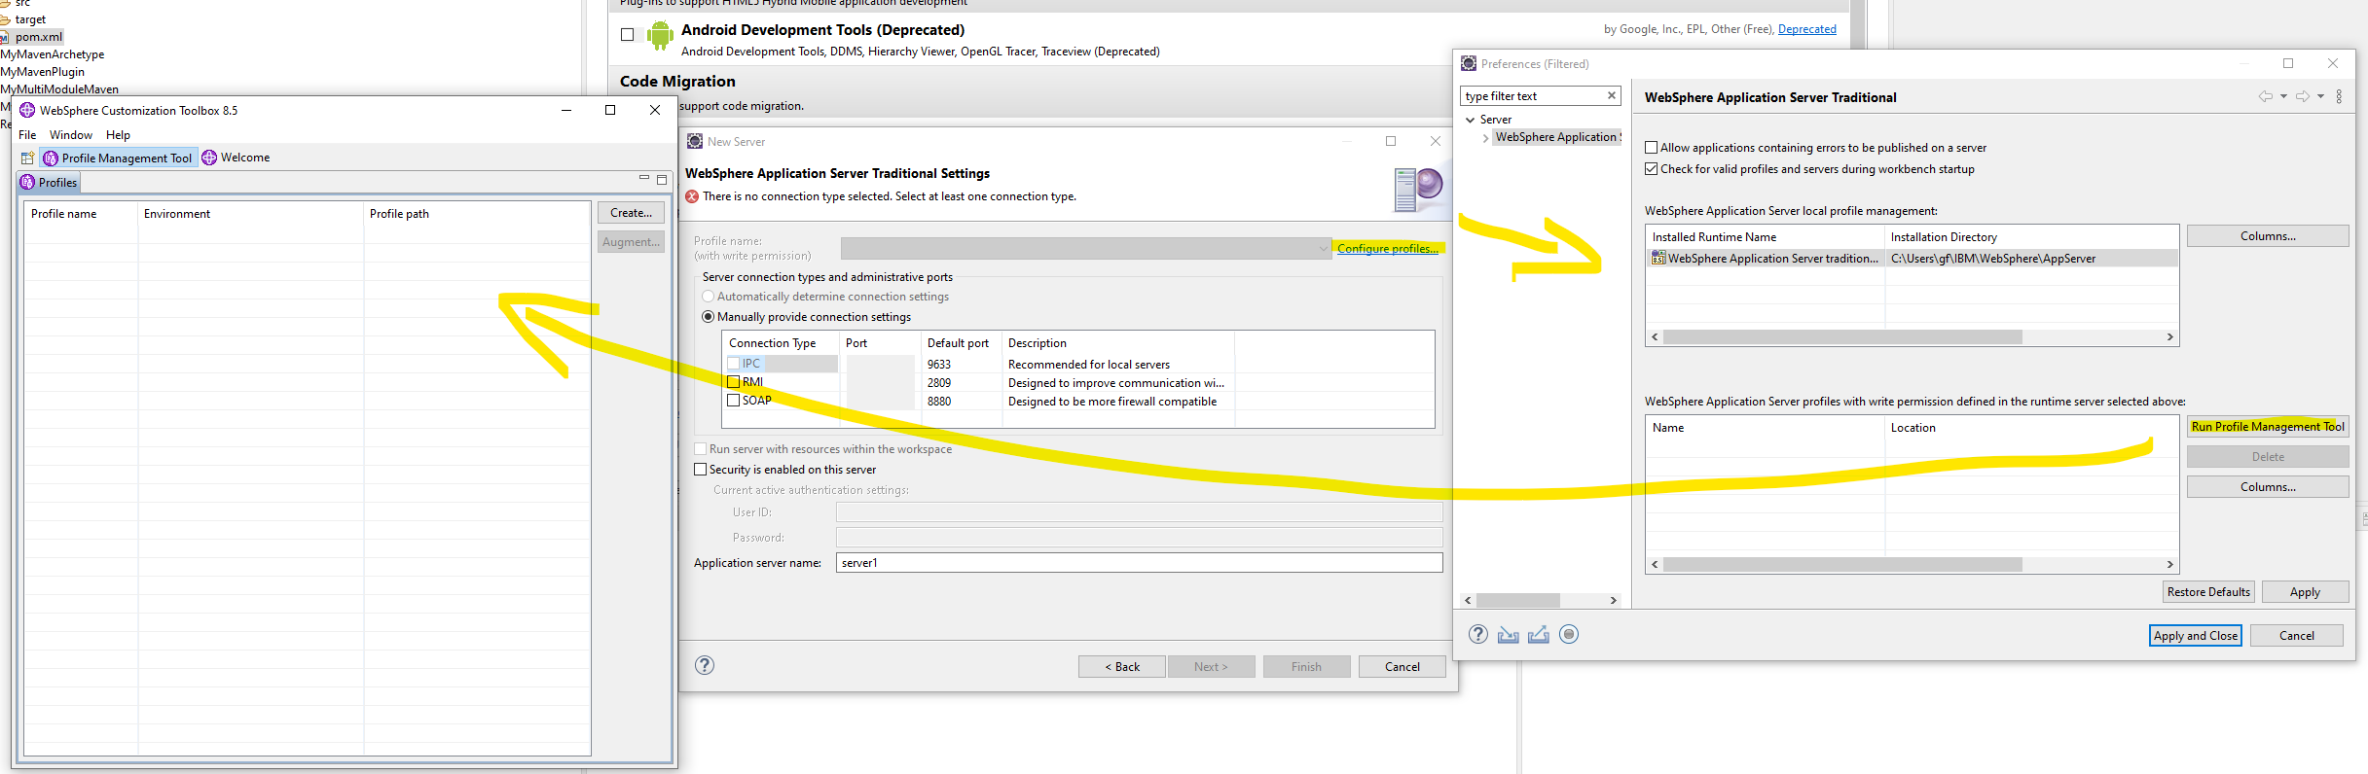

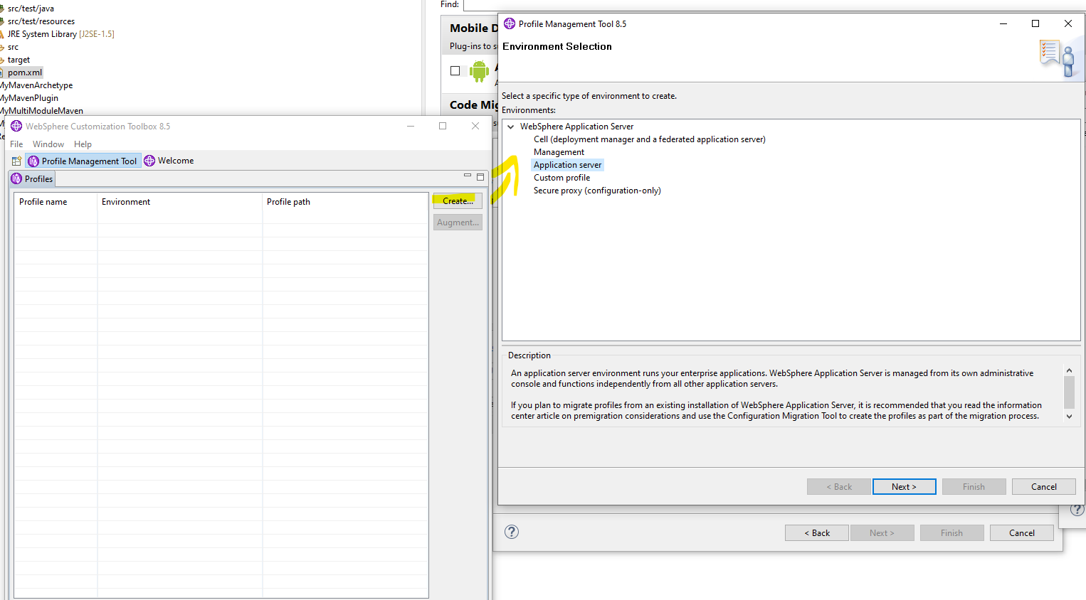

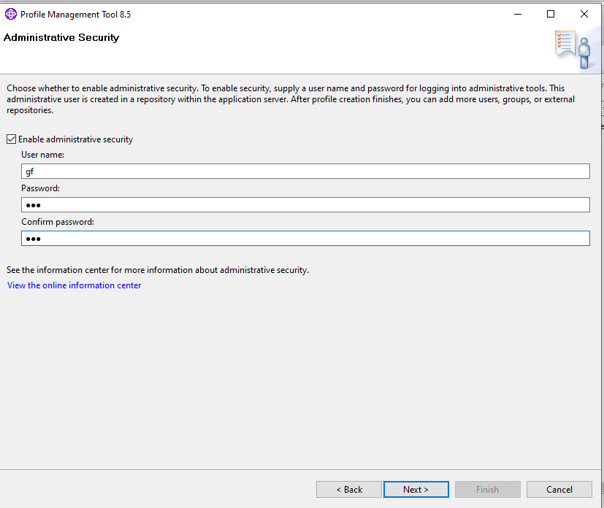

user: gf

password: 123

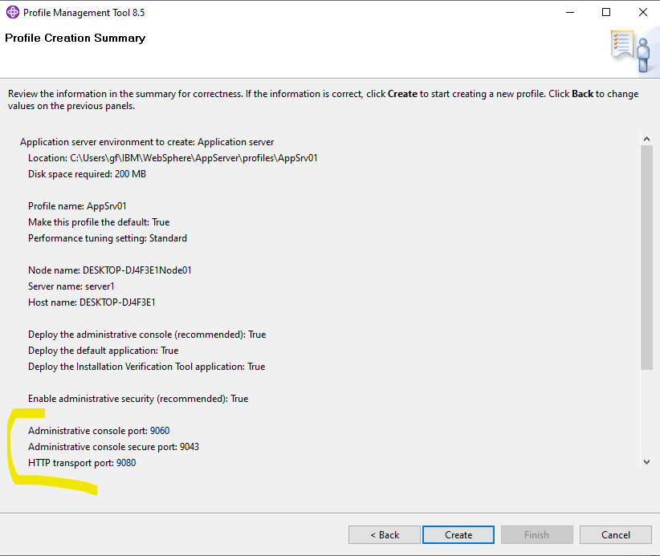

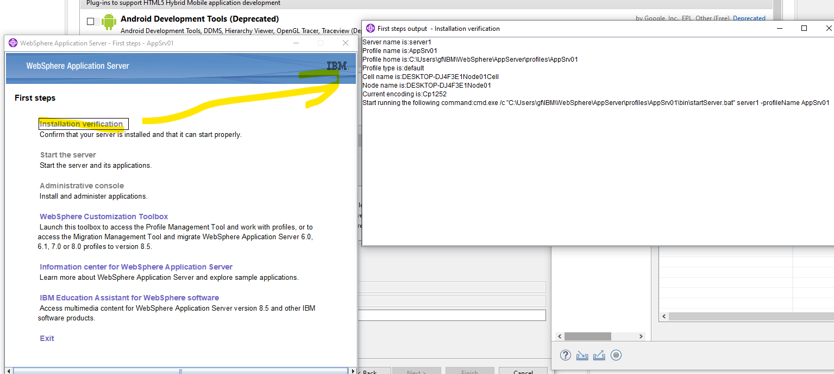

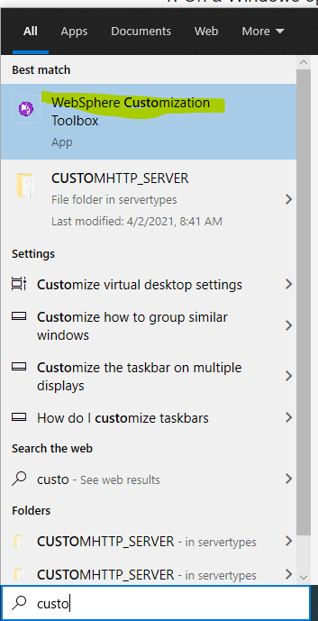

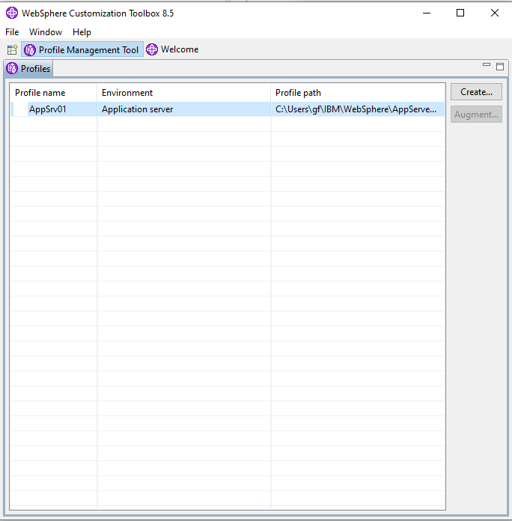

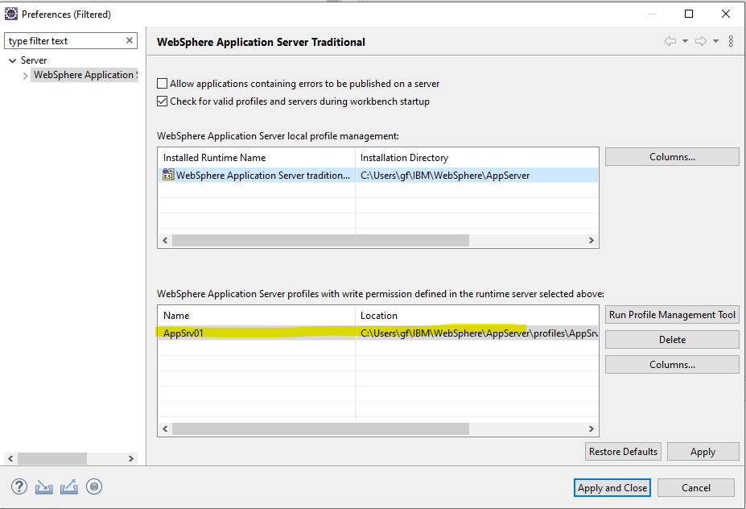

-----------------------------------------------

Run: services.msc

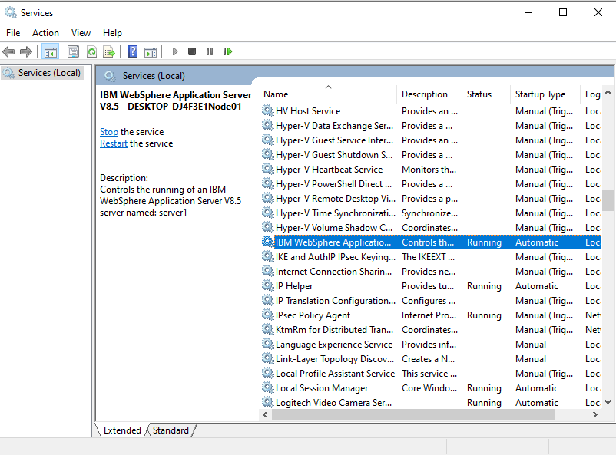

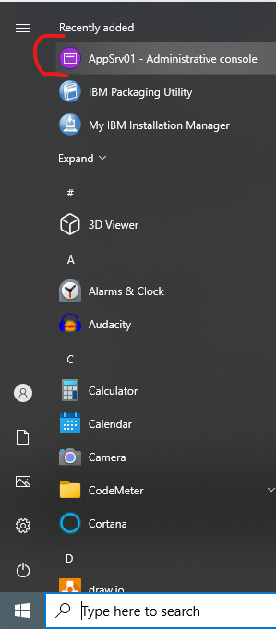

[**https://desktop-dj4f3e1:9043/ibm/console/logon.jsp**](https://desktop-dj4f3e1:9043/ibm/console/logon.jsp)

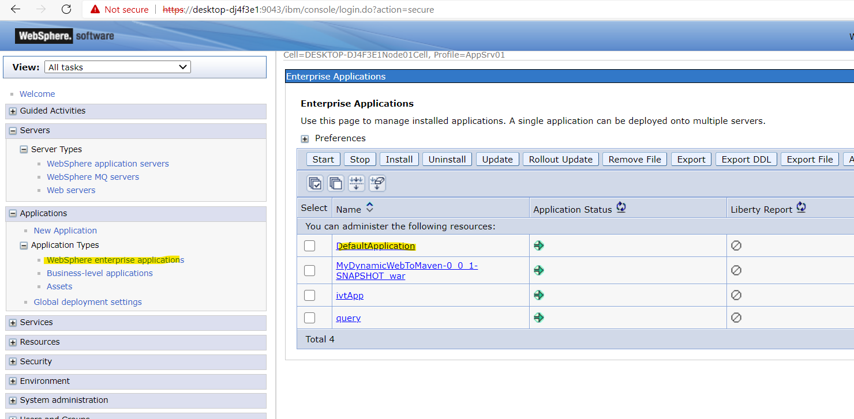

Hit Count Demonstration

**http://desktop-dj4f3e1:9080/HitCount.jsp**

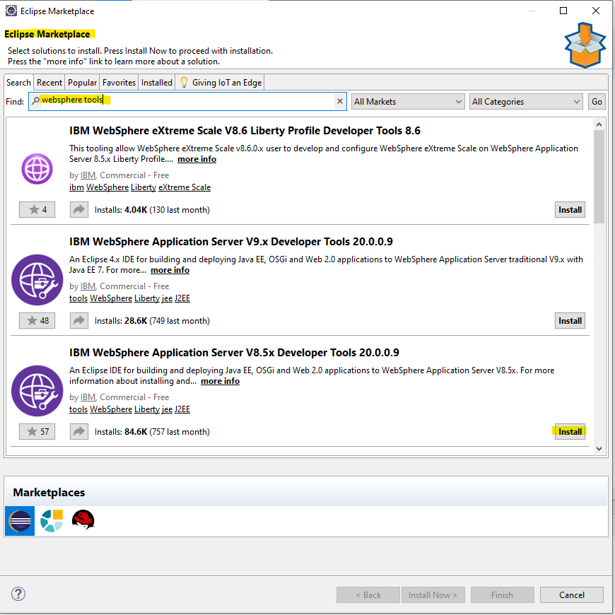

---------------------------------------------------------------------------

WebSphere deploy

[**https://desktop-dj4f3e1:9043/ibm/console/logon.jsp**](https://desktop-dj4f3e1:9043/ibm/console/logon.jsp)

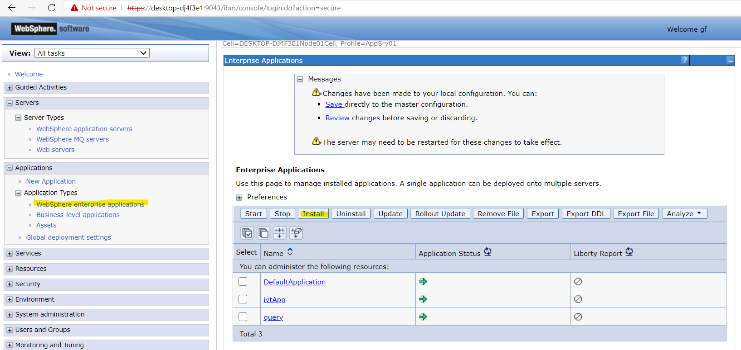

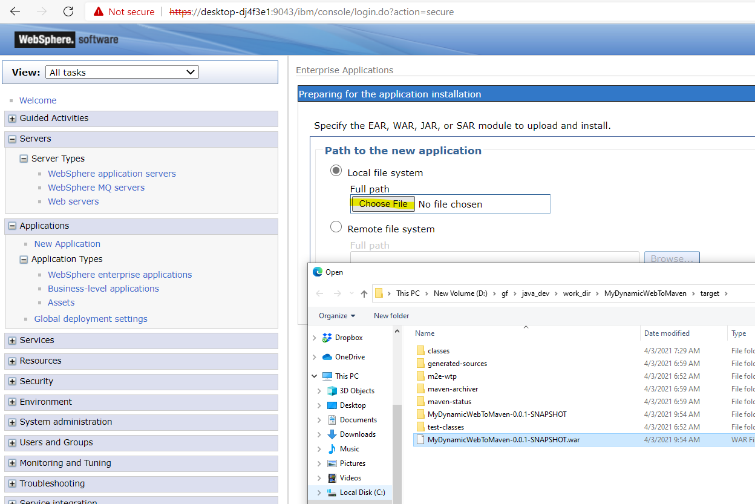

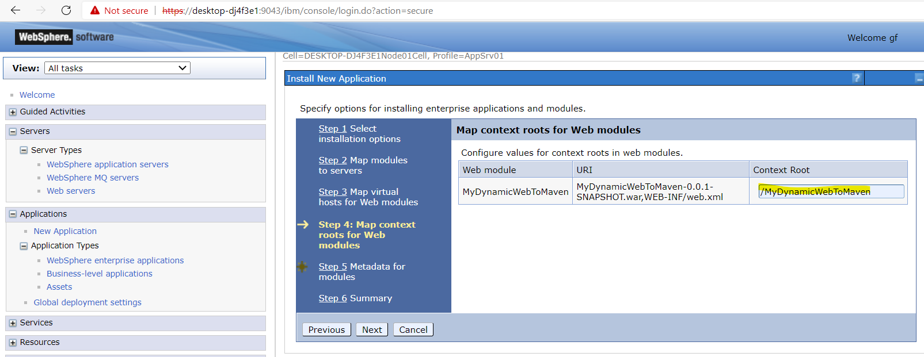

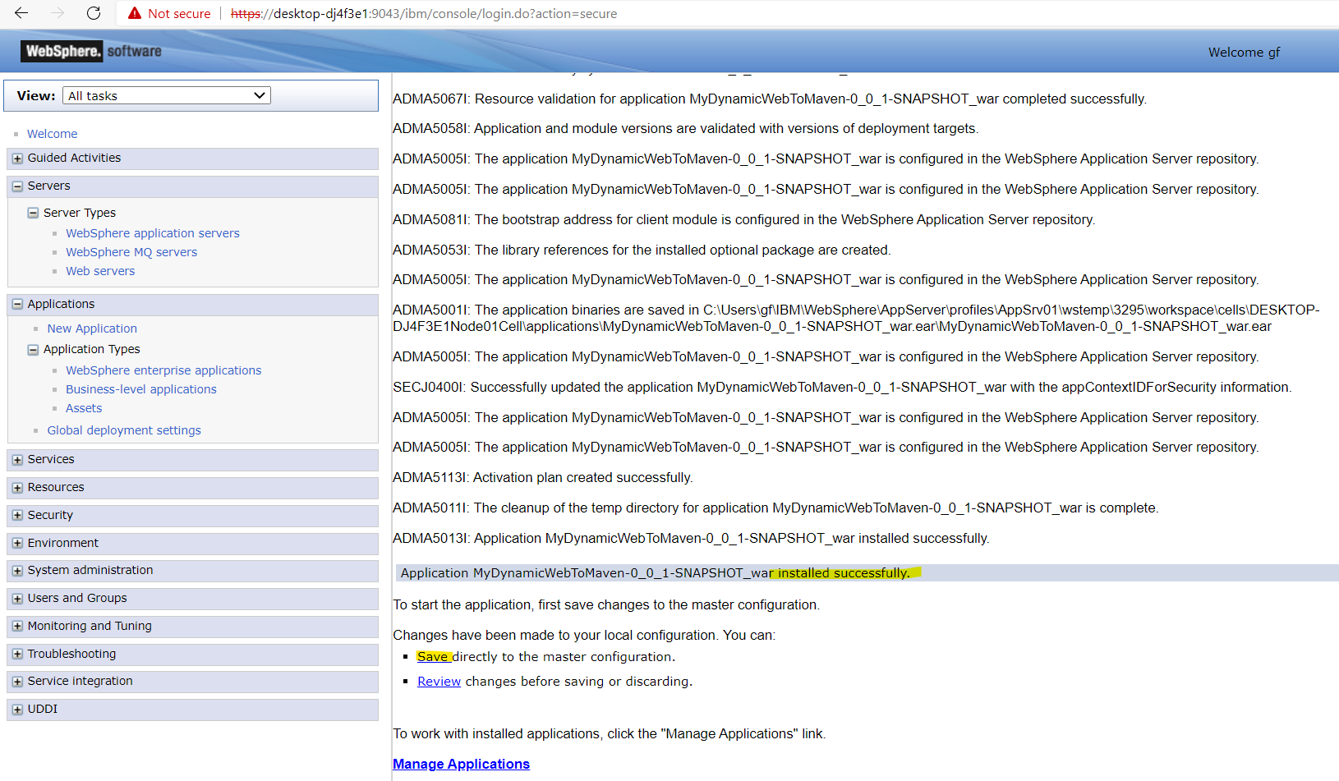

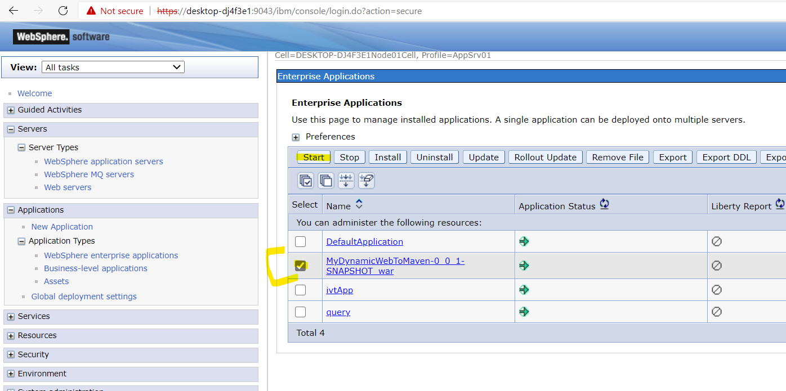

**log:**

**c:\Users\gf\IBM\WebSphere\AppServer\profiles\AppSrv01\logs\server1\ SystemOut.log**

<http://desktop-dj4f3e1:9080/MyDynamicWebToMaven/index.html>

[http://desktop-dj4f3e1:9080/MyDynamicWebToMaven/MyHelloJSP.jsp](http://desktop-dj4f3e1:9080/MyDynamicWebToMaven/index.html)

[http://desktop-dj4f3e1:9080/MyDynamicWebToMaven/MyHelloServlet](http://desktop-dj4f3e1:9080/MyDynamicWebToMaven/MyHelloServlet%20)

<http://desktop-dj4f3e1:9080/MyDynamicWebToMaven/MyHelloOldServletUrl>

-----------------------------------------------------------

Deployed apps:

c:\Users\gf\IBM\WebSphere\AppServer\profiles\AppSrv01\installedApps\DESKTOP-DJ4F3E1Node01Cell\

