**AI – Practical 3**

Vraj Chetan Patel

21BCP362

G11

AIM :- Solve 8 puzzle problem using A* algorithm where initial state and Goal state will be given by the users.

**Algorithm**

1. **Importing the Necessary Library**
   * The code imports the NumPy library for numerical operations.
2. **Defining the read_matrix Function**
   * The function displays a prompt to the user.
   * It then reads and converts a 3x3 matrix from user input into a NumPy array.
3. **Initializing Matrices and Lists**
   * The code initializes the start and end matrices by calling **read_matrix**.
   * Lists for **visited**, **open**, and **closed** states are initialized.
4. **Appending Start Matrix to Closed List**
   * The start matrix is appended to the **closed** list.
5. **Defining the heuristic Function**
   * The function calculates and returns the heuristic value, based on the difference between a given matrix and the end matrix.
6. **Defining the possibleChildren Function**
   * The current matrix is marked as visited.
   * The function locates the position of zero (empty space) in the matrix.
   * Possible movements (up, down, left, right) are defined.
   * For each movement: a. The function checks if the movement is within bounds. b. If valid, it swaps the empty space with an adjacent element, creating a new matrix. c. If the new matrix is not previously visited, its heuristic is calculated, it's marked as visited, and added to the list of children.
   * The list of children matrices is sorted based on their heuristic value.
7. **Defining the main Function**
   * The heuristic for the start matrix is calculated.
   * If the start matrix matches the end matrix, the solution path is printed.
   * Otherwise, possible children of the start matrix are added to the **open** list.
   * While the **open** list is not empty: a. The first matrix is removed from **open** and its heuristic is calculated. b. This matrix is added to **closed**. c. If this matrix matches the end matrix, the solution path is printed; if not, its children are added to **open**.
   * If no solution is found, the function returns **False**.
8. **Executing the Main Function**
   * The **main** function is executed if the script is the main program

CODE:-

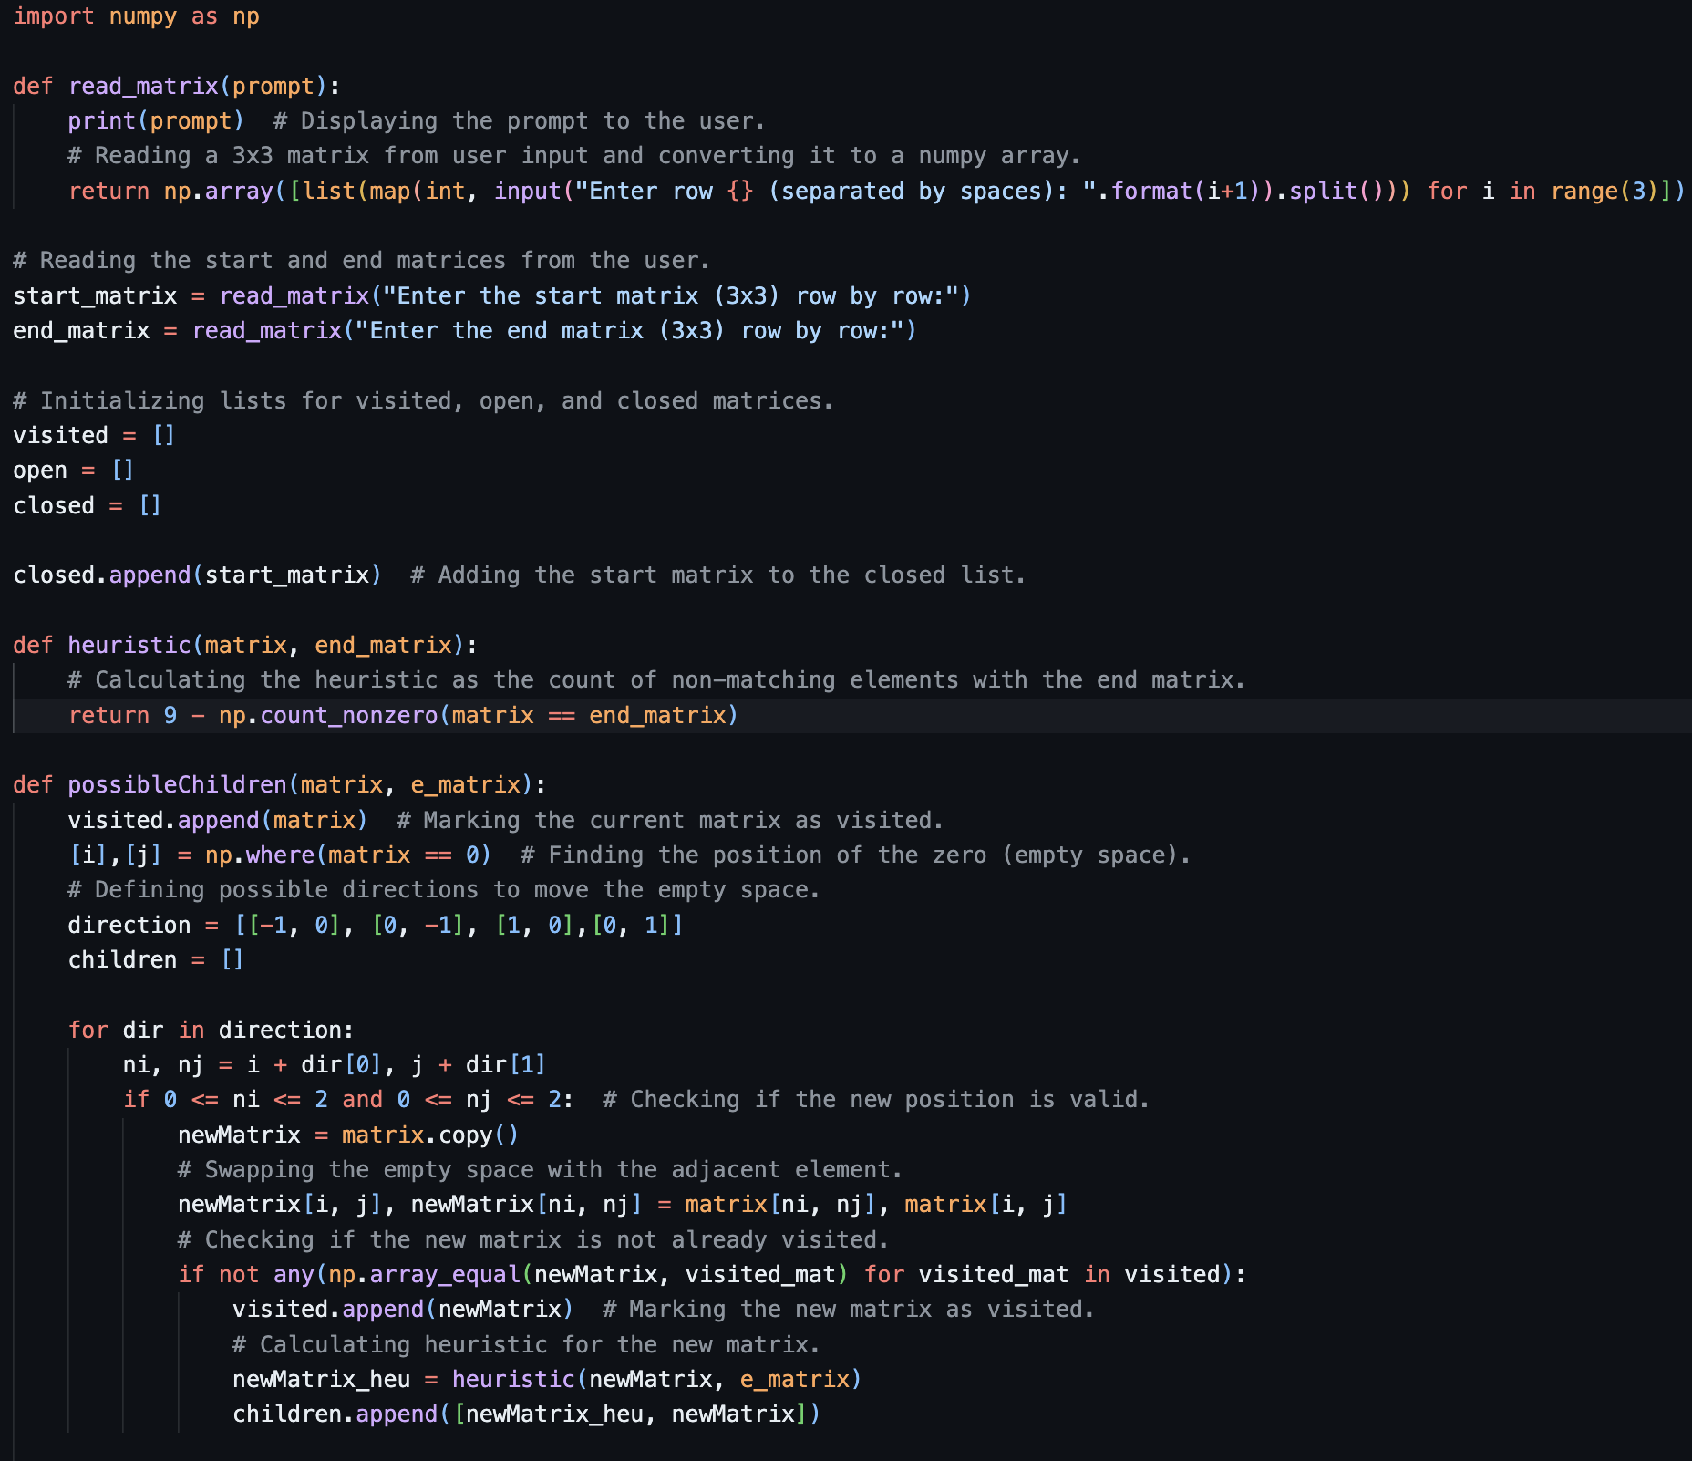

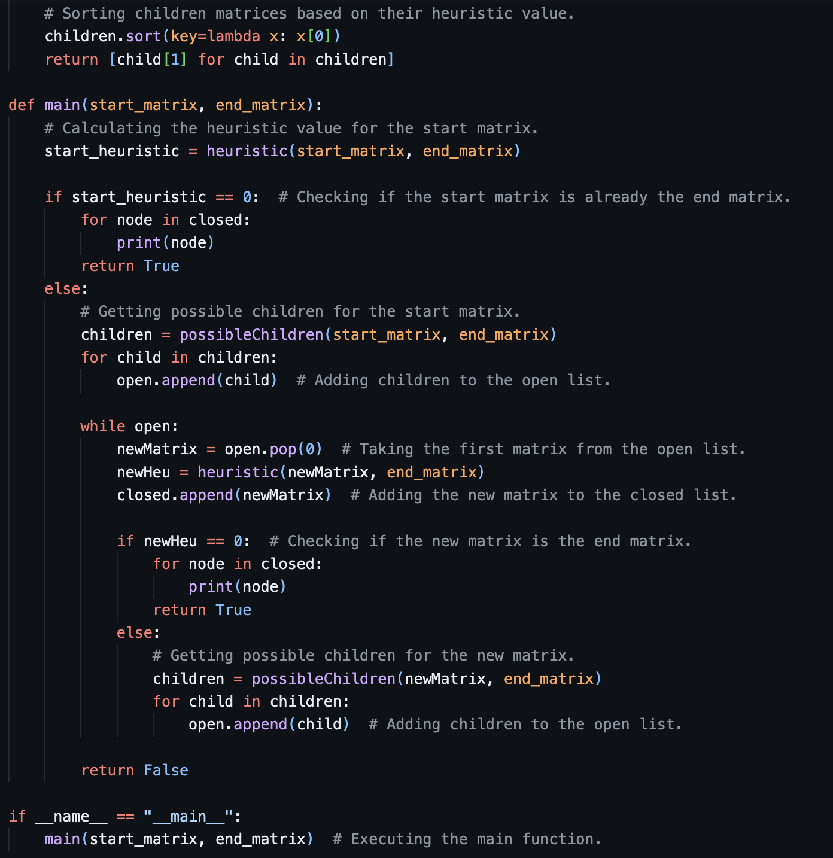

OUTPUT-

