|  |  |  |  |
| --- | --- | --- | --- |
|  | **Course Name: Advanced Web Technology** | **EXPERIMENT NO. 4** | |
| **Course Code: 20CP314P**  **Faculty: Komal Singh** | **Branch: CSE** | **Semester: VI** |
| **Submitted by: Patel Vraj ChetanKumar**  **Roll no: 21BCP362** | | | |

Objective: Building models with Mongoose

Experiment 4: Create a database schema and model using mongoose and perform MongoDB queries for operations such as insert, update, and delete while also establishing a connection to the MongoDB database.

1. **Npm init -y & npm install mongoose**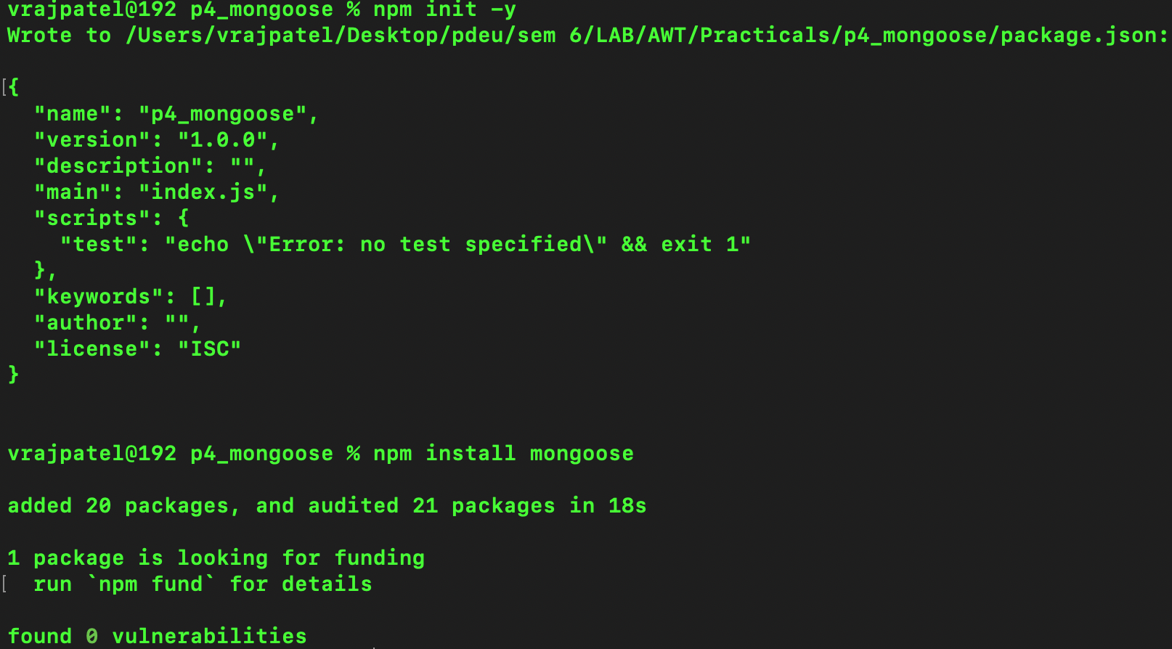
2. **Create index.js**

**Connect to mongoDB and Define Model**

const mongoose = require('mongoose');

mongoose.connect('mongodb://localhost/LibrarySystemModelMongoose', { useNewUrlParser: true, useUnifiedTopology: true })

.then(() => console.log('Connected to MongoDB successfully!'))

.catch((error) => console.error('Error connecting to MongoDB', error));

const bookSchema = new mongoose.Schema({

title: {

type: String,

required: true

},

author: {

type: String,

required: true

},

publishedYear: {

type: Number,

required: true

}

});

const Book = mongoose.model('Book', bookSchema);

1. **Run the file with nodemon index.js command**
2. **Run mongosh to connect to mongodb**

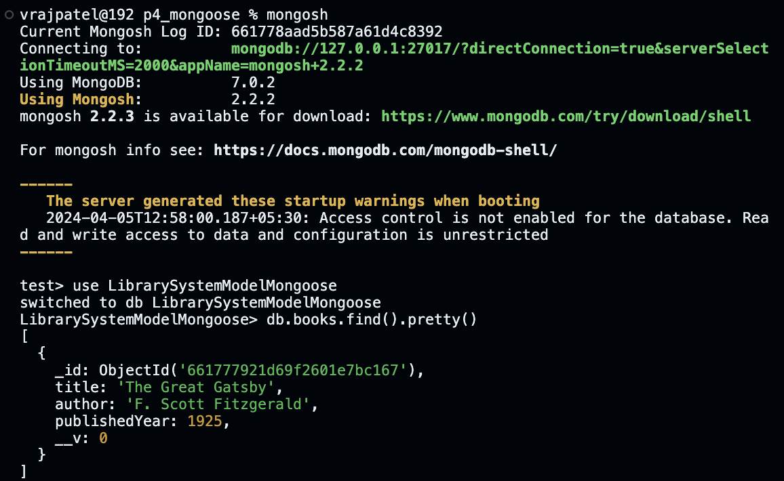

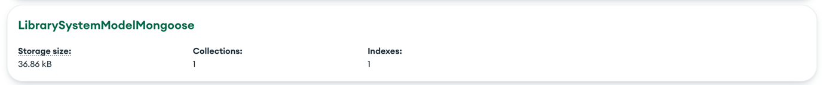



1. **Insert data**

const newBook = new Book({

title: 'The Great Gatsby',

author: 'F. Scott Fitzgerald',

publishedYear: 1925

});

newBook.save()

.then((book) => {

console.log('Book saved:', book);

})

.catch((error) => {

console.error('Error saving book:', error);

});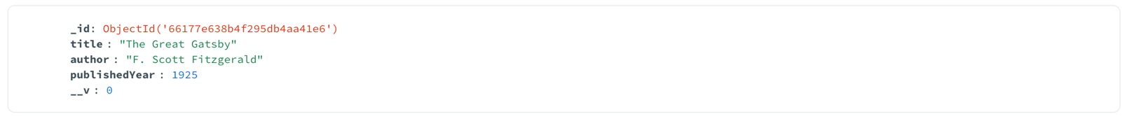

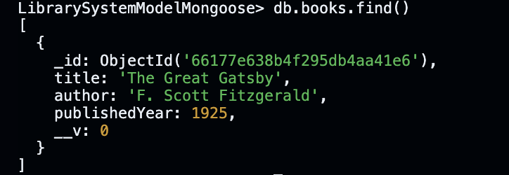

1. **Update data**

Book.updateOne({ title: 'The Great Gatsby' }, { $set: { publishedYear: 1926 } })

.then((result) => {

console.log('Book updated:', result);

})

.catch((error) => {

console.error('Error updating book:', error);

});

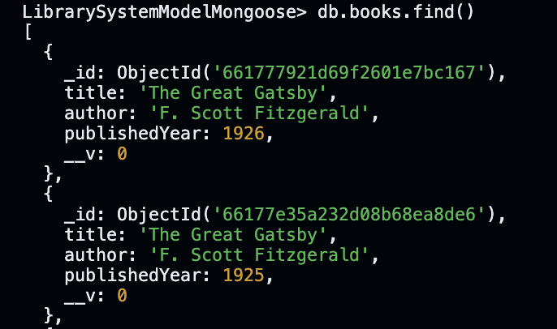

1. **Delete data**

Book.deleteOne({ title: 'The Great Gatsby' })

.then((result) => {

console.log('Book deleted:', result);

})

.catch((error) => {

console.error('Error deleting book:', error);

});



1. **Insert many**

const booksToInsert = [

{ title: 'NEW THINKING', author: 'Dagogo Altraide', publishedYear: 2017 },

{ title: 'DEEP WORK', author: 'Cal Newport', publishedYear: 2019 },

{ title: 'THE ALMANACK OF NAVAL RAVIKANT', author: 'Naval Ravikant', publishedYear: 2020 }

];

Book.insertMany(booksToInsert)

.then((books) => {

console.log('Books inserted:', books);

})

.catch((error) => {

console.error('Error inserting books:', error);

});

