|  |  |  |  |
| --- | --- | --- | --- |
|  | **Course Name: Advanced Web Technology** | **EXPERIMENT NO. 5** | |
| **Course Code: 20CP314P**  **Faculty: Komal Singh** | **Branch: CSE** | **Semester: VI** |
| **Submitted by: Patel Vraj ChetanKumar**  **Roll no: 21BCP362** | | | |

Objective: Create your first React code

Experiment 5:

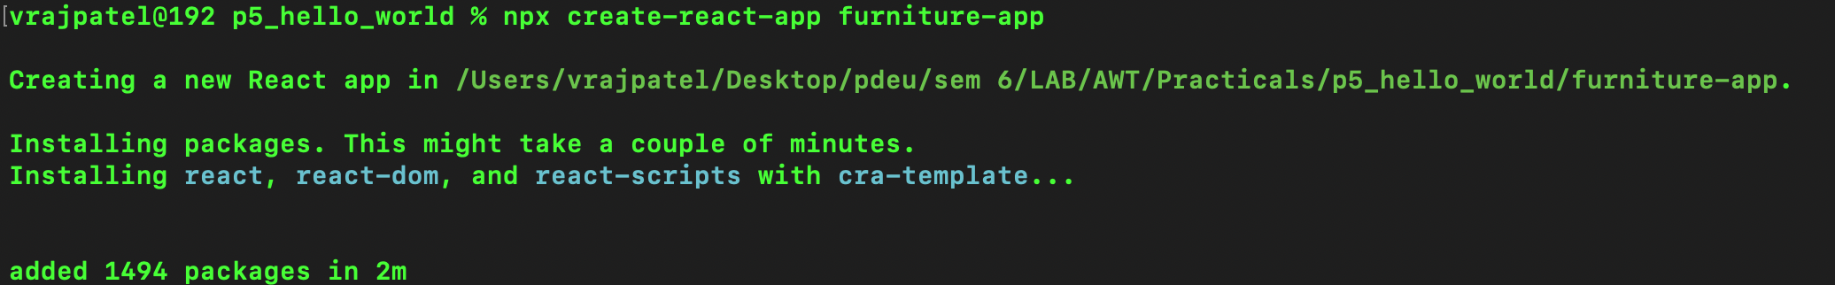Q1 Create a “hello world” react app.

Q2 Create a multiple web page commercial furniture application having a navigation bar using react components having pages such as home, products and customer review.

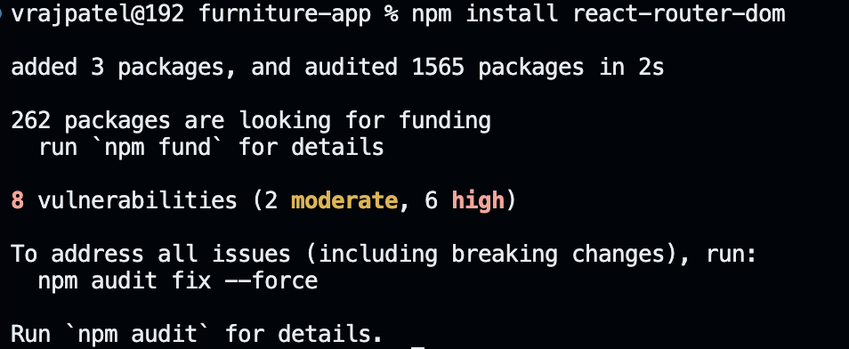

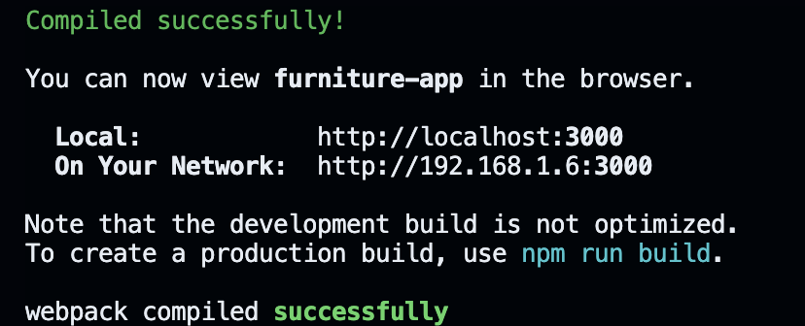

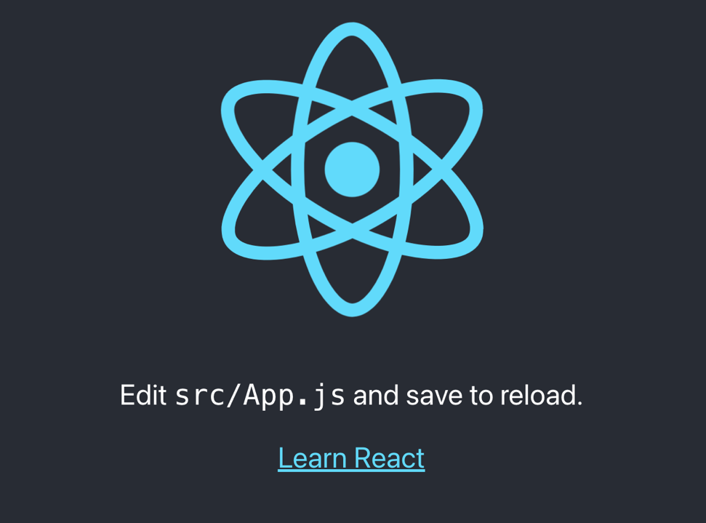

Q2 Create a multiple web page application having a navigation bar using react components having pages such as home, products and customer review.

**Steps**

1. **Create react app**

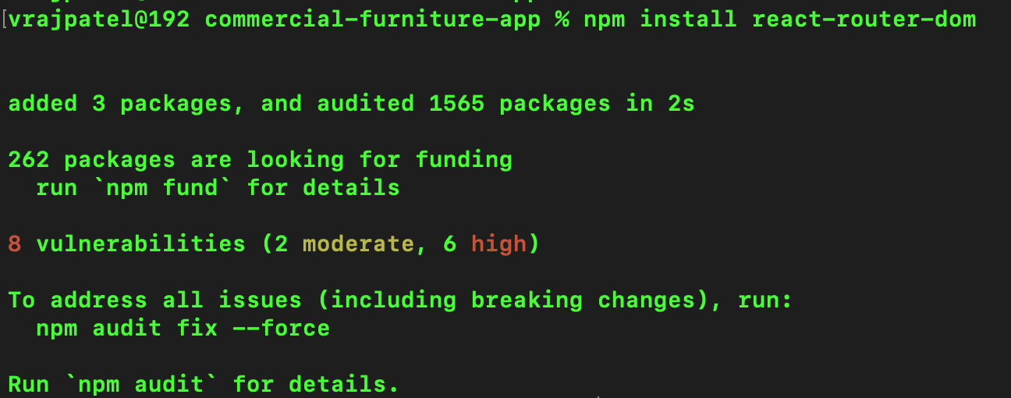

1. **Remove files that are not required**
2. **Create Files [Home.js , Products.js , Customer.js]**

|  |
| --- |
| **Home.js**  **// src/pages/Home.js**  **import React from 'react';**  **import './PageStyles.css';**  **function Home() {**  **return (**  **<div className="container home-container">**  **<h1>Welcome to Our Furniture Store</h1>**  **<p>Explore our wide range of luxury furniture. Enhance your home with our stylish and high-quality pieces.</p>**  **<div className="features">**  **<div className="feature">**  **<h2>High Quality</h2>**  **<p>Each piece is crafted with the finest materials to offer you a lasting investment.</p>**  **</div>**  **<div className="feature">**  **<h2>Eco-Friendly</h2>**  **<p>We use sustainable practices in every step of our production to protect our environment.</p>**  **</div>**  **<div className="feature">**  **<h2>Custom Designs</h2>**  **<p>Customize furniture to perfectly match your home's design and color scheme.</p>**  **</div>**  **</div>**  **</div>**  **);**  **}**  **export default Home;** |
| **Products.js**  **// src/pages/Products.js**  **import React from 'react';**  **import './PageStyles.css';**  **import elegantSofa from '../images/elegant_sofa.jpg';**  **import classicWoodenChair from '../images/classic_wooden_chair.jpg';**  **import modernCoffeeTable from '../images/modern_coffee_table.jpg';**  **import luxuryBed from '../images/luxury_bed.jpg';**  **const products = [**  **{**  **id: 1,**  **name: "Elegant Sofa",**  **price: 499.99,**  **color: "Gray",**  **manufacturer: "Comfy Home",**  **imageUrl: elegantSofa**  **},**  **{**  **id: 2,**  **name: "Classic Wooden Chair",**  **price: 249.99,**  **color: "Brown",**  **manufacturer: "Wood Crafters",**  **imageUrl: classicWoodenChair**  **},**  **{**  **id: 3,**  **name: "Modern Coffee Table",**  **price: 299.99,**  **color: "Black",**  **manufacturer: "Table Trends",**  **imageUrl: modernCoffeeTable**  **},**  **{**  **id: 4,**  **name: "Luxury Bed",**  **price: 899.99,**  **color: "White",**  **manufacturer: "Sleep Lux",**  **imageUrl: luxuryBed**  **}**  **];**  **function ProductCard({ product }) {**  **return (**  **<div className="product-card">**  **<img src={product.imageUrl} alt={product.name} />**  **<h3>{product.name}</h3>**  **<p>${product.price}</p>**  **<p>Color: {product.color}</p>**  **<p>Manufacturer: {product.manufacturer}</p>**  **</div>**  **);**  **}**  **function Products() {**  **return (**  **<div className="container">**  **<h1>Our Products</h1>**  **<div className="product-grid">**  **{products.map(product => (**  **<ProductCard key={product.id} product={product} />**  **))}**  **</div>**  **</div>**  **);**  **}**  **export default Products;** |
| **Customer.js**  **// src/pages/CustomerReview.js**  **import React from 'react';**  **import './PageStyles.css';**  **function CustomerReview() {**  **return (**  **<div className="container review-container">**  **<h1>Customer Reviews</h1>**  **<p>Share your experience with us!</p>**  **<form className="review-form">**  **<label>Name</label>**  **<input type="text" placeholder="Enter your name" />**  **<label>Rating</label>**  **<select>**  **<option value="5">5</option>**  **<option value="4">4</option>**  **<option value="3">3</option>**  **<option value="2">2</option>**  **<option value="1">1</option>**  **</select>**  **<label>Feedback</label>**  **<textarea placeholder="Describe your experience"></textarea>**  **<button type="submit">Submit Review</button>**  **</form>**  **<div className="testimonials">**  **<h2>What Our Customers Say</h2>**  **<blockquote>"Absolutely love the new coffee table. Fits perfectly in our living room!"</blockquote>**  **<blockquote>"Excellent customer service and quick delivery. Highly recommend!"</blockquote>**  **</div>**  **</div>**  **);**  **}**  **export default CustomerReview;** |

1. **Update the App.js files with import**

|  |
| --- |
| **// src/App.js**  **import React from "react";**  **import { BrowserRouter as Router, Routes, Route, Link } from "react-router-dom";**  **import Home from './pages/Home';**  **import Products from './pages/Products';**  **import CustomerReview from './pages/CustomerReview';**  **import './App.css';**  **function App() {**  **return (**  **<Router>**  **<nav>**  **<ul>**  **<li><Link to="/">Home</Link></li>**  **<li><Link to="/products">Products</Link></li>**  **<li><Link to="/customer-review">Customer Review</Link></li>**  **</ul>**  **</nav>**  **<Routes>**  **<Route path="/" element={<Home />} />**  **<Route path="/products" element={<Products />} />**  **<Route path="/customer-review" element={<CustomerReview />} />**  **</Routes>**  **</Router>**  **);**  **}**  **export default App;** |

