|  |  |  |  |
| --- | --- | --- | --- |
|  | **Course Name: Advanced Web Technology** | **EXPERIMENT NO. 9** | |
| **Course Code: 20CP314P**  **Faculty: Komal Singh** | **Branch: CSE** | **Semester: VI** |
| **Submitted by: 21BCP362**  **Roll no: 21BCP362** | | | |

Objective: Working with react hooks.

Experiment 9:

1. Write react programs displaying the usage of each of the below given react hooks:
2. useReducer
3. useMemo
4. useCallback
5. useContext
6. useEffect
7. Design a custom hook that helps you declare a default value of a component.

Note: Please include snapshots of all commands, terminal sessions, localhost outputs, and log files in your documentation with necessary steps.

UseEffect

|  |
| --- |
| // src/components/UseEffectExample.js  import React, { useState, useEffect } from 'react';  import '../ComponentStyles.css';  function UseEffectExample() {  const [count, setCount] = useState(0);  useEffect(() => {  document.title = `You clicked ${count} times`;  });  return (  <div className="hook-example use-effect-notification">  <h3>useEffect Example</h3>  <p>You clicked {count} times</p>  <button onClick={() => setCount(count + 1)}>Click me</button>  </div>  );  }  export default UseEffectExample; |

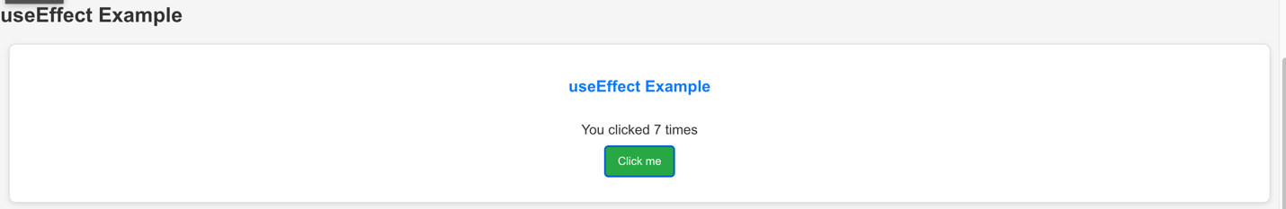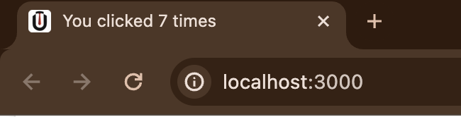

useReducer

Handles a simple counter with increment and decrement actions.

|  |
| --- |
| // src/components/UseReducerExample.js  import React, { useReducer } from 'react';  import '../ComponentStyles.css'; // Ensure the path is correct based on your project structure  function reducer(state, action) {  switch (action.type) {  case 'increment':  return { count: state.count + 1 };  case 'decrement':  return { count: state.count - 1 };  default:  throw new Error();  }  }  function UseReducerExample() {  const [state, dispatch] = useReducer(reducer, { count: 0 });  return (  <div className="hook-example">  <h3>useReducer Example</h3>  Count: {state.count}  <div className="use-reducer-buttons">  <button onClick={() => dispatch({ type: 'decrement' })}>-</button>  <button onClick={() => dispatch({ type: 'increment' })}>+</button>  </div>  </div>  );  }  export default UseReducerExample; |

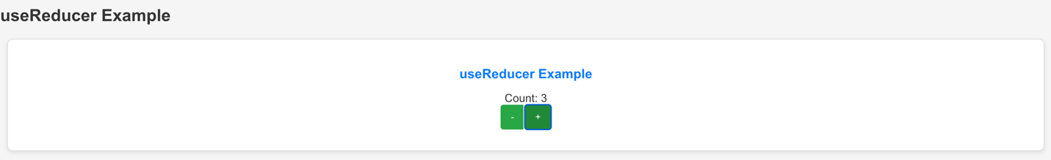

useMemo

Calculates a "multiplier" based on count and items state, but only recalculates when count or items change.

|  |
| --- |
| // src/components/UseMemoExample.js  import React, { useState, useMemo } from 'react';  import '../ComponentStyles.css';  function UseMemoExample() {  const [count, setCount] = useState(0);  const [items, setItems] = useState(10);  const multiplier = useMemo(() => {  console.log('Calculating multiplier...');  return count * items;  }, [count, items]);  return (  <div className="hook-example">  <h3>useMemo Example</h3>  <p>Multiplier: {multiplier}</p>  <button onClick={() => setCount(count + 1)}>Increment Count</button>  <button onClick={() => setItems(items + 1)}>Increment Items</button>  </div>  );  }  export default UseMemoExample; |

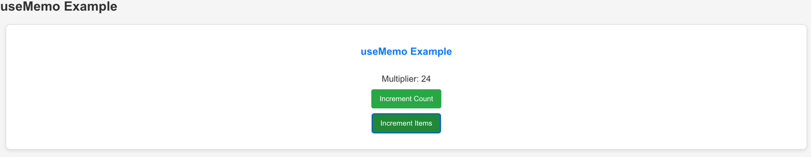

useCallback

|  |
| --- |
| // src/components/UseCallbackExample.js  import React, { useState, useCallback } from 'react';  import '../ComponentStyles.css';  function UseCallbackExample() {  const [count, setCount] = useState(0);  const increment = useCallback(() => {  setCount(c => c + 1);  }, [setCount]);  return (  <div className="hook-example">  <h3>useCallback Example</h3>  Count: {count}  <button onClick={increment} className="use-callback-button">Increment</button>  </div>  );  }  export default UseCallbackExample; |

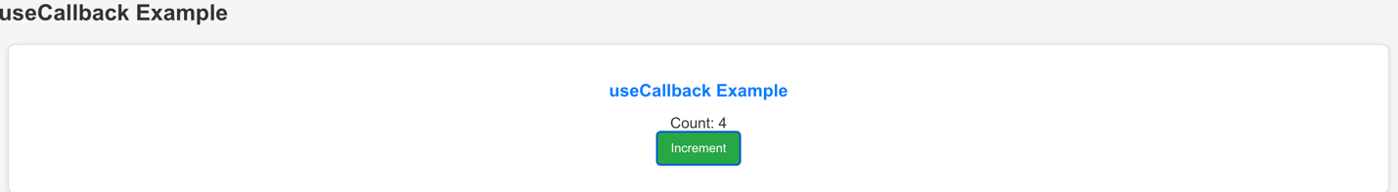

useContext

|  |
| --- |
| // src/components/UseContextExample.js  import React, { useContext, createContext } from 'react';  import '../ComponentStyles.css';  const CountContext = createContext();  function Counter() {  const count = useContext(CountContext);  return <p>Count: {count}</p>;  }  function UseContextExample() {  return (  <div className="hook-example use-context-display">  <h3>useContext Example</h3>  <CountContext.Provider value={5}>  <Counter />  </CountContext.Provider>  </div>  );  }  export default UseContextExample; |

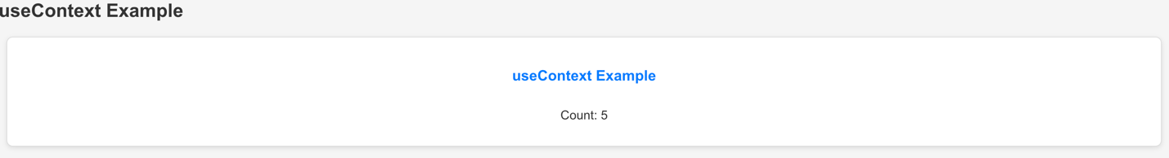

useDefault

|  |
| --- |
| // src/hooks/useDefault.js  import { useState } from 'react';  function useDefault(initialValue) {  const [value, setValue] = useState(initialValue);  return [value, setValue];  }  export default useDefault; |

CSS

|  |
| --- |
| /* src/ComponentStyles.css */  /* General Styles for All Hook Examples */  .hook-example {  margin-bottom: 40px;  padding: 20px;  background-color: #ffffff;  border: 1px solid #ddd;  border-radius: 8px;  box-shadow: 0 2px 6px rgba(0,0,0,0.1);  }  .hook-example h3 {  color: #007bff;  }  .hook-example p {  color: #666;  font-size: 16px;  }  .hook-example button {  padding: 10px 15px;  margin-top: 10px;  background-color: #28a745;  color: white;  border: none;  border-radius: 4px;  cursor: pointer;  }  .hook-example button:hover {  background-color: #218838;  }  /* Specific Styles for useReducer Example */  .use-reducer-buttons {  display: flex;  justify-content: space-between;  margin-top: 20px;  }  /* Specific Styles for useMemo Example */  .use-memo-output {  font-style: italic;  }  /* Specific Styles for useCallback Example */  .use-callback-button {  background-color: #17a2b8;  }  .use-callback-button:hover {  background-color: #138496;  }  /* Specific Styles for useContext Example */  .use-context-display {  background-color: #f8f9fa;  border-left: 5px solid #ffc107;  padding: 10px;  margin-top: 10px;  }  /* Specific Styles for useEffect Example */  .use-effect-notification {  background-color: #f4f4f4;  border: 1px solid #ccc;  padding: 15px;  font-size: 14px;  }  /* Styles for UncontrolledForm */  .uncontrolled-form-container {  background-color: #e9ecef;  border: 1px solid #ced4da;  }  .uncontrolled-reviews-display {  background-color: #f8f9fa;  border-top: 3px solid #dee2e6;  padding: 10px;  } |