TITLE

Abstract

Often in the process of designing an image processing application, one needs to visualize and to compare results of the process at different stages.

The current solution is often to add many itk::ImageFileWriter's to the code and write an image after each filter. Then, one has to open each image in a viewer, adjust the lookup-tables (LUT), try to find a region in the original image and its correspondence in the processed image. This technique slows down the processing, as one has to write each image to be visualized to the hard drive. Opening the images and trying to synchronize the visualizations is also time consuming.

To address this problem, we first created QGoImageCompare, a lightweight visualization library that can be easily incorporated to any Qt application.

Then, this project merged with Matt McCormick’s visual debugger for ITK in order to provide a complete package for visualizing images while debugging an ITK pipeline! Thus, we free the developers from the many itk::ImageFileWriter's in their code.

Introduction

QGoImageCompare was developed in the Megason Lab and at the University of Wisconsin-Madison. It is a library aimed at simple comparison of images. The library provides an easy means to add 2D and 3D image visualization and examination features to a Qt4 application, or the bundled visualization executables can be used on their own.

QGoImageCompare can be used in the process of developing an ITK or VTK image processing or data visualization program: developers can use it to quickly visualize and compare results of filters in different parts of the pipeline. It is capable of displaying images directly from the memory while debugging an ITK application. Finally, QGoImageCompare can be used in software applications like Slicer, SNAP, GoFigure2 or V3D in their plug-ins infrastructure [1] to compare the input and the resulting output of one filter.

QGoImageCompare is hosted on a github repostiroy [2]. The repository includes code source, documentation, publication, examples (in /Examples/GUI/lib/), tests (in /Testing/GUI/), and executables / applications (in /Main/).

Features

QGoImageCompare includes:

- support for ITK scalar images (see supported format for itk images support details),
- support for VTK images,
- 2D or 3D images with planar views and a tri-planar 3D view,
- a camera synchronization for fine comparison results,
- choice of look-up tables,
- pixel examination, location, index, value at a cross-hair,
- QWidget ui form for easy customization using Qt Designer,
- QWidget inheritance for integration to a Qt GUI / application,
- A manager class that takes care of visualizations properties (creation, deletion, synchronization of several views, look-up Tables…),
- ITK visual debugging / comparison pretty-printer.

Visualization library

Description of the library
The library is composed by six classes, which are all Qt objects:

- QGoSynchronizedView is the abstract class for QgoSynchronizedView2D and 3D. QGoSynchronizedView2D(3D) is used to display a QWidget containing a two(three) dimensional vtkImageData* or itk::Image*. QGoSynchronizedView2D(3D) provides the interface to synchronize cameras among several GoSynchronizedView2D(3D).
- QGoSynchronizedView2D(3D)Callbacks takes a list of QGoSynchronizedView(3D) and synchronizes their cameras by setting up callbacks. It is recommended to let the QGoSynchronizedViewManager deal with SynchronizedView synchronization.
- QGoSynchronizedViewManager is the high level class for QGoSynchronizedView2D, QGoSynchronizedView2DCallbacks,QGoSynchronizedView3D, QGoSynchronizedView3DCallbacks. This class deals with QGoSynchronizedViews for correct synchronization and handling provides a simple interface to create/delete/synchronize QGoSynchronizedViews.

For more details, readers are invited to look at the Doxygen documentation and in the source code, which is well documented.

Usage

We first describe the basic use of the visualization library, and illustrate it with an example:

Code Snippets

We introduce here the high level functions for creating QWidgets views and synchronizing visualizations, based on the QGoSynchronizedViewManager:

// Creation of the visualization manager object

// we simply create a new manager that will take

// care of creation/deletion of visualization and

// callbacks for us.

QGoSynchronizedViewManager* ViewManager

= new QGoSynchronizedViewManager();

// Visualize some images, process etc...

// Remember to delete ViewManager when no

// visualization is needed

delete ViewManager;

- Visualization of a VTK image

// the synchronization manager can create

// visualization windows given a valid pointer to a

// VTK image and a string encoding the name of the

// visualization.

ViewManager->newSynchronizedView("My VTK View",

VTKSmartPointerToImage);

ViewManager->Update();

ViewManager->show();

- Visualization of an ITK image

// the synchronization manager can create

// visualization windows given a valid pointer to an

// ITK image, the template argument representing the

// image pixel type, a string encoding the name of

// the visualization.

//

ViewManager->newSynchronizedView<InputPixelType>(

"My ITK View", ITKSmartPointerToImage);

ViewManager->Update();

ViewManager->show();

- Synchronization of the camera for several images

// the synchronization manager can synchronize the

// opened images with a simple function call

ViewManager->synchronizeOpenSynchronizedViews();

Examples
Here, we illustrate a simple segmentation pipeline design (see Figure 1), for hear cell nuclei in developing zebrafish embryo (see Figure 2a). We show synchronized images at each step of the pipeline (see Figure 2a, 2b, 2c).
Note that a possible improvement could be to add one QWidget for each filter with sliders / spin boxes to tweak each parameters involved in this process.
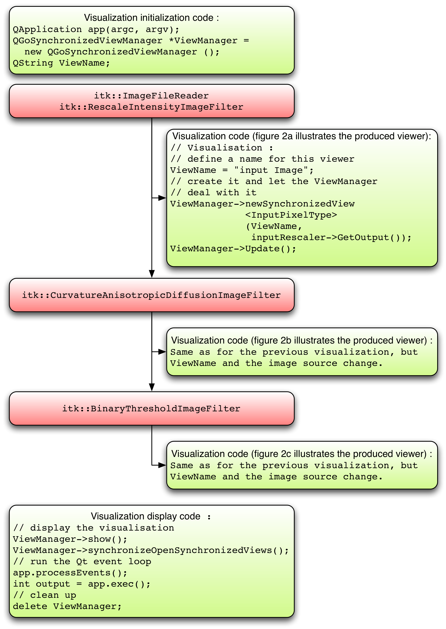
Figure 1: the following graph shows how to use the code snippets, in order to visualize intermediary results in an image-processing pipeline. (The example can be found in /Examples/GUI/lib/pipeitkexample.cxx)

- pipeitkexample takes a 3D image as an argument, and processes it, displaying the output of the filters at each stage of the pipeline, in a synchronized manner.

- Pipevtkexample takes vtk readable image as an argument, and blurs it. It displays the input and the output of the filter, in a synchronized manner.

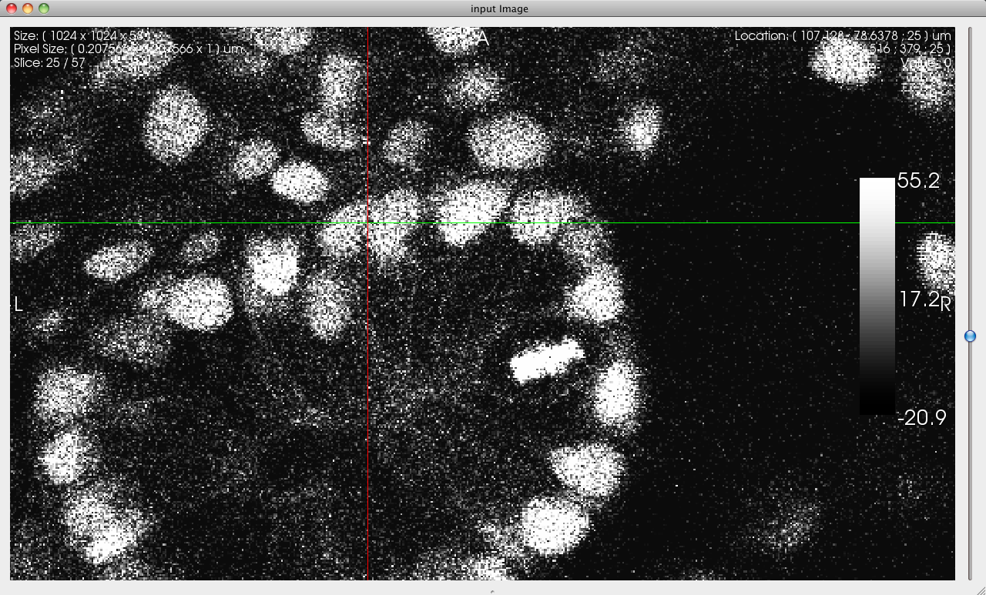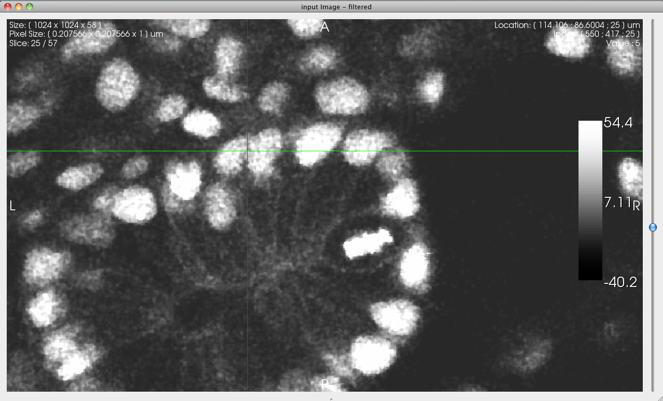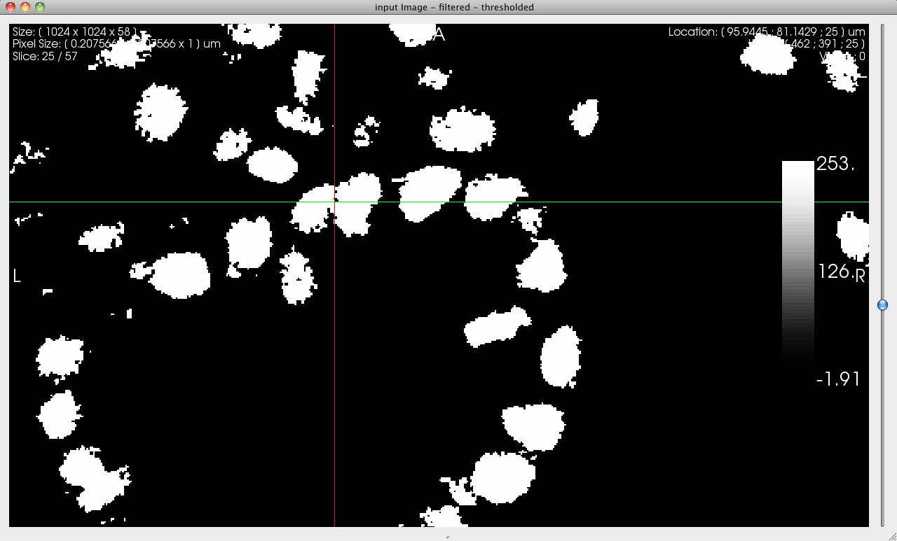
a b c
Figure 2: viewers generated by pipeitkexample, showing the input image(a), the filtered image(b), and the thresholded image(c).

Applications

- comparegui shows how to create a very basic GUI using the functionalities provided by the qgosynchronized classes. Figure 1 and 2 are screenshots of this application.

- comparesimple takes a list of 2D or 3D images as an input and displays them in synchronized viewer widgets.

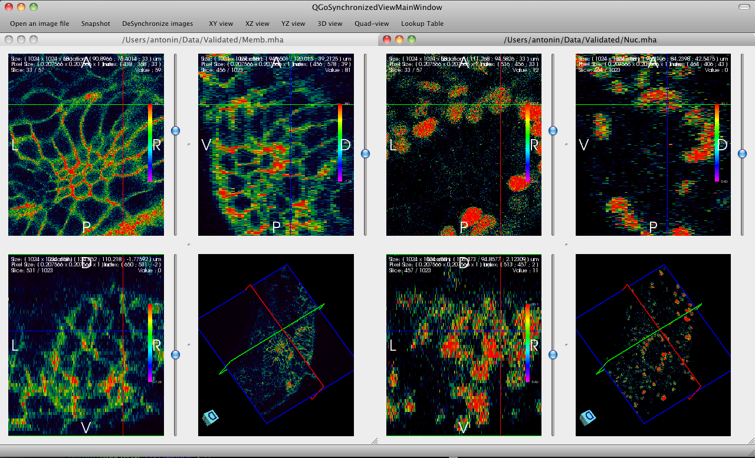
Figure 3: illustration of comparegui example application. We use it to compare two identical datasets, in a synchronized manner, with a custom look-up table.

Visual debugging:

When creating a new ITK pipeline or filter, it is often beneficial to examine the intermediate images that are generated. In a previous article in The Source [3] we demonstrated how a custom GDB Python pretty-printers could be used to launch an image viewer, which displays an itk::Image's BufferedRegion when 'printing' the object in GDB. This provides an expedient method of improving a pipeline or fixing a new filter.

Previously, we launched an independent child process, applications like Paraview or Mayavi, for each object that was printed. The Python pretty-printer based on QGoImageCompare utilizes its well-designed visualization and analysis tools, but it also has an advantage over the other image viewer pretty-printers. The camera view is synchronized between all images that are printed.

The first time print is called on an itk::Image pointer, the pretty-printer module, called icp, launches a child process, icpGui. A separate process is needed to separate the GDB event loop and the Qt event loop. The image's information (spacing, origin, etc.) and data buffer are passed from the Python module to the GUI via Qt's inter-process communication (IPC) capabilities. Subsequent images are sent across the same IPC channels and the view is synchronized between images. Simultaneous synchronized zooming, for instance, can be very helpful in image analysis.

The GDB-pretty-ITK project is still in alpha stages, but it is usable and may be helpful in your adventures with ITK. We have tried to lower the barrier to installation and usage, although there is admittedly a ways to go. A set of installation instructions has been placed on the ITK wiki [4]. Instructions exist for the QGoImageCompare pretty-printer along with the rest of the system. Note that the entire system must be installed to use the icp pretty-printer. We also developed a set of CMake modules to ease registration of the ITK pretty-printers in your project [5].

An example use of the icp pretty-printer is distributed as a CTest test within the source tree. This example includes a simple executable and a GDB script of commands that can be interactively entered into the debugger.

References:

[1] Sophie Chen, Insight Toolkit Plug-ins: Volview and V3D, Kitware’s The Source, October 2010.

[2] QGoImageCompare: Source code of QGoImageCompare. https://github.com/gofigure2/QGoImageCompare.

[3] McCormick, M. Visual Debugging of ITK. Kitware's The Source. April 2010. http://kitware.com/products/html/VisualDebuggingOfITK.html

[4] ITK/GDBPretty. The ITK Wiki. http://www.itk.org/Wiki/ITK/GDBPretty.

[5] gdb-pretty-itk-cmake: CMake scripts to register GDB pretty-printers for ITK on targets. http://gitorious.org/gdb-pretty/gdb-pretty-itk-cmake.

Biographies:

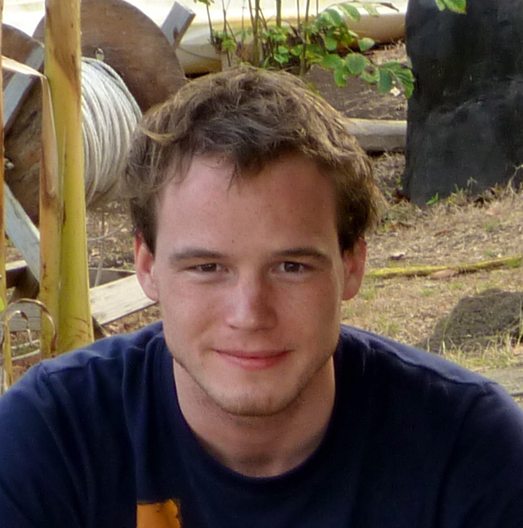
Antonin Perrot-Audet is a Ph.D. student at the CREATIS Lab, University of Lyon 1 in France, and in collaboration with the Megason Lab at Harvard Medical School, working on his thesis in registration of cell lineages.


Matthew McCormick is a PhD. candidate at the University of Wisconsin-Madison working on his thesis in medical ultrasound characterization of carotid plaques.

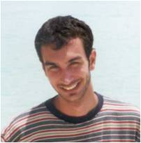
Arnaud Gelas is a Research Associate in the Megason Lab at Harvard Medical School where he is in charge of the development of GoFigure2. He is currently managing the software development process of GoFigure2.

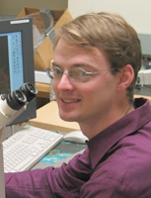
Sean Megason is an Assistant Professor in the Department of Systems Biology at Harvard Medical School. The Megason lab wants to understand how the code in the genome is executed to turn an egg into an embryo. They use VTK and ITK to segment and track cells in 4d microscopy image sets.

