TITLE

Abstract

Often in the process of designing an image processing application, one needs to
visualize and to compare results of the process at different stages.

The current solution is often to add many itk::ImageFileWriter's to the code and write an image after
each filter. Then, one has to open each image in a viewer, adjust the
lookup tables (LUT), try to find a region in the original image, and its
correspondence in the processed image. This technique slows down the processing,
as one has to write each image to be visualized to the hard drive.
Opening the images and trying to synchronize the visualizations is also time consuming.

To address this problem, we first created NAME_OF_THE_PROJECT, a lightweight
visualization library that can be easily incorporated to any Qt application.

Then, this project merged with Matt McCormick’s visual debugger for ITK
in order to provide a complete package for visualizing images while debugging an
ITK pipeline! Thus, we free the developers from the many itk::ImageFileWriter's in their code.

Introduction

NAME_OF_THE_PROJECT was developed in the Megason Lab and at the University of Wisconsin-Madison. It is a
library aimed at simple comparison of images. The library provides an easy means to add 2D and 3D image visualization and examination features to a Qt4 application, or the bundled visualization executables can be used on their own.

NAME_OF_THE_PROJECT can be used in the process of developing an ITK or VTK image
processing or data visualization program: developers can use it to quickly
visualize and compare results of filters in different parts of the pipeline. It is capable of displaying images
directly from the memory while debugging an ITK application.

ARNAUD & MATT : something to add/delete ?

Philosophy

NAME_OF_THE_PROJECT was created to simplify things: bundling the GDB-pretty-ITK project's visual
debugger and a simple viewer should make the installation process much simpler (not sure what this second part is trying to say) I was thinking, that by bundling the viewer and the pretty printer,and with the installers arnaud is working on, installing the pretty debuggers would be simplier ?. I can make installers for the widget, but making package (.deb and .rpm) for icp is more complicated than the widget ones. (I'll work on the installers, but I don't think we need to mention it in the paper).
Since this part is really short, we may merge it in the introduction. I agree for the merging. I even think that we can get rid of this part, it doesn't add much ?
The visualization library should be easy to use and modify.

Features

NAME_OF_THE_PROJECT includes :

- support for ITK scalar images (see supported format for itk images support details),
- support for VTK images,
- 2D or 3D images with planar views and a tri-planar 3D view,
- a camera synchronization for fine comparison results,
- choice of look-up tables,
- pixel examination – location, index, value for a cross-hair,
- QWidget ui form for easy customization using Qt Designer,
- QWidget inheritance for integration to a Qt GUI / application,
- A manager class that takes care of visualizations properties (creation, deletion, synchronization of several views, look-up Tables…),
- ITK visual debugging / comparison pretty-printer.

Description of the library :
I really can't read the font for the class names, may we use courrier instead ?
The library is composed by six classes, which are all Qt objects :

- QGoSynchronizedView is the abstract class for QGoSynchronizedView2D and
QGoSynchronizedView3D. QGoSynchronizedView2D(3D) is used to display a QWidget containing a two(three)
dimensional vtkImagedata* or itk::Image*. QGoSynchronizedView2D(3D) provides the
interface to synchronize cameras among several GoSynchronizedView2D(3D).

QGoSynchronizedView2D(3D)Callbacks takes a list of QGoSynchronizedView(3D) and
synchronizes their cameras by setting up callbacks. It is recommended to let the
QGoSynchronizedViewManager deal with SynchronizedView synchronization.

QGoSynchronizedViewManager is the high level class for QGoSynchronizedView2D,
QGoSynchronizedView2DCallbacks, QGoSynchronizedView3D, QGoSynchronizedView3DCallbacks.
This class deals with QGoSynchronizedViews for correct synchronization and handling
provides a simple interface to create/delete/synchronize QGoSynchronizedViews.

For more details, readers are invited to look at the Doxygen documentation and at the source code which is well-documented.

Usage

Visualization library :

We first describe the basic use of the visualization library, and illustrate it with an example :

- Basic use :

We introduce here the high level functions for creating QWidgets views and synchronizing visualizations, based on the QGoSynchronizedViewManager:

Creation of the visualization manager object
// we simply create a new manager that will take care of
// creation/deletion of visualization and callbacks for us.
//
QGoSynchronizedViewManager* ViewManager = new QGoSynchronizedViewManager();
// Visualize some images, process etc...
// Remember to delete ViewManager when no visualization is needed
delete ViewManager;

- Visualization of a VTK image

/ the synchronization manager can create visualization windows given
// a valid pointer to a VTK image and
// a string encoding the name of the visualization.
//
ViewManager->newSynchronizedView("My VTK View", VTKSmartPointerToImage);
ViewManager->Update();
ViewManager->show();

- Visualization of an ITK image
// the synchronization manager can create visualization windows given
// a valid pointer to an ITK image,
// the template argument representing the image pixel type,
// a string encoding the name of the visualization.
//
ViewManager->newSynchronizedView<InputPixelType>("My ITK View", ITKSmartPointerToImage);
ViewManager->Update();
ViewManager->show();

- Synchronization of the camera for several images

//the synchronization manager can synchronize the opened images
// with a simple function call
///
ViewManager->synchronizeOpenSynchronizedViews();

Example :

Illustration 1: the following graph shows how to use the code nippets, in order to visualize intermediary results in an image processing pipeline. (The example can be found in /Examples/GUI/lib/pipeitkexample.cxx)

pipeitkexample takes a 3D image as an argument, and processes it, displaying the output of the filters at each stage of the pipeline, in a synchronized manner.

Pipevtkexample takes vtk readable image as an argument, and blurs it. It displays the input and the output of the filter, in a synchronized manner.
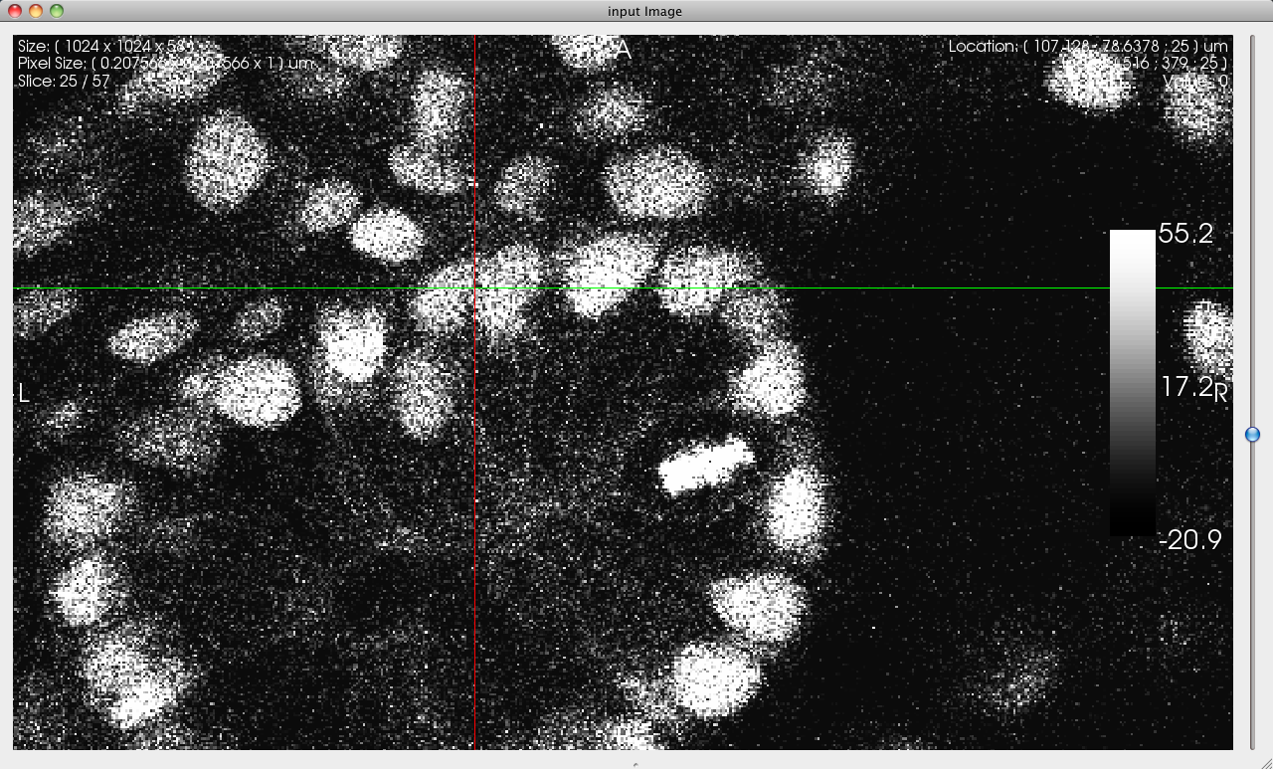Illustration 2: input image for pipeitkexample.cxx (see figure XXX for the pipeline description and the code used to generate this view)
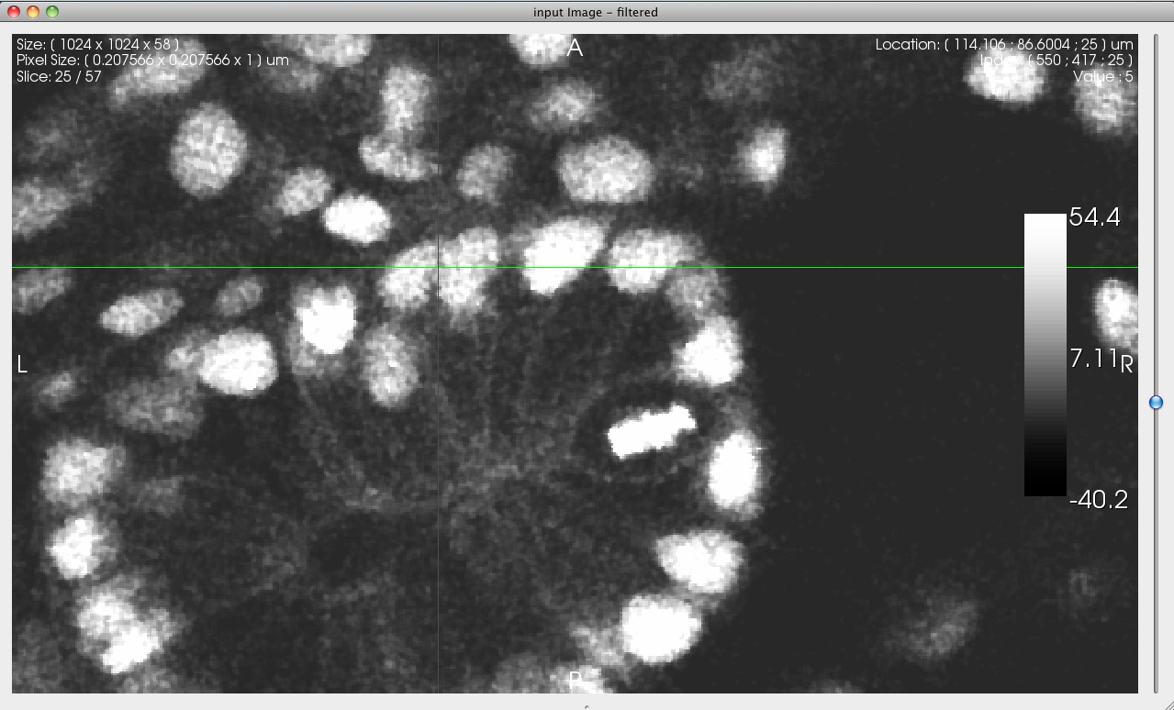Illustration 3: filtered image from pipeitkexample.cxx (see figure XXX for the pipeline description and the code used to generate this view)

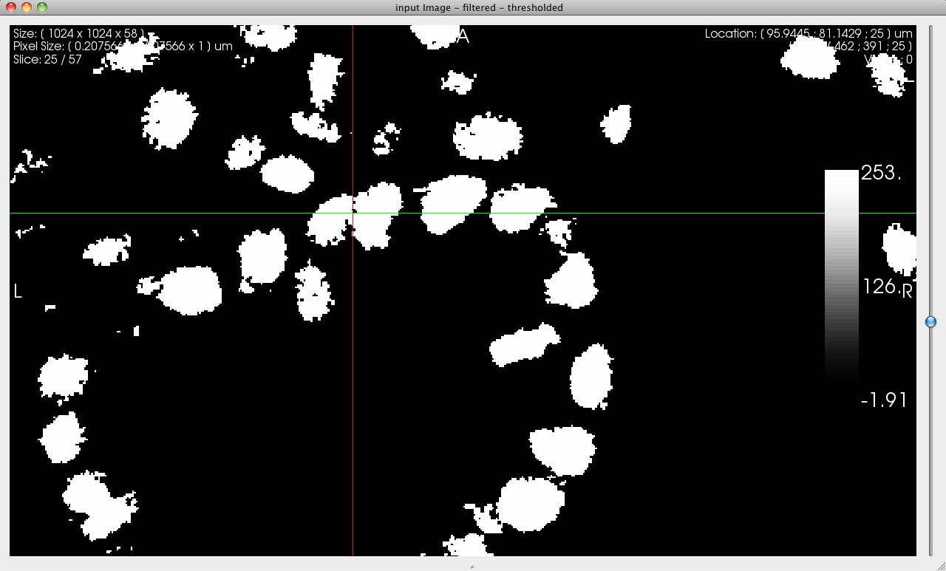Illustration 4: threshold of the filtered image from pipeitkexample.cxx (see figure XXX for the pipeline description and the code used to generate this view)

Executables :

comparegui shows how to create a very basic GUI using the functionalities provided by the qgosynchronized classes. Figure 1 and 2 are screenshots of this application.

comparesimple takes a list of 2D or 3D images as an input and displays them in synchronized viewer widgets.
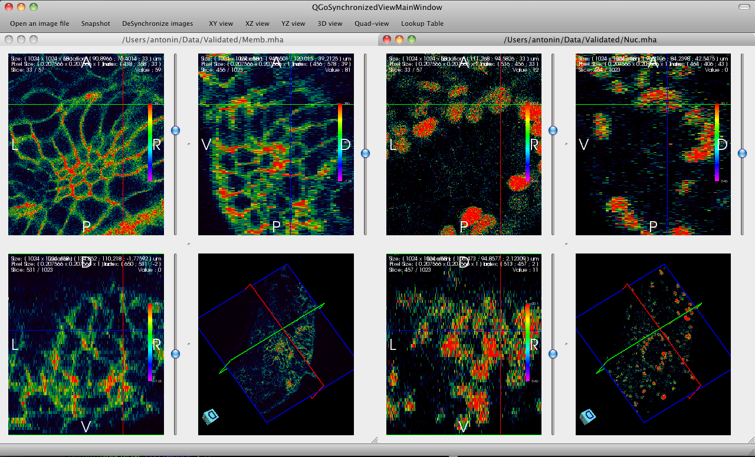Illustration 5: illustration of comparegui example application. We use it to compare two identical datasets, in a synchronized manner, with a custom colormap.

Visual debugging :

ARNAUD & MATT : Maybe one typical debugging operation here ?

[ANTONIN – edit and rearrange and make additions as necessary]

When creating a new ITK pipeline or filter, it is often beneficial to examine the intermediate images that are generated. In a previous article in The Source [prettyArticle] we demonstrated how a custom GDB Python pretty-printers could be used to launch an image viewer which displays an itk::Image's BufferedRegion when 'printing' the object in GDB. This provides an expedient method of improving a pipeline or fixing a new filter.

Previously, we launched an independent child process, applications like Paraview or Mayavi, for each object that was printed. The Python pretty-printer based on NAME_OF_THE_PROJECT utilizes its well-designed visualization and analysis tools, but it also has and advantage over the other image viewer pretty-printers. The camera view is synchronized between all images that are printed.

The first time print is called on an itk::Image pointer, the pretty-printer module, called icp, launches a child process, icpGui. A separate process is needed to separate the GDB event loop and the Qt event loop. The image's information (spacing, origin, etc.) and data buffer are passed from the Python module to the GUI via Qt's inter-process communication (IPC) capabilities. Subsequent images are sent across the same IPC channels and the view is synchronized between images. Simultaneous synchronized zooming, for instance, can be very helpful in image analysis.

The GDB-pretty-ITK project is still in an alpha stage, but it is usable and may be helpful in your adventures with ITK. We have tried to lower the barrier to installation and usage, although there is admittedly still a ways to go. A set of installation instructions have been placed on the ITK wiki [ITKWiki]. Instructions exist for the NAME_OF_THE_PROJECT pretty-printer along with the rest of the system. Note that the entire system must be installed to use the icp pretty-printer. We also developed a set of CMake modules to ease registration of the ITK pretty-printers in your project [ITKPPCmake]

An example use of the icp pretty-printer is distributed as a CTest test within the source tree. This example includes a simple executable and a GDB script of commands that can be interactively entered into the debugger.

References:

[prettyArticle] McCormick, M. Visual Debugging of ITK. Kitware's The Source. April 2010. http://kitware.com/products/html/VisualDebuggingOfITK.html

[ITKWiki] ITK/GDBPretty. The ITK Wiki. http://www.itk.org/Wiki/ITK/GDBPretty.

[ITKPPCmake] gdb-pretty-itk-cmake: CMake scripts to register GDB pretty-printers for ITK on targets. http://gitorious.org/gdb-pretty/gdb-pretty-itk-cmake.

