Student Projects
Kirsten Segeren. INFO 664: Programming Cultural Heritage. 2026
‘Bin There’ NYC Data
New York City produces 13,000 tons of landfill waste each day - 75% of these item are recyclable. The goal of this project was to create a centralized drop-off locator for common recyclable items that are not accepted in DSNY curb-side pick-up.
After a combination of web scraping and APIs from Open Data and Grow NYC, I combined all the data used leaflet.js to display the data as a single interactive map in a web application that allows users to locate a drop-off center near them based on boroughs and categories.
Data collection and interactive map visualization for recycling drop-off points in NYC. View the github site at https://kirstseg.github.io/BinThereNYC_Data/
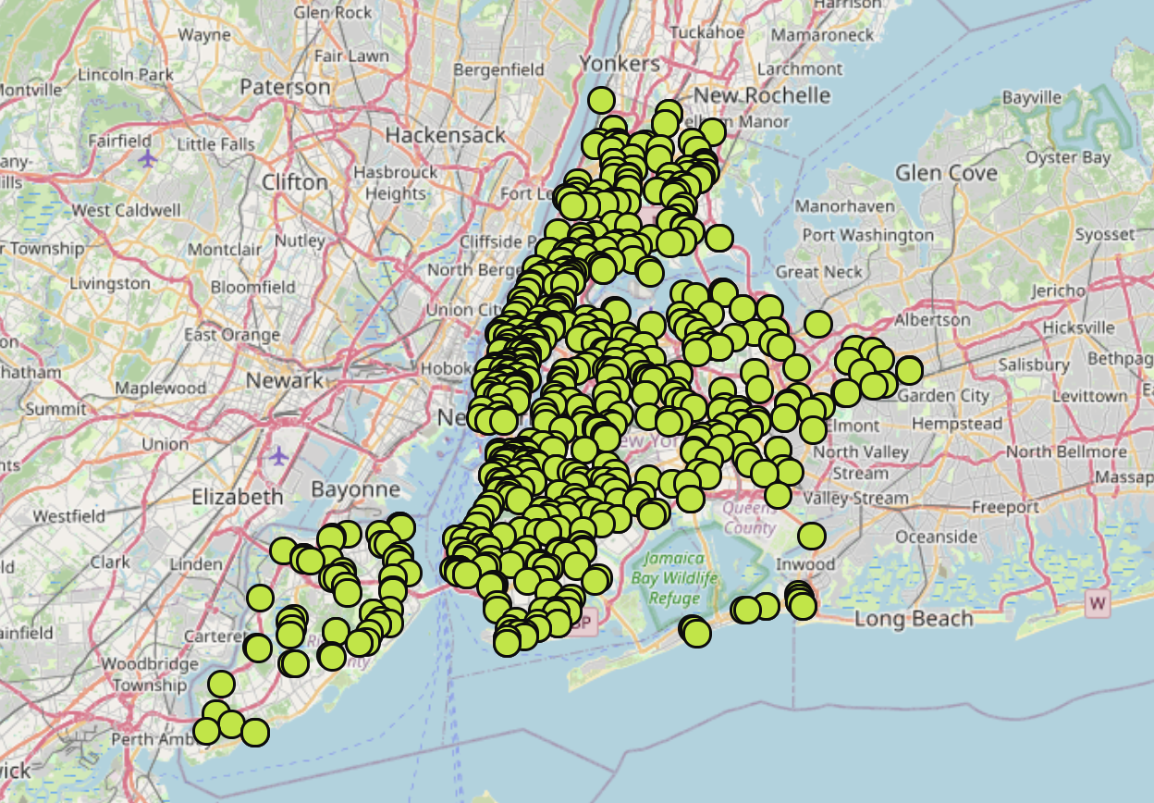
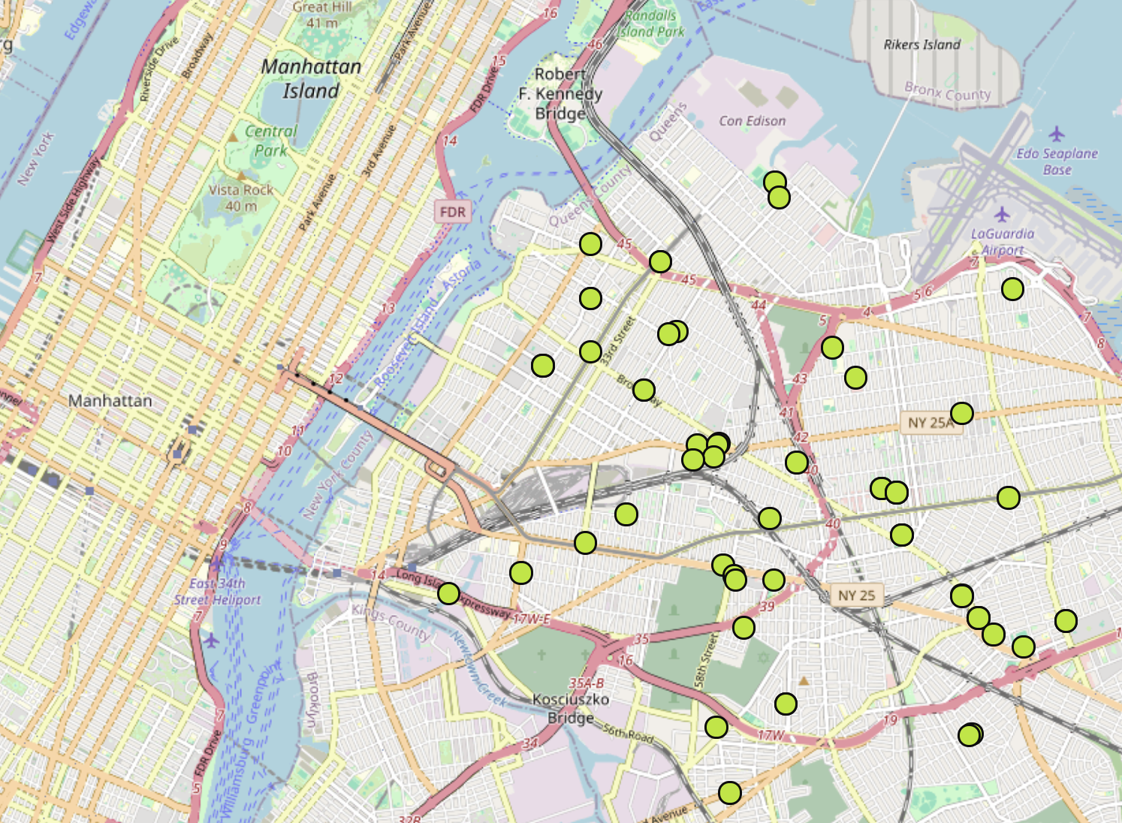

Maya Davis. INFO 664: Programming Cultural Heritage. Spring 2026.
Mapping Slavery
This project was built using Python to visualize the streets in Brooklyn that are named after slave-holding families... The streets highlighted identify slave-holding families and list the names of the people held captive.
I looked up old maps in the digital collections of the New York Public Library to investigate evidence of plantations, and I found a map from 1855, “Plan of the city of Brooklyn, L.I.”. This map showed old farm lines with the corresponding property owners, as well as planned streets and street names.
I saw a lot of familiar names on this map and decided to look further. This led me to finding enslavement information from The Journal of Slavery and Data Preservation, the NYC Municipal Archives, In Pursuit of Freedom and the North East Slavery Records Index. I confirmed a lot of the connections I made from the old city maps and decided to move ahead with this project. I feel very strongly that knowing the past informs the present and shapes the future.
See more: https://mlala.github.io/mapping_slavery/
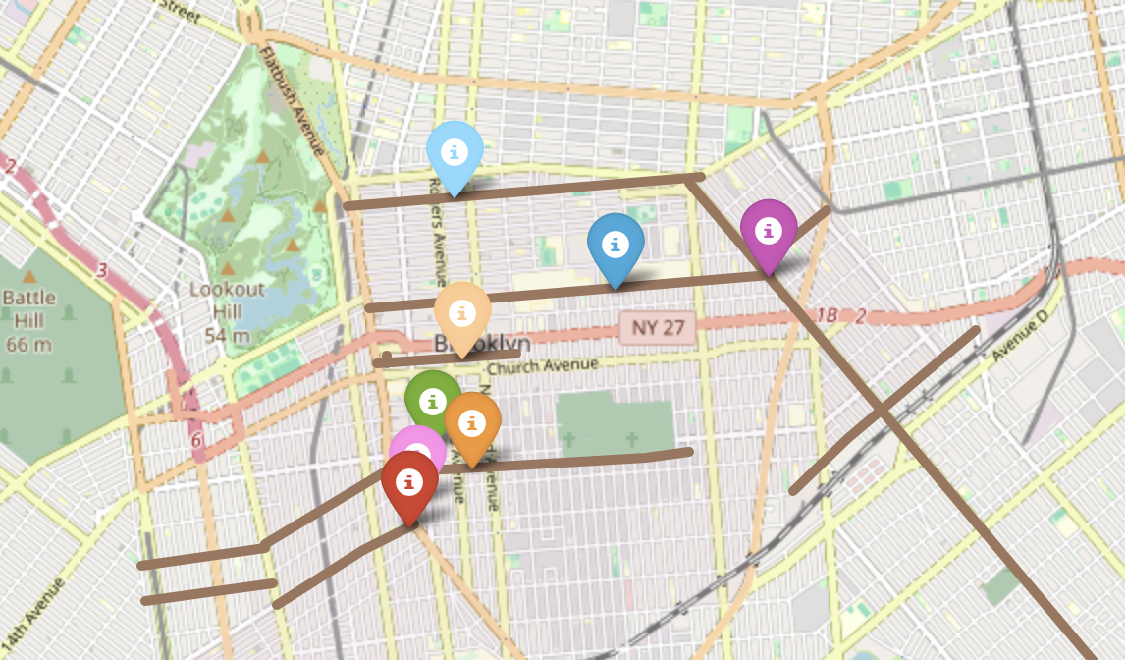
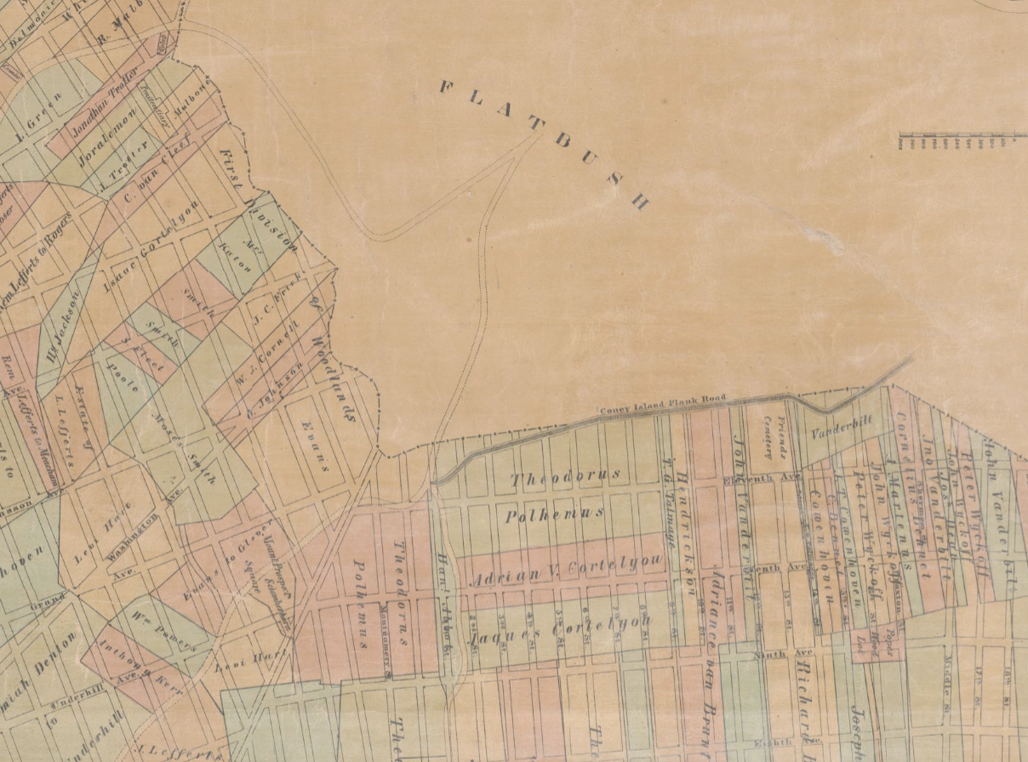
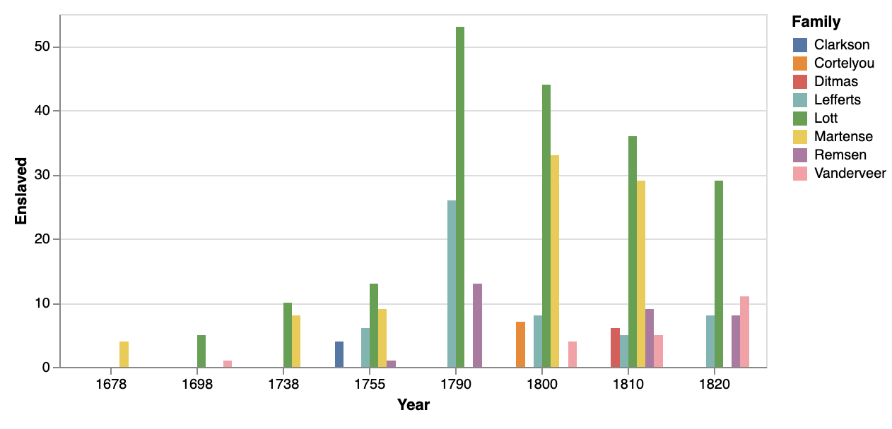

Leo Kreider. INFO 664: Programming Cultural Heritage. Spring 2026
Mapping Poetry Publishers into the 21st Century
This project collocates data about poetry publishers to explore how recent commercial and historical phenomena impact the art form. Gleaned from the Community of Literary Magazines and Presses' Directory of Publishers, its principle dataset is presented on a map that displays each publisher according to the year they were founded. A supplementary chart reflects the types of distributors these presses are now using (most notably Asterism, which rose to replace Small Press Distribution). These metrics allow for a visualization of what avenues (from book to publisher to distributor to bookstore) are opened and foreclosed at recent turning points for the industry.
See more: https://github.com/inland-thempire/poetry-publishers
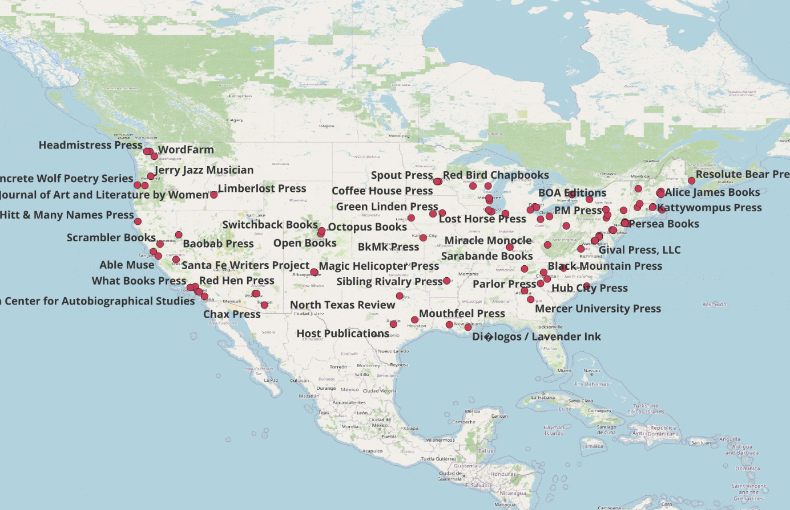
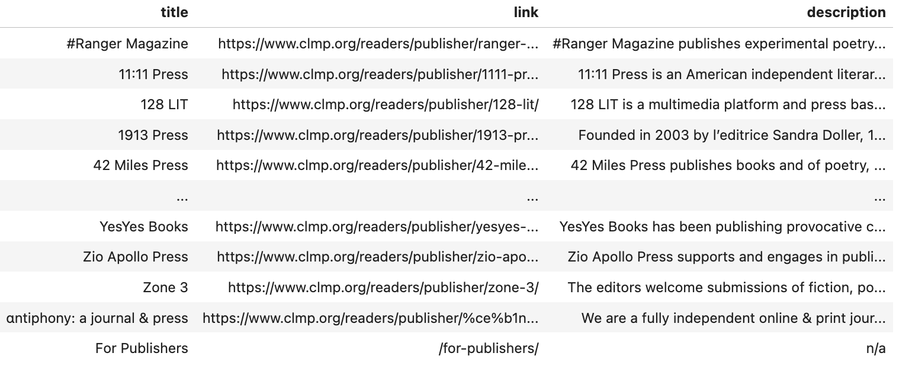
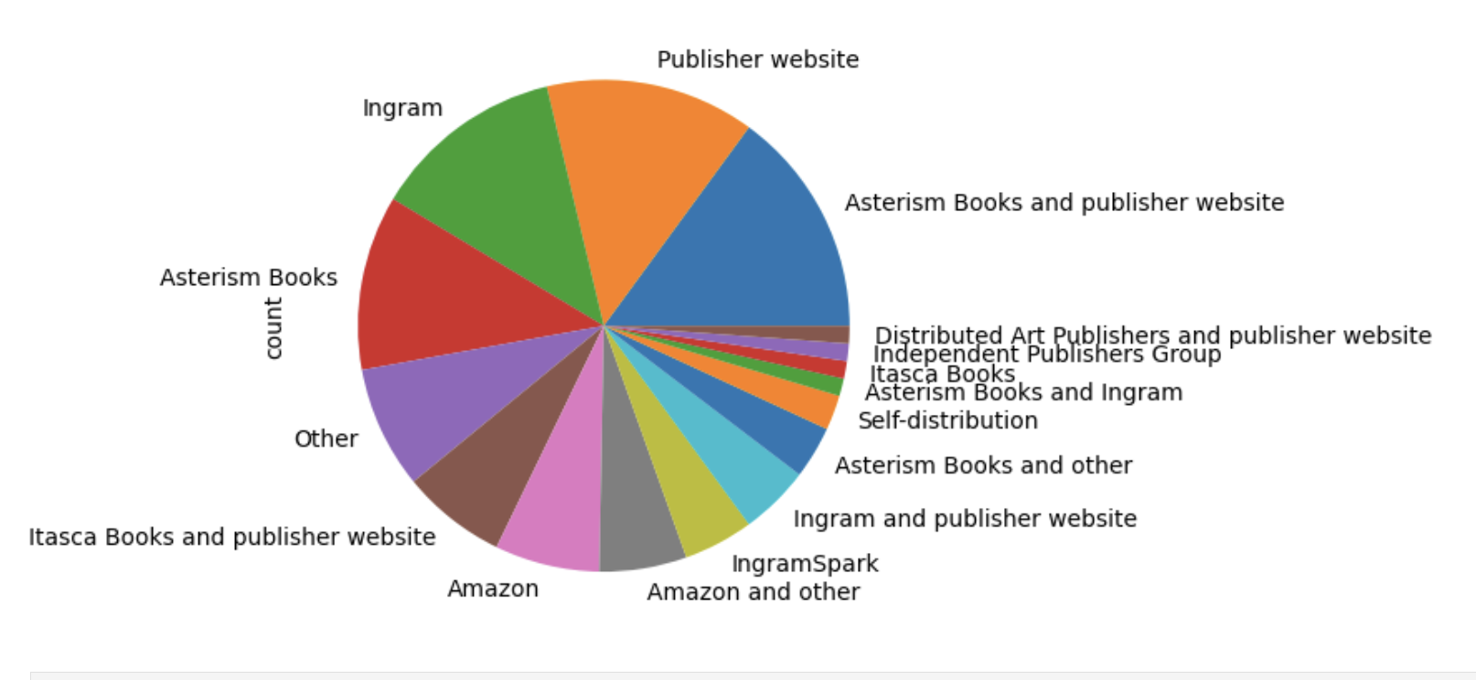

Ellie Connors. INFO 664: Programming for Cultural Heritage. Fall 2025
Machine Divinity
Machine Divinity is a computational-artistic exploration of spiritual and apocolyptic language across anonymous online spaces.
The website interface allows visitors to interact with three oracles, prompting them to speak in the style of their eschatological category. These "oracles" generate their content from three language models, trained on 9,383 4chan posts scraped for spiritual and psychosis-coded language.
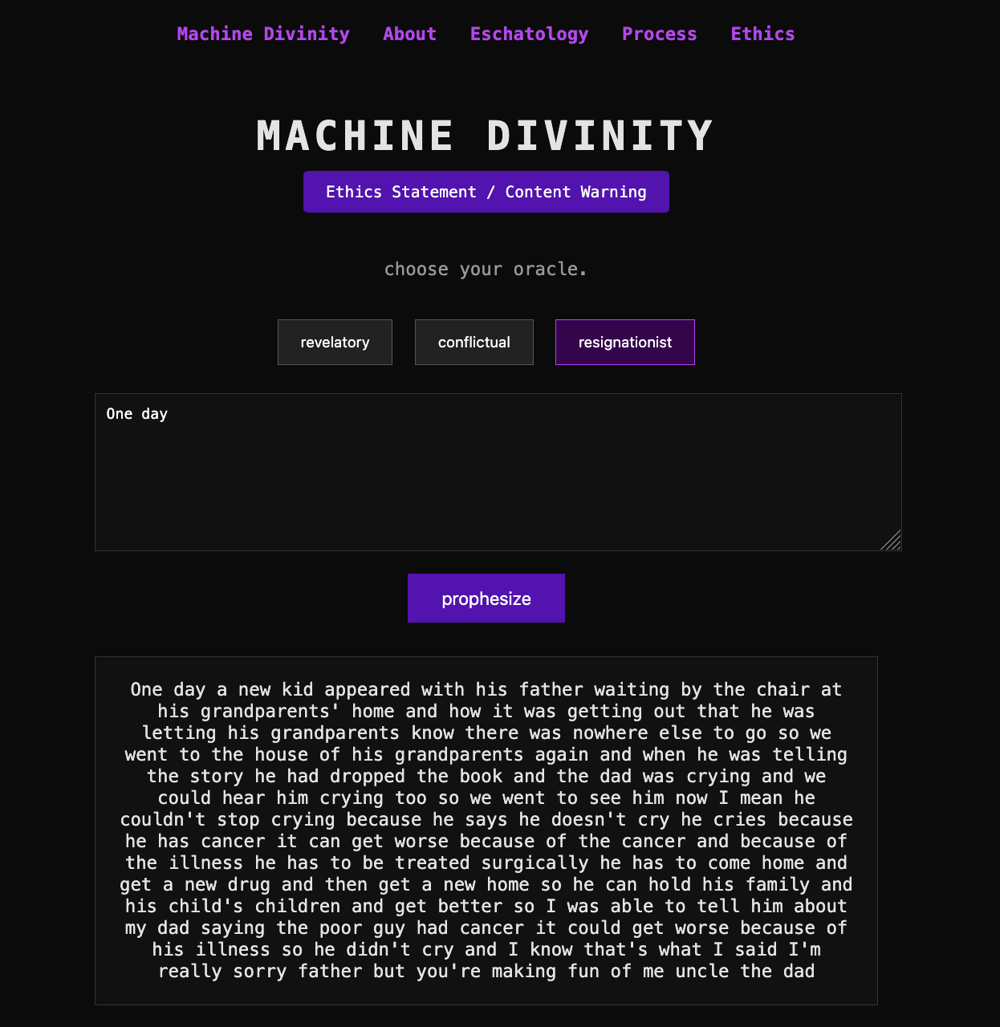
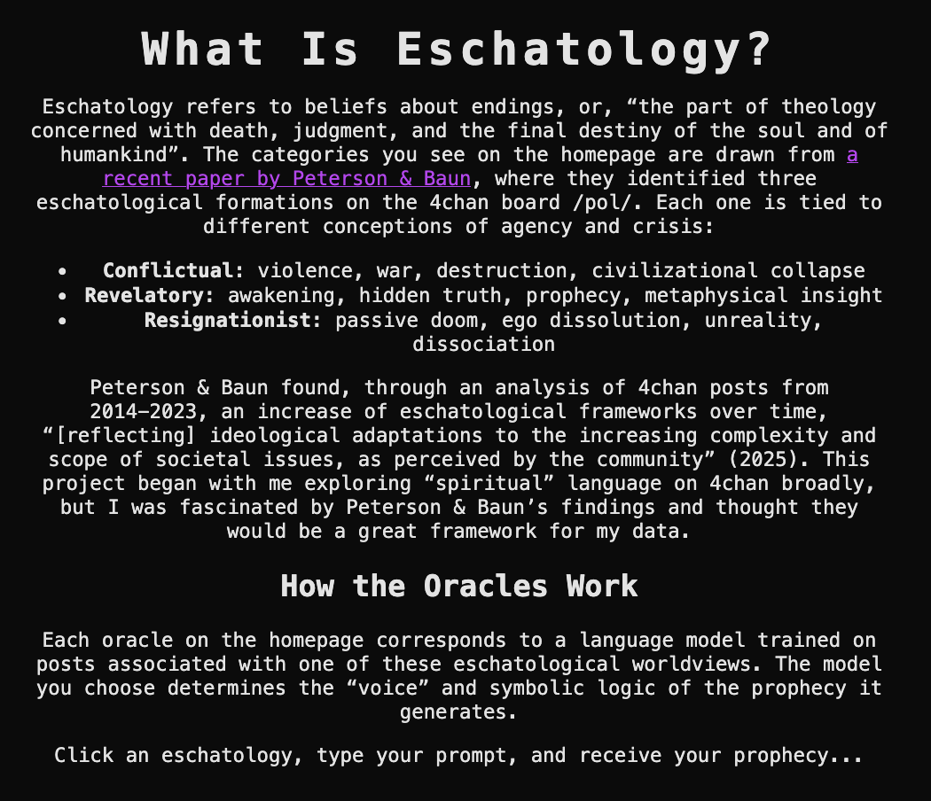
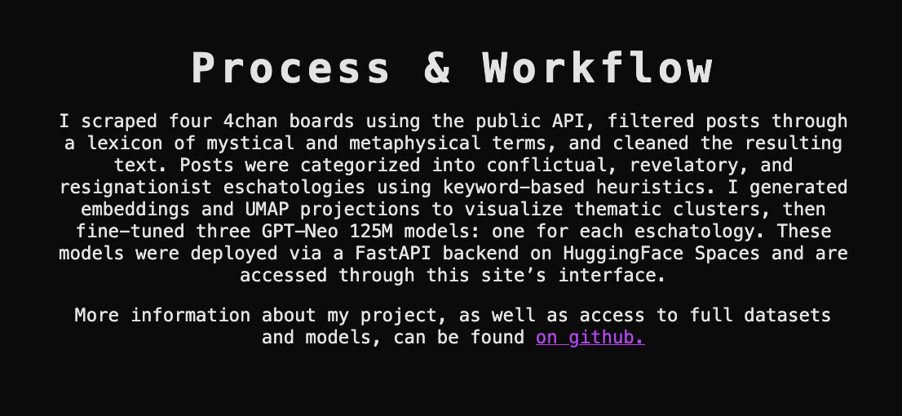

Alice Viggiani. INFO 664: Programming Cultural Heritage. Spring 2025.
Nowadays, the search for protein-rich foods is on the prescription of many fitness and muscle-building diets. But what else are we consuming along with these proteins?
The project aims to graphically relate data from foods' nutrients of animal, dairy, and plant-based protein sources with their impact, measuring greenhouse gas emissions, wasted water, and land use in the production.
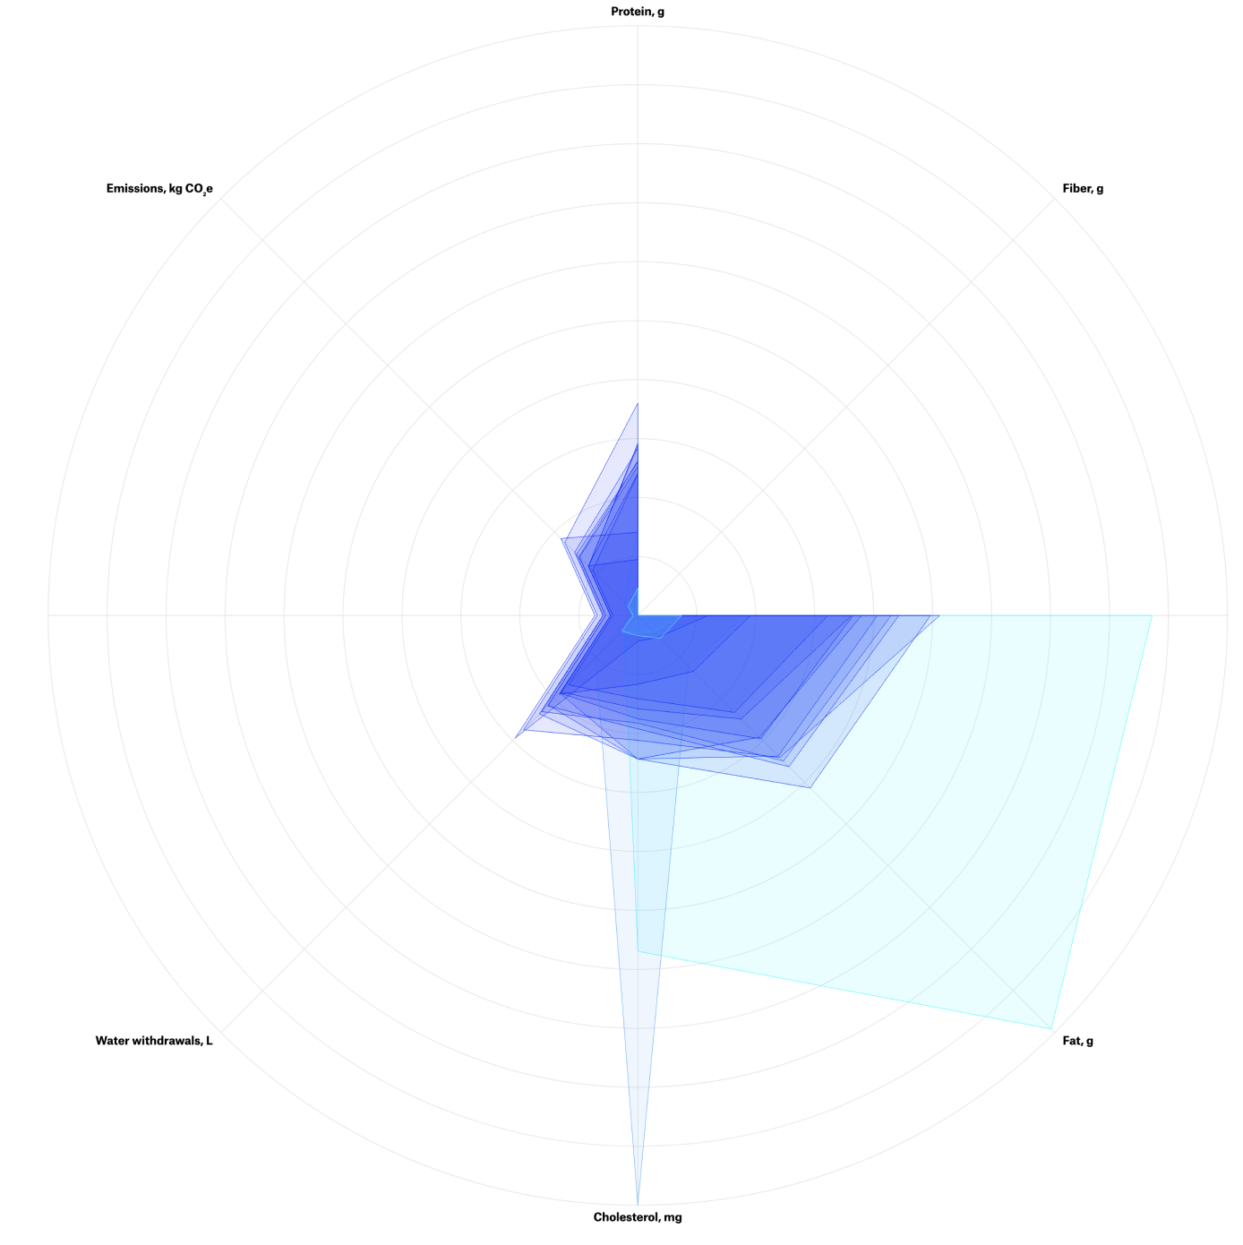
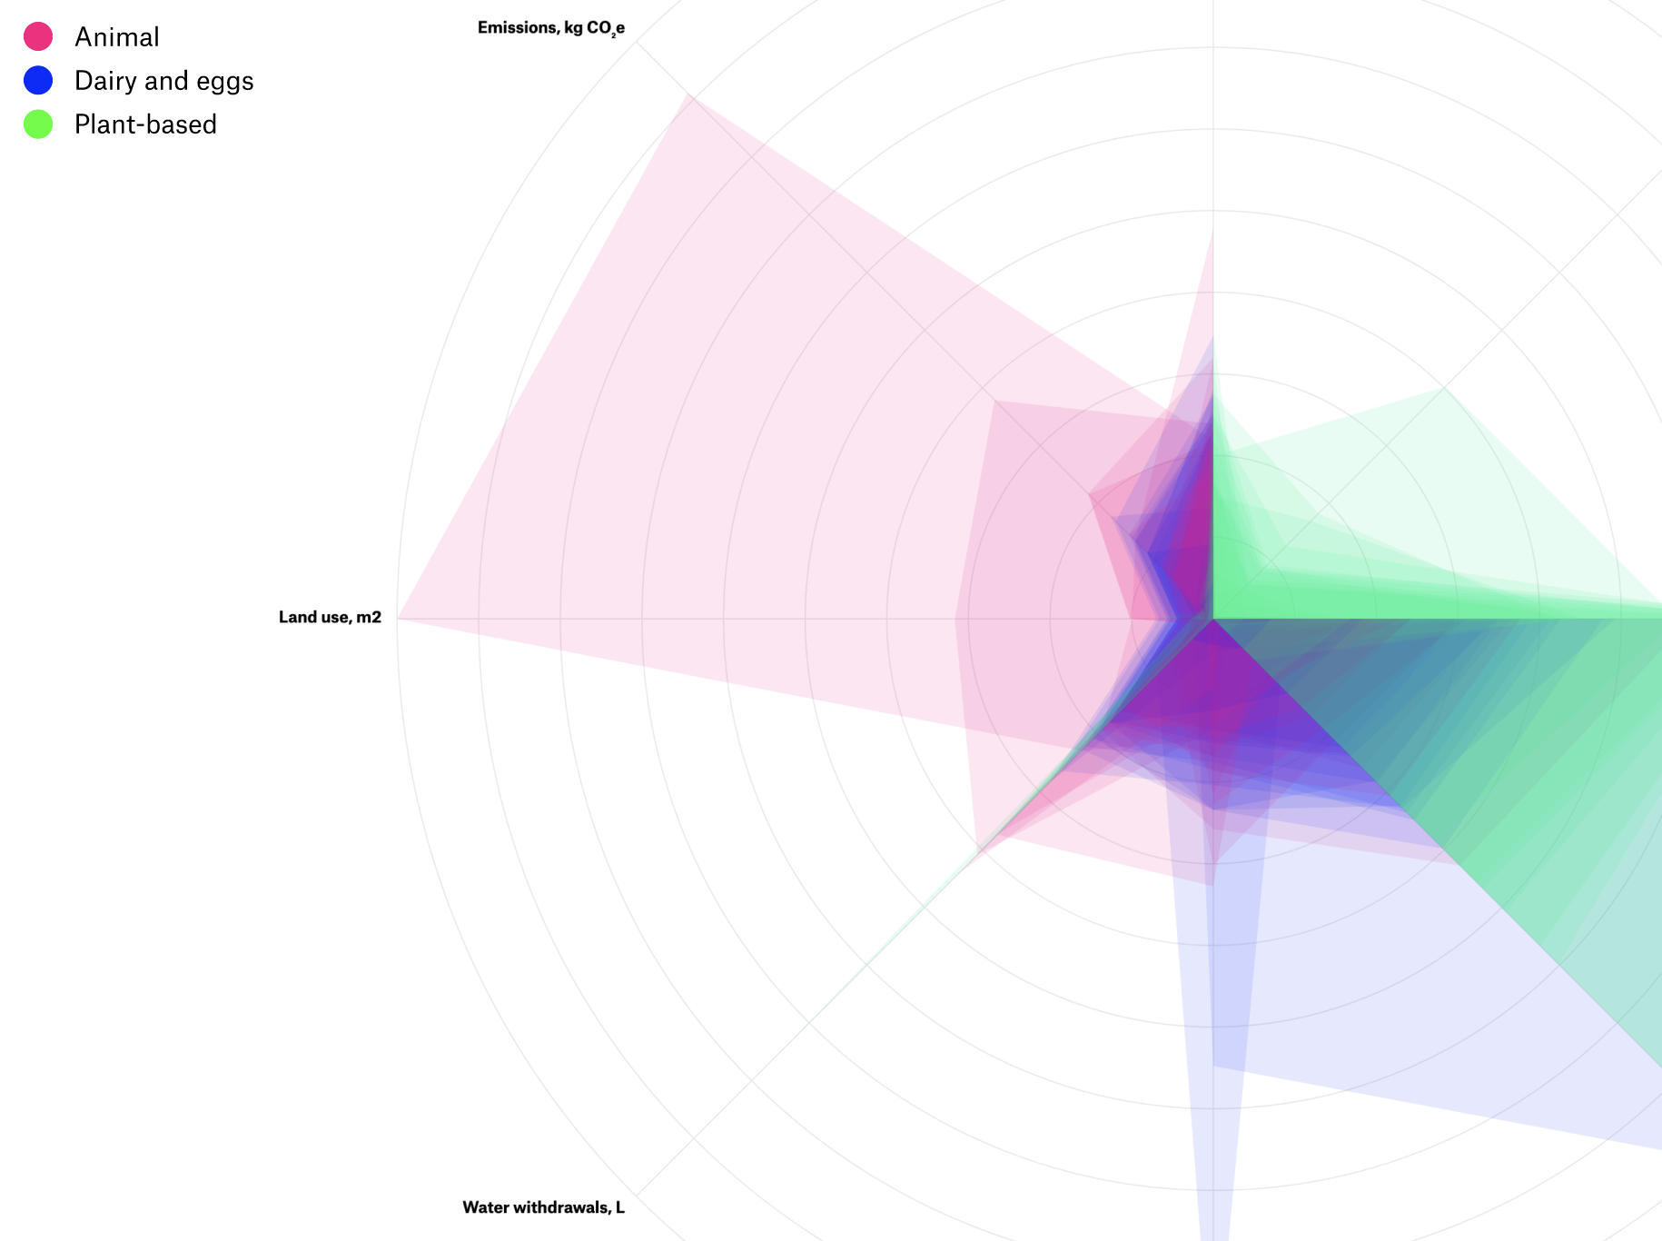

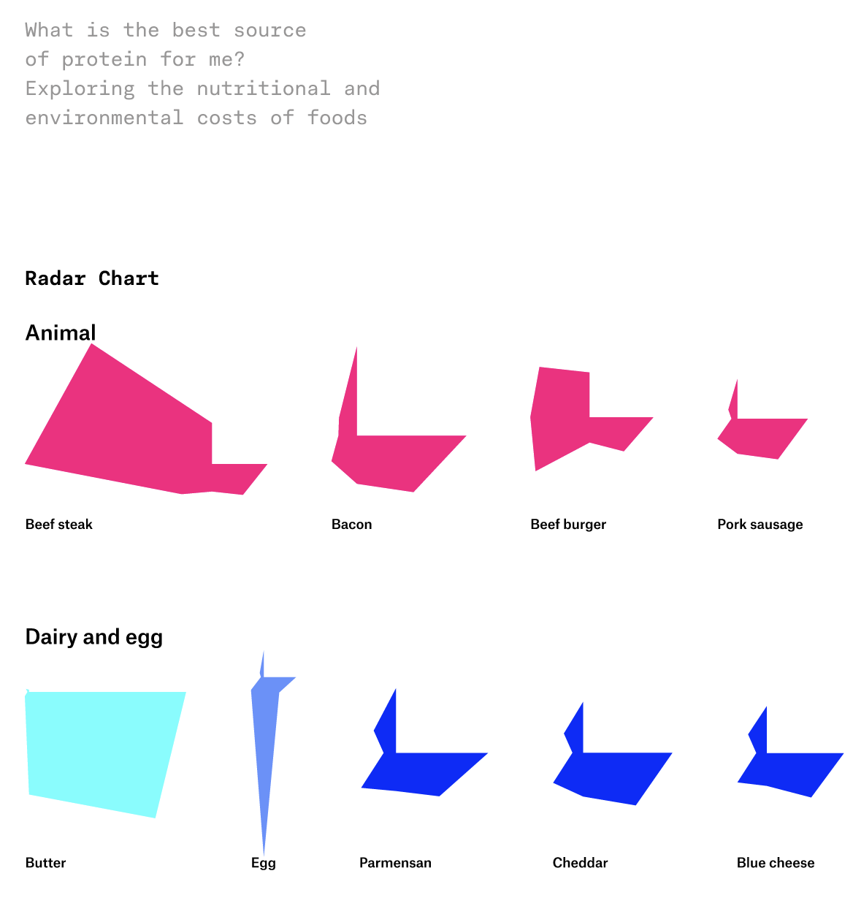

Jocelyn Fung. INFO 697 - How to Build a Bot. Summer 2025.
Masculinity Bot
This project fine-tunes a bot that generates image and text based on language from popular men’s magazines, like GQ and Esquire (see first image below). The data was gathered through web crawling, and the animation is handled with the drawbot python package and unsplash.
The second image, generated by the bot, was prompted with a text prompt “A manly man,” and an image prompt: “Man in nature.”
See more: https://github.com/jfung53/mensmagbot
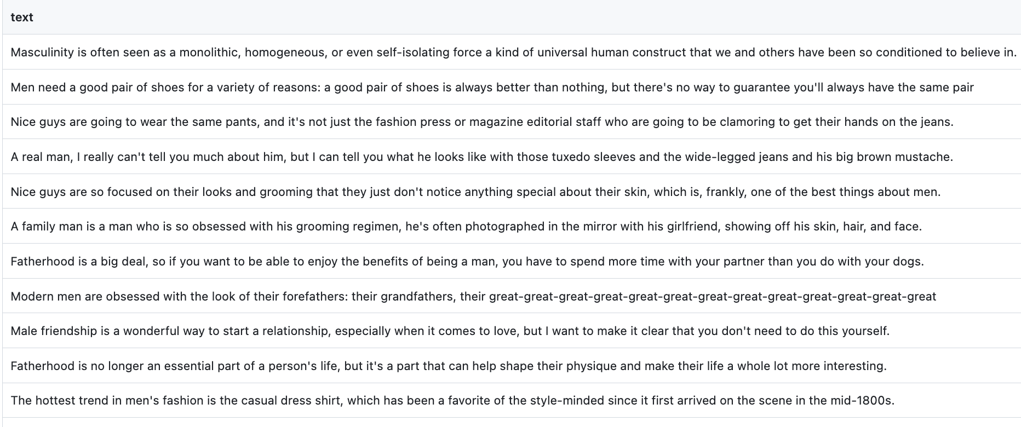



Alexa Frankelis. INFO-657: Digital Humanities. Spring 2026.
Introduction to Canopy IIIF Tutorial

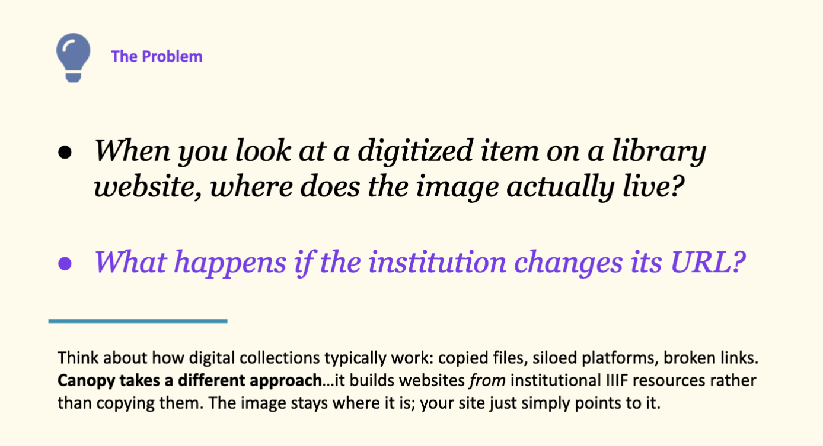

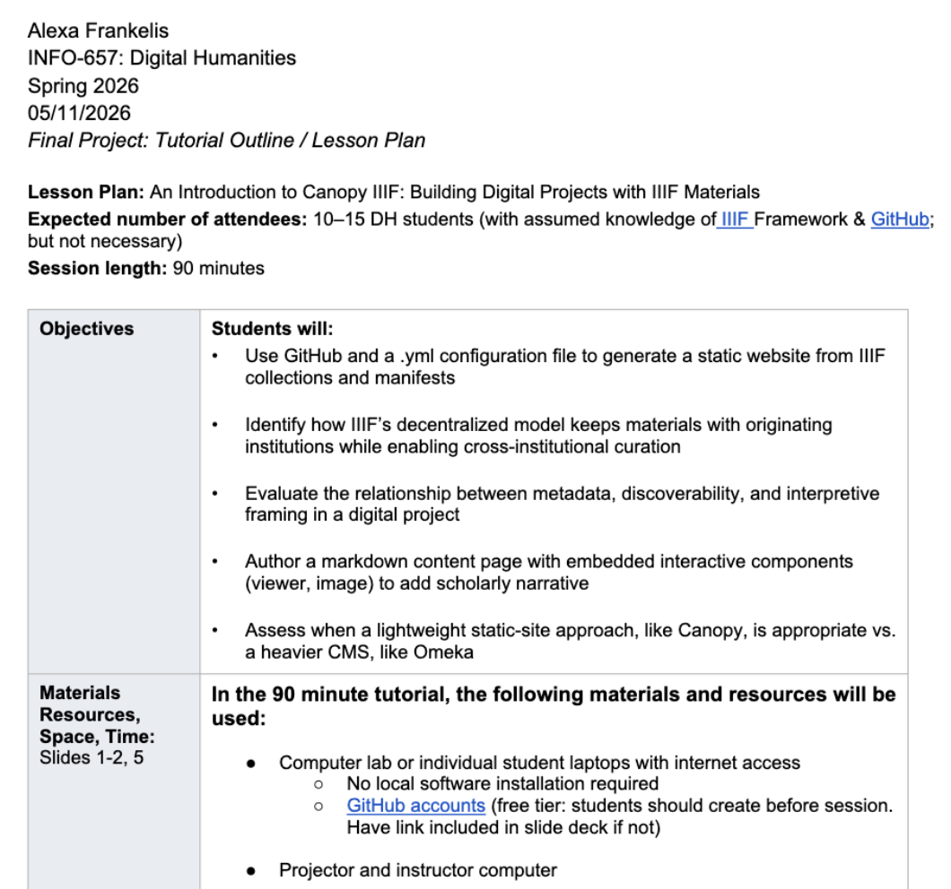
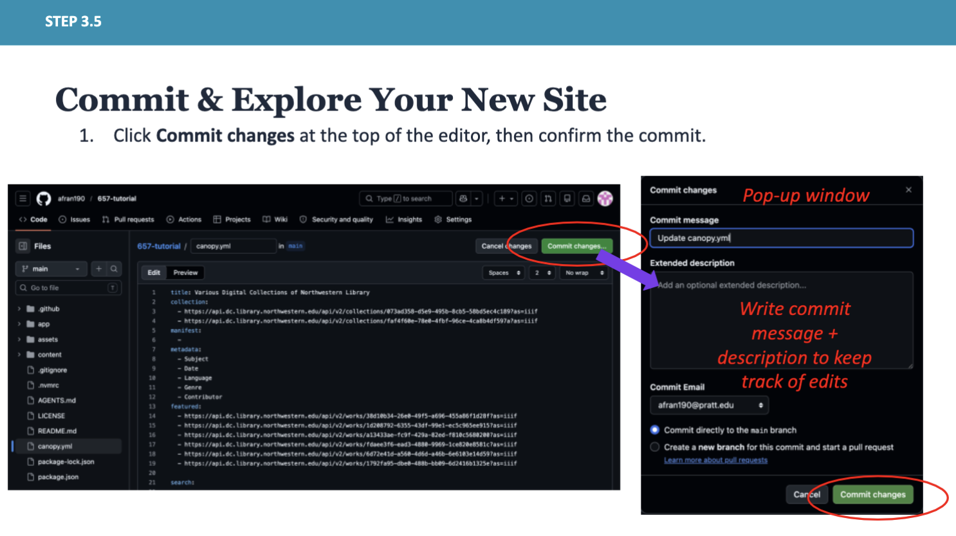
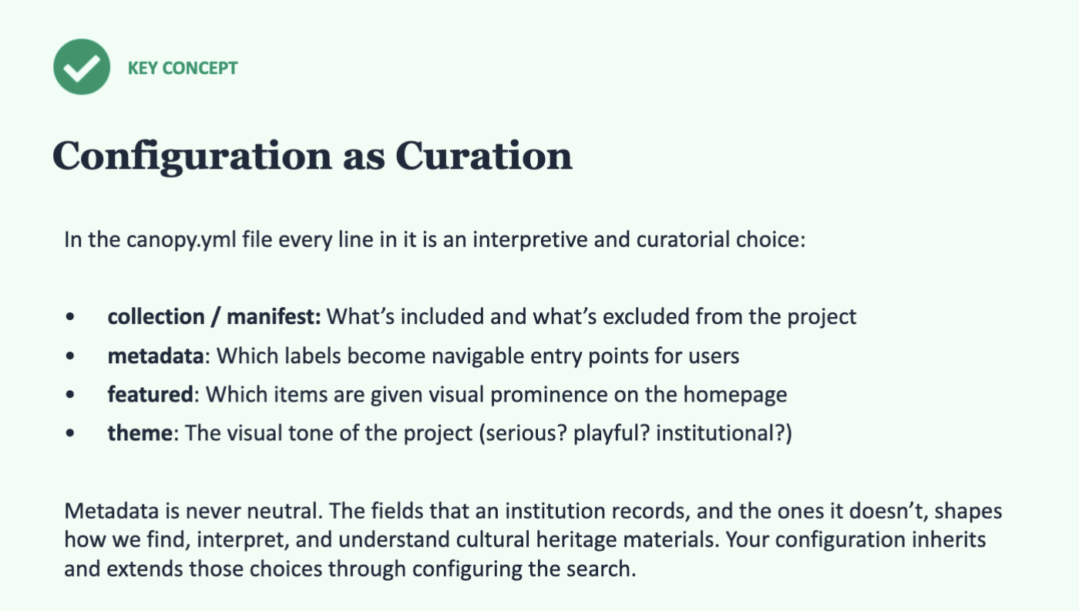

Carlos Boglio Casado. INFO 657: Digital Humanities. Spring 2026
I’m interested in how digital humanities can be rethought from non-dominant perspectives (those shaped by Caribbean, Black, queer, and Indigenous knowledge).

I’m treating this as the beginning of something that could extend beyond the course. I’ve been encouraged by professors and peers to start drafting work that could eventually be developed into an article for venues like Caribbean Studies or DH Quarterly. So I’m approaching this as an early stage of a publishable piece (very ambitious). I also want to get more comfortable positioning my own research within broader scholarly conversations in a way that could translate into future publication.

The central questions I want to explore are: How do digital humanities tools and
projects reproduce or challenge unequal power structures rooted in colonialism and
extractive systems? What happens when DH is approached from outside dominant
North American academic frameworks? How can digital scholarship produce
counternarratives through feminist, queer, Black, and Indigenous forms of resistance?

