*/Two things to note about this draft before jumping in… First, this is a paper about an annotation tool that I'm developing for teaching purposes. That being said, I don't have any information about using this tool to teach, because I haven't been able to deploy it in the classroom yet—for reasons I will explain in class. Second, I'm including a narrative of my development on the tool, in the form of "journal entries" from my development notes (essentially a daily log of my work on the tool), which are scattered throughout the essay. At this point, I'm not sure how else to incorporate a narrative of my labor on the project (interweaved with the main argument, as they are now, or as an appendix?), so I'm looking forward to your suggestions if you have them./*

“Misfittings: Social Annotation with Colors”

This project explores digital annotation as a way to make solitary reading practices more social and engaging. I modified an existing annotation tool to use in my English courses at Hunter College. As any English undergraduate instructor of English knows, close reading skills do not come naturally to most readers, and have to be cultivated through repeated modeling and practice. Instructors must make visible the attention to language required in close reading, and demonstrate how to analyze language in depth, particularly the elaboration of meaning or significance. From my experience, I’ve found that using a digital annotation tool–particularly *Hypothes.is*1–in the classroom is immensely helpful for modeling “active reading” strategies for students and following their progress as they complete the reading. However, while this tool encourages close and critical attention to language, it can also instill a limited and mechanized habit of responding to texts. In the textual comments, I see that students tend to replicate each other's response structure, turning whatever prompt or instructions I've given them into a rote analytical exercise. This makes me wonder, more broadly, about ways of using annotation that go beyond or offer alternatives to verbalized responses.

How might a digital annotation tool short circuit this traditional habit of response to address more directly the emotional and instinctual reactions that occur during reading? How can digital annotation can activate reading as an embodied practice, connecting more directly to knowledge as feeling and affect, rather than knowledge as information that exists purely in a textual form? To answer these questions, I've modified my *Hypothes.is* annotation tool to include a multi-color highlighter, rather than just yellow. The option for multiple colors, I hope, will expand "active reading" to include affect, recuperating the role of the body in reading. By prioritizing nonverbal or preverbal responses to recast reading as an embodied activity, this tool might encourage students to confront their more immediate responses, feelings, and gut reactions during the reading process.

Digital annotation engages in conversations about education, technology, and embodiment. It casts work already being done at the intersection of technology and embodiment within conversations about pedagogy.2 In thinking about technology and embodiment, I'm especially interested in the parallels across the technical and neurological. In what follows, then, I couch pedagogial interventions within discussions about how emotion functions in the body. Throughout this discussion, I also interweave a narrative of the tool’s technical development, inserting images and excerpts from my daily development notes. My aim here is to make the coding work simultaneously more visible and opaque, indicating to the nontechnical reader some of the suspensions of knowledge that are part of immersing yourself within a technical project.

*March 1, 2019: Day One at the New Media Lab.*

*Today Joe and I tried following the Client development instructions on the H docs. There were a bunch of issues, mostly to do with NPM. From what I can gather, Node requires you to install it globally, rather than just locally. As a result, every time we ran NPM we encountered a bunch of errors.*

*It took us (mostly Joe) about an hour and a half attempting to install the client and browser-extension this slow way before we finally doubled back and started over with a non-problematic installation of node. This involved deleting the repos from Github and starting over, installing the dependencies (node) via the NVM (node version manager) rather than NPM. The instructions are below:*

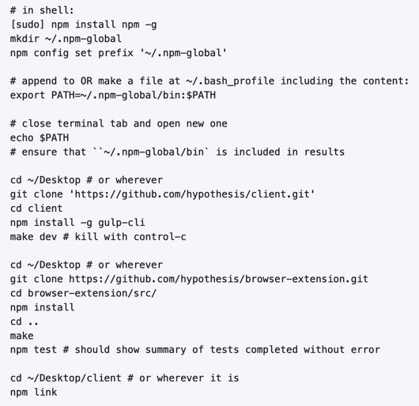

This multi-color highlighter aims to resist the pervasive and insidious nature of many “edtech” (or Educational Technology) tools and platforms, especially those that quantify or “measure” student learning. Audrey Watters explains that collecting information on students not only makes them vulnerable to those who would profit from them economically, but also reduces them to data points and labels, such as “cheat” or “at risk” ("Ed Tech and Trump"). By reducing the differences among learners, data collection and analytics–which purport to create “personalized” learning experiences—actually work to standardize and automate education. Only 10 years ago, Sharona Levy pointed out that, in English classes, “there is no mechanism to open [our student's] heads and see which neurons are firing while they are reading" (5). Just last month, primary schools in China were reported to roll out a "smart learning" program, where teachers track student learning through headbands that read brain activity. The results of their neuronal activity is visualized so the students can compete against each other:

The competition plays out in the form of a simulated rocket race on a screen at the front of the classroom. The headwear measures electric signals from neurons in the brain and translates that into an attention score using an algorithm. The more focused a student is, the higher the score gets, and the higher his or her rocket flies. If the score falls—meaning the student’s attention is waning—the rocket slows. Wang et al, "China’s Efforts"

This development of "smart learning" is part of a larger trend of surveillance including facial recognition technologies that that is much more pervasive and advanced in China than in the US, at least for the time being. China's example suggests where the the trajectory of edtech tools eventually lead—to mass neuronal surveillance.

Though things are changing dramatically in the world of edtech, Levy's point—that it is very difficult to understand how a student processes a text—still stands. Even now, neuroscientists disagree about seemingly simple questions like where consciousness is located in the brain or body, not to mention how learning functions on a neuronal level. This uncertainty leaves a space for brain functioning to be coopted into discourses about productivity and management. For example, Catherine Malabou points out the common assumption in "neuronal ideology" that brains should be made to conform and adapt to social and economic needs. Malabou finds a troubling parallel between discourses on "brain plasticity," which posits a flexible, developing brain, and capital's need for docile, networked, and adaptable workers. She suggests that people resist this understanding of "brain plasticity" by exploring another valence of the word plastic that is based off the french term *plastique*, which means "explosive." Rather than approach plastic as flexible, something that can be molded to fit economic needs, plastic can be an agent for annihilation and creativity. Plasticity in this sense is a means of refusal to submit to the managerial model, to resist complicity to capitalism. Malabou concludes that "Perhaps we ought to relearn how to enrage ourselves, to explode against a certain culture of docility, of amenity, of the effacement of all conflict even as we live in a state of permanent war" (79). Here, Malabou insists that affect—particularly anger—is a tool for refusing expectations for docility and complicity. Her exhortation to "enrage" ourselves points to a way that people can use emotion to subvert pressures to be managed or conform to standards of productivity.

Malabou's deployment of affect as a way of resisting productivity guides my own approach. Through this digital annotation tool, I experiment with reading to engage moments of emotional struggle and insight, rather than measurable “learning outcomes”. By experimenting with nonverbal, embodied reactions to reading, I hope to explore how tracking student reading can serve ends that are not exploitative, but engendering. In developing my version of the tool, I wonder how annotation might expand or reduce the quality of the student’s engagement with the text. Here, I’m concerned in the tension between what I call the “provocative”—opening up the text to new insights—and the “prescriptive”—limiting a student’s interaction with the text to a predetermined set of choices or options for responding. How do annotation tools create a standardized method or process in responding to texts? More specifically, how do certain features, such as colors, categories, or tags, for example, actually limit the kinds of responses they could have without these prompts, creating a confining structure for response?

*May 2, 2019: adder.html*

*This is the short html file for the buttons, both the "Annotate" and "Highlight" button that pop up together once you make a text selection./ /I was able to make additional buttons (which didn't actually work when pressed) on the toolbar by duplicating the html within the file. It is important to note that on its own, my work in this file was never functional. In order for the buttons to work, I had to modify some javascript files that saved and passed the data from the user’s click.*

*The image shows two files on top of each other. In the background, there’s an image of my final modifications to the adder, with an additional drop down menu for colors under the “Highlight” button. In the foreground, there’s an image of the original HTML file that configured the adder.*

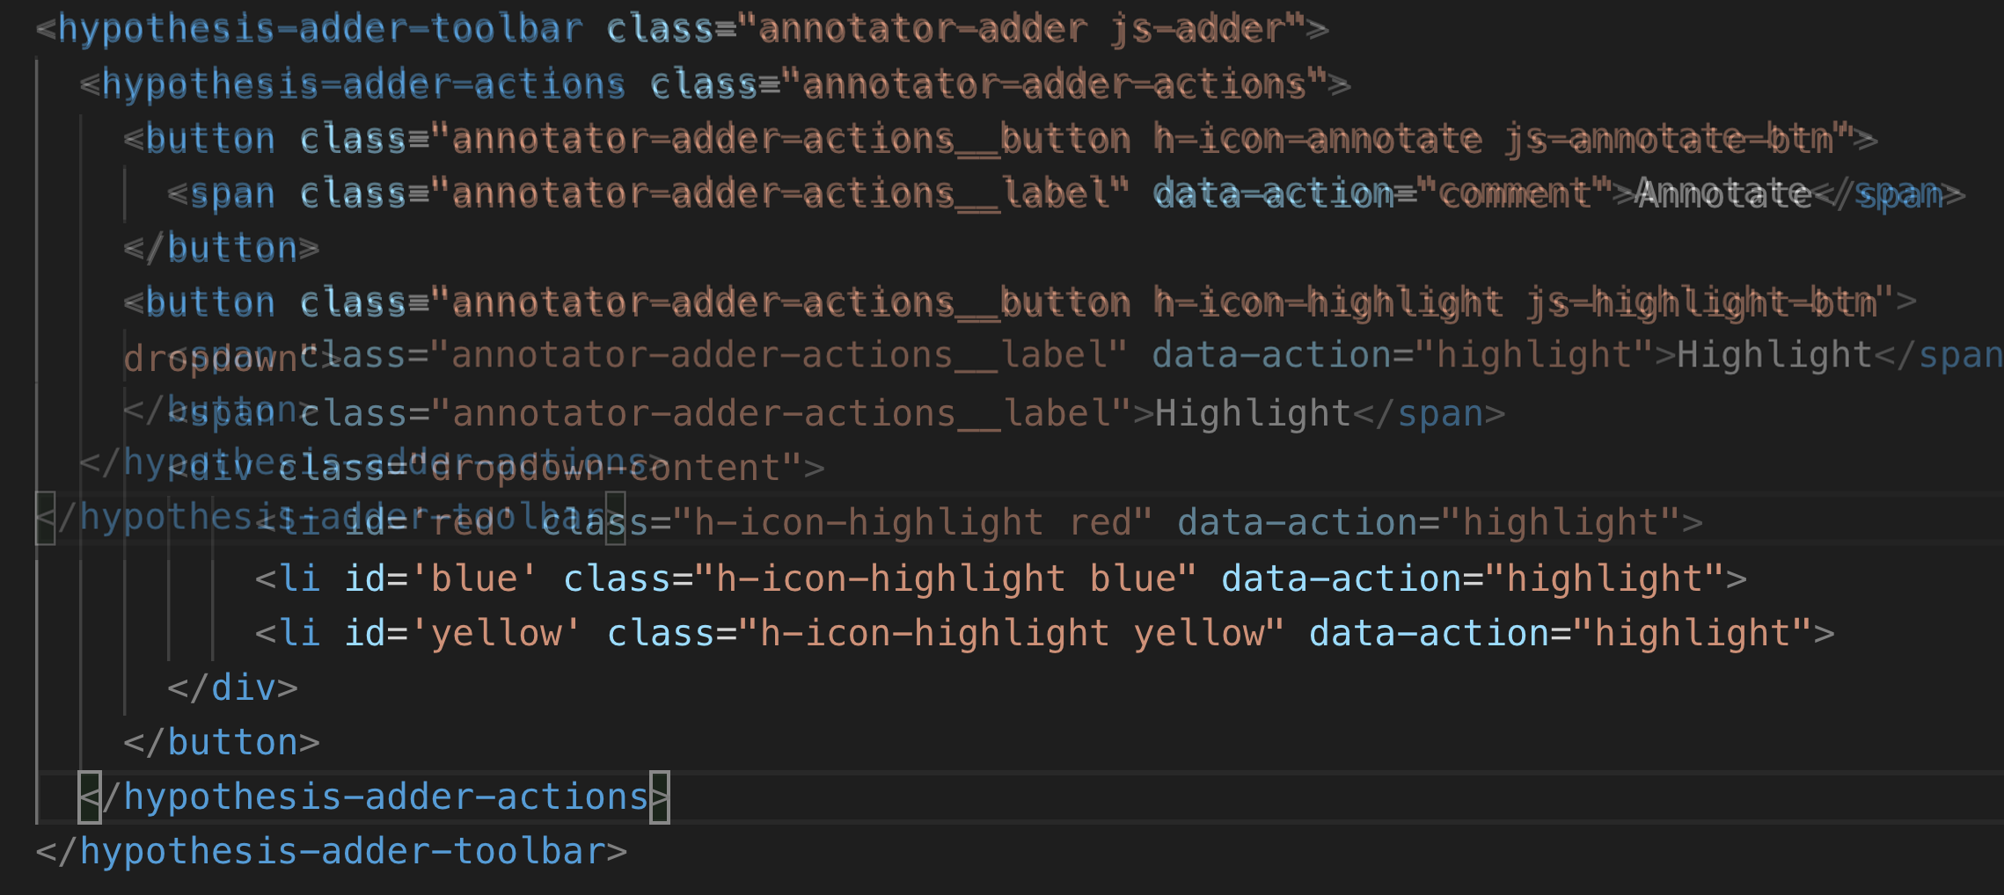

The annotation tool most compelling for my purposes is “Ponder”, created by a private tech company, Parlor Labs. Like Hypothes.is, Ponder is a browser add-on tool that can be activated on any webpage. The company describes it as a “micro-response tool”, that purports to “give teachers a view into the ‘invisible’ process of learning through higher-order critical thinking” (“About”). The tool shares a basic functionality with Hypothes.is, which is highlighting text and responding through a written annotation. But it has some additional features, including options for different “reactions”, called “sentiment tags”, and options for choosing from a list of “themes”, compiled and customized by the teacher. The “sentiment tags” are particularly interesting, because they allow students to color-code their responses according to the categories “clarification”, “analysis” or “emotion”. Carl Byth explains that goal of this “microresponse” strategy is to condense student responses into a simple expression that others can most easily engage with:

To encourage students to “read each other,” Ponder limits responses to short phrases called sentiments that fall into three categories: comments about text comprehension (e.g., “I don’t get this”), critiques of the text (e.g., “This smells like hyperbole”), and emotional responses to the text (e.g., “Tsk, I disapprove.”) Blyth 209

Here, the pithy annotations allow interpretations to be shared and recognized among readers. These “microresponses” function analagously to emoticons or emojis, which are more exaggerated methods of condensing feeling into a expression that’s easily shared across social media.

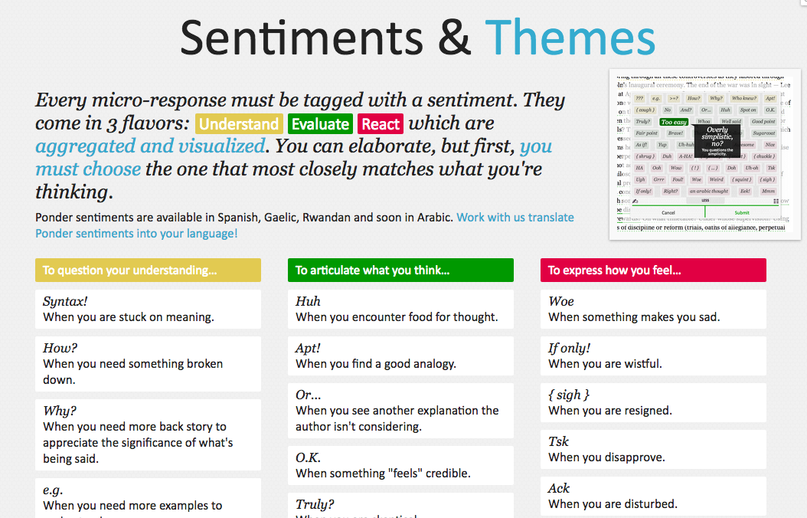

Despite the obvious social benefits of this tool, this prefabrication of responses seems constraining. By forcing the reader to choose between “clarification”, “analysis” or “emotion”, is the tool determining what kind of reaction someone might have? Or do these three tagging option (the cognitive, analytic, or emotional) function as an “enabling constraint”, that is, as a productive scaffolding that guides students toward thinking more deeply about their reading? Keeping these questions in mind, I now turn to another tool that functions similarly to Ponder.

This other example of digital annotation comes from a project called “Lacuna Stories," developed by the Poetic Media Lab at Stanford, where it is deployed as a Learning Management System. As such, it is used by schools as a central organizing space for a course, like Blackboard or Canvas, and provides a reading and writing interface for engaging with course materials. To make an annotation, the reader highlights a section of the text, and has the option of making a comment. Then, the reader is prompted by options for different types of responses. Like Ponder, there are pre-set categories for responding, which are also color-coded: here, the categories are “Comment”, “Question”, “Analyze”, “Connect”. According to Stanford instructors Amir Eshel and Brian Johnsrud, one of the tool’s main benefits is how it visualizes their students' solitary responses to reading in a way that directs classroom discussion about the text.

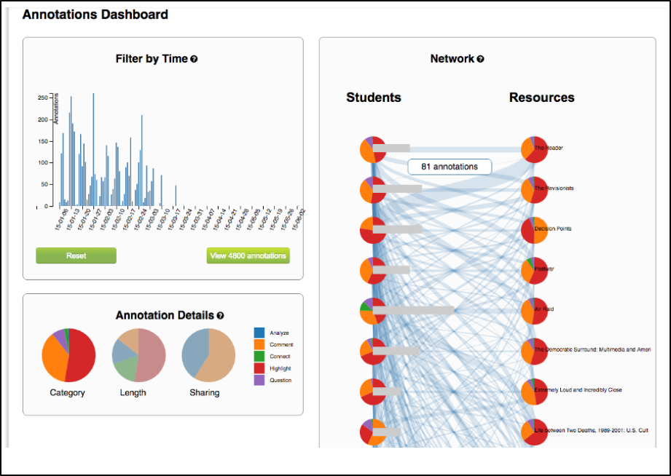

Despite the benefits, there are drawbacks that come with increased access to student annotations. Making annotations visible necessarily prescribes certain patterns of response and textual interpretations over others. The instructors admit that Lacuna creates a trade-off between what they call "guidance and discovery," that is, "a tension that must be negotiated between the desire to allow students the space for intellectual discovery and the desire to guide their learning along a pre-specified path” (“Making Reading Visible”). In other words, annotation primes students toward more fixed interpretations of the text before they even enter into the classroom. Another drawback is the way that Lacuna Stories tracks and visualizes student activity across the platform. Lacuna contains an “Annotation Dashboard” that is only visible to instructors so that they might access data about their students' annotations. On this dashboard, student data such as the number and length of annotations is quantified and visualized in a series of graphs and charts. Here, annotations "serve as an accountability mechanism for completing assigned reading in a timely fashion, because instructors will see students’ activity on the text and students will know that instructors can see this activity” (Schneider et al). For example, “Filter by Time," instructors can view the raw number of annotations made on any given day of the course, getting a sense of daily participation. In “Annotation Details”, a series of pie charts indicate the relative amount of annotations by category and the length for each annotation. Finally, the “Network” section connects students to the texts they have annotated, where the links between them are weighted according to the amount of annotations each student made on each text. By directly visualizing quantitative information about student annotations, the Annotation Dashboard potentially engages in the reductive effects of certain edtech tools that Audrey Watters warns about. How is tracking the distribution, amount, of length of annotations an effective assessment criterion?

*July 17, 2019: Label-less Icons*

*After much difficulty, I've decided to forgo the color labels on the drop down, and have the highlighter icon on its own, in the relevant color. When playing around with different sizes for the icon, its simiplicity started to appeal to me. This decision also accords with what I've said before regarding Jon Udell's script to "tag" annotations with color. My project is moving away from using verbal cues and engaging in verbal reactions. So having the color itself be the selection on the interface makes sense, because the person engages directly with that color.*

*The problem is that coloring the icons proved extremely time consuming. I wanted each icon to display the color indicated in the colors label. First, I spent a lot of time trying to find the source of the icon to change the color, ended up going on icomoon, where I still couldn't figure out how to do it. I also tried a bunch of different CSS solutions, coloring the h-icon-highlight image to red, for example. This worked, but it made all the icons red. There's no way for me to do this just to one icon. I finally ended up by using in inline CSS rule in adder.html to color the entire button. This is less elegant than I hoped, but at this point I need to move on. I'm going to leave it as is and start thinking about functionality.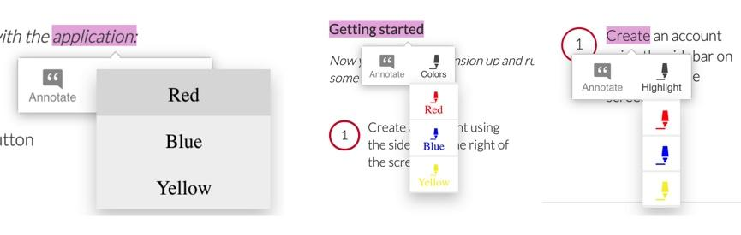*

However, there is a way that the tool uses quantified data in order to address reading experiences that cannot be quantified. The visualization of heavily annotated areas of text in the “Network” panel allows the instructors to identify moments of collective interest within annotations, and turn them back into sites of affect. The instructors explain that, “By using Lacuna as a window into students’ reading, [we] were able to pinpoint the exact places in the text that generated the most frustration, confusion, or disagreement [among] students” (“Making Reading Visible”). Here, the threaded annotations, where students engage in debate and conversation about the text, serve as an indicator of tension in their reading. Instructors can then turn the class’s attention to exploring these moments more fully.

Identifying moments of tension is one of the goals of my multi-color highlighter. The Hypothes.is highlighter contains a degree of opacity, which can be adjusted manually by going into the code. In making the colors almost transparent, one color can be layered over another, creating color mixtures and combinations. Low opacities of highlighter colors, when used in by a group of readers, create a visible palimpsest of readings. This effect recalls conversations in neuroscience about the ways that embodied cognition works within social contexts. Although much of neuroscientific work on "embodied cognition" does a good job situating thinking in the body, it tends to overlook how body specificity determines individual experience. According to Victoria Pitts-Taylor, much of this work generalizes the way that everyone accesses and experiences the world, assuming universal brain structures. In response, Pitts-Taylor explores how brains are shaped by real inequalities of race, gender, class, and sexuality, asserting that “bodily difference yields cognitive difference” (56). She gives the example of "mirror neurons," which are neurons in the brain which activate when the body engages in or witnesses action. "Mirroring" whatever action they perceive, these neurons enact the same process in the brain as if the body were really performing the action, and are therefore thought to enable empathy. According to Pitts-Taylor, however, simulation can actually get in the way of understanding. Bodily difference will cause mirror neurons to make mistakes, projecting one set of assumptions onto another body. She explains that “We cannot rely on simulation, whether propositional or neural, to do the work of knowing the other and of relating to them and feeling for them in nonviolent ways” (92). My tool aims to reveal this limit of identification through the layering feature. It is my hope that alternative reactions to a particular text will render in the color mixtures, in the alchemy of dissonances, combinations, and new concoctions that layering creates.

*August 8, 2019: Tracing the Click*

*I spent some time trying to understand exactly what happens in the code when a user makes a text selection. But, since it's so complex, I had to break it up. I outlined the parts of the code relevant to highlighting, which Joe pointed out to me. I was able to get a better sense of how the highlighting is processed here, through specific functions and calls. Things really started to come together when I followed the code backward, starting from the end, and working my way up to the event handler in adder.js. Overview of events: The onHighlight option called in addder.js here initiates a call to createHighlight which passes "true" for highlight into a larger function called createAnnotation. It's in this function that highlightRange runs with potentially three arguments, which I can configure in index.coffee. Joe suggested that I pass a CSS class into this function as a third argument, which specifies the color of the highlight. That's it!*

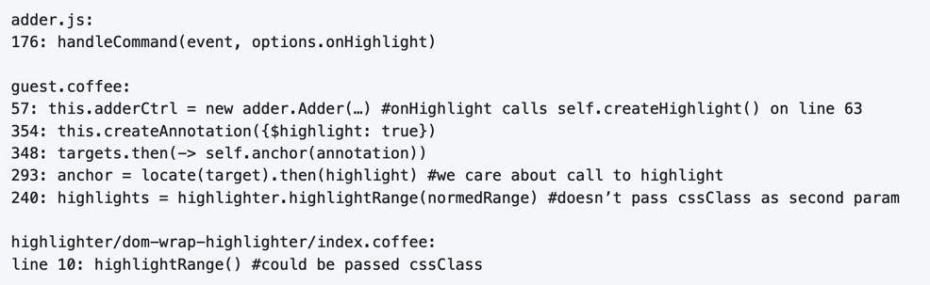

One way to harness the color opacity is to have color mixtures indicate emotions. Below is a “wheel of emotions” developed by Robert Plutchik, a professor of psychology, who transposes his own theory of emotions into a color wheel. In this image, the color differences indicate changes in emotional quality and saturation indicates the intensity of emotion. The more saturated colors on the inner ring represent more intense forms of the emotion, while the brighter colors on the outer rings are milder. There are eight primary emotions, which run along the second ring: these are joy, trust, fear, surprise, sadness, disgust, anger and anticipation. For example, apprehension (light green) is a mild form of fear, while rage (dark red) is an intense form of anger. Plutchik also theorized emotional dyads, which are feelings composed of two emotions. For example, the dyad between fear and surprise is awe, and between joy and trust is love.

What if students use these colors not only to highlight text according to their feelings or gut reactions, but also to engage with other students’ highlights in the form of layering? I wonder what would happen, for example, if one student were to highlight a piece of text as orange, for “anticipation”, and another were to highlight that same piece as red, for “anger”. The resulting dyad, which would be red-orange, signifies “aggressiveness” on the chart. How does this result change the way we read the text? My sense is that confronting and attending to these feelings will open up ways that students connect to what they read.

*August 30, 2019: it works!*

*Last week, I had a meeting with Joe and we were able to iron out the remaining issue of calling the highlight value from the button to configure the highlight color. Basically, we passed the highlight data through guest.coffee into the highlighter module, in index.coffee, where we added an else if script that configures the appropriate color depending on which button was clicked.*

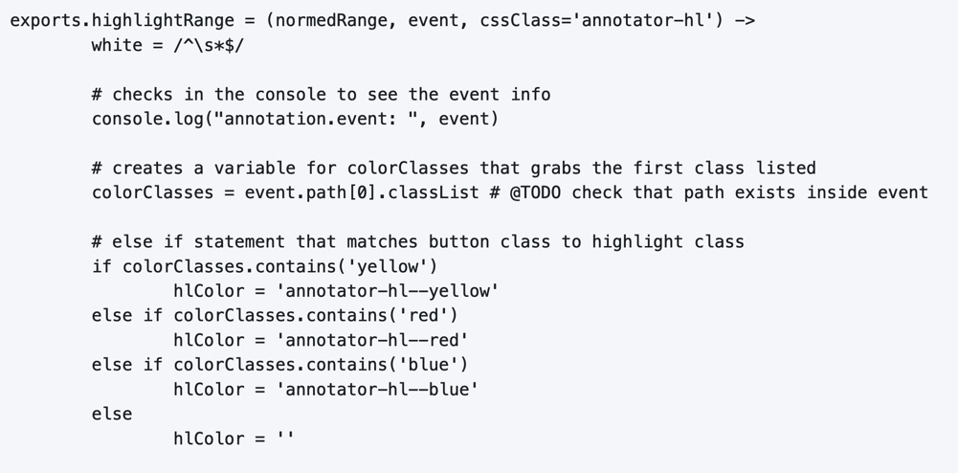

This tool approaches affect as a type of knowledge that extends into the body, and intends that the user interface will engage bodily experience. The process of embodied cognition—how thinking happens with the body—is therefore a crucial consideration to my project. Antonio Damasio, a vocal proponent for embodied consciousness, explains that consciousness arises from emotions in the body of the organism, which are experienced as "somatic markers" such as rapid heartbeat or nausea, for example. These emotive experiences in the body float then up to an organism's awareness, whereby rapid heartbeat might be noticed as anxiety, and nausea as disgust. Damasio makes this key distinction between emotion as a bodily experience and feeling as mental awareness:

Emotions are complex, largely automated programs of *actions* concocted by evolution. The actions are complemented by a *cognitive* program that includes certain ideas and modes of cognition, but the world of emotions is largely one of actions carried out in our bodies, from facial expressions and postures to changes in viscera and internal milieu. Feelings of emotion, on the other hand, are composite *perceptions* of what happens in our body and mind when we are emoting. As far as the body is concerned, feelings are images of actions rather than actions themselves; the world of feelings is one of perceptions executed in brain maps. 116-117

By the time a person is aware of a feeling, it has already released an emoting cascade in the body. According to Damasio, our feelings are often vague because their stimulation often incorporates internal, largely unconscious sensations—or "primordial feelings"—as part of the emoting cascade (108). I intend for my tool to engage the vagueness of embodied feelings through the hapic experience of using the computer interface. My idea is that the user's activity of making a text selection and choosing colors will create a rhythm of response that might harness immediate and primordial feelings that occur during the reading process.

*/This is all I have now… I need to add sections that expand on Pitts-Taylor's discussion on mirror neurons to talk about "misfitting" and connection to Disability studies, include some color theory (the choice of color palettes and whether or not color use should be used in pre-defined ways or more spontaneously), and, of course, my experience of using this in the classroom (most important). To keep you satisfied for now…. an image of the tool in action!/*

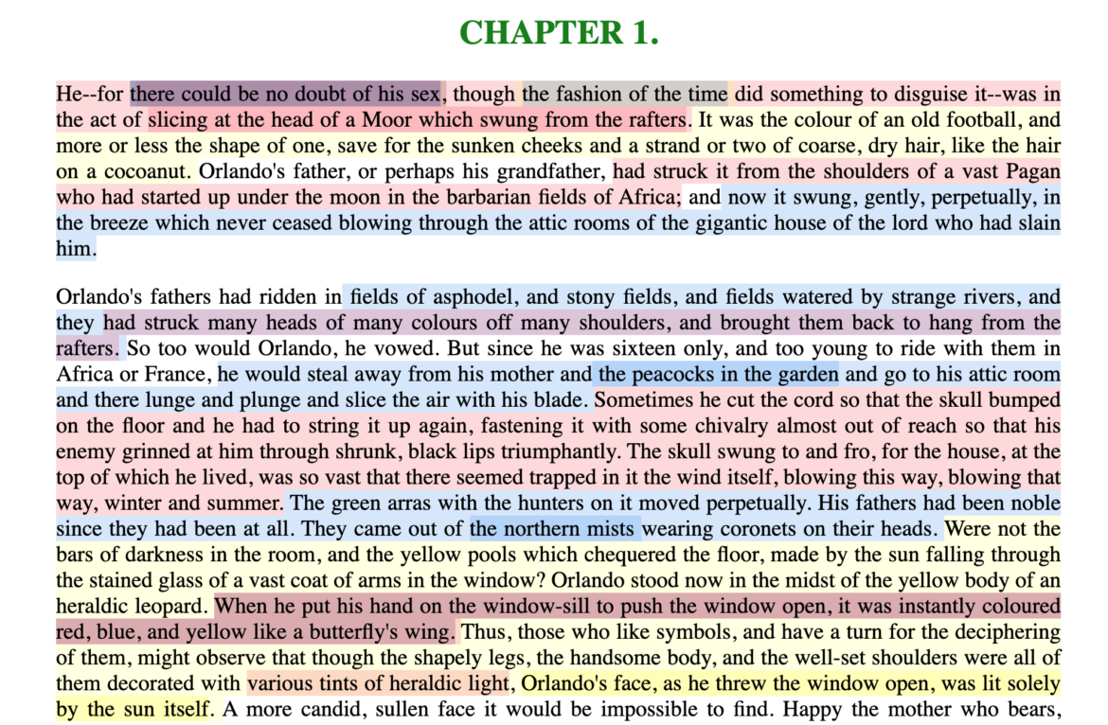

## **Notes:**

### **1** Hypothes.is operates as a browser extension and embeddable script, which means that it can be activated and used on any page that appears on a web browser. To use hypothes.is, the user must first create an account on the Hypothes.is homepage. Then, they have two options. They can either navigate to a website that already has hypothes.is embedded and activated, or they can to download a browser extension and activate it. Then, to make an annotation, users highlight the desired text and type their comment in a simple text box that appears. After saving their comment, the original text is highlighted, and all users may view the annotation on a collapsible sidebar. By selecting the “reply” button, users then can respond to the comment, which will appear below the previous annotation on the sidebar.

### 2 For example, N. Katherine Hayles traces the severance of the body from the mind, or how "information lost its body," across technological discourses (2). According to Hayles, the prioritization of rationality over emotion emerges in eighteenth century liberal humanist ideas about knowledge existing independently of the body and extends to 20th and 21st century ideas about the posthuman that imagine the body as a (detachable) prosthesis of the mind.

### 

### 

### 

### **Works Cited**

Annotation Studio . Massachusetts Institute of Technology Hyperstudio.<http://www.annotationstudio.org/>

Bean, John. Engaging Ideas: The Professor's Guide to Integrating Writing, Critical Thinking, and Active Learning in the Classroom . San Francisco: Jossey-Bass, 2001.

Blyth, Carl S. “Exploring the Affordances of Digital Social 201 Reading for L2 Literacy: The Case of eComma” Digital Literacies in Foreign and Second Language . Ed. Janel Pettes Guikema and Lawrence Williams, CALICO Monograph Series, Vol. 12. 2014.

Damasio, Antonio. *Self Comes to Mind*. 2010.

Hayles, N Katherine. How We Became Posthuman: Virtual Bodies in Cybernetics, Literature, and Informatics . University of Chicago Press, 2010. Print.

Hypothes.is . The Hypothes.is Project.<https://web.hypothes.is/>

Lacuna Stories . The Poetic Media Lab, Standford University.<https://www.lacunastories.com/>

Levy, Sharona A., “Reading the Reader”. *The Difference the Enquiry Makes*. ed. Randy Bass and Bret Enyon. Academic Commons, January 2009.

Malabou, Catherine. *What Should We Do with Our Brain?* 2008.

Pitts-Taylor, Victoria. *The Brain's Body: Neuroscience and Corporeal Politics*. 2016.

Plutchik, R. "The Nature of Emotions." *American Scientist.* Archived from the original on July 16, 2001.

Ponder . Parlor Labs, Inc.<https://www.ponder.co/about/>

Schneider, Emily, et al. “Making Reading Visible: Social Annotation with Lacuna in the Humanities Classroom.” The Journal of Interactive Technology and Pedagogy , 16 June 2016

Tai, Yifan Wang, Shen Hong and Crystal. “China’s Efforts to Lead the Way in AI Start in Its Classrooms.” Wall Street Journal, 24 Oct. 2019.

Watters, Audrey. “ Ed-Tech and Trump .” Hack Education. February 2, 2017.