Filipa Calado

Introduction
DONE create hook - 'suggest something vile'
In the first scene of the novel, The Picture of Dorian Gray (1891), the painter Basil Hallward is at pains to explain to his friend Lord Henry Wotton why he cannot exhibit the portrait of the eponymous hero. Basil finally admits, "Where there is merely love, they would see something evil, where there is spectacular passion, they would suggest something vile" (Wilde, 1889–90, p. 21). This striking line, among many others that carry homoerotic innuendos, never appears in print. It is excised during Oscar Wilde's revision process, as part of a larger project of suppressing suggestions of homoeroticism between the three main characters of the story. The textual scholarship on this revision process generally agrees that Wilde’s revisions neutralize Basil’s erotic fascination with Dorian by transforming it into aesthetic appreciation. In particular, Nicolas Ruddick argues that Wilde’s revisions aestheticize Dorian’s character in order to emphasize a moral about the dangers of vanity at the expense of another, more implicit moral about the liberalization of homosexuality. Ruddick explains that, while the moral about vanity "dramatize[s] the disastrous consequences of the preference of the beautiful at the expense of the good," the other moral, about homosexuality, "explores the destructive effects of the clandestine or closeted life" (Ruddick, 2003, p. 126, 128). According to Ruddick, the novel’s famous portrait indexes the convergence of the two morals: “the appalling changes to Dorian’s painted image… strongly suggest that the unspeakable practices indulged in by the protagonist are unspeakable in themselves” (p. 129).
To interrogate Wilde’s revisionary practice, this paper examines his treatment of the homoerotic elements across the first chapter of the manuscript of The Picture of Dorian Gray (1889-90). I use a digital tool to register and describe the material that Wilde strikes from the text. This electronic editing tool, called the Text Encoding Initiative (TEI, explained further below) allows me to "mark up" the deletions, additions, and other alterations in the manuscript. This project uses TEI markup not only to interrogate the nature of Wilde's revisions, but also the potential for technological tools to engage queer elements in text. In doing so, it endeavors to answer a question that plagues the emerging field of Queer Digital Humanities, or Queer DH. As literary and electronic textual scholar Julia Flanders asks--do we need to queer markup, or is markup already queerable? By "already queerable," Flanders refers to TEI's inherent customizability, which allows researchers to create descriptive schemas that suit their project's needs. Her question considers TEI's place between two current approaches in Queer DH. The first approach wants to disrupt formal systems by imagining alternative ones; and second, the approach in which queerness is built into computing, is inherent in computational logic. The first approach tends to center around speculative or critical making projects that problematize the constructed nature of technical objects. For example, Zach Blas and micha cárdenas propose a suite of programming tools with functions such as the "destabilizationLoop," that "breaks apart any process that acts as a continuously iterating power," and "nonteleo()," which "strips any program of a goal-oriented result" (2007-2012). Their transCoder project, a "queer programming anti-language," is a speculative codebase that disrupts the expectated functionality of our tools (Blas, cárdenas, 2007-2012). Another project that probes the possibilities of queering digital tools is "Queer OS: A User’s Manual," which is a set of guidelines that describe how various components of an operating system, such as interfaces, applications, and memory might function within an ethos of queerness. For example, this project reconceives how a digital interface "might seek out self-modification as its ontological premise… transform[ing] both the user and the system" (Barnett et al, 2016). This work, along with Blas and cárdenas, expose and interrogate the ways that technology reduces, delimits, or determines queer identity and practices. As the creators of QueerOS affirm: "This is a speculative proposition for a project that does not yet exist and may never come to exist, a project that does not yet function and may never function" (Barnett et al, 2016). The other side of the debate explores how current technological systems and tools already contain elements that encourage queer modes of analysis. For example, work by Jacob Gaboury explores how the NULL value in computation signals a "refusal to cohere, to become legible" as a built-in option in computational systems. Gaboury explains how the NULL value "corresponds with the epistemological condition of queerness as an excessive illegibility collapsed into an unwieldy frame, an aberrant third-ness within an otherwise normative system of relations" (Gaboury, 2018). In his work on "The Queer History of Computing," Gaboury asserts that "queerness is itself inherent to computational logic… there exists a structuring logic to computational systems that, while nearly totalizing, does not account for all forms of knowledge, which excludes certain acts, behaviors, and modes of being" (Gaboury, 2013, par. 13).
DONE intervention language; queer encoding
In attempt to cut between these debates, this paper identifies one major "constraint" of TEI which enables the analysis of queerness in Wilde's manuscript revisions. TEI's constraint is that it works best with data that is discrete, rather than smooth or ambiguous data, like the homoerotic elements obscured by Wilde's pen. In this project, I apply the rigid structure of the TEI toward marking up and analyzing the smooth data of the text's homoerotic themes, which include "intimacy," "beauty," "passion," and "fatality." The fixed nature of the TEI as a naming and bounding tool allows me to explore the boundaries of these queer themes in the text. This experiment in "queer encoding" bases the challenge of marking homoerotic elements as a foundation for theorizing queer engagements with computational methods. It does so by bringing researchers to reconsider their roles in acts of marking and labelling textual data.

Textual Scholarship
In analyzing the changes of the manuscript, I draw from debates in two fields that inform my approach for homoerotic subject matter within digital contexts: Textual Scholarship and Queer Historiography. I draw out a parallel debate from within these fields about what to do with what electronic editing scholar Jerome McGann calls our "textual inheritance" (McGann, 2001, p. xi). The parallel debate across these fields will allow me to carve out a methodology for working with TEI to analyze queer literary material.
This parallel occurs in the debates between editorial and historiographic methodologies in these fields, which can be loosely grouped into what I call the "productive" and "restorative" approaches. In Textual Scholarship, these approaches pose editorial practices that increasingly delimit the role of the editor as a recoverer or preserver of texts and those practices that permit empower the editor as an enabler of textual readings. The history of Textual Criticism first tends toward the restorative approach, which is about "correcting" an "ideal" text according to a prior witness. Then, spurred by the advent of digital technology and the popularization of digital tools, editing becomes more about finding ways to multiply the text's potential forms and readings.
DONE streamline narrative, cutting down to necessary elements,
taking out deformance (?)
The "restorative approach" begins with the work of Ronald B. McKerrow, a leading twentieth-century Shakespearean scholar, who maintains that the goal of scholarly editing is to preserve authorial intention. McKerrow's influential model for "copy-text" editing, which establishes the base-text for editing on an early witness that most closely resembles the author's original intention, eventually gives way to Walter W. Greg's approach that expands critics' purview to more than a single witness. Subsequently, Fredson Bowers and Thomas Tanselle advance Greg's work, emphasizing the influence of authorial intention and favoring the "eclectic edition," which depends heavily on the editor's judgment to determine authorial intention from multiple sources. Tanselle in particular places a high value in the editor who is the only one able to recognize and handle inevitable textual corruption. Guiding Tanselle's position is his claim that a text is vessel for an ideal "work" that can only be realized by the editor:
Those who believe that they can analyze a literary work without questioning the constitution of a particular written or oral text of it are behaving as if the work were directly accessible on paper or in sound waves… its medium is neither visual nor auditory. The medium of literature is the words (whether already existent or newly created) of a language; and arrangements of words according to the syntax of some language (along with such aids to their interpretation as pauses or punctuation) can exist in the mind, whether or not they are reported by voice or in writing. Tanselle, 1989, p. 16-17
Tanselle explains that because the act of inscription involves physical tools that corrupt the writer's pure ideas, the writer requires an editor whose distance from the creation of enables his objective evaluation of its intention.
Toward the end of the 20th century, D.F. McKenzie's theory of "the sociology of text" challenges the claim that no single text, regardless of scrupulous editing by the critic, can represent an "ideal" version. According to McKenzie, the book is never a single object, but a product of a number of human agencies and mechanical techniques that are historically situated: "Every society rewrites its past, every reader rewrites its texts, and if they have any continuing life at all, at some point every printer redesigns them" (McKenzie, 1986, p. 25). Jerome McGann explores how this sociological perspective expands into digital editing environments, where electronic formats create opportunities for presenting textual variation. McGann explains that textual criticism in print format is limited because a print text must conform to the linear and two-dimensional form of the codex–the same form as its object of study. Digital editions, by contrast, can be designed for complex, reflexive, and ongoing interactions between reader and text. McGann notes that his work on the digital Rossetti Archive brought him to repeatedly reconsider his earlier conception and goals, explaining that the archive "seemed more and more an instrument for imagining what we didn’t know" (McGann, 2016, p. 82). McGann's approach counters the traditional fidelity toward authorial intention with a drive to harness the potentiality of textual variation. The transformation of literary material into electronic format becomes a vehicle for a critical analytical method that McGann and Lisa Samuels call "deformative criticism." Deformative criticism works by distorting, disordering, or re-assembling literary material, continually subscribing the text to new configurations, in order to estrange the reader from her familiarity of the text. This estrangement forces the reader to encounter the text in a new way and discover new insights about its formal significance and meaning.

Queer Historiography
DONE expand Halperin & Traub positions & add quote
Two competing approaches in Queer Historiography parallel the "restorative" and "productive" approaches from Textual Scholarship. Susan McCabe defines "Queer Historicism" as the "critical trend of locating 'identifications' (rather than than identity), modes of being and having, in historical contexts" (McCabe, 2005, p. 120). In Queer Historiography, contemporary critics ofen debate the extent to which they in the present can adequately define queerness in the past. On the "restorative" side, there is the "Queer Historicist" position, advocated by scholars like David Halperin and Valerie Traub, who maintain that homosexuality is historically constructed, that "queerness" means something different today than it does in the past, and that we can get at its meaning by employing a Foucauldian genealogical method. For example, Halperin characterizes homosexual identity as a modern cultural production: "no single category of discourse or experience existed in the premodern and non-Western worlds that comprehended exactly the same range of same-sex sexual behaviors… that now fall within the capacious definitional boundaries of homosexuality" (Halperin, 2000, p. 88). On the "productive" side are the "unhistoricists," including Jonathan Goldberg and Madhavi Menon who are wary of historiographical methods that demarcate queer subjectivity across history in ways that imply progress. They maintain that one can not fully define "queer," and the attempt to do so would subscribe queerness to teleology (Goldberg, Menon, 2005, p. 1609). Goldberg and Menon caution that historiographical methods that attempt to pin down "queer" throughout history have the effect of normalizing (and therefore evacuating) queerness: "to produce queerness as an object of our scrutiny would mean the end of queering itself" (2005, 1608). In response to this "unhistoricist" position, Valerie Traub argues that "queer" would lose its value if applied ahistorically:
Queer's free-floating, endlessly mobile, and infinitely subversive capacities may be strengths–allowing queer to accomplish strategic maneuvers that no other concept does–but its principled imprecision implies analytic limitations… if queer is intelligible only in relation to its social norms, and if the concept of normality itself is of relatively recent vintage (Locherie), then the relations between queer and the changing configurations of gender and sexuality need to be defined and redefined. Traub, 2013, p. 33
According to Traub and the historicists, queerness requires historical specificity in order to be legible.
Heather Love refocuses this debate to examine the relationship between the critic and the object of study. Love makes the argument that, ultimately, the queer historian cannot validate the queerness of the past. However, although queer subjects fail to fit within contemporary conceptions of identity and desire, the project of queer history continues. Love explains that "Queer history has been an education in absence: the experience of social refusal and of the denigration of homosexual love has taught us the lessons of solitude and heartbreak" (Love, 2009, p. 52). Her methodology takes negative affects like shame, anger, disgust, hatred, disappointment as phenomena that cannot be resolved, recuperated, or rescued by the queer historian. Rather than attempt fix the past, Love offers the methodology of "feeling backward," an accounting of "the social, psychic, and corporeal effects of homophobia" (Love, 2009, p. 2). By "feeling backward," Love is interested in exploring the way that subjects turn away or refuse the critic's attempt to "redeem" or "rescue" them: She gives the example of the myth of Orpheus and Eurydice, pointing out that Orpheus prefers to behold Eurydice in the darkness of the Underworld rather than in the sunlight . Love explains that this is a crucial lesson for queer critics:
[Eurydice's] specific attraction for queer subjects is an effect, I want to argue, of a historical experience of love as bound up with loss. To recognize Eurydice as desirable in her turn away is a way of identifying through that loss. Such an approach would be consistent with an important aspect of contemporary queer politics, which has tended to define community not as constituted by a shared set of traits, but rather as emerging from a shared experience of social violence. Love, 2009, p. 51
Although Orpheus intends to rescue her, bringing Eurydice into the light of day would transform her into something fully accessible, and therefore less desirable.
DONE what TEI will allow me to do & 'queer form'
Like Textual Scholarship, the field of Queer Historiography is plagued by the problem of what to do with the past. The impulse that Love describes of the queer theorist to "rescue" queer figures evokes Tanselle's aim to recover the ideal text in scholarly editing. Love, however, knows this rescue is impossible:
Such is the relation of the queer historian to the past: we cannot help wanting to save the figures from the past, but this mission is doomed to fail. In part, this is because the dead are gone for good; in part, because the queer past is even more remote, more deeply marked by power's claw… Such a rescue effort can only take place under the shadow of loss and in the name of loss; success would constitute failure. Love, 2009, p. 51
Taking this impossibility as inspiration, one might rethink how to preserve the queer textual inheritance. Accepting queerness as something that eludes containment may encourage the critic to plumb how queerness continues to escaoe critical analysis. Love suggests one possibility: "a mode of historiography that recognizes the inevitability of a 'play of recognitions' but that also sees these recognitions not as consoling but as shattering" (Love, 2009, p. 45). By "play of recognitions," Love means the critic's "search for roots and resemblances" in the subject matter (p. 45). Her method of paying attention to elusive affects without trying to transform them into something more palatable can also be applied within digital contexts, and toward productive ends. One may, borrowing from McGann and Samuel's idea of deformance, reconceive textual editing of queer material as a formal experiment. Specifically, to explore the way that electronic editing tools impose new formal structures and configurations on queer subject matter. TEI is one such tool that allows researchers to explore the potential of encoding as an exercise in what Kadji Amin, Amber Jamilla Musser, and Roy Pérez describe as "queer form:" "the range of formal, aesthetic, and sensuous strategies that make difference a little less knowable, visible, and digestible" (Amin et al, 2017, p. 235).
DONE distinguish project of exploring intentions with productive
Markup with TEI engages a longstanding debate about Wilde's intension with revising the story's homoerotic elements. Textual scholars like Donald Lawler, Joseph Bristow, and Nicolas Ruddick claim that Wilde's changes to the manuscript fit within a larger project of aestheticization Wilde undertook as he composed and revised the novel. The surviving manuscript and typescript indicate that Wilde and his publisher, John Marshall Stoddart, revises his work multiple times before it is published in Lippincott's on June 20, 1890. This first printing of "The Picture of Dorian Gray," which spans 98 pages over 13 chapters, was widely criticized for its seemingly ambiguous stance on an immoral protagonist. Textual editor Joseph Bristow explains that "[Wilde’s] narrative struck the [reviewers] as a work that appeared 'corrupt', displayed 'effeminate frivolity', and dealt 'with matters only fitted for the Criminal Investigation Department/'" (2000, p. xviii). Wilde would spend the next several days defending his work in letters to the editors, entering into a public correspondence with them.
A few months later, in the early spring of 1891, Wilde publishes a "Preface" that makes such claims as "Those who find ugly meanings in beautiful things are corrupt without being charming. This is a fault" and "To reveal art and conceal the artist is art’s aim." Scholar Barbara Lecklie asserts that, by these complex and incisive statements, "Wilde's strategy is to refocus on art and disparage the focus on the reader by saying that the reader is the one who makes a work immoral" (2013, p. 173). Similarly, textual scholar Donald Lawler argues that "the 'Preface' relates to the novel only obliquely by… holding up aesthetic beauty and artistic effect as the only legitimate criteria of critical evaluation" (1988. p. 16). Published in a book version by Ward, Lock & Company in April 1891, the next edition of Dorian Gray contains 20 chapters including the "Preface." According to the editor of the Uncensored Edition of Dorian Gray, Victor Frankel, Wilde here makes significant deletions of passages with explicit homosexual references, promiscuous or illicit heterosexuality, and "anything that smacked generally of decadence" (2011. pp. 47-48). Wilde also "heighten Dorian’s monstrosity toward the novel’s conclusion" to bring the story "to a moral conclusion that he thought would silence his critics" (Frankel, 2011, p. 30).
The textual scholarship on Dorian Gray generally agrees that Wilde's revisions of the homoerotic elements are part of a larger project of aestheticizing the text. One way of achieving this aestheticization is by suppressing the moral of the story which, Wilde himself states is that "all excess, as well as all renunciation, brings its own punishment" (Wilde, 1890, cited in Wilde, Gillespie, 2007, p. 355-356). Lawler explains that "the dominant motive underlying all of the important changes made by Wilde was an artistic desire to supress an underlying moral which Wilde considered too obvious and, for that reason, distracting" (1988, 2). Lawler adds that "the offensive passages shown above in the notes were cut because of their mawkish and sentimental writing as much for their affront to contemporary moral standards" (1988, p. 65). Nicolas Ruddick, as explained above, argues that two morals are at play in this text–one about the dangers of vanity, and the other, about the liberalization of homosexuality. He explains that the two morals associate vanity and closeted homosexuality with corruption: "the appalling changes to Dorian’s painted image in DG90 strongly suggest that the unspeakable practices indulged in by the protagonist are unspeakable in themselves" (Ruddick, 2003, p. 129). Ruddick contends that Wilde, as he revised the text, "chose the route of suppression" by reducing the homoerotic elements and including a preface protecting art from the moral judgement (2003, p. 133).

TEI introduction
DONE combine first two paragraphs which intro TEI
TEI allows researchers to work productively with textual data by creating formal structures that can mark and register desired elements of the text. TEI (short for Text Encoding Initiative), is an electronic editing standard for digitizing textual elements so that computers can "read" them. In more technical terms, TEI is a "markup language," that enables users to "mark up" aspects of literary texts that they think are important, like structural elements (chapters, paragraphs, line breaks), physical details about the text (revisions, illegible text) or conceptual elements (like persons or places). Created specifically for working with literary material, TEI offers a set of guidelines for transcribing and editing print text or manuscripts into electronic format. The guidelines contains rules for using various "tags" to mark up certain textual elements, such as <line> to indicate a line of text, <del>, to indicate deleted text, and <person>, for a reference to a person. Below is an image of a manuscript and its diplomatic transcription, along an excerpt of the underlying TEI code, from Mary Shelley's manuscript of Frankenstein; or, The Modern Prometheus (1818), encoded by the Shelley-Godwin Archive (see Fig. 4).
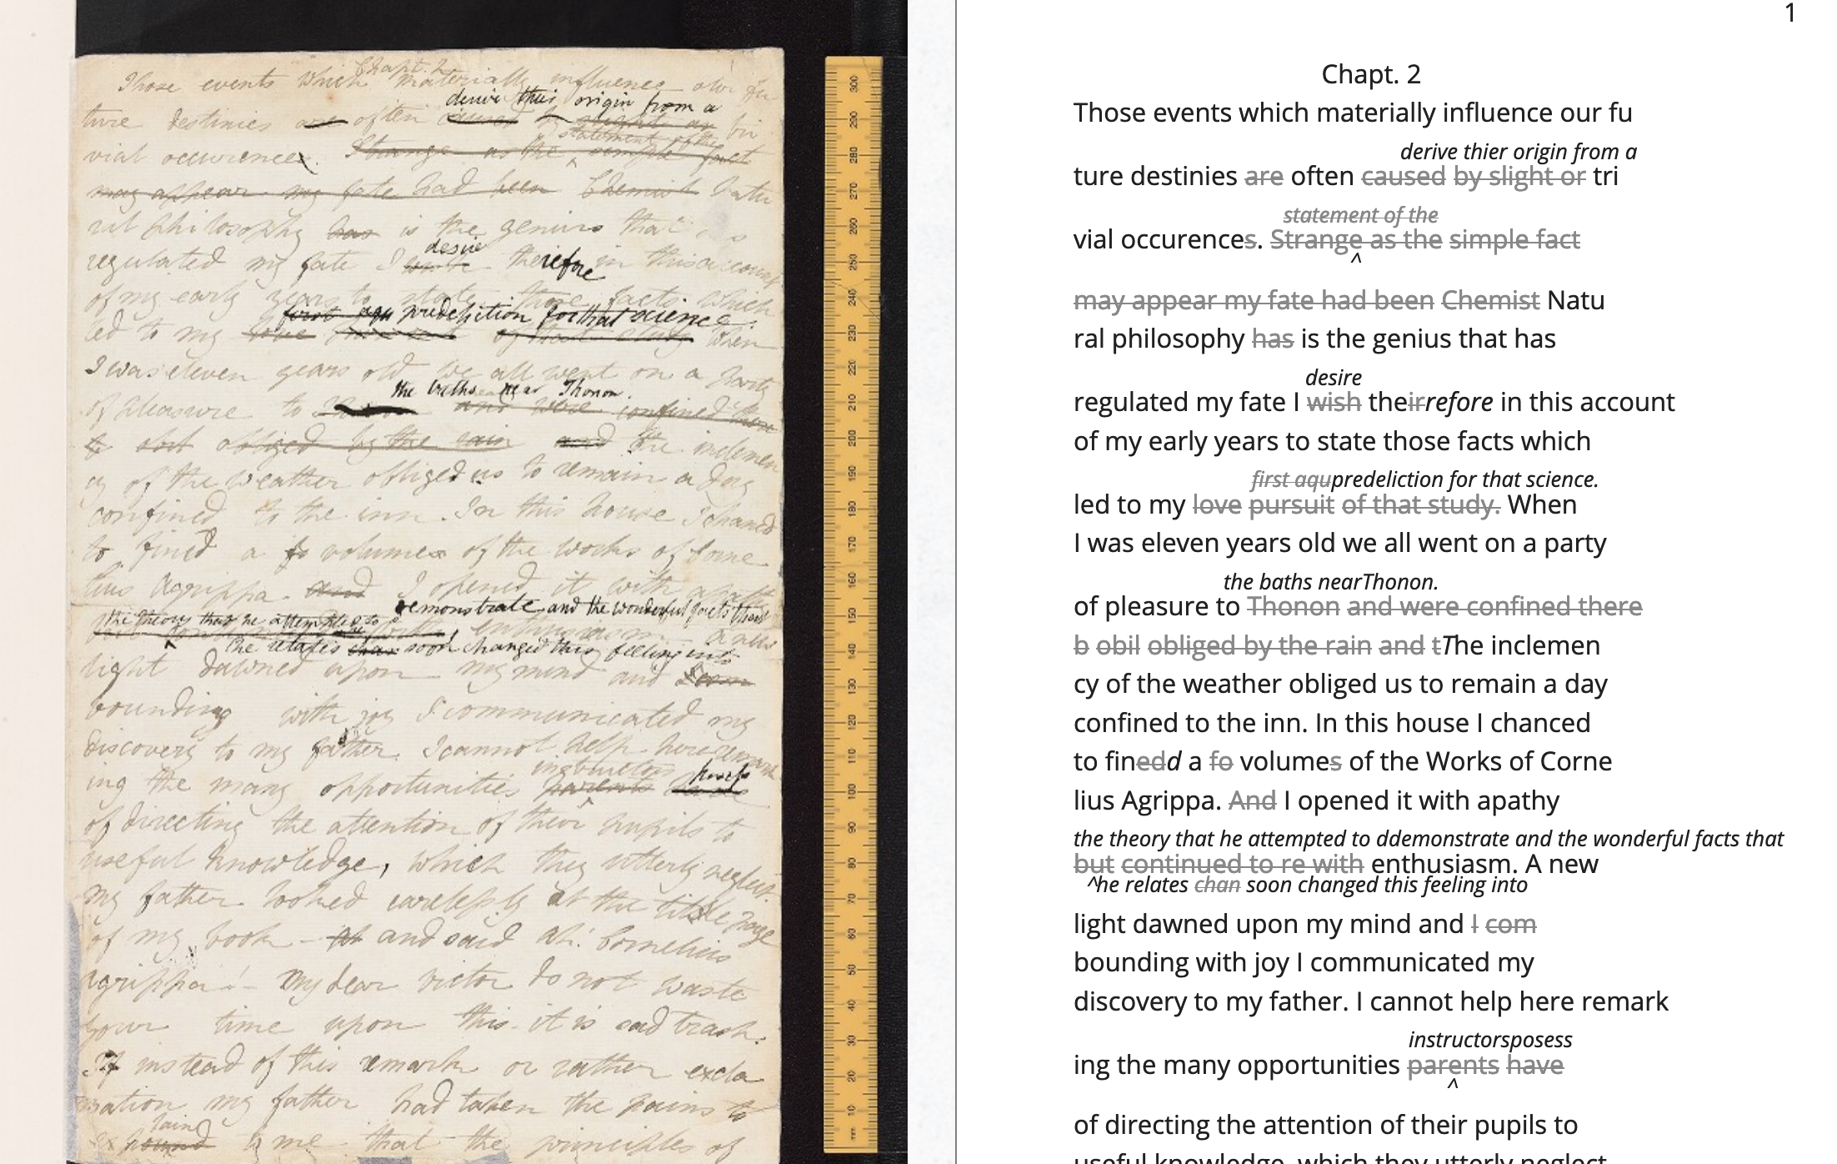Fig 4: Image of the manuscript and diplomatic transcription of Frankenstein from the Shelley-Godwin Archive.
<handShift medium="pen" new="#mws"/> <line>Those events which materially influence our fu</line> <line>ture destinies <del rend="strikethrough">are</del> often <mod> <del rend="strikethrough">caused</del> <del rend="strikethrough">by slight or</del> <add hand="#pbs" place="superlinear">derive thier origin from a</add> </mod> tri </line> <line>vial occurence <del rend="strikethrough">s</del>. <mod spanTo="#c56-0005.01"/> <del rend="strikethrough" next="#c56-0005.02">Strange as the</del>
Through this level of detail, TEI facilitates deep and complex description of textual material that facilitates scholarly research. Note that the first few lines of the text contained within the <line> tags, and the deleted text contained within <del> tags. This excerpt also includes a <handShift> tag and @hand attribute, which indicate whose "hand" is reponsible for each section of text. This is valuable information for a text that was composed by Mary Shelley, and co-edited by her husband, Percy Shelley.
DONE remove Willa Cather example
As in the above example, TEI documents resemble an ordered hierarchy or nested tree structure, with the one "root" component and several "branches," known as "nodes." This hierarchical nature of the TEI means that all elements in the text must be contained as discrete nodes within this bounded structure, where one cannot overlap elements. Though the strict tagging structure of TEI forces encoders to label textual elements as discrete data, it also enables them to create their own labels for the elements. Perhaps the most useful aspect about TEI is this customizability, which it inherits from its parent language, XML, or eXtensible Markup Language. As an "extensible" language, TEI enables users to to create their own tags to describe the particular elements they wish to encode. The Women Writers Project, directed by Julia Flanders, adequately frames how TEI's inherent extensibility can address textual ambiguity. According to the WWP:
Unlike many standardization efforts, the TEI … explicitly accommodat[es] variation and debate within its technical framework. The TEI Guidelines are designed to be both modular and customizable, so that specific projects can choose the relevant portions of the TEI and ignore the rest, and can also if necessary create extensions of the TEI language to describe facets of the text which the TEI does not yet address. Flanders, 1999-2021
Because TEI is built from a language that allows its users to build their own version of that language, there is potential for representing the elements necessary to a project by customizing these elements on a project-by-project basis.
TODO incorporate Boyd in some way (?) - maybe in discreteness
DONE add reference to 'queer encoding'
As queer studies scholars well know, however, there are always elements that cannot be contained within rigid categories. Accordingly, there are a number of projects that explore the potential of TEI for what Julia Flanders calls "queer encoding." The encoding of queer gender, is one interesting case study because the <person> tag, which describes persons referenced within a text, is limited to one value for gender. For scholars working to encode multiple or diverse sexual identities, this data structure creates obstacles. Pamela Caughie and Sabine Meyer, for example, attempt to encode gender identity in Man Into Woman, the life narrative of Danish painter Lili Elbe who undertook one of the first gender affirming surgeries in 1930. The attempt to mark up Elbe's complex gender ontology brought Caughie and Meyer against this structural limitation of the TEI which cannot accomodate plural sexual identities:
[T]he deeper we got into mark-up, the more evident it became that the categories and hierarchies available to us were inadequate for our task… to identify a male subject who at times presents himself as masquerading as a woman, at others as being inhabited by one, and who eventually becomes a woman, in a life history narrated retrospectively from the perspective of Lili Elbe. Caughie, Meyer, 2018, p. 231
Interestingly, the TEI forces these scholars to consider the ways that computation works on a deeper level to reify gender as essential. In particular, the fixity that the TEI imposes upon Elbe as a queer subject brings out the ways that gender is situational and relational across this text.
Other scholars find advantage in TEI's data structure. While TEI is strict about what constitutes a person–as an entity with one sex, for example–it also enables an approach toward personhood as multiple. Like Caughie and Meyer, Marion Thain also works with a complex writing subject, the late-19th-century English poet, Michael Field, which is a pen name for the lesbian couple, Katharine Bradley and Edith Cooper. Thain works to encode the diaries of Michael Field who, according to Thain, signifies "the assumed names of two separate women, as well as appearing to signify one single male identity" (Thain, 2016, p. 228). Fortunately for Thian, the TEI enables the encoding of multiple identities, which is central for understanding the queerness of the diaries:
[T]he proliferation and slipperiness of names is no mere childish caprice but a core part of the articulation of queer: an unhinging of 'given' or apparently predetermined identity through a strategy that articulates identity as constantly shifting, constructed, and performative. Text encoding can, in a simple but powerful way, help us explore and map this crucial strand of queer identity construction across the diary. Thain, 2016, p. 233
Thain's approach harnesses the hierarchical nature of the TEI to list the various references to each personage within the <persName> tag. This <persName> tag allows Thain to "render searchable words not in the text but intimately tied to it. This is not a small issue in a diary in which Katharine Bradley herself is referred to by more than 20 different names" (Thain, 2016, p. 233). By encoding each identity to its proper personage, TEI enables Thain to solve the manage the of multiple identities in this text.
Why do Caughie and Meyer struggle to encode Elbe's identity while Thain appears to succeed with Field? While a queerness like Fields's might be delineated and contained, in Elbe's there is a quality of blending which the markup, by its nature, means to separate and fix. As Flanders points out, markup, as a tool for naming, bounding, and containment, registers information as distinct components, rather than smooth information with vague boundaries (Flanders, 2017). Field's identity is multiple: the diaries "do not pretend to record the life of a single male, as two different hands record the experience of two clearly differentiated people" (Thain, 2016, p. 229). As long as identities, like Field's, are distinct and contained within specific entities, TEI can encode them. Elbe's identity, by contrast, is not multiple as much as it is plural, containing several identities whose relationship to each other is ambiguous or continually shifting within one entity. Elbe's relation to gender is best described qualitatively, as one that alternatively masquerades or inhabits simultaneous gender ontologies (Caughie, Meyer, 2018, p. 231).

The Manuscript of Dorian Gray
DONE categorizing smooth info as exercise in queer encoding
For Wilde's text in particular, the rigid structure of the TEI tags offer an opportunity for exploring the potential of bounding and labelling as an exercise in "queer encoding." I created a customization that explores the potential of semantic labelling against the demands for fixity and structure within the TEI schema. My customization registers physical and conceptual changes to the MS by creating two new attributes to mark the revisions. First, to mark the physical traces of Wilde's pen as he struck out portions of the text, the custom attribute, "strokes" (@strokes in formal TEI notation), registers the number of pen strokes through any given section of text. Most often, Wilde uses one or two strokes of his pen, although sometimes, the strokes are too heavy or thick to enumerate, in which case, I set the @strokes attribute to the value, "inconclusive." In addition to @strokes, the custom attribute @implication marks the general theme of revision from a list of recurring themes, which include: "intimacy," "beauty," "passion," and "fatality," with the additional values of "inconclusive" or "illegible."
In what follows, I detail how this customization registers the elisions and conversions of homoeroticism in the MS as Wilde prepared it for publication. That being said, the goal here is not to establish a formal method for marking queer elements. Rather, this work surfaces a formal resistance in the text–an indeterminacy that resists capture by TEI data structure. Here, the difficulty is in engaging the boundedness of the TEI elements, which must encapsulate data, with the indistinctiveness of the queerness of the text, which resist demarcation within the four themes of "intimacy," "beauty," "passion," and "fatality." Often, the boundaries between these elements are fuzzy or blurred, constituting a spectrum of smooth information that threatens the confines of the tags. To add another layer of ambiguity, the number of pen strokes also resists easy demarcation. Depending on Wilde's pen, they can be difficult to enumerate and their boundaries often fail to map with the themes. Therefore, in order to mark up this text, one must make imposing decisions on its data.
DONE high level summary of patterns in the themes
The evocative opening scene, which consists of a lively dialogue between Basil Hallward and Lord Henry Wotton, sets the tone, reveals character dynamics, and lays out some of the conflict for the ensuing story. In these first few pages, Basil comes across as a sympathetic, sensitive, albeit slightly exasperated artist, who confides to his close friend Lord Henry the powerful influence that Dorian Gray has had upon his life and work. Lord Henry, by contrast, appears as an affable and witty gentleman aesthete, who counters Basil’s confessional utterances with offbeat and pardoxical observations.
A few general patterns emerge from the revisions across these pages. First, the revisions work to stifle the emotional tension and physical affection in the dialogue between Basil and Lord Henry, replacing it with a lighter or more neutral tone. Because these revisions generally work to shore up the friendship between Basil and Lord Henry, conveying the fondness in their rapport, they are encoded according to the theme of "intimacy." Second are the themes of "beauty" and "passion," which mostly concern revisions where Dorian is reformulated from a romantic object into an artistic subject for Basil's painting. Third, and finally, the theme of "fatality," which focus heavily on moments when Basil struggles to explain the consuming and self-destructive effects of Dorian's influence on his life. that Dorian's has on his life.
DONE intimacy/fatality
Beginning with the revisions that suppress suggestions of intimacy between the three main characters. Wilde’s pen slashes through evidence of physical contact between Basil, Lord Henry, and Dorian. These include Basil "taking hold of his [Lord Henry’s] hand" (p. 9), Basil recounting that Dorian's "cheek just brushed my [Basil's] cheek" (p. 20), and that Basil and Dorian "sit beside each other" (p. 22). Additionally, the dialogue between Basil and Lord Henry develops an intimacy in their tone and subtle mannerisms, an intimacy that facilitates Basil's confession of his feelings for Dorian. In some casese, Wilde diminishes this intimacy in their conversation with the effect of mitigating the sense of foreboding that surrounds Basil's attraction to Dorian. Wilde replaces tense pauses with laughter or exchanges dramatic statements and descriptions with more playful ones. One striking example occurs when Basil struggles to convey his reasoning for refusing to exhibit Dorian's portrait:
"The reason why I will not exhibit this picture, is that I am afraid that I have shown in it the secret of my own soul."
Lord Henry hesitated for a moment. ‘And what is that?’ he asked, in a low voice. ‘I will tell you,’ said Hallward, and a look of pain came over his face. ‘Don’t if you would rather not,’ murmured his companion, looking at him." p. 9
The revised version in the manuscript, incorporating the deletions and interlinear additions, reads:
"The reason why I will not exhibit this picture, is that I am afraid that I have shown in it the secret of my own soul."
Lord Henry laughed. ‘And what is that?’ he asked. ‘I will tell you,’ said Hallward, and an expression of perplexity came over his face. ‘I am all expectation Basil,’ murmured his companion, looking at him. p. 9
Here, several changes mitigate the emotions of the scene. First, rather than "hesitate," Lord Henry "laugh[s]," and he no longer speaks “in a low voice": the effect is to overwrite a previously intimate moment with levity. Basil also exchanges his facial expression from one of agony to confusion when “a look of pain” becomes “an expression of perplexity” (discussed further below). And lastly, Lord Henry, rather than sympathizing with his friend and releasing him from the impulse to explain himself, instead encourages him to speak–"I am all expectation, Basil." Together, these changes work obscure Basil’s internal suffering with the effect of lightening the mood of the scene.
Another example similarly tempers an intense emotional energy while also mitigating a sense of anxiety or foreboding. It occurs on the next page, when Basil is on the verge of revealing the reasons behind his attraction for Dorian. The original dialogue proceeds:
Lord Henry felt as if he could hear Basil Hallward’s heart beating, and he heard his own breath, with a sense almost of fear. ‘Yes. There is very little to tell you,’ whispered Hallward, ‘and I am afraid you will be disappointed. Two months ago…' p. 10
The manuscript’s revised version reads:
Lord Henry felt as if he could hear Basil Hallward’s heart beating, and he wondered what was coming. 'Yes. There is very little to tell you,' whispered Hallward rather bitterly, 'and I dare say you will be disappointed. Two months ago…' p. 10
Here, rather than draw attention to Lord Henry’s breathing, Wilde mentions Lord Henry’s “wonder” about Basil’s pending explanation, shifting Lord Henry’s sense of anticipation from fear to curiosity. He also makes slight changes to Basil’s delivery: in the revised version, Basil speaks “rather bitterly” and uses the expression “I dare say” rather than “I am afraid”. Both changes diminish the confessional tone that originally precedes Basil’s revelation about Dorian Gray.
Across this dialogue, the close rapport between Basil and Lord Henry enables Basil's confession about the self-consuming qualities of his feelings for Dorian. Therefore, the theme of intimacy implicates that of fatality. The data structure of the TEI, however, fails to capture this complicated dynamic. Intimacy and fatality cannot both be expressed in the @implication attribute, which is limited to one value. Therefore, the encoder must choose one theme per item of revision, either "intimacy" or "fatality."
DONE beauty/passion word shifts to dilute powerful connotations
Often throughout this chapter, Wilde swaps out words with the effect of diluting or diverting the original connotation. He focuses this type of revision on Basil’s dialogue, when Basil speaks about his passionate attachment to Dorian, and the effect of Dorian's beauty upon his art. Here, Wilde will trade expressive nouns with words that convey relatively weaker or more generalized ideas. For example, in the sentence "Every portrait that is painted with passion is a portrait of the artist, not of the sitter," Basil replaces "passion" with "feeling" in the manuscript (p. 9), exchanging the romantic connotation of "passion" with a more neutral one of "feeling."
On page 11, Wilde swaps out words and phrases which connote a strong sense of romantic passion for ones that suggest an aesthetic interest instead. The manuscript, prior to revision, reads: "I knew that I had […] come across someone whose mere personality was so fascinating that it would be Lord over my life, my soul, my art itself (p. 11). Wilde changes this line to, "I knew that I had come face to face with someone whose mere personality was so fascinating that it would absorb my nature, my soul, my art itself" (p. 11). Here, Wilde swaps out "life" for "nature," with the effect of subscribing Dorian's influence to his "nature," that is, part of his personailty or behavior, rather than encompassing his "life." Wilde also replaces "be Lord over" with "absorb," which maintains Basil's sense of submission to an external force, without the masculine designation in "Lord." These changes were encoded under the theme of "passion" because they diffuse the intensity of attraction into a more benign sensitivity to Dorian's aesthetic influence. The subtle changes in word choice in this section also begin to gesture to the theme of fatality, which fully develops over the next several pages.
In addition to words associated with "passion," Wilde often replaces the word "beauty" in Basil's references to Dorian. In doing so, Wilde neutralizes the power of Dorian's physical allure. For example, Wilde changes "Suddenly I found myself face to face with the young man whose beauty had so stirred me" to "Suddenly I found myself face to face with the young man whose personality had so strangely stirred me" (p. 13, my emphasis). The replacement of "beauty" with "personality" allows Basil to completely avoid mentioning Dorian’s physical appearance, and the addition of "strangely" serves to mystify Dorian’s influence over Basil. Throughout the rest of chapter, Wilde makes several changes that similarly dilute Dorian's powerful appearance: he replaces "beauty" with "good looks" and he exchanges "beauty" for "face" two separate times (p. 6, 18). Finally, in reference to Dorian Gray, the word "Narcissus" is replaced with "man" (p. 13).
Like the changes with "passion," the subtle shifts in word choice with "beauty" and related words diverts the original connotation. Here, the decision to replace "beauty" with references to "face" or "good looks" maintains the emphasis on the physical while muting the suggestive power of "beauty" in the abstract. In doing so, connotations about the ideal, the charming, and the alluring, which usually accompany descriptions of beauty, are redirected toward material attributes, which evacuate Dorian's mysterious allure and diminish the overwhelming influence that he holds over Basil.
Removing associations to beauty and passion is part of a larger project of Dorian's aestheticization, where Dorian is transformed from an erotic into an aesthetic object. At the end of the first chapter, Basil implores Lord Henry to refrain from influencing the young and impressionable Dorian. The original version reads:
'Don't take away from me the one person that makes life lovely for me. Mind, Harry, I trust you.' He spoke very slowly, and the words seemed wrung out of him, almost against his will.
'I don't suppose I shall care for him, and I am quite sure he won't care for me,' replied Lord Henry smiling, and he took Hallward by the arm, and almost led him into the house. p. 27-28
Lord Henry’s assurance that neither he nor Dorian shall "care for" each other characterizes Basil’s passionate feelings for Dorian as a kind of possessiveness. However, the source of Basil’s anxiety changes with the next revision, where Wilde gives him more lines of explanation and accordingly alters Lord Henry’s response. The revision thus proceeds:
'Don't take away from me the one person that makes life absolutely lovely to me, and that gives my art whatever wonder or charm it possesses. Mind. Harry, I trust you.' He spoke very slowly, and the words seemed wrung out of him almost against his will.
'What nonsense you talk,' said Lord Henry smiling, and, taking Hallward by the arm, he almost led him to the house. p. 27, 27B
In this revision, Basil attributes an aesthetic value to Dorian, asserting Dorian’s importance for his art, giving it "whatever wonder or charm it possesses." Lord Henry’s response moves from reassurance to dismissal, rejecting Basil’s anxiety as “nonsense,” and ending the scene on a slightly humorous note. Across these changes, Wilde reformulates Basil's jealous passion into an anxiety about losing Dorian as an artistic subject. Additionally, the shift from sincere reassurance to light-hearted repartee in Lord Henry's response evacuates the strong emotional tone of the scene, replacing it with friendly banter. The effect is to divert the suggestion Basil's passion for Dorian into an aesthetic appreciation.
DONE alter to inextricable fatality/passion
Like the interelationship between intimacy and fatality, there exists an overlap between passion and fatality across Wilde's revisions. Inextricable from Wilde's project in redirecting Basil's passion toward artistic ends are the attempts to soften Basil's intense and consuming devotion to Dorian, a devotion that emerges in references to Basil's troubled state of mind. One example occurs when Basil recounts his first meeting with Dorian to Lord Henry, when Basil admits: “I had a strange feeling that Fate had in store for me exquisite joys and exquisite sorrows. I knew that if I spoke to him, I would never leave him till either he or I were dead. I grew afraid, and turned to quit the room” (MS 12). Here, Basil's passion swells with a life threatening quality, an intensity that Wilde's pen works to mitigate by removing the association with death. In the manuscript, Wilde crosses through “never leave him till either he or I were dead” and adds “become absolutely devoted to him, and that I ought not to speak to him.” Wilde again tempers the self-consuming quality of Basil's devotion when he professes that “I could not live if I did not see him every day" (MS 17). On the manuscript, Wilde changes the line to read, “I couldn’t be happy if I didn’t see him every day” (MS 17). By shifting the focus from Basil's life to his happiness, Wilde's pen dilutes the profound peril that Basil's passion has generated.
DONE passion/fatality engaging strokes
The TEI data structure reinforces the difficulty of disambiguating the revisions within the themes of passion and fatality. One phras in particular, "look of pain," is revised to "an expression of perplexity" (p. 9, see fig. 6). Working with this revision within the TEI presents two points of difficulty. First, does the phrase "look of pain" express passion or fatality? On the one hand, "pain" denotes a strong, passionate feeling. On the other hand, Basil often draws on pain in his references to the fatalistic qualities about his attraction to Dorian, as in the following quote, which was deleted: "I feel, Harry, that I have given away my whole soul to someone seems to take a real delight in giving me pain" (p. 23). The difficulty of disambiguating the theme is mirrored by the strokes of Wilde's pen, which vary even across the same phrase: while the word "look" is struck so heavily that the number of strokes are uncountable, the word "pain" contains a single stroke. With TEI, it is impossible to mark the variations in strokes without separating the single revision into two instances, which would break up the integrity of the phrase. Therefore, the value "inconclusive" is most appropriate for this change. The incongruity in the number of strokes also points one in semantic value: the heavier strokes are focused on a revision (from "look to "expression") that carries less semantic weight than the single stroke (from "pain" to "perplexity"). Here, the TEI here demonstrates the arbitrariness of meaning and structure in semantic markup. In this case, the labelling fails to adequately register the ways that different components are interrelated, so that marking up the text does not make its components more amenable to analysis. The revision remains recalcitrant: keeping relationship between the themes and the strokes a secret.
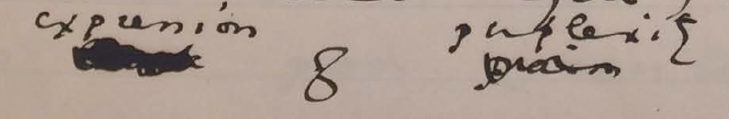Figure 5: Close-up image of detail on MS 9 from The Morgan Library and Museum.
<quote> "I will tell you," said Hallward, and <mod type="subst"> <del rend="strikethrough" strokes="inconclusive" implication="fatality"> a look of pain </del> <add place="above">an expression of perplexity</add> </mod> came over his face. </quote>
DONE incorporate strokes: how do they complicate reading/revision
My final example concerns a longer passage (see Figs. 2 & 3) that was heavily revised in the manuscript. The treatment of this passage crystallizes the various patterns of revision seen so far—-diminishing signs of intimacy, passion, and references to Basil's fatalism. The passage in the manuscript bears quoting in full. Prior to any revisions, it reads:
"You remember that landscape of mine… It is one of the best things I have ever done. And why is it so? Because, while I was painting it, Dorian Gray sat beside me, and as he leaned across to look at it, his cheek just brushed my cheek. The world becomes young to me when I hold his hand, as when I see him, the centuries yield up all their secrets!"
"Basil, this is [illegible] you must not talk [illegible] [illegible] his power, [indecipherable] to make yourself the [illegible] slave! It is worse than wicked, it is silly. I hate Dorian Gray."
Hallward got up from the seat, and walked up and down the garden. A curious smile curled his lips. He seemed like a man in a dream. After some time he came back. ‘You don’t understand, Harry…’ he said. ‘Dorian Gray is merely to me a motive in art. He is never more present in my work then when no image of him is there. He is simply a suggestion, as I have said, of a new manner. I see him in the curves of certain lines, in the loveliness and subtleties of certain colours. That is all.’
‘Then why won’t you exhibit his picture?’
‘Because I have put into it the romance of which I have never dared to speak to him. He knows nothing about it, but the world might guess it, where there is merely love, they would see something evil, where there is spectacular passion, they would suggest something vile.' p. 20-21
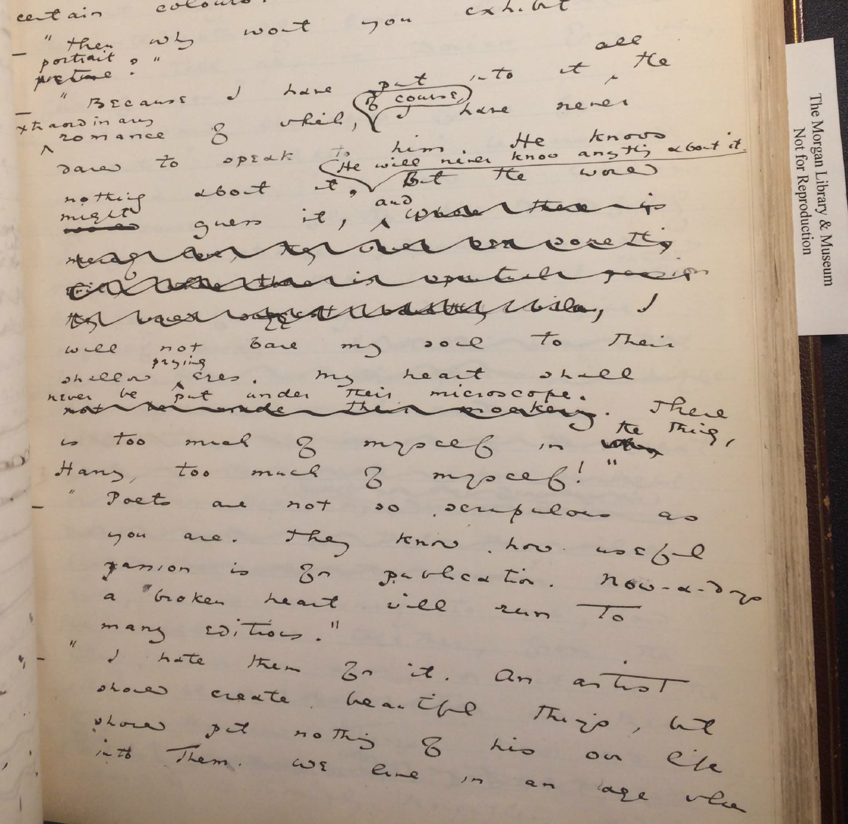Figure 2: Image of manuscript passage beginning on MS 20 from The Morgan Library and Museum.
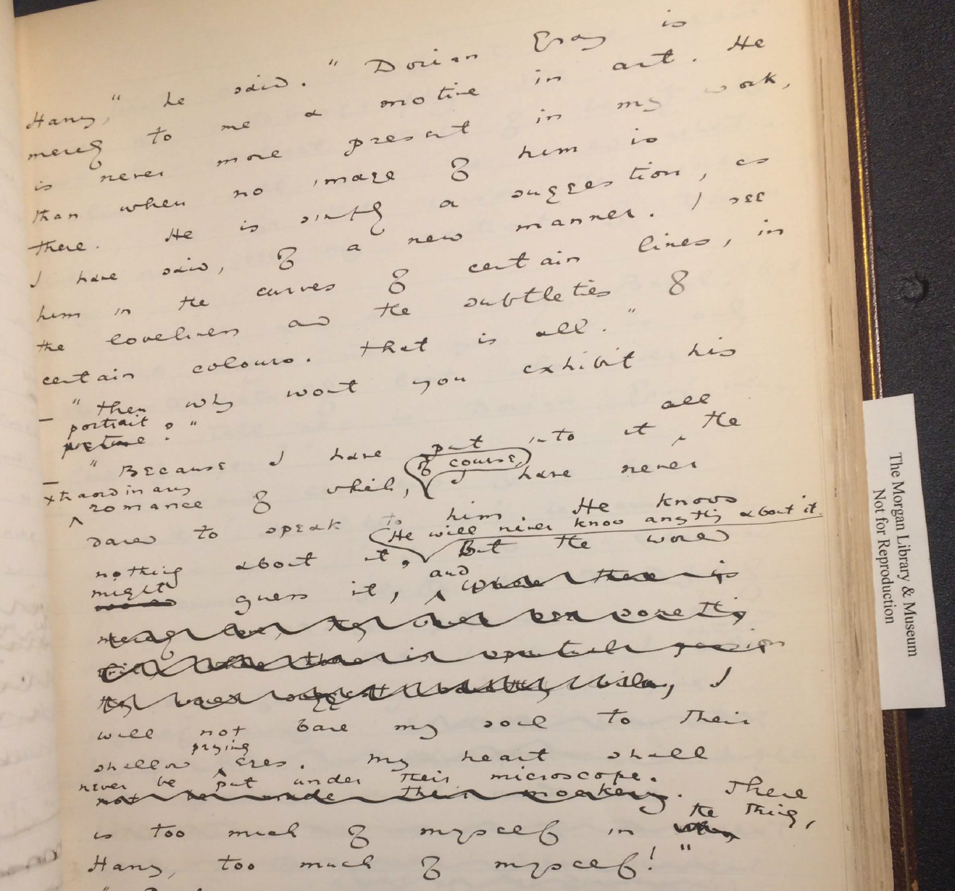Figure 3: Image of manuscript passage ending on MS 21 from The Morgan Library and Museum.
What remains legible of this passage suffice to draw some conclusions about Wilde’s revision practice. First, in the opening paragraph, the encoding is complicated by the layered levels of revision. Wilde eliminates a span of text, from "and as he leaned" to "secrets!". Within this span, Wilde makes additional changes, adding text like "hair just touched my hand" (see fig. 2). Due to its physical nature, this particular phrase is marked as "intimacy" in the TEI, while the longer section is enclosed by the label of "passion," which denotes the nature of the other revisions within the same sentence, like "The world becomes young to me when I hold his hand" (see fig. 3). The TEI here enables a layered approach to markup, where one element can be nested within another.
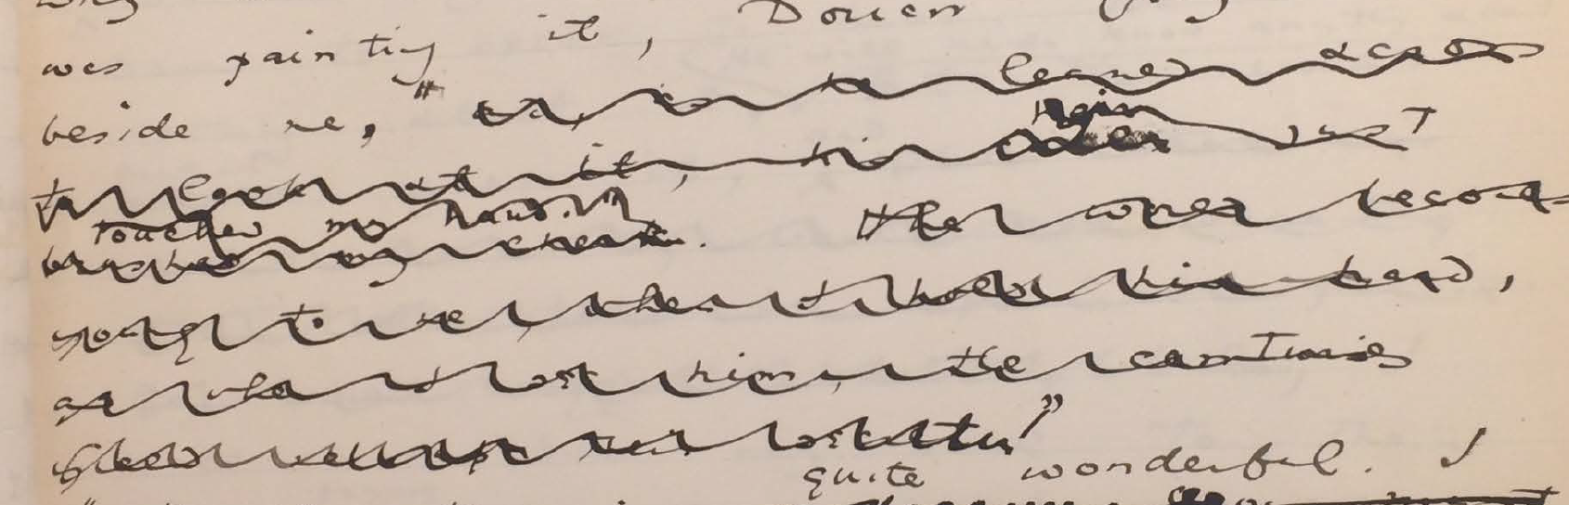Figure 8: detail on MS 20 from the Morgan Library and Museum.
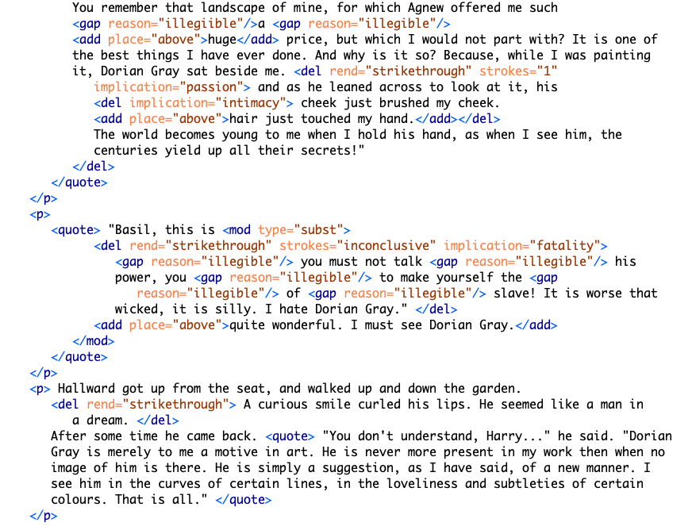Figure 9: TEI encoding for MS 20 detail
While this first paragraph is legible, the next one, by contrast, is almost completely blotted out. It consists of Lord Henry’s condemnatory and jealous protestations–"his power," "to make yourself the… slave!" and "I hate Dorian Gray." Here, Wilde obscures the fatalistic conntoations of Basil's passion, which exasperates Lord Henry. Accordingly, the revision is marked as "fatality" and the strokes as "inconclusive."
Most of the third paragraph is preserved, presumably, for the way it furthers Dorian's aestheticization. Here, Basil elaborates upon Dorian's aesthetic influence–as an artistic ideal that inspires the apprehension of beauty in the natural world. In the following paragraph, however, Wilde alters obscures much of language, which revolves around the theme of passion and fatality. On the theme of fatality, the small adjustment from "would" to "might" eliminates a sense of inevitability about Basil's feelings for Dorian. On the theme of passion, the revelatory line: "where there is merely love, they would see something evil, where there is spectacular passion, they would suggest something vile" is completely struck out. This statement clarifies the Dorian's importance for Basil: he exudes a powerful allure that suffuses Basil's art with beauty. Notably, the strokes over the phrase "suggest something vile" are doubled, which cannot be encoded in TEI without separating the revision into two instances. Here, the text's recalcitrance toward encoding recalls another revision, from "look of pain" to "expression of perplexity" (p. 9). To mark each element with precision would require separating into distinct entities what is in fact one act of revision which contains plural motives. It would involve resolving their indeterminability into a single intention.
DONE conclusion - the themes working interrelatedly
Could it be possible that Wilde strikes this line from the manuscript for a same reason that Basil cannot exhibit the portrait?
Together, the changes in the manuscript reinforce the scholarship which claims that Wilde diminishes the homoerotic elements as part of a larger project to turn Dorian into an aesthetic object. They achieve this goal in three ways: first, by removing the destructive connotations of Basil’s attachment to Dorian; second, by easing the tension surrounding his dialogue with Lord Henry; and finally, by emphasizing Dorian as an ideal subject for art.
However, this scholarship has yet to content with the ways that Wilde's intentionality is distributed among the revisions. The themes of intimacy, beauty, passion, and fatality operate in complicated ways: at times they are plural, co-existing within a single line of text; more often, they are inextricable, with one enabling the other, like intimacy and passion which enable fatality; at other times they enfold one within the other, encompassing a plurality of intentions. The TEI, which requires strict disambiguation, works to surface how these themes are working together in ways that cannot be captured by the markup. Besides registering the indistinctness of the themes, the TEI also registers the inconsistency of the strokes. In many cases, the number of strokes appears to have an arbitrary relation to the theme of revision. There can be multiple strokes for seemingly innocuous changes, like from "said" to "cried" (p. 8). Or, there can be single strokes for some of the more fatalistic revisions, like the line "I would never leave him till either he or I were dead" (p. 12). In such cases, the strokes appear to have an arbitrary relationship to the content of the revisions.

Conclusion: Toward A Queer Form
To resolve some of the inconsistences with the strokes and themes in this section, one might employ more precise qualitative markers such as "tension" in addition to "intimacy," or "ardor" and "devotion," in addition to "passion," for example. But such tagging would dilute the analytical utility of the TEI, which is meant to be decisive rather than exhaustive. Additionally, the more diverse the tags, the less possibility of finding connections between them.
Additionally, remembering Heather Love's characterization of queerness as "always bound up with loss," the attempt to "rescue" or "recover" certain textual elements will only lead to inevitable failure (2009, p. 51). TEI enables an approach toward queerness as something not to be resolved, but something to be produced. By encouraging encoders to impose a level of fixity on the text, TEI allows them to discover exactly where queerness eludes containment. This computational constraint of the TEI is an enabling constraint–producing a failed disambiguation, the TEI reinforces the encoder as the one who ascribes semantic value to Wilde's revisions. This is perhaps an ironic disambiguation: the practice of pinning something down only to realize that such intelligibility is impossible.
That being said, I have tried to tag the homoerotic elements in such a way that allows them to retain some of their elusiveness, without attempting to resolve them into something more intelligible. The TEI has been productive precisely because it requires the encoder to construct labels for things which, ultimately, cannot be recovered. Moving forward, we might look at formalizations produced by this TEI schema not for what it reveals about Wilde's intentions, but for how ti releases potential readings of his composition history. Keeping a critical awareness of the TEI limitations, one might use the tool to mark and visualize queer form, particularly the elusive affects, repressed desires, and other coded elements of queerness within this text. When grappling with the strict structure of the TEI, running up against what can and cannot be encoded, one recognizes what escapes or eludes our structures for understanding and analyzing queerness to understand, without resolving, new forms of queerness.

commands
c-c c-x f => create a new footnote c-u c-c c-x f then select sort then renumber footnotes
block quotes: #+BEGINQUOTE & #+ENDQUOTE

Works Cited
Amin, Kadji, Amber Jamilla Musser, and Roy Pérez “Queer Form: Aesthetics, Race, and the Violences of the Social” ASAP/Journal, Volume 2, Number 2, May 2017. pp. 227-239.
Barnett, Fiona, Zach Blas, Micha Cárdenas, Jacob Gaboury, Jessica Marie Johnson, and Margaret Rhee, "QueerOS: A User’s Manual." Debates in the Digital Humanities, eds Matthew K. Gold and Lauren Klein. University of Minnesota Press. 2016.
Blas, Zach and micha cárdenas, transCoder: A Software Development Kit, 2007-2012.
Bowers, Fredson. Textual & Literary Criticism, Cambridge University Press, 1959.
Caughie, Pamela L., Emily Datskou, and Rebecca Parker. "Storm Clouds on the Horizon: Feminist Ontologies and the Problem of Gender." Feminist Modernist Studies 1.3 (2018): 230-242.
Flanders, Julia. "Encoding Identity." Keynote, Queer Encoding: Encoding Diverse Identities, the Digital Scholarship Center, Temple University. April 28, 2017.
Flanders, Julia. "What is the TEI?" The Women Writers Project. 1999-2021. https://wwp.northeastern.edu/about/
Gaboury, Jacob, "Becoming NULL: Queer relations in the excluded middle," Women & Performance: a Journal of Feminist Theory 28.2 (2018): 143-158.
Gaboury, Jacob, "A Queer History of Computing," Rhizome.org, 2013.
Goldberg, Jonathan, and Madhavi Menon. “Queering History.” PMLA, vol. 120, no. 5, 2005, pp. 1608–1617.
Greg, Walter W. "The Rationale of Copy-Text," Studies in Bibliography Vol. 3, 1950/1951, pp. 19-36.
Halperin, David M. "How to Do the History of Male Homosexuality." GLQ: A Journal of Lesbian and Gay Studies, vol. 6 no. 1, 2000, p. 87-123.
Jewell, Andrew. The Willa Cather Archive. U of Nebraska-Lincoln, 2004-2013. Web. 13 Dec. 2012.
Lawler, Donald L. An Inquiry into Oscar Wilde's Revisions of the Picture of Dorian Gray. New York, Garland Pub, 1988.
Leckie, Barbara. “The Novel and Censorship in Late-Victorian England.” The Oxford Handbook of the Victorian Novel. Corby: Oxford University Press, 2013.
Love, Heather. Feeling Backward: Loss and the Politics of Queer History. Harvard University Press, 2009.
McCabe, Susan. "To Be and to Have: The Rise of Queer Historicism," GLQ: A Journal of Lesbian and Gay Studies, Volume 11, Number 1, 2005, pp. 119-134.
McGann, Jerome. "Radiant Textuality: Literary Studies after the World Wide Web." Springer, 2016.
McKenzie, D.F. Bibliography and the Sociology of Texts. Cambridge University Press, 1986.
McKerrow, R B. Prolegomena for the Oxford Shakespeare: A Study in Editorial Method. Oxford: Clarendon Press, 1939. Greg, W. W. “The Rationale of Copy-Text.” Studies in Bibliography 3 (1950): 19–36.
Ruddick, Nicolas. “‘The Peculiar Quality of my Genius’: Degeneration, Decadence, and Dorian Gray in 1890-1891.” Oscar Wilde: The Man, His Writings, and His World. ed. Robert N Keane. New York: AMS Press, 2003. pp.125-137.
The Shelley-Godwin Archive. University of Maryland, College Park. Maryland Institute for Technology in the Humanities (MITH).
Tanselle, Thomas. “A Rationale of Textual Criticism,” University of Pennsylvania Press, 1989.
Thain, Marion, "Perspective: Digitizing the Diary - Experimentsin Queer Encoding," Journal of Victorian Culture, Volume 21, Issue 2, 1 June 2016, Pages 226–241.
“To the Editor of the St James Gazette,” 25 June 1890. Rpt. in Wilde, Oscar, and Michael Patrick Gillespie. The Picture of Dorian Gray: Authoritative Texts, Backgrounds, Reviews and Reactions, Criticism. 2nd ed. ed., New York, W.W. Norton, 2007. pp. 355-356.
Traub, Valerie. “The New Unhistoricism in Queer Studies.” PMLA, vol. 128, no. 1, 2013, pp. 21–39.
Wilde, Oscar. The Picture of Dorian Gray: Original Manuscript. 1889–90. MS. Morgan Library & Museum, New York, NY.
Wilde, Oscar, and Joseph Bristow. The Complete Works of Oscar Wilde. Vol. 3. Oxford, Oxford University Press, 2000.
Oscar, Wilde, and Nicholas Frankel. The Picture of Dorian Gray: An Annotated, Uncensored Edition. Harvard University Press. 2011.
Wilde, Oscar, and Michael Patrick Gillespie. /The Picture of Dorian Gray: Authoritative Texts, Backgrounds, Reviews and Reactions, Criticism/. 2nd ed. ed., New York, W.W. Norton, 2007. Wilde, Oscar, and Nicholas Frankel. The Picture of Dorian Gray : An Annotated, Uncensored Edition. Cambridge, Mass., Belknap Press of Harvard University Press, 2011.

See McKerrow, R B. Prolegomena for the Oxford Shakespeare: A Study in Editorial Method. Oxford: Clarendon Press, 1939. Greg, W. W. “The Rationale of Copy-Text.” Studies in Bibliography 3 (1950): 19–36. Bowers, Fredson. Textual & Literary Criticism, Cambridge University Press, 1959. Tanselle, Thomas. “A Rationale of Textual Criticism,” University of Pennsylvania Press, 1989.
As the condition of rescuing his lover Eurydice from Hades, Orpheus must not look at her until they exit the Underworld and re-emerge into the sunlight. Unable to restrain himself, Orpheus turns to gaze at Eurydice as they are about to pass through the threshold. In this glimpse he manages to catch of his lover, she is already shrinking away, into the darkness where she will be forever imprisoned.
See pp. 40-54 in Nicolas Frankel's The Picture of Dorian Gray: An Annotated, Uncensored Edition for a more complete accounting of of Stoddart's role in preparing the typescript for publication.
See the Norton Critical Edition of The Picture of Dorian Gray, ed. Michael Patrick Gillespie, for a selected list of full-length reviews from The Scots Observer, The St James Gazette and the Daily Chronicle, and Wilde’s responses.
Wilde, Oscar, and Michael Patrick Gillespie. /The Picture of Dorian Gray: Authoritative Texts, Backgrounds, Reviews and Reactions, Criticism/. 2nd ed. ed., New York, W.W. Norton, 2007. Wilde, Oscar, and Nicholas Frankel. The Picture of Dorian Gray : An Annotated, Uncensored Edition. Cambridge, Mass., Belknap Press of Harvard University Press, 2011. p0. 3-4.

