CaladoF

Table of Contents

1. thank you

2. 1. overview of diss - critical look at technology - 10

2.1. main idea

2.2. orlando close reading

2.3. reduction

3. detail of my work - text encoding - 20 min.

3.1. queer studies trajectory

3.2. text encoding chapter overview

3.3. hierarchy

3.4. Dominance structures in the archive

3.5. disidentification to queer form

4. 3. where my work is now going - algorithmic bias - 10

4.1. anti trans & text generation

# thank you

Thank you for having me. Today I'll be talking about my dissertation, which I defended in November in the English department at the Graduate Center at CUNY. For that project, I applied a methodological approach based in Queer Studies to analyze Digital Humanities tools that work with language and language forms. I will show how these digital tools flatten or reduce some expressive qualities of language, particularly language that relates to sex, gender and sexuality, and how Queer Studies can be deployed to surface these qualities. Toward the end of the talk, I will discuss how this work has led me to a follow-up project, which applies the same analytical spirit to examine what AI tools and gender bias, specifically by using language models to analyze legislation that limits transgender peoples’ rights, which is currently proliferating across the United States.

# 1. overview of diss - critical look at technology - 10

## main idea

First, my dissertation, entitled "Since No Expressions Do: Queer Tools for Reading Literature", uses literature, and queer literature in particular, as a test case for exploring what happens to language when it is transformed into electronic formats and processed with digital tools. Each of my chapters takes up a different aspect of computation–such as programming logics, data structures, and interface effects–to explore how that aspect handles stylistic and formal aspects of sex, sexuality and gender. I find that digital processes, which by design flatten semantic expressiveness of language into text data that can be categorized and counted by the machine—that these same processes can be reframed to index the semantic expressiveness that has been lost.

My methodology is to do “close readings” of digital tools, to examine how each one handles the complexity and nuances of language forms. I look into the mechanism of the tool, tracing the way that it transforms language into text data and manipulates that data for electronic processing and display. I closely examine the logical structures of computer code, across programming and markup languages such as Python, JavaScript, and XML. From the code’s internal logics, I isolate a specific constraint, an aspect of the tool that collapses or reduces expressive qualities of language into computable data. Then, I draw from theorizing in Queer Studies and its critiques to find ways of working within this constraint. Queer Studies offers this project methodologies for working within totalizing and oppressive systems, such as that of heteronormativity. I look to these systems as models for reading the strict and disambiguating logics of computer codes.

## orlando close reading

Before elaborating on my theoretical intervention, I'll share a small example of what this “close-reading” method looks like, to concretize the kinds of reductions that are inherent to computational processes, and how these reductions specifically affect language data.

SLIDE 2: Tilda Swinton image from *Orlando* film.

I’ll begin with a close-reading from the first sentence of Orlando, a novel by Virginia Woolf. For those who are unfamiliar with the text, it tells the story of Orlando, 16th century English nobleman who has a sex change halfway through the book, and lives the rest of her life as a woman. There’s a famous film by Sally Potter that stars Tilda Swinton as *Orlando*.

SLIDE 3: first sentence of Orlando.

The novel opens with a scene of violence, within which is embedded important assumptions about gender:

“He–-for there could be no doubt of his sex, though the fashion of the time did something to disguise it—-was in the act of slicing at the head of a Moor which swung from the rafters” (11).

This scene launces the reader into a history of Imperial conquest—with Orlando using a sword to swipe at a severed human head that his ancestors brought back to England from the Crusades.

From this first sentence, we can read important assumptions about gender.

For example, the reassurance that there could be "no doubt of [Orlando's] sex," belies itself: it doesn't serve to reassure it at all, but rather, is conspicuous in its certitude. That this reassurance follows an em dash interrupting the first word, a bold gender declaration–HE–draws even more attention to gender as something that is in contention. The associations here deepen when we connect this certainty and even defensiveness about gender with the imagery of English imperial conquest (the "slicing at the head of a moor"). Masculinity here becomes co-constructed along with nationality and race.

If one were to pass this text into a computer program for text analysis, that processing would evacuate the subtle ways that gender is unsettled in the sentence. All text analysis is based on counting: counting the number of times a certain word appears, for example, and how many times its surrounding words appear, and what words tend to surround those words, within their own contexts, and so on, with the ultimate goal of deriving patterns from these word frequencies. In order to count the words, however, the text must be prepared: if semantic features, which are deemed "minor" (like articles, prepositions, punctuation) are frequently occuring, they must be removed. This preparation process also includes the removal of word endings and inflections, capital letters, and other idiosyncracies in order to standardize the original text into a computable dataset. This process of "cleaning" or "regularization" ensures that minor details won't skew the counting, the word frequencies, of the text, which is the basic foundation of all text analysis tasks. For this sentence in particular, that means the pronoun "HE" and the em dash following that "HE" would be removed, thus losing the subtle ways that pronouns and punctuation can inflect meaning in language.

‘could’, ‘doubt’, ‘sex’, ‘though’, ‘fashion’, ‘time’, ‘something’, ‘disguise’, ‘act’, ‘slicing’, ‘head’, ‘moor’, ‘swung’, ‘rafter’.

## reduction

Obviously, digital processes like text cleaning are there for a reason: they make certain kinds of analyses possible. My work does not intervene those kinds analyses. Rather, I'm interested in reading those reductions as opportunities to unleash textual meaning, to create a kind of resistance to the compulsory disambiguation required by machine processes.

In my work, reduction becomes an opportunity. Here, I turn to Queer Studies, which arose in 1990s with modes for analyzing (and revealing the contradictions of) sex, gender, and sexuality as social constructions. Because Queer Studies offers strategies for not only recognizing oppressive structures, like compulsory heterosexuality, but of working within and against them simultaneously, I find them to be useful models for re-thinking my usage of digital tools in a practical way.

For example, with text analysis, I found a connection between the computational processes of cleaning a text with the ways that gender is constructed according to Judith Butler's famous theory of Gender Performativity, a theory that helped to inaugurate the field of Queer Studies. This connection centers on the concept of iteration, which is central to both text cleaning and gender performativity.

Quote on iteration?

“Performativity must be understood not as a singular or deliberate “act,” but, rather, as the reiterative and citational practice by which discourse produces the effects that it names” (Butler 2)

For text cleaning, I examine how the Python programming language (a popular language for Natural Language Processing tasks) works with text data through a mechanism known as the "loop," which is a concept that exists across programming languages and a core building building block of algorithms. The loop enables a program to do things en masse to data by repeatedly applying the same series of actions to each piece of data, one by one. The technical language describes loops as a process of "iterating over" data.

I then turn to Judith Butler’s concept of gender performativity, which defines gender as a series of repeated acts (in other words, of behaviors) that conform to an authorizing norm, which together create a subject. Her central intervention is that behavior determines identity, or at least the illusion of identity. According to Butler, tt is by adopting gendered modes of behavior that subjects come to exist at all. From this theory of Gender Performativity, I am interested in her characterization of gender as a "re-iterative… practice… by which discourse produces the effect that it names". To resist the compulsory nature of gender performativity, Butler claims that subjects can subvert social structures through repeatedly "performing" gender constraints in ways that deviate from the norm.

Taking this shared quality of iteration between Python and gender, I propose a text analysis methodology that combines different tasks for analyzing text. I demonstrate this process in a custom text analysis application, which I designed and coded using Python libraries for text analysis, like NLTK and Word2Vec, for those who are familiar with Natural Language Processing. Resisting traditional "reproducible" social science methods for text analysis, my custom text analysis application, which is available online, offers an iterative method that flips between close, textual detail and distant views of language data.

# detail of my work - text encoding - 20 min.

## queer studies trajectory

For this text analysis project, Butler's theory of Gender Performativity offers a model for re-deploying the programmatic logics of Python programming toward an innovative text analysis practice. Similarly, throughout my disseration, I look to Queer Studies for strategies for resisting oppressive structures, particularly as they pertain to gender, sex, and sexuality, but also increasingly, to race. With prominent theorists like Judith Butler and Eve Kosofsky Sedgwick, Queer Studies began by attending to and disentangling the transgressions and contradictions within gender, sex, and sexuality. But the trajectory of Queer Studies as a field changed with the Queer subject's increasing incorporation into mainstream politics and progressive agendas, such as the prioritization on same-sex marriage and inclusion in the military. As a result, numerous critiques emerged based on Queer's movement toward normativity (called "homonormativity") on the one hand, and a doubling down of the transgressive potential of "Queer" at all costs, which manifested in theorizing around a total rejection of mainstream acceptance, known as the "the anti-relational" or "anti-social" turn.

This trajectory influences my approach toward analyzing technology throughout the project. Throughout my chapters, I use these critiques of Queer Studies, beginning with Queer of Color Critique, to encourage the continual re-thinking of ways that computational structures constrain and reduce language into computable elements, into components that function within larger, totalizing systems.

For example, I draw from Queer Studies scholar Jose Estaban Munoz's critique of Queer Studies, who brings intersectional thinking from Women of Color Feminism in the 80s and 90s to re-energize the theorization of Queer's political potential. As a corrective to Queer Studies' implicit (and sometimes not so implicit) whiteness in its critical frameworks, where gains in the Queer community are trapped within the limiting, normative time of the present, Munoz offers a definition for queerness as futurity. He defines queerness as a desire, a "longing that propels us onward," for what is "not yet here." He explains that

Queerness is a structuring and educated mode of desiring that allows us to see and feel beyond the quagmire of the present… Queerness is a longing that propels us onward, beyond romances of the negative and toiling in the present. Queerness is that thing that lets us feel that this world is not enough, that indeed something is missing. (Cruising Utopia)

Munoz's thinking opens possibilities of theorizing from political and social environments that allow some subjects visibility and acceptance while attempting to erase the existence of others. I find these critiques of Queer Studies useful for expanding beyond the field, in particular to theorizing from Black Feminist Studies, Latinx Studies, and the history of the Black Atlantic.

## text encoding chapter overview

For example, in another chapter of my dissertation, I examine how data structures might re-worked by drawing from critical methods in the history of the Black Atlantic.

In this chapter, I consider a data structure called XML (short for eXtensible Markup Language), which is widely used for encoding, or "marking up" written content within a hierarchical structure, similar to HTML. Like HTML, this data structure uses "tags" to wrap written content, using descriptive labels like <p> for paragraph or <quote> for a quotation. All content must be enclosed with these descriptive tags, which must themselves be nested neatly within one another, so that so-called "child" elements are contained within their "parent" elements. All XML documents, like the one above, resemble a tree structure, with one "root" element and several "branches."

Like my critique of text analysis's programming logics, I was interested in how this tool flattens or reduces expressive aspects of language as it relates to gender, sex, and sexuality. To seek out its constraint with language, I used it in an editorial project, for transcribing the written text of a literary manuscript, that was edited multiple time to remove evidence of homosexuality. Here, I chose the manuscipt of Oscar Wilde's novel, The Picture of Dorian Gray, which Wilde revised heavily before its first publication in 1890. For this text, I used the tool in attempt to register the subtle and fascinating ways that Wilde mitigated and obscured traces of homosexuality and eroticism. For those who don't know, the story, set in late 19th century London, follows a beautiful youth named Dorian Gray who sells his soul for perpetual youth. Dorian makes a deal with his portrait: if only Dorian can keep his youth, the portrait might grow old and ugly in his place. The story then follows Dorian's descent into corruption, through which he remains young and beautiful. The novel, which celebrates male beauty and artisitic ideals, was variously criticized for its apparently ambiguous stance toward Dorian's hedonistic lifestyle, as well as undertones of homoeroticism. (For example, parts of the novel were read as evidence in a trial where Wilde was of "gross indecency", a law in England that criminalized sex acts between men). The critical scholarship on the novel's revision history generally agrees Wilde attempts to neutralize eroticism and passion by transforming it into aesthetic appreciation.

Nicolas Ruddick, for example, argues that Wilde emphasizes an obvious moral about beauty at the expense of another, more covert moral about sexuality. Here, Wilde’s revisions emphasize beauty by highlighting the dangers of vanity, while at the same time, obscuring a dark and painful lesson about "the destructive effects of the clandestine or closeted life” (126, 128). Ruddick explains that the eponymous portrait indexes the convergence of these two morals: "the appalling changes to Dorian’s painted image… strongly suggest that the unspeakable practices indulged in by the protagonist are unspeakable in themselves" (Ruddick 129).

In this passage, for instance, Wilde makes small changes in word choice that have significant effects on the tone and overall mood of the scene.

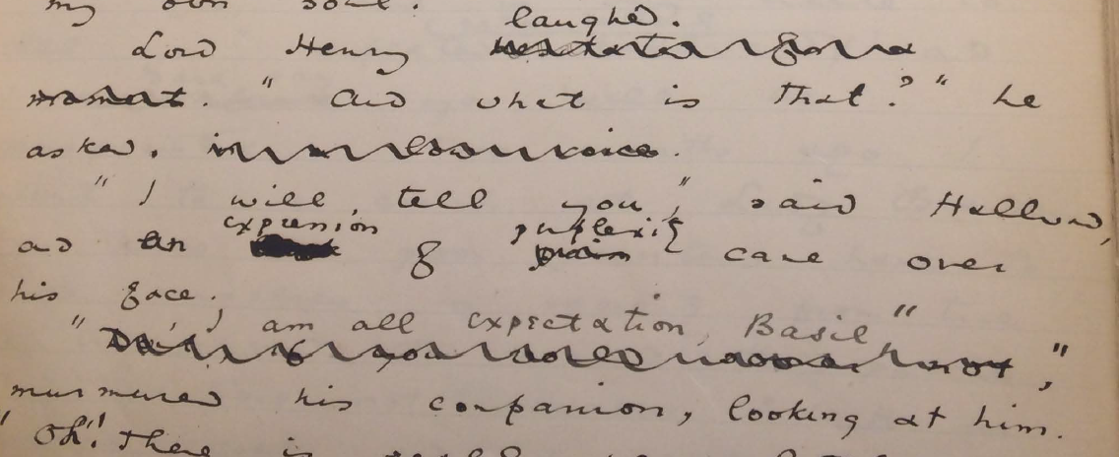Figure 3.2.1: Image of detail from MS of Dorian Gray, page 9

In this section, the painter, Basil Hallward, is about to explain to his friend, Lord Henry, why he cannot exhibit his portrait of Dorian Gray. Before revisions, these section originally reads

Lord Henry hesitated for a moment. "And what is that?" he asked in a low voice.

"I will tell you," said Hallward, and a look of pain came over his face.

"Don't if you would rather not," murmured his companion. (9)

In the revision, hesitation becomes a laugh, and the look of pain becomes an expression of perplexity. These changes trade affliction for confusion, and diminish the fatalistic connotations of Basil's passion. They also an underlying sense of shame or restraint, especially from Lord Henry, who no longer hesitates or speaks in a low voice, and instead encourages Basil to share his story. Together, these changes work to lighten the mood of the scene.

To encode Wilde's manuscript, I customized a variant of the XML language, called TEI (stands for Text Encoding Initative, which is commonly used for projects involving literary and other artistic and cultural objects). Using the XML data structure as a base, I created a schema with custom tags for registering the kinds of homosexual content and innuendos in Wilde's revisions. The image here demonstrates how one would encode a section of the manuscript containing multiple revisions.

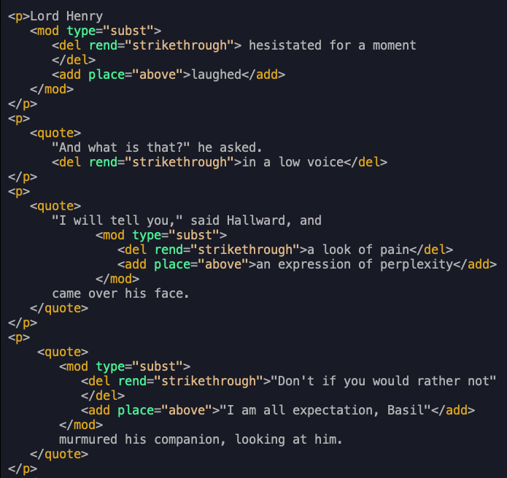Figure 3.2.2: Image of xml encoding for MS of Dorian Gray, page 9.

In this detail, we see the tree-like structure of the XML, along with the tags (in dark yellow) that are particular to editorial projects, like tags for indicating deleted text in <del>, added text in <add>, and their parent tag, <mod>, which stands for modification. Additionally, we can see attributes in green, like "type" to indicate the type of modification (in this case, a substitution of one text for another), "rend" to indicate how a bit of deleted text should be rendered, such as with a strikethrough; and "place" to indicate where the addition was made, which is above the line.

Following the critical scholarhip of this text's revision history, I created a markup schema that would label the revisions according to several general categories, like passion, intimacy, and fatality. These labels correspond with the critical consensus about Wilde's authorial intention in revising the novel, that he suppressed the homosexual content by transformating the main character, Dorian Gray, from an erotic into an aesthetic object. Additionally, I also wanted to encode the revision within a physical dimension, to mark out each individual instance of revision.

## hierarchy

My work on the minute, detailed labor of encoding the manuscript revealed a constraining quality about XML data structure–that of hierarchial dominance. The XML requires that all data be contained as discrete components within this bounded structure, and they cannot overlap unless the inner element is fully nested within an outer element. When child elements do not fit neatly within the parent, the text file will display error. The problem is that language structures are often overlapping: for example, syntax (that is, phrase-based structures) overlap with semantic structures, as happens often with in poetry.

Through the XML encoding, I discovered the difficulty of disentangling the revisions from one another, which appears to operate in inscrutable ways with Wilde's authorial intention. While my work substantiated to central claims in the criticism, for example, that Wilde substituted words or phrases to ease tension in the dialogue, and that he removed the destructive connotations surrounding the various exhortations of beauty and passion, it also made it more difficult to understand the revisions as discrete entites.

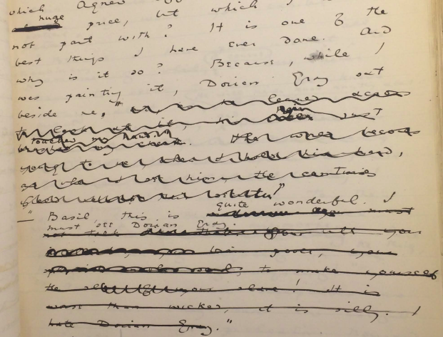Figure 3.3.1: Image of detail from MS of Dorian Gray, page 20.

For example, one passage layers revisions to intimacy, passion, and fatality within what are apparently several rounds of revision. In the original version of the text, the the painter Basil is explains his fascination with Dorian Gray to their friend, Lord Henry:

“You remember that landscape of mine… It is one of the best things I have ever done. And why is it so? Because, while I was painting it, Dorian Gray sat beside me, and as he leaned across to look at it, his cheek just brushed my cheek. The world becomes young to me when I hold his hand, as when I see him, the centuries yield up all their secrets!”

Lord Henry's response, as you can see, is mostly illegible, but I could make out some words and phases, like "you must not talk", "his power," and "slave", as well as the final line, which reads: "It is worse than wicked, it is silly. I hate Dorian Gray."

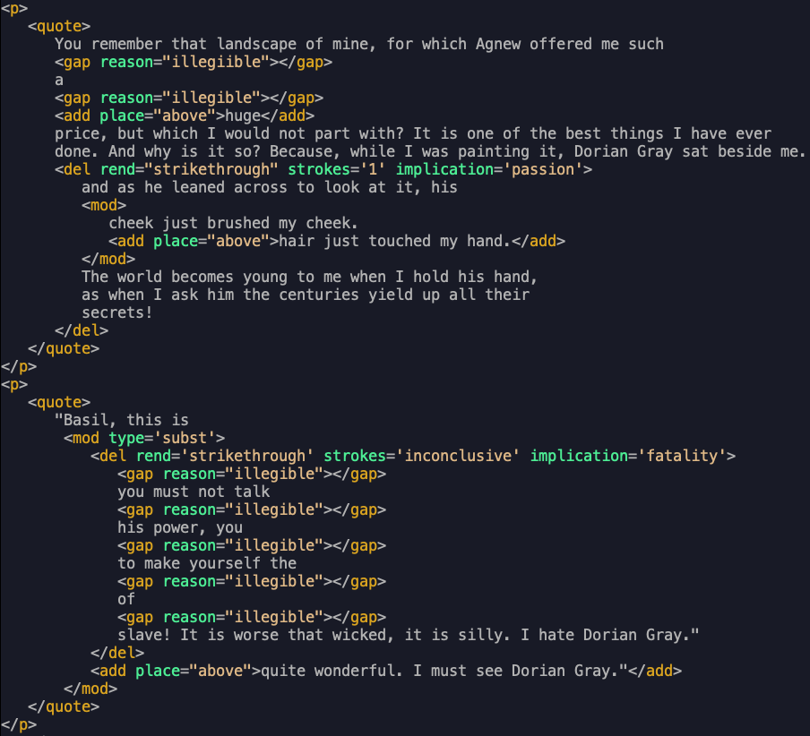Figure 3.3.2: Image of XML encoding for MS of Dorian Gray, page 20.

In Wilde's revisions, as you can see in the XML encoding, he replaces "cheek just brushed my cheek," with "hair just touched my hand," before striking out the entire line, as well as the following sentence, ending his dialogue with the words "sat beside me." Wilde also strikes out much of Lord Henry's response, replacing Lord Henry's intensity with a relatively subdued interest–"Basil, this is quite wonderful. I must see Dorian Gray."

With the XML, I struggled to register the complexity of the revisions with precision. The ways in which the thematics are distributed among the rounds of revision, across multiple layers of deletion, proved was difficult to capture in the strict, disambiguated format. Rather, this work surfaces how these themes work together in ways that cannot be captured by its data structure and its need for strict disambiguation. They may be plural, co-existing within a single line of text; they may be inextricable, with one enabling the other, like intimacy and passion, which enable fatality; or they might enfold one within the other, encompassing a plurality of intentions.

Like my critique of text analysis, this computational constraint reveals a connection to queerness: As a labelling tool, the text encoding (which I explain in more detail in a moment) indexes moments where queerness, in this case, queer desire, transgresses the bounds of the data structure.

## Dominance structures in the archive

The more that I work with the XML, the more I come to realize that the problem with its data model goes beyond the boundedness of its elements, and toward a dominating, top-down structure that it imposes on textual data. At the root of the XML’s rigidity is its hierarchical document model where each element within the tree structure subscribes to its parent element and dominates its subordinate ones. Within this tree-like architecture, information is not only encapsulated or bound, it is delineated by the standards of each governing tag, its syntax, model, attributes, and contents.

I find that underlying Ruddick’s two “unspeakable” morals about beauty and homosexuality, there is a third level of “unspeakability”—about power, about who has it and who is subject to it. For this text in particular, the dominant force is that of the writer himself, a writer with nearly every privilege—gender, racial, financial, cultural, and educational—who censors his own writing. What about texts whose writers or subjects are subscribed to larger systems of domination, such historical forces of discrimination, exploitation, and oppression?

To better understand the role of dominance in delimiting data formats, I turned to an archival project that has been totally dominated by hierarchical power structures. This is Atlantic slavery scholar Jessica Marie Johnson’s research on the lives of black women in the 17th and 18th century Atlantic world. Johnson's archive consists mostly of records like birth certificates and marriage licesnses, and censuses, among other historiographical and official documents, all written by slave-owning men, traders, and colonial officials. From this sparse and highly delineated dataset, she finds methods of surfacing a narrative of what was and what might have been. She does that by reading through these records, which “often contain incomplete information,” and weaves a history “in careful and creative ways” (Johnson 5). Her readings of these documents surface a complicated and nuanced picture of black womens’ lives and how they negotiated their own freedom practices within slave-owning, male dominated world.

In line with current critical methodologies in the history of Slavery and the Black Atlantic, for example in work by Saidiya Hartman, Johnson turns to narrative strategies for working with the problem of missing data and constraining data structures. Here, Johnson interweaves fragments that, on their own, tell a story of bondage and subjection to power. She begins by foregrounding her work with a figure from the archive, constructing for the reader a vivid scene, sense of character, and accomplishments. The first chapter of her book, Wicked Flesh, for example, presents a dinner party hosted by Seignora Catti, “a wealthy merchant" [who] had leveraged her status as the wife of a European official "against her commercial savvy… "for her own benefit” (Johnson 16). The notes reveal that the sources for Catti’s biography stem from biographical writings featuring a French commercial agent for a slaving company based in Senegal. But in Johnson’s narrative, this agent's role is delimited to a supporting character, to a guest at Catti’s dinner party whose presence serves to bring Catti into the foreground.

Johnson works from multiple constraining data sources to create something new, original. I find this method of interweaving to be inspiration for thinking the ways we approach data structures like the XML.

## disidentification to queer form

The point of isolating these constraints is not to try to grasp or translate the vestige of lost meaning, but to recognize that gap as a space that constitutes queer experience and subjectivity.

According to the late Queer Studies scholar, Jose Esteban Muñoz, queer subjectivity is defined by working within the gaps of identification, what he calls “disidentification,” where subjectivity emerges in the failure to adhere to social expectations (Disidentifications 5). Within this gap, minority subjects find alternative pathways to connect with majority culture, “read[ing] oneself and one’s own life narrative in a moment, object, or subject that is not culturally coded to ‘connect’ with the disidentifying subject” (Disidentifications 12).

I find that reduction and constraints in technology are opportunities for reading the workings of power and other oppresive structures, and for surfacing not only what has been flattened by the machine, but an incommensurable element, which cannot be apprehended or expressed.

Posing the incommensurable qualities of queer identity and experience against the necessary disambiguation of technological processes, I try to surface what Queer Studies theorists Kadji Amin, Amber Musser, and Roy Perez describe as "Queer Form," that is, "an aesthetics that moves persistently around the visual,” “mak[ing] difference a little less knowable, visible, digestible” (235). According to these theorists, Queer Form “resist[s] the dictates of transparency normally required of non-normative subjects by illuminating the unseen” (233).

My work seeks out such forms, ones that figure the contour, boundary, and edge around the elusive identities, repressed desires, and other coded elements of queerness in text. For this project I have built two digital applications, one for text analysis and one for text encoding, that demonstrates in practice how these tools reveal, not solutions for understanding or “fixing” queerness, but opportunities for exploring its shifting permutations.

The goal, as I try to demonstrate with the digital applications that I created, called "the Queer Text Toolkit", is not to build reproducible schemas and models for analyzing queerness. Rather, it is to harness the opacity and unintelligibility of queer forms. I hope this experimental work will encourage further developments for reading our queer literary heritage, that, as Judith Butler says, “begin, without ending, without mastering, to own—-and yet never fully to own—-the exclusions by which we proceed” (25).

# 3. where my work is now going - algorithmic bias - 10

Now I turn to my follow-up project, which I've already begun researching.

This project applies a similar analytical spirit of deonstructing technical mechanisms toward a new object: Large Language Models. Now, I am in the middle of a data gathering and cleaning process with the goal of fine-tuning a LLM to study how it perpetuates gender bias in its training data. So far, I am have gathered definitions of gender identity and related terms from Federal legislation that limits transgender peoples’ rights, known as the “anti-trans” legislation, which is being currently debated and passed throughout the US. Next, I will use this dataset to train a Text Classification model that can score gender bias in language.

Primarily, I am interested how the training processes for these tools perpetuate and amplify the sexist, racist, and other hegemonic perspectives from their training data.

## anti trans & text generation

The anti-trans legislation movement is a fascinating one. It's being used a galvanizing tool, as a way of conscripting folks who may hesitate to condemn homosexuality into what is ultimately a hetero-hegemony, a hetero-normativizing project. It seems to me that the threat to gender has to do with the binary gender paradigm that is inalienable, that cannot be transgressed, which is used as their rallying cry. (Of course, as trans activists and scholars have been saying for years, this is only the beginning. Because once they get the trans folk, they will move on to the rest of the non-normatives.)

I think it's important that we understand, today, the threat of gender transgression. And this threat is what I'm interested in. I'm interested in examining the language outlawing gender transgression, and this particular transgression, of transitioning from one gender to another, or of opting out of binary systems of gender. Why is this particular kind of transgression so controversial, so contentious? why is it so seductive to much of the public?

So I'm going to look at the definitions of words like gender identity, using LLMs to study them. I am also interested in what we can learn about the mechanism of AI tools, and claims about it's so-called "intelligence," and "world modelling," as AI researchers refer to it. There's this really strange phenomenon where the LLMs are very good at generating synthetic, plausible text but not so good at improvising from details. It cannot say something original, such as explain why a particular metaphor is powerful, like a human reader can.

It is a text generator, a synthetic text generator, in the words of Emily Bender, the author of the famous (in the field of AI Ethics) paper, "Stochastic Parrots". It can only generate what it has already seen before. Even a phenomenon like "hallucination," this idea that a language model can "create" text that is not true, that no bearing in reality, is based on the tendency of LLMs to reproduce what they've already seen before. They hallucinate not because they are "creative", but because they are designed from statistical processes meant to generate what is most plausible.

Ted Chiang, science fiction writer (author of the story that inspired the "Arrival" film) describes it like a blurry photograph, where the compression program guesses what pixel to use through estimation and calculation. He explains that:

common technique used by lossy compression algorithms is interpolation—-that is, estimating what’s missing by looking at what’s on either side of the gap. When an image program is displaying a photo and has to reconstruct a pixel that was lost during the compression process, it looks at the nearby pixels and calculates the average.

The compression means that the tool is guessing, estimating. What we would call an educated guess. Is prediction the same as creativity? What about improvisation? These are larger questions looming in the background.

But being in this gap, in the blur between prediction and creativity, is to study the construction of gender. What can we distill, compress, or create about the way we understand gender and sex in the juridical and carceral realms?

I hope to find something in the language, something that tells us something about the allure, the threat, the seduction, as trans scholar Cassius Adair puts it. For example, there is a widespread fear of Rapid Onset Gender Dysphoria, this idea that transness is something that transmits from trans person to cis person, like a contagion. Adair (and other trans scholars) caution that we need to get ahead of this "trans panic": "to anticipate the emergent rhetorics of anti-trans sexual panic and draw a line in the sand around our right to find each other".

Thank you.