Filipa Calado

Binary Modernisms: Re/Appropriations of Modernist Art in the Digital Age

October 18, 2021

Encoding Queer Erasure in Oscar Wilde’s *The Picture of Dorian Gray*

Literary and textual scholars have long speculated about Wilde’s intentions for revising the homoerotic content of his famous novel, *The Picture of Dorian Gray* (1891). More recently, electronic editing standards enable scholars to explore textual composition histories within a digital space. This project uses the Text Encoding Initiative (TEI) method, an electronic editing standard that allows researchers to “mark up,” or tag, textual elements. Using the TEI, I mark up the first chapter of Wilde’s manuscript of *Dorian Gray*, which introduces the story’s three main characters, Basil Hallward, Lord Henry Wooten, and Dorian Gray. In identifying moments of suppressed homoeroticism, I draw from debates in Textual Scholarship and Queer Historiography to question how electronic editing with TEI might register or “rescue” the queer affects of this text. My work here pushes against what I identify as TEI’s main constraint, which is its limitation for handling data that is discrete, rather than smooth or ambiguous data, like the homoeroticism of this text. I conclude by proposing a TEI customization that marks Wilde's revisions according to the four affects of “intimacy,” “beauty,” “passion” and “fatality.” As an experiment in “queer encoding,” this customization works with the strict data structure of the TEI to engage the fluidity and complexity of queerness in the text.

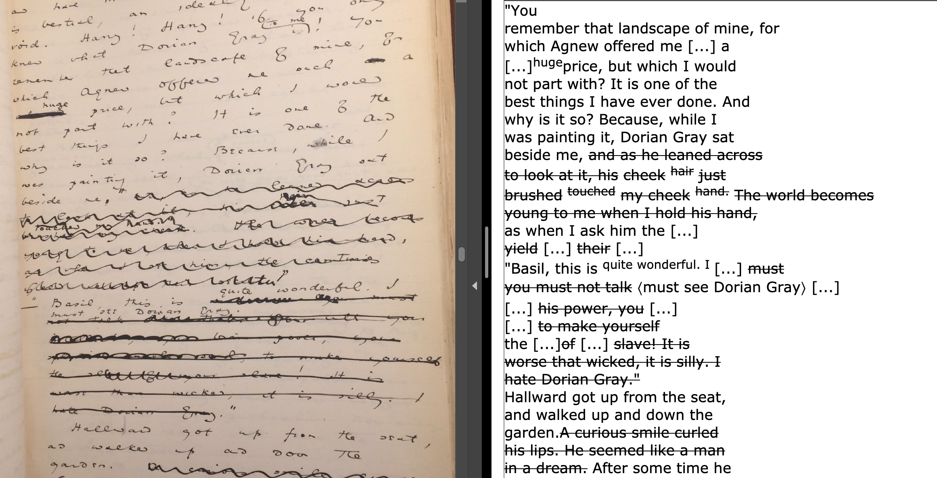

Figure 1: Side-by-side images of original manuscript with the electronic transcription

Author Bio

Filipa is a PhD Candidate in the English program at the Graduate Center, CUNY. Her research explores the interface between digital media and queerness, and her dissertation, entitled "Queer Tools," takes a critical look at digital tools to study life writing by queer authors. She's interested in manuscripts, diaries, journals, and memoirs from the "long 20th century," including works by Oscar Wilde, Virginia Woolf, Djuna Barnes, Gloria Anzaldua, Alison Bechdel, Jordy Rosenberg, and Carmen Maria Machado, among others. Each chapter of her dissertation takes up one digital tool for reading, editing, and archiving, and explores how the tool might be "queered" to explore the limitations of human-technological interactions. She has teaches courses on Queer and Latinx Literature, Critical Thinking, and Digital Methods at Hunter College and NYU.