­­Filipa Calado

Clark Memorial Library Predoctoral Fellowship

January 30, 2020

Encoding Queer Erasure in Oscar Wilde’s *The Picture of Dorian Gray*

Within the broad field of the Digital Humanities (DH),[1] an emerging *Queer* DH explores what is queer about digital methods and media. These initiatives often critique the practice of using digital tools to verify, correct, or establish “facts” about cultural materials, preferring instead to orient technological contexts around speculation and experimentation. In support of such efforts, my project excavates the limitations of digital methods that overlook or collapse the complexity of literary materials to consider how they might open possibilities for queer scholarship. I examine how the processes of electronic editing, social reading and archiving tools draw attention to the ambiguities of queer subjectivity, experience, and embodiment. The second chapter of my dissertation, “Encoding Queer Erasure,” employs a popular tool for “text encoding” to mark up Oscar Wilde’s revisions of homosexual and homoerotic content in his novel, *The Picture of Dorian Gray*. So far, I have begun to encode the first chapter of the manuscript and collate it with the periodical and print book versions. In order to complete this project, however, I need to access the original typescript, held at the Clark Memorial Library at the University of California, Los Angeles.

My digital collation would address both the limitations of paper-based editing and the scholarly disagreement over an ideal version of the text. Joseph Bristow affirms that this text, “like the story’s duplicitous protagonist,” cannot be presented as a single document (xii). From manuscript to novella to full length book, Wilde’s revisions on *Dorian Gray* reveal a complicated transmission process, especially concerning the treatment of its homosexual themes. Textual scholars including Bristow, Donald Lawler, and Nicolas Frankel have long speculated over Wilde’s shifting intentions across the manuscript, typescript, and two published versions. According to Lawler, Wilde suppresses the homoerotic content from the manuscript for an aesthetic purpose: “in most cases the offensive passages… were cut because of their mawkish and sentimental writing as much for their affront to contemporary moral standards” (65). In direct contrast, Frankel argues that Wilde’s aesthetic ideal actually lies in the typescript, as “Wilde envisioned it in the spring of 1890, before [the editor] began to work his way through the typescript” (21). An alternative to Frankel’s “Uncensored Edition” of the typescript version, Bristow’s variorum edition restores the two published versions of the story, from *Lippencot’s* periodical and Ward, Lock & Co’s print novel, which Bristow argues are “written for two different occasions and thus with two different sets of aims in mind” (Bristow xxxi).

My project brings together the various witnesses within a digital format that allows readers to trace Wilde’s revisions. My work on the first chapter of the manuscript restores some of the paragraphs that have been heavily obscured by Wilde’s pen (see Fig. 1). In one scene, the painter Basil explains to Lord Henry the influence that Dorian Gray has on his work: “[W]hile I was painting it, Dorian Gray sat beside me, and as he leaned across to look at it, his cheek just brushed my cheek.’” (MS 20). In the novel, the passage reads with the following addition in italics: “‘[W]hile I was painting, it, Dorian Gray sat beside me. *Some subtle influence passed from him to me, and for the first time in my life I saw in the plain woodland the wonder I had always looked for, always missed*’” (Gillespie, 13-14). This scene is one of several instances in the first chapter where Wilde detaches the aesthetic effect of Basil’s attraction to Dorian from its physically passionate cause. I intend to spend one to two months at the Clark, during which I will encode a full transcription of the typescript and the third chapter of the manuscript (also held at the Clark). After this work, I will seek to publish selections from the transcription, along with my interpretation of the revisions.

Figure 1: Side-by-side images of original manuscript with the electronic transcription

My encoding work critiques the role of digital methods in editing by posing the limitations of electronic editing against the instability of queer identity and subjecthood. How do the abstractions and rules of editing tools allow us to “encode” or “decode” queer subjectivity and desire? To answer this question, I explore Text Encoding Initiative (TEI), an encoding standard or “markup language” for electronic editing, and its options for handling complex textual data (see Fig. 2). My experience with using this rigid encoding standard to mark tonal shifts and elisions suggest that queer experience is hardly legible, despite our tools (Caughie et al.). This illegibility, however, opens possibilities for understanding queer identity and desire as something irresolvably dynamic, and therefore open to more attempts at figuration. This project exposes, rather than resolves, the tension between queer presence and erasure that permeates Wilde’s composition practice.

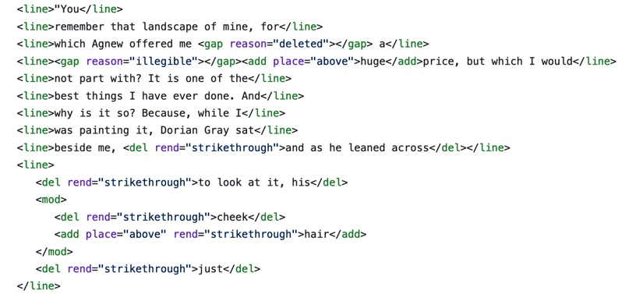

Figure 2: Text Encoding with TEI on the manuscript of *Dorian Gray*

Works Cited

Caughie, Pamela, et al. “Storm Clouds on the Horizon: Feminist Ontologies and the Problem of

[Gender,”](https://www.tandfonline.com/doi/full/10.1080/24692921.2018.1505819?src=recsys) *Feminist Modernist Studies*, 1:3, 230-242, 2018.

Drucker, Johanna. "Introduction," *SpecLab: Digital Aesthetics and Projects in Speculative Computing*. 2009.

Wilde, Oscar, and Michael Patrick Gillespie. *The Picture of Dorian Gray: Authoritative*

*Texts, Backgrounds, Reviews and Reactions, Criticism*. 2nd ed. ed., New York, W.W. Norton, 2007

Lawler, Donald L. *An Inquiry into Oscar Wilde's Revisions of the Picture of Dorian Gray.* New York,

Garland Pub, 1988.

Moretti, Franco. *Graphs, Maps, Trees: Abstract Models for Literary History*. 2007.

Wilde, Oscar. *The Picture of Dorian Gray: Original Manuscript*. 1889–90. MS. Morgan Library &

Museum, New York, NY.

Wilde, Oscar, and Joseph Bristow. *The Complete Works of Oscar Wilde.* Edited by Joseph

Bristow. Oxford, Oxford University Press, 2005.

Wilde, Oscar, and Nicholas Frankel. *The Picture of Dorian Gray: An Annotated, Uncensored Edition.*

Cambridge, Mass., Belknap Press of Harvard University Press, 2011.

Clark Materials

*The picture of Dorian Gray*. 1890. Typescript. 231 leaves. Bound in full gray French levant

morocco, gilt tooled. Original typescript with corrections and emendations in Wilde's hand. Also available on microfilm: CLC 566; Wilde 25-10. (box W6721M3, P611 [1890]).

*The picture of Dorian Gray*. Chapter III. 1890. MS. 23 leaves. Also available on microfilm: CLC

567; Wilde 25-9. (box 80, folder 5).

Oscar Wilde, Personal Correspondence, between 1889-91.

Reviews and Articles, Subseries 3.2, 1881-1997

News Coverage of Wilde's Trials, 1.5.3.

1. DH theorists take a range of stances on whether digital methods and tools facilitate more objective, or what Franco Moretti calls “falsifiable,” method of criticism, where graphs and other visualizations might answer questions about literary history and form, or a more “speculative” mode, championed by Johanna Drucker, who purposefully skews graphical metrics in order to reflect the ambiguity and partiality of the data they represent.