K-means 알고리즘 구현

2020.08.10 ~

1. **사용한 모듈**

import pandas as pd

from sklearn import datasets

from sklearn.cluster import KMeans

import matplotlib.pyplot as plt

import seaborn as sns

from sklearn.pipeline import make_pipeline

from sklearn.preprocessing import StandardScaler

import numpy as np

from mpl_toolkits.mplot3d import Axes3D

import pcl

KMeans 모듈 설명 및 사용법

class KMeans(TransformerMixin, ClusterMixin, BaseEstimator):

*"""K-Means clustering.*

*Read more in the :ref:`User Guide <k_means>`.*

*Parameters*

*----------*

*n_clusters : int, default=8*

*The number of clusters to form as well as the number of*

*centroids to generate.*

*init : {'k-means++', 'random', ndarray, callable}, default='k-means++'*

*Method for initialization:*

*'k-means++' : selects initial cluster centers for k-mean*

*clustering in a smart way to speed up convergence. See section*

*Notes in k_init for more details.*

*'random': choose `n_clusters` observations (rows) at random from data*

*for the initial centroids.*

*If an ndarray is passed, it should be of shape (n_clusters, n_features)*

*and gives the initial centers.*

*If a callable is passed, it should take arguments X, n_clusters and a*

*random state and return an initialization.*

*n_init : int, default=10*

*Number of time the k-means algorithm will be run with different*

*centroid seeds. The final results will be the best output of*

*n_init consecutive runs in terms of inertia.*

*max_iter : int, default=300*

*Maximum number of iterations of the k-means algorithm for a*

*single run.*

*tol : float, default=1e-4*

*Relative tolerance with regards to Frobenius norm of the difference*

*in the cluster centers of two consecutive iterations to declare*

*convergence.*

*It's not advised to set `tol=0` since convergence might never be*

*declared due to rounding errors. Use a very small number instead.*

*precompute_distances : {'auto', True, False}, default='auto'*

*Precompute distances (faster but takes more memory).*

*'auto' : do not precompute distances if n_samples * n_clusters > 12*

*million. This corresponds to about 100MB overhead per job using*

*double precision.*

*True : always precompute distances.*

*False : never precompute distances.*

*.. deprecated:: 0.23*

*'precompute_distances' was deprecated in version 0.22 and will be*

*removed in 0.25. It has no effect.*

*verbose : int, default=0*

*Verbosity mode.*

*random_state : int, RandomState instance, default=None*

*Determines random number generation for centroid initialization. Use*

*an int to make the randomness deterministic.*

*See :term:`Glossary <random_state>`.*

*copy_x : bool, default=True*

*When pre-computing distances it is more numerically accurate to center*

*the data first. If copy_x is True (default), then the original data is*

*not modified. If False, the original data is modified, and put back*

*before the function returns, but small numerical differences may be*

*introduced by subtracting and then adding the data mean. Note that if*

*the original data is not C-contiguous, a copy will be made even if*

*copy_x is False. If the original data is sparse, but not in CSR format,*

*a copy will be made even if copy_x is False.*

*n_jobs : int, default=None*

*The number of OpenMP threads to use for the computation. Parallelism is*

*sample-wise on the main cython loop which assigns each sample to its*

*closest center.*

*``None`` or ``-1`` means using all processors.*

*.. deprecated:: 0.23*

*``n_jobs`` was deprecated in version 0.23 and will be removed in*

*0.25.*

*algorithm : {"auto", "full", "elkan"}, default="auto"*

*K-means algorithm to use. The classical EM-style algorithm is "full".*

*The "elkan" variation is more efficient on data with well-defined*

*clusters, by using the triangle inequality. However it's more memory*

*intensive due to the allocation of an extra array of shape*

*(n_samples, n_clusters).*

*For now "auto" (kept for backward compatibiliy) chooses "elkan" but it*

*might change in the future for a better heuristic.*

*.. versionchanged:: 0.18*

*Added Elkan algorithm*

*Attributes*

*----------*

*cluster_centers_ : ndarray of shape (n_clusters, n_features)*

*Coordinates of cluster centers. If the algorithm stops before fully*

*converging (see ``tol`` and ``max_iter``), these will not be*

*consistent with ``labels_``.*

*labels_ : ndarray of shape (n_samples,)*

*Labels of each point*

*inertia_ : float*

*Sum of squared distances of samples to their closest cluster center.*

*n_iter_ : int*

*Number of iterations run.*

*See also*

*--------*

*MiniBatchKMeans*

*Alternative online implementation that does incremental updates*

*of the centers positions using mini-batches.*

*For large scale learning (say n_samples > 10k) MiniBatchKMeans is*

*probably much faster than the default batch implementation.*

*Notes*

*-----*

*The k-means problem is solved using either Lloyd's or Elkan's algorithm.*

*The average complexity is given by O(k n T), were n is the number of*

*samples and T is the number of iteration.*

*The worst case complexity is given by O(n^(k+2/p)) with*

*n = n_samples, p = n_features. (D. Arthur and S. Vassilvitskii,*

*'How slow is the k-means method?' SoCG2006)*

*In practice, the k-means algorithm is very fast (one of the fastest*

*clustering algorithms available), but it falls in local minima. That's why*

*it can be useful to restart it several times.*

*If the algorithm stops before fully converging (because of ``tol`` or*

*``max_iter``), ``labels_`` and ``cluster_centers_`` will not be consistent,*

*i.e. the ``cluster_centers_`` will not be the means of the points in each*

*cluster. Also, the estimator will reassign ``labels_`` after the last*

*iteration to make ``labels_`` consistent with ``predict`` on the training*

*set.*

*Examples*

*--------*

*>>> from sklearn.cluster import KMeans*

*>>> import numpy as np*

*>>> X = np.array([[1, 2], [1, 4], [1, 0],*

*... [10, 2], [10, 4], [10, 0]])*

*>>> kmeans = KMeans(n_clusters=2, random_state=0).fit(X)*

*>>> kmeans.labels_*

*array([1, 1, 1, 0, 0, 0], dtype=int32)*

*>>> kmeans.predict([[0, 0], [12, 3]])*

*array([1, 0], dtype=int32)*

*>>> kmeans.cluster_centers_*

*array([[10., 2.],*

*[ 1., 2.]])*

*"""*

2. **구현 과정**

pcl.load로 data.pcd 파일 로드 후 로드한 데이터를 쉽게 연산하기 위해 Numpy 형으로 변환 시켜준다.

pc = pcl.load("data2.pcd") # "pc.from_file" Deprecated

pc_array = pc.to_array() # pc to Numpy

Numpy로 변환된 pc_array를 pandas의 DataFrame에 넣어 준 후 X,Y,Z의 colum을 붙여준다.

data = pd.DataFrame(pc_array)

data.columns=['X','Y','Z']

print(data)

## Inertia value를 이용한 적정 군집수 판단

K Means를 수행하기전에 k개의 클러스터 개수를 정해줘야 한다. 그렇다면 몇 개의 클러스터의 수가 가장 적절할지 결정할 필요가 있다. 여기서 Inertia value 라는 값을 보면 적정 클러스터 수를 선택할 수 있는 기준을 얻을 수 있는데 Inertia value는 군집화가된 후에, 각 중심점에서 군집의 데이타간의 거리를 합산을 하여 군집의 응집도를 나타내는 값이다, 이 값이 작을 수록 응집도가 높게 군집화가 잘되었다고 평가할 수 있다.

inertia value는 KMeans 모델이 학습된 후에, model.inertia_ 값으로 볼 수 있다.

다음은 iris 데이타를 가지고 1~k개의 클러스터로 클러스터링을 했을때, 각 클러스터 개수별로 inertia value를 출력해 볼 수 있다.

# we can find appropriate the number of clusters with Inertia

k_Num = int(input())

ks = range(1, 5) # range denpend on k's number

inertias = []

for k in ks:

model = KMeans(n_clusters=k)

model.fit(data)

inertias.append(model.inertia_)

# Plot ks vs inertias

plt.plot(ks, inertias, '-o')

plt.xlabel('number of clusters, k')

plt.ylabel('inertia')

plt.xticks(ks)

plt.show()

군집화 모델을 만들고 예측하는 부분

# create model and prediction

model = KMeans(n_clusters=3,algorithm='auto')

model.fit(data)

predict = pd.DataFrame(model.predict(data))

predict.columns=['predict']

# concatenate labels to df as a new column

r = pd.concat([data,predict],axis=1)

print(r)

2D plot과 3D plot으로 PCD 데이터와 군집화 CENTROID 표시

# Clustering data visualization

#2D plot

plt.scatter(r['X'], r['Y'], r['Z'], c=r['predict'], alpha=0.5)

# 3d plot

fig = plt.figure(figsize=(10, 5))

ax = fig.add_subplot(111, projection='3d') # Axe3D object

ax.scatter(r['X'], r['Y'], r['Z'], c=r['predict'], alpha=0.5)

centers = pd.DataFrame(model.cluster_centers_,columns=['X','Y','Z'])

center_x = centers['X']

center_y = centers['Y']

center_z = centers['Z']

# if you want to see 2D centroid plot, delete below '#'

# plt.scatter(center_x,center_y,center_z, marker='D',c='b')

# if you want to see 3D centroid plot

ax.scatter(center_x,center_y,center_z,s=50, marker='D',c='r')

plt.show()

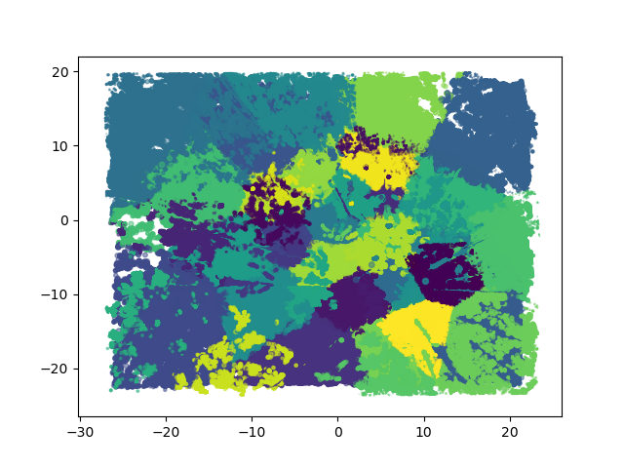

**일부 test 데이터를 뽑아 적용 했을때**

**2d**

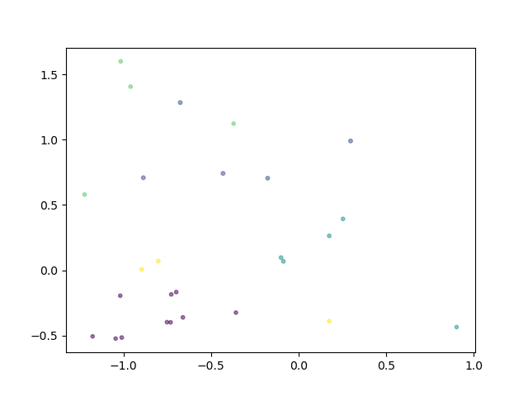

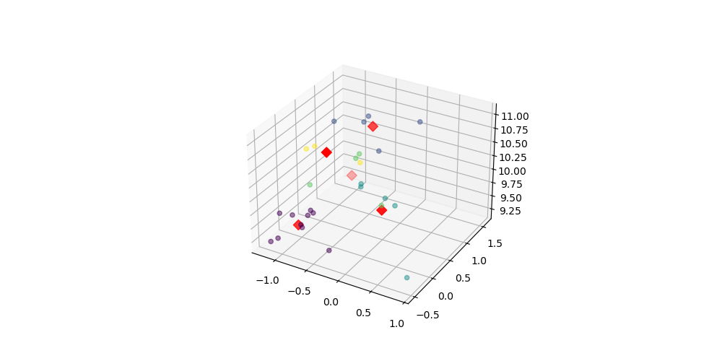**3d**

**k를 50이라 가정하고 군집화를 했을때의 2D plot**



**사양 문제인지 모르겠으나 3d plot 오류 – 2020.08.14**

/home/gofmsldks/anaconda3/lib/python3.6/site-packages/matplotlib/collections.py:922: RuntimeWarning: invalid value encountered in sqrt

scale = np.sqrt(self._sizes) * dpi / 72.0 * self._factor

Traceback (most recent call last):

File "/home/gofmsldks/anaconda3/lib/python3.6/site-packages/matplotlib/backends/backend_qt5.py", line 480, in _draw_idle

self.draw()

File "/home/gofmsldks/anaconda3/lib/python3.6/site-packages/matplotlib/backends/backend_agg.py", line 407, in draw

self.figure.draw(self.renderer)

File "/home/gofmsldks/anaconda3/lib/python3.6/site-packages/matplotlib/artist.py", line 41, in draw_wrapper

return draw(artist, renderer, *args, **kwargs)

File "/home/gofmsldks/anaconda3/lib/python3.6/site-packages/matplotlib/figure.py", line 1864, in draw

renderer, self, artists, self.suppressComposite)

File "/home/gofmsldks/anaconda3/lib/python3.6/site-packages/matplotlib/image.py", line 132, in _draw_list_compositing_images

a.draw(renderer)

File "/home/gofmsldks/anaconda3/lib/python3.6/site-packages/matplotlib/artist.py", line 41, in draw_wrapper

return draw(artist, renderer, *args, **kwargs)

File "/home/gofmsldks/anaconda3/lib/python3.6/site-packages/mpl_toolkits/mplot3d/axes3d.py", line 447, in draw

reverse=True)):

File "/home/gofmsldks/anaconda3/lib/python3.6/site-packages/mpl_toolkits/mplot3d/axes3d.py", line 446, in <lambda>

key=lambda col: col.do_3d_projection(renderer),

File "/home/gofmsldks/anaconda3/lib/python3.6/site-packages/mpl_toolkits/mplot3d/art3d.py", line 511, in do_3d_projection

fcs = mcolors.to_rgba_array(fcs, self._alpha)

File "/home/gofmsldks/anaconda3/lib/python3.6/site-packages/matplotlib/colors.py", line 301, in to_rgba_array

result = c.copy()

MemoryError: Unable to allocate 749. MiB for an array with shape (24539700, 4) and data type float64

Process finished with exit code 130 (interrupted by signal 2: SIGINT)

사양 문제인지 모르겠으나 3d plot 오류 – 2020.08.14

참고: <https://bcho.tistory.com/1203> [조대협의 블로그]