
http://www.tupian114.com/download/11908779.html


http://www.tupian114.com/psd_12143293.html


https://www.caipuce.com/139/

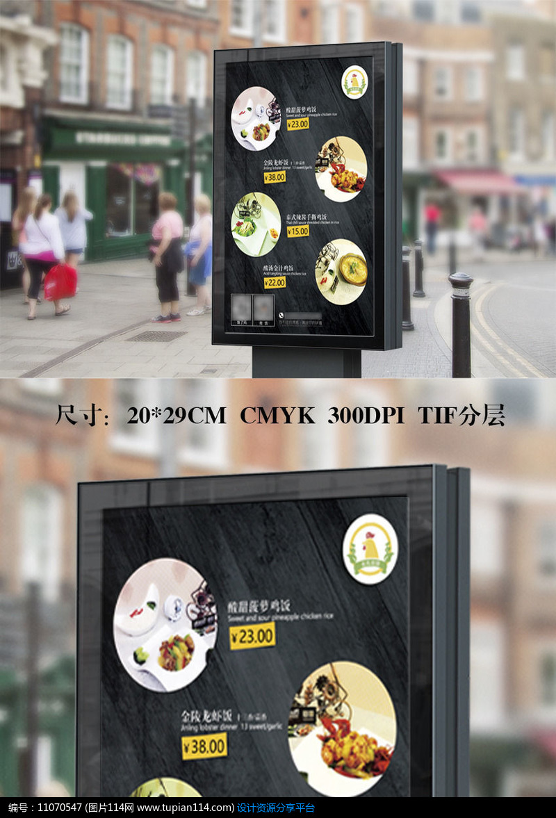
http://www.tupian114.com/psd_11070547.html

