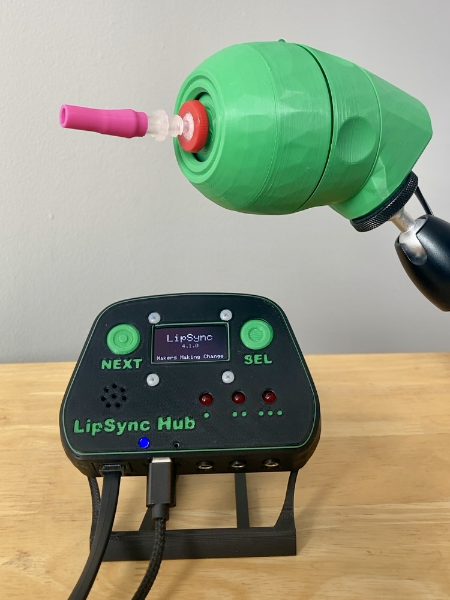

LipSync User Guide
V4.1 – March 2025

Table of Contents
Introduction 4
Features 4
Joystick Features 5
Hub Features 6
Specifications 7
LipSync Compatibility 7
Setting Up the LipSync 8
1. Mount the LipSync Joystick 8
2. Mount the LipSync Hub 10
3. Connect the LipSync Joystick to the LipSync Hub 11
4. Optional: Connect Assistive Switches to the LipSync Hub 12
Connecting the LipSync Hub to the Host Device 12
Powering the Device 13
Changing the Operating Mode 14
Connecting in USB Mouse Mode 15
Connecting in Wireless Mouse Mode 17
Connecting in USB Gamepad Mode 19
Setting Up Host Device 20
Enable On-Screen Controls 20
Operating the LipSync 22
How to Perform LipSync Inputs 22
USB & Wireless Mouse Mode 23
USB Gamepad Mode 25
Input and Feedback Summary 27
The Hub Menu 30
Accessing the Hub Menu 30
Navigating the Hub Menu 30
Hub Menu Options 31
Adjusting the LipSync 34
Center Reset 34
Full Calibration 35
Changing LipSync Settings 36
Maintenance 41
Replacing the Mouthpiece 41
Cleaning the LipSync 42
Frequently Asked Questions 42
Troubleshooting 42
Error Codes 44
Contacting Support 45
References 45
Appendix A: Serial Interface (Application Programming Interface) 46
Serial Interface Setup 46
Sending Commands 46
API Format LipSync 4.1 Command List 47


Introduction
Figure 1. QuickStart Guide QR Code
The LipSync is a mouth-operated sip-and-puff joystick that can emulate a mouse, wireless mouse, or gamepad to control a computer, gaming console, smart phone, or tablet. The joystick can be moved with the mouth to move a cursor or control a joystick. By sipping and puffing on the joystick mouthpiece, clicks and buttons presses can be entered.
A shorter QuickStart Guide is available on GitHub.

Features
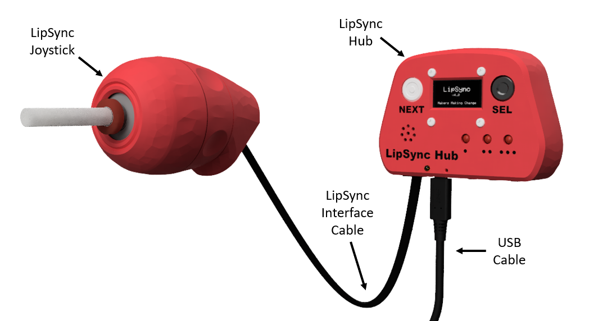
LipSync Joystick: The LipSync Joystick is the interface for the primary user. It measures the movement of the mouthpiece and the pressure of sips and puffs applied to the mouthpiece.
LipSync Hub: The LipSync Hub provides user feedback through a graphical display, LEDs, and a speaker. It also has two built in buttons and provides the connection to the host device and up to three external assistive switches.
LipSync Interface Cable: The LipSync Interface Cable is an RJ11 phone cable used to connect the LipSync Joystick to the LipSync Hub.
USB Cable: The USB Cable is used to supply power to the LipSync and in some cases, act as the primary connection to the host device. The side of the cable going to the Hub must be USB-C.

Joystick Features
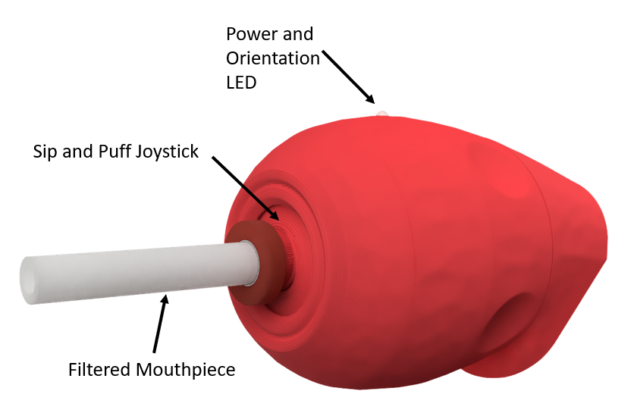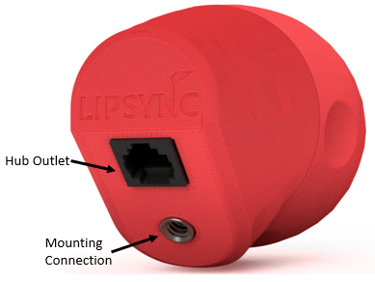
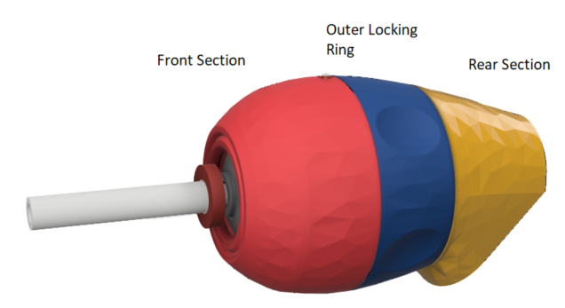
Sip and Puff Joystick: Measures the movement of and pressure applied to the mouthpiece
Filtered Mouthpiece: The mouthpiece is a consumable part that uses a hydrophobic filter to protect the interior pressure sensor. It threads on to the Sip and Puff Joystick.
Power and Orientation LED: The Power and Orientation LED signifies that the joystick is plugged into the Hub when powered and is also used to properly orient the joystick. The LED is on the very top middle on the joystick.
Rotatable Mounting: The Mounting Angle of the LipSync can be adjusted by loosening the Outer Locking Ring, rotating the Front Section, and retightening the Outer Locking Ring.
Hub Port: The Joystick plugs into the Hub using the LipSync Interface Cable.
Mounting Connection: The joystick can be mounted using the ¼-20 (standard camera mount) threads on the rear section.

Hub Features
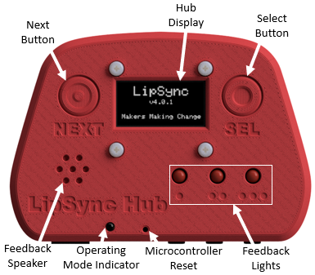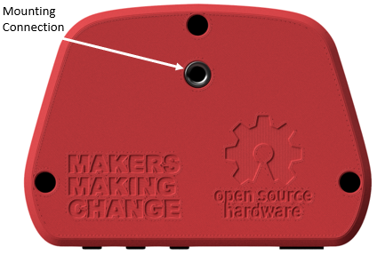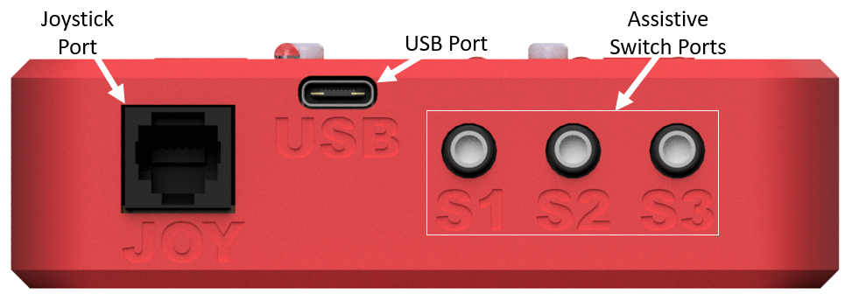
Hub Display: The Hub Display allows the users to make quick adjustments to device settings, calibrate the joystick, and change the operating mode. It also displays mode and version information upon start-up.
Next & Select Buttons: The Next and Select Buttons on the Hub allows a support person to access the Hub Menu without the need to use sip and puff, or the assistive switch ports.
Feedback Speaker: The Feedback Speaker gives auditory feedback through beeping tones. The sound can be turned on or off through the Hub Menu.
Feedback Lights: The Feedback Lights give visual feedback through flashing on input durations. Each light represents a specific set of inputs.
Operating Mode Indicator: The Operating Mode Indicator is used to show whether the device is in USB Mouse, Wireless Mouse, or USB Gamepad mode.
Microcontroller Reset: The Microcontroller Reset hole allows access to the reset pin on the microcontroller using a paperclip or similar sized object.
Mounting Connection: The Hub can be mounted in view beside the host device screen so that it is easy to see/hear the feedback and read the Menu Screen when adjusting settings. The ¼-20 threads are the same as a standard camera mount.
Joystick Port: The LipSync Joystick plugs into this port using the LipSync Interface Cable.
USB Port: This port provides the device with power and can also be the direct connection to the host device.
Assistive Switch Ports: Up to 3 assistive switches with 3.5 mm audio plugs can be connected to the LipSync Hub. By default, these external switches can be used in place of the Sip and Puff controls.

Specifications
Specification | Value
Joystick Size (Length x Width x Height) [mm] | 170 mm x 53 mm x 66 mm
Hub Size (Length x Width x Height) [mm] | 104 mm x 29 mm x 72 mm
Joystick Mass | 123 g
Hub Mass | 90 g
Power Consumption | ~0.1 W (20mA @ 5 V)
Joystick Angular Range | ± 10°
Joystick Movement Range | ± 10 mm (using standard mouthpiece)
Operating Force | ~30 grams-force

Operating System |  | Compatibility per Mode
 |  | USB Mouse | Wireless Mouse | USB Gamepad
Phone/Tablet | Android | ¹ |  | ¹
Phone/Tablet | iOS²
Phone/Tablet | iPadOS
Phone/Tablet | Windows
Desktop | macOS
Desktop | Linux
Desktop | Windows
¹ Only with devices with USB OTG HID (Universal Serial Bus On-The-Go Human Interfere Device)
² Only for iOS13+ and iPadOS.

LipSync Compatibility
The LipSync is compatible with host devices that support a USB Mouse, a Bluetooth Mouse, or a USB-HID Gamepad. This includes Windows, macOS and Linux computers, most Android and Windows phones and tablets, and Apple iOS phones and tablets with iOS13 and iPadOS. Not all mobile phones and tablets support external pointing devices like the LipSync or other mouse replacements. Check with the manufacturer before purchasing. Look to see if your device supports “USB OTG HID” or “Universal Serial Bus On-the-Go Human Interface Device” profile.

Setting Up the LipSync
This section outlines the necessary steps to setup the LipSync. First, the LipSync Joystick and the LipSync Hub need to be positioned and mounted appropriately. Next, the Joystick must be connected to the Hub using the LipSync Interface Cable. Assistive Switches are then connected to the Hub if desired. Once these steps are complete, the LipSync is ready to connect to a Host Device. The following sections expand on each of these steps in more detail.
- Mount the LipSync Joystick
- Mount the LipSync Hub
- Connect the LipSync Joystick to the LipSync Hub
- Optional: Connect Assistive Switches to the LipSync Hub

Mount the LipSync Joystick
The LipSync Joystick should be mounted securely in front of the user’s face in a way that minimally obstructs their field of view. The mouthpiece should be within reach of the user’s mouth.
Warning: The LipSync Joystick contains 3 rare earth magnets. Do not mount the joystick within 6 inches of any implanted medical devices, such as pacemakers. [1]
The LipSync Joystick has a female ¼”-20 UNC threaded mounting connection. This type of connection is compatible with a variety of commercially available and DIY mounting systems and is the standard for most camera mounting gear. This threaded connection is compatible with the Magic Arm, RAM, and Loc-Line mounting systems.
The LipSync Joystick also has a rotatable mounting connection, so the threaded connection and interface cable can be directed in whichever way works best for the user. The “Up” position of the joystick should be rotated so that it matches the “Up” direction of the host device. Once mounted, the mounting angle of the LipSync Joystick can be adjusted by loosening the Outer Locking Ring, rotating the Front Section, and retightening the Outer Locking Ring.
Once a suitable mounting solution is selected, the following are the general steps to mount the LipSync Joystick:
- Attach the LipSync Joystick to the end of your mounting arm using the ¼-20 threads and any necessary adapters. | 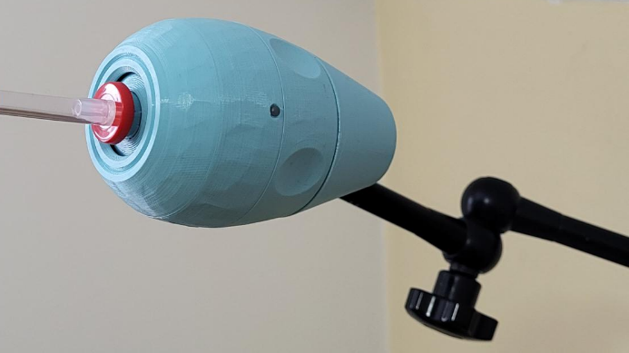
- Move your mounting arm to position the joystick as desired. The orientation of the Joystick in this step does not matter except that the overall device is positioned as the user prefers.

- Keeping the LipSync Joystick mounted in place, unscrew the Outer Locking Ring of the joystick by up to half a turn, or until the front section of the joystick can rotate freely against the fixed and mounted rear section. | 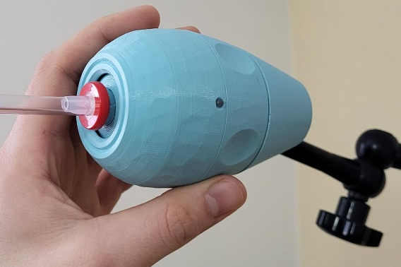
- Turn the front section of the joystick so that the Power Indicator LED points directly upwards. | 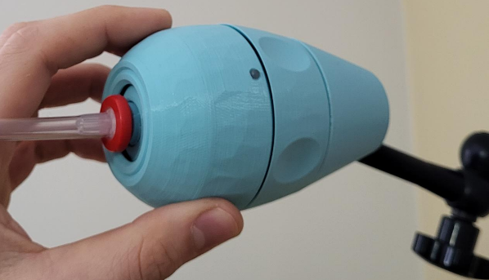  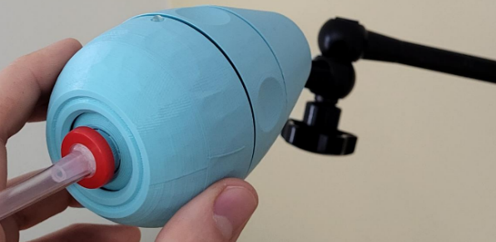
- Holding the front section in place, tighten the outer locking ring again until the front section is locked in place.  Note: This step will require two hands. | 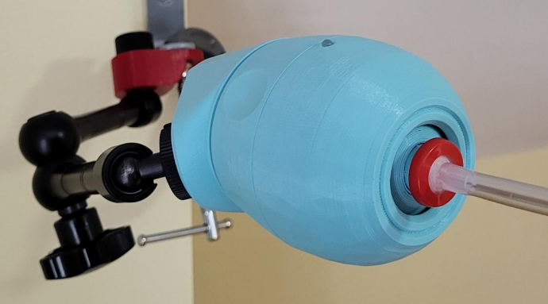

Mount the LipSync Hub
The LipSync Hub should be mounted or placed in a location within view of the user. Ideally the LipSync Hub is located within 1 m of the user, near the host device screen. Like the Joystick, the LipSync Hub has a female ¼”-20 UNC threaded mounting connection on the back side of the device.
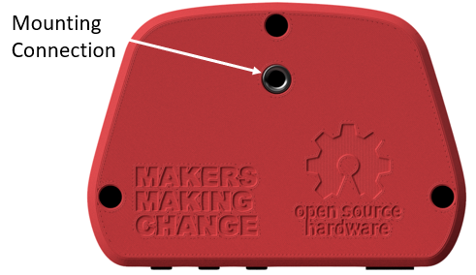

Using a mounting arm
- Position your mounting arm so it does not interfere with your view of the screen so that the ¼-20 threaded end sits where you want to mount the Hub.
- Connect the Hub to the Mounting Arm using the ¼-20 threads.
- Adjust your mounting arm as needed to position the Hub specifically where you want it to be.
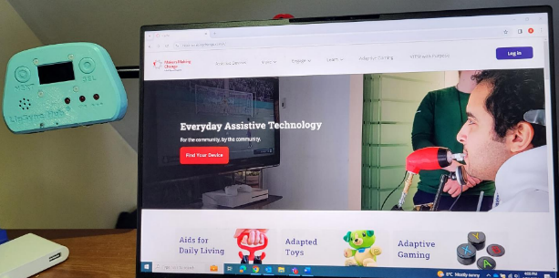

Mounted on a desk or table
- Clear a space for the Hub to sit on the desk near the monitor. The Hub can rest on the back surface or can be connected to an optional desktop stand.
- If using, mount the Hub in the stand with a ¼-20 bolt.
- Place the Hub in the cleared off spot.
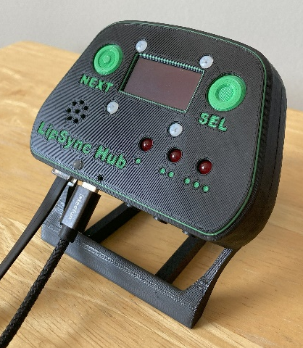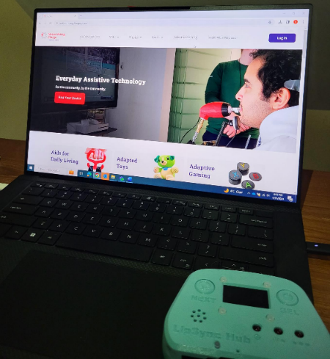

Connect the LipSync Joystick to the LipSync Hub
The LipSync Joystick must be connected to the LipSync Hub using the LipSync Interface Cable. Attach one end of the cable to the Hub Port on the LipSync Joystick. Attach the other end of the cable to the Joystick Port on the LipSync Hub, which is labelled “JOY”. Ensure the cable is routed and secured appropriately to keep it from getting snagged or damaged.
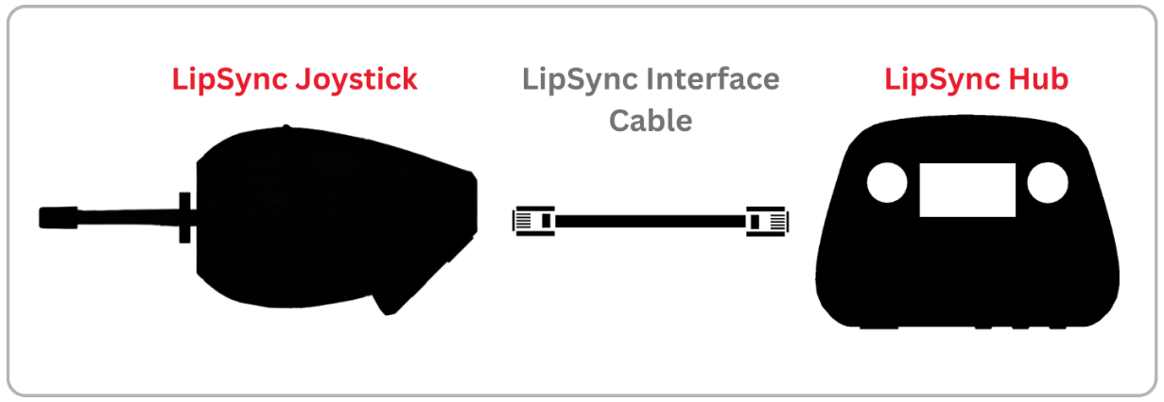
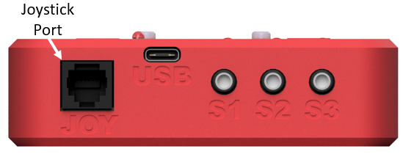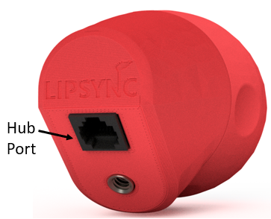
Ensure you plug in the LipSync Interface Cable in the correct orientation. The tab side of the plug inserts into the narrower side of the outlet.
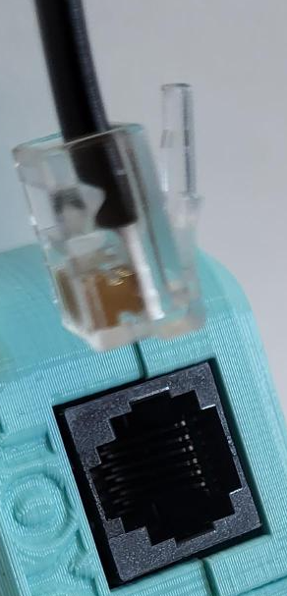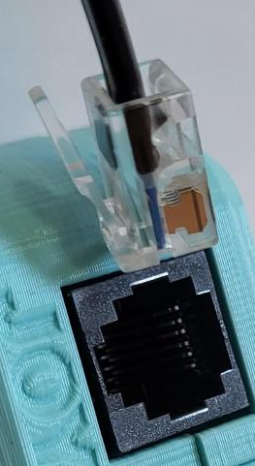
If the cable is damaged or a different length is required, the LipSync Interface Cable is a 4 conductor RJ11 phone cable.

Optional: Connect Assistive Switches to the LipSync Hub
The LipSync Hub has three 3.5 mm ports for connecting external assistive switches. The three ports are labelled S1, S2, and S3. You can plug a switch into any combination of, or all the assistive switch ports as needed.
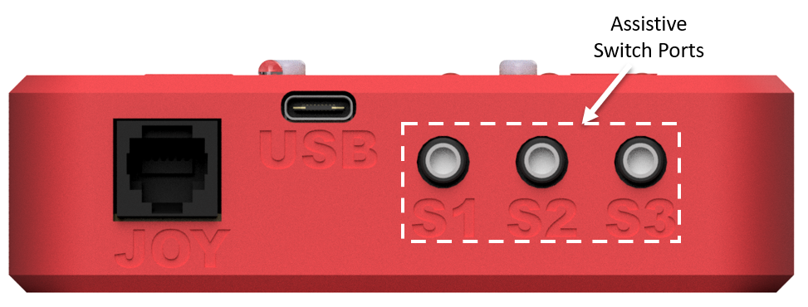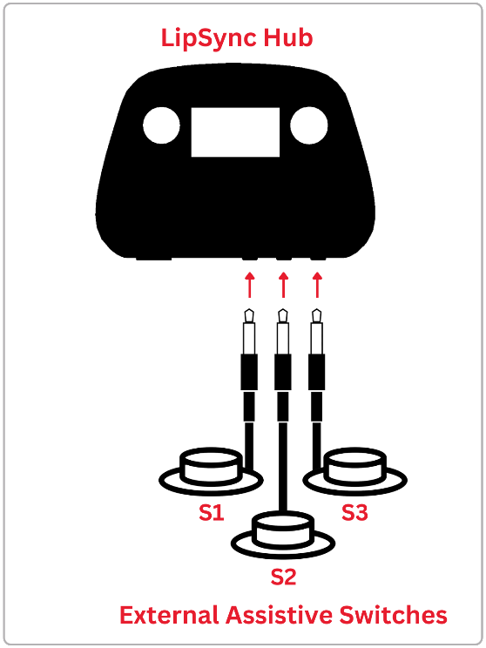
By default, an assistive switch attached to S1 will do puff inputs and an assistive switch attached to S3 will do sip inputs. These inputs can be used as an alternative input method if a user is unable to use sip or puff inputs effectively through the mouthpiece. A full summary of the Assistive Switch mapping is available in the Assistive Switch Inputs section.
After completing these steps, the LipSync is now ready to connect to the Host Device which is outlined in the next section.

Connecting the LipSync Hub to the Host Device
The Host Device is the computer, tablet, laptop, smartphone, or other device that the user wants to control with the LipSync. How the LipSync is connected will depend on the type of Host Device and whether the LipSync is intended to operate as a USB Mouse, USB Gamepad, or Wireless Bluetooth Mouse.
The LipSync requires both a communication connection and a power connection.
To connect to the Host Device, you must first ensure that the device is powered, then check what mode it is in and change through the menu if required.

Powering the Device
The LipSync requires an external power source. Users can draw power from the host device (except on iOS devices) or use a USB power bank via the USB port on the Hub. The LipSync is provided with a USB-C to USB-A cable. Depending on the host device and operating mode, a suitable adapter or USB-C to a specific USB plug type cable may be required.
The general set-up will look like the following for any operating mode, where the required connection or adapter will vary depending on how you want to connect the device. When in Wireless mode, the LipSync can be connected directly to any power source.
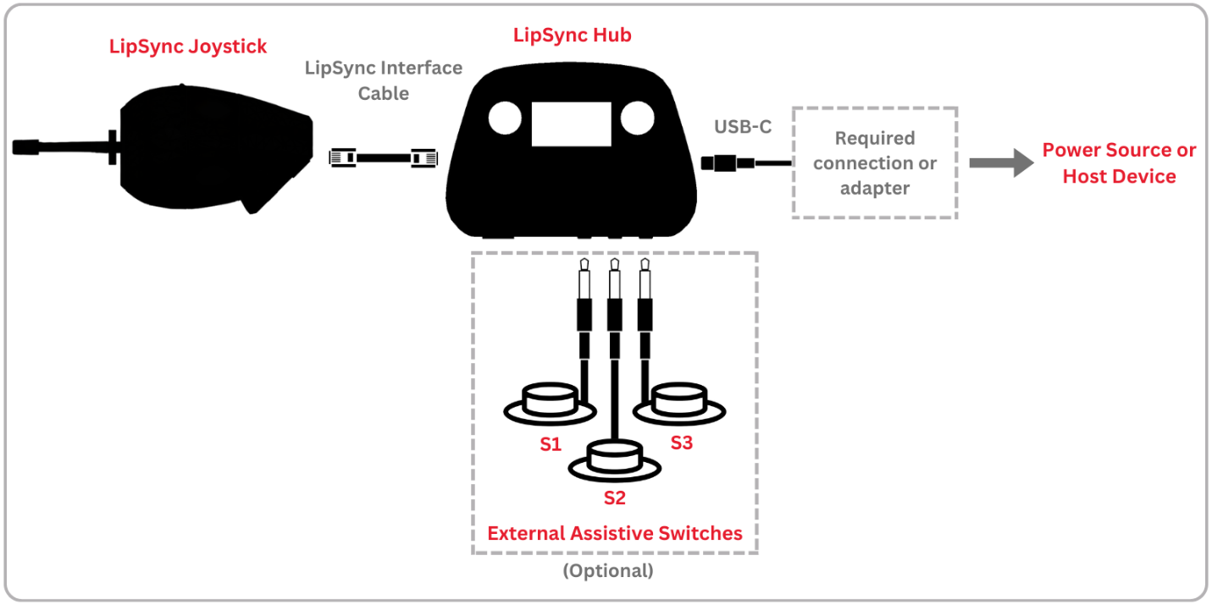
See the below table for compatible power connection types for common host devices.
Common Host Devices | Power Connections |  | Common Cables for Direct Connection to Host Device | Common Adapters for Splitting to External Power
Common Host Devices | Direct to Host Device | Using External Power Source | Common Cables for Direct Connection to Host Device | Common Adapters for Splitting to External Power
Windows PC |  |  | USB-C to USB-C | Male USB 2 to Dual Female USB 2 Splitter
Windows PC |  |  | USB-A to USB-C | Male USB 2 to Dual Female USB 2 Splitter
Mac |  |  | USB-C to USB-C | USB-C Splitter
Android Phone/Tablet |  |  | USB-C to USB-C | USB-C Splitter
Android Phone/Tablet |  |  | USB-C to USB-B Micro | Male USB-B Micro to Dual Female USB 2 Splitter
Apple Phone/Tablet |  |  | USB-C to Lightning | Lightning to USB 3 Adapter
Apple Phone/Tablet |  |  | USB-C to USB-C | USB-C Splitter
More detailed instructions for how to connect the LipSync to various host devices in different modes are found below.
Once the LipSync is connected to power, it will turn on automatically. The Hub will emit a start-up tone and the Hub Display will show the current code version and the current operating mode. The Joystick must be plugged into the Hub for the device to fully power on.

Changing the Operating Mode
The LipSync can operate in three modes: USB Mouse, Wireless Bluetooth Mouse, and USB Gamepad. The current operating mode is indicated on the display on startup and by the color of the Operating Mode Indicator. The default operating mode is USB Mouse.
Operating Mode | Operating Mode Indicator
USB Mouse | Purple
Wireless Mouse | Blue (Solid = connected, flashing = searching)
USB Gamepad | Yellow
The operating mode can be changed using the Hub Menu. For an explanation on how to perform the given inputs, see the section How to Perform LipSync Inputs.
Activating and navigating the Hub menu can be done using Sip and Puff, Hub Buttons or Assistive Switches according to the following table:
Output | Input
Output | Sip / Puff | Assistive Switch | Hub Buttons
Enter/Exit menu | Puff – very long  (>3 seconds) | S1 very long press  (>3 seconds) | Select very long press (>3 seconds)
Enter/Exit Menu | N/A | Simultaneous Press of S1 and S3 | Simultaneous Press of Next and Sel
“Next” – goes to next option | Sip | S3 | Next
“Select” – Selects the current option | Puff | S1 | Sel

Connecting in USB Mouse Mode
Using the Hub Menu, ensure you are in USB Mouse mode. This is the default setting when the device is first programmed. When in USB Mouse mode, the operating mode indicator will turn purple.

Plugging Direct into a Computer or Laptop
If you have the appropriate cable, the LipSync can be directly plugged into the device’s USB port to work in USB Mouse or Gamepad mode. The Hub port requires a USB-C plug, and most host devices will require either USB-A or USB-C plug types.
The order in which you connect the USB cables may affect how the LipSync works. Connect the cables in the following order:
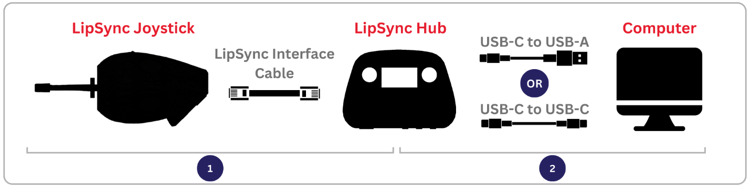
- Connect the LipSync Interface Cable to the LipSync Joystick and LipSync Hub.
- Connect a cable with a USB-C connection to the LipSync Hub, and the other end (either USB-C or USB-A) to the host device.
- Wait 3 seconds for the LipSync to initialize. Initialization is complete when the Hub Display reads “Ready for use”.

Plugging Direct into an Android Mobile Device
The LipSync can be directly plugged into the device’s USB port to work in USB Mouse or Gamepad mode using the appropriate cable and/or adapter. The Hub port requires a USB C plug, and most host devices will require either USB-C, USB-B Micro, or USB-A plug types.
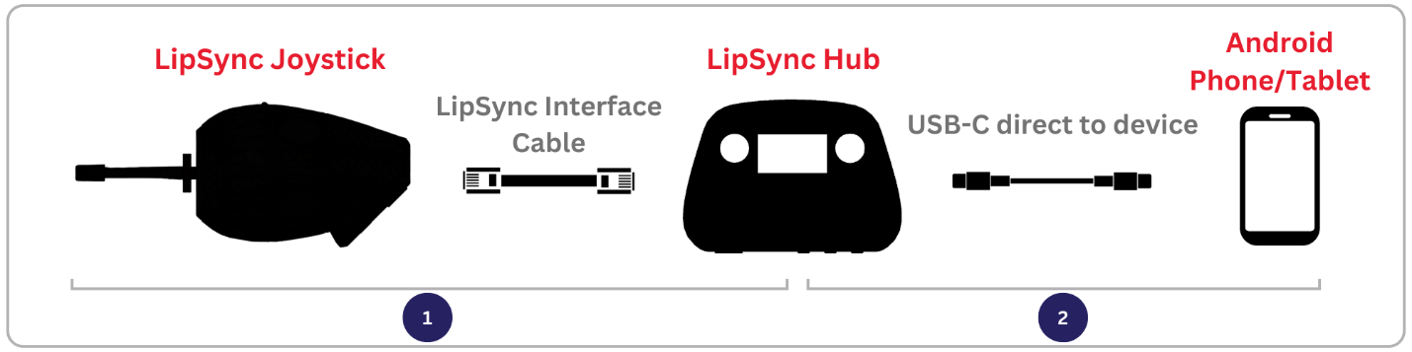
- Connect the LipSync Interface Cable to the LipSync Joystick and LipSync Hub.
- Connect a cable with a USB-C connection to the LipSync Hub, and the other end (depending on the device) to the host device.
- Wait 3 seconds for the LipSync to initialize. Initialization is complete when the Hub Display reads “Ready for use”.

Plugging into an iOS or Android Mobile Device with an External Power Source
The LipSync cannot draw power from an iOS device, and therefore must have a powered USB hub or powered USB splitter to connect between the LipSync Hub and iOS device. For an Android mobile device (phone or tablet), using an external power source is optional, but can extend the battery life of your device.
The order in which you connect the USB cables may affect how the LipSync works. Connect the cables in the following order if using an external power source:
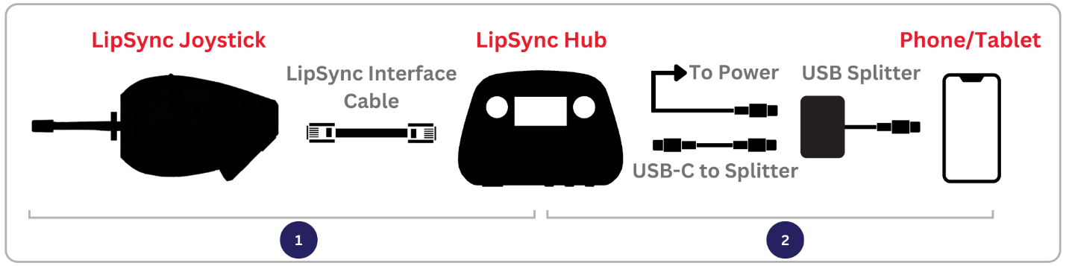
- Connect the LipSync Interface Cable to the LipSync Joystick and LipSync Hub.
- Connect a USB-C cable to the LipSync Hub, and plug the other end into a USB Splitter or Powered Adapter. Connect the USB Splitter to power with the required cable.
- Connect the other end of the splitter/adapter into the host device (USB-C or USB-B micro).
- Wait 3 seconds for the LipSync to initialize. Initialization is complete when the Hub Display reads “Ready for use”.
Note that to use the LipSync with an iOS device, the device must have AssistiveTouch within the Accessibility Settings turned on. Instructions for how to set this up are in the Setting Up Host Device section.

Connecting in Wireless Mouse Mode
Using the LipSync as a Wireless Bluetooth Mouse requires a Bluetooth-compatible Host Device and an external power source. In Wireless Mouse Mode, the LipSync can be paired by a different host device, a USB Power Bank, or a USB wall power adapter.
The LipSync will need to be initially paired with the Host Device using the Host Device interface, which will likely require additional assistance. Once the LipSync is paired to a Host Device, it will automatically reconnect if the power is turned off and on again.
Use the following steps to connect in Wireless Mouse Mode:
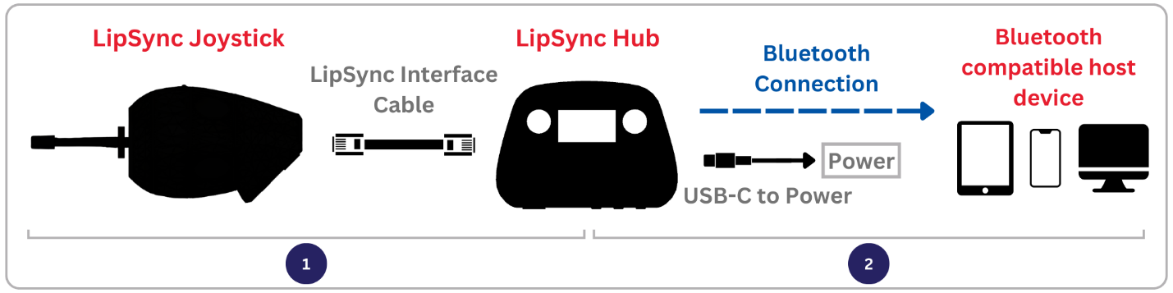
- Connect the LipSync Interface Cable to the LipSync Joystick and LipSync Hub.
- Connect the LipSync Hub to a power source through the USB-C cable.
- Wait 3 seconds for the LipSync to initialize. Initialization is complete when the Hub Display screen reads “Ready for use”.
- If necessary, activate the Hub Menu and change the operating mode to BT Mouse mode.

Pairing the LipSync to a Bluetooth-Compatible Host Device
When the LipSync is in Wireless Mouse mode, it will automatically advertise itself as “LS_<Device-ID>”. The Device-ID is a sequence of 8 alphanumeric characters that are specific to each LipSync. You can determine the Device ID of your LipSync in the Info Menu. The Operating Mode Indicator on the Hub will flash blue indicating it is ready to pair.
On the host device:
- Confirm that Bluetooth is activated.
- Navigate to Settings > Bluetooth
- Tap on LS_<Device-ID> to pair (where <device-ID> is a set of characters unique to each LipSync).
- A Connected message will show beside the device name when it successfully connects.

Once paired, the indicator will remain a solid blue.

Note that when pairing with an iOS device, the device must have AssistiveTouch within the Accessibility Settings turned on to use the paired LipSync. Instructions for this are in the Setting Up Host Device Section.

Reconnecting the LipSync to a Bluetooth-Compatible Host Device
If the LipSync is powered off, it will automatically reconnect to the previously paired Bluetooth Host Device when the LipSync is powered on again.

Disconnecting the LipSync from a Bluetooth-Compatible Host Device
If you no longer wish to use the LipSync with a particular device, you will need to disconnect the LipSync using the Bluetooth settings on the Bluetooth Compatible Host Device.

Connecting in USB Gamepad Mode
Gamepad mode is available through USB connection only and is compatible with any device that supports USB-HID connection. The LipSync Hub can be connected directly to a Computer, Laptop, or Android device in the same way as in USB Mouse Mode.
Using the menus through the Hub Display, ensure you are in Gamepad mode. USB Mouse mode is the default setting when the device is first programmed. When in Gamepad mode, the operating mode indicator will turn yellow.
When connecting to the Xbox Adaptive Controller (XAC), the XAC must be connected and paired with a device for the LipSync to receive power and function. The LipSync Hub can be plugged into either the left or right USB Joystick inputs. The following table links to resources for using the XAC and configuring controllers in Steam, a gaming platform.
QR Code | Resource
 | Adaptors for XAC compatibility with other systems.
 | Guide for remapping LipSync inputs with the XAC.
 | Guide for configuring a controller in Steam.

Setting Up Host Device
There may be settings on the host device that enable the LipSync to be used more easily and/or more effectively.
Enable On-Screen Controls – Enables access to functions that usually require physical access to the device.
Enable On-Screen Keyboard – Provide a keyboard for inputting characters.
Adjust Host Device Cursor Size – Increasing cursor size can make it easier to see.
Adjust Host Device Cursor Speed – The cursor speed is adjustable on some devices. The cursor speed can also be adjusted separately on the LipSync.
Adjust Host Device Double Click Speed – Increasing the allowable delay between clicks may make it easier to input a double click.

Enable On-Screen Controls
The assistant menu is a floating onscreen menu that allows access to important functions that cannot be accessed without physically touching the device, like the home button, back, zoom in and out, screen capture, volume, and restart.
On Android devices, turn on the Assistant Menu/ Accessibility Menu by going to Setting → Accessibility → Dexterity and Interaction → Assistant Menu
On iOS devices, turn on AssistiveTouch by going to Settings → Accessibility → Touch → AssistiveTouch
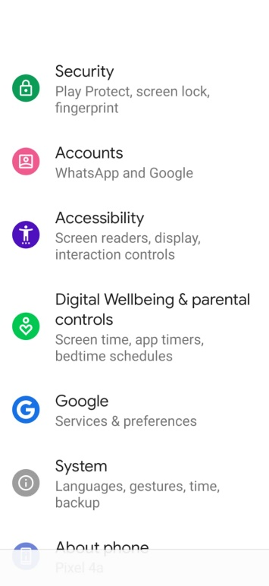
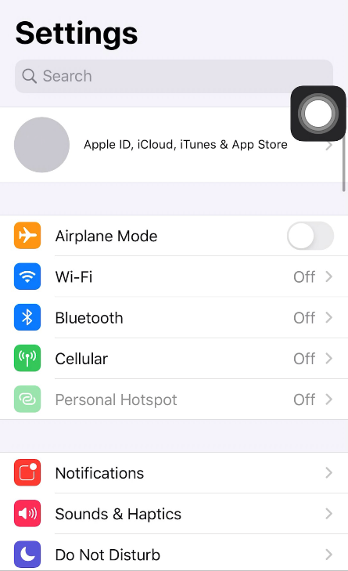

Android device
iOS device
On some devices, a swiping action is required to unlock it. This can be avoided by turning off screen lock. Alternatively, applications such as Keep Screen On can be downloaded from the Android Play store to prevent the phone from going to sleep. However, this will drain your phone battery faster.
QR Code | Resource
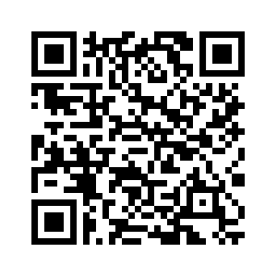 | iPhone accessibility features.
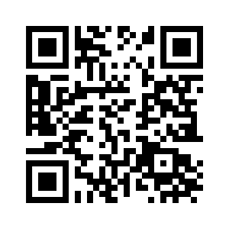 | Android accessibility features.
 | Windows accessibility features.
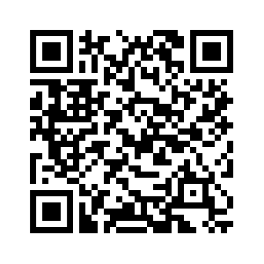 | Mac accessibility features.

Operating the LipSync
The LipSync has a range of inputs including the mouthpiece, optional assistive switches, and the buttons on the Hub. Using these inputs, the user, or support person, can adjust settings, change modes, and access the various output actions available in each mode.

How to Perform LipSync Inputs
The LipSync has a range of inputs available through the mouthpiece, assistive switches, and Hub buttons. This section outlines how to perform each input type.

Moving The Joystick
To use the joystick, move the mouthpiece in the desired direction. You can hold the mouthpiece lightly in your mouth or lips, or between your lower lip and chin. The further the mouthpiece is moved, the faster the cursor will move. When the mouthpiece is released, it will return to its resting position.

Using Sip and Puff
Sip and puffs are the two forms of input available through the LipSync mouthpiece.

Sip
To perform a Sip Input, close your lips around the end of the mouthpiece and sip like you would a drink through a straw (i.e., inhale or apply negative pressure) and then release.

Puff
To perform a Puff Input, close your lips around the opening on the mouthpiece and blow air into it (i.e., exhale or apply positive pressure) and then release.

Using External Assistive Switches
Up to three External Assistive Switches with standard 3.5 mm audio jack plugs can be used with the LipSync to provide input. The Assistive Switches are connected to the LipSync Hub via the external switch ports labeled S1, S2, and S3.
By default, S1 and S3 are mapped to Puff and Sip to provide an alternate way to access those inputs for users who are unable to perform a puff and/or sip. S2 is not required but can provide access to an additional set of inputs.

Using the Hub Buttons
The Hub Buttons provide two functions: they provide a way to navigate the Hub Menu and they enable a support person to perform the same actions as sips and puffs without having to use the LipSync mouthpiece or the user’s assistive switches.
To activate the Hub Buttons, simply press down and then release on one or both of the round buttons on the face of the Hub. Next and Select (Sel) are both mapped to Sip and Puff, respectively.

Timed Inputs
The amount of time that any input (Sip/puff/switches/buttons) is held before being released will trigger different actions.
Short: Less than 1 second. Indicated by the respective LED blinking once.
Long: Between 1 to 3 seconds. Indicated by the respective LED lighting up and staying on.
Very Long: 3 seconds or longer. Indicated by the respective LED turning back off.
For each input in regular operating modes, a specified Feedback Light will indicate the input duration. The feedback lights are designated to the inputs as follows:
Left Light •: Puff, S1, Select (Sel) button on Hub
Middle Light ••: S2
Right Light •••: Sip, S3, Next button on Hub
For example, to perform a Very Long Sip, close your lips around the end of the mouthpiece and apply a sip to the tube. After you hold the Sip for 1 second, the Right Feedback Light on the Hub will turn on. After 3 seconds, the Right Feedback Light will turn off. Release the pressure to trigger a Very Long Sip.

USB & Wireless Mouse Mode
In either USB or Wireless Mouse Mode, the joystick controls the cursor, and the sip and puff are mapped to different mouse button clicks.

Mouse Mode Functions
Function | Description
Moving the Cursor | Performs the same function as moving a mouse to move the pointer/cursor on the screen.
Left Click | Performs the same function of the left click on a mouse
Right Click | Performs the same function of the right click on a mouse
Middle Click | Performs the same function of the scroll wheel push on a mouse
Drag Mode | Will mimic the left click on the mouse held down to drag items on the screen such as folders
Scroll Mode | Keeps the mouse stationary and the joystick can control the scroll speed

Moving the Cursor
To move the cursor, move the mouthpiece in the desired direction. You can hold the mouthpiece lightly in your mouth or lips, or between your lower lip and chin. The further the mouthpiece is moved, the faster the cursor will move. Releasing the mouthpiece will return it to the center position and the cursor will stop moving.
If the cursor continues to move after the mouthpiece is released see the Troubleshooting Section: page 42.
The maximum cursor speed can be adjusted by the user in the Hub Menu. See the Changing the Cursor Speed section.

Left Clicking
To do a left click, use your mouth to do a short puff on the mouthpiece (i.e., exhale or apply positive pressure). The left click will be generated when the short puff is released, and the left LED will blink once.
A left click can also be generated by a short press of the Hub “Select” button or S1.

Right Clicking
To do a right click, use your mouth to do a short Sip (<1 second) on the mouthpiece (i.e., inhale or apply negative pressure). The right click will be generated when the short sip is released, and the right LED will blink once.
A right click can also be generated by a short press of the Hub “Next” button or S3.

Double Clicking
To do a double click, use your mouth to do two short puffs on the mouthpiece. The left LED will blink once for each puff.
It may be helpful to decrease the double click speed on the host device.

Middle Clicking
Middle click is used for tasks such as turning the cursor into scroll mode in web browsers and in documents. On a typical mouse, a middle click is accomplished by clicking the scroll wheel. Note that not all mice have a scroll wheel that clicks.
To do a middle click, apply and maintain a very long sip (At least 3 seconds) to the mouthpiece and then then release the sip. The right-side LED will begin flashing quickly once the duration has been reached.
A middle click can also be generated by a very long press of S3 or the Hub “Next” button, or a short press of S2.

Drag
Drag is used for tasks such as repositioning windows or icons, or selecting objects such as text. On a typical mouse, drag is accomplished by pressing and holding the left click. On the LipSync, drag is accomplished by starting Drag mode.
To start Drag Mode, apply and maintain a long puff (between 1 and 3 seconds) on the mouthpiece and then release the puff. The Left Feedback Light will turn on and stay on once the duration has been reached. Alternative inputs are a long press of the Hub “Select” button, or a long press of S1.
To drag, move the mouthpiece in any direction.
To stop drag mode, apply a short sip or a short puff on the mouthpiece.

Vertical Scroll
Vertica scroll is useful for scrolling up and down within documents or webpages. On a typical mouse, this is often controlled by rotating a scroll wheel. On the LipSync, vertical scrolling is accomplished by activating Scroll Mode and using vertical motion of the mouthpiece.
To start Scroll Mode, input a Long Sip (1 and 3 seconds). The Right Feedback Light will turn on when the Long Sip threshold has been reached. Alternative inputs are a long press of the Hub “Next” button, or a long press of S3. The right Feedback Light will remain on while Scroll Mode is active.
To scroll, move the mouthpiece up or down. The further the mouthpiece is moved, the faster the scroll.
To stop scroll mode, apply a short sip or a short puff on the mouthpiece.
The scroll speed can be adjusted by the user using the Hub Menu. See the Changing the Scroll Speed section.

USB Gamepad Mode
In Gamepad mode, the LipSync inputs are translated to gaming outputs instead of mouse functions. The LipSync will act as a gamepad with one joystick and 6 buttons.
In some direct applications, these buttons will have default functions, such as when plugged into the XAC, or plugged into a mobile smart phone. When used with a program such as Steam, the inputs will have to be mapped to the desired outputs to setup the LipSync as a controller. Note that while the LipSync inputs are set to default outputs with the XAC, you can modify this mapping through the Xbox Accessories App.

Gamepad Mode Functions
Function | Description
Moving the Joystick | Performs the same function as moving a standard joystick or thumbstick in gaming applications.
Button 1 Press | Performs the same function of pressing button 1 on a standard gamepad.
Button 2 Press | Performs the same function of pressing button 2 on a standard gamepad.
Button 3 Press | Performs the same function of pressing button 3 on a standard gamepad.
Button 4 Press | Performs the same function of pressing button 4 on a standard gamepad.
Button 5 Press | Performs the same function of pressing button 5 on a standard gamepad.
Button 6 Press | Performs the same function of pressing button 6 on a standard gamepad.

Moving the Joystick
To move the joystick, move the mouthpiece in the desired direction. You can hold the mouthpiece lightly in your mouth or lips, or between your lower lip and chin. The further the mouthpiece is moved, the further the joystick will move. Releasing the mouthpiece will return it to the center position and the joystick will return to center.
If the cursor continues to move after the mouthpiece is released see the Troubleshooting Section: page 42.

Button 1 Press
To do a button 1 press, use your mouth to do a short puff on the mouthpiece (i.e., exhale or apply positive pressure). The button 1 press will be generated when the short puff is released.
A button 1 press can also be generated by a short press of the Hub “Select” button or S1.

Button 2 Press
To do a button 2 press, use your mouth to do a short Sip (<1 second) on the mouthpiece (i.e., inhale or apply negative pressure). The button 2 press will be generated when the short sip is released.
A button 2 press can also be generated by a short press of the Hub “Next” button or S3.

Button 3 Press
To do a button 3 press, apply and maintain a long puff (between 1 and 3 seconds) on the mouthpiece and then release the puff. The button 3 press will be generated when the long puff is released.
A button 3 press can also be generated by a long press of the Hub “Select” button or S1.

Button 4 Press
To do a button 4 press, apply and maintain a long sip (between 1 and 3 seconds) on the mouthpiece and then release the sip. The button 4 press will be generated when the long sip is released.
A button 4 press can also be generated by a long press of the Hub “Next” button or S3.

Button 5 Press
To do a button 5 press, apply and maintain a very long sip (between 1 and 3 seconds) on the mouthpiece and then release the sip. The button 5 press will be generated when the very long sip is released.
A button 5 press can also be generated by a very long press of the Hub “Next” button, or a short press of S2.

Button 6 Press
To do a button 6 press, perform a long press (between 1 to 3 seconds) of S2. The button 6 press will be generated when the long press of S2 is released.

USB Gamepad Mode connected to an Android Smart Phone or Tablet
When connected to a smart phone in Gamepad Mode, the LipSync acts similar to switch scanning, but uses the joystick to move the scanning target.
Function | Description
Moving the Scanning Target | Moves the target selector around the screen one target at a time, side to side, or up and down.
Select | Performs the same function as tapping on the selected field.
Back | Performs the same function as the back button on an Android smart phone.

Moving the Scanning Target
To move the scanning target, move the joystick in one of the four cardinal directions: up, down, left, or right. If the joystick is held in the chosen direction, the selection field will move in that direction, highlighting the different apps or selections as it goes.

Select
To select the highlighted field, use your mouth to do a short puff on the mouthpiece (i.e., exhale or apply positive pressure). The Select function will be performed when the short puff is released.
The Select function can also be generated by a short press of the Hub “Select” button or S1.

Back
To use the Back function, use your mouth to do a short Sip (<1 second) on the mouthpiece (i.e., inhale or apply negative pressure). The Back function will be performed when the short sip is released.
A Back function can also be performed by a short press of the Hub “Next” button or S3.

Input and Feedback Summary
The overall mapping of the LipSync inputs and feedback features is as follows:

Feedback Features
Each Feedback Light is designated to a set of inputs:
Left Light •: Puff, S1
Middle Light ••: S2
Right Light •••: Sip, S3
The time durations Short, Long, and Very Long for the Sip/Puff and switch/button inputs are the following:
Short: Less than 1 second. Feedback Light blinks once when released.
Long: Between 1 to 3 seconds. Feedback Light turns on and stays on.
Very Long: 3 seconds or longer. Feedback Light turns back off.

Mouthpiece Inputs
LipSync Mouthpiece Inputs | Hub Menu | Mouse  (PC or Mobile) | Gamepad
LipSync Mouthpiece Inputs | Hub Menu | Mouse  (PC or Mobile) | PC | Mobile (Android) | XAC (Left USB) | XAC (Right USB)
Joystick | Can move joystick to test cursor speeds and view on screen | Cursor movement | Joystick movement | Directional pad | Left Thumbstick | Right Thumbstick
Short Puff | Select | Left click | Button 1 | Select | X1 (Left Stick Up) | View
Long Puff | N/A | Start Drag Mode | Button 3 | Select | Left Stick Press | Right Stick Press
Very Long Puff | Exit Hub Menu | Enter Hub Menu | Enter Hub Menu | Enter Hub Menu | Enter Hub Menu | Enter Hub Menu
Short Sip | Next | Right click | Button 2 | Back | X2 (Left Stick Down) | Menu
Long Sip | N/A | Start Scroll Mode | Button 4 | N/A | Left Bumper | Right Bumper
Very Long Sip | N/A | Middle Click | Button 5 | Select | A | X

Assistive Switch Inputs
LipSync Assistive Switch Inputs | Hub Menu | Mouse  (PC or Mobile) | Gamepad
LipSync Assistive Switch Inputs | Hub Menu | Mouse  (PC or Mobile) | PC | Mobile (Android) | XAC (Left USB) | XAC (Right USB)
S1 Short Press | Select | Left Click | Button 1 | Select | X1 (Left Stick Up) | View
S1 Long Press | N/A | Start Drag Mode | Button 3 | Select | Left Stick Press | Right Stick Press
S1 Very Long Press | Exit Hub Menu | Enter Hub Menu | Enter Hub Menu | Enter Hub Menu | Enter Hub Menu | Enter Hub Menu
S2 Short Press | N/A | Middle Click | Button 5 | Back | A | X
S2 Long Press | N/A | N/A | Button 6 | N/A | B | Y
S2 Very Long Press | N/A | Perform Center Reset | Perform Center Reset | Perform Center Reset | Perform Center Reset | Perform Center Reset
S3 Short Press | Next | Right Click | Button 2 | Select | X2 (Left Stick Down) | Menu
S3 Long Press | N/A | Start Scroll Mode | Button 4 | N/A | Left Bumper | Right Bumper
S3 Very Long Press | N/A | Middle Click | N/A | Select | N/A | N/A
Chorded Inputs (Simultaneous short press)
S1 and S3 | Exit Hub Menu | Enter Hub Menu | Enter Hub Menu | Enter Hub Menu | Enter Hub Menu | Enter Hub Menu

Hub Button Inputs
LipSync Hub Button Inputs | Hub Menu | Mouse  (PC or Mobile) | Gamepad
LipSync Hub Button Inputs | Hub Menu | Mouse  (PC or Mobile) | PC | Mobile (Android) | XAC (Left USB) | XAC (Right USB)
Select Short Press | Select | Left Click | Button 1 | Select | X1 (Left Stick Up) | View
Select Long Press | N/A | Start Drag Mode | Button 3 | Select | Left Stick Press | Right Stick Press
Select Very Long Press | Exit Hub Menu | Enter Hub Menu | Enter Hub Menu | Enter Hub Menu | Enter Hub Menu | Enter Hub Menu
Next Short Press | Next | Right Click | Button 2 | Back | X2 (Left Stick Down) | Menu
Next Long Press | N/A | Start Scroll Mode | Button 4 | N/A | Left Bumper | Right Bumper
Next Very Long Press | N/A | Middle Click | Button 5 | Select | A | X
Chorded Inputs (Simultaneous short press)
Next and Select | Exit Hub Menu | Enter Hub Menu | Enter Hub Menu | Enter Hub Menu | Enter Hub Menu | Enter Hub Menu
Note: Default XAC mappings can be modified through the Xbox Accessories App.

The Hub Menu
The Hub is an interface device used to connect the LipSync joystick and assistive switches to the Host Device. The Hub also contains a display that shows the Hub Menu, an interface for adjusting settings, calibrating the joystick, changing the operating mode, restarting the device, and resetting to the default settings.

Accessing the Hub Menu
The Hub Menu is normally off to reduce power consumption and wear on the screen. To use the Hub Menu, it must first be activated using sip and puff, assistive switches, or the Hub Buttons. The following table shows the corresponding input options to enter/exit the Hub Menu.
Action | Input
Action | On Hub Button | Assistive Switch | Sip / puff
Enter/Exit menu | Select very long press (>3 seconds) | S1 very long press  (>3 seconds) | Puff – very long  (>3 seconds)
Enter/Exit Menu | Simultaneous Press of Next and Sel | Simultaneous Press of S1 and S3 | N/A

Navigating the Hub Menu
Once the Hub Menu is activated, it will display a list of menus. The current selection will be indicated by a left arrow (>). The Hub Menu is navigated using inputs from sip and puff, assistive switches, and/or the Hub Buttons. The following table shows the corresponding input options to navigate the Hub Menu.
Action | Input
Action | On Hub Button | Assistive Switch | Sip / puff
“Next” – goes to next option | Next | S3 | Sip
“Select” – Selects the pointed to option | Sel | S1 | Puff
When “Next” is activated, the selection will change to the next item on the list. If “Next” is activated when the selection is on the last item of the list, the selection will change to the top item on the list. A “Next” action is trigged using a Sip, a short press on S3, or by pressing the Next button on the Hub.
When “Select” is activated, the current selection will be activated, such as opening a submenu, starting calibration, etc. The “Select” action is trigged using a Puff, a short press on S1, or by pressing the Select button on the Hub.

Hub Menu Options
The Hub Menu is arranged as sets of submenus and pages. Each submenu has a “… Back” option at the end of its list to return to the top of the previous menu. Any selection made will walk you through the required steps with instructions on the Hub Display. The overall structure of the Hub Menu is as follows:
- Exit Menu
- Center Reset
- Mode
  - Mouse USB
  - Mouse BT
  - Gamepad
- Cursor speed
- More
  - Sound
  - Light Brightness
  - Scroll Speed
  - Sip & Puff
    - Sip threshold
    - Puff threshold
  - Full Calibration
  - Restart LipSync
  - Factory Reset
  - Info

Exit Menu
The top menu item is to exit and deactivate the Hub Menu. After performing any other setting changes, or backing out of submenus, the menu display will always return to the top of the main menu, so it is easy to exit the menu after changing settings. When selected, you will be asked to confirm you wish to leave the menu and can select “Confirm” to exit, or “… Back” to return to the menu.
As shown in the table for navigating the menus, any function used to enter the menu, can also be used to exit it.

Center Reset
A center reset will reset the neutral resting position of your joystick and should be used if you are experiencing drift. Do not touch the joystick while performing a center reset.

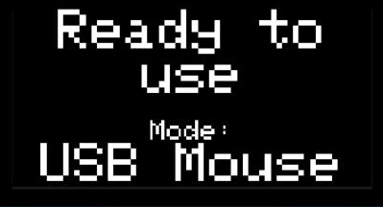
Mode
The Mode submenu allows you to change the operating mode by selecting one of three modes: USB Mouse, BT Mouse, or Gamepad. Note that it is important to ensure you are in the correct mode for the device you want to connect to. After changing modes, the Hub will reset and perform a center reset upon powering on. Do not touch the joystick until you see the Hub display read “Ready for use” and the mode.

Cursor Speed
The Cursor Speed submenu allows you to increase or decrease the mouse cursor speed in increments of 1 from a scale of 1 to 10. While changing the increment, the cursor can still be moved across the screen to test the current speed setting.

More
The More submenu contains further Menu Items that generally will not be used as often.

Sound On/Off
This menu item will toggle the sound feedback for LipSync inputs on or off. There is no volume control.

Light Brightness
Thie menu allows you to increase or decrease the brightness of the lights on the Hub in increments of 1 from a scale of 0 to 10.

Scroll Speed
This menu allows you to increase or decrease the mouse scroll speed in increments of 1 from a scale of 1 to 10.

Sip & Puff
This menu allows you to adjust the sip and puff threshold to fine tune the required air pressure for sips and puff. The sip and puff thresholds can be set independently.

Full calibration
A full calibration is used to set the extents of your joystick and should be done if you are having issues moving in certain directions with the joystick.

Restart LipSync
This option provides a way for the user to reset the LipSync without physically disconnecting it from power.

Factory Reset
This option will trigger a factor reset that returns all settings back to default. This includes the operating mode, cursor speed, calibrations, and any settings adjusted through the API.

Info
This option will display a page with information about the LipSync, including the current firmware version and the unique hardware ID that is used for the Bluetooth device name.

Adjusting the LipSync
Adjustments to the LipSync involve calibrating the joystick, and changing settings. To adjust the LipSync, most settings can be changed through the Hub Display menu.

Center Reset
A Center Reset resets the neutral position of the joystick in its resting position. If the position of the cursor is moving when the mouthpiece is released and stationary, a Center Reset can help resolve the cursor drift.
A Center Reset should be performed in the following situations:
- The LipSync mounting angle is adjusted.
- The LipSync filter and/or mouthpiece is replaced.
- The cursor continues to move when the mouthpiece is released and is stationary.
A Center Reset is automatically performed when the LipSync is first powered on, and at the end of the Full Calibration process. A Center Reset can also be started manually using the Hub Menu or outside of the menu using a Very Long Press on an Assistive Switch attached to S2:
- Using the Hub Menu:
- Activate the Hub Menu by applying a very long (>3 seconds) Puff (or Select Button or S1) on the mouthpiece and then release it.
  - An alternative way to open the Hub Menu is a simultaneous short press of S1 and S3, or Next and Select on the Hub.
- The Hub Menu will turn on.
- Use a short Puff input (Or Next button or S3) to move through the Menu options until you reach “Center Reset.”
- Use a Short Sip (<1 seconds) input (Or Select Button or S1) to select “Center Reset.”
- Use a Short Sip (<1 seconds) input (Or Select Button or S1) to select “Center Reset” again.
- Release the joystick and do not touch it until the menu screen returns to the regular menu.
2. Using Long Press on Assistive Switch S2:
- Perform a Very Long Press (>3 seconds) of S2.
- Release the joystick and do not touch it until the Hub screen states that the center reset is complete.
When the Center Reset is started, the Hub Menu Display will prompt you to not touch the joystick. It is important to release the mouthpiece and leave it to sit in its neutral resting position to perform the center reset.

Full Calibration
The Full Calibration of the LipSync should be completed upon initial assembly of the device. It may also need to be repeated if the user is experiencing strange cursor movements or no change in movement at the extents of the joystick.
The calibration procedure is a timed process that required the joystick to be moved to each corner of the movement range. The Hub menu display will give prompts to follow for moving the joystick.
- Initiate Full Calibration
  - Apply and maintain a very long (>3 seconds) Puff (or Select Button or S1) on the mouthpiece and then release it.
    - An alternative way to open the Hub Menu is a simultaneous short press of S1 and S3, or Next and Select on the Hub.
  - The Hub Menu will turn on.
  - Use a short Sip (<1 second) input (Or Next button or S3) to move through the Menu options until you reach “More”
  - Use a short Puff (<1 second) input (Or Sel Button or S1) to select “More”
  - Use a short Sip (<1 second) input (Or Next button or S3) to move through the menu options until you reach “Full Calibration.”
  - Use a short Puff (<1 second) input (Or Sel Button or S1) to select “Full Calibration”
  - On the screen reading “Are you sure?” use a short Puff (<1 second) input (Or Sel Button or S1) to select “Confirm.”
  - Release the joystick and follow the prompts on the Hub Menu Display.
- Follow Full Calibration Prompts

  - The Hub Display will show “Follow on screen prompts”
  - The Hub will beep once, all lights will flash once, and the Display will show “Hold joystick top left”
    - Move the joystick/mouthpiece to the top left corner extent of the joystick and hold it there until the prompt changes, also signified by the Hub beeping once and all lights flashing once.
  - The Hub Display will show “Hold joystick top right”
    - Move the joystick/mouthpiece to the top right corner extent of the joystick and hold it there until the prompt changes, also signified by the Hub beeping once and all lights flashing once.
  - The Hub Display will show “Hold joystick bottom right”
    - Move the joystick/mouthpiece to the bottom right corner extent of the joystick and hold it there until the prompt changes, also signified by the Hub beeping once and all lights flashing once.
  - The Hub Display will show “Hold joystick bottom left”
    - Move the joystick/mouthpiece to the bottom left corner extent of the joystick and hold it there until the prompt changes, also signified by the Hub beeping once and all lights flashing once.
  - The Hub Display will show “Release, do not move joystick”
    - Release the joystick back to its neutral position and do not touch it.

NOTE: during each step of the full calibration, if the joystick is not moved to one of the corners, and is left at rest in the center, the display will show the message “Movement too small. Returned to default.” Meaning that the default value for the corner of a typical joystick will be used, so that the calibration does not lead to undesired results.

- Calibration Complete
  - When the calibration is complete, the Hub Display will show “Joystick Calibrated” and then return to the main menu screen.
  - You can test the joystick movement on the host device screen to ensure the calibration was successful.
  - You can now continue through the menu settings or exit the menu and use your joystick.

Changing LipSync Settings
There are numerous settings that control the operation of the LipSync. Some of these settings can be adjusted independently through the Hub Menu.
Table 1: LipSync Settings
Setting | Default | Min | Max | Note
Cursor Speed | 5 | 0 | 10 | Changes the cursor speed in any Mouse Mode.
Sound Feedback | On | Off | On | Turns the sound on or off.
Light Brightness Level | 5 | 0 | 10 | Adjust the brightness of the LED lights. To turn off the lights completely, set to level 0.
Scroll Speed | 5 | 1 | 10 | Changes the scrolling speed in any Mouse Mode.
Sip Threshold | 3.0 | 1.0 | 100.0 | Changes the pressure required for a Sip input.
Puff Threshold | 3.0 | 1.0 | 100.0 | Changes the pressure required for a Puff input
Inner Deadzone | 0.05 | 0.0 | 0.5 | Changes the distance the joystick must be moved from rest to cause cursor/gamepad movement.  Only adjustable through API, not Hub menu.
Outer Deadzone | 0.95 | 0.5 | 1.0 | Changes the distance the joystick must be moved from the outer edge to provide full cursor/gamepad movement.  Only adjustable through API, not Hub menu.

Changing the Cursor Speed
To change the cursor speed, the host device settings can be adjusted, or the LipSync cursor speed can be adjusted. To change the LipSync cursor speed:
- Activate the menu using a very long Puff (>3 seconds) on the mouthpiece
- Alternatively, the Hub Menu can be activated using a very long press on Select Button or S1; or by a simultaneous short press of S1 and S3, or Next and Select on the Hub.
- Use a short Sip (<1 second) input (Or Next button or S3) to move through the Menu options until you reach “Cursor speed”
- Use a short Puff (<1 second) input (Or Sel Button or S1) to select “Cursor speed”
- Use a short Sip (<1 second) input (Or Next button or S3) to move through the Menu options “increase” and “decrease”
- Use a short Puff (<1 second) input (Or Sel Button or S1) to select “increase” or “decrease” as desired.
  - Note: the minimum cursor speed level is 1, and the maximum is 10.
- Test the cursor speed on the host device by moving the joystick while in the menu.
- Once happy with the cursor speed, navigate to “…Back” using a short (<1 seconds) Sip input (Or Next button or S3).
- Use a short Puff (<1 second) input (Or Sel Button or S1) to select “…Back”
- Use a short Puff (<1 second) input (Or Sel Button or S1) to select “Exit Menu” or continue through the menu to adjust other settings.

Changing the Scroll Speed
The scroll speed controls how much the screen scrolls with vertical motion of the mouthpiece when Scroll Mode is activated. To change the LipSync scroll speed:
- Activate the menu using a very long Puff (>3 seconds) on the mouthpiece
- Alternatively, the Hub Menu can be activated using a very long press on Select Button or S1; or by a simultaneous short press of S1 and S3, or Next and Select on the Hub.
- Use a short Sip (<1 second) input (Or Next button or S3) to move through the Menu options until you reach “More”
- Use a short Puff (<1 second) input (Or Sel Button or S1) to select “More”
- Use a short Sip (<1 second) input (Or Next button or S3) to move through the Menu options until you reach “Scroll speed”
- Use a short Puff (<1 second) input (Or Sel Button or S1) to select “Scroll speed”
- Use a short Sip (<1 second) input (Or Next button or S3) to move through the Menu options “increase” and “decrease”
- Use a short Puff (<1 second) input (Or Sel Button or S1) to select “increase” or “decrease” as desired.
  - Note: the minimum scroll speed level is 1, and the maximum is 10.
- Test the scroll speed on the host device by moving the joystick while in the menu.
- Once happy with the scroll speed, navigate to “…Back” using a short (<1 seconds) Sip input (Or Next button or S3).
- Use a short Puff (<1 second) input (Or Sel Button or S1) to select “…Back”
- Use a short Puff (<1 second) input (Or Sel Button or S1) to select “Exit Menu” or continue through the menu to adjust other settings.

Changing the Light Brightness
The brightness of the Hub lights can be adjusted to suit the user’s preference. A user may wish to increase the brightness when working in a bright environment or decrease the brightness when working in a dark room. The brightness of the lights can be adjusted from Level 0 (completely off) to Level 10 (full brightness). To change the brightness:
- Activate the menu using a very long Puff (>3 seconds) on the mouthpiece
- Alternatively, the Hub Menu can be activated using a very long press on Select Button or S1; or by a simultaneous short press of S1 and S3, or Next and Select on the Hub.
- Use a short Sip (<1 second) input (Or Next button or S3) to move through the Menu options until you reach “More”
- Use a short Puff (<1 second) input (Or Sel Button or S1) to select “More”
- Use a short Sip (<1 second) input (Or Next button or S3) to move through the Menu options until you reach “Light Brightness”
- Use a short Puff (<1 second) input (Or Sel Button or S1) to select “Light Brightness”
- Use a short Sip (<1 second) input (Or Next button or S3) to move through the Menu options “increase” and “decrease”
- Use a short Puff (<1 second) input (Or Sel Button or S1) to select “Increase” or “Decrease” as desired.
  - Note: the minimum brightness level is 0, and the maximum is 10.
- The Hubs lights will briefly illuminate to preview the new brightness.
- Once happy with the brightness, navigate to “…Back” using a short (<1 seconds) Sip input (Or Next button or S3).
- Use a short Puff (<1 second) input (Or Sel Button or S1) to select “…Back”
- Use a short Puff (<1 second) input (Or Sel Button or S1) to select “Exit Menu” or continue through the menu to adjust other settings.

Changing the Sound Mode
Sound feedback can be turned on or off. To change the LipSync Sound Mode:
- Activate the menu using a very long Puff (>3 seconds) on the mouthpiece
- Alternatively, the Hub Menu can be activated using a very long press on Select Button or S1; or by a simultaneous short press of S1 and S3, or Next and Select on the Hub.
- Use a short Sip (<1 second) input (Or Next button or S3) to move through the Menu options until you reach “More”
- Use a short Puff (<1 second) input (Or Sel Button or S1) to select “More”
- Use a short Sip (<1 second) input (Or Next button or S3) to move through the Menu options until you reach “Sound”
- Use a short Puff (<1 second) input (Or Sel Button or S1) to select “Sound”
- The current sound mode will be indicated (either ON or OFF).
- Use a short Puff (<1 second) input (Or Sel Button or S1) to select “Turn off “ or “Turn on” to toggle the Sound Mode.
- Once happy with the Sound Mode, navigate to “…Back” using a short (<1 seconds) Sip input (Or Next button or S3).
- Use a short Puff (<1 second) input (Or Sel Button or S1) to select “…Back”
- Use a short Puff (<1 second) input (Or Sel Button or S1) to select “Exit Menu” or continue through the menu to adjust other settings.

Changing the Sip & Puff Thresholds
The Sip and Puff thresholds can be individually changed to accommodate the user’s preferences. This changes how hard the user needs to Sip or Puff (i.e. the amount of pressure) for the input to be registered. Sip and Puff thresholds can be set from 1 to 100 hPa and are defaulted to 3 hPa. To change the sip or puff thresholds:
- Activate the menu using a very long Puff (>3 seconds) on the mouthpiece (or Select Button or S1)
- An alternative way to open the Hub Menu is a simultaneous short press of S1 and S3, or Next and Sel on the Hub.
- The Hub Menu will turn on.
- Use a short (<1 seconds) Sip input (Or Next button or S3) to move through the Menu options until you reach “More”
- Use a short (<1 seconds) Puff input (Or Sel Button or S1) to select “More”
- Use a short (<1 seconds) Sip input (Or Next button or S3) to move through the Menu options until you reach “Sip & Puff”
- Use a short (<1 seconds) Puff input (Or Sel Button or S1) to select “Sip & Puff”
- Use a short (<1 seconds) Sip input (Or Next button or S3) to move through the Menu options to select “Sip Threshold” or “Puff Threshold”
- Use a short (<1 seconds) Puff input (Or Sel Button or S1) to select “Sip Threshold” or “Puff Threshold”
- Use a short (<1 seconds) Sip input (Or Next button or S3) to move through the Menu options “increase” and “decrease”
- Use a short (<1 seconds) Puff input (Or Sel Button or S1) to select “increase” or “decrease” as desired.
- Once happy with the Sip or Puff Threshold, navigate to “…Back” using a short (<1 seconds) Sip input (Or Next button or S3).
- Use a short (<1 seconds) Puff input (Or Sel Button or S1) to select “…Back”
- Use a short (<1 seconds) Puff input (Or Sel Button or S1) to select “Exit Menu” or continue through the menu to adjust other settings.

Input-Output Mapping
The mapping of inputs (e.g., Short Sip, Very Long Puff) to actions (e.g., Right Click, Activate Menu) are currently fixed in code and not adjustable by the user. Contact your maker or support for assistance.

Changing Settings Through the Serial Interface (API)
All the user-adjustable settings of the LipSync are accessible through the Serial Interface. This is a more challenging method intended only for advanced users. Refer to Appendix A: Serial Interface (Application Programming Interface) for more information.

Maintenance
This section outlines how to perform common maintenance tasks for the LipSync. The device should be kept clean of dust and debris as needed by following the cleaning instructions.

Replacing the Mouthpiece
The filtered mouthpiece should be replaced as needed, or at least every 30 to 90 days under normal daily use. To replace the mouthpiece: The mouthpiece is a single-user item: do not share it between users. Replacement mouthpiece assemblies are standard consumables — the silicone straw tip and the hydrophobic syringe filter are listed with sourcing links in the LipSync Bill of Materials (see the design files on the LipSync project page), so a maker can supply replacements in bulk.
- Remove the mouthpiece.
Hold the filter and rotate it counter-clockwise until it comes out of the gimbal connector.
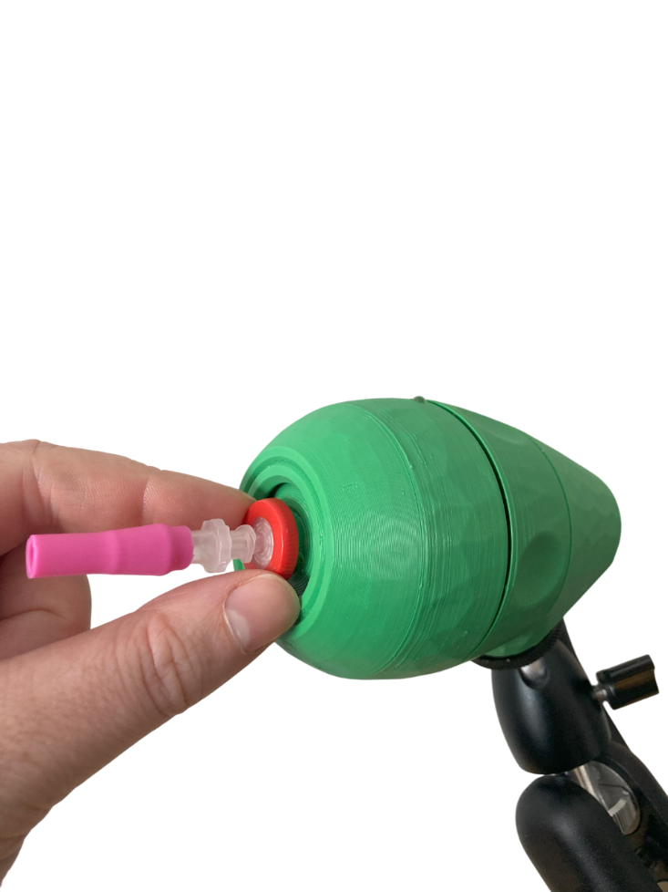

- Discard the mouthpiece assembly.
- Install a new mouthpiece assembly.
Twist the filter clockwise until finger tight. Do not overtighten.
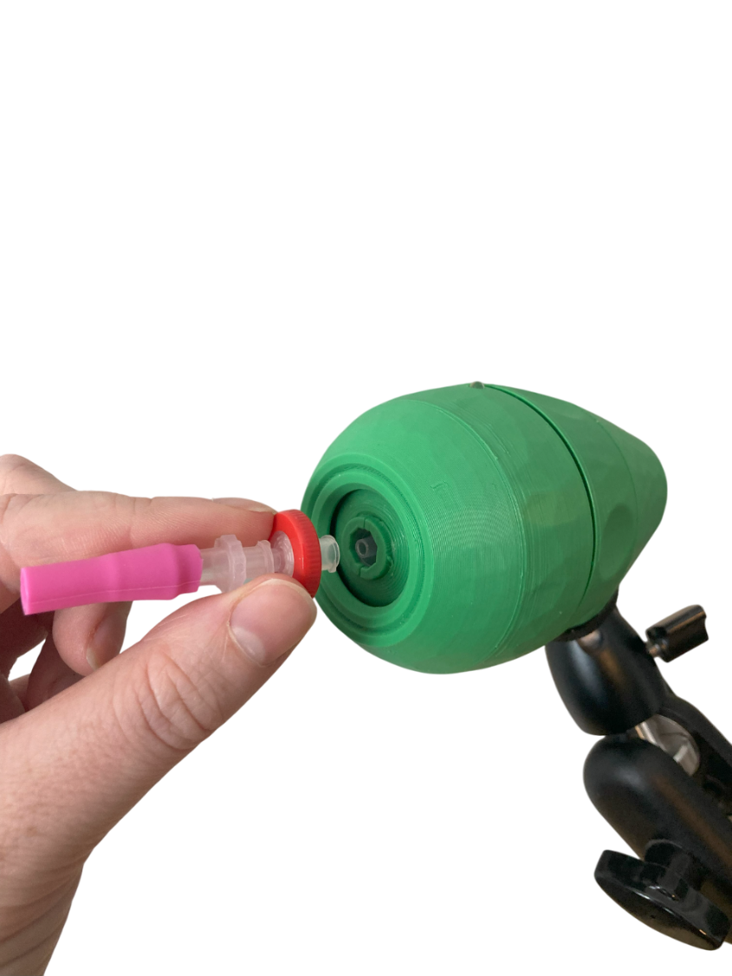

Cleaning the LipSync
Cleaning the LipSync Joystick  - Wipe with a damp cloth  - Don’t use abrasive cleaning materials  - Don’t soak the LipSync Joystick in any cleaning solutions  - Don’t immerse the LipSync Joystick | Cleaning the LipSync Hub  - Wipe plastic enclosure with a damp cloth  - Don’t scrub or press down on the Hub Display  - Don’t use abrasive cleaning materials  - Don’t soak the LipSync Hub in any cleaning solutions  - Don’t immerse the LipSync Hub
Wipe the Hub and the outside of the joystick housing with a slightly damp, lint-free cloth. Never submerge any part of the device or let liquid enter the mouthpiece tube.
The mouthpiece tube and filter should not be washed — they are replaced instead (see Replacing the Mouthpiece above).
Replace the mouthpiece assembly if it becomes discolored, damaged, or difficult to sip through.

Frequently Asked Questions
Can the LipSync be used by multiple users?
- The LipSync Joystick is intended as a single user device. The Hub can be used for different joysticks, but the joystick itself should only be used by one person.

Troubleshooting
Mouse cursor is not visible
- Make sure device is connected
- Make sure device is in the intended operating mode (e.g., USB, not Wireless)
- Make sure the device has proper onscreen settings (e.g., AssistiveTouch on iOS)
Mouse cursor is difficult to see
- Adjust the size or color of the cursor on the host device
Producing sips and puff required too much or too little air pressure
- Adjust the sip and puff threshold
- Change the mouthpiece
Cursor movement is too slow or too fast
- Adjust the cursor speed on the LipSync
- Adjust the cursor speed on the host device
Difficulty inputting a double-click
- Adjust host devices double click rate
Cursor / Joystick Drift
- Trigger a center reset
  - Activate the Hub Menu and navigate to Center reset.
  - Using a very long press of Assistive Switch 2
  - Disconnected and reconnect power.
The cursor moves in the wrong direction (flipped or mirrored)
Run a Full Calibration from the Hub Menu (More ▸ Full Calibration); a Center Reset does not correct orientation.
If a whole axis is inverted (for example, pushing the mouthpiece up moves the cursor down) the magnet in the joystick may have been installed the wrong way around — see the magnet orientation step in the Maker Guide.
If the problem persists, contact support.
Clicks come out swapped (a puff does a right click and a sip does a left click)
Check whether the host device is set to “left-handed mouse”: that operating-system setting swaps the primary and secondary buttons for every mouse, so the LipSync’s puff (left click) and sip (right click) will appear exchanged.
Turn the left-handed setting off (or on, if it is the desired configuration) in the host’s mouse settings.
If the host is configured as expected, contact support — the device’s action mapping can be checked against the Input-Output Mapping table in this guide.
Display reads “No USB. Use menu to change modes”
- If you would like to connect to your device through a Bluetooth connection, simply open the Hub Menu, navigate to Mode, and select “MOUSE BT.” The LipSync will reset and there should no longer be any error messages.
- If you are trying to connect to your device through a wired USB connection:
  - Check that the host device is powered on and ready to use.
  - Check that the LipSync is securely plugged in on both ends of the USB cable.
  - Make sure you are using a USB-C cable that transmits data, not a power-only cable.
  - Try doing a LipSync Reset
  - If the problem persists, contact support (see below).
Display shows error messages and enters safe mode
  - Disconnect the Hub from power.
  - Wait 15 seconds.
  - Unplug the LipSync Interface cable on both ends and plug both ends back in.
  - Reconnect the Hub to power.
If this does not resolve the error, make note of the error code on the Safe Mode menu screen, and refer to Table 2.

Error Codes
The LipSync automatically detects several hardware problems on startup. If an error is detected, a two-tone error sound will play and the device will go in to Safe Mode and display an error code. Table 2 lists the error codes and the corresponding actions to take as a user.
In some cases, a hardware error will be triggered when the power is disconnected and reconnected quickly. This can be resolved by disconnected the USB cable, waiting 30 seconds, and reconnecting the USB. If the problem persists, there might be a problem with the internal sensor or cable.
The error code is a sum of one point per missing component: 1 = Joystick Sensor, 2 = Mouthpiece Pressure Sensor, 4 = Ambient Pressure Sensor, 8 = Display. For example, ERROR-009 (8 + 1) means the display and the joystick sensor were both not detected. Firmware 4.2.0 and newer also survive a faulty sensor gracefully: an unhealthy sensor pauses its inputs instead of freezing the device, and the LipSync Connect health check reports per-sensor state.
ERROR-007 can indicate that the LipSync Interface cable between the Hub and the Joystick is not connected properly. Disconnect the USB cable from the Hub, check both ends of the LipSync Interface Cable are securely attached, then reconnect the USB Cable to the Hub.
Table 2. LipSync Error Codes – User
Error Code | Connection Error |  |  |  | User Action
Error Code | Display | Ambient Pressure | Mouthpiece Pressure | Joystick Sensor
ERROR-001 |  |  |  | ● | 1. Disconnect USB, wait 30 second, reconnect USB.  2. Contact support.
ERROR-002 |  |  | ●
ERROR-003 |  |  | ● | ●
ERROR-004 |  | ●
ERROR-005 |  | ● |  | ●
ERROR-006 |  | ● | ●
ERROR-007 |  | ● | ● | ● | 1. Check that the LipSync interface cable is securely connected on both ends.  2. Confirm the LipSync Interface Cable is the right type.  3. Contact support
ERROR-008 | ● |  |  |  | 1. Disconnect USB, wait 30 second, reconnect USB.  2. Contact support.
ERROR-009 | ● |  |  | ●
ERROR-010 | ● |  | ●
ERROR-011 | ● |  | ● | ●
ERROR-012 | ● | ●
ERROR-013 | ● | ● |  | ●
ERROR-014 | ● | ● | ●
ERROR-015 | ● | ● | ● | ●

Contacting Support
- Contact the person who made the device.
- Email info@makersmakingchange.com

References
[1] Center for Devices and Radiological Health, “Magnets in cell phones, smart watches may affect implanted devices,” U.S. Food and Drug Administration, https://www.fda.gov/radiation-emitting-products/cell-phones/magnets-cell-phones-and-smart-watches-may-affect-pacemakers-and-other-implanted-medical-devices (accessed Mar. 7, 2024).

Appendix A: Serial Interface (Application Programming Interface)
The LipSync has an Application Programming Interface that can be used to change settings through a serial interface. Once the serial connection is established, text commands can adjust a number of settings on the LipSync.

Serial Interface Setup
To use the API, you will need a host device capable of supporting a serial connection and a serial terminal emulator program. The Arduino IDE is a convenient option.

Serial Settings
Select the appropriate COM port and set the speed to 115200.

Sending Commands
Once the serial connection is established, text commands can be sent to the LipSync. Make sure the line ending is set to ‘No Line Ending’. The commands should be sent in all capitals. Commands are sent in a two step process.
First, send the following command to activate the interface:
SETTINGS
If the serial connection is setup properly, the LipSync will respond with:
SUCCESS,0:SETTINGS
Next, send the desired command. The command consists of a two letter end-point code followed by a comma and either a zero or a one. Then, a colon is used to separate the parameter. All of the end-points are listed in
Table 3: Serial Interface Commands.
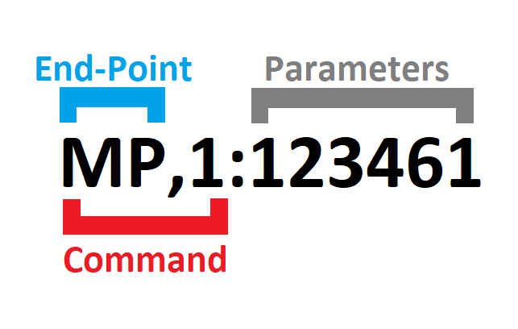

API Format LipSync 4.1 Command List
Command | Success Response | Description
SETTINGS | SUCCESS,0:SETTINGS | Enter Settings mode
EXIT | SUCCESS,0:EXIT | Exit Settings mode

Table 3: Serial Interface Commands
Command | Success Response | Description
MN,0:0 | SUCCESS,0:MN,0:1 | Get Model number
VN,0:0 | SUCCESS,0:VN,0:V{N.NN} | Get version number (V{N.NN})
ID,0:0 | SUCCESS,0:ID,0:{Unique Device ID} | Get Unique Device ID (8 alphanumeric
OM,0:0 | SUCCESS,0:OM | Get operating mode (1 = USB Mouse, 2= USB Gamepad)
OM,1:{OM} | SUCCESS,1:OM | Set operating mode (1 = USB Mouse, 2= USB Gamepad)
CM,0:0 | SUCCESS, 0:CM | Get communication mode value (  0=No HID Output,  1=USB mode enabled  2=Bluetooth mode enabled )
CM,1:1 | SUCCESS,0:CM,1:1 | Set communication mode value to 1 (USB mode enabled)
CM,1:2 | SUCCESS,0:CM,1:2 | Set communication mode value to 2 (Bluetooth mode enabled)
CM,1:{CM} |  | Set Communication Mode (
LM,0:0 | SUCCESS,0:LM | Get light mode (0 = All LEDS off, 1 = Minimal LEDs, 2 = Normal LEDs)
LM,1:{LM} | SUCCESS,1:LM | Set light mode (0 = All LEDS off, 1 = Minimal LEDs, 2 = Normal LEDs)
LL,0:0 | SUCCESS,1:{Light Brightness Level} | Get current light brightness level (0 = Light off, 10 = brightest)
LL,1:{LL} | SUCCESS,1:{Light Brightness Level} | Set light brightness level (0 = Light off, 10 = brightest)
SM,0:0 | SUCCESS,0:SM | Get sound mode (0 = Sound off, 1 = Basic Sound, 2 = All sounds
SM,1:{SM} | SUCCESS,1:SM | Set sound mode (0 = Sound off, 1 = Basic Sound, 2 = All sounds
SS,0:0 | SUCCESS,0:SS,0:{Cursor Speed Level} | Get the mouse cursor speed value (Level)
SS,1:{Cursor Speed Level:0-10} | SUCCESS,0:SS,1:{Cursor Speed Level} | Set the mouse cursor speed value (Level)
SL,0:0 | SUCCESS,0:SL,0:{Scroll Level} | Get the mouse scroll level value. (1-10)
SL,1:{Scroll Level:1-10} | SUCCESS,0:SL,1:{Scroll Level} | Set the mouse scroll level value. (1-10)
PV,0:0 | SUCCESS,0:PV,0:{Pressure Difference in hPa} | Get pressure value (Pressure Difference in hPa)
JV,0:0 | SUCCESS,0,JV,0:{Joystick Value
ST,0:0 | SUCCESS,0:ST,0:{ Sip Threshold in hPa } | Get sip pressure Threshold (Pressure Threshold in hPa)
ST,1:{Threshold 1.0 to 100.0} | SUCCESS,0:ST,1:{ Sip Threshold in hPa } | Set sip pressure Threshold (Pressure Threshold in hPa)
PT,0:0 | SUCCESS,0:PT,0:{ Puff Threshold in hPa } | Get puff pressure Threshold (Pressure Threshold in hPa)
PT,1:{ Threshold 1.0 to 100.0} | SUCCESS,0:PT,1:{ Puff Threshold in hPa } | Set puff pressure Threshold (Pressure Threshold in hPa)
IN,0:0 | SUCCESS,0:IN,0:{ x|y } | Get current joystick center values (x and y)
IN,1:1 | SUCCESS,0:IN,1:{ x|y } | Activate joystick center reset to set new joystick neutral values (x and y)
CA,0:0 | SUCCESS,0:CA,0:{ x0|y0, x1|y1, x2|y2, x3|y3, x4|y4 } | Get current joystick calibration values (point 0, point 1, point 2, point 3, point 4)
CA,1:1 | SUCCESS,0:CA,1:{ x0|y0 } | Activate full joystick calibration process
 | SUCCESS,0:CA,1:{ x1|y1 } | Perform joystick calibration using command (Step 1)
 | SUCCESS,0:CA,1:{ x2|y2 } | Perform joystick calibration using command (Step 2)
 | SUCCESS,0:CA,1:{ x3|y3 } | Perform joystick calibration using command (Step 3)
 | SUCCESS,0:CA,1:{ x4|y4 } | Perform joystick calibration using command (Step 4)
IZ,0:0 | SUCCESS,0:IZ,0:{ Inner Deadzone Factor 0.0 to 1.0 } | Get joystick inner deadzone (0.0 to 1.0)
IZ,1:{ Joystick Inner Deadzone Factor 0.0 to 1.0} | SUCCESS,0:IZ,1:{ Deadzone Factor 0.0 to 1.0 } | Set joystick inner deadzone (0.0 to 1.0)
OZ,0:0 | SUCCESS,0:OZ,0:{ Outer Deadzone Factor 0.0 to 1.0 } | Get joystick outer deadzone (0.0 to 1.0)
OZ,1:{ Joystick Outer Deadzone Factor 0.0 to 1.0} | SUCCESS,0:OZ,1:{ Outer Deadzone Factor 0.0 to 1.0 } | Set joystick outer deadzone (0.0 to 1.0)
CH,1,{Menu Control} | SUCCESS,1,CH,1:{Menu Control} | Control Hub Menu (  0=No action,  1=Open Menu,  2=Select Item,  3=Next Item,  4=Close Menu)
DM,0:0 | SUCCESS,0:DM,0:{Debug Mode} | Get debug mode value (  0=debug mode off,  1=joystick debug mode  2=pressure debug mode  3=button debug mode  4=switch debug mode  5=sip and puff debug mode)
DM,1:0 | SUCCESS,0:DM,1:0 | Set debug mode value to 0 (Disabled)
DM,1:1 | SUCCESS,0:DM,1:1 | Set debug mode value to 1 (joystick debug mode enabled)
DM,1:2 | SUCCESS,0:DM,1:2 | Set debug mode value to 2 (pressure debug mode enabled)
DM,1:3 | SUCCESS,0:DM,1:3 | Set debug mode value to 3 (button debug mode enabled)
DM,1:4 | SUCCESS,0:DM,1:4 | Set debug mode value to 4 (switch debug mode enabled)
DM,1:5 | SUCCESS,0:DM,1:5 | Set debug mode value to 5 (sip and puff debug mode enabled)
RT,1:{Test Number} | SUCCESS,1:RT,1:{Test Number} | Run LipSync Test (  1=LED Test,  2=Sound Test,  3=Watchdog Test)
SR,1:1 | SUCCESS,0:RS,1:1 | Perform a soft reset.
FR,1:1 | SUCCESS,0:FR,1:1 | Perform factory reset

Response Code
Response Status | Response Code | Description
SUCCESS | 0 | The command has successfully performed.
FAIL | 0 | The serial API mode is not enabled. Please enter the serial API mode.
FAIL | 1 | The requested command does not exist. Returns the response code and the requested parameter.
FAIL | 2 | The requested command exists, but the entered parameter is in incorrect format. Returns the response code and the requested parameter.
FAIL | 3 | The requested command exists, but the entered parameter is out of range. Returns the response code and the current value stored in the Flash.

Debug Mode
Debug Mode | Debug Mode | OUTPUT
0 | Debug Mode Off | None
1 | Joystick Debug Mode | DEBUG,1:{  raw x | raw y [mT],  filtered x | filtered y,  output x | output y}
2 | Pressure Debug Mode | DEBUG,2:{  Absolute Mouthpiece Pressure [hPa],  Absolute Ambient Pressure [hPa],  Sip and Puff Pressure [hPa],  Sensor offset [hPa]}
3 | Button Debug Mode | DEBUG,3:{ Main State, Secondary State, Elapsed Time}
4 | Switch Debug Mode | DEBUG,4:{ Main State, Secondary State, Elapsed Time}
5 | Sip and Puff Debug Mode | DEBUG,5:{ Main State, Secondary State, Elapsed Time}

Table 4. Button Debug Mode
States | Buttons
Main State | Button1 + 2*Button2 + 4*Button3 | 0 = No buttons pushed,  1 = Next button pushed,  2 = Select button pushed,  3 = Both buttons pushed
Secondary State | Waiting = 0,  Started = 1,  Released = 2
Elapsed Time | Time in ms since start of current state

States | Button Debug Mode | Switch Debug Mode | Sip & Puff Debug Mode
Main State | Button1 + 2*Button2:  0 = No buttons pushed,  1 = Next button pushed,  2 = Select button pushed,  3 = Both buttons pushed | Switch1 + 2* Switch2 + 4* Switch3:  0 = No Switches pressed;  1 = | None: 0,  Sip: 1,  Puff: 2
Secondary State | Waiting = 0, Started = 1, Released = 2 | Waiting = 0, Started = 1, Released = 2 | Waiting = 0, Started = 1, Released = 2
Elapsed Time | Time in ms since start of current state | Time in ms since start of current state | Time in ms since start of current state

Example
Input | Response | Note
SETTINGS | SUCCESS,0:SETTINGS | LipSync Ready for API Command
VN,0:0 | SUCCESS,0:VN,0:4.1.0 | Return firmware version

INPUT | RESPONSE | ACTION
SETTINGS | SUCCESS,0:SETTINGS | LipSync Ready for API Command
PT,0:0 | SUCCESS,0:PT,0:2.5 | LipSync return current puff pressure threshold of 2.5 hPa
PT,1:2.0 | FAIL,0:PT,1:2.0 | (Attempt to set puff pressure threshold failed – need to resend SETTINGS for each command)
SETTINGS | SUCCESS,0:SETTINGS | LipSync Ready for API Command
PT,1:2.0 | SUCCESS,0:PT,1:2.0 | LipSync set new puff pressure threshold of 2.0 hPa

Available at no cost: https://www.arduino.cc/en/software

