Overview
This document contains the necessary information to build the LipSync. The Maker Checklist outlines the required steps, including questions for the User. The Tool List contains a comprehensive list of all tools and supplies required to complete the build. The Custom PCB contains information on how to order the required printed circuit board (PCB). The 3D Printing Guide contains print settings and quantities for the 3D printed components. The Assembly Guide contains all the necessary steps to assemble and program the device. Finally, the Testing Guide contains a set of tests to confirm the LipSync is working properly.
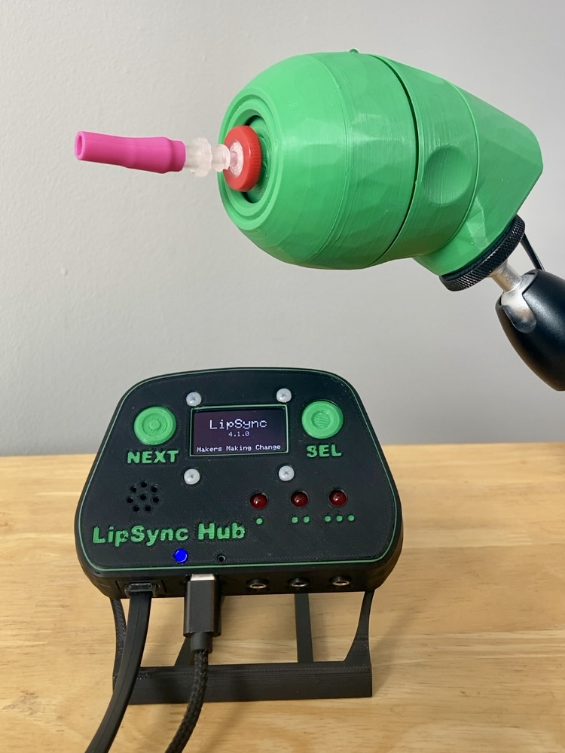

Contents
Overview 1
Maker Checklist 5
Maker To Do List 5
Items to Give to User 5
Tool List 6
Tools/ Equipment 6
Supplies 6
Custom PCB Guide 7
Ordering the Custom PCB 7
3D Printing Guide 8
3D Printing Summary 8
3D Printing Settings 8
Customization Options 9
Joystick 9
Hub 9
Post-Processing 10
Examples of Quality Prints 10
Master Component List 12
Assembly Guide 21
Part A: Hub PCB Assembly 23
Part A: Components 23
Part A: Tools 24
Part A: Personal Protective Equipment (PPE) 24
Part A: Hub PCB Assembly Steps 25
Part B: Joystick Component Preparation 32
Part B: Components 32
Part B: Tools 32
Part B: Personal Protective Equipment (PPE) 32
Part B: Assembling Hub Enclosure Steps 33
Part C: Flashing Firmware 37
Part C: Components 37
Part C: Tools 37
Part C: Firmware Flashing Steps 38
Part D: Hub Enclosure Assembly 42
Part D: Components 42
Part D: Tools 43
Part D: Personal Protective Equipment (PPE) 43
Part D: Assembling Hub Enclosure Steps 44
Part E: Joystick Gimbal Assembly 49
Part E: Components 49
Part E: Tools 50
Part E: Personal Protective Equipment (PPE) 50
Part E: Joystick Gimbal Assembly Steps 51
Part F: Joystick Housing Assembly 63
Part F: Components 63
Part F: Tools 64
Part F: Personal Protective Equipment (PPE) 64
Part F: Assembling Joystick Housing Steps 65
Part G: Mouthpiece Assembly 74
Part G: Components 74
Part G: Tools 74
Part G: Personal Protective Equipment (PPE) 74
Part G: Assembling the Mouthpiece Steps 75
Part H: Initial LipSync Setup and Testing 78
Part H: Components 78
Part H: Initial LipSync Setup Steps 78
Testing Guide 80
Testing the LipSync 80
Testing Mouse Mode 80
Testing Sip and Puff 80
Testing External Switches 81
Testing Hub Buttons 81
Troubleshooting 82

Maker Checklist
This list provides an overview of the steps required to build and deliver the device.

Maker To Do List
- Read through the Maker Guide to become familiar with required components, tools, supplies, safety equipment, and overall assembly steps.
- Talk to User about customization options (e.g., color, any special requests, etc.)
  - Hub Color
  - Joystick Color
  - Hub Stand
- Order Custom PCBs.
- Order hardware components.
- Print 3D printed components.
- Gather tools, supplies, and safety equipment.
- Assemble the LipSync Hub.
- Assemble the LipSync Joystick.
- Assemble the LipSync Mouthpieces.
- Assemble and flash firmware to the LipSync.
- If requested, print and assemble the Hub Stand.
- Test the LipSync.
- Print LipSync Info Sheet.

Items to Give to User
- (1) LipSync Joystick. Assembled and tested.
- (1) LipSync Hub. Assembled, flashed, and tested.
- (1) LipSync Interface Cable.
- (1) USB-C Cable.
- (5) Mouthpiece Assemblies, sealed in a clean baggy.
- Printed Info Sheet

Tool List

Tools/ Equipment
Tool | Description |  | Notes
T01 | Soldering Iron | Required | For soldering electronic components.
T02 | Flush cutters | Required | For trimming soldered leads
T03 | Needle Nose Pliers | Recommended | Installing bearings; routing cables.
T04 | Crescent wrench / wrench / hex key | Recommended | For installing tee nuts into Hub and Joystick enclosures.
T05 | Screwdriver, Phillips, Small | Required | A jeweller’s screwdriver or similar for securing M2.5 machine screws.
T06 | Sandpaper / Files | Recommended | Cleaning up 3d prints; fixing bearing fits
T07 | Computer with Arduino IDE | Required | For flashing firmware to microcontroller

Supplies
Supplies ID | Description | Quantity | Notes
S01 | Solder

Custom PCB Guide
The LipSync V4.0 uses one (1) custom circuit board for the Hub.
The Custom PCB can be ordered from one of a variety of PCB Manufacturers. Typically, the minimum quantity for a custom PCB is five. Shipping options vary significantly in cost and shipping time. Plan on at least a week from the time of order to the PCBs arrival.

Ordering the Custom PCB
- Select a PCB Fabrication Company
  - JLPCB
  - PCBWay
  - OSH Park
  - Seeed Fusion PCB
- Create an account or use a guest login.
- Upload the Gerber Files (e.g., LipSync_Hub_PCB_YYY-MM-DD.zip).
- Select the fabrication options:
  - PCB Layers: 2 Layers
  - PCB Quantity: 5
  - PCB Thickness: 1.5 mm
  - Surface Finish: HASL
  - PCB Color: Choose what you like. Note that certain colors may impact build time.
  - The default settings for the other settings should work.
- Select shipping option.
  - Shipping options and costs vary significantly. Select the best option based on your budget and timing.
- Submit the order.
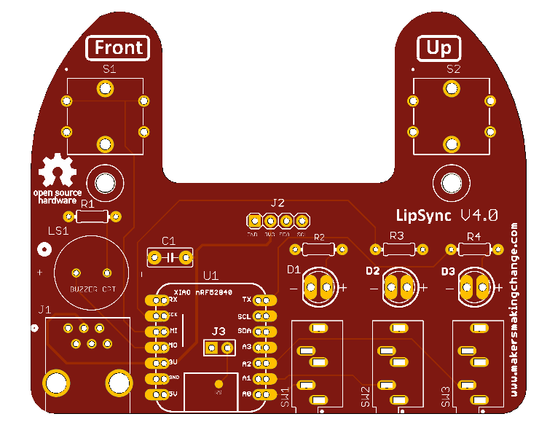

3D Printing Guide
The 3D printable parts of the LipSync were designed for and tested on well-calibrated, modern consumer-grade fused filament fabrication (FFF) printers (e.g., Prusa Mk3S, Bambu P1S). All parts were printed in PLA. Unless otherwise requested by the user, the recommended color for all parts is black.
 | CAUTION: It is not recommended to use alternative print processes (e.g., Stereolithography (SLA)) as the parts may not fit correctly.

3D Printing Summary
Metrics | LipSync Hub | LipSync Joystick | Complete Unit
Total Print Time (min) | 4:16 | 9:58 | 13:50
Total Number of Components | 5 | 11 | 16
Typical Total Mass (g) | 49 | 103 | 151
Typical Number of Print Setups | 1 | 2 | 2

3D Printing Settings
Table 1: LipSync Joystick 3D Printing Settings
Print File Name | Qty | Total Print Time (hr:min) | Mass (g) | Infill (%) | Support  (Y/N) | Layer Height/ Nozzle Diameter(mm) | Notes
LS4_Inner_Gimbal_1.stl | 1 | 0:29 | 3 | 20 | N | 0.2/0.4 | - You may require paint-on supports on the arm going to the magnet slot
LS4_Inner_Gimbal_2.stl | 1 | 0:30 | 3 | 20 | N | 0.2/0.4 | - You may require paint-on supports on the arm going to the magnet slot
LS4_Outer_Gimbal_1.stl | 1 | 0:19 | 2 | 20 | N | 0.2/0.4
LS4_Outer_Gimbal_2.stl | 1 | 0:19 | 2 | 20 | N | 0.2/0.4
LS4_Gimbal_Shield.stl | 1 | 0:18 | 4 | 20 | N | 0.2/0.4
LS4_Magnet_Clip.stl | 2 | 0:02 | 1 | 20 | N | 0.2/0.4
LS4_Gimbal_Sled.stl | 1 | 0:43 | 5 | 20 | N | 0.2/0.4
LS4_Front_Cap.stl | 1 | 0:58 | 14 | 20 | N | 0.2/0.4 | Change outer seam to random
LS4_Joystick_Housing.stl | 1 | 2:05 | 27 | 20 | N | 0.2/0.4 | Change outer seam to random
LS4_Outer_Locking_Ring.stl | 1 | 1:15 | 17 | 20 | N | 0.2/0.4 | Change outer seam to random
LS4_Inner_Locking_Ring.stl | 1 | 0:33 | 6 | 20 | N | 0.2/0.4
LS4_Rear_Housing.stl | 1 | 2:27 | 22 | 20 | N | 0.2/0.4 | Change outer seam to random

Table 2: LipSync Hub 3D Printing Settings
Print File Name | Qty | Total Print Time (hr:min) | Mass (g) | Infill (%) | Support(Y/N) | Layer Height/ Nozzle Diameter(mm) | Notes
LS4_Hub_Top | 1 | 1:34 | 20 | 15 | N | 0.2/0.4
LS4_Hub_Bottom | 1 | 2:07 | 26 | 15 | N | 0.2/0.4
LS4_Hub_LED_Spacer | 1 | 0:13 | 2 | 15 | N | 0.2/0.4
LS4_Hub_Next_Button_Pusher | 1 | 0:11 | 1 | 15 | N | 0.2/0.4
LS4_Hub_SEL_Button_Pusher | 1 | 0:11 | 1 | 15 | N | 0.2/0.4

Customization Options

Joystick
Each outward facing component of the Joystick enclosure (Front Cap, Joystick Housing, Outer Locking Ring, and Rear Housing) can be printed in a combination of different or matching colors to customize the look of the LipSync Joystick. Otherwise, muted or neutral tones (e.g., black or grey) are generally preferred.

Hub
There are several options for customizing the look of the LipSync Hub depending on the color(s) of the filament available.
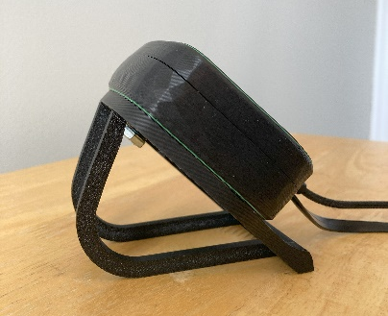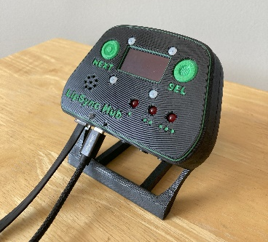

Matching
Print the Hub Top, Hub Bottom, and both Buttons in the same color.

Different Colored Buttons
Print the buttons in a different color from the Hub Top, and optionally different from each other.

High Contrast Labels
Use a layer-based color swap so the labels are a different color than the surface of the Hub. This can be done on both the Hub Top and Hub Bottom. A second layer swap can be used to make the Hub Enclosure look consistent.

Post-Processing
Remove any stringing or rough edges of parts with a hobby knife, seam remover, or other appropriate tool.

Examples of Quality Prints
Joystick
LS4_Inner_Gimbal_1.stl | LS4_Inner_Gimbal_2.stl | LS4_Outer_Gimbal_1.stl
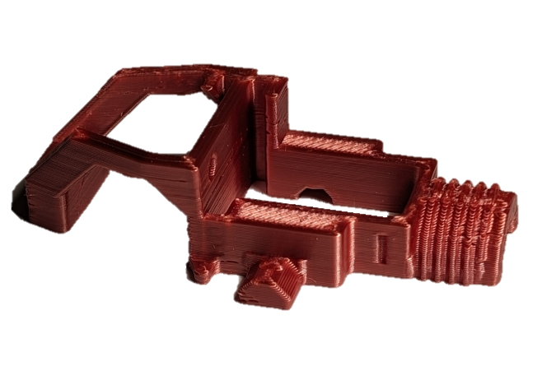 | 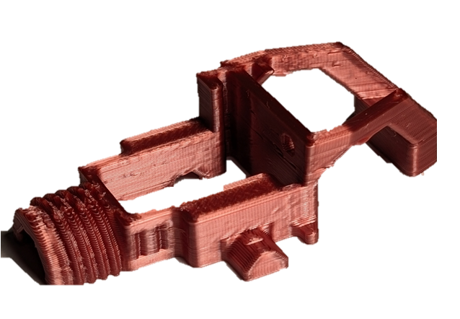 | 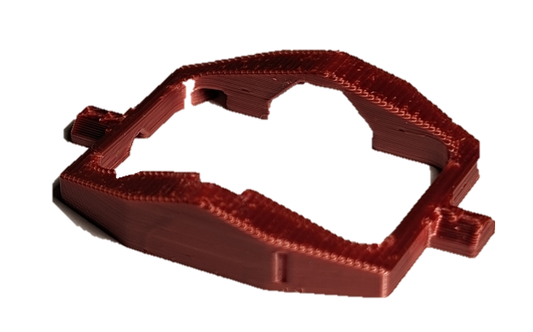
LS4_Outer_Gimbal_2.stl | LS4_Gimbal_Shield.stl | LS4_.Gimbal_Sled.stl
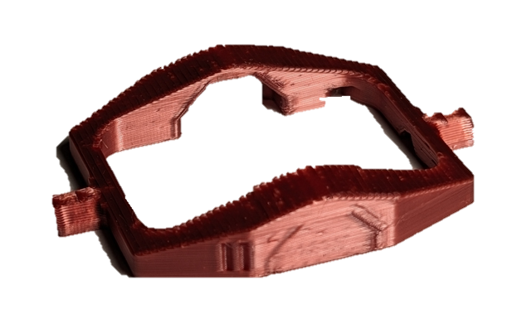 | 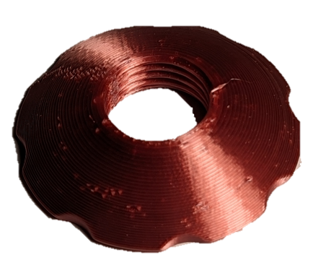 | 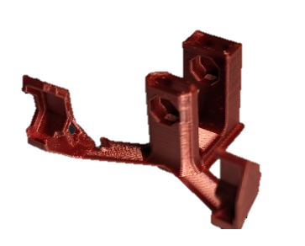
LS4_Magnet_Clip.stl | LS4_Front_Cap.stl | LS4_Joystick_Housing.stl
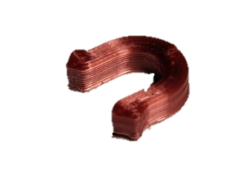 | 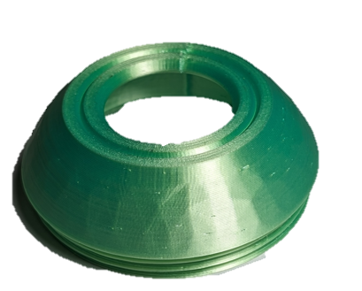 | 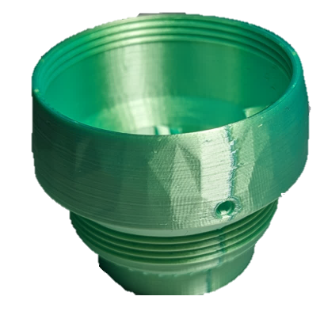
LS4_Inner_Locking_Ring.stl | LS4_Outer_Locking_Ring.stl | LS4_Rear_Housing.stl
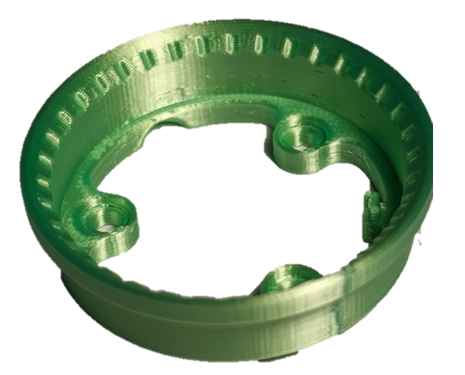 | 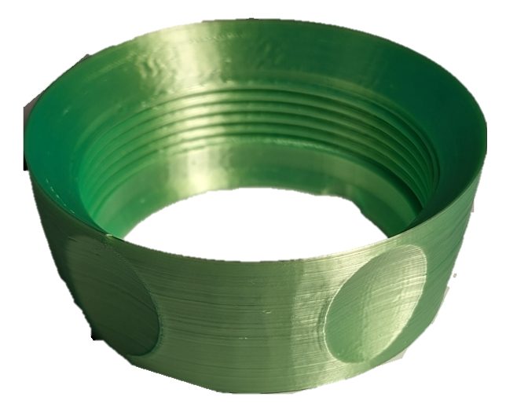 | 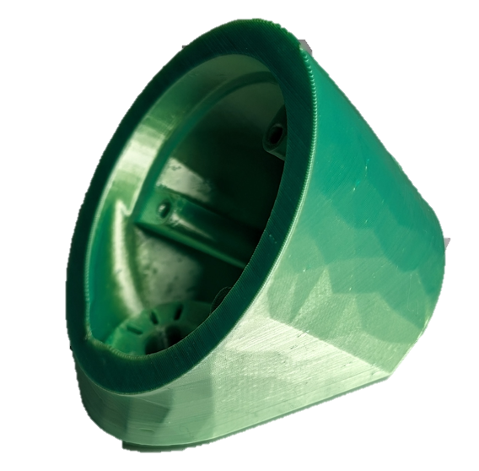
Hub
LS4_Hub_Bottom.stl | LS4_Hub_.stl | LS4_Hub_Next_Button.stl
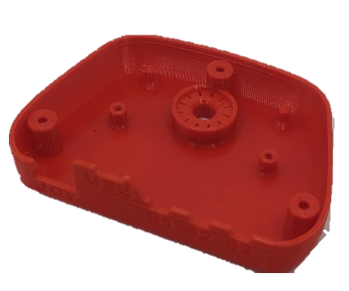 | 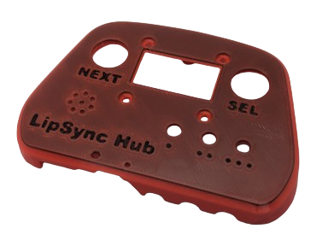 | 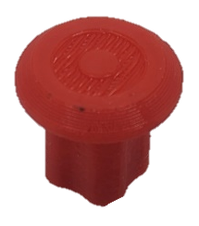
LS4_Hub_Select_Button.stl | LS4_Hub_LED_Spacer.stl
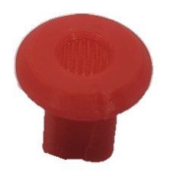 | 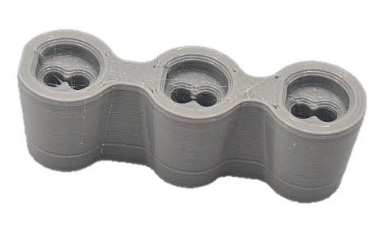

Master Component List
Part A Components
A1 | LipSync Hub PCB | QTY 1 | A2 | Capacitor, 10uF | QTY 1 | A3 | Resistor R1, 100 Ω, ¼ W, Through hole | QTY 1
 |  |  | 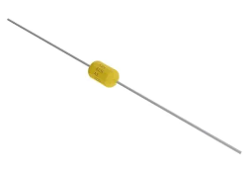 |  |  | 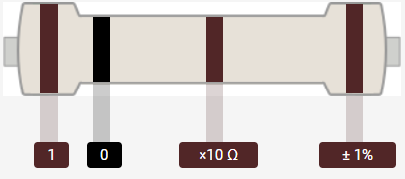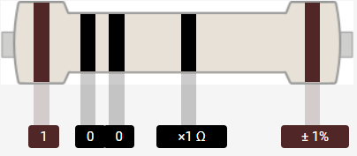
A4 | Resistor R2/R3/R4 68 Ω, ¼ W, Through hole | QTY 3 | A5 | Tactile Buttons S1/S2 | QTY 2 | A6 | Piezo Buzzer PS1240 | QTY 1
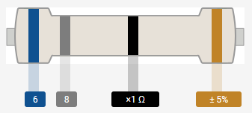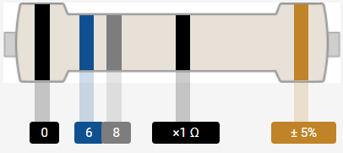 |  |  | 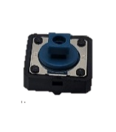 |  |  | 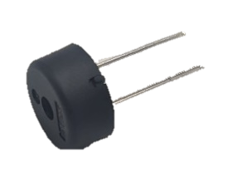
A7 | Male Header, 4 position | QTY 1 | A8 | Sparkfun QWIIC Adapter | QTY 1 | A9 | Mono Switch Jacks | QTY 3
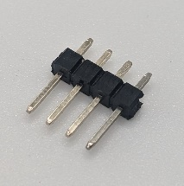 |  |  | 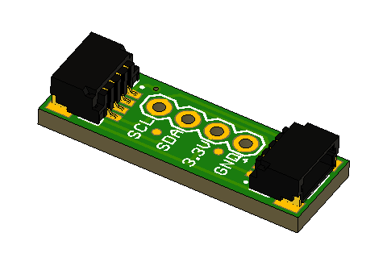 |  |  | 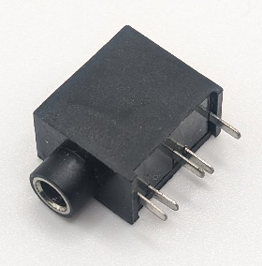
A10 | RJ11 Modular Connector Jack | QTY 1 | A11 | SeeedStudio Xiao nrF52840 | QTY 1 | A12 | Male Header, 7 position | QTY 2
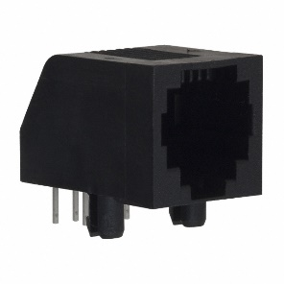 |  |  | 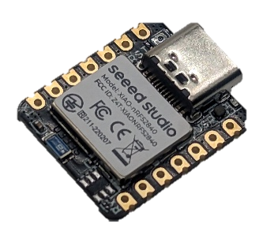 |  |  | 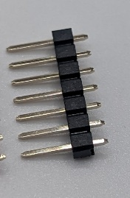
A13 | Headers, Female, 7 Position | QTY 2 | A14 | LEDs, 5mm though hole | QTY 3 | A15 | LipSync Hub LED Spacer | QTY 1
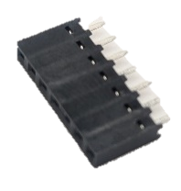 |  |  | 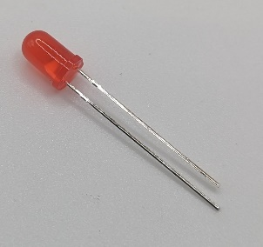

Part B Components
B1 | RJ11 Breakout Board | QTY 1 | B2 | RJ11 Jack | QTY 1 | B3 | Cable, STEMMA – DuPont, 150 mm | QTY 1
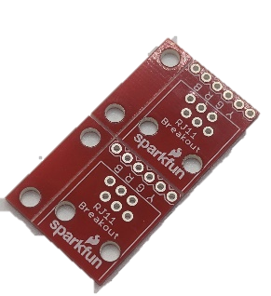 |  |  |  |  |  | 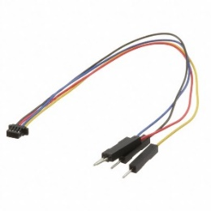
B4 | LPS22 STEMMA QT Board | QTY 1 | B5 | TLV493D STEMMA QT Board | QTY 1 | B6 | LPS33 STEMMA QT Board | QTY 1
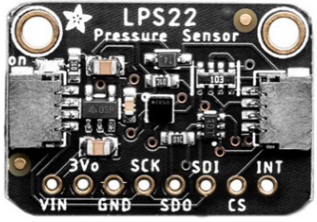 |  |  | 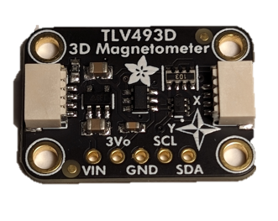 |  |  | 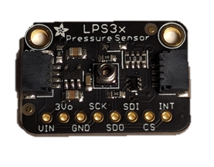
B7 | Cable, STEMMA, 200 mm | QTY 1 | B8 | Cable, STEMMA, 50 mm | QTY 1
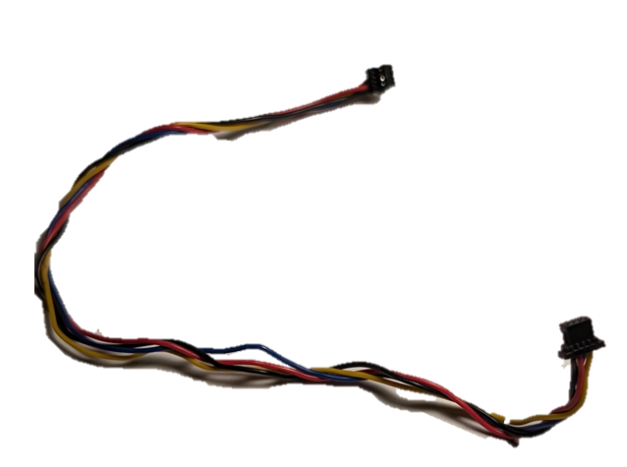 |  |  | 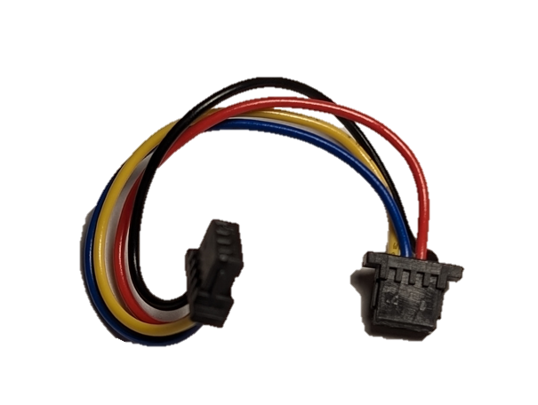

Part C Components
C1 | Populated LipSync 4 Hub PCB | QTY 1 | C2 | STEMMA QT Cable – 100 mm | QTY 1 | C3 | OLED Display | QTY 1
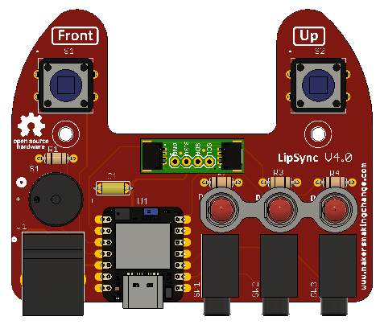 |  |  | 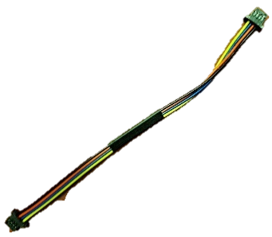 |  |  | 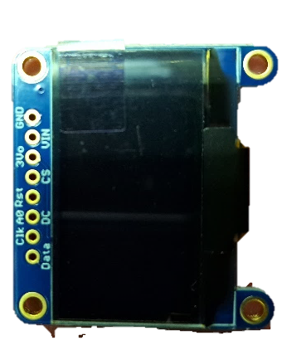
C4 | Joystick Component Assembly | QTY 1 | C5 | LipSync Interface Cable (RJ11) | QTY 1 | C6 | USB-C-USB-A Cable | QTY 1
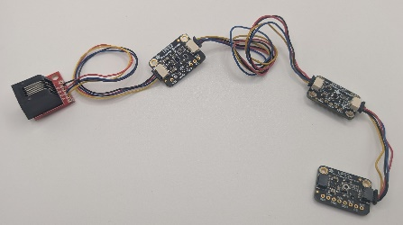 |  |  | 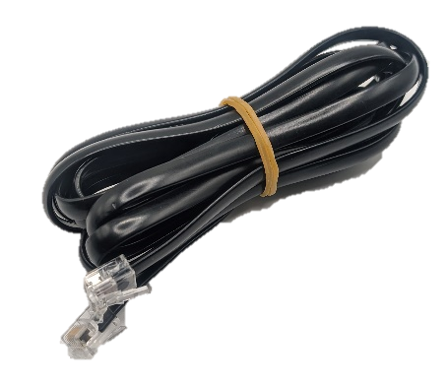 |  |  | 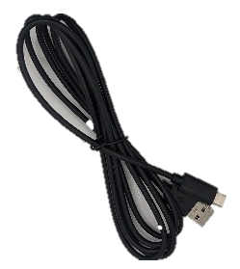

Part D Components
D1 | Populated LipSync 4 Hub PCB | QTY 1 | D2 | STEMMA QT Cable – 100 mm | QTY 1 | D3 | OLED Display | QTY 1
 |  |  |  |  |  | 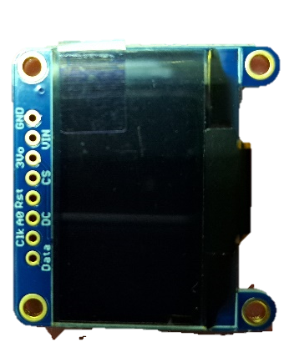
D4 | LipSync Hub Enclosure Top | QTY 1 | D5 | LipSync Next Button Pusher | QTY 1 | D6 | LipSync Select Button Pusher | QTY 1
 |  |  | 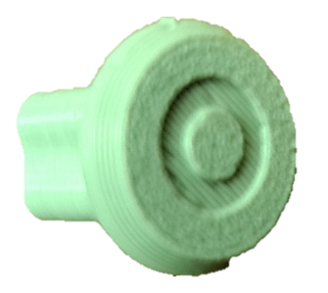 |  |  | 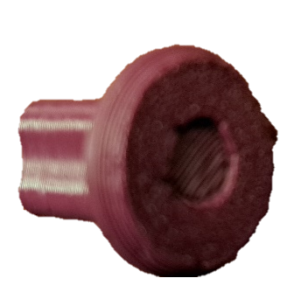
D7 | LipSync Hub Enclosure Bottom | QTY 1 | D8 | Screw, #4, 3/8” Length | QTY 5 | D9 | M2.5 Machine Screw, 8 mm | QTY 4
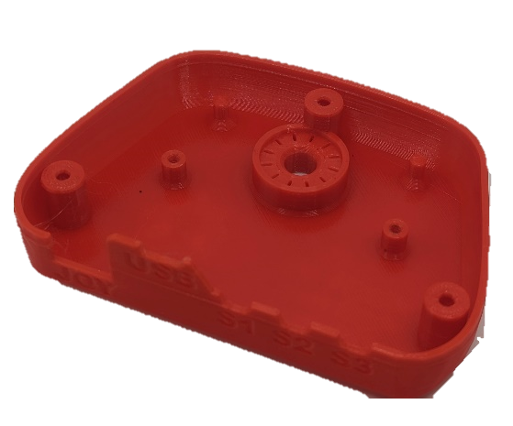 |  |  | 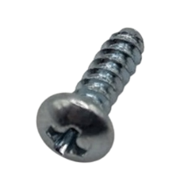 |  |  | 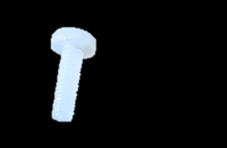
D10 | M2.5 Nut | QTY 4 | D12 | Tee Nut | QTY 1 | D13 | Light Pipe | QTY 1
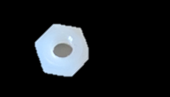 |  |  | 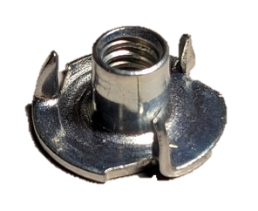 |  |  | 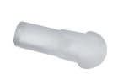

Part E Components
E1 | Inner_Gimbal_1 | QTY 1 | E2 | Inner_Gimbal_2 | QTY 1 | E3 | Outer_Gimbal_1 | QTY 1
E4 | Outer_Gimbal_2 | QTY 1 | E5 | Gimbal Shield | QTY 1 | E6 | Sled | QTY 1
E7 | Magnet Retainment | QTY 2 | E8 | LPS33 STEMMA QT Board | QTY 1 | E9 | TLV493D STEMMA QT Board | QTY 1
E10 | Male Luer Connector | QTY 1 | E11 | 2mm ID 4mm OD Tube | QTY 1 | E12 | Cable, STEMMA, 200 mm | QTY 1
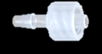 |  |  | 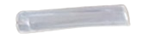
E13 | Magnet | QTY 3 | E14 | Bearings | QTY 4 | E15 | Cable, STEMMA, 50 mm | QTY 1
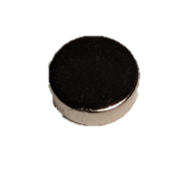 |  |  | 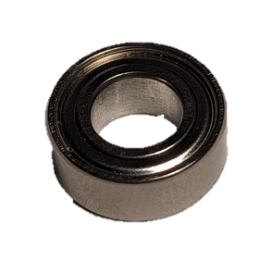
E16 | M2.5 Nut | QTY 2 | E17 | M2.5 Machine Screw, 8 mm | QTY 2
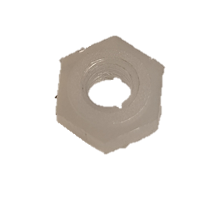 |  |  | 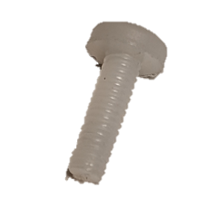

Part F Components
F1 | Front Cap | QTY 1 | F2 | Joystick Housing | QTY 1 | F3 | Inner Locking Ring | QTY 1
 |  |  | 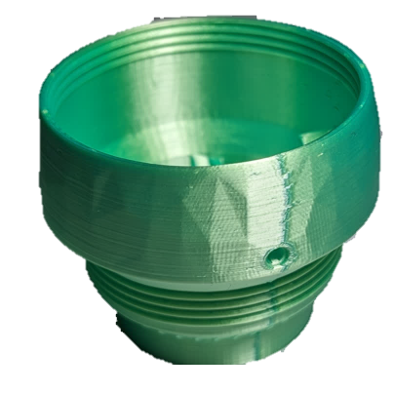
F4 | Outer Locking Ring | QTY 1 | F5 | Rear Housing | QTY 1 | F6 | LPS22 STEMMA QT Board | QTY 1
F7 | RJ11 STEMMA QT Connector | QTY 1 | F8 | M2.5 x Machine Screw | QTY 1 | F9 | M2.5 Nut | QTY 1
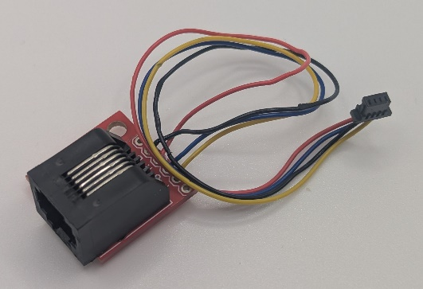
F10 | Light Pipe 0.250” | QTY 1 | F11 | ¼-20 Tee Nut | QTY 1 | F12 | Screw, #4, 3/8” Length | QTY 3
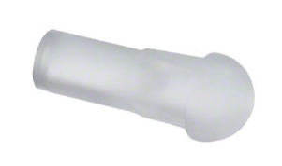 |  |  |  |  |  | 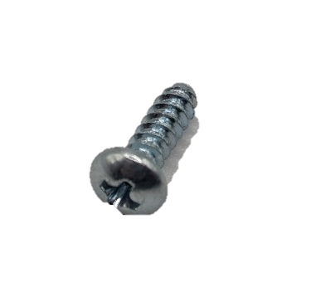
F13 | Assembled Joystick Gimbal | QTY 1
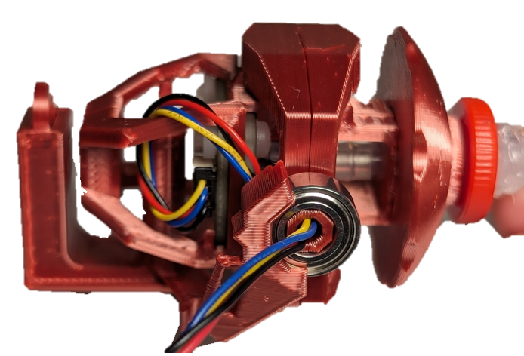

Part G Components
G1 | Syringe FIlter | QTY 6 | G2 | Mouthpiece Adapter,  1/4” Barb Connector to Female Luer | QTY 6 | G3 | Silicone Straw | QTY 2
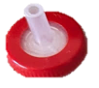 |  |  | 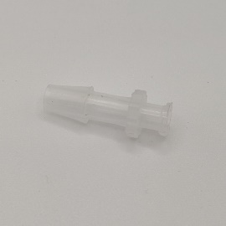 |  |  | 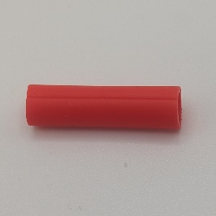
G4 | Resealable Bag
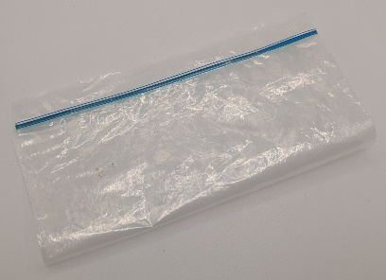

Part H Components
H1 | LipSync System | QTY 1 | H2 | LipSync Mouthpiece | QTY 1 | H3 | Host Device | QTY 1
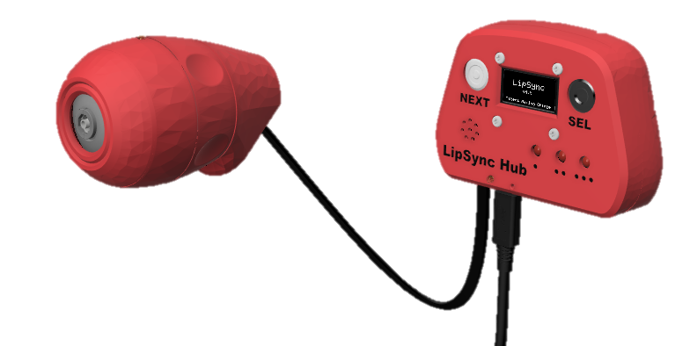 |  |  | 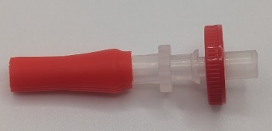 |  |  | 

Assembly Guide

The assembly of the LipSync is divided into several parts. In Part A, the Hub PCB is populated. In Part B, the joystick components are prepared. In Part C, the firmware is updated and tested with the Hub PC and Joystick components. In Part D, the Hub PCB is assembled along with other components into the Hub Enclosure. In Part E, the joystick mechanism is assembled. In Part F, the joystick mechanism is assembled into the Joystick Enclosure. In Part G, the mouthpiece components are assembled. In Part H, the LipSync is powered on and calibrated.
It is recommended to follow the assembly instructions in the order provided. A video build guide can be found here or by scanning the QR code to the right.

Assembly Section
Part A: Hub PCB Assembly | 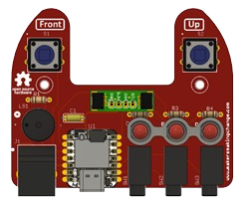
Part B: Joystick Component Preparation | 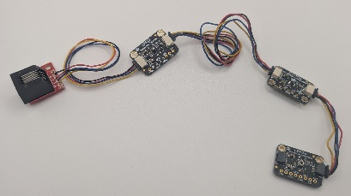
Part C: Flashing Firmware | 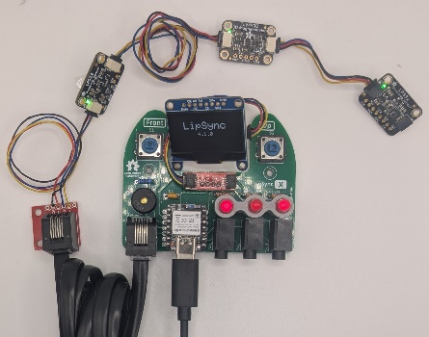
Part D: Hub Enclosure Assembly | 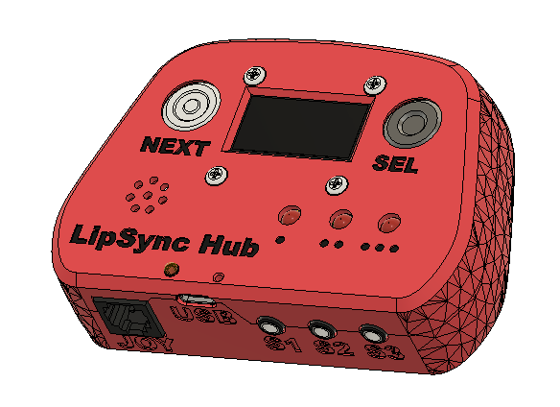
Part E: Joystick Gimbal Assembly | 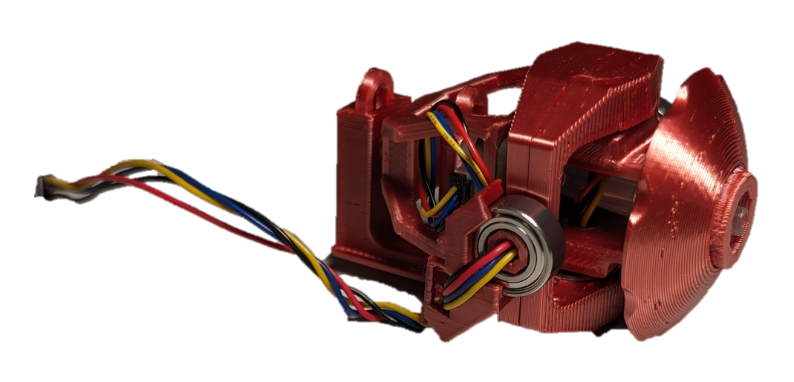
Part F: Joystick Housing Assembly | 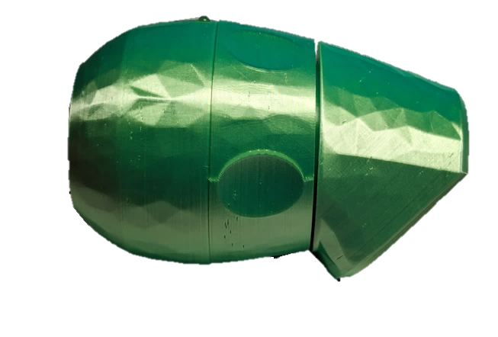
Part G: Mouthpiece Assembly | 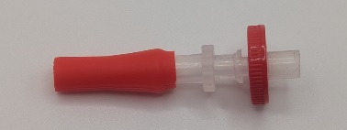
Error! Not a valid result for table. | 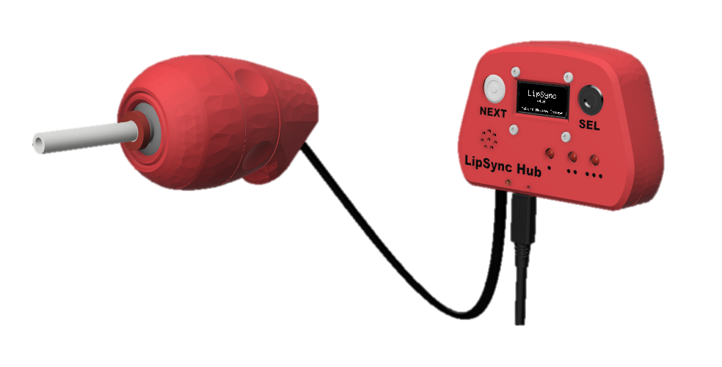

Part A: Hub PCB Assembly

Part A: Components
A1 | LipSync 4 Hub PCB | QTY 1 | A2 | Capacitor, 10uF | QTY 1 | A3 | Resistor R1, 100 Ω, ¼ W, Through hole |  | QTY 1
A4 | Resistor R2/R3/R4 68 Ω, ¼ W, Through hole | QTY 3 | A5 | Tactile Buttons S1/S2 | QTY 2 | A6 | Piezo Buzzer PS1240 |  | QTY 1
A7 | Male Header, 4 position | QTY 1 | A8 | Sparkfun QWIIC Adapter | QTY 1 | A9 | Mono Switch Jacks |  | QTY 3
A10 | RJ11 Modular Connector Jack | QTY 1 | A11 | SeeedStudio Xiao nrF52840 | QTY 1 | A12 | Male Header, 7 position | QTY 2
A13 | Headers, Female, 7 Position | QTY 2 | A14 | LEDs, 5mm though hole | QTY 3 | A15 | LipSync Hub LED Spacer | QTY 1

Part A: Tools
- Soldering iron
- Flush cutters
- Phillips Head Screwdriver
- OPTIONAL: Solderless Breadboard (For soldering male headers to microcontroller)

Part A: Personal Protective Equipment (PPE)
- Safety glasses

Part A: Hub PCB Assembly Steps
Note that all parts will be inserted onto the side of the PCB labeled “Front”, and all soldering will be done on the side labeled “Back”.

Step A-01: Solder in 10 micro Farad capacitor, C1.
Insert the 10 micro-Farad (µF) capacitor (A2) into the position labeled C1 on the PCB (A1). Bend the leads of the capacitor to the side to hold it in place. Solder the capacitor onto the PCB. Once soldered, trim the extra from the leads.
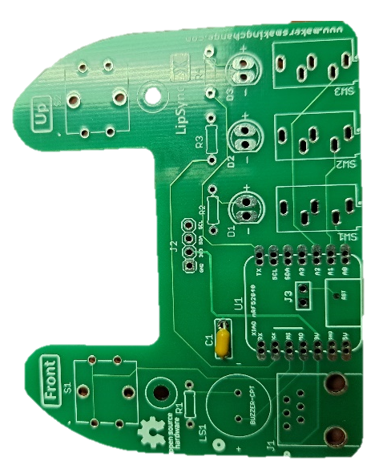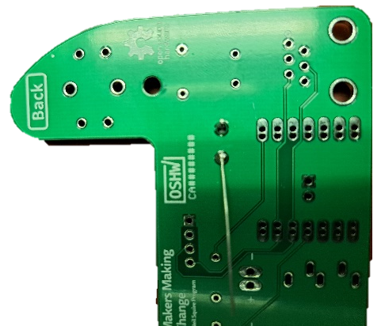

Step A-02: Solder in 100 Ohm resistor, R1.
Insert the 100 Ohm resistor (A3) into the position labeled R1 on the PCB. Bend the leads of the resistor to the side to hold it in place. Solder the resistor onto the PCB. Once soldered, trim the extra from the leads.
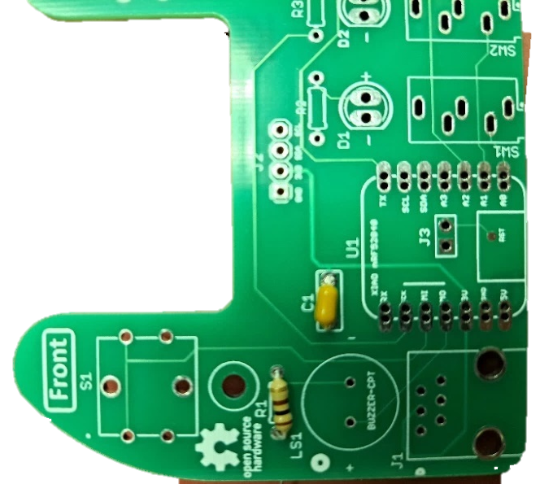

Step A-03: Solder in 68 Ohm resistors, R2, R3, and R4.
Insert the 68 Ohm resistors (A4) into the positions labeled R2, R3, and R4 on the PCB. Bend the leads of the resistors to the side to hold them in place. Solder the resistors onto the PCB. Once soldered, trim the extra from the leads.
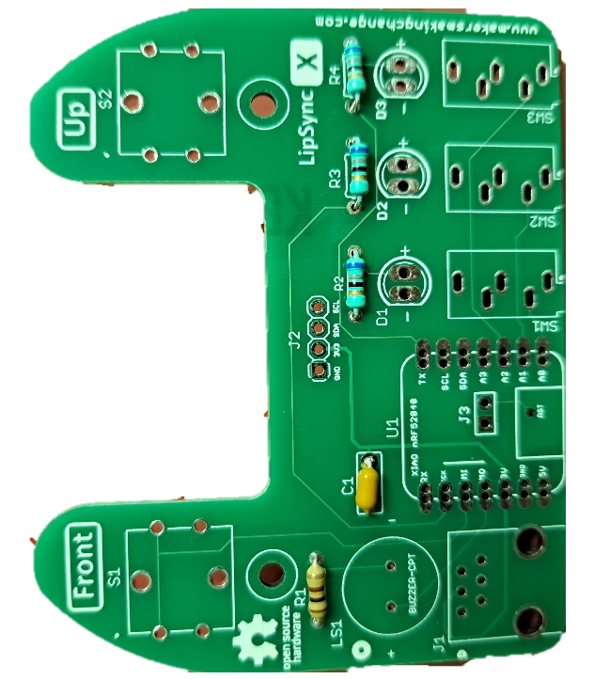

Step A-04: Insert, solder, and trim the 4-pin Male header.
Insert the longer pins of the 4-pin male header (A7) into the position labeled J2. Solder it into place and trim the excess from the bottom.
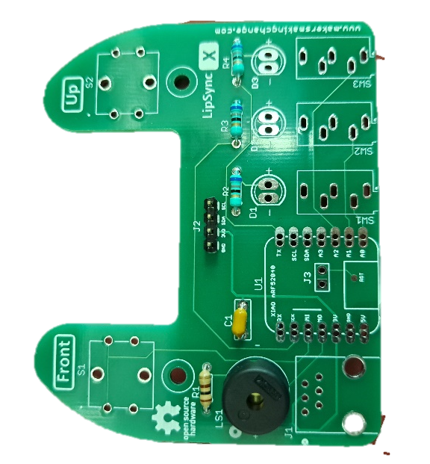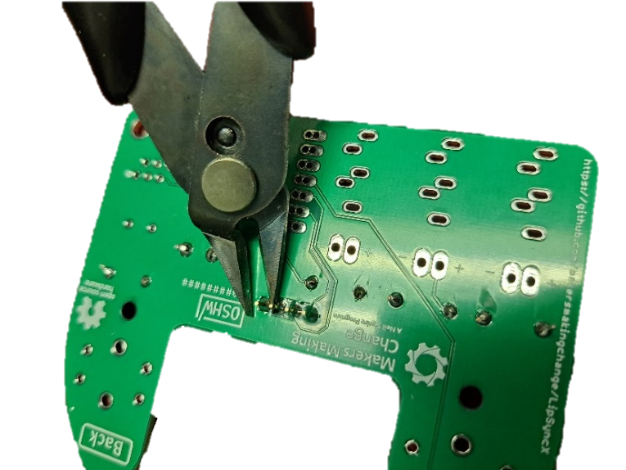

Step A-05: Insert, solder, and trim buzzer.
Insert the buzzer (A6) into the position labeled LS1. If using a buzzer with polarity, make sure the positive lead is in the hole marked with a “+” on the PCB. Note that the Piezo Buzzer PS1240 does not have polarity. Bend the leads to the side to hold the buzzer in place. Solder in place and trim excess from the leads.
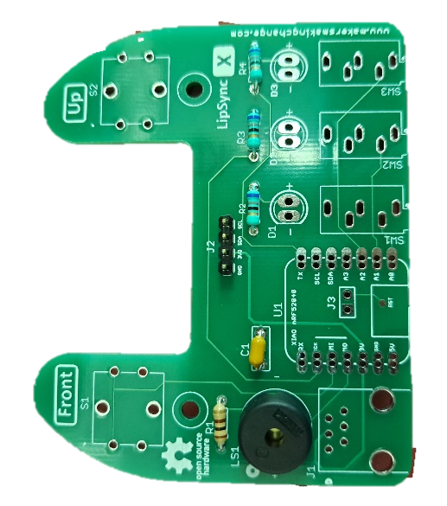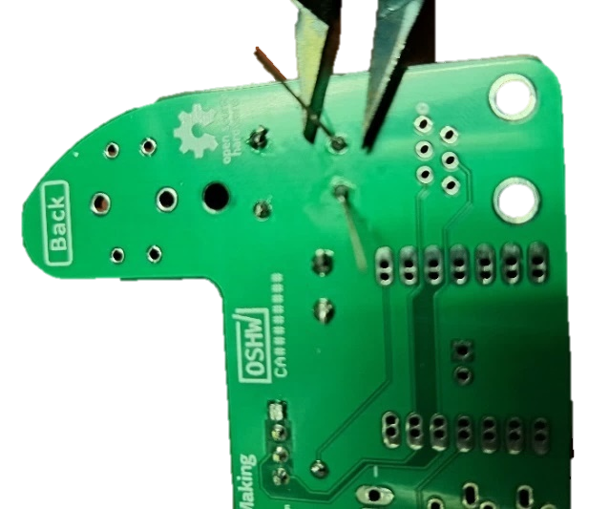

Step A-06: Insert, solder, and trim switches.
Insert the two tactile switches (A5) into the positions labeled S1 and S2. Once soldered in place, trim any excess from leads of the switches.
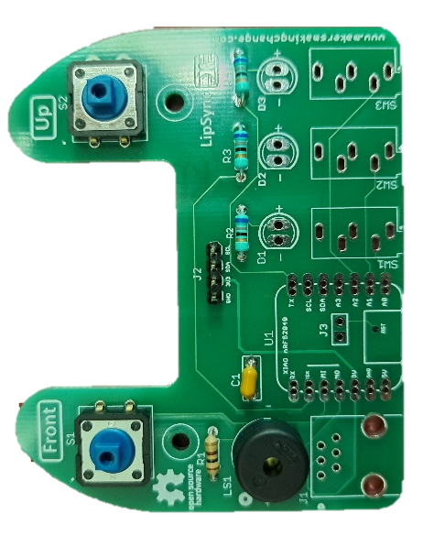

Step A-07: Insert and solder SparkFun QWIIC Adapter.
Place the SparkFun QWIIC Adapter (A8) on the 4-pin male header (A7) that was attached to J2 in step A-04. Ensure the pin labels on the adapter matches the pin labels on the Hub PCB. Solder the four pins on the adapter.
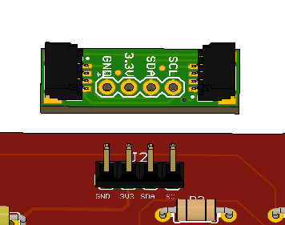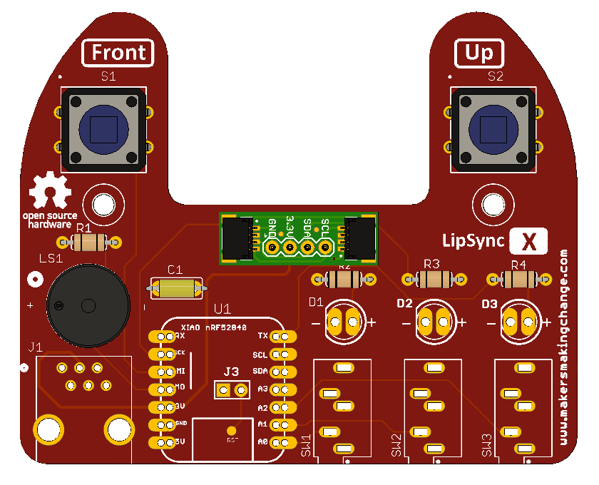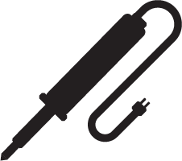

Step A-08: Insert and solder switch jacks.
Insert the switch jacks (A9) into the positions labeled SW1, SW2, and SW3. Solder one pin on each switch jack, then check the alignment. If the alignment needs to be changed, reheat the solder joint until the solder melts, then reposition the jack. Once the jacks are positioned properly, solder the remaining pins.
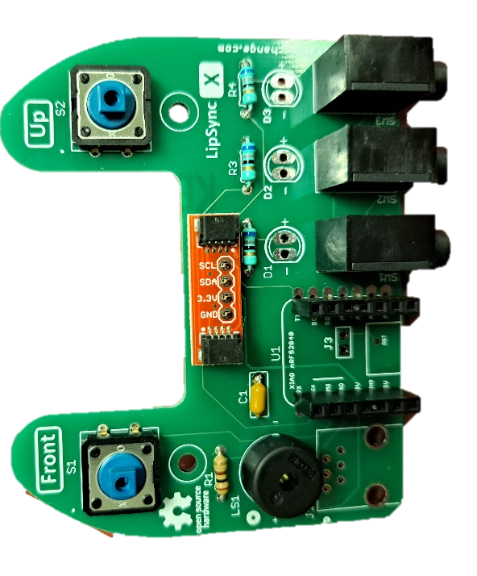

Step A-09: Solder male headers onto microcontroller.
Insert the short side of the male headers (A12) into the SeeedStudio Xiao nrf52840 microcontroller (A11) from the bottom of the board. To align the male headers and keep them straight when soldering, take the 7-position female headers (A13), and insert the male headers into the female headers across the microcontroller (as shown in the picture on the left).
Alternatively, a solderless breadboard can be used, plug the unsoldered microcontroller and headers into the protoboard and the protoboard will hold the headers in the proper alignment.
Solder the male headers onto the microcontroller, making sure not to connect adjacent pads together with solder. Once soldered, remove the 7-pin female headers from the male headers.
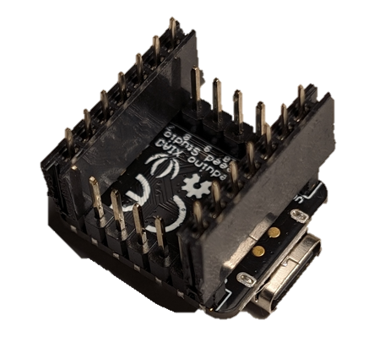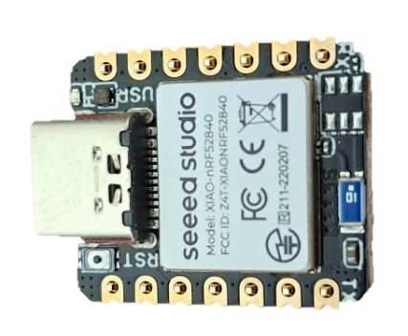

Step A-10: Solder female microcontroller header into PCB.
Insert microcontroller with male headers into the female headers (A13). Insert the female headers into PCB. Solder 1 pin on each header. Check alignment and adjust if necessary. If you need to adjust the alignment, heat the single soldered pin until the solder melts again and adjust the position of the row of headers. Once aligned, solder remaining headers.
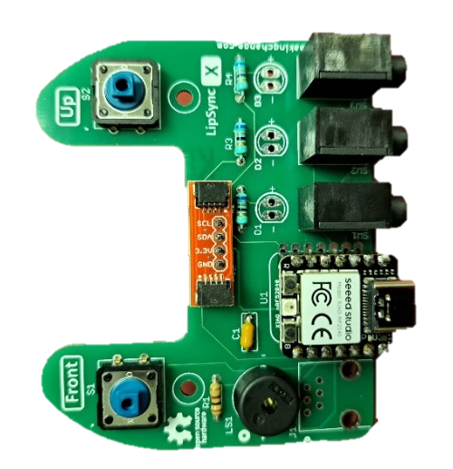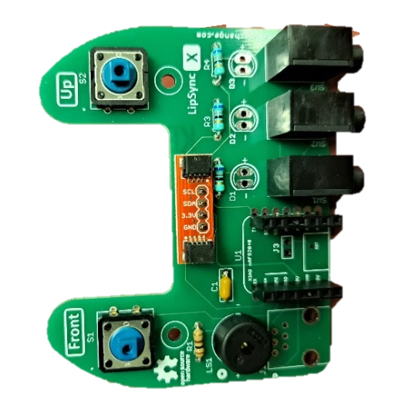

Step A-11: Insert and solder the RJ11 jack.
Insert the RJ11 jack (A10) into the position labeled J1 on the PCB. Solder the six pins into place.
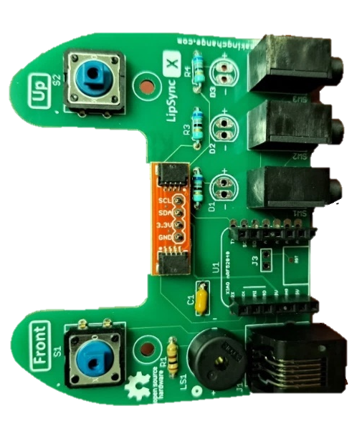

Step A-12: Insert, solder, and trim LEDS.
Insert the three LEDs (A14) into the 3D printed LED Spacer(A15). Ensure the shorter lead of the LED (the negative lead) is on the same side as the flat edge of the LED Spacer. The LED will also have a flat edge matching the flat edge on the spacer.
With the LEDs inserted into the spacer, insert the LEDs into the matching holes in the PCB. The flat side of the LED spacer should be on the left with the rounded side on the right, when looking at the PCB from the front. Solder the LEDs in place and trim the excess from the leads.
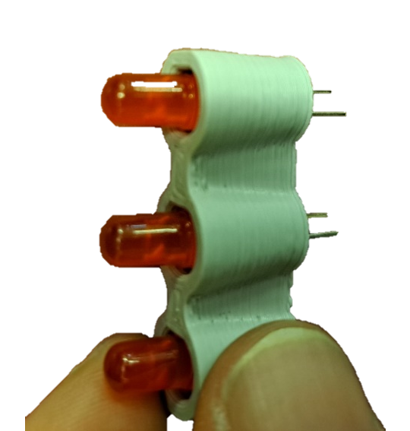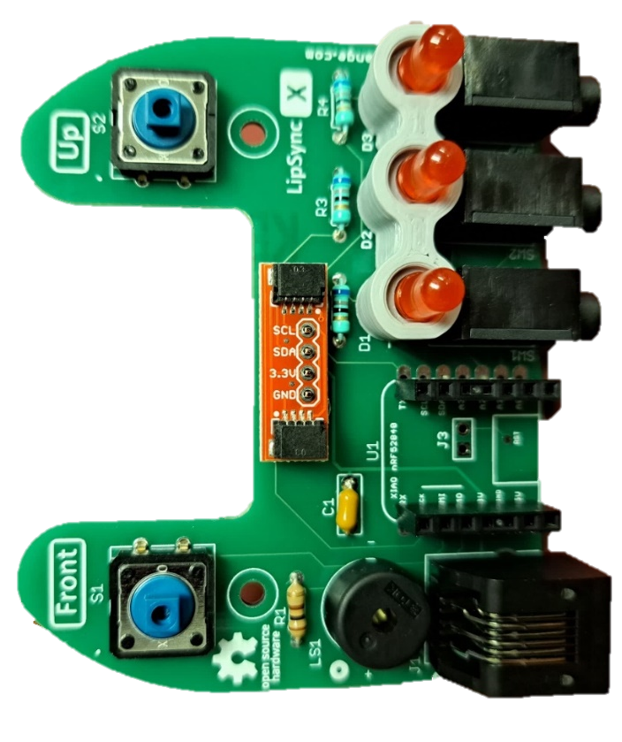

Part A Complete
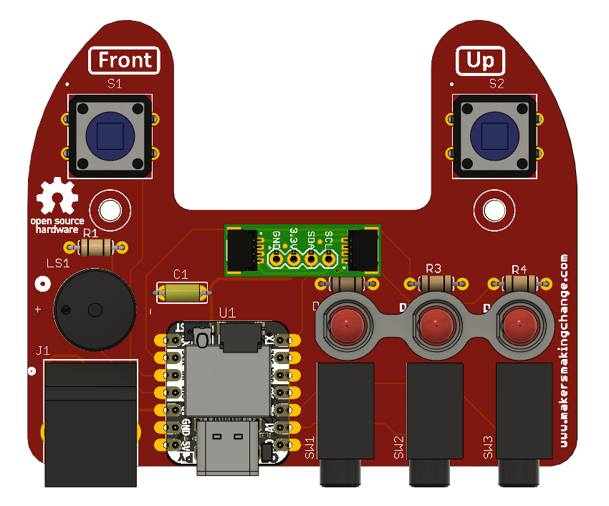

Part B: Joystick Component Preparation

Part B: Components
B1 | RJ11 Breakout Board | QTY 1 | B2 | RJ11 Jack | QTY 1 | B3 | Cable, STEMMA – DuPont, 150 mm | QTY 1
B4 | LPS22 STEMMA QT Board | QTY 1 | B5 | TLV493D STEMMA QT Board | QTY 1 | B6 | LPS33 STEMMA QT Board | QTY 1
B7 | Cable, STEMMA, 200 mm | QTY 1 | B8 | Cable, STEMMA, 50 mm | QTY 1

Part B: Tools
- Soldering Iron

Part B: Personal Protective Equipment (PPE)
- Safety Glasses

Part B: Assembling Hub Enclosure Steps

Step B-01: Prepare the RJ11 Breakout Board
Separate the two RJ11 Breakout Boards (B2) by snapping them apart by hand. Make sure the thin portion with the two mounting hole remains attached. Only one is required for the build.
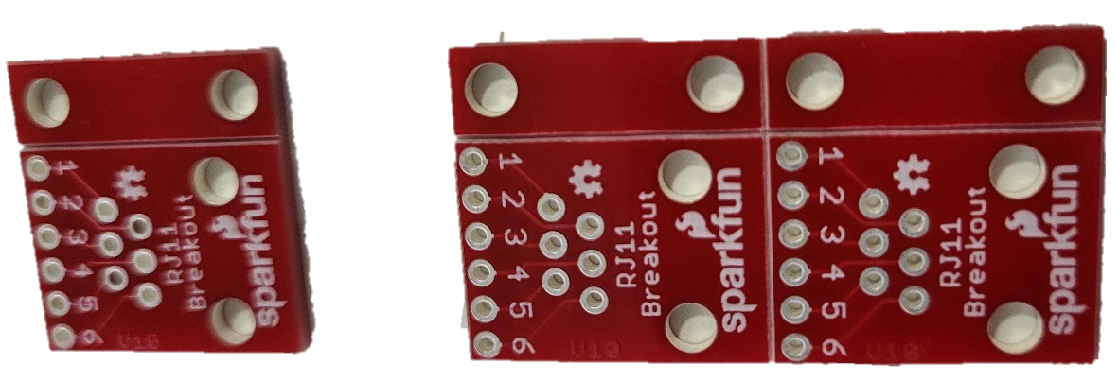

Step B-02: Solder the RJ11 jack to the RJ11 Breakout Board
Press the RJ11 Jack (B3) into the RJ 11 Breakout Board so the pins stick out of the numbered side. Solder the six RJ11 pins poking through the board, NOT THE NUMBERED HOLES.
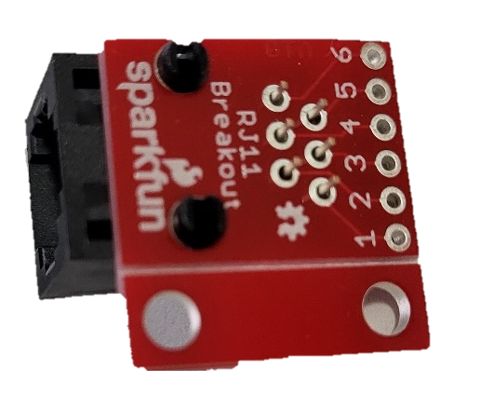

Step B-03: Solder the STEMMA QT Cable to the RJ11 Breakout Board
Cut the Dupont Headers off the Dupont STEMMA QT Cable (B4) and strip the insulation back 5 mm. Insert the stripped wires through the corresponding holes on the RJ11 Breakout Board from the same side as the RJ11 Connector, following the order in the table. Solder in place, and trim the ends sticking out the back side.
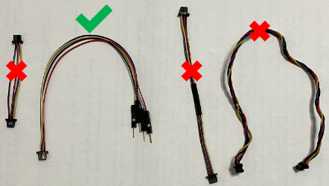 |  | 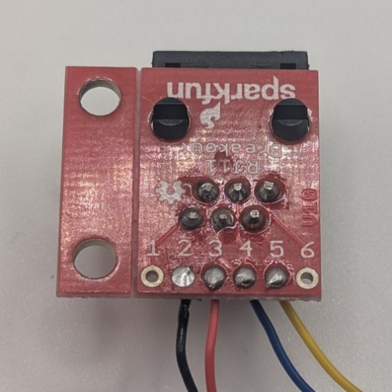
RJ 11 Breakout | STEMMA QT Cable
2 (B) | Black (Gnd)
3 (R) | Red (Vcc)
4 (G) | Blue (SDA)
5 (Y) | Yellow (SCL)

Step B-04: Solder the pads on the back of the LPS22 Pressure Sensor Board
Use solder to create a bridge between the solder pads on the back of the LPS22 STEMMA QT Board (B5) to change the default i2C address.
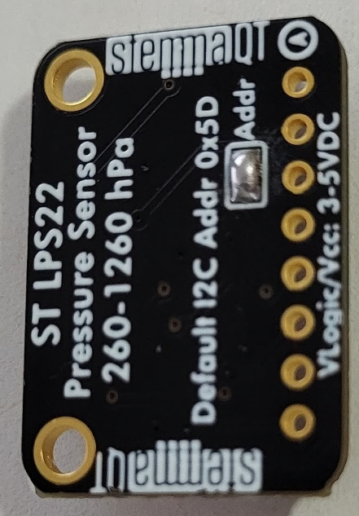

Step B-05: Attach the LPS22 Sensor to the RJ11 Assembly
Insert the STEMMA QT Connector from the RJ11 Assembly into one of the ports on the LPS22 Sensor.
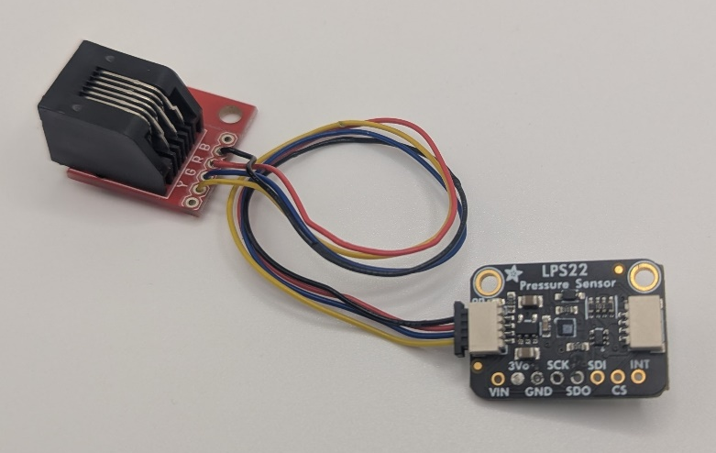

Step B-06: Connect the Magnetic Sensor to the LPS22 Sensor using the 200 mm STEMMA Cable.
Take the 200 mm STEMMA cable (B7). Attach one end to the open port on the LPS22 Sensor and the other end to one of the ports on the Magnetic Sensor (B8).
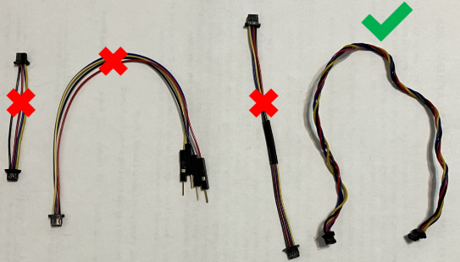 | 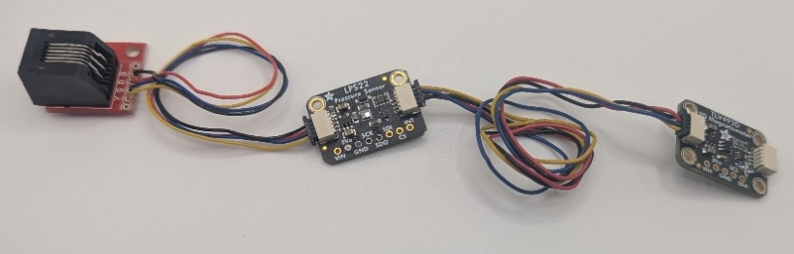

Step B-07: Connect the LP33 Pressure Sensor to the Magnetic Sensor using the 50 mm STEMMA Cable
Take the 50 mm STEMMA Cable (B8). Connect one end to the open port on the Magnetic Sensor. Connect the other end to port on the LPS33 STEMMA QT Board (B6).
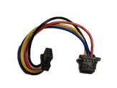  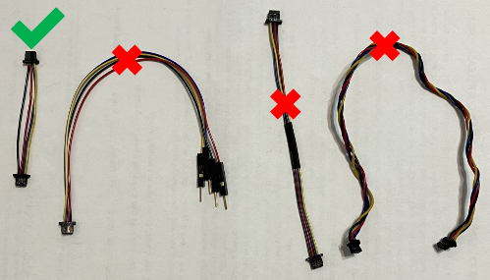  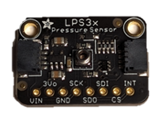 | 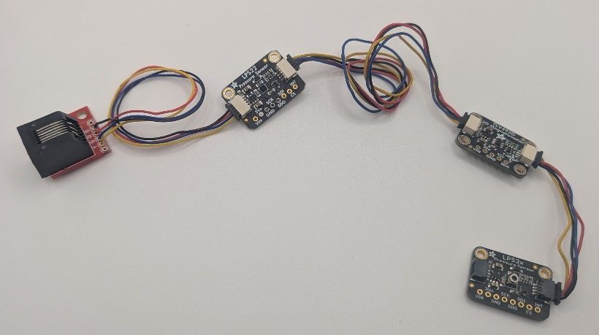

Part B Complete
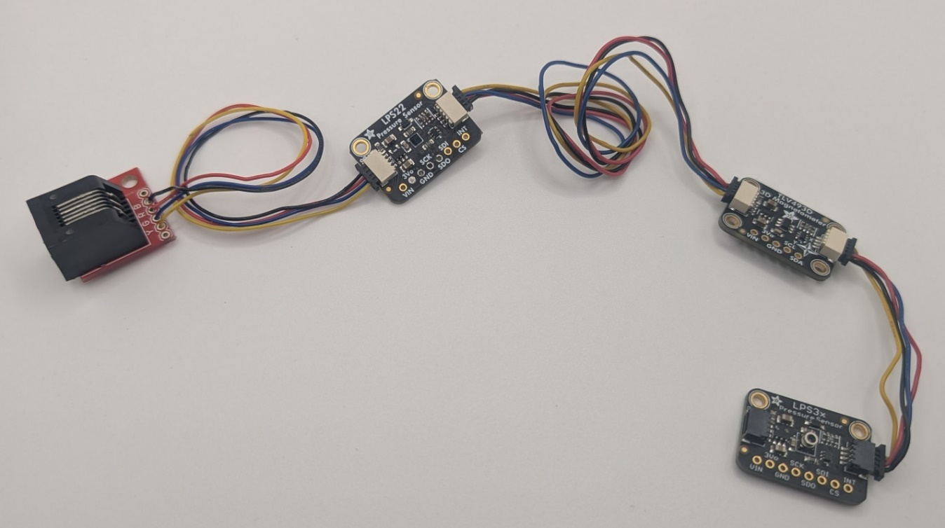

Part C: Flashing Firmware

Part C: Components
C1 | Populated LipSync 4 Hub PCB | QTY 1 | C2 | STEMMA QT Cable – 100 mm | QTY 1 | C3 | OLED Display | QTY 1
C4 | Joystick Component Assembly | QTY 1 | C5 | LipSync Interface Cable (RJ11) | QTY 1 | C6 | USB-C-USB-A Cable | QTY 1

Part C: Tools
- Computer with Arduino IDE to flash firmware

Part C: Firmware Flashing Steps

Step C-01: Connect the Display to the PCB using the 100 mm STEMMA Cable
Connect one end of the 100 mm STEMMA QT Cable (C2) into the left hand i2C connector on the LipSync Hub PCB (C1). Connect the other end of the cable into the OLED Display (C3).
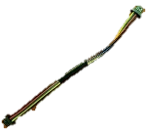  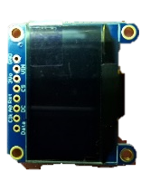 | 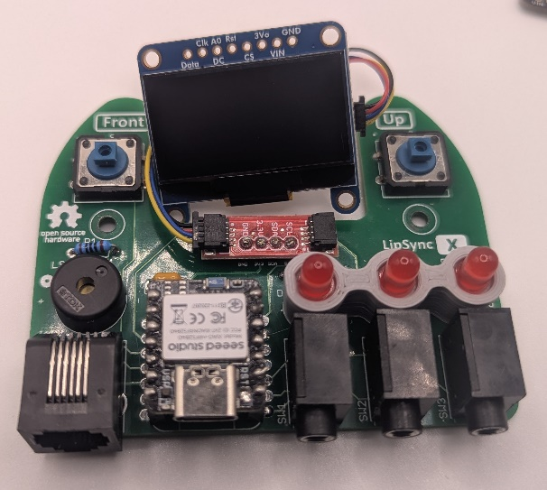

Step C-02: Connect the Joystick Component Assembly to the PCB using the Interface Cable
Take the LipSync Interface Cable (C5). Connect one end to the RJ11 Connector on the PCB and one end to the RJ11 Connector on the RJ11 Connector of the Joystick Component Assembly (C4).
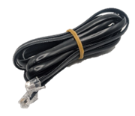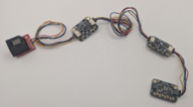 | 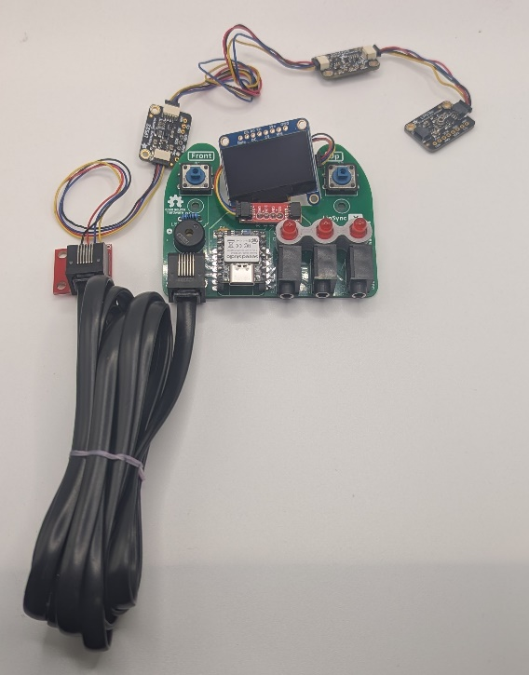

Step C-03: Connect the LipSync Hub PCB to the Computer
Plug in the Hub PCB (C1) to a computer using the USB Cable (C6).

Step C-04: Setup Arduino IDE on Computer
- Download Arduino IDE for your operating system at https://www.arduino.cc/en/software
- Install the Arduino IDE.

Step C-05: Setup Arduino IDE for Seed Studio Xiao nRF52840 Development Board
- Open Arduino IDE.
- Click on File -> Preferences.
- Locate the text field that says Additional Boards Manager URLs beside it.
- Copy and paste the following link into the field as a new line:
https://files.seeedstudio.com/arduino/package_seeeduino_boards_index.json
- Click on OK.
- Restart the Arduino IDE.
- Open the Boards Manager option from the Tools-> Board-> Boards Manager...,
- Search for “Seeed nrf52” and select “Seeed nRF52 Boards” by Seeed Studio.
- Click Install to install the board.

Step C-06: Install Libraries
- In the Arduino IDE, go to Tools -> Manage Libraries…
- For each of the libraries in the table below, search for the name, and click Install. If prompted to install any dependent libraries, click OK.
Name | Author
Adafruit_LPS2X | Adafruit
Adafruit_LPS35HW | Adafruit
Adafruit_SSD1306 | Adafruit
ArduinoJson | Benoit Blanchon
Adafruit_TinyUSB | Adafruit
- Directly download the compressed zip file for the TLV493D-A1B6 Library:
  - https://github.com/Infineon/TLV493D-A1B6-3DMagnetic-Sensor/archive/refs/heads/master.zip
- In the Arduino IDE, go to Sketch -> Include Library -> Add .ZIP Library… When the dialog box opens, navigate to where the library ZIP file was downloaded in the previous step, select it, and press and select the library downloaded in the previous step.

Step C-07: Setup Local Code Directory
- Download the Firmware_Files from the GitHub Repository: https://github.com/makersmakingchange/LipSync/blob/main/Build_Files/Firmware_Files/LipSync_Firmware.zip
- Extract / unzip the folder to a known location.
- Confirm that you have the following folder structure:
- LipSync_Firmware (folder)

  - LipSync_Firmware.ino
  - LSAPI.ino
  - LSTest.ino
  - LSBLE.h
  - LSBuzzer.h
  - LSCircularBuffer.h
  - LSConfig.h
  - LSInput.h
  - LSJoystick.h
  - LSMemory.h
  - LSOutput.h
  - LSPressure.h
  - LSScreen.h
  - LSTimer.h
  - LSUSB.h
  - LSUtils.h
  - LSWatchdog.h

Step C-08: Upload the Code to the microcontroller.
- Open LipSync_Firmware.ino with Arduino IDE.
- Select Seeed Xiao NRF52840 from Tools -> Board -> Seeed NRF52 Boards
- Connect the LipSync using the USB cable to the computer.
- Select the correct port from Tools -> Port menu.
- Verify and upload the code.

Step C-09: Verify the PCB and Sensors work as expected.
When the USB cable is connected, a green LED should illuminate on each of the sensors and the back of the display.
Once the code is uploaded, the LipSync should play the startup noise, the 3 LEDs on the Hub should turn on briefly, and the display should show the splash screen, with the words “LipSync” the version number, and “Makers Making Change”.
If all goes well, proceed to the next step. If there are any problems or errors on the display, unplug the USB cable and proceed to troubleshooting.

Step C-10: Remove the USB cable from the Hub PCB
Remove the USB cable from the Hub PCB to disconnect the power.

Step C-11: Disassemble the Joystick Component Assembly and Display
Unplug the LipSync Interface Cable from the Joystick Component Assembly and the Hub PCB. Carefully unplug the STEMMA QT Cable from the Display and the Hub PCB.
Carefully unplug the STEMMA QT Cables from each of the three sensors.
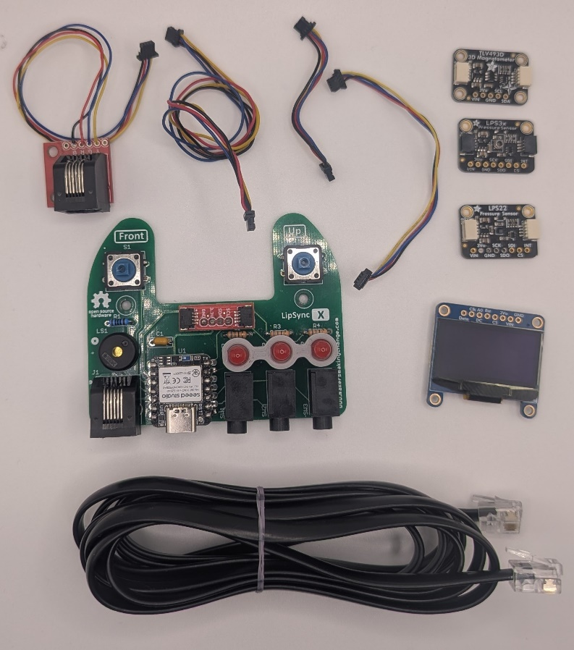

Part D: Hub Enclosure Assembly

Part D: Components
D1 | Populated LipSync 4 Hub PCB | QTY 1 | D2 | STEMMA QT Cable – 100 mm | QTY 1 | D3 | OLED Display | QTY 1
D4 | LipSync Hub Enclosure Top | QTY 1 | D5 | LipSync Next Button Pusher | QTY 1 | D6 | LipSync Select Button Pusher | QTY 1
D7 | LipSync Hub Enclosure Bottom | QTY 1 | D8 | Screw, #4, 3/8” Length | QTY 5 | D9 | M2.5 Machine Screw, 8 mm | QTY 4
D10 | M2.5 Nut | QTY 4 | D12 | Tee Nut | QTY 1 | D13 | Light Pipe | QTY 1

Part D: Tools
- Phillips Head Screwdriver

Part D: Personal Protective Equipment (PPE)
- Safety glasses

Part D: Assembling Hub Enclosure Steps

Step D-01: Connect Display to LipSync 4 Hub Enclosure Top
Peel off the protective film on the Display (D3) and connect it to the Hub Enclosure Top (D4) using four nylon M2.5 machine screws (D9) and four nylon M2.5 hex nuts (D10). Do not overtighten.
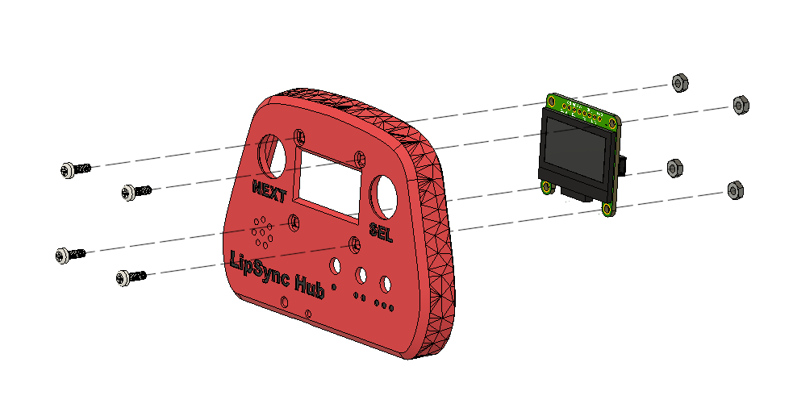

Step D-02: Insert the Light Pipe
From the front side, insert the light pipe (D13) into the Hub Enclosure Top.
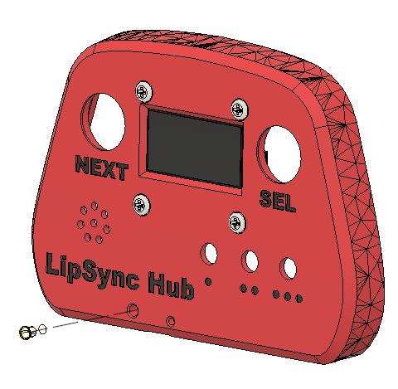

Step D-03: Connect STEMMA / QWIIC Cable to Display
Flip the Hub Top over so the Display is facing down. Connect the 100 mm STEMMA/QWIIC cable (D2) to the port on the right-hand side of the Display as shown. Ensure the holes for the pins in the cable line up with the pins in the port on the PCB. Do not connect the second end of the STEMMA/QWIIC cable to the second port on the screen.
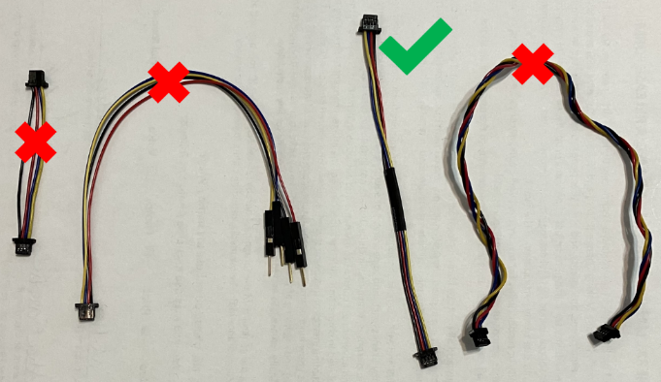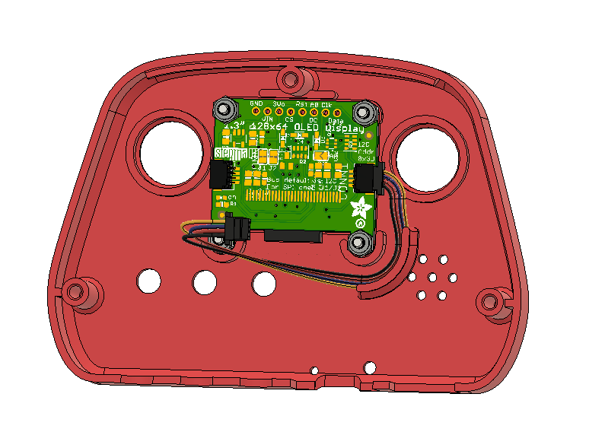

Step D-04: Insert the Tee Nut into the Hub Bottom
Insert the tee nut (D12) into the slots inside the Hub Bottom. A ¼” machine screw or hex bolt can be used to tighten the Tee Nut into place. The nut should sit flush with the enclosure.
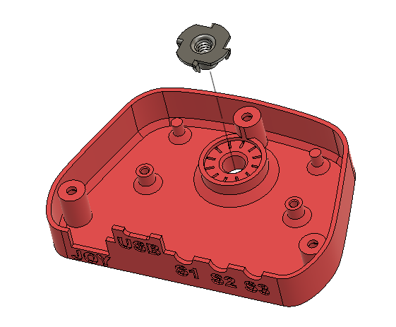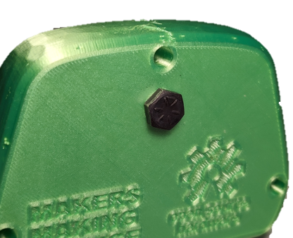

Step D-05: Secure LipSync Hub PCB into Hub Bottom
Use two #4 sheet metal screws (D8) to secure the PCB (D1) into the Hub Bottom.
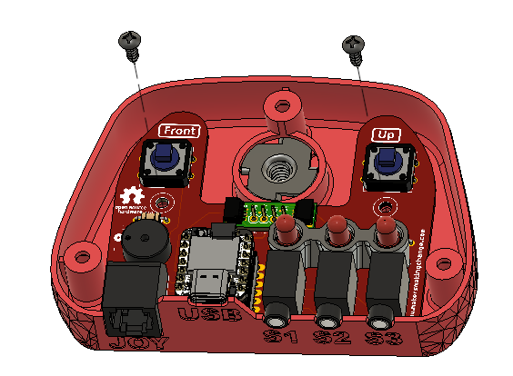

Step D-06: Connect the STEMMA / QWIIC Cable to the QWIIC Adapter on the PCB
Connect the 100 mm STEMMA/QWIIC cable from the display to the QWIIC adapter on the PCB. Again, ensure the holes for the pins in the cable line up with the pins in the port on the PCB.
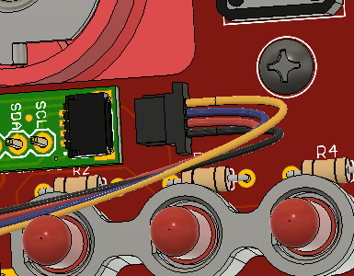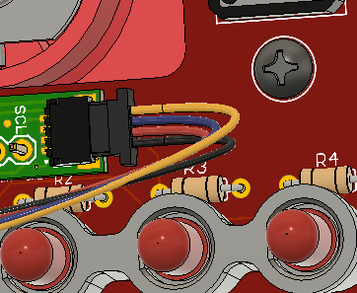

Step D-07: Place the Button Pushers on top of the Buttons
Position the Select Button (D6) and the Next Button (D5) on top of the Buttons on the PCB. The Next Button goes on the left button and has a target shape on the front. The Select Button goes on the right button and has a ring printed on the front.
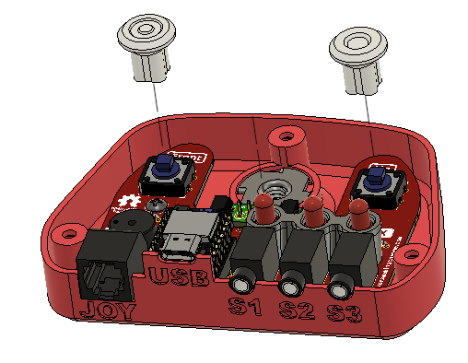

Step D-08: Position the Hub Top on to the Hub Bottom
Position the Hub Top onto the Hub Bottom, making sure to align the Button Pushers and their LEDs with the corresponding hole.
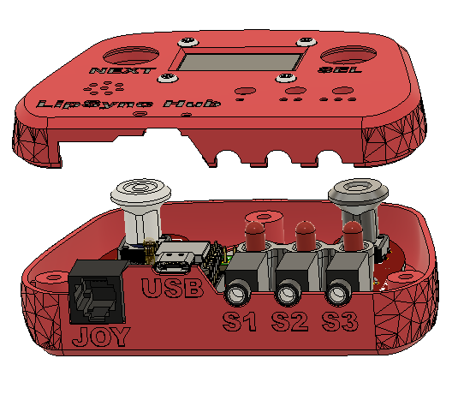

Step D-09: Secure the Hub Top and Hub Bottom
Carefully turn the Hub over. Use a #4 sheet metal screw (D8) in each of the three holes to secure the two parts together.
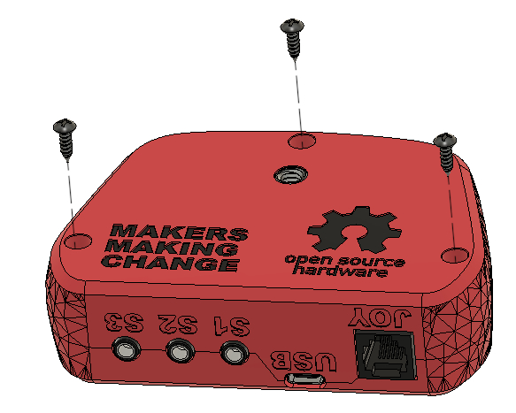

Part D Complete

Part E: Joystick Gimbal Assembly

Part E: Components
E1 | Inner_Gimbal_1 | QTY 1 | E2 | Inner_Gimbal_2 | QTY 1 | E3 | Outer_Gimbal_1 | QTY 1
E4 | Outer_Gimbal_2 | QTY 1 | E5 | Gimbal Shield | QTY 1 | E6 | Sled | QTY 1
E7 | Magnet Retainment | QTY 2 | E8 | LPS33 STEMMA QT Board | QTY 1 | E9 | TLV493D STEMMA QT Board | QTY 1
E10 | Male Luer Connector | QTY 1 | E11 | 2mm ID 4mm OD Tube | QTY 1 | E12 | Cable, STEMMA, 200 mm | QTY 1
E13 | Magnet | QTY 3 | E14 | Bearings | QTY 4 | E15 | Cable, STEMMA, 50 mm | QTY 1
E16 | M2.5 Nut | QTY 2 | E17 | M2.5 Machine Screw, 8 mm | QTY 2

Part E: Tools
- Phillips Head Screwdriver
- Scissors
- Flush cutters
- OPTIONAL: File or coarse sandpaper

Part E: Personal Protective Equipment (PPE)
- Safety glasses

Part E: Joystick Gimbal Assembly Steps
The rulers shown in this section are to-scale so can be used to measure the required lengths of each part.

Step E-01: Cut the Tubing to length
Cut a 1.5 cm length of tubing (E11).
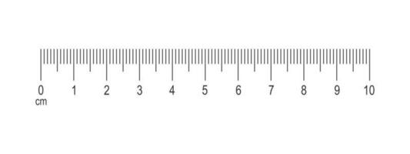
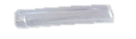

Step E-02: Connect the tubing to the Luer connector
Push the tubing over the barb on the Luer connector(E10), until about 2 mm is past the barb.
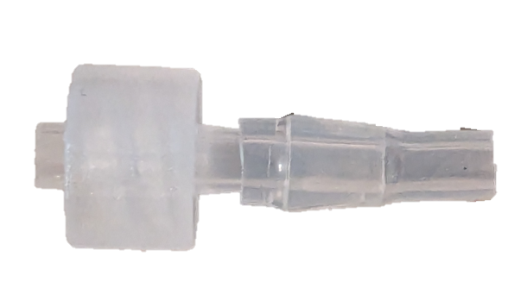

Step E-03: Connect the tubing to the Pressure Sensor
Press the other end of the tubing over the circular port on the LPS33 Pressure Sensor (E8).
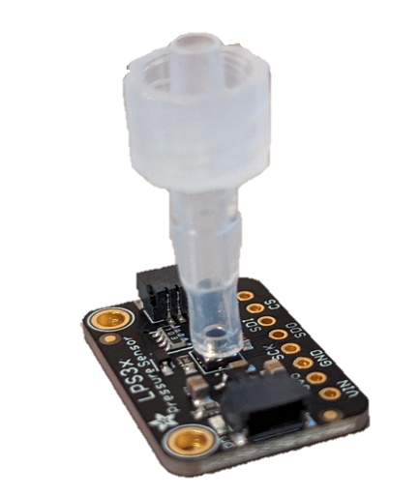

Step E-04: Attach the Tubing Assembly to the Joystick
Take the Inner Gimbal 1 3D print (E1) and press the Luer connector assembly into the slot at the front by the threads. The Luer connector must be inserted so there is a flat edge along the top and bottom, as seen in the photo on the right. The tube length should be such that the pressure sensor fits into the first slot behind the bearing shafts. When viewing the assembly from the front, the text on the sensor should be on the side facing the bearing shafts.
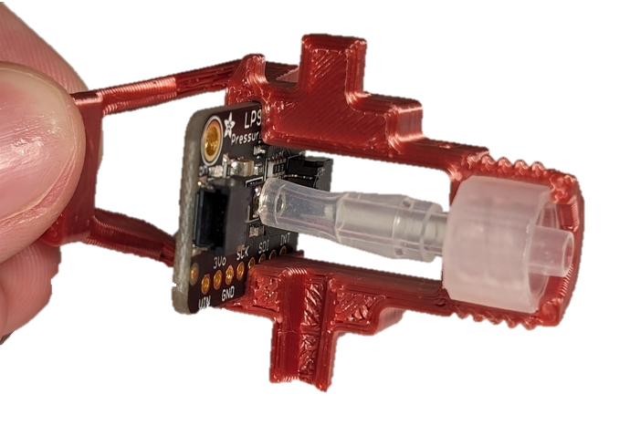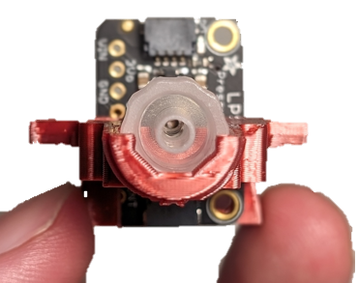

Step E-05: Attach the Magnetic Sensor
Slide the Magnetic Sensor (E9) into the Inner Gimbal 1 so that it is arranged back-to-back with the pressure sensor with the text facing to the left. The two sensors should have the same up/down orientation, with the text at the top, and the breakout pins at the bottom.
Secure the two sensors in place by inserting a nylon M2.5 machine screws (E17) into the left-most hole in the Pressure Sensor board, through the hole in the Inner Gimbal and through the hole in the Magnetic Sensor. Loosely attach the nylon hex nut (E16), but do not fully tighten.
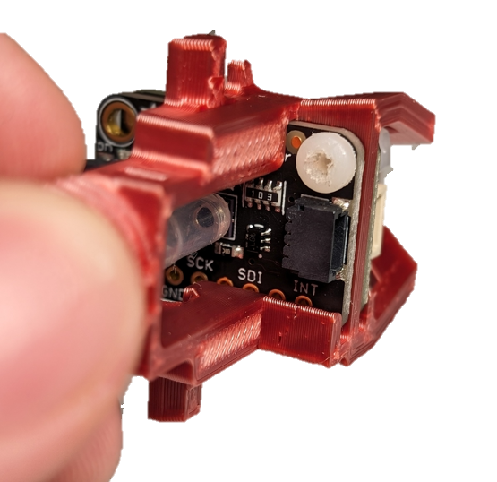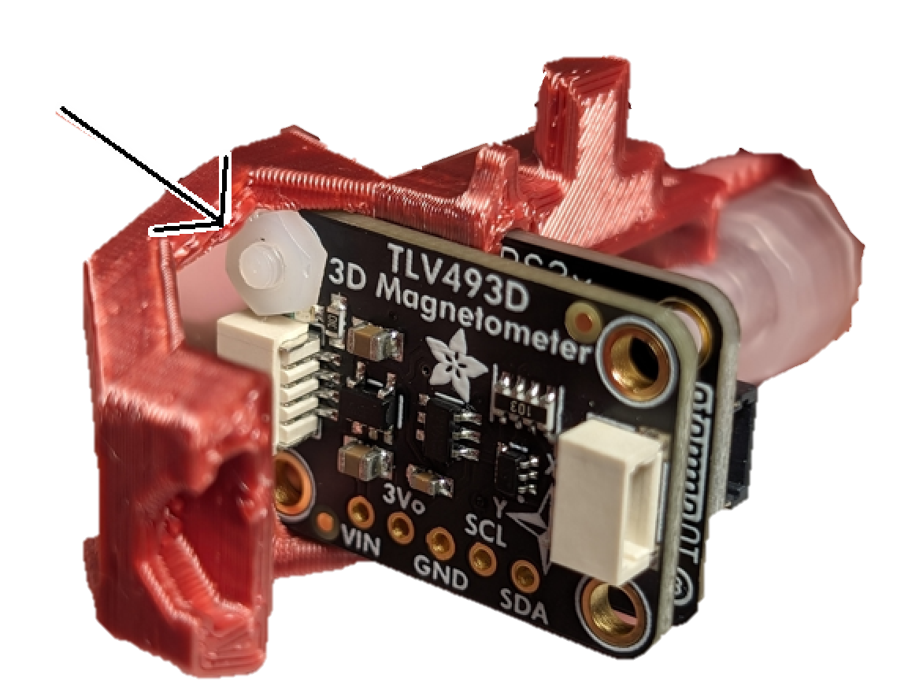

Step E-06: Attach the STEMMA Cable
Take the 200 mm STEMMA cable (E12) and attach it to the magnetic sensor on the side that has the bolt attached. Route it above the pressure tube as seen in the below photo.
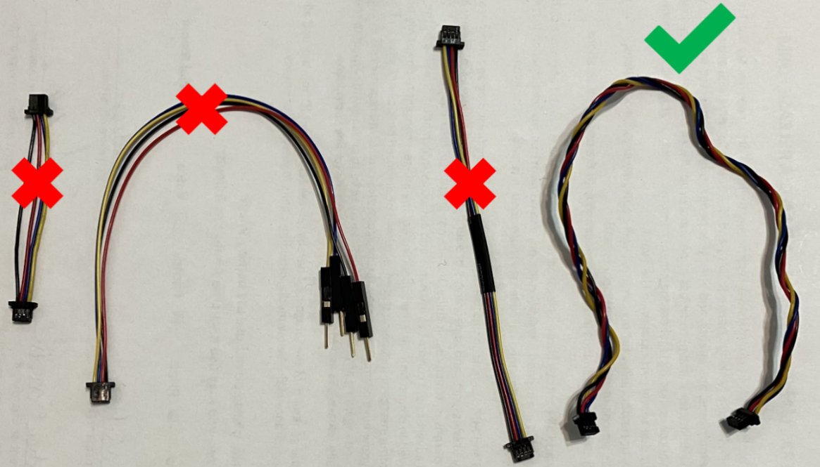
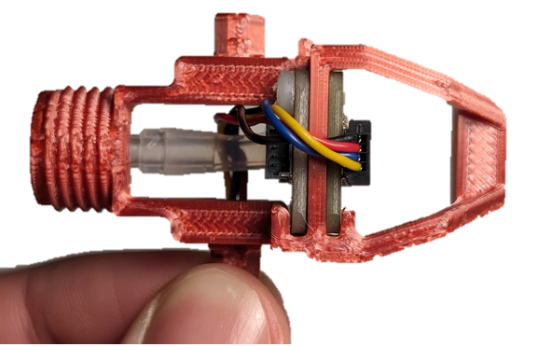

Step E-07: Route the cable out of the Inner Gimbal
Route the cable over the air path, and through the slot in the bearing shaft as seen in the photo.
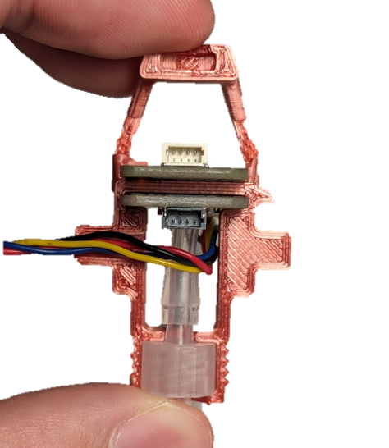

Step E-08: Insert the Moving Centering Magnet
Gently press a magnet (E13) into the cradle in the very back of the assembly. Any way the magnet fits in the cradle is mechanically fine — the firmware’s Full Calibration routine detects the field direction automatically, so the magnet’s polarity does not need to be checked at this step. If a finished device ever reports an inverted axis even after a Full Calibration (for example, pushing the mouthpiece up moves the cursor down), re-seat this magnet the other way around and run Full Calibration again (see the User Guide’s troubleshooting section).
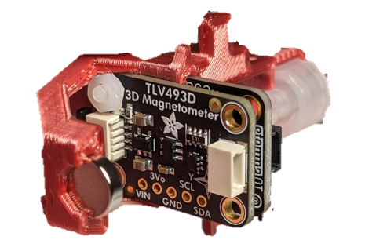

Step E-09: Attach the other half of the Inner Gimbal
Slide Inner Gimbal 2 (E2) over the assembly. Make sure that the Luer connector, sensor boards, and magnet line up with their corresponding slots.
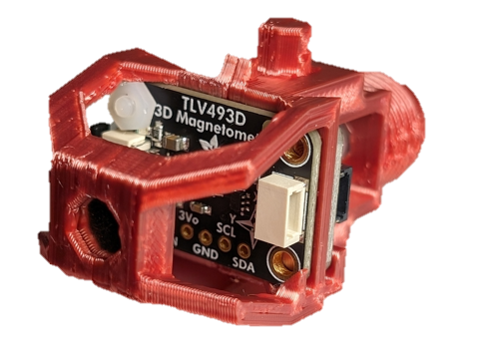

Step E-10: Attach the second Machine Screw and Nut
Add the second nylon nut (E16) and bolt (E17) in the same orientation as the first, and fully tighten them both.
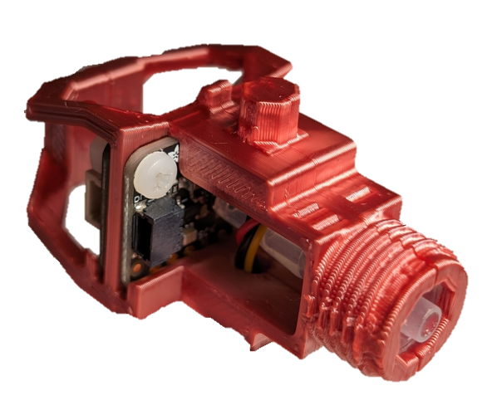

Step E-11: Trim the edges of the STEMMA Cable Connector
Take the free end of the 200 mm STEMMA cable that exits the Inner Gimbal Assembly and trim the two flanges on the end of the connector flush.
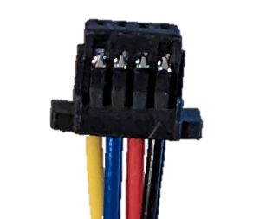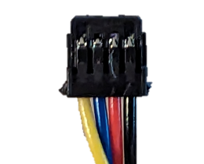

Step E-12: Attach Bearings to the Inner Gimbal
Press one bearing (E14) over each of the two bearing shafts on the inner gimbal. For the shaft with the cable coming out, pass the cable through the inside of the bearing before placing it on the shaft.
Note: If you are having trouble getting the bearings to fit on the shafts, first try sanding down the corners of the octagonal shafts. If they still do not fit, use pliers to gently press them onto the shaft.
WARNING: Do not hit the bearings with a hammer or mallet. Do not hit the gimbal on the table or any other hard surface.
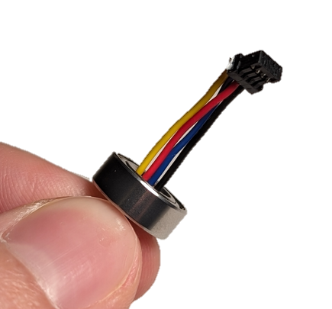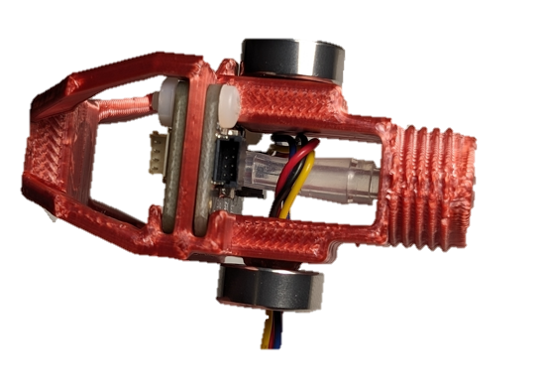

Step E-13: Connect the Pressure Sensor and Magnetic Sensor
The 50 mm STEMMA Cable (E15) is used to connect the Pressure Sensor to the Magnetic Sensor. First, connect one end of the STEMMA Cable to the open connector on the Pressure Sensor Board. Next, wrap the cable around the post of the Inner Gimbal. Finally, attach the other end of the STEMMA Cable to the connector on the Magnetic Sensor Board on the same side as the Pressure Sensor.
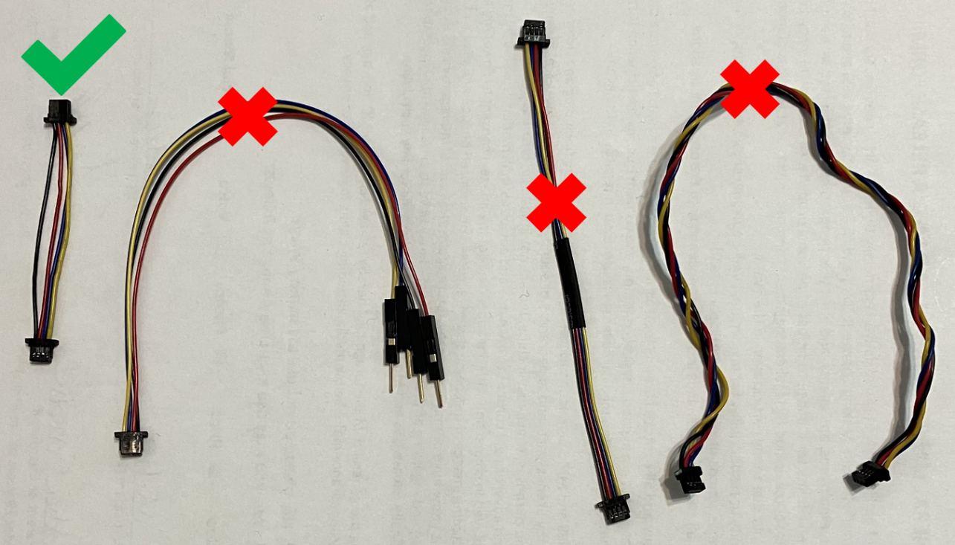
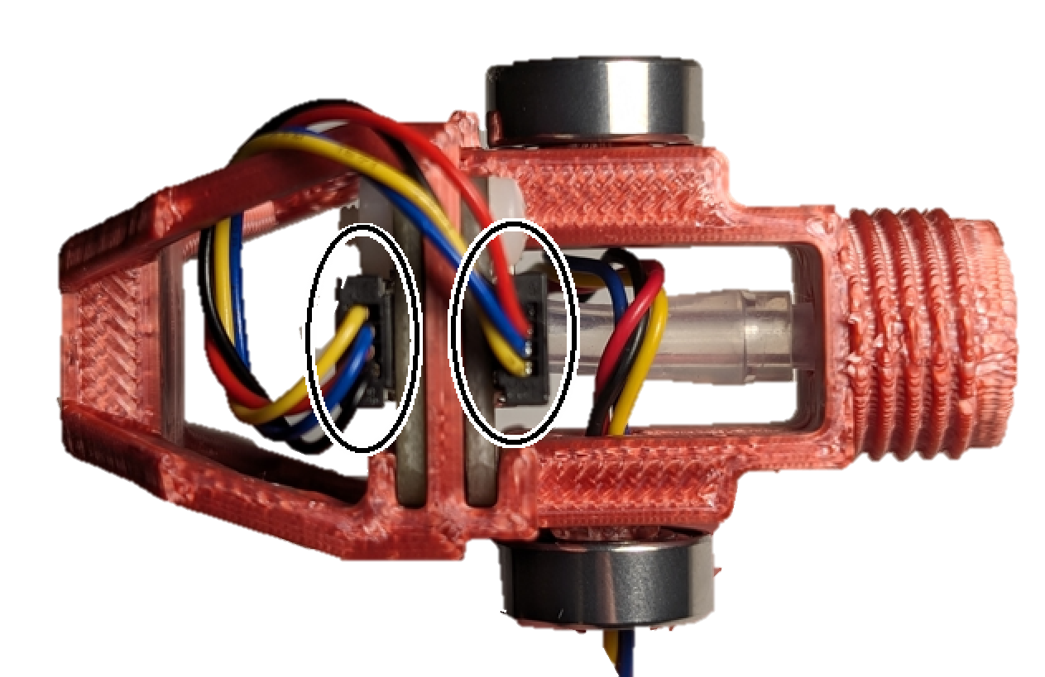

Step E-14: Assemble the Outer Gimbal on to the Inner Gimbal Assembly
Take Outer Gimbal 1 (E3, marked with “I”) and coming from the magnet side towards the Luer connector side, pass it over the Inner Gimbal Assembly. One side of the bearing cover will be hollow, and one will be covered. Align the outer gimbal so that the hollow side is on the same bearing that the STEMMA cable is passing through.
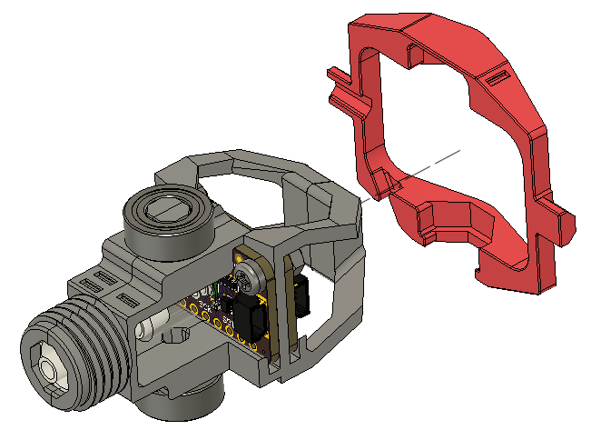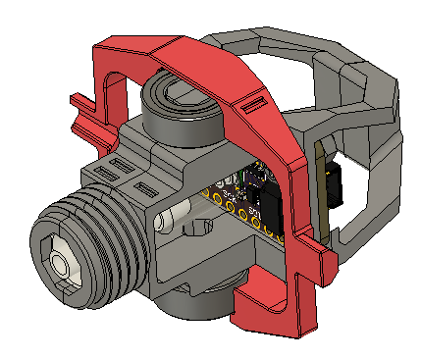

Step E-15: Route cable through the Outer Gimbal
Pass the cable through the slot on the outer gimbal, and then out through the hollow bearing shaft. A pair of tweezers can be used to push the wires into the slot.
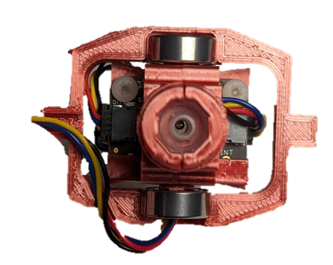

Step E-16: Connect the second half of the Outer Gimbal
Press the front half of the Outer Gimbal (Outer Gimbal 2, E4, marked with “II”) over the front Luer section and towards the rear, ensuring that the cable is properly connected to the correct cable management slots.
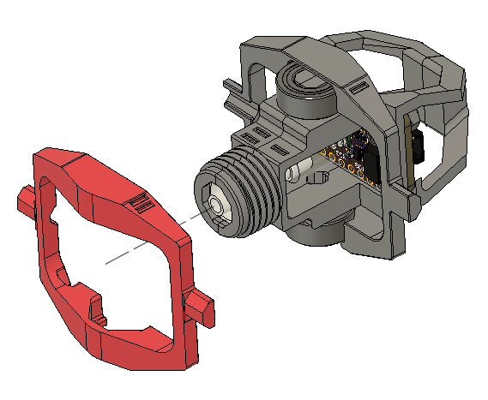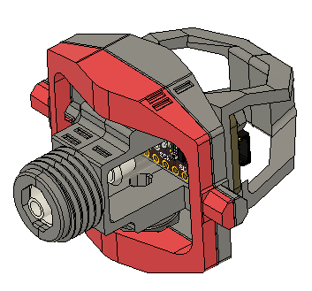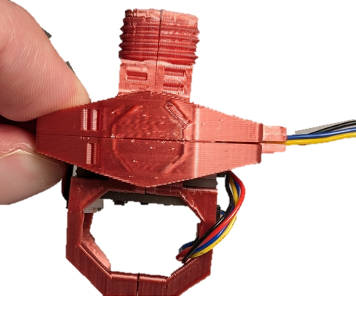

Step D-17 Secure Outer Bearing to Gimbal
Secure the two halves of the Outer Gimbal using two bearings (D14). Gently pull on the cable after the bearings are attached to remove any slack.
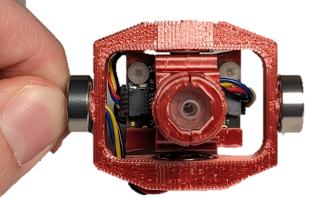

Step E-18: Screw on the Gimbal Shield
Take the Gimbal Shield (E5) and screw it onto the threads at the front of the gimbal until it hits the gimbal hard stop at the back.
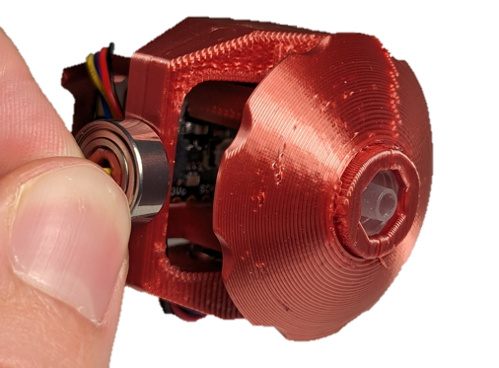

Step E-19: Insert Magnets into Sled
Take the Sled (E6), and two Magnets (E13). Stick the two magnets to either side of the gimbal magnet from the previous steps, and make note of their orientation. While keeping them in the same orientation, gently but firmly push them into the two highlighted slots in the sled, until they are firmly seated at the bottom of the slots. It is very important to seat these magnets at the bottom of the slots.
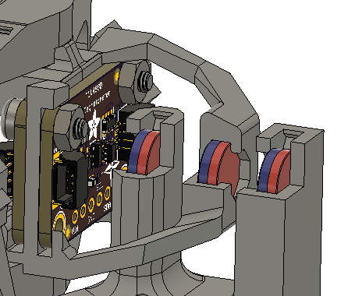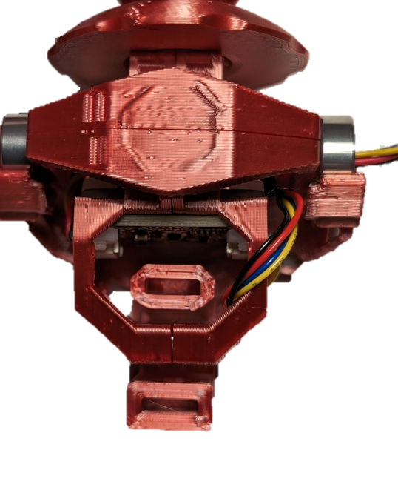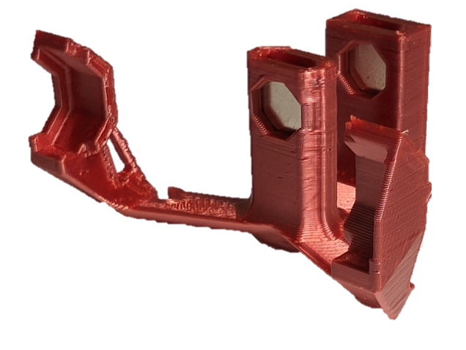

Step E-20: Secure the Magnets into the Sled
With the magnets pushed down fully, push a Magnet Clip (D7) into each of the Sled slots to secure the magnets in place.
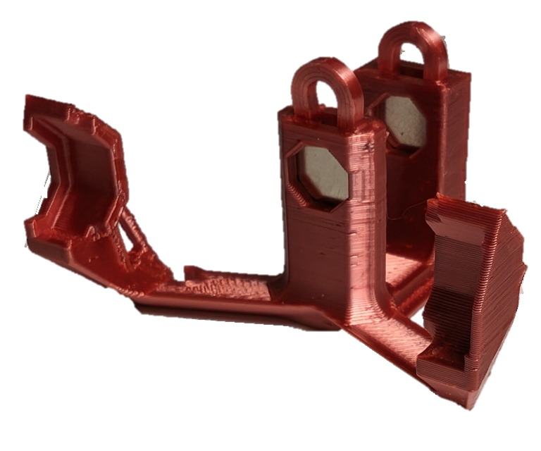

Step E-21: Place Gimbal Assembly in the Sled
Slot the Gimbal into the Sled. Slot the magnet in the back of the gimbal between the two towers on the sled, and then gently attach the arms to the bearings. One side of the sled has a cover over the bearing slot and one side has an open bearing slot. The side of the gimbal with the cables coming out of it lines up with the open bearing slot with no cover.
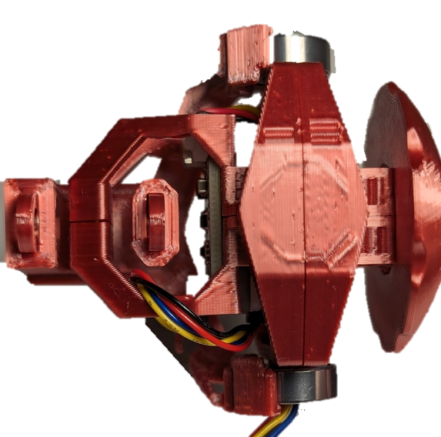

Step E-22: Route the STEMMA Cable through the Sled
Take the STEMMA Cable that is leaving the gimbal through the bearing, and thread it through slot on the sled, then clip it into the ¾ circle at the bottom of the sled, as seen in the below photos.
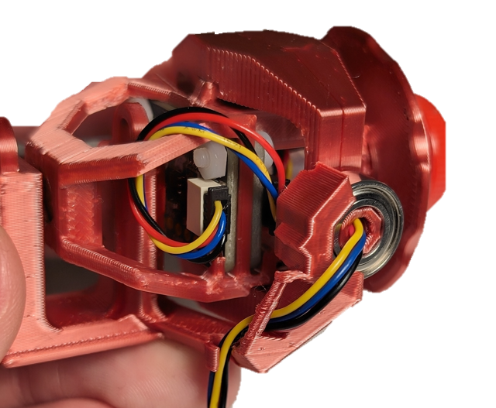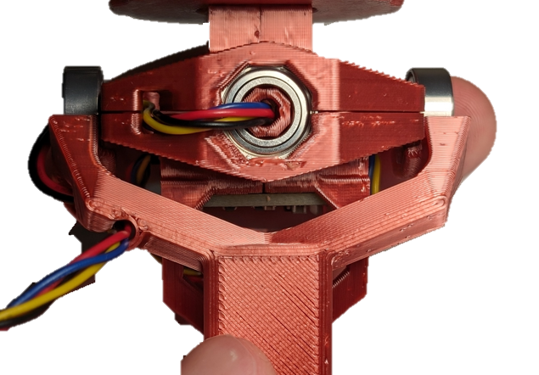

Part E Complete

Part F: Joystick Housing Assembly

Part F: Components
F1 | Front Cap | QTY 1 | F2 | Joystick Housing | QTY 1 | F3 | Inner Locking Ring | QTY 1
F4 | Outer Locking Ring | QTY 1 | F5 | Rear Housing | QTY 1 | F6 | LPS22 STEMMA QT Board | QTY 1
F7 | RJ11 STEMMA QT Connector | QTY 1 | F8 | M2.5 x Machine Screw | QTY 1 | F9 | M2.5 Nut | QTY 1
F10 | Light Pipe 0.250” | QTY 1 | F11 | ¼-20 Tee Nut | QTY 1 | F12 | Screw, #4, 3/8” Length | QTY 3
F13 | Assembled Joystick Gimbal | QTY 1

Part F: Tools
- Phillips Head Screwdriver

Part F: Personal Protective Equipment (PPE)
- Safety glasses

Part F: Assembling Joystick Housing Steps

Step F-01: Insert the Light Pipe into the Joystick Housing
From the outside, press the light pipe (F10) into the Joystick Housing (F2). You can use a table or a hard surface to slowly press against to push the Light Pipe into place.
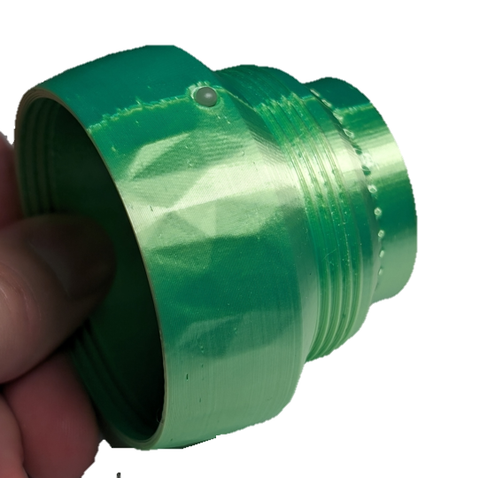

Step F-02: Connect the LPS22 Sensor Board to the gimbal STEMMA QT Cable
Connect the STEMMA QT cable coming from the gimbal (F13) to the LPS22 board. Ensure it is connected to the left port when viewing the board right-side up from the front. This is the port that has “on” printed above it.
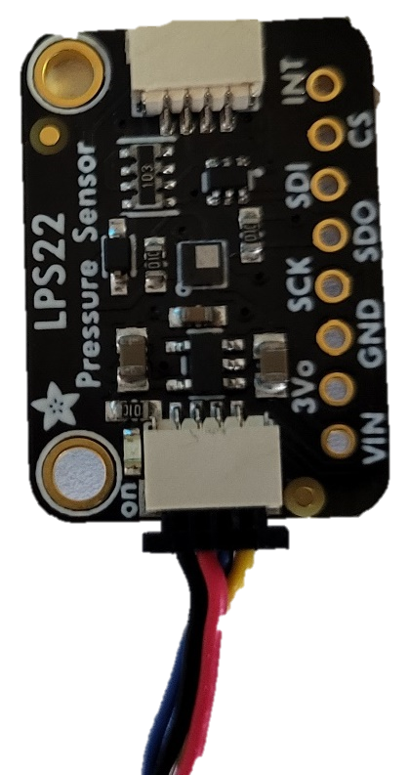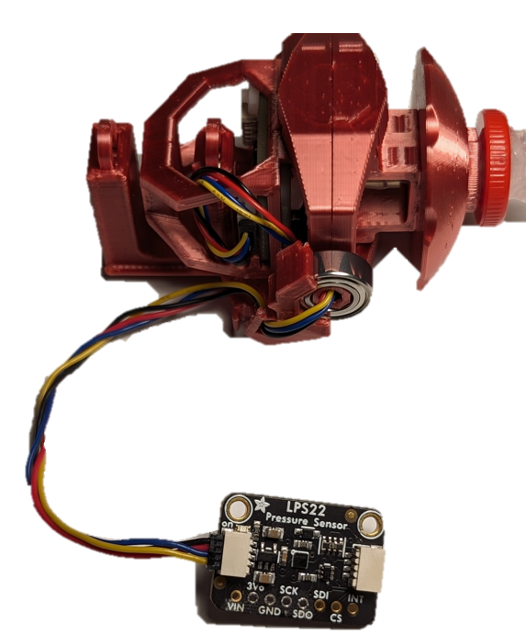

Step F-03: Insert the LPS22 board into the Joystick Housing
Entering through the larger opening (side with internal threads) of the joystick housing, snap (not slide) the LPS22 board into place directly below the light pipe so that the cable points toward the opening you just entered the part through. The components on the board should be facing towards the outer wall of the 3D print, not the hollow middle.
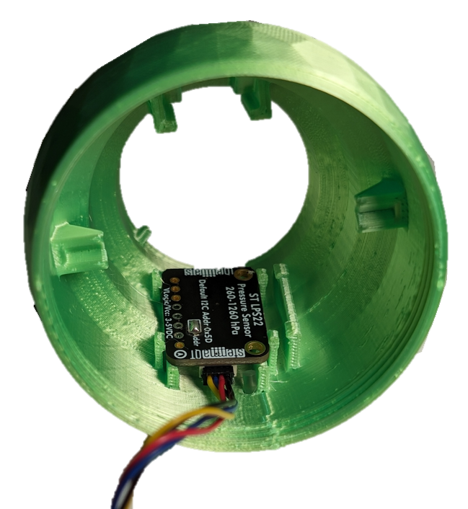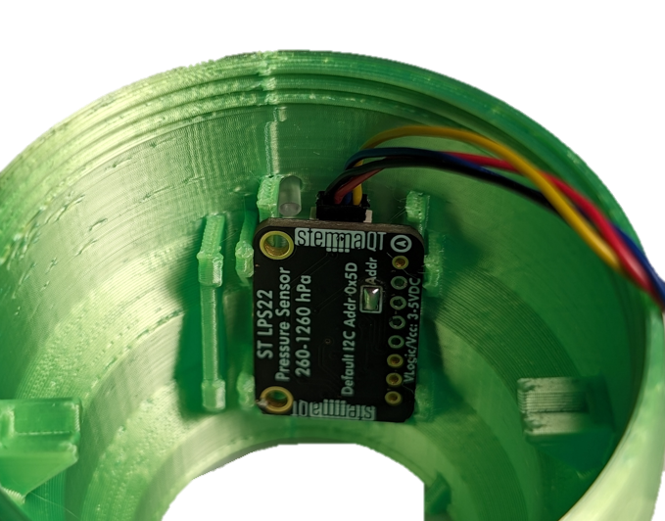

Step F-04: Route the Cable
Route the cable from where it connects to the LPS22 Sensor Board beside the board and towards the rear of the Joystick Housing. Insert the cable into the snap-fit beside the board.
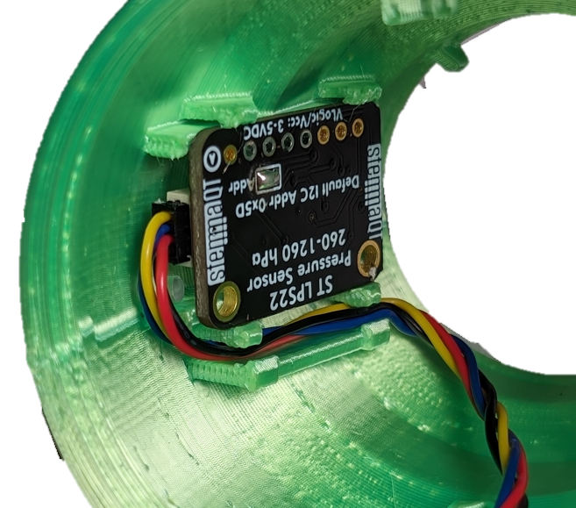

Step F-05: Insert the Gimbal Subassembly into the Joystick Housing
Entering through the same side as step 4, line up the sled so it will slot into the rails at the rear end of the joystick housing and slide it into place. Be careful to keep the STEMMA QT cable from getting pinched between printed parts.
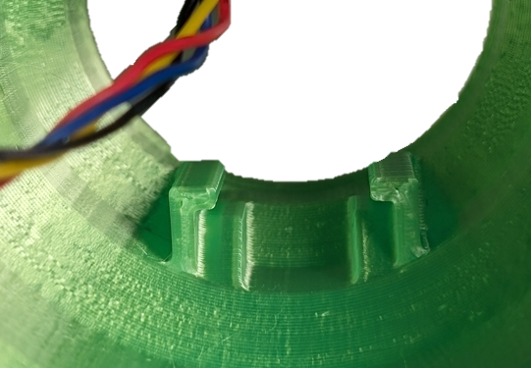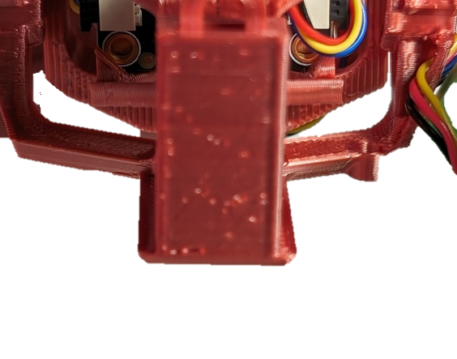
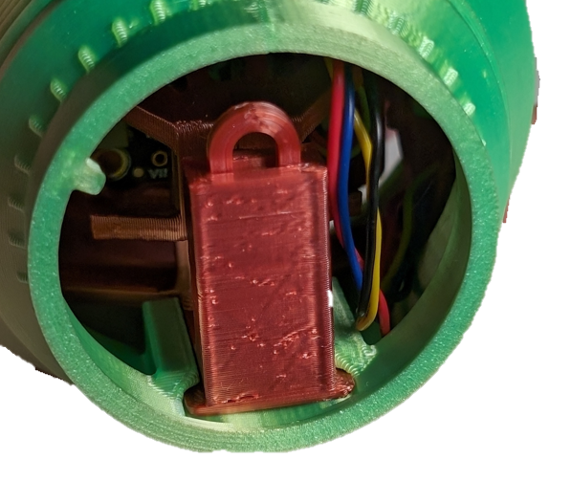

Step F-06: Screw on the Front Cap
Ensure the joystick is fully inserted and the cable is not interfering with any internal parts. Screw on the front cap (F1) by rotating clockwise.
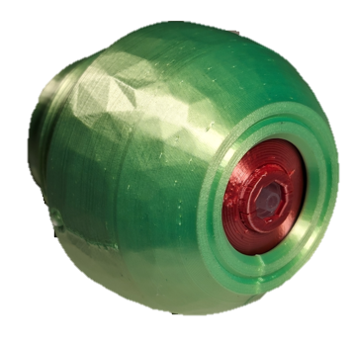

Step F-07: Insert the Tee Nut
Insert the Tee Nut (F11) into the hole in the Rear Housing. Line up the prongs with the slots and press the Tee Nut into the Rear Housing until the bottom is flush.
Note: Once the Tee Nut is aligned, a ¼-20 UNC bolt or machine screw can help pull the Tee Nut down into place. Insert the bolt or machine screw into the Tee Nut and tighten until the bottom of Tee Nut is flush with the bottom of the print. Make sure to remove the bolt once the Tee Nut is installed.
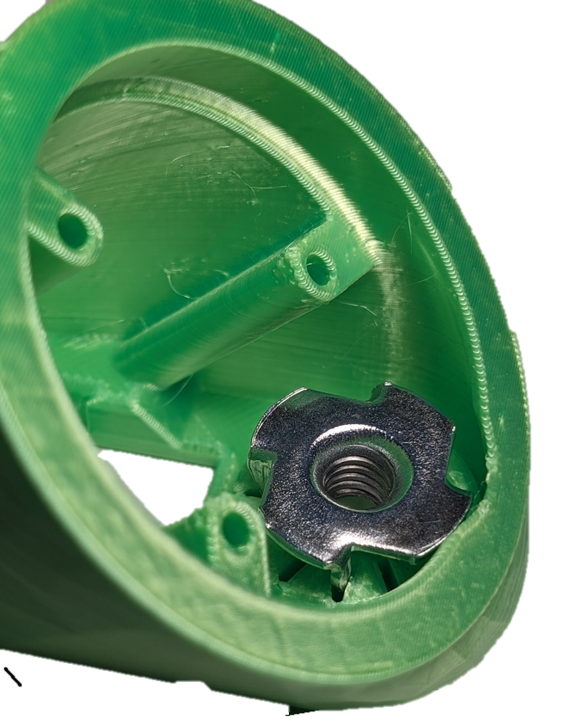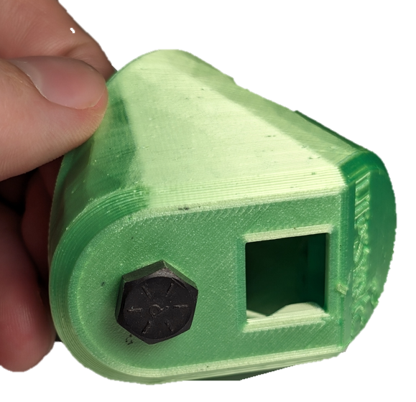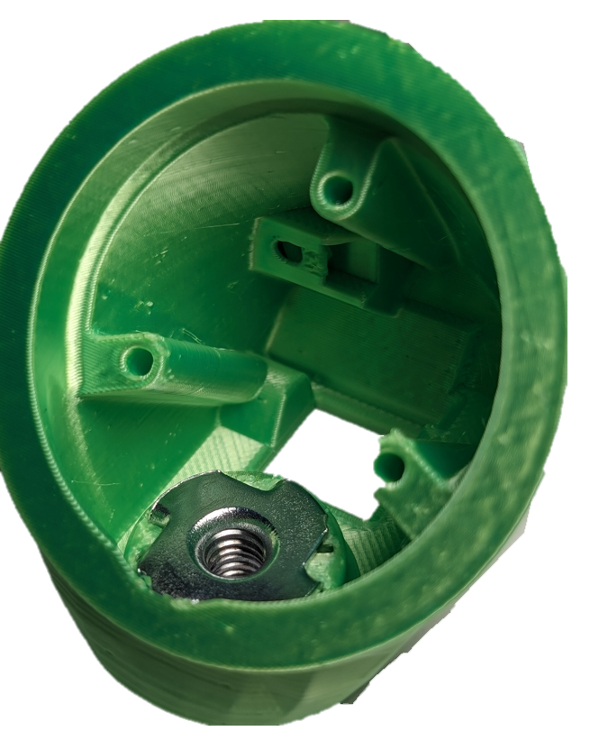

Step F-08: Insert the Captive Nut into Rear Housing
Insert a M2.5 nylon nut (F9) into the captive nut slot shown on the Rear Housing (F5).
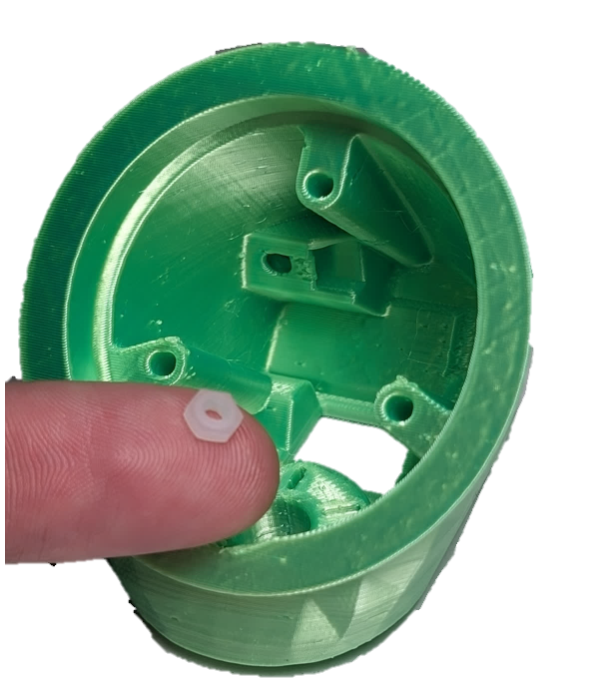

Step F-09: Insert and fasten the RJ11 Breakout Board into the Rear Housing
Slide the RJ11 Breakout Board in the slot in the back of the Rear Housing. Secure it in place with a nylon M2.5 machine screw (F8) into the captive nut.
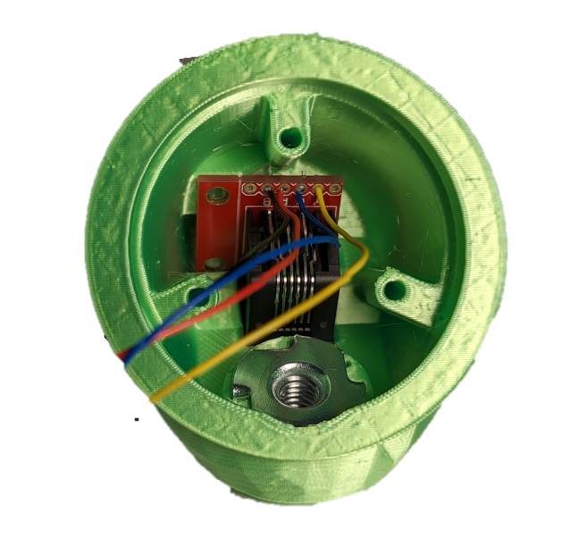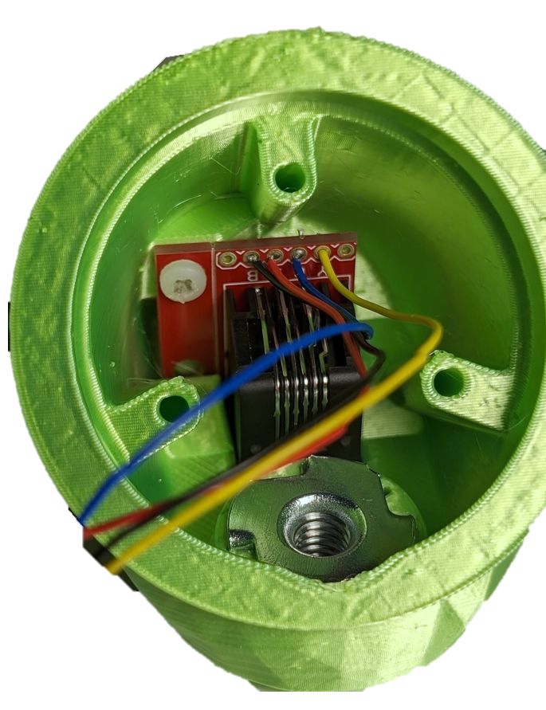

Step F-10: Nest the locking rings
Take the Inner (F3) and Outer (F4) Locking Rings, and pass the Inner Ring through the Outer Ring until it has gone as far as it can go as seen in the below photos. The flat print face should be facing the same direction on each piece. The Inner Ring has a tab, and the Outer Ring has a slot. The only way for the rings to fit together is for the tab on the Inner Ring to be aligned with the slot on the Outer Ring, as seen in the photos.
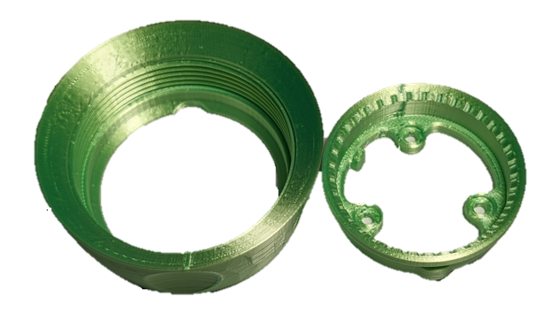
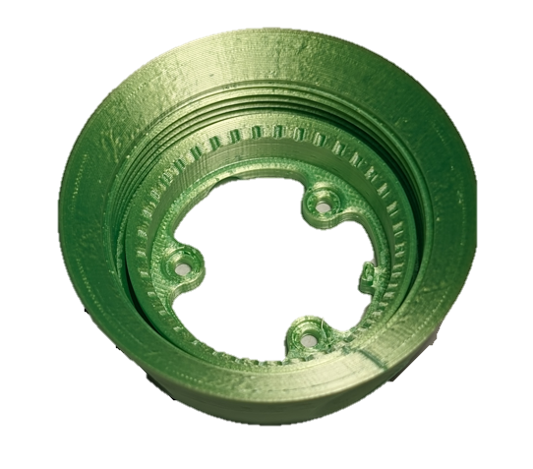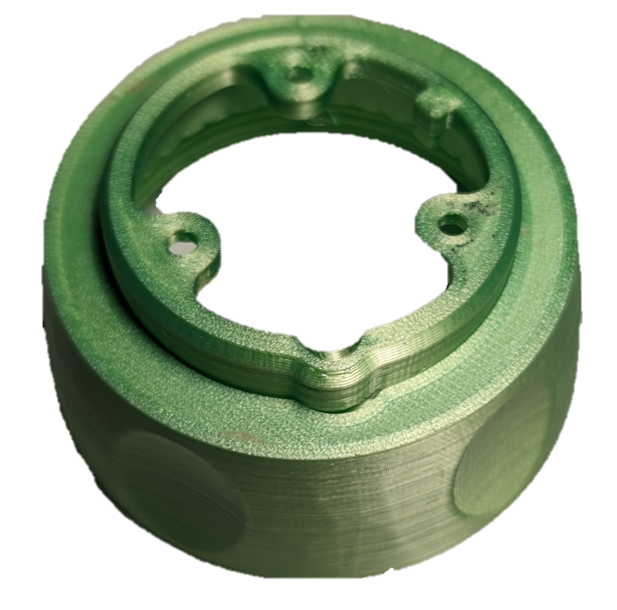

Step F-11: Fasten Locking Rings to Rear Housing
As with the previous step, there is a slot on the rear housing that lines up with the tab on the Inner Locking Ring. If this is done correctly, the three holes on the inner ring will line up with the three holes on the rear housing. Using #4 3/8 (F12) screws, fasten the locking rings onto the rear housing.
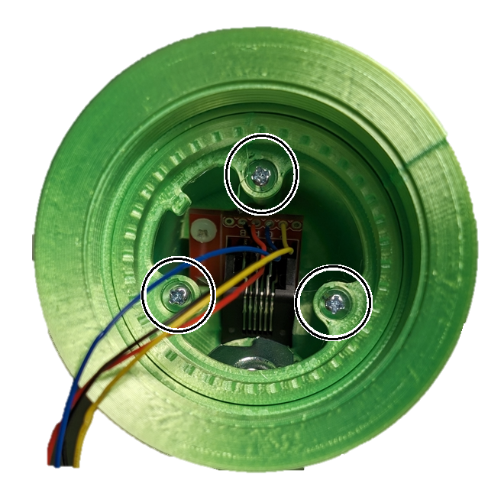

Step F-12: Connect the Dupont to Stemma cable to the Ambient Pressure Sensor Board.
Plug the STEMMA QT end of the STEMMA-DuPont cable into the open port of the LPS22 board at the rear of the joystick housing.
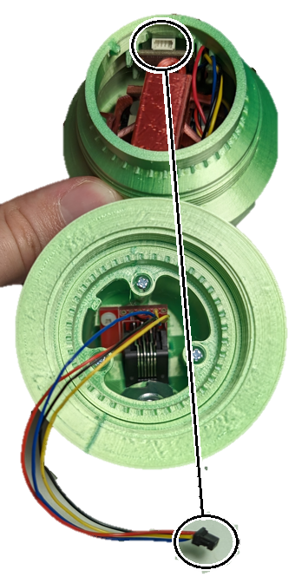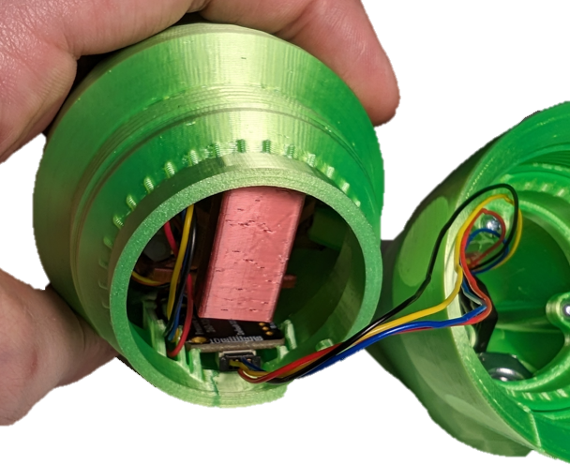

Step F-13: Connect the two halves of the Joystick Housing
Screw the locking ring from the back section of the enclosure to the threads on the front half of the enclosure. Tighten the locking ring until the two halves are locked together. Be careful to not rotate the two halves relative to each other so the STEMMA-DuPont cable does not get twisted.
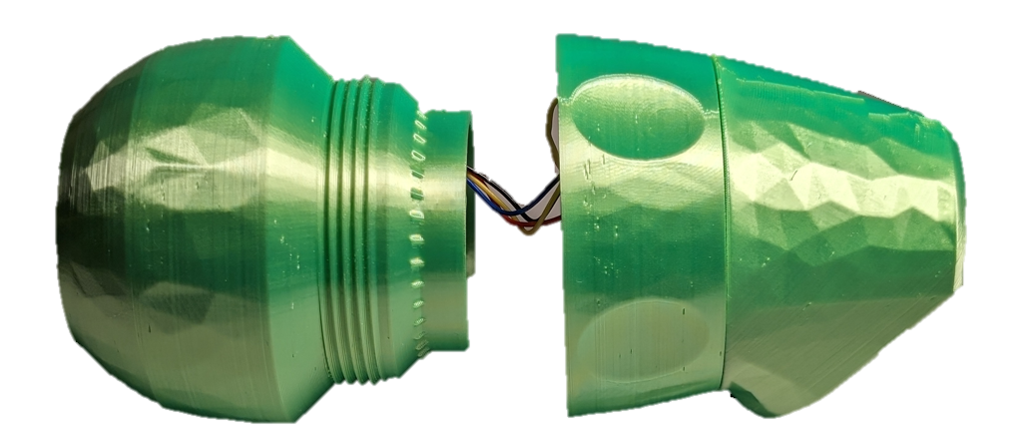
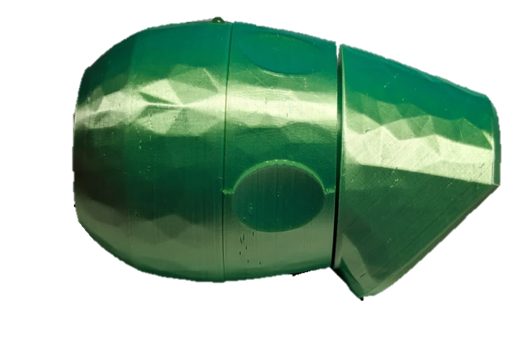

Part F Complete: Joystick Unit Assembled

Part G: Mouthpiece Assembly
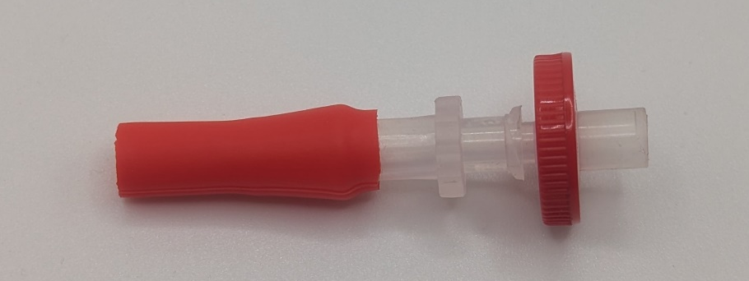

Part G: Components
G1 | Syringe FIlter | QTY 6 | G2 | Mouthpiece Adapter,  1/4” Barb Connector to Female Luer | QTY 6 | G3 | Silicone Straw | QTY 2
G4 | Resealable Bag

Part G: Tools
- Scissors or Hobby Knife

Part G: Personal Protective Equipment (PPE)
- Safety glasses

Part G: Assembling the Mouthpiece Steps

Step G-01: Prepare a clean work surface.
Since the mouthpieces are intended a user’s mouth, the parts (except for the filter) should be washed beforehand using dish detergent. Mouthpiece assembly should be performed on a clean dry surface, such as a cutting board, suitable for food preparation.

Step G-02: Cut the Silicone Straw to length
Cut the silicone straw (G3) to 28 mm length. The rulers shown below is to-scale and can be used to measure the required length.
Repeat this step 6 times.
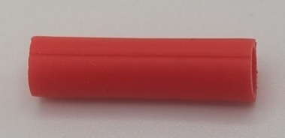

Step G-03: Slide the Silicone Straw on to the Mouthpiece Tube Adapter
Slide the cut length of silicone straw over the barb connection on the Luer Fitting (G2).
Repeat this step 6 times.
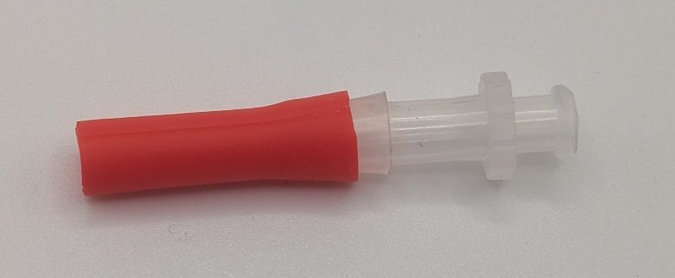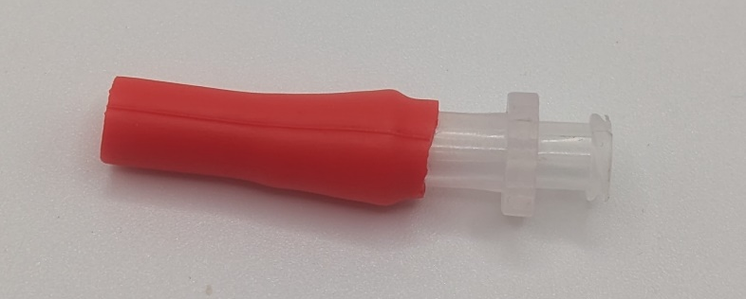

Step G-04: Attach the Mouthpiece Adapter to the Filter
Insert the male Luer of the filter into the female Luer portion of the mouthpiece adapter. Push it as far down as possible using a twisting motion.
Repeat this step 6 times.
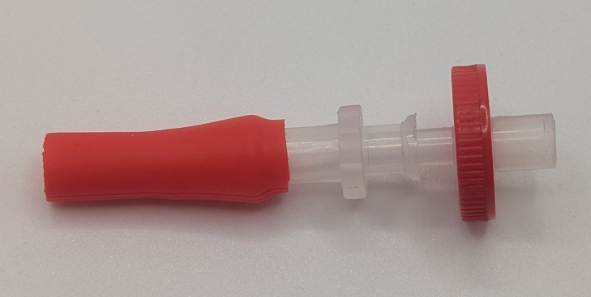
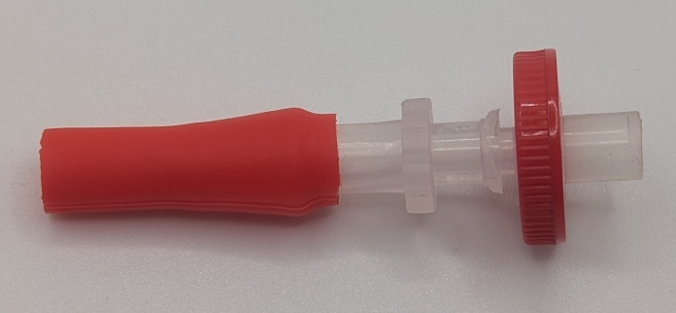

Step G-05: Store the mouthpieces in a clean container.
Take the 5 mouthpieces intended for the user and place them within a clean sealable bag. The final mouthpiece can be used by the maker for initial testing and calibration.
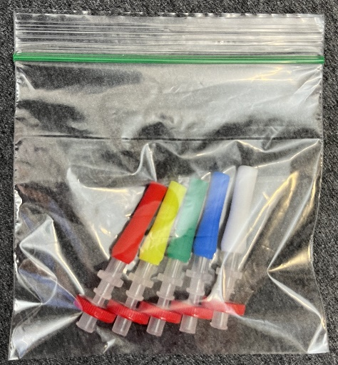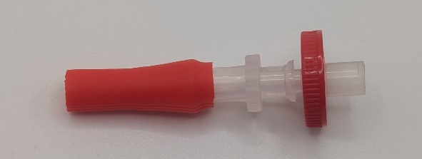

Part G Complete

Part H: Initial LipSync Setup and Testing

Part H: Components
H1 | LipSync System | QTY 1 | H2 | LipSync Mouthpiece | QTY 1 | H3 | Host Device | QTY 1

Part H: Initial LipSync Setup Steps

Step H-01: Connect the Mouthpiece to the Joystick
Hold the mouthpiece (H2) by the outer edge of the filter, put it in the Luer connector on the LipSync (H1) and gently twist to make a connection. Twist until finger tight.
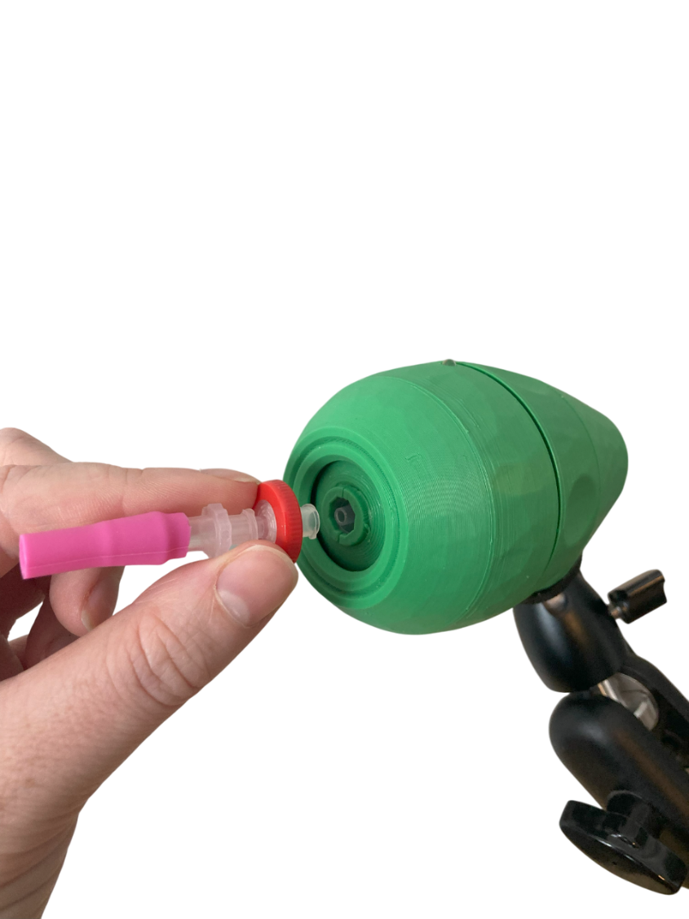

Step H-02: Connect the LipSync to Host Device using USB Cable
- Plug in the Joystick to the Hub via the RJ 11 Cable.
- Plug in the Hub to a computer via USB cable.
- The Hub should power on with a startup tone and display the current code version and operating mode on the Hub display screen.

Step H-03: Calibrate the Joystick
NOTE: Use the extra mouthpiece to perform the calibration to ensure the user receives a clean mouthpiece.
- Enter the settings menu by:
  - Short press (<1 seconds) Next and Select on the Hub simultaneously.
  - Holding down the “Next” button on the Hub for at least five seconds.
- Use the “Next” and “Select” buttons to navigate to the Calibrate menu and select it.
- In the submenu, select “Full Calibration” and follow the prompts that appear on the Hub Display to calibrate the joystick. Detailed instructions can be found in the User Guide.

Testing Guide
After building the LipSync Hub and Joystick, you must verify both units are functioning properly.

Testing the LipSync
- Does Display turn on?
  - Ensure that the LipSync joystick in plugged into the Hub using the RJ11 cable.
    - Ensure that the LipSync Joystick light pipe lights up green.
  - If the Hub turns off and does not work, reset the device, and open the serial monitor in Arduino IDE right after resetting to see if one of the STEMMA boards is not being recognised.

Testing Mouse Mode
Refer to the LipSync User Guide for instructions on how to connect the LipSync to a Host Device and change the operating mode to USB Mouse Mode. When in USB Mouse Mode, ensure moving the joystick moves the mouse cursor. Additionally, test the sip and puff function, external switches, and buttons on the Hub. Ensure that each sip/puff, external switch, and Hub button action are consistent with the following tables.

Testing Sip and Puff
Install one of the assembled mouthpieces to the LipSync joystick. Once you have tested and confirmed that the sip and puff functions work, dispose of the mouthpiece you used to test.

Sip
To perform a Sip Input, close your lips around the end of the mouthpiece and sip like you would a drink through a straw (i.e., inhale or apply negative pressure) for less than 1 second and then release. The Right-side Feedback light should blink once after releasing the sip input, and the mouse should perform a right click.

Puff
To perform a Puff Input, close your lips around the opening on the mouthpiece and blow air into it (i.e., exhale or apply positive pressure) for less than 1 second and then release. The Left Feedback light should blink once after releasing the puff input, and the mouse should perform a left click.
LipSync Mouthpiece Input | Joystick | Short Puff | Long Puff | Very Long Puff | Short Sip | Long Sip | Very Long Sip
Mouse Action | Cursor Movement | Left click | Start Drag Mode | Enter Hub Menu | Right Click | Start Scroll Mode | Middle Click

Testing External Switches
Plug an assistive switch into the external switch jacks and activate the assistive switch. The behaviour for each switch and type of activation is outlined in the table below:
Input | Mouse | Gamepad | Menu/Settings Mode
S1 Short Press | Left Click | Button 1 press | Next
S1 Long Press | Start drag mode | Button 3 press | N/A
S1 Very Long Press | Enter settings mode | Enter settings Mode | Exit settings mode
S2 Short Press | Middle Click | Button 5 press | N/A
S2 Long Press | Middle click | Button 6 press | N/A
S2 Very Long Press | Perform Center Reset | Perform Center Reset | N/A
S3 Short Press | Right Click | Button 2 press | Select menu item
S3 Long Press | Start scroll mode | Button 4 press | N/A
S3 Very Long Press | Middle click | N/A | N/A
S1 is the left switch, S2 is the center switch, and S3 is the right switch.

Testing Hub Buttons
Ensure the following behaviours are consistent when pressing the buttons on the Hub.
LipSync Hub Button Inputs | Select Short Press | Select Long Press | Select Very Long Press | Next Short Press | Next Long Press | Next Very Long Press | Next and Select
Mouse Behaviour | Left Click | Start Drag Mode | Enter Hub Menu | Right Click | Start Scroll Mode | Middle Click | Next and Select

Input Feedback
Each LED is designated to a set of inputs:
Left LED •: Puff, Next (Hub), S1
Middle LED ••: S2
Right LED •••: Sip, Sel (Hub), S3
The time durations Short, Long, and Very Long for the Sip/Puff and switch/button inputs are the following:
Short: Less than 1 seconds. Indicated by the respective LED blinking once.
Long: Between 1 to 3 seconds. Indicated by the respective LED flashing slowing.
Very Long: 3 seconds or longer. Indicated by the respective LED flashing quickly.
Ensure the LEDs behave as outlined above.

Troubleshooting
- Arduino IDE is stuck when uploading code to the board.
You can first try to reset the board by clicking the "Reset Button" once. If that does not work, rapidly click it twice to enter bootloader mode. If that also doesn't work, disconnect the board from the PC, and connect the board again.
- The board is not showing up as a serial device on Arduino IDE.
You can first try to reset the board by clicking the "Reset Button" once. If that does not work, rapidly click it twice to enter bootloader mode.
- Arduino IDE states an error about Python not being found.
The Seeed nRF52 core’s post-build step runs adafruit-nrfutil through a “python” command, which does not exist on systems where only “python3” is installed. Install Python 3, make sure it is on the PATH, and restart the Arduino IDE. On setups where the command is still not found, edit the core’s platform.txt (see the Seeed board package folder) and change the post-build hook to call “python3” instead.
The build fails with cryptic tool errors when the sketch path contains spaces.
The Seeed nRF52 build tools do not handle spaces in file paths. Move the sketch (or the whole Arduino sketchbook) to a folder whose full path has no spaces — for example C:\LipSync on Windows or ~/LipSync on macOS/Linux — and build again.
The upload fails right after compiling, with an error mentioning adafruit-nrfutil.
The core’s post-build step invokes the adafruit-nrfutil tool that packages the firmware. If it was installed with pip but the upload reports “permission denied”, run chmod +x on the adafruit-nrfutil program inside the Python bin folder (for example ~/Library/Python/3.x/bin/adafruit-nrfutil on macOS) and retry.
- The LipSync plays an error tone and then lists an error in Safe Mode.
  - Disconnect the Hub from power.
  - Wait 15 seconds.
  - Unplug the LipSync Interface cable on both ends and plug both ends back in.
  - Reconnect the Hub to power.
If this does not resolve the error, make note of the error code on the Safe Mode menu screen, and refer to the table below:
The error code is a sum of one point per missing component: 1 = Joystick Sensor, 2 = Mouthpiece Pressure Sensor, 4 = Ambient Pressure Sensor, 8 = Display. For example, ERROR-013 (8 + 4 + 1) means the display, the ambient pressure sensor and the joystick sensor were all not detected — which usually points at the shared I2C connection (the interface cable) rather than three independent failures.

Table 3. LipSync Error Table - Makers
Error Code | Connection Error |  |  |  | Maker Action
Error Code | Display | Ambient Pressure | Mouthpiece Pressure | Joystick Sensor
ERROR-001 |  |  |  | ● | Check that I2C cables are securely inserted into each sensor inside joystick.
ERROR-002 |  |  | ●
ERROR-003 |  |  | ● | ●
ERROR-004 |  | ●
ERROR-005 |  | ● |  | ●
ERROR-006 |  | ● | ●
ERROR-007 |  | ● | ● | ● | 1. Check that the LipSync interface cable is securely connected on both ends.  2. Confirm the LipSync Interface Cable is the right type.  3. Check that the RJ11 Connector board inside the joystick has all wires connected.
ERROR-008 | ● |  |  |  | Check that I2C cable is securely inserted into Display within Hub.  Check that I2C cables are securely inserted into each sensor inside joystick.
ERROR-009 | ● |  |  | ●
ERROR-010 | ● |  | ●
ERROR-011 | ● |  | ● | ●
ERROR-012 | ● | ●
ERROR-013 | ● | ● |  | ●
ERROR-014 | ● | ● | ●
ERROR-015 | ● | ● | ● | ●

Diagnosing a Faulty Sensor (firmware 4.2.0 and newer)
Firmware 4.2.0 and newer are built to survive a flaky or dead sensor: an unhealthy sensor pauses its inputs (sip and puff stop triggering actions) instead of freezing the device, the shared I2C bus is monitored and recovered in place, and every diagnostic below is available over the serial interface at 115200 baud. Open a serial terminal, send “SETTINGS”, and use the commands below to pinpoint a fault.
Read the live sensors: PV,0:0 answers the mouthpiece, ambient and differential pressures; JV,0:0 answers the joystick’s raw, filtered and output values. Zeros or unchanged values across several reads point at the sensor or its connection.
Watch a live stream: DM,1:1 streams joystick values, DM,1:2 streams pressures and DM,1:5 streams the sip-and-puff state machine, about ten times per second (DM,1:0 turns streaming off).
Read the bus health: BH,0:0 answers the number of I2C bus recoveries since power-on, whether the bus is being held right now, and the per-device health state (0 = not detected, 1 = healthy, 2 = gated/backed-off). A climbing recovery count with the display or a sensor marked 2 is the signature of the interface cable or a failing connection.
A pressure sensor that stops answering prints “ERROR: Pressure sensors not responding” over the serial line, and the device pauses sip and puff until the sensor answers again — this is a safety behavior, not a crash.
When contacting support, send the output of EX,0:0 — it prints every stored setting as one labeled dump (the device identifier is deliberately excluded), so support sees the whole configuration in one paste. The LipSync Connect web app shows the same information as a health check and a downloadable settings export.

