Practical Report on Spark-Based Data Assetization and Predictive Modeling for Tens of Millions of Clickstream Data
1.Project Background and Objectives
The objective of this project is to process raw click-log data—which lacks headers, features a wide-table structure, and contains user attributes, item/store attributes, contextual information, and historical click sequences—into an analyzable, reusable, and model-ready data asset. The entire project covers not only the key steps of data engineering but also user-level aggregations tailored for business analysis.
The dataset is sourced from Alibaba Tianchi, comprising a total of 500,000 records. Data source:：
https://tianchi.aliyun.com/dataset/145340

2.Runtime Environment and Spark Session Initialization
First, Spark parameters are configured, including temporary directories, driver/executor memory, and spark.sql.debug.maxToStringFields. This ensures that structured fields—specifically long sequence fields—are not truncated during subsequent data inspection or printing. To meet the demands of distributed computing and provide sufficient storage for processing 500,000 records, we provisioned an Alibaba Cloud ECS instance equipped with 120GB of cloud disk storage and a hardware configuration of 8 vCPUs and 16GiB of RAM.

3.Data Ingestion and Field Alignment
Since the raw files are stored as headerless CSVs, the project adopts a workflow of "initial ingestion followed by explicit column naming":
First, spark.read.csv(..., header=False) is used to load the data, followed by limit().show() to inspect the row structure via sampling. Subsequently, a new_column_names list (containing 39 entries) is defined to map the default indices _c0 through _c38 to business-relevant field names. The fields covered are as follows:

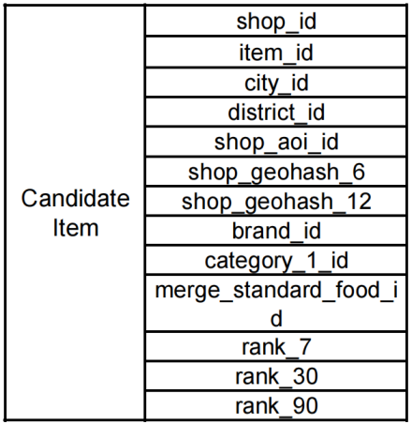

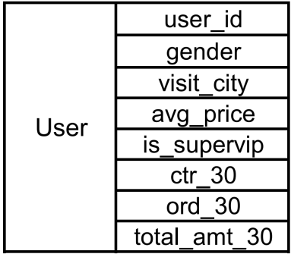

Table1 Table2

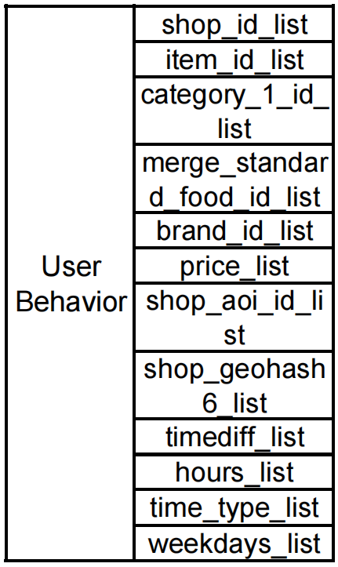

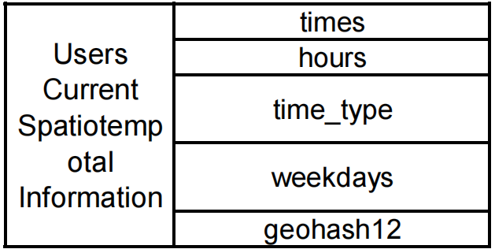

Table3 Table4

This step serves as the foundation for the entire codebase; all subsequent data cleaning, statistical analysis, and aggregation depend on the accurate field semantics established here.

4.Basic Quality Checks, Deduplication, and Data Type Processing
Following field alignment, two primary types of basic processing were implemented:
Timestamp Format Validation: Due to frequent errors encountered during subsequent aggregation stages, a regular expression (regex) check was retroactively applied to request_timestamp to verify it consisted of 10-digit integers (second-level timestamps). This step was crucial to ensure there was no data misalignment and that the time field values were valid. The validation identified 43 records that did not conform to the 10-digit format.
Code Block:
good = df.where(F.col("request_timestamp").rlike("^[0-9]{10}$")).count()
bad = df.where(~F.col("request_timestamp").rlike("^[0-9]{10}$")).count()
print(good, bad, bad / (good + bad))
Deduplication and Type Casting: Duplicate rows are removed using drop_duplicates(). Additionally, specific columns—such as user_avg_price_hist and user_trade_amt_30d—are cast to the float type. This ensures that subsequent operations, including quantile calculations, aggregations, and statistical analysis, are not hindered by string-type data.
At the same time, _c0 (the positive/negative sample label) and click_hist_time_diff_s (the activity time-difference sequence) are retained. Although these metrics may appear insignificant at first glance, they are highly valuable for subsequent Click-Through Rate (CTR) prediction and data modeling.
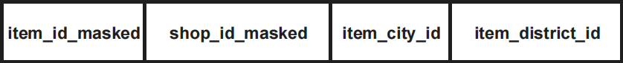
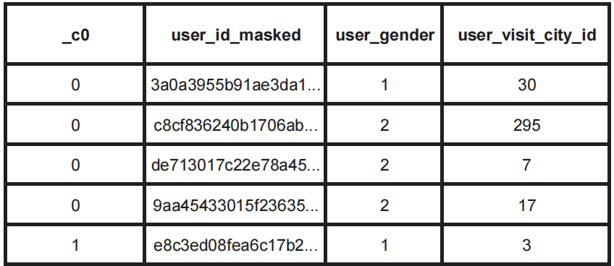
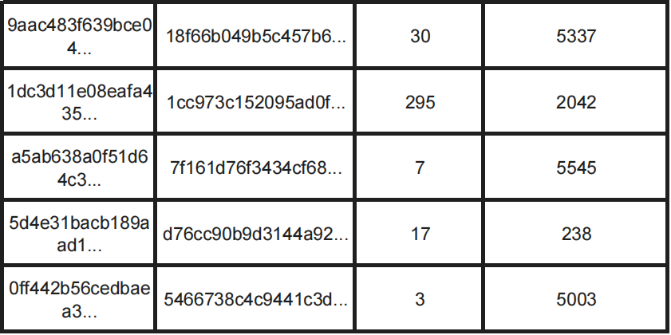

Table 5 Table6
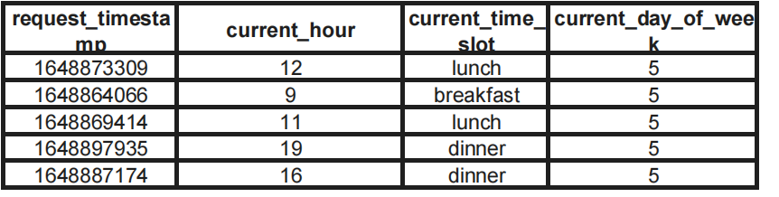
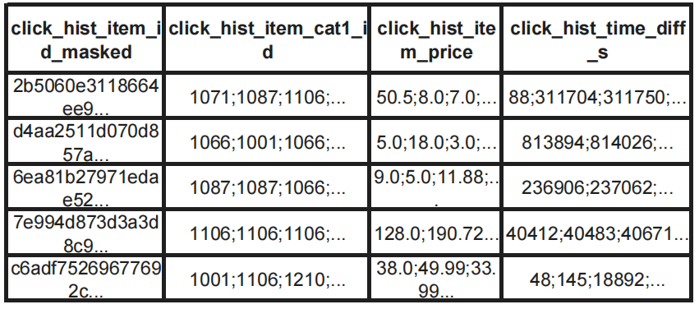

Table 7 Table8

5. Standardization of Missing Value Criteria and Type-Based Cleaning

To identify the structure of anomalies, the following key cleaning logic was established and implemented:
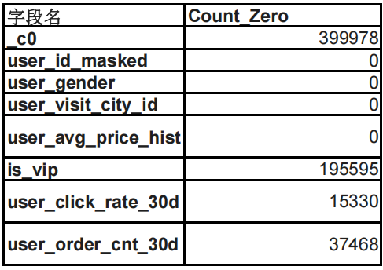
Standardizing Missing Value Definitions: For specific fields, values such as -1, 0, or -99 (e.g., in user_gender) were treated as missing values. This unified approach allowed for a more accurate analysis of the overall anomaly structure within the dataset.

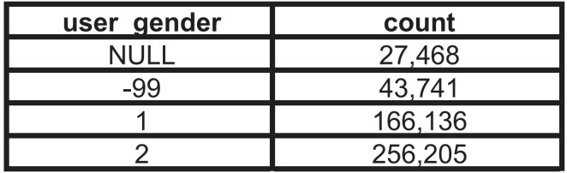

Table9 User Gender Distribution Count Table Table 10 Partial Field Zero‑Value Statistics Display

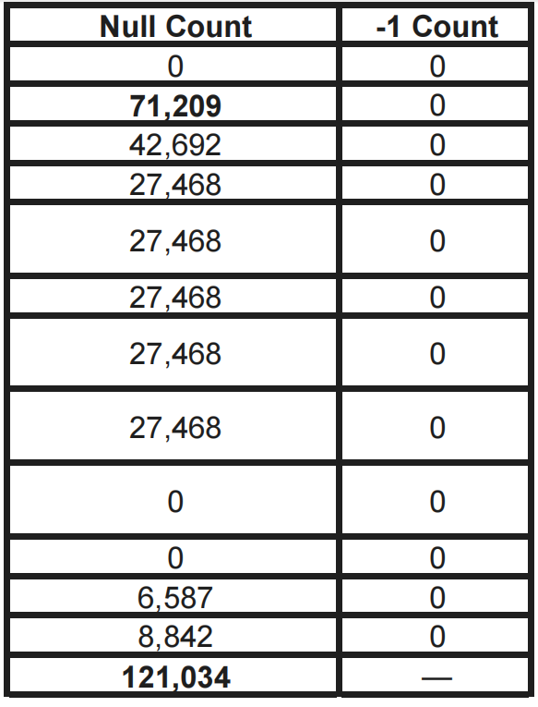
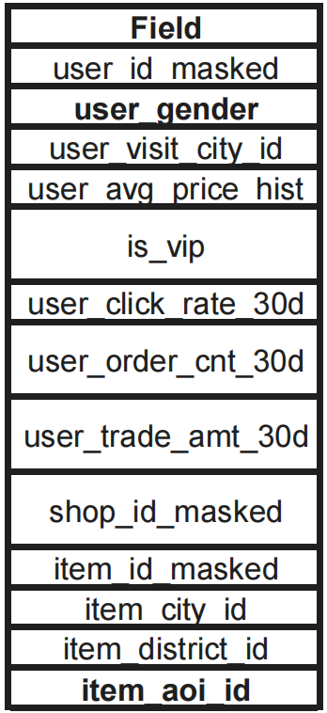
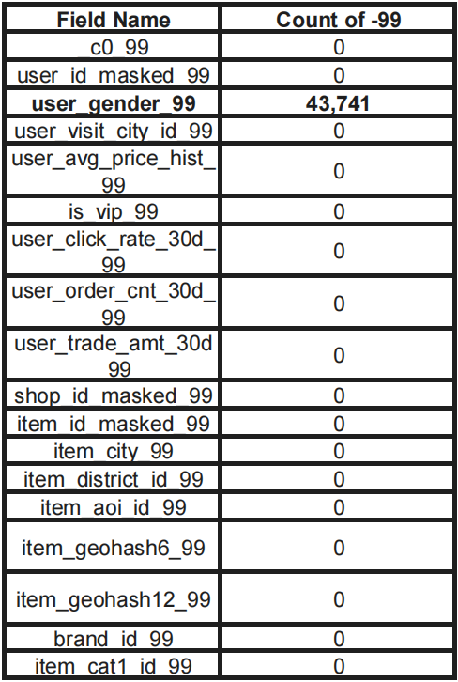
Table11 Partial Field -99‑Value Statistics Display Table12 Partial Field Null/-1‑Value Statistics Display

To facilitate subsequent processing, values such as 0, -99, and existing nulls were standardized to a uniform Null value, followed by a comprehensive count of Nulls across all fields. (Note: Since a value of 0 carries legitimate semantic meaning in certain columns, this replacement was applied selectively only to specific fields.)
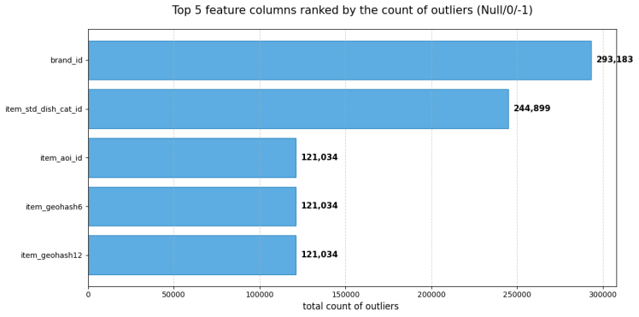
Fig.1

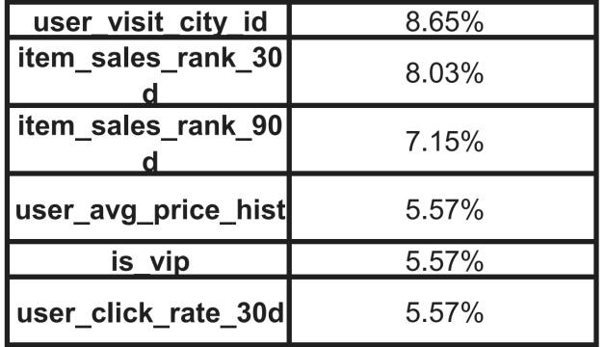
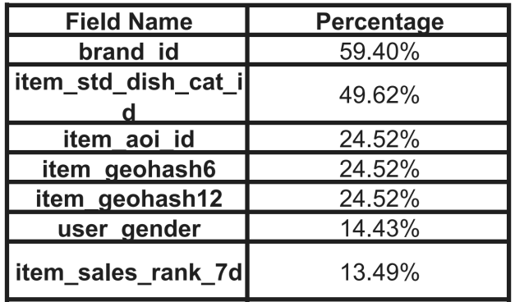

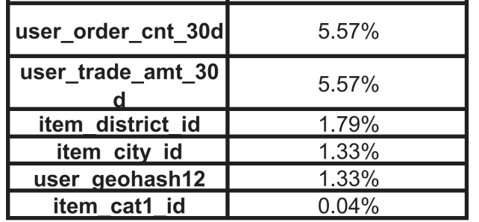

Table 13 Statistical Table of Missing Value Percentages by Field
Furthermore, the analysis indicates that identical missing value counts for item_aoi_id, item_geohash6, and item_geohash12 may suggest a shared dependency on the same LBS (Location-Based Services) pipeline or location service, pointing to correlated missingness. This also suggests potential information redundancy among geohash fields of different precisions, implying that features can be selectively retained during the modeling phase to optimize performance.

6. Missing Value Handling Methods
First, calculate the missing value counts and the missing rate percentage for each column to guide the subsequent stratified handling.
Low Missingness (0%–3%): Apply a row-deletion strategy for columns with a missing rate between 0% and 3%.
Category/ID Imputation: For the remaining data, perform imputation based on field types. Specifically, for ID-related columns (brand_id, item_std_dish_cat_id, item_aoi_id, item_geohash6, item_geohash12, user_gender, user_visit_city_id), fill missing values with "unknown" and cast the entire column to a uniform string format.
Ranking Columns: For ranking fields (item_sales_rank_7d, item_sales_rank_30d, item_sales_rank_90d), use 9999 as a sentinel value to represent "Unknown/Unranked."

Continuous Numerical Columns: For user_avg_price_hist, impute missing values using the median (approximately 40.9). If the median calculation is invalid (e.g., None or < 0), use 20.0 as a fallback value.
Note: All other numerical columns not mentioned above should retain their Null values

7.Structuring Historical Sequence Fields, From Semicolon-Delimited Strings to Arrays
In the raw dataset, fields related to click_hist_* are primarily stored as strings concatenated by semicolons (;). To facilitate downstream processing, a generic str_to_array function has been implemented to convert these raw strings into structured array formats.
By transforming the data this way, historical behavior sequences are no longer non-computable long strings but rather Spark-operable array types. This provides the structural foundation for calculating downstream metrics such as click frequency distinct counts, active days, and average clicks per active day.

8. Modeling Data Warehouse Tables for MySQL
To analyze click-through rate (CTR) behavior, user behavior sequence fields are extracted and modeled into five distinct tables (exported to MySQL):
fact_db: The Fact Table, which records item details and their corresponding relationships.
geo_table_db: The Geographic Information Table, used for storing location-based records.
Item_table_db: The Item Mapping Table, which maintains record relationships.
Shop_click_summary_table: A specialized table dedicated to recording aggregated shop click counts.
diff_table_db: This table specifically records item click activity and popularity. Notably, the field click_hist_time_diff_s has been processed: it is first split into an array to align with items and shops, and then used to back-calculate the specific day each behavior occurred. The formula is as follows:
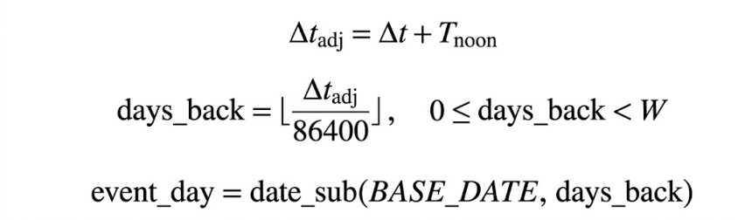

Tnoon=12*3600=86400,BASE_DATE is fixed as April 2nd, from which the daily click volume for items across each day of the week can be derived. Subsequently, the difference between two adjacent records is calculated based on the same row_id, item_id, and shop_id sequence.
Δt−Δt_{next}，Take the absolute value and aggregate the data to calculate the avg_diff per weekday; this allows for the determination of the activity level for an item or shop on a specific day of the week. Notably, a measure was constructed in Power BI:
Click_Efficiency = DIVIDE(1, diff_table_db[avg_diff] + 0.001)
This converts the values into a standardized metric for measurement. Finally, the minimum value of click_hist_time_diff_s is extracted across the same row_id, item_id, and shop_id sequence to determine the popularity of a specific item or shop.

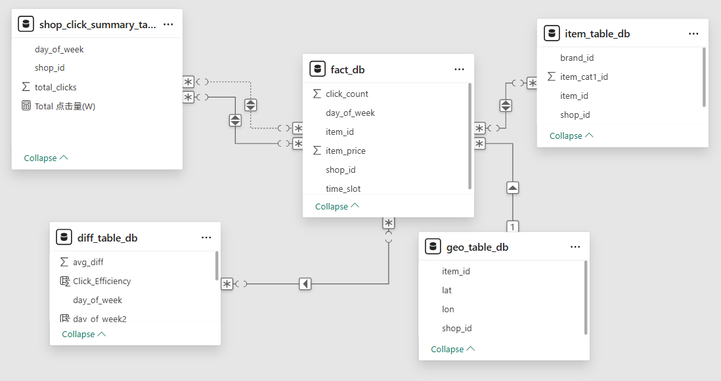
Fig.2 Star Schema Modeling with Five Tables
9.EDA in PowerBi
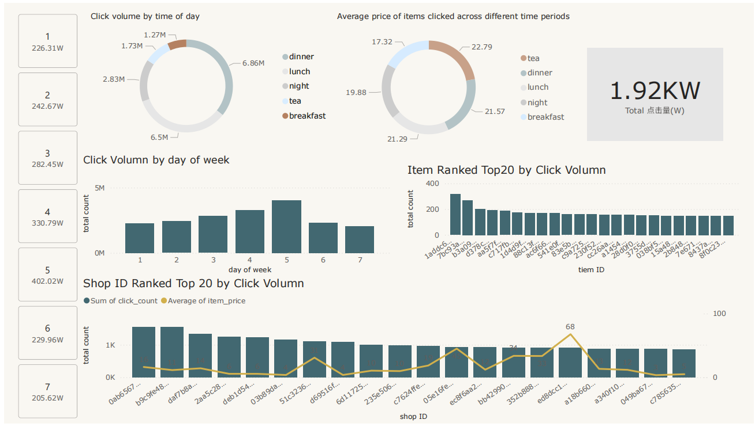

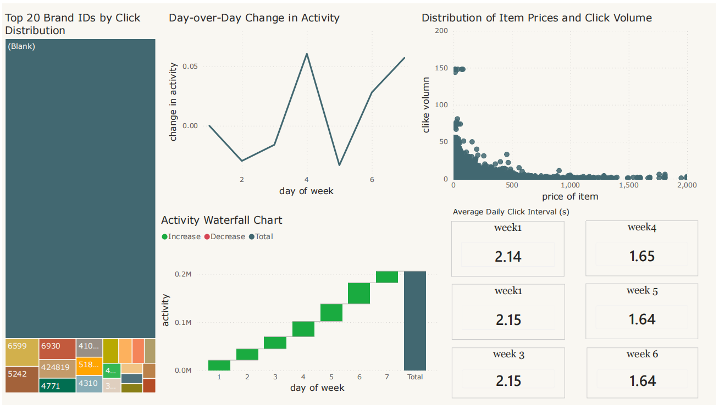
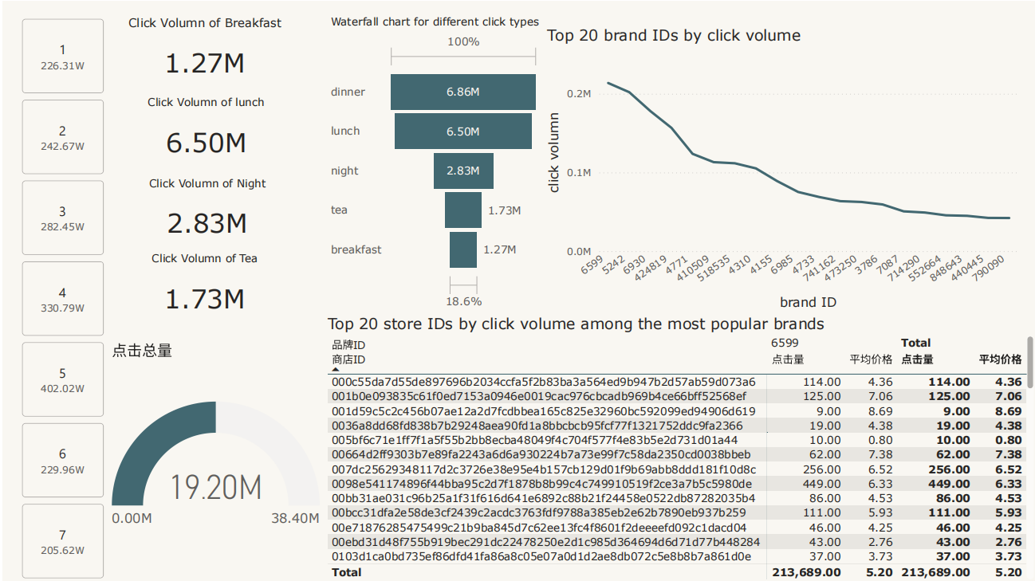

- RFM Analysis
A user-oriented summary table df_final is constructed and written as RFM_analysis.parquet. This table selects and retains fields related to user activity, frequency, value, and diversity, as follows:
R: (User Activity)
days_since_last_click ("click_hist_time_diff_s") (User Activity)
F: (User Frequency)
User_order_count_30d (number of orders placed within 30 days)
click_days_30d: number of unique days with click behavior in the last 30 days
click_cnt_30d: total number of click behaviors in the last 30 days
M:
User_trade_amt_30d (user's transaction amount within 30 days)
E: (Activity Breadth)
distinct_shop_30d, distinct_item_30d, distinct_cat1_30d
D (Activity Depth)
avg_click_per_active_day, user_click_rate_30d
For each dimension (R, F, M, E, D), quantiles are calculated across all users at approximately the 20%, 40%, 60%, and 80% thresholds, and users are assigned to tiers 1 to 5. For F, M, E, and D, the higher the value, the higher the tier; for R, the lower the value, the higher the tier. Finally, a weighted score is computed using the following weights: R 25%, F 20%, M 25%, E 15%, D 15%. Based on this total score, we obtain the business value for each user.

11. Click_through prediction analysis
The dataset exhibits a significant class imbalance, with non-click events outnumbering click events by approximately 4.2:1. A CTR of ~19% is quite high for typical online advertising or recommendation systems, suggesting this may be a specific domain (e.g., food delivery, e-commerce with high user engagement) or that the data represents a filtered/triggered set of impressions.
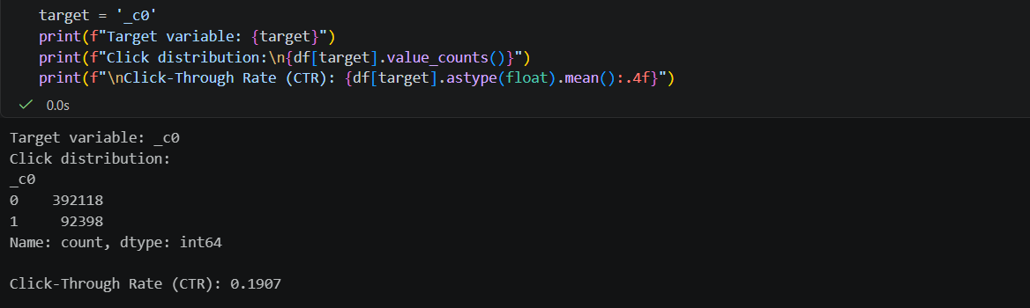
11.1 Implications
Consistency: The CTR in both training and test sets is identical (0.1917), confirming that stratification worked correctly. This ensures representative class distribution across splits.
Feature Set: The model will use 21 features derived from the original data, including both user attributes and item category. Note that user_order_cnt_30d and item_category appear in the categorical list but are not explicitly listed in the “retained” columns — they may have been derived or renamed.
Sampling Choice: Using 100,000 samples instead of the full 484,516 rows is a pragmatic decision to speed up training while still providing a statistically representative subset. However, the final model should ideally be trained on the full dataset for production use.
Missing Context: The exact encoding method (e.g., one-hot, label encoding) and scaling applied are not shown, but the presence of a scaler object suggests numeric features (like user_avg_price_hist) were standardized.

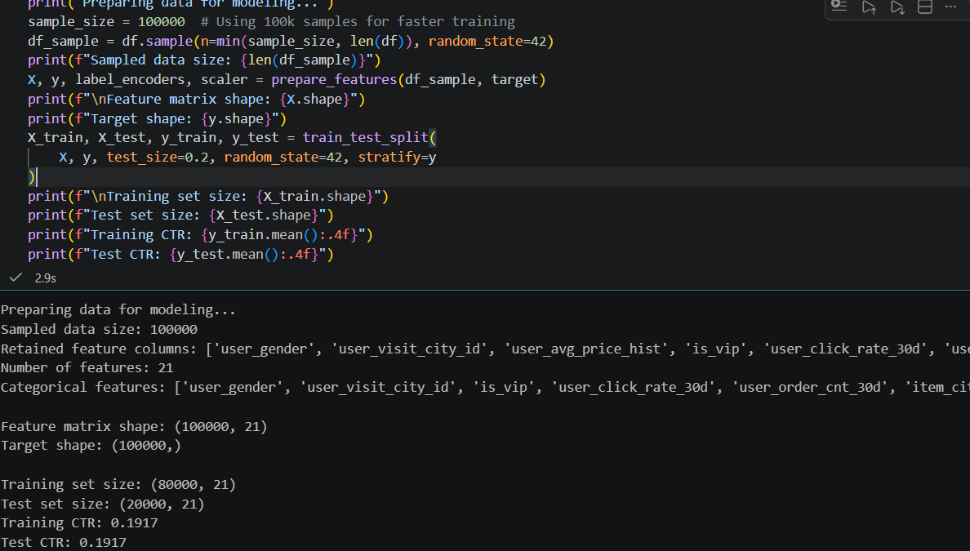
11.2 Model Evaluation and Comparison
The inclusion of both tree-based models (Random Forest, XGBoost, LightGBM) and a linear model (Logistic Regression) allows for comparison across different algorithm families.
The use of random_state=42 ensures reproducibility.
n_jobs=-1 in Random Forest enables parallel processing to speed up training.
XGBoost and LightGBM are configured with relatively shallow trees (max_depth=6), which helps prevent overfitting given the dataset size (80,000 training samples).
The evaluation focuses on probability-based AUC, which is appropriate for imbalanced CTR prediction (19% positive class).
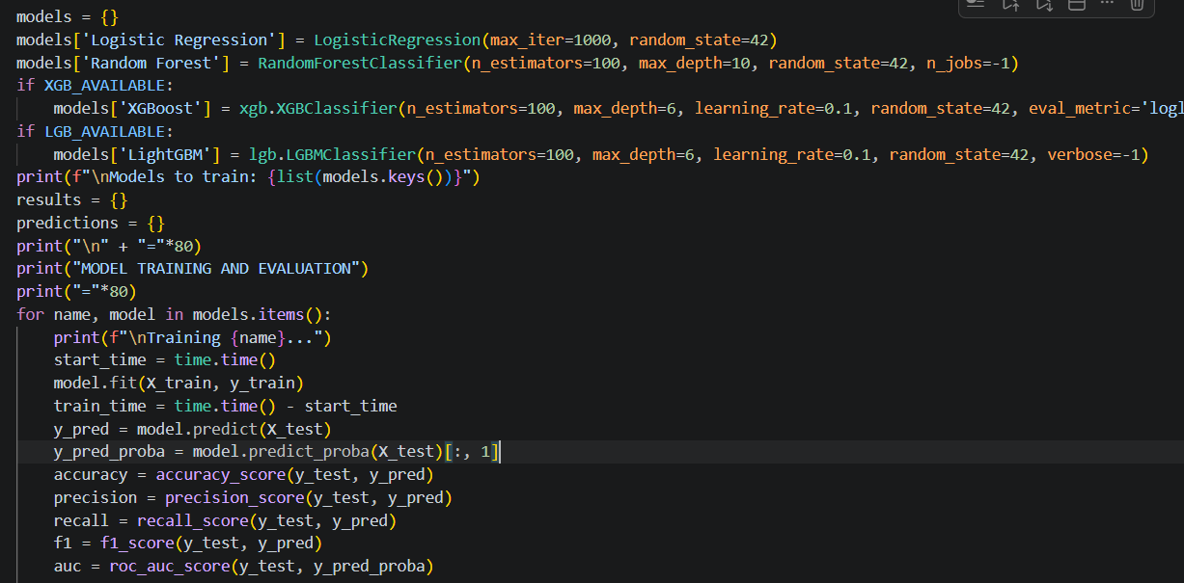
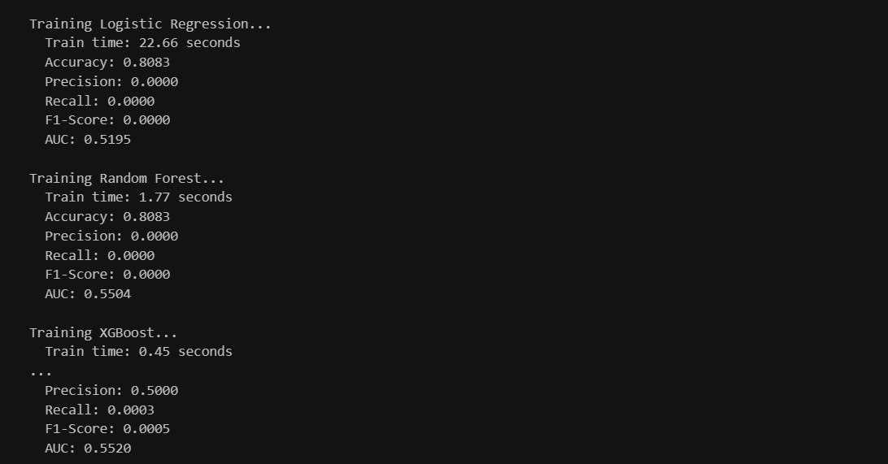
The visualization approach allows quick comparison of:
Predictive performance (accuracy, precision, recall, F1, AUC) across models.
Efficiency (training time) to help balance performance vs. computational cost.
Horizontal bar charts with sorting make it easy to identify the best-performing model for each metric.
The inclusion of both probability-based (AUC) and threshold-dependent metrics (precision, recall) provides a holistic view, which is especially important for imbalanced CTR data.
