Duality
课程链接：https://www.youtube.com/watch?v=AAcvn41Xqbk&list=PLMHSr8fseBzWKsCDYRz7jFukOciviyXgc&index=4

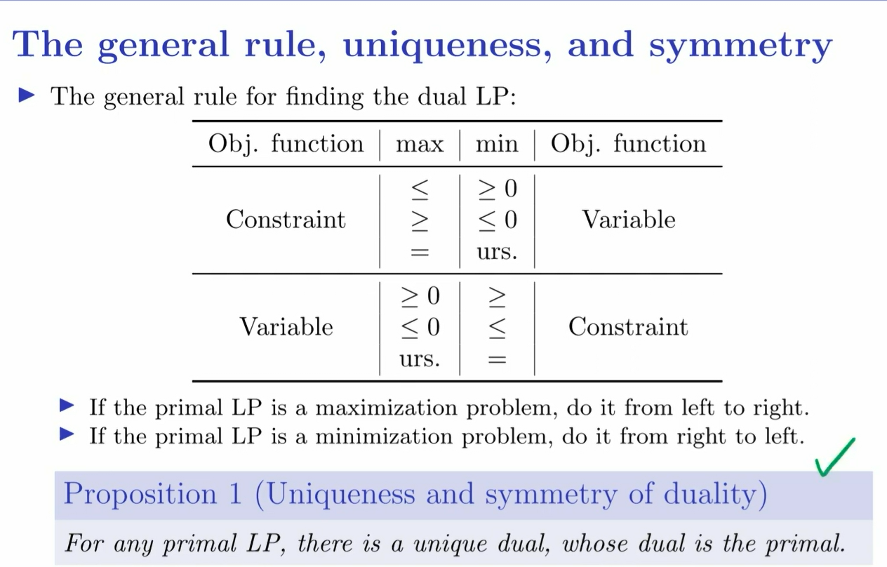

对偶定理：https://baike.baidu.com/item/%E5%AF%B9%E5%81%B6%E5%AE%9A%E7%90%86/6362185

