Convex
https://www.youtube.com/watch?v=uFK958Pfa6c&list=PLMHSr8fseBzWKsCDYRz7jFukOciviyXgc&index=32

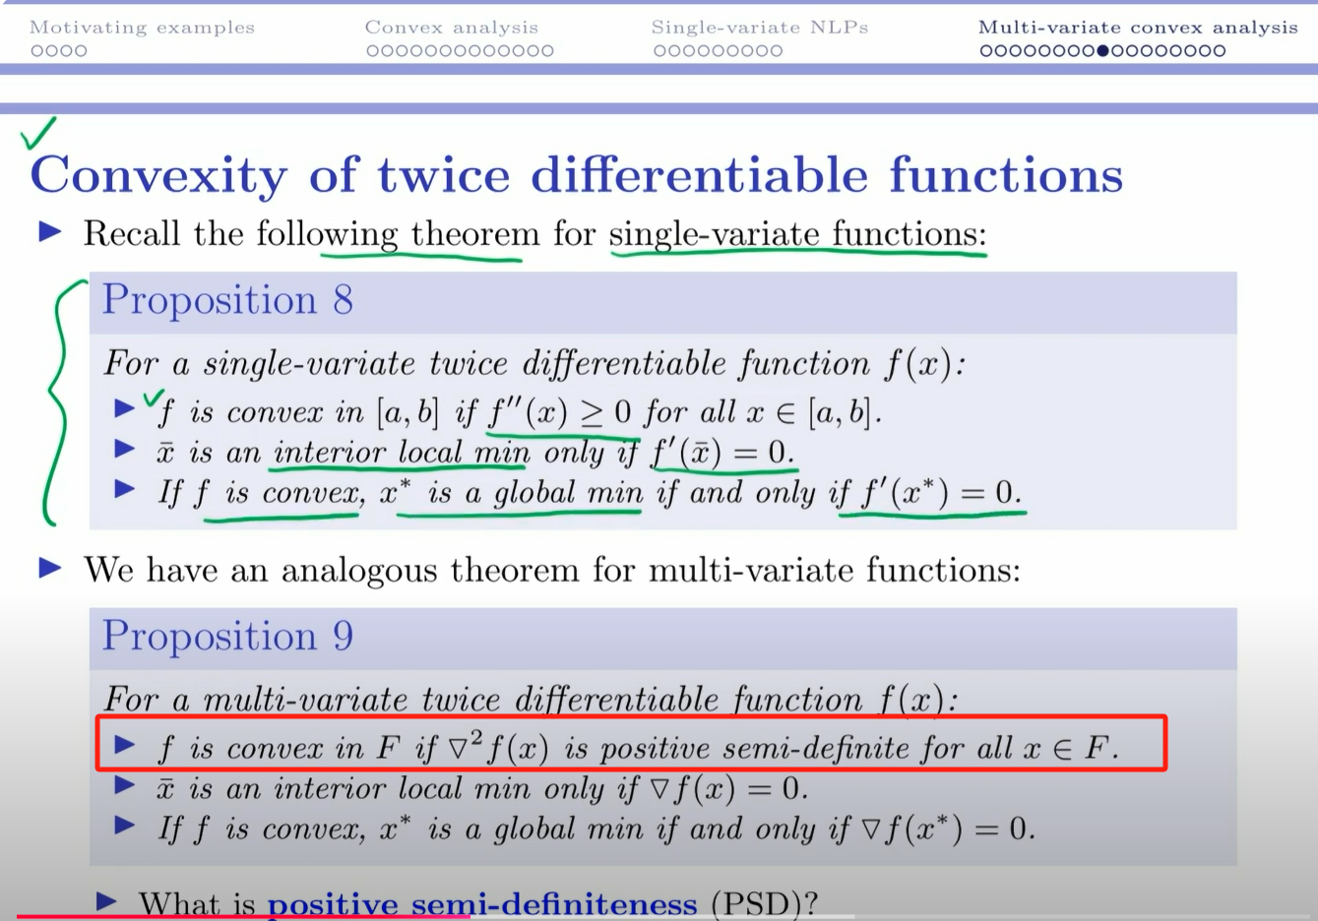
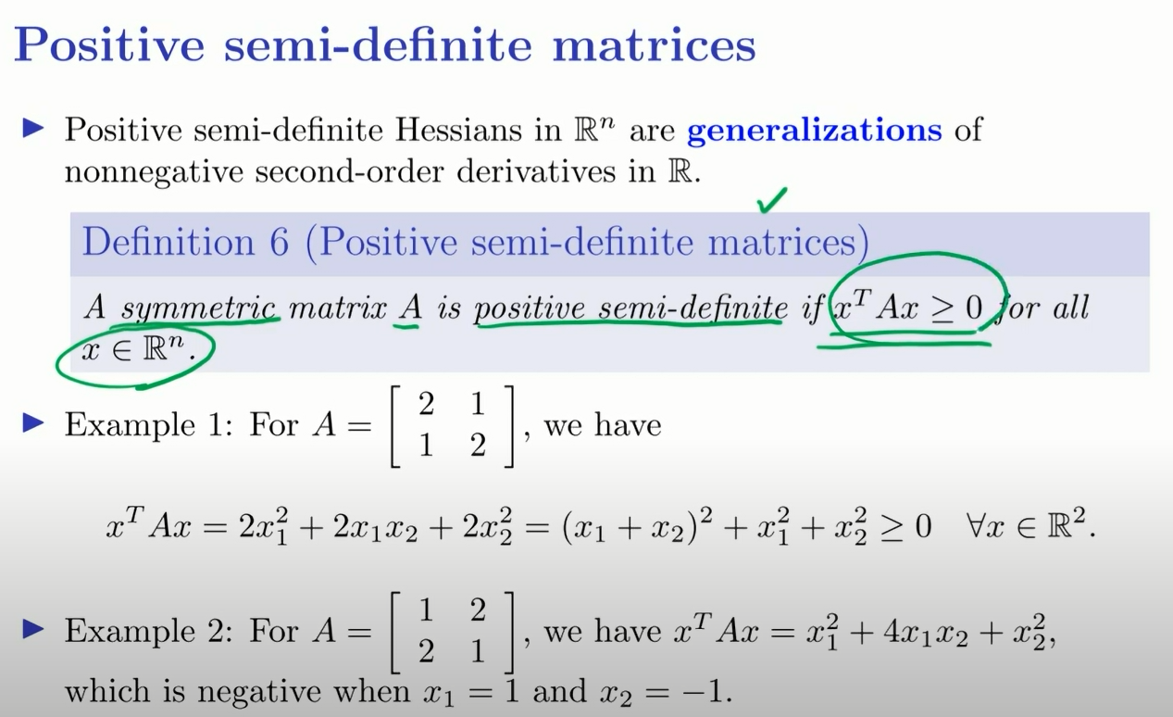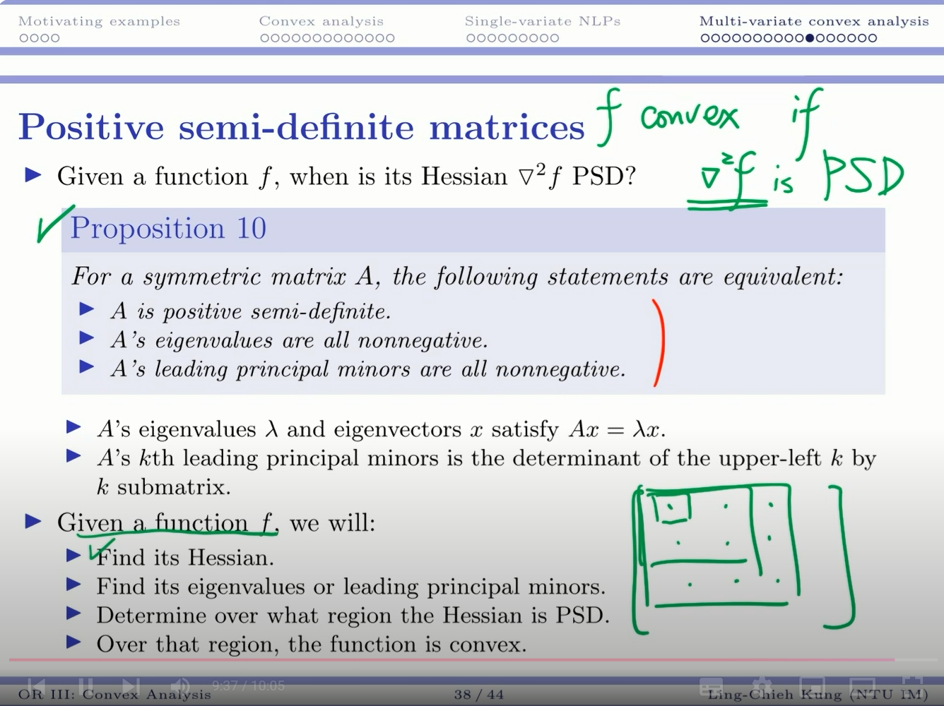

例子：https://www.youtube.com/watch?v=zdXbMqIKiBQ&list=PLMHSr8fseBzWKsCDYRz7jFukOciviyXgc&index=33

