**COMP9032 Project: Smart Airplane Window Controller**

**Name: Chuang-Yin, Wang zID:z5281578**

**Description**

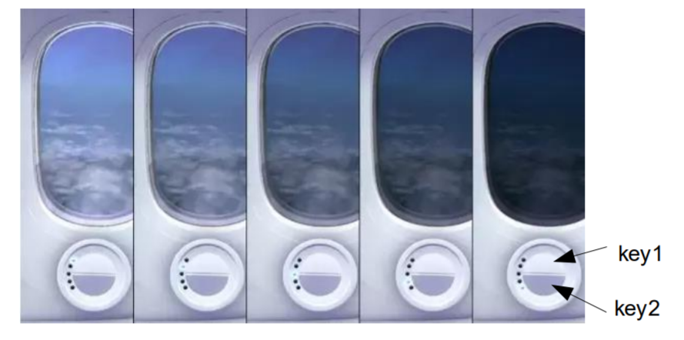

The project aims to create an airplane windows system with different control modes that can simulate different control circumstances. The structure of the airplane windows system can be illustrated as below:

**Input**

**Output**

Push button

**Interrupt**

LED

LCD

Microprocessor

Keypad

The system can be divided into three parts: Input part, microprocessor part and output part. In this project we use keypad for input. If one of the keypad button is pressed, it will generate a signal to the microprocessor. The microprocessor will have different operations depending on which keypad button is pressed. The opaque level is showed on both LCD and LED. In LCD we use different number to indicate the opaque level, in LED we use different brightness to indicate the opaque level. Furthermore, we use a push button to generate an interrupt to simulate an emergency situation during the flight. Detailed information about each part is explained as below.

**Keypad**

In this AVR Development board, we use Port C to manipulate keypad. PC0~PC3 are set as output, each pin gives an output value to a column in keypad. PC4~PC7 are set as input, used to read the value of rows in keypad. During the program operation, each columns will sequentially be set to 0 and check the row value. If there is a bit is zero in the row, then go to find where the row bit is zero, and that is the place where button is pressed. If there is no bit is zero in the row, then skip to scan the next column.

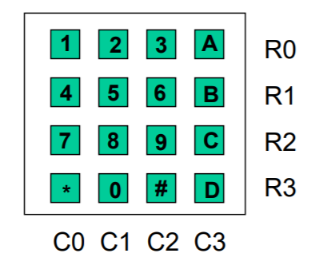

**central control**

**Iocal control**

In this keypad, row 1 and row 2 are used for local control, and each column in this area indicates an individual windows (w1, w2, w3 and w4). When an upper button (1, 2, 3, A) is pressed, the opaque level of this windows will be increased by 1. When a lower button (4, 5, 6, B) is pressed, the opaque level of this windows will be decreased by 1. Button 7 and 8 are used for central control. When button 7 is pressed, all the windows opaque level will be set to maximum level 3, while all the windows will be set to minimum level when pressing the button 8.

**LCD**

We use LCD to show the opaque level of the windows and which control are using right now. Port A is used for LCD control, including RS, R/W and E signal control. Port F is used for LCD. Before using the LCD, LCD need to be initialized. LCD display will first be cleared, and set the LCD mode as 2 line display, entry mode as increment and no shift.

After LCD initialized, set the LCD display to initial state (s), where all the number of each windows is 0, and the control indicator on the left is shown as **S**. During local operation, the opaque level of that specific windows will be update, and the control indicator on the left is shown as **L**. During central operation, the opaque level of **all** the windows will be update, and the control indicator on the left is shown as **C**. The LCD display is shown as below:

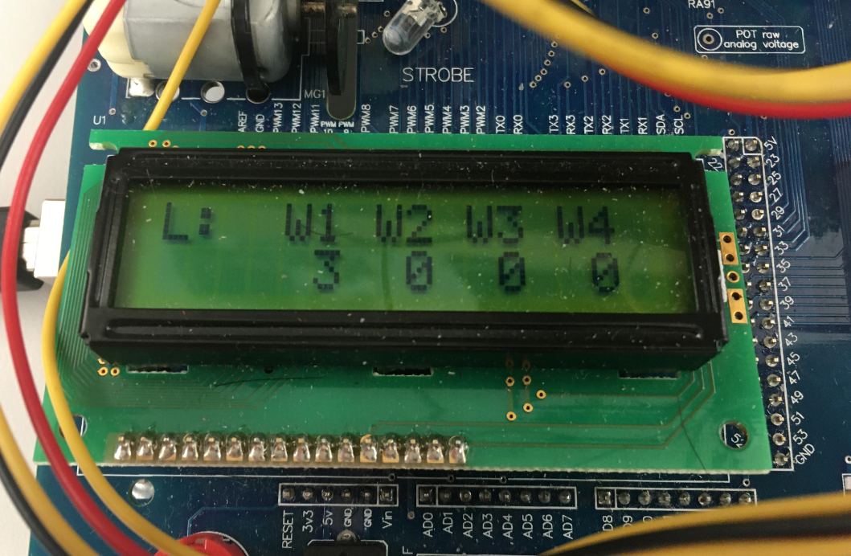

**LED**

We use the brightness of the LED to indicate the opaque level of the windows, and we use Timer to generate PWM waveform to create different brightness in LED. In this project, we use 2 timer to generate 4 PWM signal output OC5A, OC5B, OC5C and OC3A and the corresponding pin is PL3, PL4, PL5 and PE3.

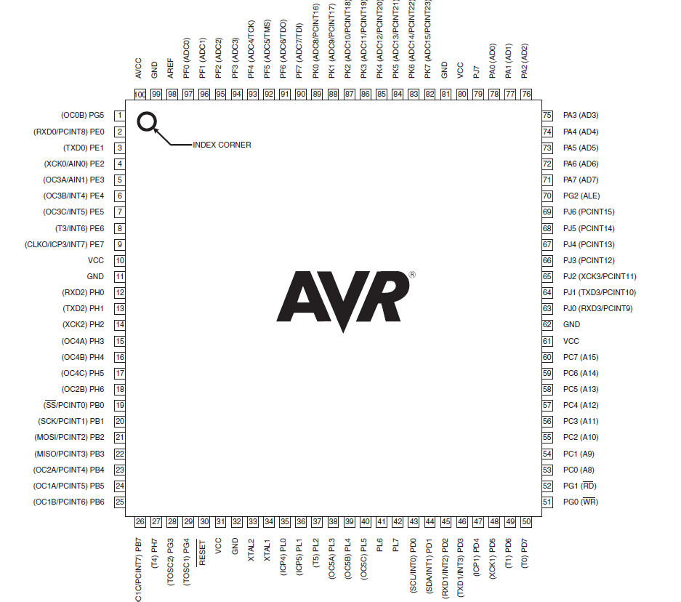

At first we set timers’ frequency to no prescaling, and set the mode to Phase Correct PWM mode. After that set all the PWM compare value to zero, indicates that all the PWM signal will output zero at the initial state. When a windows’ opaque level is changed, set the corresponding PWM value to level*0.33*TOP(Maximum number of PWM compare value) (e.g. level 0 for 0, level 1 for 0.33*TOP……). As soon as the PWM compare value is changed, it will change the PWM signal output and therefore change the brightness of LED. The pictures below are different brightness of LED.

|  |  |  |  |
| --- | --- | --- | --- |
| Level 0 | Level1 | Level2 | Level3 |

**Interrupt**

There are two interrupt in the program. RESET interrupt and INT0 interrupt.

* **RESET interrupt**

Highest priority interrupt. RESET interrupt will be activated when the program starts or when the RESET button is pressed. During RESET interrupt, all the input and output device will be initialized, and all windows’ opaque level will set to zero, and the LCD display will show initial state. The setting of INT0 interrupt will also be set (falling edge triggered, interrupt mask set).

* **INT0 interrupt**

When the press button PB0 is pressed, INT0 interrupt is activated. During this interrupt, all windows’ opaque level will be set to zero. The PWM signal for all LED will also be set to zero to turn off all the LED. The opaque level of all the windows will be shown as zero, and the control indicator on the left is shown as **!** to indicate an emergency interrupt. After the interrupt, the program will jump back to the next instruction of the place where INT0 interrupt occurred.

**Table of used ports and pins**

|  |  |
| --- | --- |
| **Used Pins** | **Connected to** |
| Port A (LCD control) | |
| PA4 | BE |
| PA5 | R/W |
| PA6 | E |
| PA7 | RS |
|  |  |
| Port F (LCD) | |
| PF0~PF7 | D0~D7 |
|  |  |
| Port C (Keypad) |  |
| PC0~PC3 | R0~R3 (input) |
| PC4~PC7 | C0~C3 |
|  |  |
| Port L (Timer 5 for generating pwm) |  |
| PL3(OC5A) | LED0 LED1 |
| PL4(OC5B) | LED2 LED3 |
| PL5(OC5C) | LED4 LED5 |
|  |  |
| Port E (Timer 3 for generating pwm) |  |
| PE3(OC3A) | LED6 LED7 |
|  |  |