Souradeep Bhattacharya

EE120B HW 1

# Problem 1

|  |
| --- |
| #include "rims.h"  void main**()**  **{**  **while** **(**1**)**  **{**  char input **=** A**;**  char count **=** 0**;**  char maxCount **=** 0**;**  char bitMask **=** 1**;**  char i **=** 0**;**  **for(;** i **<** 8**;** i**++)**  **{**  **if((**input **&** bitMask**)** **==** bitMask**)**  **{**  count**++;**  **}**  **else**  **{**  **if** **(**count **>** maxCount**)**  **{**  maxCount **=** count**;**  **}**  count = 0;  }  bitMask = bitMask << 1;  }  if(count > maxCount)  {  maxCount = count;  }  B = maxCount;  }  } |

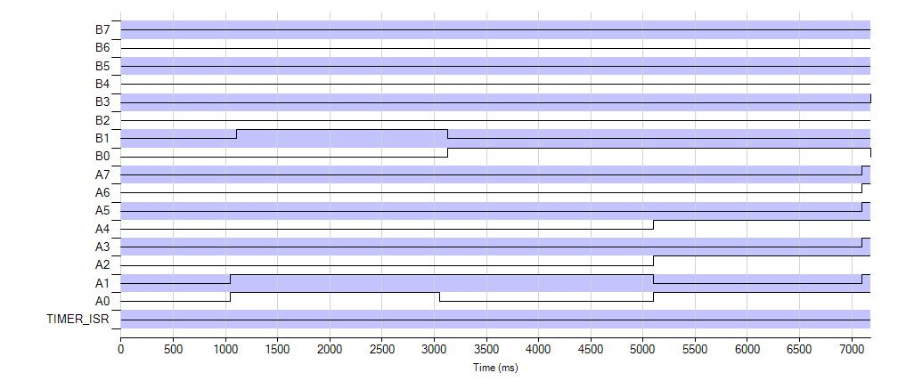

# Problem 2

|  |
| --- |
| #include "rims.h"  void main**()**  **{**  **while** **(**1**)** **{**    char sum **=** 0**;**  char A1 **=** A **&** 0x03**;**  char A2 **=** **(**A **&** **(**0x03 **<<** 2**))** **>>** 2**;**  char A3 **=** **(**A **&** **(**0x03 **<<** 4**))** **>>** 4**;**  char A4 **=** **(**A **&** **(**0x03 **<<** 6**))** **>>** 6**;**  sum **=** A1 **+** A2 **+** A3 **+** A4**;**  B **=** 0xF0 **|** sum**;**  **}**  **}** |

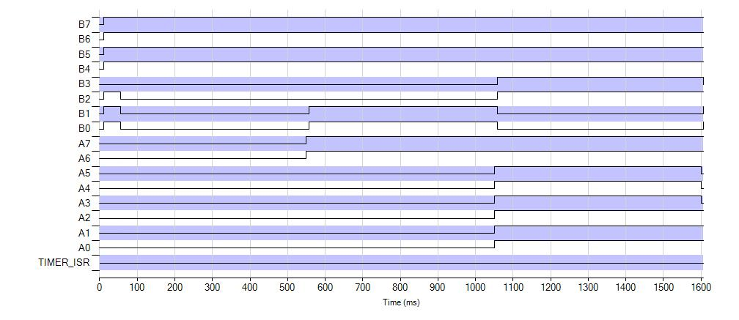

# Problem 3

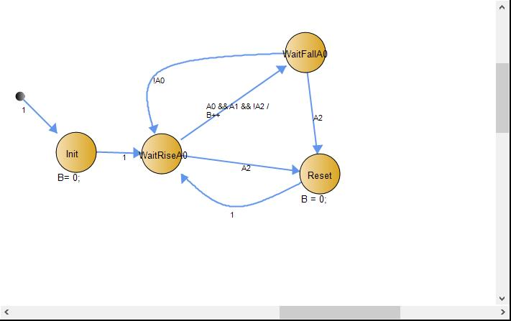

|  |
| --- |
| #include "rims.h"  enum SM1_States **{** SM1_Init**,** SM1_WaitRiseA0**,** SM1_WaitFallA0**,** SM1_Reset **}** SM1_State**;**  TickFct_State_machine_1**()** **{**  **switch(**SM1_State**)** **{** // Transitions  **case** **-**1**:**  SM1_State **=** SM1_Init**;**  **break;**  **case** SM1_Init**:**  **if** **(**1**)** **{**  SM1_State **=** SM1_WaitRiseA0**;**  **}**  **break;**  **case** SM1_WaitRiseA0**:**  **if** **(**A0 **&&** A1 **&&** **!**A2**)** **{**  SM1_State **=** SM1_WaitFallA0**;**  B**++;**  **}**  **else** **if** **(**A2**)** **{**  SM1_State **=** SM1_Reset**;**  **}**  **break;**  **case** SM1_WaitFallA0**:**  **if** **(**A2**)** **{**  SM1_State **=** SM1_Reset**;**  **}**  **else** **if** **(!**A0**)** **{**  SM1_State **=** SM1_WaitRiseA0**;**  **}**  **break;**  **case** SM1_Reset**:**  **if** **(**1**)** **{**  SM1_State **=** SM1_WaitRiseA0**;**  **}**  **break;**  **default:**  SM1_State **=** SM1_Init**;**  **}** // Transitions  **switch(**SM1_State**)** **{** // State actions  **case** SM1_Init**:**  B**=** 0**;**  **break;**  **case** SM1_WaitRiseA0**:**  **break;**  **case** SM1_WaitFallA0**:**  **break;**  **case** SM1_Reset**:**  B **=** 0**;**  **break;**  **default:** // ADD default behaviour below  **break;**  **}** // State actions  **}**  int main**()** **{**  SM1_State **=** **-**1**;** // Initial state  B **=** 0**;** // Init outputs  **while(**1**)** **{**  TickFct_State_machine_1**();**  **}** // while (1)  **return** 0**;**  **}** // Main |

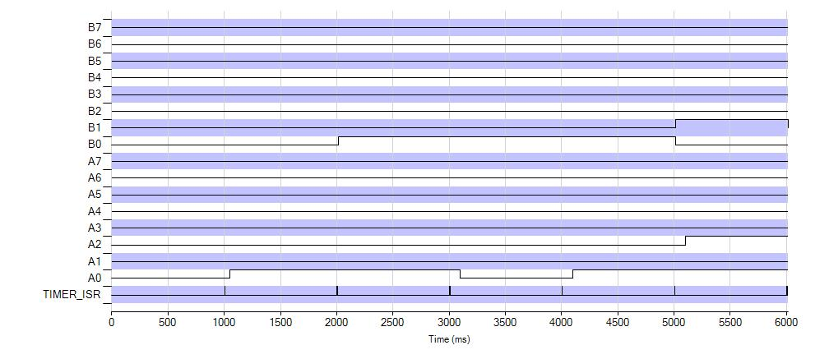

# Problem 4

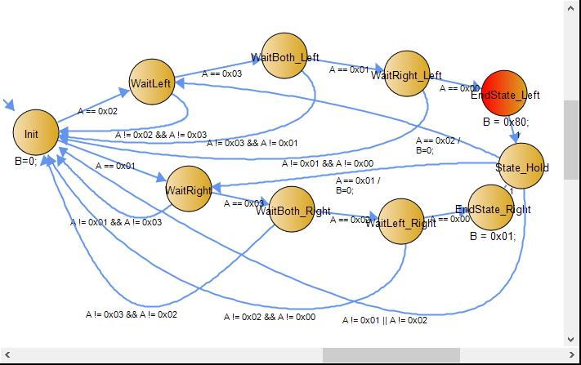

|  |
| --- |
| #include "rims.h"  enum SM_States **{** SM_Init**,** SM_WaitLeft**,** SM_WaitRight**,** SM_WaitBoth_Right**,** SM_WaitBoth_Left**,** SM_WaitRight_Left**,** SM_WaitLeft_Right**,** SM_EndState_Left**,** SM_EndState_Right**,** SM_State_Hold **}** SM_State**;**  TickFct_State_machine_1**()** **{**  **switch(**SM_State**)** **{** // Transitions  **case** **-**1**:**  SM_State **=** SM_Init**;**  **break;**  **case** SM_Init**:**  **if** **(**A **==** 0x02**)** **{**  SM_State **=** SM_WaitLeft**;**  **}**  **else** **if** **(**A **==** 0x01**)** **{**  SM_State **=** SM_WaitRight**;**  **}**  **break;**  **case** SM_WaitLeft**:**  **if** **(**A **==** 0x03**)** **{**  SM_State **=** SM_WaitBoth_Left**;**  **}**  **else** **if** **(**A **!=** 0x02 **&&** A **!=** 0x03**)** **{**  SM_State **=** SM_Init**;**  **}**  **break;**  **case** SM_WaitRight**:**  **if** **(**A **==** 0x03**)** **{**  SM_State **=** SM_WaitBoth_Right**;**  **}**  **else** **if** **(**A **!=** 0x01 **&&** A **!=** 0x03**)** **{**  SM_State **=** SM_Init**;**  **}**  **break;**  **case** SM_WaitBoth_Right**:**  **if** **(**A **==** 0x02**)** **{**  SM_State **=** SM_WaitLeft_Right**;**  **}**  **else** **if** **(** A **!=** 0x03 **&&** A **!=** 0x02**)** **{**  SM_State **=** SM_Init**;**  **}**  **break;**  **case** SM_WaitBoth_Left**:**  **if** **(**A **==** 0x01**)** **{**  SM_State **=** SM_WaitRight_Left**;**  **}**  **else** **if** **(**A **!=** 0x03 **&&** A **!=** 0x01**)** **{**  SM_State **=** SM_Init**;**  **}**  **break;**  **case** SM_WaitRight_Left**:**  **if** **(**A **==** 0x00**)** **{**  SM_State **=** SM_EndState_Left**;**  **}**  **else** **if** **(**A **!=** 0x01 **&&** A **!=** 0x00**)** **{**  SM_State **=** SM_Init**;**  **}**  **break;**  **case** SM_WaitLeft_Right**:**  **if** **(**A **==** 0x00**)** **{**  SM_State **=** SM_EndState_Right**;**  **}**  **else** **if** **(**A **!=** 0x02 **&&** A **!=** 0x00**)** **{**  SM_State **=** SM_Init**;**  **}**  **break;**  **case** SM_EndState_Left**:**  **if** **(**0**)** **{**  SM_State **=** SM_Init**;**  **}**  **else** **if** **(**1**)** **{**  SM_State **=** SM_State_Hold**;**  **}**  **break;**  **case** SM_EndState_Right**:**  **if** **(**0**)** **{**  SM_State **=** SM_Init**;**  **}**  **else** **if** **(**1**)** **{**  SM_State **=** SM_State_Hold**;**  **}**  **break;**  **case** SM_State_Hold**:**  **if** **(**A **==** 0x01**)** **{**  SM_State **=** SM_WaitRight**;**  **}**  **else** **if** **(**A **==** 0x02**)** **{**  SM_State **=** SM_WaitLeft**;**  **}**  **else** **if** **(**A **!=** 0x01 **||** A **!=** 0x02**)** **{**  SM_State **=** SM_Init**;**  **}**  **break;**  **default:**  SM_State **=** SM_Init**;**  **}** // Transitions  **switch(**SM_State**)** **{** // State actions  **case** SM_Init**:**  B**=**0**;**  **break;**  **case** SM_WaitLeft**:**  **break;**  **case** SM_WaitRight**:**  **break;**  **case** SM_WaitBoth_Right**:**  **break;**  **case** SM_WaitBoth_Left**:**  **break;**  **case** SM_WaitRight_Left**:**  **break;**  **case** SM_WaitLeft_Right**:**  **break;**  **case** SM_EndState_Left**:**  B **=** 0x80**;**  **break;**  **case** SM_EndState_Right**:**  B **=** 0x01**;**  **break;**  **case** SM_State_Hold**:**  **break;**  **default:** // ADD default behaviour below  **break;**  **}** // State actions  **}**  int main**()** **{**    SM_State **=** **-**1**;** // Initial state  B **=** 0**;** // Init outputs  **while(**1**)** **{**  TickFct_State_machine_1**();**  **}** // while (1)  **}** // Main |

