UNIVERSITY OF TARTU

Institute of Computer Science

Innovation and Technology Management Curriculum

Tedo Gogoladze

The Importance of Personality Traits in Agile Software Development: A Case Study

Master’s Thesis (30 ECTS)

Supervisor(s): Ezequiel Scott

Tartu 2020

The Importance of Personality Traits in Agile Software Development: A Case Study

Abstract:

During the last decade, more and more companies have transformed their way of working to agile, making it the most common software development methodology in the industry. The core principle of Agile as given in the original manifesto states, that individuals and their interactions are more important than the tools and processes. This convention leads to the need of the study of the software developer individuals in the psychological level of personality, and the performance results associated to the specific personality. There researches that study the personality of the developers and their performances have been set either, in academia, or in the different software development methodology environment, than agile. This paper aims to research the software developers personalities relationship with the metrics of agile, that these developers perform. Within this research the logs of the most common agile software development tool, Jira, is used to retrieve the personality trait of the developers, and to calculate their performance metrics, and finally, the link of the former two is assessed with the association rules. Additionally, this paper studies the related researches of agile metrics and the personality traits to find out how the recent studies define the same relationship.

Keywords:

Layout, formatting, template

**CERCS: P170**

Pealkiri eesti keeles

Lühikokkuvõte:

Selles mallis kirjeldatakse ingliskeelse lõputöö mall, stiilid ja antakse soovitusi töö teostamisel kasutades Microsoft Wordi.

Võtmesõnad:

Kujundus, paigutus, mall

**CERCS:**

Table of Contents

1 Introduction 5

2 Background 7

2.1 Personality type assessment model 7

2.2 Researchers preferred model of Personality type assessment 8

2.3 Agile software development 9

2.3.1 Agile methodologies 11

2.3.1.1 SCRUM 11

2.3.1.2 XP 11

2.3.1.3 FDD 11

2.3.2 Agile Metrics 12

3 Methodology 15

3.1 Technical environment 15

3.2 Datasets 15

3.3 Developers’ metrics 16

3.3.1 Actual development time 17

3.3.2 Prioritization 17

3.3.3 Effort estimates 17

3.4 Developers’ personality traits 18

3.5 Data cleaning and pre-processing 18

3.5.1 Text pre-processing and cleaning 18

3.5.2 Retrieving developers` personality traits 20

3.5.3 Calculation of metrics 22

3.5.3.1 Actual development time 22

3.5.3.2 Task status 24

3.5.3.3 Prioritization 25

3.5.3.4 Effort estimates 25

3.5.3.5 Cleaned Dataset 26

3.6 Association rule mining 27

3.6.1 Methods 27

3.6.2 Results 32

3.6.2.1 Openness 32

3.6.2.2 Conscientiousness 34

3.6.2.3 Extraversion 36

3.6.2.4 Agreeableness 38

3.6.2.5 Neuroticism 40

3.6.2.6 RQ2: 42

4 Discussions 46

5 Conclusions 50

6 References 51

Appendix 52

I. Glossary 52

II. Text cleaning 53

III. License 57

Non-exclusive licence to reproduce thesis and make thesis public 57

# Introduction

Agile software development has already become the most common software development methodology in the industry. Number of previous researches have found out that agile frameworks are the most used in software development due to impressive results of high quality, productivity and client satisfaction [1]. In general, the right diversity of personalities within the team has a significant effect on the team performance [2], in this paper, we will research the personality traits more specifically within the Agile software development teams.

One of the first values of the Agile Manifesto [4] is that Individuals and Interactions are over the processes and tools. Furthermore, it states that developers should work together with business people during the whole project on a daily basis; Developers need to stay motivated and be trusted to get the job done; Face-to-face conversation is the most efficient method of communication and information conveying within the development team; Developers should keep the constant pace indefinitely; The best performance emerges from self-organized teams; Team needs to reflect on effectiveness and adjust behavior accordingly. Coming from the principles and values of Agile manifesto, the high priority is set on the interaction of the software developers within the development team, and outside the team to communicate with the business people.

Personality traits of the developers are not only the subject of study of personal performance and preferences, but also for the team results. Having homogenous personality and mixture of personality types within the team reported higher cohesion and performance in the research experiments of Karl et al [5]. Therefore, the personality types of the development team are important indicators of the team performance as well.

The model of the personality traits assessment varies in different researches. The formerly mentioned research is using Myers-Briggs Type Indicator (MBTI) to assess personality traits. The same MBTI model was very popular tool during the last decades of past century, but the position has been changed lately. Big Five Personality Traits is another personality traits assessment model, that is currently a dominant choice of psychologists as the preferred consensual model of assessing the personality traits - Openness, Conscientiousness, Extraversion, Agreeableness, Neuroticism. It is also known to have more suitability in assessing the Agile team members personality traits, comparing to the traditional models, including the Myers-Briggs Type Indicator, Big 5 not only provides the better measurement of all the factors measured by MBTI, but also it allows to assess Neuroticism, a very important personality factor when working in the teams [6].

Although the recent studies about personality in software development have actively switched to use Big 5 model, there is still a lack of developers` personality traits relation to the Agile software development. it makes problematic to link it with the studies that using Big 5.

To address this issue, we dig into the topics of Agile metrics, where E.Kupainen, M.V.Mantyla and J.Itkonen have studied highly influential metrics in Agile software development by the systematic literature review. High number of occurrences of a metric in the researched literature considered as a sign of high importance. [9]. Within this research, personality traits of the Agile software developers are studied in the context of these Agile performance metrics, specifically, Task prioritization, task complexity Estimation, Actual development time, and task state. Accordingly, our first research question is:

- RQ1) What is the relationship between the personality traits and agile metrics?

For this research question, we use the dataset of open source JIRA logs of eight Agile software development teams. For the first step of our research, we study the personality traits of the software developers from this dataset using the text mining techniques and IBM Watson API. IBM Watson platform uses the LIWC (Linguistic Inquiry and Word Count) to analyse the textual data and predict the personality trait of the individual who is the author of the former text data. The result of IBM Watson is an assessment of personality with Big 5 Personality Traits model, therefore, developers are assigned the score for each of the Big 5 traits – Openness, Conscientiousness, Extraversion, Agreeableness, Neuroticism. LIWC has been used for detecting personality traits of Facebook users, Stackoverflow community users [7], Apache ecosystem and Github users [2]. The next step towards answering this research question is to analyze the logs of JIRA and calculate the metrics mentioned in above paragraph. Finally, these metrics and personality traits of the software developers are used to make association rules to find out the evident and reliable relationship between them.

Furthermore, we performed the literature review related to the Agile software development framework and personality traits. There are studies that have been done solely on Agile, and solely on Big 5 personality traits model, that have a link in common. In his paper, Scott et. al [1] has studied the Agile software development, specifically, SCRUM, within the context of learning styles using the Felder–Silverman Learning Style Model (FSLSM), on the other hand, the research of Siddiquei et. al [8] examined and found out the significant correlation between Learning styles using the above mentioned Felder–Silverman Learning Style Model (FSLSM) and Personality traits of individuals using the Big 5 Personality Traits model. The papers are identifying relation of 1) Agile and FLSM and 2) FLSM and Big 5, notably, both the papers are linked and use the same FLSM model. The experiment and analysis in these two papers are done on the research of the educational institution students, however, there are no scientific analysis of the industry beyond the academia. Coming from these studies, within the current research, we check if there is the scientific evidence of the logical link between these two papers. We will examine How the Agile metrics studied in Scott et.al [1] work are related to the Personality traits model (Big 5 Personality Traits) studied in the work of Siddiquei et. al [8], Therefore, our second research question is as follows:

- RQ 2) What is the relationship between Big 5 personality traits and FSLSM in the context of agile software development?

For answering this question, we take the association rules of.Scoot et. al [1] that use the FSLSM model, replace FSLSM with Big 5 personality traits using FSLSM /Big 5 correlation matrix of Siddiquei et. al [8], and finally, we examine significance of these new association rules comparing to the Scott`s original rules. In his work, Scott et. al [1]has used several SCRUM performance metrics that are also commonly used within the Agile software development, additionally, some of these metrics are studied in the previous research question of this paper, therefore, these metrics are applied in this question as well and the same dataset of open source JIRA logs of the software development teams will be used.

Answering the research questions will be beneficial mainly for the software development industry. Knowledge of the relationships of the personality traits and the specific Agile metrics can be useful for the team and product management to analyze, forecast and handle the performance of the developers and the teams accordingly. They would be able to recognize the certain behaviors in advance, and be aware of the possible outcomes of having the developers of the specific personalities in their teams.

For the developers, knowing their own personality traits can be a note for the possible positive or negative results in their work. Considering the fact, that the personalities of the developers can be changed over the short time [2], they can work on their own specific personality traits to improve the personal and team productivity.

For the Researchers, answer of the questions of this paper can be useful for the further researches on the Agile teams and Personalities. Furthermore, answering to the second question can add more scientific proof and strengthen the research findings of the linked researches. Having the positive results in relationship of Big 5 Personality traits and Agile preference metrics can make a solid bridge that will make a solid and fact-based triangular relationship of Felder–Silverman Learning Style Model, Big 5 Personality Traits model and Agile metrics.

# Background

## Personality type assessment model

The Big Five Personality Traits Model is a five-dimensional personality assessment tool. These five factors are Openness, Conscientiousness, Extraversion, Agreeableness, Neuroticism.

* Openness shows being open to new ideas and experiences, it also indicates how creative they are.
* Conscientiousness indicates the level of goal-orientation, commitment, self-discipline, organization and persistence of the individuals.
* Extraversion denotes the level of gregariousness and sociability of a person, ease of interaction with the others.
* Agreeableness measures degree of trust to the other individuals, cooperation and level of friendliness, adaptive and adjustable to the others needs.
* Neuroticism describes the level of negative emotions expression and personal tolerance and to the stress [6].

Personality trait factors and their definer adjectives, scales and sort items, as described by McCrae and John, are given in Table 1 [11].

The claim of five-factor theorists is that these factors, singly or in combination, can be found in virtually all personality instruments [McCrae and John, 1992]. Big Five personality traits model does not imply that the whole of the individuals` personality traits can be divided by these five traits, these traits are more broad definitions and each of these traits summarizes various specific, distinct characteristics of the personality. *[12]*.

|  |  |  |  |
| --- | --- | --- | --- |
| **Factor** | **Factor Definers** | | |
| **Name** | **Adjectives** | **Q-sort items** | **Scales** |
| Extraversion | Active  Assertive  Energetic  Enthusiastic  Outgoing  Talkative | Talkative  Skilled in play, humor  Rapid personal tempo  Facially, gesturally expressive  Behaves assertively  Gregarious | Warmth  Gregatiousness  Assertiveness  Activity  Excitement Seeking  Positive Emotions |
| Agreeableness | Appreciative  Forgiving  Generous  Kind  Sympathetic  Trusting | Not critical, sceptical  Behaves in a giving way  Sympathetic, considerate  Arouses liking  Warm, compassionate  Basically trustful | Trust  Straightforwardness  Altruism  Compliance  Modesty  Tender-Mindedness |
| Conscientiousness | Efficient  Organized  Planful  Reliable  Responsible  Thorough | Dependable, responsible  Productive  Able to delay gratification  Not self-indulgent  Behaves ethically  Has high aspiration level | Competence  Order  Dutifulness  Achievement Striving  Self-Discipline  Deliberation |
| Neuroticism | Anxious  Self-pitying  Tense  Touchy  Unstable  Worrying | Thin-skinned  Brittle ego defenses  Self-defeating  Basically anxious  Concerned with adequacy  Fluctuating moods | Anxiety  Hostility  Depression  Self-Consciousness  Impulsiveness  Vulnerability |
| Openness | Artistic  Curious  Imaginative  Insightful  Original  Wide interests | Wide range of interests  Introspective  Unusual thought processes  Values intellectual matters  Judges in unconventional terms  Aesthetically reactive | Fantasy  Aesthetics  Feelings  Actions  Ideas  Values |

*Table 1: Personality trait factors and definers*

## Researchers preferred model of Personality type assessment

A systematic literature review on Information systems researches show that by the end of the nineties, Myers Briggs Type Indicator (MBTI), a Jungian typology personality assessment model, was the most common approach to measure personality traits, also these researches had focused more on individual personality rather than the team of individuals. [6].

Researches on the personality traits of Information System personnel with Jungian Instruments (MBTI) conclude that they tend to be Feeling and Thinking types. Some studies reveal that Sensing is the most dominant trait characteristic, while the studies with Non-Jungian instruments (Big five personality traits model) reveal that Information systems personnel are conscientious, confident, persistent, self-assured, assertive, dominant and abstract thinking.

Authors` systematic Literature review is concluded by the statement that the Big Five Personality Traits model provides better measures for these five factors. Moreover, Big Five includes trait Neuroticism, which is not fully covered by MBTI, while it is a major factor to study in case of a collaborative team of individuals. [6]

Several researchers have complied the tables that show standard personality measures to the big five personality traits, also the deep understanding and comparability of the five factors. Researchers may interpret and convert various factors into the big five personality traits model using these tables. Table 2 shows empirically relation of some of such scales to the big five [12].

|  |  |  |  |  |  |
| --- | --- | --- | --- | --- | --- |
| **Instrument** | **Factor** | | | | |
|  | Extraversion | Agreeableness | Conscientiousness | Neuroticism | Openness |
| Hogan Personality Inventory | Sociability | Likeability | Prudence | Adjustment (-) | Intellectance |
| California Psychological Inventory | Sociability | Femininity | Norm-Favoring | Well-Being (-) | Achievement via independence |
| Multidimensional Personality Questionnaire | Social Closeness | Aggression (-) | Control (-) | Stress Reaction | Absorption |
| Adjective Check List | Self-Confidence | Critical Parent (-) | Military Leadership | Ideal Self (-) | Creative Personality |
| MMPI Personality Disorder Scales | Histrionic | Paranoid (-) | Compulsive | Borderline | Schizotypal |

*Table 2: Big five factors personality traits relation to the other instruments.*

## Agile software development

Agile has emerged in recent years as the substituting software development solution of the complex, or plan-driven software development methods. The main focus of Agile is set on customer satisfaction. Goals of Agile are delivered by the continuous process of the high-quality software development. Agile values individuals and interactions, working software, customer collaboration and fast responding to the changes. [4]

Main characteristics of the agile projects are [13]:

* The software starts with a minimum viable product, goes on with small changes and frequent release cycles, development goes incremental;
* Developers work closely with the customers, both entities have an interest of cooperation and keep close communication;
* The working method is easy to learn and use, straightforward and well-documented;
* The software development process is adaptive, the system is open for the late software changes.

Boehm (2002) has compared and analysed process-oriented methodologies vs the agile software development methodology. In his work, Open source software is included as a multifaceted variant method of Agile. Table 3 shows the comparative analysis according to the author [13]:

|  |  |  |
| --- | --- | --- |
| **Ground Area** | **Agile methods** | **Plan-driven methods** |
| *Developers* | Agile;  Knowledgeable;  Collocated;  Collaborative; | Plan-oriented;  Adequate skills;  Access to external knowledge; |
| *Customers* | Dedicated;  Knowledgeable;  Collocated;  Collaborative;  Representative;  Empowered; | Access to knowledge;  Collaborative;  Representative;  Empowered; |
| *Requirements* | Largely emergent;  Rapid change; | Knowable early;  Largely stable; |
| *Architecture* | Designed for current; | Designed for current and foreseeable requirements; |
| *Refactoring* | Inexpensive | Expensive; |
| *Size* | Smaller teams and products | Larger teams and products |
| *Primary objective* | Rapid value | High assurance |

Table 3: comparison of Agile and Plan-driven methodologies

## Agile methodologies

## SCRUM

SCRUM is a commonly used Agile software development method. Its full product development phase is represented by the sprints that release the incremental development states of the needed product. All of these task items are gathered in backlog, each item has estimated velocity and complexity, and for each sprint, the items are taken that do not exceed the available resources. During the sprints, the team has short stand-up meetings where the team members talk about the status and the progress of their tasks and discuss the daily work topics. After the sprint is over, the team has the meeting for the past sprint review. The team gathers once more time to have a retrospective analysis of the past sprints. [3]

Software development approaches consider the development processes to be unpredictable and risky, while SCRUM on the high level offers reliable, agile and responsive results, that is considered as a mechanism that reduces the risk and unpredictability. [3]

## XP

Extreme Programming (XP) has been actively used in software development after 2000. The method has been derived from the traditional development methodologies, as the development lifecycles have been lengthy causing various issues and dissatisfaction. [13]

The typical lifecycle of extreme programming is made of five stages: [13]

* Exploration: The customers of the project make user stories of the features they want to be in the scope of the first release. They write a short description of each feature on the stories. At the same time, the system prototype is built to test the architectural design and possibilities by the programmers. The first phase takes from a couple of weeks up to several months.
* Planning: The user stories are agreed and prioritized, the programmers estimate the efforts needed for the user stories to be released and the schedule is agreed, then the first short release is done.
* Interactions: on this stage, the schedule is split to the iterations, that will take up to several weeks to implement. During the iterations, the system architecture is created for the whole system. Customers assign the stories selected for each iteration and create the functional tests. At the end of the iterations, the tests that are run, and at the end of all the iterations, the system goes for production.
* Productionizing: Before the product will be released to the end customer, the system gets additional tests, performance is checked and if the changes are needed, the decision is agreed if the lacking features will be included or not in that release.

Death: the stage is current when the customers` requirements have been fulfilled and no more user stories are left to be implemented. At this phase, the customer is satisfied with the whole system, it’s reliability and performance. Other alternatives to the death stage to occur is when features become impossible or expensive for development.

## FDD

The feature-driven development methodology is described as the adaptive and agile application of systems development. Generally, FDD has the focus on the building and designing stages, rather than reaching the whole software development process, also the method is designed to be compatible with the other tasks of the project. FDD prioritizes the quality of the project with careful monitoring and the persistent deliveries of the processes. [13]

The process of FDD consists of five sequential phases: First, overall model development, when the system context and the requirements are built, use cases and the functional specifications are set and the domain area specialists know the scope. Second, building a list of the features. the development team builds and presents the list of the functions grouped for each of the domain area, that makes the feature sets. The third phase is Planning by features – all the features are sequenced and prioritized and assigned to the expert programmers. The fourth stage is Designing by feature when the set of the features and the respective development teams are selected. Finally, the fifth stage is Building by feature – the building of the features is divided into the iterations, within each of the iteration there are selected feature sets to be built. The iterations generally take up to two weeks to complete. [13]

## Agile Metrics

E.Kupainen, M.V.Mantyla and J.Itkonen have studied 30 researches and 36 case studies in the systematic literature review of Agile Software Development methodologies and it’s main Metrics. Authors have revealed various domain areas, among those, Information Systems, Telecommunication, web applications were in majority. The results of their research show that SCRUM was the most preferred method of software development, while eXtreme Programming was the second most popular, and Lean and Kanban were following the leaders with less popularity. [9]

Researchers have listed the Metrics that were used by the Primary works about Agile software development, and they have also listed the ones that were not mentioned in the primary works and the practitioners had to invent them according to the needs. Metrics massively used in primary studies of Agile development are presented in Table 4. In most of the measurements, internal attributes show Product class entities, while under external is listed also Resource class entities. Additionally, some of the metrics can be grouped in more than one category. [9]

|  |  |  |
| --- | --- | --- |
| **Entities** | **Attributes** | |
| ***Internal*** | ***External*** |
| ***Products*** | | |
| *Products* | Running tested features, build status | Customer satisfaction, progress as working code |
| *Test plans* | Number of test cases |  |
| *Code* | Technical debt in categories, technical debt in an effort, violations of static code analysis |  |
| *Features* | Task’s expected end date, the task done, effort estimate, story completion percentage | Business value delivered |
| *Requirements* | Requirement’s cost types, percentage of stories prepared for sprint |  |
| Defects |  | Defect trend indicator, predicted the number of defects |
|  | | |
| ***Processes*** |  |  |
| *Testing* | Defect count, test success rate, test failure rate, defects deferred, test coverage, test growth ratio | Number of bounce backs, fault slips |
| *Implementation* | Velocity, number of unit tests, completed web pages, cost performance index, schedule performance index, planned velocity, common tempo time, check-ins per day, fix time of failed build | story flow percentage |
| *Requirements Engineering* | Velocity of elaborating features |  |
| *Whole* | Development cycle | Cycle time, lead time, processing time, queue time, maintenance effort, work in progress, variance in handovers, through put, queue, implemented vs wasted requirements |
|  | | |
| ***Resources*** |  |  |
| *Team* |  | Team effectiveness |
| *Customer* | Revenue per customer |  |

Table 4: Agile metrics in primary studies.

The Authors have also identified the metrics, that are suggested by agile literature, as a result, Effort estimate and Velocity are the most popular. Furthermore, quality assurance metrics were also prominent, followed by measures of actual development time, Load factor, Work in Progress and Lead time. [9]

The Authors have also grouped five reasons of metric usage and identified metrics for each of these categories. Results yield, that for sprint and project planning, Velocity and Effort Estimate are the most important, for sprint progress tracking, completed work, number of automated tasks, burn-down check-ins and defects are the main indicators. For understanding and Improving quality, Number of change requests, maintenance effort, Net Promoter Score and Defects are the most influential. For Fixing Software Process Problems, major indicators are time-related metrics: Lead time, processing time, Queue time. For Motivation of the people defects, defect trend, fix times of failed build and build status are among the ones that matter the most. [9]

# Methodology

In this section, the methodology of answering research questions are defined in a detail level, technical solutions are described and the all the major calculations are present.

To answer RQ1, the following steps were conducted: obtained the written texts by the software developers from the open-source dataset of software development projects, that required the text cleaning procedures and creating corpuses for each developer. Corpuses were used as input for retrieving the big 5 personality traits. Afterwards, metrics were calculated and finally, developers personality profiles were joined with metrics to create association rules and study the interesting relationships of Big 5 personality traits and metrics, that directly answers the first research question.

To answer RQ2, the association of FSLSM and software development metrics from the work of Scott et. al [1] were analyzed and transformed into association rules of Big 5 personality traits and software development metrics using the correlation of Big 5 and FSLSM researched by Siddiquei et. al [8]. Finally, the reliability of the outcome association rules are checked following the same methodology that was conducted for answering RQ1.

## Technical environment

Majority of the research analysis was done on Jupyter notebooks using Python and SQL. Third-party libraries were managed by Anaconda, including Pandas, Numpy, Matplotlib, Seaborn, Re (regular expression), Collections, Pandasql (SQLite local), Apyori (apriori algorithm for association rules). The datasets and the source code written for the analysis are publicly available in a github repository:

<https://github.com/gogoladzetedo/Personalities_In_Agile>.

## Datasets

This study analyses data extracted from JIRA issue trackers of 8 open-source projects, that cover the range of scenarios with regards to project domain, number of issues and developer experience The projects are:

* Aptana Studio (APSTUD), a web development IDE;
* Dnn Platform (DNN), a web content management system;
* Apache Mesos (MESOS), a cluster manager;
* Mule (MULE), a lightweight Java based enterprise service bus and integration platform;
* Sonatype’s Nexus (NEXUS), a repository manager for software artifacts required for development;
* Titanium SDK/CLI (TIMOB), an SDK and a Node.js based command-line tool for managing, building, and deploying Titanium projects;
* Appcelerator Studio (TISTUD), an Integrated Development Environment (IDE);
* Spring XD (XD), a unified, distributed, and extensible system for data ingestion, realtime analytics, batch processing, and data export.

The dataset includes data of the developers involved in the projects, the issue reports, the changelog of the issues, and the sprints. Figure 1 describes the entity-relationship (ER) diagram of these datasets and shows attributes of each of them.

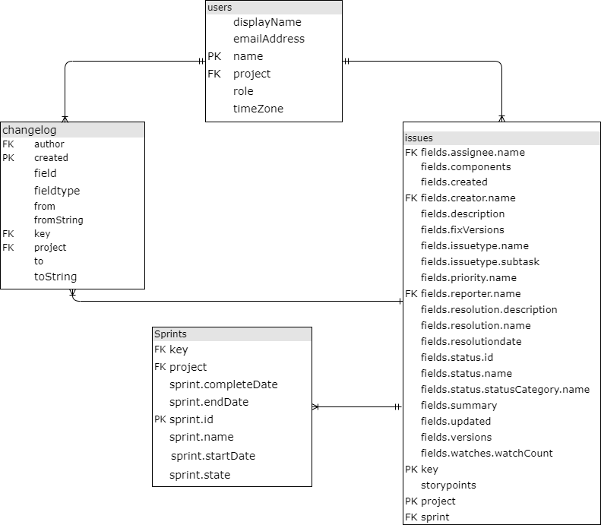

Figure 1. ER diagram of the dataset used.

In total, the dataset consists of 18090 issue reports, out of which there are 15155 unique issues. Each issue report contains references to the sprint in which was developed, its creator and reporter. A total of 1533 unique users (developers) across all the projects were identified as „creator“ or „reporter“.

In addition, the dataset contains information of every change made to the fields of the issue reports. For example, a change on the status of an issue from „To Do“ to „Done“ is recorded in this changelog along with its timestamp and creator. In total, there are 332690 changes recorded in the original dataset.

## Developers’ metrics

In order to characterize the individual performance of the developers, a set of common-used metrics in agile software development were selected. These metrics involved the actual development time, prioritization, effort estimates, and the status of the issues. During the selection of the metrics the following arguments were taken into account:

- Popularity and usage of the metric - selected metrics are popular, commonly used and accepted in the modern agile software development according to the systematic literature review of Agile metrics usage by E.Kupiainen, J. Itkonen and M.Mantyla [8];

- availability in the current research dataset – these four metrics are retrievable from the existing open-source dataset of software developers used in this research;

- Variety of the metrics – selected metrics can measure various aspects of software development and cover sprint planning (prioritization metric), progress tracking (task status metric), prioritization (prioritization metric), scoping and resourcing (effort estimate metric and actual development time metric) [8];

- Consistency with the related literature – the second research question requires the metrics that were analyzed in the related literature. All the selected metrics are used by the authors of the related literature [1], therefore these metrics are applicable in this research and consistent with the others.

### Actual development time

`Actual development time` denotes the time spent on a specific issue by a developer. Actual development time will catch only the times that was actually being worked, excluding the waiting times.

### Prioritization

Prioritization is a type of activities that is commonly studied to monitor and control the project planning [9] – prioritization denotes the urgency of the task from the point of view of the developer. The prioritization values of the issue reports can be easily retrieved from the dataset since they are recorded in a specific field, which makes it worth to be analysed.

### Effort estimates

Effort estimation is another important activity of planning related to the scoping and resourcing of an agile software project [9]. In agile projects, effort estimates are given in story points and the number of story points completed during a sprint is known as velocity. Although there Velocity is the most widely used metric[9], it does not take into account the single developer’s perspective for a given issue.

Since we are interested in having a more detailed understanding on the personal level, the story points assigned by the individual developers were studied.

* + 1. **Task status**

There are progress tracking metrics that are used for monitoring the progress. Depending on the project, the metrics can be divided into project progress or increasing visibility and achieving goals [9]. These metrics are commonly accepted measurement [9]

In this study, the task status was the choice of metric for the individual developers’ progress tracking. The task status metric assesses how the developers tend to assign the status to the issue (e.g. close them, put in progress or in to do status list).

## Developers’ personality traits

Within this research, IBM Watson Personality Insight was used for getting the developers’ personality traits . This approach has been also used by several related works [2] IBM Watson Personality Insights is the platform that detects the individuals` personality traits based on the writing style of the person. IBM Watson has implemented API (Application Programming interface) that extracts the values of each dimension of the Big5 model by analysing written text. IBM Watson uses linguistic analytics to determine the personality characteristics within the Big 5 personality traits model.

Since this study is interested in the developers’ personality traits, we collected every single piece of text in the dataset written by the developers. We use the fields […], which contains information on …

## Data cleaning and pre-processing

## Text pre-processing and cleaning

This section describes the pre-processing and cleaning steps performed to make the data suitable for the analysis.

IBM Watson offers the Big 5 personality traits assessment for the input of 600 or more words written by a person. Therefore, we need to get the developers with enough and meaningful texts, where enough refers to the developers having the corpuses with 600 or more words, and meaningful refers to the texts that are useful to detect the personality traits. In order to obtain the data of developers with meaningful corpuses, it is required to perform the text cleaning procedures, get rid of the system-generated and automatic texts, and create corpus of the text for each developer. For getting the developers with enough texts, the developer corpuses must be filtered according to criteria of IBM Watson Personality Insights. The corpus of the developer must contain minimum 600 words. Accordingly, the steps performed for getting meaningful and enough developer corpuses are described in the following paragraphs.

The first task is to apply text cleaning procedures to get the meaningful texts from Jira fields written by the developers.

There are several fields in Jira that are filled by the developers. These fields are: 'summary', 'description', 'Acceptance Criteria', 'Comment', 'Epic Name', 'Out of Scope', 'QA Test Plan', 'Epic/Theme', 'Migration Impact', 'Business Value’. Table 5 shows the number of different written texts in each field. Based on these numbers, we decided to use the following fields:since they were holding the most written textswritten textsfilled in the formerly mentioned fields

|  |  |
| --- | --- |
| **Text Field** | **Written texts** |
| Acceptance Criteria | 97 |
| Business Value | 1 |
| Comment | 522 |
| Epic Name | 57 |
| Epic/Theme | 414 |
| Migration Impact | 6 |
| Out of Scope | 10 |
| QA Test Plan | 21 |
| description | 4227 |
| summary | 3695 |

Table 5. Jira changelog text fields

Additionally, a cleaning step to avoid duplicated text was performed since a JIRA user may submit a change of the textual value into one column multiple times. For example, one can write the half of the description in the description text. Then, after a while when one realizes the data was partial, they can input the full description text. In such case, there will be two records of `description` field change in the changelog dataset, while the last edit is the only complete and thus sufficient for this research, while the very first edit is the partial copy of the last one, which is on one hand, a duplicate, and on the other hand, an incorrect/insufficient edit of the data. Possibility of such duplicates/incorrect data has to be avoided. It is necessary to include only one edit on each task field for each user. Therefore, the following technique was applied: the calculation logic is defined to take the latest one change of the task field by user, and the latest one will be calculated from the `created` column value.

Considering the fact that this study analyses data from software projects repositories, the text written by developers contain many technical terms, and in many cases, just a copy of the code snippet of a certain programming language, error code and syntax, system logs, stack traces, technical commands, or other technically formatted texts. for this reason, several text-cleaning activities are performed to get only the meaningful textual inputs that were handwritten by the developers. The cleaning steps include deleting of the standard code snippets and commands, cleaning the text from special characters and tags, removing the texts with system logs. The full list of cleaning steps are given in Appendix II.

After applying the aforementioned cleaning steps, all the text written by a given developer were put together in a single corpus. Then, this corpus represents all the text written by the developer during the project and it will be used to automatically calculate their personality traits. Furthermore, we introduced variable number of words in corpus, in order to meet the criteria of IBM Watson Personality Insights tool. For having the developer corpuses with enough written texts, as stated in the beginning of this paragraph, it is necessary to filter the dataset and keep only the corpuses with 600 or more words. Dataset filtered with 600 or more words in corpuses is calculated and the descriptive statistics are shown in Table 6.

|  |  |
| --- | --- |
|  | **Number_of_words_in_corpus** |
| **count** | 100 |
| **mean** | 2568.81 |
| **std** | 3987.884 |
| **min** | 603 |
| **25%** | 942.5 |
| **50%** | 1419.5 |
| **75%** | 2339.5 |
| **max** | 34135 |







Table 6: description of number of words in corpus variable from the texts dataset.

Description of this dataset shows, that there are corpuses of 100 different developers having enough number of words. Vale of mean number of words (2568.81) is 81% more than the median (1419.5%) number of words, which indicates, that there are several corpuses with the comparably high number of words than the vast majority of the corpuses.

Getting the dataset with the clean written texts corpuses and filtering with the given threshold fulfils the goal set in the beginning of the paragraph – having the developers corpuses with the meaningful and enough number of words, thus the dataset is ready to retrieve the personality traits of the developers.

## Retrieving developers` personality traits

After cleaning and filtering the text in the dataset, a total of 100 unique developers were subject to analysis. Table 8 shows the number of developers per project.

|  |  |  |  |  |  |  |  |  |
| --- | --- | --- | --- | --- | --- | --- | --- | --- |
| ***Project*** | tistud | timob | Dnn | xd | mesos | nexus | apstud | mule |
| ***developers*** | 33 | 30 | 20 | 15 | 12 | 11 | 10 | 5 |

Table 8. Projects with the number of developers

Notably, the sum of the users in this table is more than the total number users mentioned above (100), because, this table presents unique users per project, meaning that one user could work in multiple projects. As it is shown on Table 9, out of the 100 developers 68 of them work solely on one project, while 26 of them work on two projects and 4 developers are presented on 3 projects.

|  |  |
| --- | --- |
| **Number of projects** | **Number of developers** |
| 1 | 68 |
| 2 | 28 |
| 3 | 4 |

Table 9. Number of developers on number of projects.

The corpuses of the developers are provided to IBM Watson Personality Insights API in JSON format. The API returns the results in JSON format, which is parsed and stored into dataset. The resulting JSON file contains assessment of personality traits with percentile and raw score along with a significance indicator. Percentiles scores are generalized on the whole users` dataset of IBM. It is normalized based on all the users that have been requested to Watson, while raw scores are the plain results based solely on the person`s characteristics. Raw scores are the same as what the personality assessment test would return. Normalized and raw score percentiles are both real numbers ranging from 0 to 1.

The histograms of the personality traits assessment obtained are shown in Figure 4. The first row in the graph represents the personality assessment percentiles of the developers as normalized by IBM, while the second row shows the raw scores. Y axis shows the number of times that the given personality scored occurred.

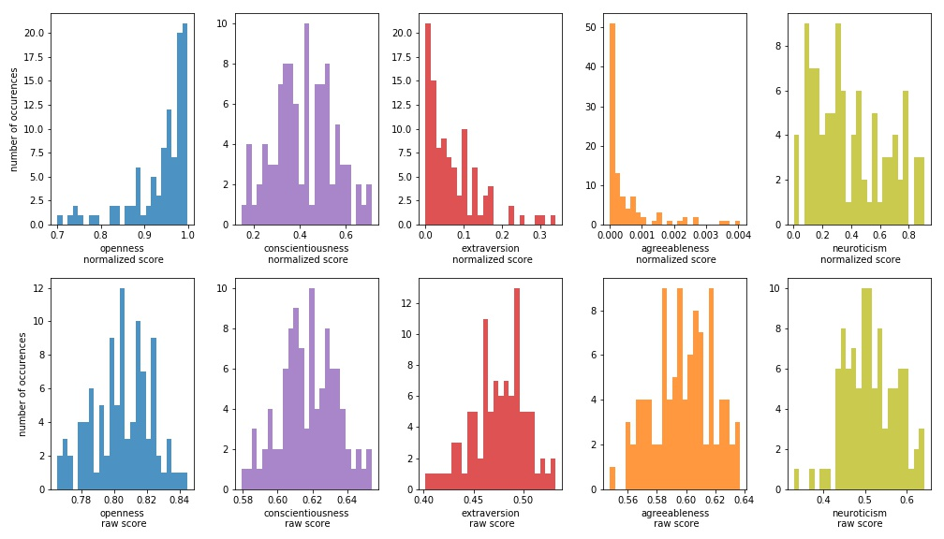

Figure 4: Histograms of developers` personality trait raw scores and percentiles

To compare the result of each trait, first look makes it clear that raw scores are more normally distributed, than the normalized scores.

Openness raw score varies from 0.75 to 0.85, while on the normalized percentile it scores from 0.7 to 1, and notably the most of the results here are distributed in 0.95 to 1 percentile bin, meaning that the raw scores of the developer`s openness are higher than the sample population scores. This trait is more or less in accordance within raw and normalized score, similarly to conscientiousness and neuroticism, those have wider percentile range on IBM`s adjusted scores than on raw scores. Extraversion scores are also significantly lower on normalized percentiles, as the developers seem to be less open, than the sample users of IBM. Most distinctive difference between these two scores are returned on agreeableness. Raw score seems reasonable – varying from 0.54 to 0.64, but the normalized scores show extremely low scores - less than the 0.004, meaning that the absolute majority of the IBM sample users have more scores than all the users of this dataset.

Same results summarized within the projects are present on Figure 5. It shows that certain projects users tend to have more polar personalities, than the others, specifically project `mesos` developers are more open and conscientious, project `xd`, `dnn` and `nexus` developers are also conscientious, extravert and agreeable, and finally `timob` and `tistud` project developers share similarities in being less open, conscientious, extravert, agreeable, and more neurotic, than the other project developers. Notably, the last two projects have significantly more users checked for IBM Personality traits, than the others, giving more confidence in their results as a group of developers. This can be the reason, why these two projects have similar results in all the personality traits.

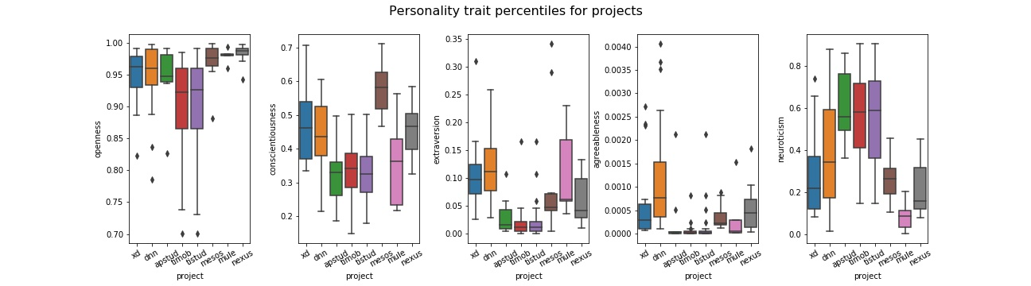

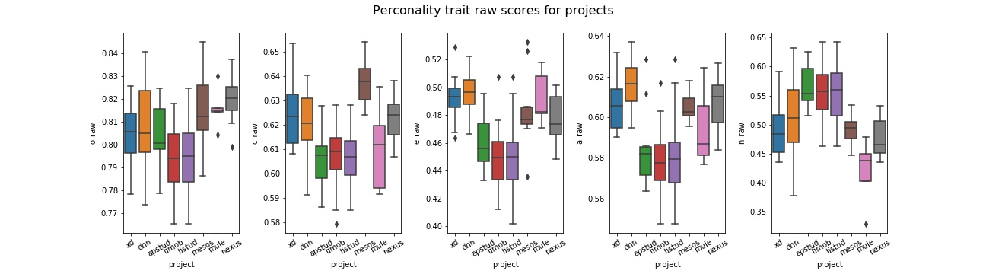

Figure 5. boxplots of users` personality trait raw scores and percentiles per project

Raw scores are used in this study since IBM uses a sample population for normalizing the scores, which may not be representative to a population of developers.

In addition, raw are normally distributed, unlike the normalized scores , as shown in Figure 4.

## Calculation of metrics

### Actual development time

For calculating the actual development time, the logics were applied on Jira issues change log dataset. First, was defined the time spent per task by a developer: time that is passed while the task was set to 'In Progress' status. In technical terms, this is the time between the two log records when 1) the task status was set to 'In Progress' and 2) task status was changed from 'In Progress'. Therefore, the records were retrieved from Jira change log, that have status set from In Progress to any other status, and the records that have set status set to In Progress from any other status.

In case when several developers have worked on one task – calculation occurs on a time for each of them separately. In case when one developer has set status to 'In Progress' multiple times within one task, the function calculates the sum amount, so that each developer has one number of minutes spent on one task.

The histogram in Figure 6 shows the distribution of actual development time. Noticeably, there are outliers that put the vast majority of the records into the first few bins.

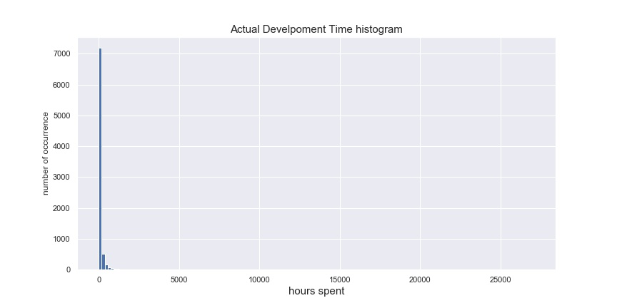

Figure 6. Histogram of actual development time spent by developers

To have the better picture, need to filter out the records with minutes spent greater than 5000 and less than 1, the result is on the Figure 7. Now it is visible that although the majority of the records are with the 300 minutes or less, there still are considerable amount of records with higher number of minutes spent.

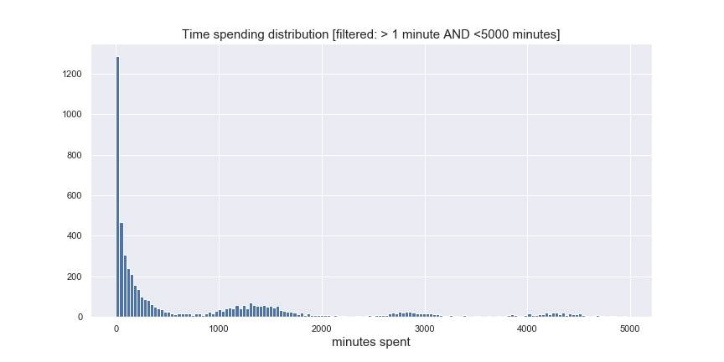

Figure 7. Histogram of actual development time spent by developers on a subset of dataset.

The end-goal of getting the Actual development time measurement is to have the categorical variables. The top and bottom threshold are defined for high, medium and low development time spent tasks considering the number of records that would fall into each of these categories, and taking into account the reasonability of each category boundaries:

* Low category of actual development time : tasks, that took 1 working day or less. Equal to 8 working hours, and equal to 480 minutes spent, respectively.
* Medium category of actual development time: tasks, that took more than 1 day and up to 1 week, which is equal to 5 working days, and equal to 2400 minutes spent, respectively.
* High category of actual development time: tasks, that took more than a working week (2400 minutes spent) to complete.

In the sections of metric calculations, we use term transaction that denotes an occurrence of the metric value per one developer on one issue, meaning that for each metric one developer can have one transaction on one jira issue, therefore, in total developer can have up to as many transactions, as the number of jira issues he/she has worked on. The whole dataset of actual development time metric contains 8093 transactions in total, whereas the low actual development time category is 4159 transactions (52%), medium actual development time category holds 1418 transactions (17%) and high actual development time category contains 2516 transactions (31%), as presented in the Table 9.

|  |  |  |  |
| --- | --- | --- | --- |
| Actual_***development_time_category*** | high | low | medium |
| ***Number of transactions*** | 2516 | 4159 | 1418 |

Table 9. Actual development time transactions.

The rest of the developers’ metrics used in this study (i.e. state, estimation and prioritization) are categorical, and the identical approaches are used for working on all these metrics.

### Task status



To identify whether the developers tend to put the tasks on hold, or gather in to-do list, or mark them done, the field `status` of the changelog was used. This field can take values from 28 possible statuses. To facilitate the analysis, the possible values were grouped into 3 categories that represents the most common statuses of tasks during agile software development [1]

* ‘todo’ state values: 'To Do', 'Open', 'Reopened', 'Reviewable', 'To Be Merged', 'Scoped', 'Refine', 'New', 'Raw', 'Waiting for Response', 'To Be Tested', 'Pending 3rd-Party', 'Defered', 'Triaged';
* ‘in progress’ state values: 'Pull Request Submitted', 'Planned Development', 'In Progress', 'In PR', 'In Review', 'In Review', 'Writing', 'Waiting for Review', 'Testing In Progress';
* ‘Done’ state values: 'Closed', 'Resolved', 'Done', 'Inactive - Pending Closure', 'Accepted'.

As a result, in total we get 21585 transactions of status metric, out of which majority (17073) is grouped in category `done`, 2315 transactions are `in progress`, and 2197 transactions are grouped into `todo` status, as shown on Table 11.

|  |  |  |  |
| --- | --- | --- | --- |
| ***Tas status*** | done | in progress | todo |
| ***number of transactions*** | 17073 | 2315 | 2197 |

Table 11. Tas status transactions

### **Prioritization**

Priority metric is used to define how the developers are prioritizing their tasks, weather they assign low, medium or high priority.

The changelog dataset is filtered with ‘priority’ field and checked what are the values that developers are assigning to their tasks. Table 12 shows the priority values within the Jira changelog and the number of transactions that have assigned the given priority.

|  |  |  |  |  |  |  |  |  |  |  |
| --- | --- | --- | --- | --- | --- | --- | --- | --- | --- | --- |
| ***Priority status*** | High | Medium | Critical | Major | Low | Blocker | Minor | None | Trivial | To be reviewed |
| ***number of transactions*** | 1978 | 1267 | 1031 | 742 | 670 | 254 | 240 | 166 | 89 | 3 |

Table 12. Jira issues priorities

These statuses were grouped into high, medium and low prioritization categories to facilitate the analysis, which is quite intuitive considering by the values in the field: 'High', 'Critical', 'Blocker' tasks were ranked as `high` priority, 'Medium', and 'Major' values were ranked as ‘medium’ priority, and 'Low', 'Minor', 'None', 'Trivial', 'To be reviewed' were categorized under `low` priority, respectively.

Resulting dataset contains 4796 transactions in total, where the low priority transactions are 1412, medium priority transactions are 865 and high priority transactions are 2518, as shown on table 13.

|  |  |  |  |
| --- | --- | --- | --- |
| ***Prioritization*** | high | low | medium |
| ***number of transactions*** | 2518 | 1412 | 865 |

Table 13. Prioritization transactions.

## **Effort estimates**

Estimation metric is used to show the tendency of developers to mark the tasks complexity by assigning the respective number of Story Points.

In general, story points are based on an adapted version of the fibonnaci sequence: 0, 0.5, 1, 2, 3, 5, 8, 13, 20, 40, 100. The heatmap in the figure 8 shows that in majority of the cases this rule was thoroughly followed, with slight deviation – some issues have assigned the different story point numbers than that, but there are few of such cases. For this reason, the story points that are represented by different numbers than the ones in the adapted Fibonacci sequence were discarded. After this cleaning step, the resulting 6840 transactions were discretized in 3 categories as follows:

* low estimation: values 0, 0.5, 1, and 2;
* medium estimation: values 3 and5;
* high estimation: values 8, 13, 20, 40, and 100.

Table 14 shows the representation of number of transactions of each effort estimation category.

|  |  |  |  |
| --- | --- | --- | --- |
| ***Effort Estimation*** | high | low | medium |
| ***number of transactions*** | 1188 | 2872 | 2780 |

Table 14. Effort Estimation transactions

## **Cleaned Dataset**



First step towards creation of the rules is mapping the personality trait scores to the binary variables – weather the particular personality score yields a positive or negative result. The personality trait assessment results are mapped as Positive when the particular developers raw score is greater than the mean raw score of all the retrieved developers. Accordingly the personality trait assessment result is mapped as negative when the raw score is less or equal than mean raw score of all the samples in the dataset of retrieved personality scores of developers.

In overall, out of the 100 developer profiles that has been analysed during this research have the personality trait results as shown on the Table 16.

|  |  |  |  |  |  |
| --- | --- | --- | --- | --- | --- |
|  | agreeableness | conscientiousness | extraversion | neuroticism | openness |
| **Negative** | 50 | 48 | 47 | 54 | 50 |
| **Positive** | 50 | 52 | 53 | 46 | 50 |

Table 16. Number of developers falling into each category of the personality traits.

Following the calculations we get the dataset of metrics, as described on Table 17. In total, there are 41314 transactions. Later, personality trait assessment results are joined and the resulting dataset has the columns: user, issue name, project name and metric, openness, conscientiousness, extraversion, agreeableness, neuroticism. The personality trait variables have only Positive or Negative as the value. Metric variable has all the possible metric values.

Additionally, in order to have the association rules in context of each personality trait, following steps are performed: Dataset is split horizontally for each personality trait and subsequently gives one dataset for openness, one for conscientiousness, one for extraversion, one dataset for agreeableness and finally, one for neuroticism. These datasets also have 41314 transactions in total and they consist of the following variables: user, issue name, project name, metric and personality trait.

|  |  |  |  |
| --- | --- | --- | --- |
| ***dataset of metric:*** | **Nbr of transactions** | **Nbr Of unique users** | **Nbr of unique issues** |
| *Effort Estimate* | 6840 | 76 | 6677 |
| *Prioritization* | 4796 | 81 | 4464 |
| *Task status* | 21585 | 97 | 12283 |
| *Actual development time* | 8093 | 80 | 7723 |

Table 17. Available number of transactions of each metric



## Association rule mining

## **Methods**

Next step towards the answering of the RQ1 is conducting association rules . Association rule mining is a technique used in machine learning to discover the interesting and reliable relation patterns in the large datasets. Association rule consists of two parts: antecedent – an item belonging the dataset, and consequent – an item that belongs to the dataset in the combination with the antecedent item.

In the context of this research, association rules of the form X => Y, where X is a personality trait and Y is a software development metric.

|  |  |  |  |  |  |
| --- | --- | --- | --- | --- | --- |
|  |  |  |  |  |  |
|  |  |  |  |  |  |
|  |  |  |  |  |  |







Since there are 4 agile metrics studied within this research and each of them is three dimensional, it gives total of 12 metric values. There are 2 dimensions for each personality trait – Positive and Negative, therefore, there are in total, 24 possible combination of values. Table 18 gives an example for the case of Neuroticism.

|  |  |  |  |
| --- | --- | --- | --- |
| Rule Id | **Neuroticism** | **metric** | **metric value** |
| 1 | Negative | Effort estimation | high |
| 2 | low |
| 3 | medium |
| 4 | Prioritization | high |
| 5 | low |
| 6 | medium |
| 7 | Task status | done |
| 8 | inprogress |
| 9 | todo |
| 10 | Actual development time | high |
| 11 | low |
| 12 | medium |
| 13 | Positive | Effort estimation | high |
| 14 | low |
| 15 | medium |
| 16 | Prioritization | high |
| 17 | low |
| 18 | medium |
| 19 | Task status | done |
| 20 | inprogress |
| 21 | todo |
| 22 | Actual development time | high |
| 23 | low |
| 24 | medium |

Table 18: Possible association rule values between the metrics and Neuroticism personality trait.

In this research, three measures of interest are used for finding out high-quality association rules between the metrics and the personality traits: Support, Confidence, and Lift. Support is used to measure how frequent the itemset appears in dataset, and the confidence measures the conditional probability of the of occurrence of consequent given the antecedent. Lift values are also used to compare the rule confidence with the expected confidence.

To define important relationships and associations, first it`s needed to define minimum support. By the definition, support of an itemset is the ratio of transactions where the given itemset exists: support (X => Y) = support (X ∪Y).

In the dataset of one particular personality traits association rules, there are 2 variable items from personality traits (positive and negative) and 12 items from the metrics (4 metrics, and 3 values for each metric). That gives in total 24 rules by 2 personality traits items as antecedent associated with 12 different metric items as the consequent, and 24 inverse rules - 12 metric items as the antecedent associated with 2 personality traits as the consequent. Considering all these rules information, one association rules dataset was created. The support for one of these rules on average should be one rules portion in the whole rules, 1/24, which is equal ~ 0.04.

The average itemset support value can be used as the threshold for the filtering of the frequent itemsets. All the itemsets, that have higher support than the average support value (0.04) will be labelled as the frequent itemset and be used in the analysis of the personality trait/metric relationship.

Additionally, two more variables are added into the rule parameters - confidence value can be used as a measurement of reliability of the rule, and the lift value for the confidence comparison to the expected confidence of the rule.

Moreover, all the itemsets contain only 1 item, therefore, the support value of a rule and it`s inversive rule will always be the same. However, the confidence variable is different within the inversive rules: On one hand, the rules with metric as antecedent, for each metric value, there are only 2 possible personality trait consequents, and in total, these two give confidence 1 as the sum. For example, within the neuroticism rules, antecedent `Effort estimation low` has two possible consequents – ‘Positive neuroticism` and `No Neuroticism`:

* 1. Confidence (`Effort estimation low`=>`Neuroticism Positive`) = Support (`Effort estimation low`∪ `Neuroticism Positive`) / Support (`Effort estimation low`)
* 2. Confidence (`Effort estimation low`=>`Neuroticism negative`) = Support (`Effort estimation low`∪ `Neuroticism negative`) / Support (`Effort estimation low`)

Naturally, the sum of these two confidence values give 1 as a result. Hence, the rule with more than 0.5 confidence in this case be trusted more than the other one.

On the other hand, the rules with Personality trait as antecedent, each value of the personality trait (positive/negative) confidences give 1 in total. For example, within the neuroticism rule, antecedent `Neuroticism Positive` has 12 possible consequents - `Effort estimation` low/medium/high, Prioritization low/medium/high, status todo/inprogress/done, development time low/medium/high:

* Confidence (` Positive Neuroticism` => `Effort estimation low`) = Support(`Positive Neuroticism` U `Effort estimation low`) / Support (`Positive Neuroticism)
* Confidence (` Positive Neuroticism` => `Effort estimation medium`) = Support(`Positive Neuroticism` U `Effort estimation medium`) / Support (`Positive Neuroticism)
* Confidence (` Positive Neuroticism` => `Effort estimation high`) = Support(`Positive Neuroticism` U `Effort estimation high`) / Support (`Positive Neuroticism)

And the same way for all the 12 metric value. Evidently, all these 12 rules confidence values gives 1 as the sum, and therefore, the mean confidence value for each of these twelve rules is 1/12 = 0.08.

The above mentioned logic can be used to filter more reliable rules – in the case of first example, when the antecedent is a metric, the reliable rule should have the confidence greater than 0.5, and in the other case, when the antecedent is personality trait, the reliable rule should have confidence greater than 0.08.

The second research question aims to analyze how the Big 5 personality traits in the context of agile software development is related to previous studies.

In a previous study, Scott et. Al [1] found evidence of the relationship between several software development metrics and another personality trait model, the FSLSM. The main approach used for discovering these relationships was association rule mining, and the main results are summarized in Table 20.

|  |  |  |  |
| --- | --- | --- | --- |
| **antecedent variable** | **antecedent value** | **consequent variable** | **consequent value** |
| priority | high | Perception | sensing |
| priority | low | Perception | intuitive |
| time | low | Perception | intuitive |
| time | high | Perception | sensing |
| status | done | Perception | intuitive |
| Perception | intuitive | time | low |
| Perception | intuitive | Effort estimation | high |
| Effort estimation | high | Perception | intuitive |
| Perception | sensing | time | high |
| Perception | sensing | Effort estimation | high |
| Effort estimation | high | Processing | active |
| time | low | Processing | active |
| priority | low | Processing | active |
| Processing | active | time | low |
| Processing | active | Effort estimation | high |
| status | done | Processing | active |
| status | todo | Processing | active |
| status | todo | Processing | reflexive |
| Processing | reflexive | status | todo |
| Processing | reflexive | Effort estimation | high |
| status | done | Understanding | global |
| status | todo | Understanding | sequential |
| time | low | Understanding | sequential |
| Understanding | global | status | done |
| Understanding | global | Effort estimation | high |
| priority | low | Understanding | sequential |
| Understanding | sequential | status | todo |
| Understanding | sequential | time | low |
| Understanding | sequential | Effort estimation | high |
| priority | high | Understanding | sequential |

Table 20. Relevant association rules between software development metrics and the FSLSM (adapted from Scott et. Al [1]).

In a different study, Siddiquei et. Al [8] found that the FSLSM and the Big 5 model are related. The authors studied the correlation between these two models and found several correlations, which are shown in Table 21.

|  |  |  |  |  |
| --- | --- | --- | --- | --- |
| **Variable** | **Value** | **Trait** | **Correlation** | **Correlation value** |
| Perception | intuitive | Agreeableness | Negative | -0.268 |
| Perception | intuitive | Conscientiousness | Positive | 0.247 |
| Perception | sensing | Agreeableness | Positive | 0.261 |
| Perception | sensing | Conscientiousness | Positive | 0.239 |
| Processing | active | Extraversion | Positive | 0.228 |
| Processing | active | Openness | Positive | 0.234 |
| Processing | reflexive | Extraversion | Positive | 0.236 |
| Processing | reflexive | Openness | Negative | -0.243 |
| Understanding | sequential | Neuroticism | Negative | -0.199 |
| Understanding | global | Neuroticism | Positive | 0.199 |

Table 21. Correlated FSLSM and Big 5 personality traits

Based on these two studies, a comparison between the results obtained from RQ1 and the findings from Scott et. al [1] was conducted. In order to make the results comparable, the relationship between the FSLSM and the Big5 model is given by the correlations found by Siddiquei et. al [8]. Therefore, an association rule is consistent with the previous study of it is a logical consequence of the premises given by the previous studies. More formally, the rule x→z is consistent with previous studies if it is entailed by the premises x→y (c.f. Scott et al. []) and y↔z (c.f. Siddiquei et al.). (See eq. 1)

Eq. 1 : x→y, y↔z ⊧ x→z

|  |  |  |  |
| --- | --- | --- | --- |
| Findings related to the FSLSM [Scott et. al] | Big5 and FSLSM correlation [Siddiquei et. al] | Findings related to Big5 (RQ1) | Conclusion |
| X 🡪 Z | Y ↔ Z | X 🡪 Y | Consistent / Inconsistent |

Within the RQ2 validation, the same association rules were used, as discussed for the RQ1. Only difference is, that here, for the proper data representation, minimum frequency threshold value has been decreased, due to the fact that more than half of the dataset records are related to only one specific metric (status). Minimum value of support and confidence have been altered respectively, and then performed the same association rules mining techniques as in the previous chapters. As the result, the association rules function checks the association rules that was generated respectively from the original rules of Scott et. al [1] and N. Siddiquei et. al [8].

During the association rules mining, a package `apyori` was used to analyze interesting patterns. apyori is an open-source distributed package for Python programming language, that uses apriori algorithm and provides API and command line interface. Package description is available on the Python Package Index website: <https://pypi.org/project/apyori/>.

apyori package provides the function `apriori` that requires items, minimum support and confidence as the input, and provides the list of rules on the base of the common apriori algorithm functionality. In a frequent pattern mining, apriori algorithm uses the fact that any subset of a frequent itemset is also frequent, and that way, algorithm excludes the itemsets, whose support is less than the minimum support, and therefore, it excludes all of their supersets as well. Apriori algorithm returns frozenset results formatted as JSON, then JSON output is parsed and stored the antecedent, consequent, support, confidence and lift variables into the working dataframe.

## **Results**

In order to answer the RQ1: The relationship between the personality traits and the software development metrics, association rule results are analyzed. Following chapters are describing the relationship of the avilable 100 developers personality traits and four metrics in the context of all big five personality traits separately, therefore, the following five chapters answer the RQ1 in the context of openness, conscientiousness, extraversion, agreeableness, neuroticism separately.

The association rule graphs in the next five chapters show only the frequent itemsets` association rules with support, confidence and lift in the context of each personality trait, to show only the reliable relationship between the variables of RQ1. The filter criteria of the rule significance is applied as described in the former chapter.

## **Openness**

Figure 9 show the association rules of the Openness personality trait. Open developers usually give low effort estimation to their tasks and mark the tasks done (openness:Positive => effort estimation:low, openness:Positive => status:done), while the less open developers tend to spend low time on actual development and also mark the task status to done (openness:Negative => development time: low, openness:Negative=> status:done). The rules show that open developers tend to take the tasks that are less complex, also this pair has the significant evidence on the inversive as well (effort estimation:low => openness:Positive), furthermore, the confidence of both, nominal and inversive rule is high enough to conider it reliable, and finally, the lift value is positive and high, meaning that low effort estimation and openness trait are positively correlated. But in the contrary, less open developers are the ones that actually spend less time for the development on the tasks, and similarly to the former one, the respective inverse rule (openness:Negative => development time: low) also has the sufficient support and confidence for the trustworthyness of the rule. Notably, here the lift value is very close to 1, yelding the independence of the former two variables.

Both of these developer subgroups – open and not open, fall into the main class of developers that finish the tasks with the done status, however, among the rules with done status as the antecedent, non-open developers are the ones that have sufficient confidence to be on the consequent side (status:done => openness:Negative).

Among the other significant relationships, the notable is rule priority:high=>openness:Negative, meaning that developers that set the task priority to high, are less open people.

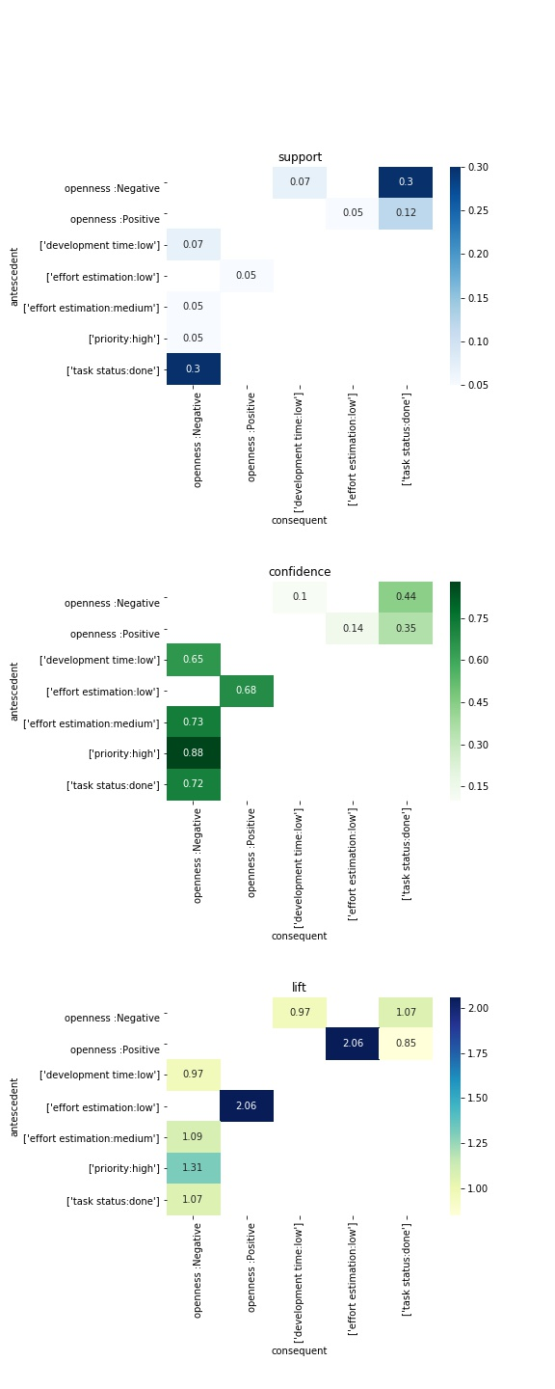

Figure 9: Openness personality trait and related assocaition rules.

## **Conscientiousness**

Association rules related to Conscientiousness is shown in the Figure 10. Likewise the openness trait, on one hand, conscientiousness is also associated with low effort estimation and done task status (conscientiousness:Positive => effort estimation:low, conscientiousness:Positive => status:done), additionally, positive value of this personality trait has significant association with low development time. These relations show, that more conscientious developers assign low number of story points to the tasks, spent low time on them, and tend to mark them done at the end, that is quite a valid relation considering the definition of the conscientiousness. The inversive rule of the above mentioned conscientiousness:Positive => effort estimation:low has also satisfactory support and confidence to be considered as the frequent and reliable, moreover, the lift value shows that there is a positive correlation between the former two variables, while the conscientiousness:Positive => development time:low has not enough confirmation to be considered as reliable.

On the other hand, less conscientious developers also set high priority, spend low time and mark done status on the development of the tasks, alike the negative valued variable of former personality trait. All these three rules have the sufficiently supported inversive rule as well.

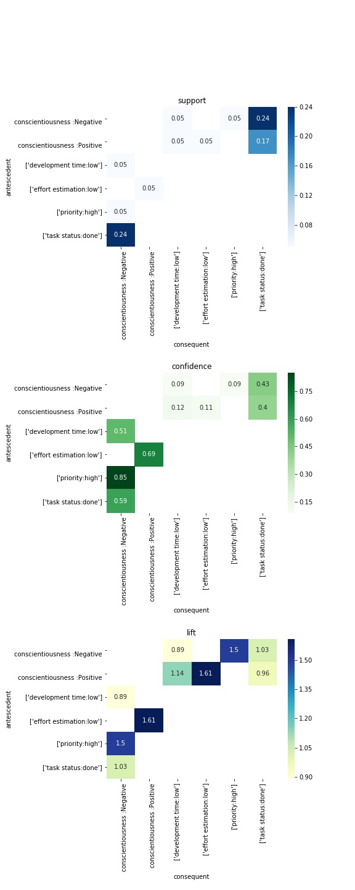

Figure 10: Conscientiousness personality trait and related assocaition rules.

## **Extraversion**

As the figure 11 shows, the association rules of Extraversion personality trait are very similar to the ones within Conscientiousness trait – positive valued variable of the trait Extraversion is associated with low effort estimation, low development time and done task status, while the negative value of the Extraversion trait is related to high prioritization, low development time and done task status. The support, confidence and lift values are also similar to the ones from Conscientiousness personality trait (no more than 0.01 difference in support, no more than 0.05 difference in confidence and lift).

Apart from the similarities, there is one rule regarding the extraversion that is not present within conscientiousness trait – effort estimation:medium => extraversion:Negative, meaning that among the developers that estimate efforts on task as medium, mainly there are introversive people. This could also mean that introversive developers are trying to keep the balance and choosing to give their tasks the medium range story points.

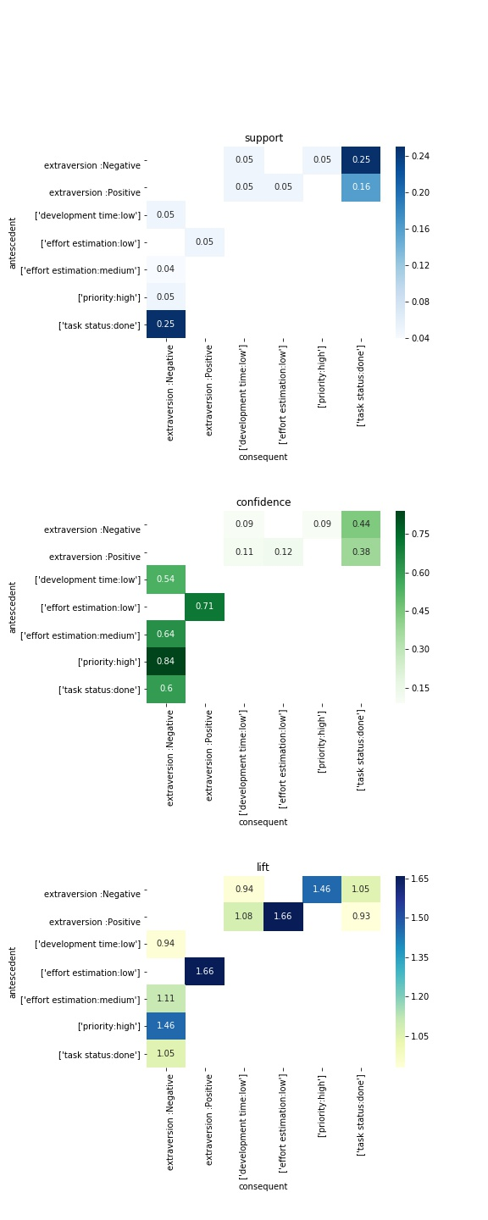

Figure 11: Extraversion personality trait and related assocaition rules.

## **Agreeableness**

Figure 12 shows the association rules related to agreeableness personality trait. Agreeable developers tend to set the low story points to their issues (agreeableness:Positive => effort estimation: low) and mark them done afterwards (agreeableness:Positive => status:done). The first mentioned rule has also significant inversive rule, while the lift value is high enough to consider these two variables as positively correlated.

Non agreeable developers, likewise in the formerly described personality traits, also tend to set high priority, spend low time and mark task as done. All three respective inverse rule (priority:high => agreeableness:Negative, development time:low => agreeableness:Negative, status:done => agreeableness:Negative) are also significant, moreover there is a notably high confidence of the rule priority:high => agreeableness:Negative, that is entirely understandable point since the developers that consider their tasks as the most important, would not be among the most altruistic and modest ones, and these are two of the major facets of agreeableness. The other two association rules have lift value narrowly close to 1, that implies the statistical independence of the two variables in each of these rules.

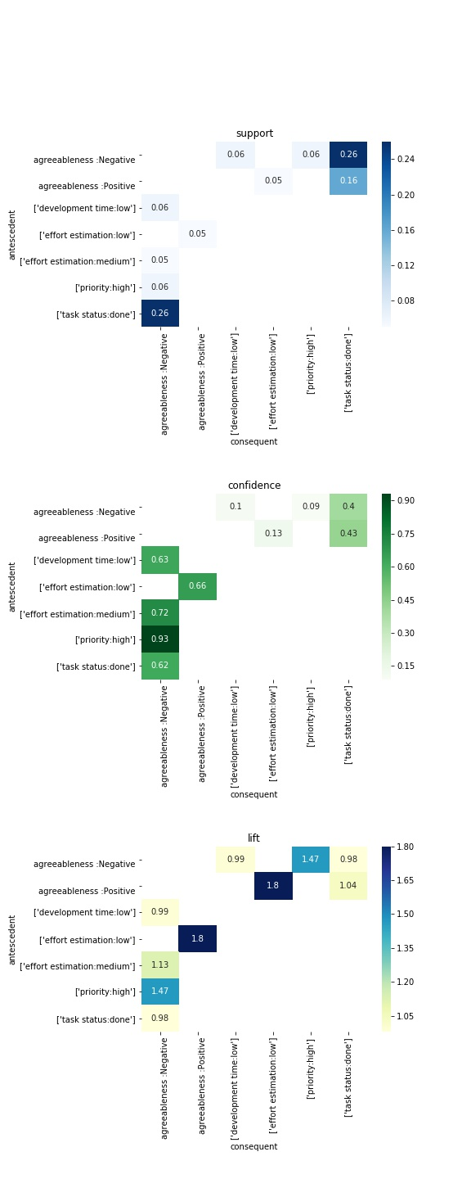

Figure 12: Agreeableness personality trait and related assocaition rules.

## **Neuroticism**

Figure 13 shows Neuroticism personality traits associations with metrics. According to the plot, neuroticism is associated with high prioritization, low development time and done task status. (neuroticism:Positive => prioritization: high, neuroticism:Positive => development time: low, neuroticism:Positive => status: done). The respective inverse association rules are also supported by the sufficient support and confidence. On the other hand, non-neurotic developers are assigning low story points to their tasks, spend low time and mark the tasks done. However, form the inverse rules, only the effort estimation:low => neuroticism:Negative has satisfactory support value to be considered as the valid rule and furthermore, it has the highest lift value among all the neuroticism related rules, which means it is the most correlated (positively) variable to the non-neuroticism personality trait.

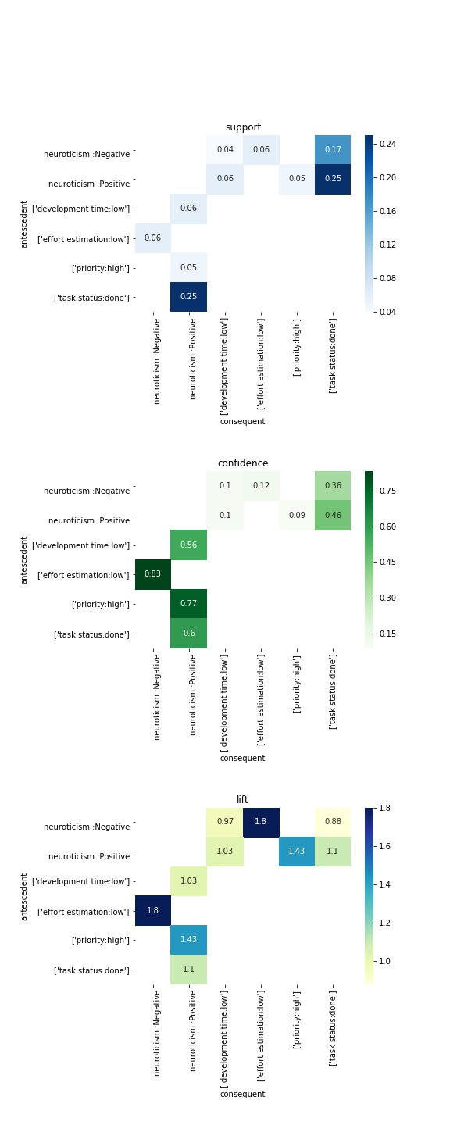

Figure 13: Extraversion personality trait and related assocaition rules.

## **RQ2:**

RQ2 of this paper is to explore the relationship between Big 5 personality traits and FSLSM in the context of agile software development, specifically, using the researches of Scott et al. [1] and Siddiquei et al. [8]. The methodology of answering the RQ2 is defined in the chapter of Association rules mining method.

|  |  |  |  |
| --- | --- | --- | --- |
| Findings related to the FSLSM [Scott et. al] | Big5 and FSLSM correlation [Sid-diquei et. al] | Findings related to Big5 (RQ1) | Conclusion |
| priority: high 🡪 Perception: sensing | Perception: sensing ↔ Agreeableness: positive;  Perception: sensing ↔ Conscientiousness: positive | priority: high 🡪 Agreeableness: positive;  priority: high 🡪 Conscientiousness: positive | Inconsistent |
| priority: low 🡪 Perception: intuitive | Perception: intuitive ↔ Agreeableness: negative;  Perception: intuitive ↔ Conscientiousness: positive | priority: low 🡪 Agreeableness: negative;  priority: low 🡪 Conscientiousness: positive | Consistent |
| time: low 🡪 Perception: intuitive | Perception: intuitive ↔ Agreeableness: negative;  Perception: intuitive ↔ Conscientiousness: positive | time: low 🡪 Agreeableness: negative;  time: low 🡪 Conscientiousness: positive | Consistent |
| time: high 🡪 Perception: sensing | Perception: sensing ↔ Agreeableness: positive;  Perception: sensing ↔ Conscientiousness: positive | time: high 🡪 Agreeableness: positive;  time: high 🡪 Conscientiousness: positive | Consistent |
| status: done 🡪 Perception: intuitive | Perception: intuitive ↔ Agreeableness: negative;  Perception: intuitive ↔ Conscientiousness: positive | status: done 🡪 Agreeableness: negative;  status: done 🡪 Conscientiousness: positive | Consistent |
| Perception: intuitive 🡪 time: low | Perception: intuitive ↔ Agreeableness: negative;  Perception: intuitive ↔ Conscientiousness: positive | Agreeableness: negative 🡪 time: low;  Conscientiousness: positive 🡪 time: low | Consistent |
| Perception: intuitive 🡪 effort estimation: high | Perception: intuitive ↔ Agreeableness: negative;  Perception: intuitive ↔ Conscientiousness: positive | Agreeableness: negative 🡪 effort estimation: high;  Conscientiousness: positive 🡪 effort estimation: high | Consistent |
| effort estimation: high 🡪 Perception: intuitive | Perception: intuitive ↔ Agreeableness: negative;  Perception: intuitive ↔ Conscientiousness: positive | effort estimation: high 🡪 Agreeableness: negative;  effort estimation: high 🡪 Conscientiousness: positive | Consistent |
| Perception: sensing 🡪 time: high | Perception: sensing ↔ Agreeableness: positive;  Perception: sensing ↔ Conscientiousness: positive | Agreeableness: positive 🡪 Actual development time: high;  Conscientiousness: positive 🡪 Actual development time: high | Consistent |
| Perception: sensing 🡪 effort estimation: high | Perception: sensing ↔ Agreeableness: positive;  Perception: sensing ↔ Conscientiousness: positive | Agreeableness: positive 🡪 effort estimation: high;  Conscientiousness: positive 🡪 effort estimation: high | Inconsistent |
| effort estimation: high 🡪 Processing: active | Processing: active ↔ Extraversion: positive;  Processing: active ↔ openness: positive | effort estimation: high 🡪 Extraversion: positive;  effort estimation: high 🡪 openness: positive | Inconsistent |
| time: low 🡪 Processing: active | Processing: active ↔ Extraversion: positive;  Processing: active ↔ openness: positive | Actual development time: low 🡪 Extraversion: positive;  Actual development time: low 🡪 openness: positive | Inconsistent |
| priority: low 🡪 Processing: active | Processing: active ↔ Extraversion: positive;  Processing: active ↔ openness: positive | priority: low 🡪 Extraversion: positive;  priority: low 🡪 openness: positive | Inconsistent |
| Processing: active 🡪 time: low | Processing: active ↔ Extraversion: positive;  Processing: active ↔ Openness: positive | Extraversion: positive 🡪 Actual development time: low;  Openness: positive 🡪 Actual development time: low | Consistent |
| Processing: active 🡪 effort estimation: high | Processing: active ↔ Extraversion: positive;  Processing: active ↔ Openness: positive | Extraversion: positive 🡪 effort estimation: high;  Openness: positive 🡪 effort estimation: high | Inconsistent |
| status: done 🡪 Processing: active | Processing: active ↔ Extraversion: positive;  Processing: active ↔ openness: positive | status: done 🡪 Extraversion: positive;  status: done 🡪 openness: positive | Inconsistent |
| status: todo 🡪 Processing: active | Processing: active ↔ Extraversion: positive;  Processing: active ↔ openness: positive | status: todo 🡪 Extraversion: positive;  status: todo 🡪 openness: positive | Consistent |
| status: todo 🡪 Processing: reflexive | Processing: reflexive ↔ Extraversion: positive;  Processing: reflexive ↔ Openness: negative | status: todo 🡪 Extraversion: positive;  status: todo 🡪 Openness: negative | Inconsistent |
| Processing: reflexive 🡪 status: todo | Processing: reflexive ↔ Extraversion: positive;  Processing: reflexive ↔ Openness: Negative | Extraversion: positive 🡪 status: todo;  Openness: Negative 🡪 status: todo | Consistent |
| Processing: reflexive 🡪 effort estimation: high | Processing: reflexive ↔ Extraversion: positive;  Processing: reflexive ↔ Openness: Negative | Extraversion: positive 🡪 effort estimation: high;  Openness: Negative 🡪 effort estimation: high | Inconsistent |
| status: done 🡪 Understanding: global | Understanding: global ↔ Neuroticism: positive; | status: done 🡪 Neuroticism: positive; | Consistent |
| status: todo 🡪 Understanding: sequential | Understanding: sequential ↔ Neuroticism: negative; | status: todo 🡪 Neuroticism: negative; | Consistent |
| time: low 🡪 Understanding: sequential | Understanding: sequential ↔ sequential; | Neuroticism: negative 🡪 sequential; | Inconsistent |
| Understanding: global 🡪 status: done | Understanding: global ↔ Neuroticism: positive; | Neuroticism: positive 🡪 status: done; | Consistent |
| Understanding: global 🡪 effort estimation: high | Understanding: global ↔ Neuroticism: positive; | Neuroticism: positive 🡪 effort estimation: high; | Inconsistent |
| priority: low 🡪 Understanding: sequential | Understanding: sequential ↔ Neuroticism: negative; | priority: low 🡪 Neuroticism: negative; | Inconsistent |
| Understanding: sequential 🡪 status: todo | Understanding: sequential ↔ Neuroticism: negative; | Neuroticism: negative 🡪 status: todo; | Consistent |
| Understanding: sequential 🡪 time: low | Understanding: sequential ↔ Neuroticism: negative; | Neuroticism: negative 🡪 Actual development time: low; | Consistent |
| Understanding: sequential 🡪 effort estimation: high | Understanding: sequential ↔ Neuroticism: negative; | Neuroticism: negative 🡪 effort estimation: high; | Inconsistent |
| priority: high 🡪 Understanding: sequential | Understanding: sequential ↔ Neuroticism: negative; | priority: high 🡪 Neuroticism: negative; | Inconsistent |

Table 22. Combined association rules of E.Scott and correlated Big 5 Personality traits.

As the table 22 shows, there are 1 or 2 association rules respective to each of the original association rule. In cases where at least one rule is frequent on the base of the new defined threshold of support and reliable enough based on the confidence value provided, then the rule is considered as consistent. If none of the rules respective of the original rule is frequent or reliable enough, then this rule will be labelled as inconsistent. The results of this association rules analysis are shown on Table 22. Apparently, more than the half of these research rules have been found consistent (16), while the rest of the rules (14) are not frequent or reliable based on the datasets used within this research, therefore, these are counted inconsistent.















# Discussions

In this chapter the results of the research questions are explained in more detail and the perspectives and the applications of the research are discussed.

This research aimed to study the relation of developers` personality and the metrics of software development. As the results show, there are some consistent patterns.

Notably, the following personality traits association rules graphs is that the `status done` metric has the highest support due to the high availability of the respective data in the dataset, more than half of the jira metrics observations are the `Task status`(~22k rows), and moreover, out of that ~22k rows, 17k are specifically with the `done` value. This can be interpreted as the common habit of the developers – getting things. However, on the other hand, it is interesting to study the personality of the developers that tend to leave the tasks on todo or in progress state, although the number of such habitat-attributed developers and the respective cases is relatively low, it can be influential if such habitat is repetitive, or if the task is critical. Knowing the personalities of the author - developers of unfinished tasks could be crucial information – management should be more observant on the tasks of such developers when the completion of these tasks is vital.

Based on this argument, one more narrow-filtered frequent associations have been analyzed - rules within the task status `done` and `in progress`, as shown on figure 14. Circle size is the indicator of the confidence, more the support – greater the confidence. Similarly, Color variable shows support value, darker the color – greater the value of support. It appears, that having the status in `to do` status in most frequent within the developers with less neuroticism personality – one way of understanding this association rule is that developers which do not suffer from anxiety or immoderation, have also more patience and can have the multiple tasks assigned themselves without being oppressed to proceed with all of them. Furthermore, the association rules also show that status `in progress` is common among the more extravert and less open developers (status:inprogress => extraversion:Positive, status:inprogress => openness:Negative, status:todo => neuroticism:Positive and their respective inverse rules). The knowledge about this very specific type of metric and the respective associated personalities can greatly benefit the software company, letting them lower down the scope of the possible causalities of the certain result of the respective metric.

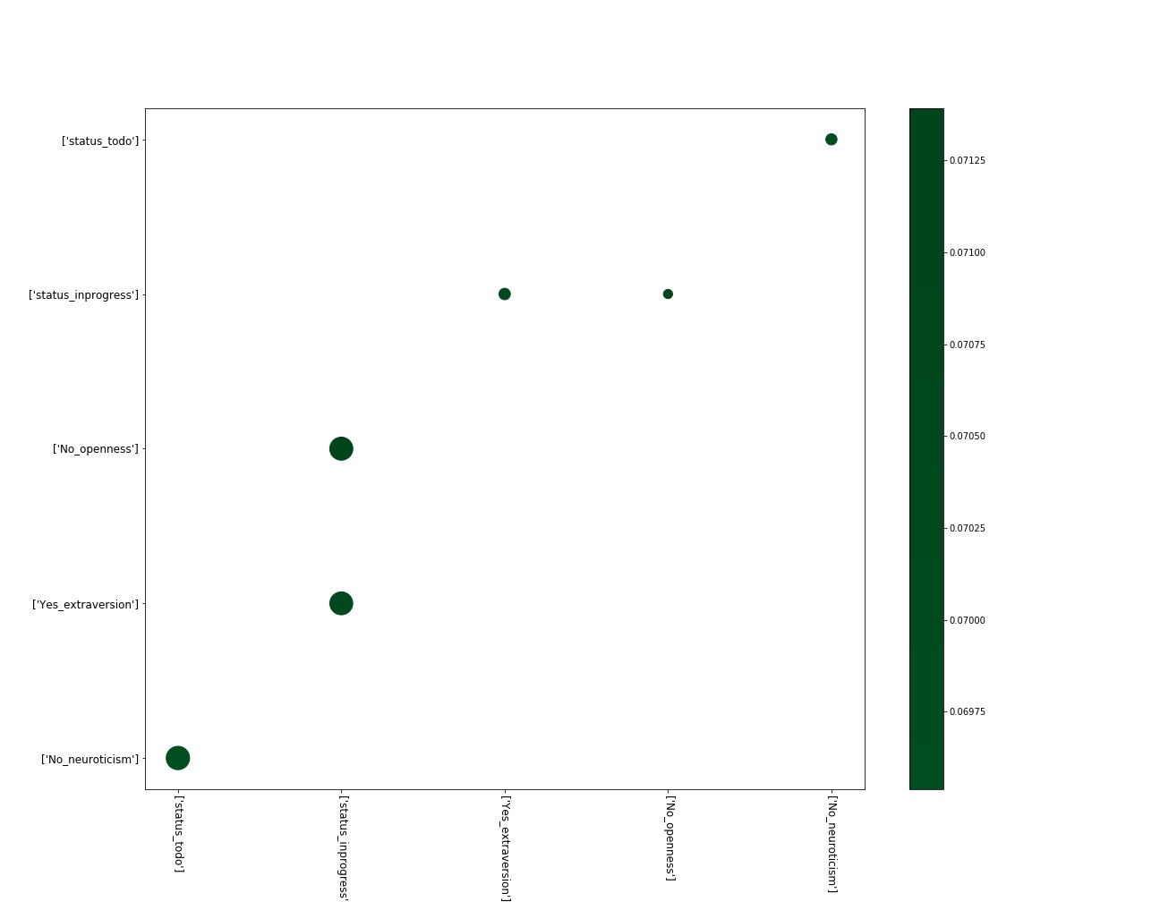

Figure 14: association rules for task status `done` and `in progress`

Secondly, developers within the number of personalities favor estimating the task efforts as `low`. As the association rules were showing, developers with positive values of Openness, Conscientiousness, Extraversion, Agreeableness and the negative value of Neuroticism – share the tendency of assigning low number of story points to their tasks.

On one hand, developers are assigning story points to the task by themselves to assess the estimation of task complexity. This is purely predictive process, since there can be the complications or ease within the tasks that is not possible to foresee in advance. On the other hand, there is an `actual story points` or `actual estimate` term, that describes the actual complexity of the issue, however it can be measured only after the completion of the task (although, this metric requires existence of the additional attributes that were not possible to obtain within this research dataset), and this leads to the outcome, that the pre-estimation of the efforts can be varied from the actual complexity of the task. The value that the business should pursue regarding this metric is to reduce the difference between the estimated effort and actual complexity of the task, while the result of this research can greatly contribute this idea by providing the group of personalities of developers, that are consistent with task estimation. Seeing that the personality traits, like strong Openness, Conscientiousness, Extraversion, Agreeableness and less Neuroticism are associated with low task effort estimation, can point out the following tendency: these traits are associated with personality facets, like calmness, friendliness, trust, altruism, dutifulness, liberalism etc. These personalities apparently give developers confidence, letting them feel in control of their responsibilities and usually considering their tasks as easily solvable. How accurate they are – this is another question, and possibly the topic of further research, but even without knowing that – it already lets the software project manager to narrow down the analysis and have answers to actions of certain personality developers.

On the opposite side of these traits – the developers with less Openness, Conscientiousness, Extraversion, Agreeableness and the ones with more Neuroticism also share a trend of spending low time on development. This can be explained by the common facets these traits have, that the people with more neuroticism are anxious and try to complete the tasks faster, and less conscientiousness people are less organized, not fully disciplined and more chaotic, they may not be fully realizing the impact and dependences of the task, and only working on the core idea of the issue without realizing the other aspects of the task. Similarly, the developers with less openness and less extraversion are the ones that are closed to the experiences, like imagination, adventurousness, excitement-seeking, and likewise the previous trait – they will likely only focus narrowly on the core idea of the task without exploring the further results. The same way can be explanation of the behavior of the less agreeable people who lack altruism, morality and modesty.

One more common association rule with the sufficient support and confidence among the developers with the less scores of Conscientiousness, Extraversion, Agreeableness and more score of Neuroticism is that they frequently set the task priority to high. Since the trait conscientiousness is associated with the facets – orderliness and dutifulness, this relation can be considered to be a logical. It is also notable, that Extraverted people are more friendly, cheerful and active, apparently, less these traits are in people – more likely these people are to consider their tasks as the highest priority. Regarding the low agreeable developers – the rule show quite interesting, yet intuitive pattern: The less agreeable, altruistic and cooperative the person is – more is the likelihood that person will consider their tasks as the most important ones in the sprint and therefore, put the highest priority to them. It is pragmatic to be aware of this tendency when the software product owner or manager is taking care of the prioritization of the tasks assigned to the developers.

As the majority of the results of the association rules show, the developers with the four traits – Openness, Conscientiousness, Extraversion, Agreeableness share the similarities in their performance in Agile software development. There is also sufficient indication of the negative relationship of these personality traits with the Neuroticism trait. Considering the facets of Neuroticism, the anxious traits of the personality are yielding the opposite results comparing to the more constructive personality traits. The former statement is also backed in the correlation matrix of the developers` personalities, as presented on the Table 19. As the matrix show, the same four personalities have positive correlation with each other, while neuroticism has the negative correlation with all the other traits. Software project management can take an advantage with the formerly mentioned relationship as well – knowing the patterns of the behavior of the specific personality they can identify in advance some general tendencies within these specific characteristics attributed developer, implement the better forecasting of the performance on the individual or team level.

|  |  |  |  |  |  |
| --- | --- | --- | --- | --- | --- |
|  | **openness** | **conscietiousness** | **extraversion** | **agreeableness** | **neuroticism** |
| **openness** | ------ | 0.429 | 0.534 | 0.365 | -0.508 |
| **conscietiousness** |  | ------ | 0.337 | 0.407 | -0.519 |
| **extraversion** |  |  | ------ | 0.723 | -0.41 |
| **agreeableness** |  |  |  | ------ | -0.271 |
| **neuroticism** |  |  |  |  | ------ |

Table 19. Big 5 Personality Traits correlation matrix

When comparing these results with the existing literature, in particular based on the studies of Scott et al. [1] and Siddiquei et al. [8], we must note that both of these studies are done with students as research subjects. In contrast, the current work focuses on software developers that develop their projects in non-academic settings. The findings of this research shows that there is enough evidence to conclude that majority of the rules found in the related work [1] are consistent with the current student, being as frequent and reliable as the previous study. Sixteen out of the 30 original rules have had the related association rule with the Big 5 personality trait that have out to be significant

Seemingly, the new relationship within the FSLSM, Big5 and Agile metrics is a strong bond of the former variables, can be used both, for the other researches in Academia, and within the actual working environment, since it has been proven on the open source software development project and on the researches of the students. Value for the business is to have the opportunity to analyze personality traits of the developer, learning styles preferences, and the certain agile methodology metrics within the three dimensional relationship, having more confidence within the analysis, and perform accurate forecast of the certain metric for the given personality/learning style of the developer.

# Conclusions

This research was conducted in order to understand the relationship between the personality traits of the developers and their performance in Agile software development projects. Previous studies have investigated personality of developers [2],[5],[6],[7]. These studies have been focused on the developers personality type changes over time and contribution of the developers within the teams, additionally, these papers were not explicitly focused on Agile software development environment. The goal of this research was the study of developers personality types within agile software development environment and moreover, create the link between developers personalities and their respective results in agile environment.

I have achieved the main goal of this research by analyzing dataset of the various software development teams JIRA logs. Retrieved the big 5 personality types of the developers and calculated the metrics from the developers` contribution logged into the dataset. Next, I have performed the association rules mining to study the relationships between the personality traits and the metrics and finally, I have discussed these relationships to address the research questions.

As for the first research question, How Big 5 Personality Traits model is related to the frequently used metrics in Agile, there were several significant relationships between the studied agile metrics and the developers personality traits. First, all personality traits tend to finish their task and mark them done. Secondly, the developers with the negative score range of the Neuroticism and the positive score of the rest of the traits are favoring the low complexity estimation of their tasks. Furthermore, developers with the openness, conscientiousness, extraversion, agreeableness, and the ones with high neuroticism are spending low time on the actual development of their tasks. Additionally, the developers with low score of conscientiousness, extraversion and agreeableness, and the ones with higher score of neuroticism personality trait frequently set their task priority to high. Considering the bigger picture of all the personality traits, it was evident that the developers with the low level of the neuroticism have the similar preferences of the metrics, as the developers with the high level of the rest of the personality traits, and vice versa. It is reviewed in discussion paragraph, that the results of the research can be beneficial for both, management of the software development teams to improve the performance, meet the set goals and be more precise in the analysis and forecast of the upcoming results, and also for the software developers, to be aware of the possible links of their personality traits to the certain work outcomes

With regard to the second research question, how the Big 5 personality traits and the Agile metrics are linked according to the previous studies, I have found that the results from this research are consistent with previous studies [1][8]. As a result, more than the half of the association rules found by Scott et al. (16 out of 30) are consistent and reliable within this research as well, that leads to the conclusion, that there is a link of the developers personality traits and their performances.

# References

[1] E.Scott - Are learning styles useful indicators to discover how students use Scrum for the first time?

[2] F.Calefato - On Developers’ Personality in Large-scale Distributed Projects

[3] K. Schwaber, M. Beedle, Agile Software Development with Scrum

[4] M.Fowler, J.Highsmith – The Agile Manifesto

[5] J.S. Karn - A study into the effects of personality type and methodology on cohesion in software engineering teams

[6] V. Balijepally, R.K. Mahapatra - Assessing Personality Profiles of Software Developers in Agile Development Teams

[7] B.Bazeli - On the Personality Traits of StackOverflow Users

[8] N.L. Siddiquei and R. Khalid - The relationship between Personality Traits, Learning Styles

[9] E.Kupainen, M.V.Mantyla and J.Itkonen - Using metrics in Agile and Lean Software Development – A systematic literature review of industrial studies x

x

[10] R.M. Ryckman, Theories of Personality

[11] R.R. McCrae, O.P. John, An Introduction to the Five-Factor Model and Its Applications

[12] O.P. John, S. Srivastava - Handbook of personality

[13] P. Abrahamsson, O. Salo, J. Ronkainen, J. Warsta – Agile software Development Methods: Review and Analysis

[14] J.Henrick - On Word-Length and Dictionary Size.

Appendix

1. Glossary

|  |  |
| --- | --- |
| Caret  The bar (or other symbol) marking the active editing point. | Sisestusmärk  Märk, mis märgib teksti sisestamise asukohta. |
| Template  A gauge, pattern, or mold, commonly a thin plate or board, used as a guide to the form of the work to be executed. | Mall  Näidik, muster või valuvorm, mis esitab täitmisele võetava töö struktuuri. |

1. Text cleaning

Using Regular Expression is the common practice for text cleaning and pattern recognition, simplicity of use and the recognition (and therefore trust) by most of the modern programming languages were the main argumetns that backed it`s usage, hence it was the text-cleaning library of choice within this research as well. Specifically, regular expression library and its substitution functions (re.sub) alongside with simple string substring (str().replace) functions were used in the environment of Jupyter notebook. Parts of the texts that have been excluded by the regular expression:

* Texts within not formatted Jira command tags
  + {noformat}(.+?){noformat};
* texts within common Jira code formatting tags
  + {code(.+?){code};
* texts within code tags, squared bracket tags and Html tags
  + <(.+?)>
  + {{(.+?)}}
  + {(.+?)}
  + \[([^[\]{}()]+?)\]
* java commands / JDBC calls
  + "jdbc(.+?)";
* texts of SQL command execution
  + sp_executesql ’’
* texts of command execution
  + exec ’’;
* module calls
  + module(.+?);
* scheduled job calls
  + "job(.+?)";
* texts within MS SQL transaction commands
  + \s*(B|b)(egin|EGIN)\s+. +\s+(E|e)(nd|ND)\s*;
* SQL SELECT, INSERT, DELETE statements
  + (\s*(s|S)(elect|ELECT).+(f|F)(rom|ROM)\s*\S+(\s*(w|W)(here|HERE)\s*\S+\s*\S*\s*\S*\s|))
  + (\s*(I|I)(nsert|NSERT)\s*(I|i)(nto|NTO)\s+.+(V|v)(alues|ALUES)\s*.+\(.+\)\s*)
  + (\s*(d|D)(elete|ELETE)\s*(f|F)(rom|ROM)\s*\S+(\s*(w|W)(here|HERE)\s*\S+\s*\S*\s*\S*\s|);
* texts of System version descriptions
  + [*][*][*]Version(.+?)[*][*][*];
* texts of deployment system technical descriptions
  + [*][*][*]Describe XD Deployment(.+?)[*][*][*];
* texts of system component descriptions
  + [*][*][*]Describe Other Components(.+?)[*][*][*];
* texts within the headers generated by the system
  + '***Description', '***Steps to recreate the problem', '***Error Message:';
* web-links
  + http[s]?://\S+;
* local path links with slashes and backslashes
  + \S+?(?=\/)\/\S*\/\S*
  + r'\S+?(?=\\)\\\S*\\\S*';
* system logs within the asterisks
  + \*{50,}(.+?)\*{50,}
  + \*+(.+?)\*+;
* texts of the word that has the length of more than 18 characters
  + .\S{15,}.;
* email addresses
  + \s|\S+(?=@))@\S*;
* SQL command parameters
  + \s|\S+(?=@))@\S*;
* cmd commands
  + --(\s{0,1})\S*
  + ~(\s{0,1})\S* ;
* texts of words with colons
  + \S+\:\S+;
* texts of application version numbers
  + \S+\.\S+;
* texts of command words and versions
  + \S*(_|-|:|\.)\S*(_|-|:|\.)\S+
* non-textual special characters
  + r'(\||~|=|>|_|\[|\]|{|}|--|\/|\\|#)';
* whitespaces
  + \s{2,};
* non-unicode characters
  + r'[^\x00-\x7F]+'
* dates;

Text cleaning techniques removed the most common patterns of the texts generated by the various systems, however, there still are the less frequent cases where the regular expressions could not catch the system log texts. In order to detect and clean these texts with system logs, we introduced text length variable for each written text.

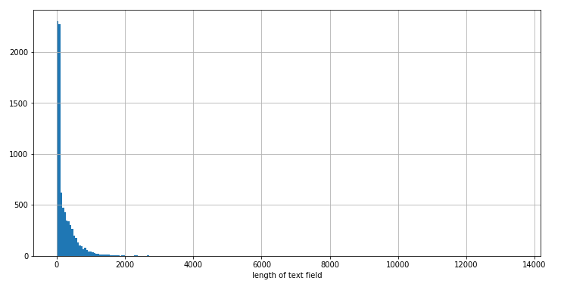

Figure 2: Distribution of word lengths.

Figure 2 shows the histogram of the written text lengths distribution. First, we checked the outliers manually – written texts with more than 5000 characters and these texts were indeed the logs generated by system. These outliers were removed (6 such written texts). Next, we checked the distribution of the character length of the written texts.

To have the better picture of the written texts lengths, the distributions are plotted in Figure 3.

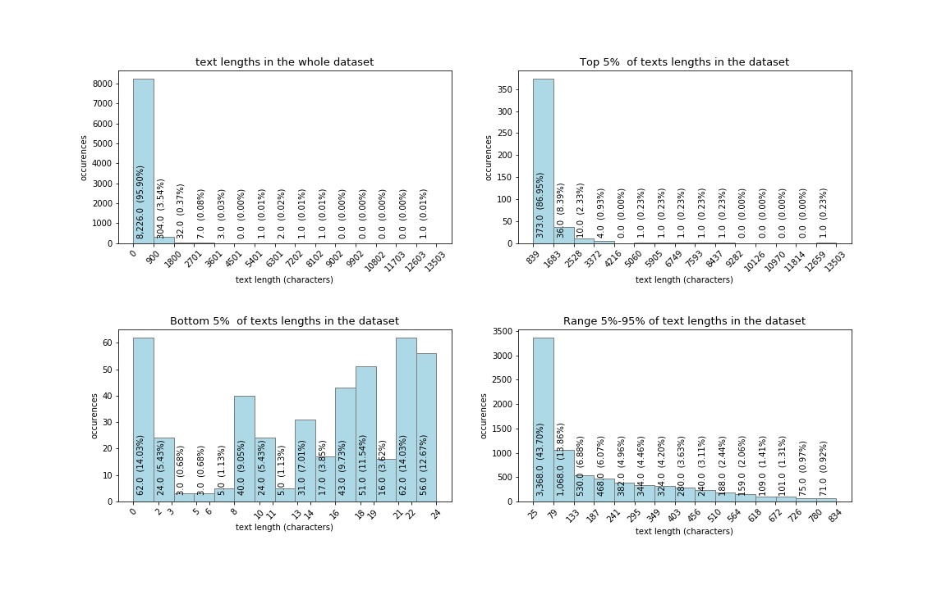

Figure 3. distribution of written text lengths.

The detailed plots of text length distribution show that more than 95% of the written texts have the length of 900 characters or less.

Longest 5% written texts plot shows that majority – more than 86% of these long written texts are 1683 characters or less, while the rest of the long written texts, more than 13% (and out of the whole dataset – 0.13*0.05=0.065, roughly 6.5%) are still with an unusually long number of characters. Although the text cleaning procedure excluded the majority of the automatically generated texts and we removed the outliers, there still are the cases of the texts that are likely to be not written by the developers. After a thorough check of the written texts with the highest number of characters, it was found out, that some of them still contain the system logs. Removing the top records with the relatively long written texts would help to make sure that automatically generated texts by system are presented with down to the minimum in this dataset.

Shortest 5% written texts graph shows that all of them are 24 characters or less, and as many as half of these records are even less than 15 characters long. Considering the following facts, that each English word on average contain 6-8 characters [14], and that 15 characters would make only two words, it is easy to understand that the texts with two words are less likely to contribute into forming of the 600 words threshold (The word count threshold is set by the IBM Watson Personality Insights tool that we use in the next chapters for detecting personality traits of the developers), while on the other hand, these two words can be system commands that are useless and even more, can affect the personality traits assessment results.

Based on this reasoning, the transactions with longest 1% written texts (86 written texts in total with more than or equal to 1504 characters length), and shortest 2% written texts (172 written texts in total, less than or equal to 13 characters length) were removed. As a result, the dataset gets 8308 written texts from the original 8578.

1. License

Non-exclusive licence to reproduce thesis and make thesis public

1. I, Tedo Gogoladze,
2. herewith grant the University of Tartu a free permit (non-exclusive licence) to reproduce, for the purpose of preservation, including for adding to the DSpace digital archives until the expiry of the term of copyright,

The Importance of Personality Traits in Agile Soft-ware Development: A Case Study, (*title of thesis*)

supervised by Ezequiel Scott.

(*supervisor’s name*)

2. I grant the University of Tartu a permit to make the work specified in p. 1 available to the public via the web environment of the University of Tartu, including via the DSpace digital archives, under the Creative Commons licence CC BY NC ND 3.0, which allows, by giving appropriate credit to the author, to reproduce, distribute the work and communicate it to the public, and prohibits the creation of derivative works and any commercial use of the work until the expiry of the term of copyright.

3. I am aware of the fact that the author retains the rights specified in p. 1 and 2.

4. I certify that granting the non-exclusive licence does not infringe other persons’ intellectual property rights or rights arising from the personal data protection legislation.

*Tedo Gogoladze*

***dd/mm/yyyy***