DevOps Andersen
Exam by Juri Gogolev

________________________________________________________________________________

For my examination task I choose jenkins as main CI/CD. I start this task without ci/cd experience, and choose jenkins only because hear about them on course. Working on this task I get experience in different systems, and that was interesting.
For “hello world” apps I choose php ( because have good knowledge in it) and python (I’m use docker from docker-flask task). Github as control version manager.

Without experience I spend a lot of time for this task, but now its working...Really I’m not satisfied with the result what I have, but only for one reason ( I don’t have much time for adding some features : notification, tests, alarms, etc. )
Below u can check small pipeline scheme

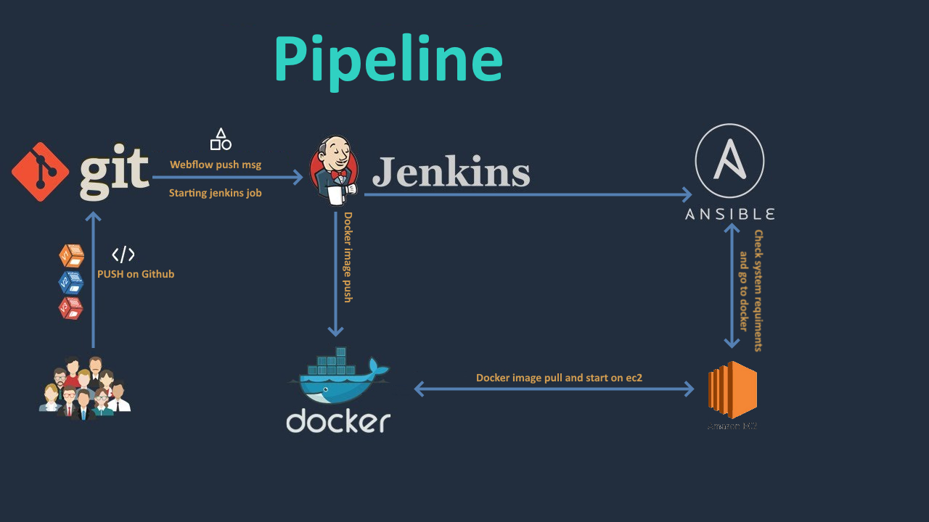
I don’t make scheme with utopia variant because it will be too big… on exam I try explain why

repo with first app https://github.com/gogolevjuri/examapp1/
repo with first app https://github.com/gogolevjuri/examapp2/

