**Backing up a MySQL database using MySQL Workbench 6.1 CE**

1. The first time you open MySQL Workbench it will be empty. The first thing you want to do is create a connection to your database. Start by clicking the + next to “MySQL Connections.”

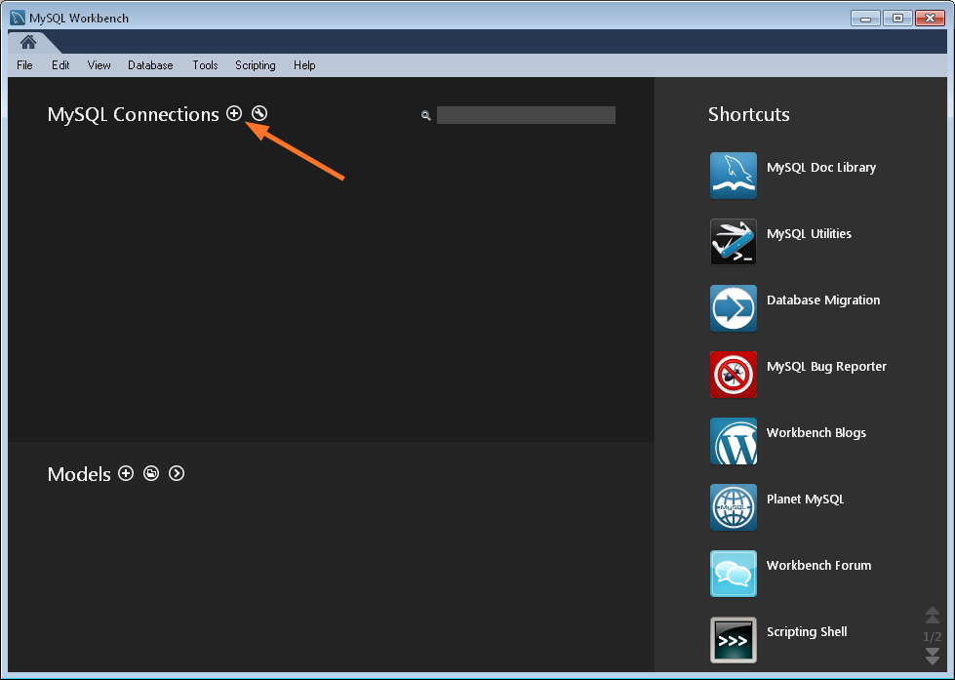

1. Next you’ll populate the connection configuration fields. Some of the information you’ll need here is located in the “**MySQL_Credentials.txt**” file. Now in the MySQL Workbench connection configuration you need to add at least the following:

**Connection Name**: You can put anything you’d like here.

**Hostname:** That’s the “Database Server” in the file.

**Username:** That’s the “Database User” in the file.

**\*\*\* Do not click on Store in Vault. You will be asked for password after clicking Test Connection**

**Password:** That’s the “Database Password” in the file.

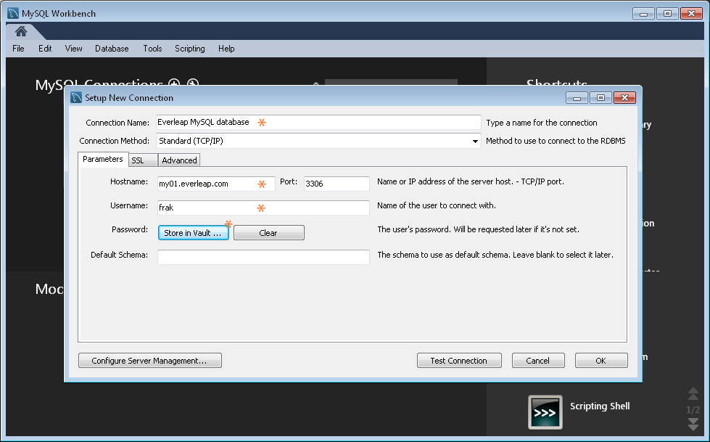

1. Once you’ve completed those fields click **Test Connection** to make sure you’ve got everything entered correctly. If the test is successful, click **OK** to save the connection.

** When a connection warning appears you click **Connect Anyway**.

1. Now you should see the connection listed, and to start the backup (or to do anything in MySQL Workbench) just click the connection box.

** You will be prompted for password multiple times.

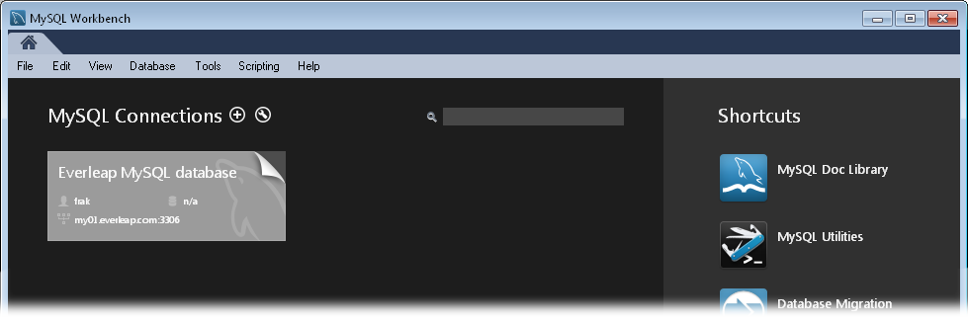

1. MySQL Workbench will connect to your database and pop up the following screen.

** Click on the **Management Tab** within the Navigator window to get the Data Import/Restore and Data Export options.

1. To perform a backup, click **Data Export**.

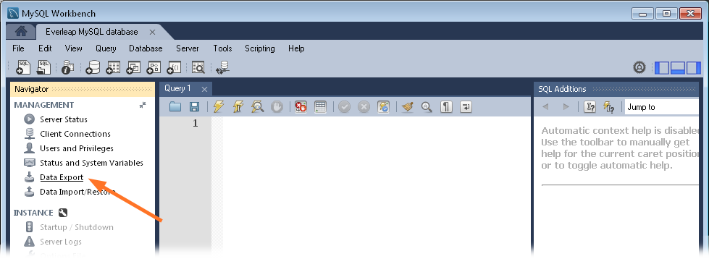

1. Now click the checkbox next to the database you want to back up, and for the easiest backup/restoration, select the **Export to Self-Contained File** option (that creates a single backup file containing your schema and all of your tables and data).

** You can also select the **Export to Dump Project Folder** to export the tables individually into a single folder.

** Check the **Dump Stored Routines (Procedures and Functions)**

**\*\*** Check **Skip table data (no data)** to export only the structure of database. Otherwise just keep it unchecked to include all data in the backup file.

1. Set the destination path for the backup file, and click **Start Export**.
2. Name the backup file with date to know the exact date when the backup was taken.

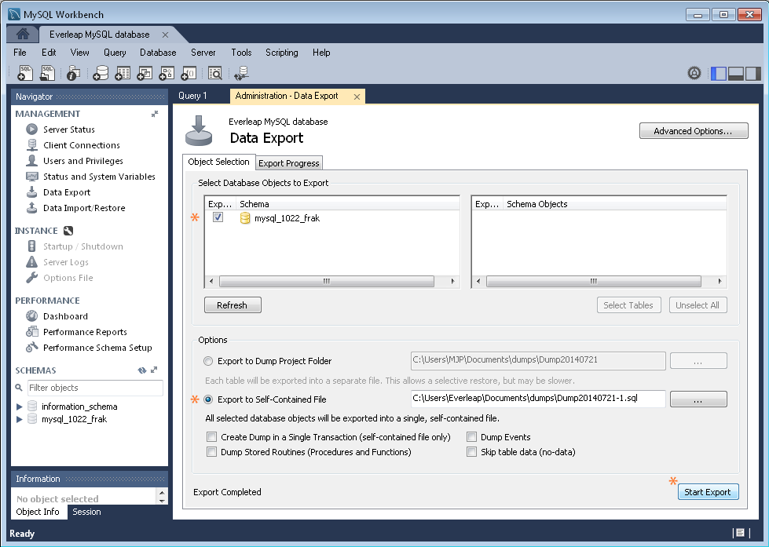

1. That’s it. Backup time depends on the size of your database.

**Restoring a MySQL database backup using MySQL Workbench 6.1 CE**

1. Follow steps 1 through 5 above and click **Data Import/Restore** to get to the following screen.

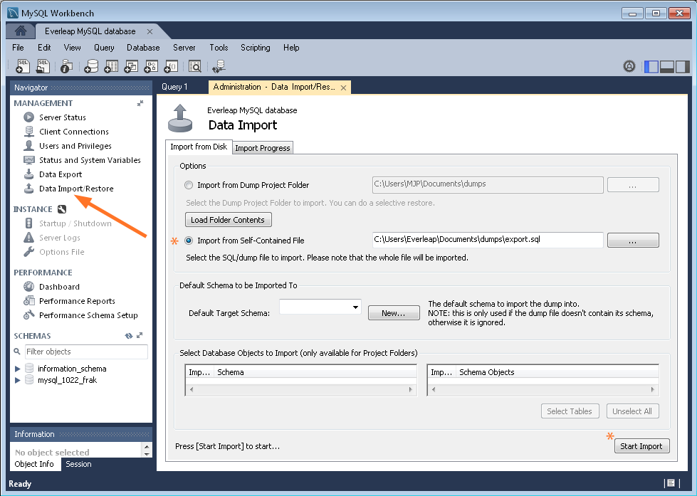

1. Click the **Data Import/Restore** link, select the **Import from Self-Contained File** option or the other option, enter the path to the backup file and click **Start Import**.