*GoGRAB*

**SmartPhone App**

Business Requirements Specifications

|  |  |
| --- | --- |
| To : | AnyCommerce |
| Names : |  |

|  |  |
| --- | --- |
| Your contact: | ORGWARE Technologies |
| Name : | Jaffer |
| Tel : |  |
| eMail : |  |
| Web : | [www.orgware.in](http://www.orgware.in) |

**Origin of the document**

|  |  |
| --- | --- |
| Author | Company |
| Bamini BASKAR | ORGWARE Technologies |

**Change history**

|  |  |  |  |
| --- | --- | --- | --- |
| Version | Date | Author | Modifications |
| 1 | 23/10/2015 | Bamini BASKAR |  |
|  |  |  |  |

**Distribution list**

|  |  |  |
| --- | --- | --- |
| Name | Company | Function |
|  |  |  |
| Senthil | Anycommerce |  |
| Ram | Anycommerce |  |
| Nandhagopal | Orgware Technologies | Sr. Android Developer |
| Jonsi | Orgware Technologies | Jr. Android Developer |

Table of Contents

*GoGRAB* 1

1 Description of the service 4

2 Introduction 4

**2.1** **Definitions** 4

**2.2** **Legend of the tables** 4

**2.3** **General specifications** 5

**2.4** **Icon App** 5

3 Screen description 6

**3.1** **Starting System (SS)** 6

**3.2** **Sideboard System (SB)** 7

**3.3** **Home System (HO)** 8

**3.4** **Restaurant System (RS)** 10

**3.5** **My Profile System (MP)** 12

# Description of the service

The service of gograb allows the users to order food online see the menu and pickup without any waiting time through smart phones and web platforms.

This application provides several services:

View restaurants in the specific location

Order online and avoid waiting time

Get offers on food

# Introduction

## **Definitions**

|  |  |
| --- | --- |
| Names | Meaning |
| Screen | The content displayed on the physical screen of the platform (web, mobile, tablet, etc...) |
| Mosaic | A way to display media (pictures, video, etc ...) on lines and columns |

## **Legend of the tables**

|  |  |  |
| --- | --- | --- |
| Names | Meanings | |
| ID | Each screen of the interface has a descriptive explanation and is detailed by a list of requirements.  Each requirement is identified by a unique ID. The ID is the combination of a token for the service and a token for the category of requirement followed by a consecutive number. | |
| Main and secondary services :  GS = General Specifications  HO = Home  RE = Registration  SI = Sign in  SU = Sign up  ... | Categories of specifications :  UI = User Interface specifications  MA = Marketing specifications  BE = Backend specifications |
| Specification | Description of all the specifications of the screen describing the features proposed to the user | |
| Author | Identifying the author of a specification | |
| Date | Date of availability of a specification | |
| Priority | Priority is defined in 3 levels:  H High: must have  M Medium: important to have  L Low: nice to have | |
| Rel. | Indicates the version (release) of the service | |

## **General specifications**

|  |  |  |  |  |  |
| --- | --- | --- | --- | --- | --- |
| ID | User Interface Specifications | Specs | Date | Prio | Rel. |
| GS-UI-01 | The logo of gograb must be displayed on home screen only | 0.1 |  | H | 1 |
| GS-UI-02 | Font: Sans Serif to facilitate the readability | 0.1 |  | H | 1 |
| GS-UI-03 | The language is set by default on the language of the user platform  At the launching of the App there will be X languages  The default languages in case of other languages of the X is English  The user can change the check spelling of the language during the Instant messaging (chat) | 0.1 |  | H | 1 |

## **Icon App**

# Screen description

## **Starting System (SS)**

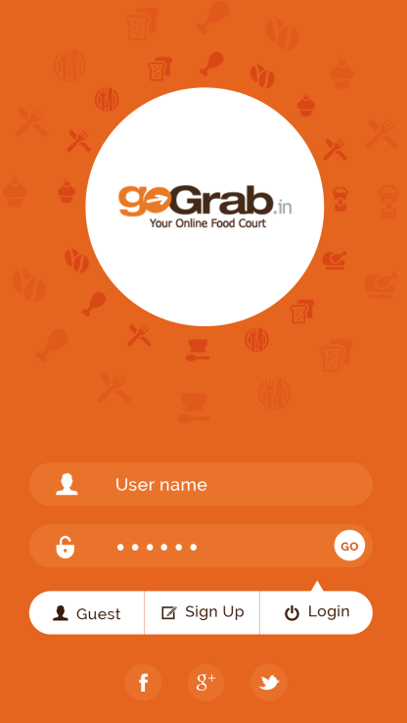

SS-UI-07

SS-UI-06

SS-UI-05

SS-UI-04

SS-UI-03

SS-UI-02

SS-UI-01

SS 1

|  |  |  |  |  |  |
| --- | --- | --- | --- | --- | --- |
| ID | User Interface Specifications | Specs | Date | Prio | Rel |
| SS-UI-01 | Text field allows user to enter username | 0.1 | 23/10/2015 | H | 1 |
| SS-UI-02 | Text field allows user to enter password | 0.1 | 23/10/2015 | H | 1 |
| SS-UI-03 | Goto HS 1 | 0.1 | 23/10/2015 | H | 1 |
| SS-UI-04 | Login in as a guest user without sigin Goto HS 1 | 0.1 | 23/10/2015 | H | 1 |
| SS-UI-05 | Goto SS 3 For registration | 0.1 | 23/10/2015 | H | 1 |
| SS-UI-06 | Goto Login page SS 1  This tab will be active by default | 0.1 | 23/10/2015 | H | 1 |
| SS-UI-07 | Connect through a social network login | 0.1 | 23/10/2015 | H | 1 |
|  |  |  |  |  |  |

## **Sideboard System (SB)**

SB-UI-01

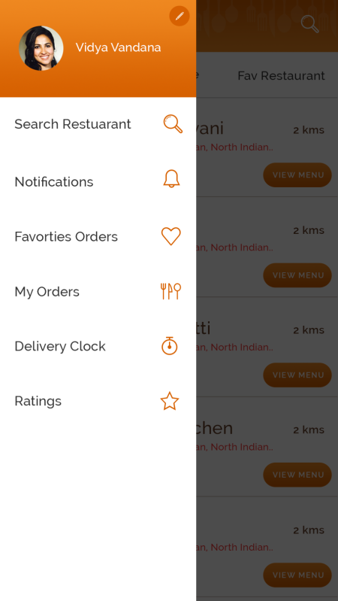

SB-UI-08

SB-UI-07

SB-UI-06

SB-UI-05

SB-UI-04

SB-UI-03

SB-UI-02

SB 1

|  |  |  |  |  |  |
| --- | --- | --- | --- | --- | --- |
| ID | User Interface Specifications | Specs | Date | Prio | Rel |
| SB-UI-01 | Edit user profile pic Show a popup to select from gallery or take a picture | 0.1 | 23/10/2015 | H | 1 |
| SB-UI-02 | Goto Profile screen MP 1 | 0.1 | 23/10/2015 | H | 1 |
| SB-UI-03 | Goto home screen HO 1 | 0.1 | 23/10/2015 | H | 1 |
| SB-UI-04 | Display notification screen Goto MP 5 | 0.1 | 23/10/2015 | H | 1 |
| SB-UI-05 | Display favourite order screen Goto MP 2 | 0.1 | 23/10/2015 | H | 1 |
| SB-UI-06 | Display myorder screen Goto MP 2 | 0.1 | 23/10/2015 | H | 1 |
| SB-UI-07 | Display a clock which shows delivery time(V2) | 0.1 | 23/10/2015 | H | 1 |
| SB-UI-08 | Goto MP 6 To allow user to provide ratings for the menu and and also overall rating | 0.1 | 23/10/2015 | H | 1 |

## **Home System (HO)**

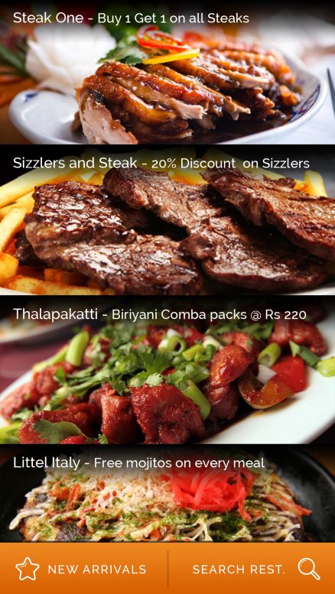

HO-UI-02

HO-UI-03

HO-UI-01

HO – 1

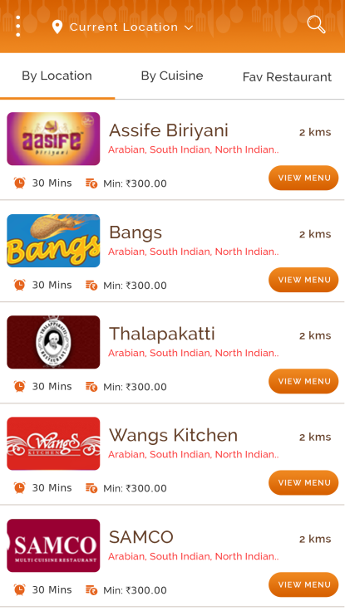 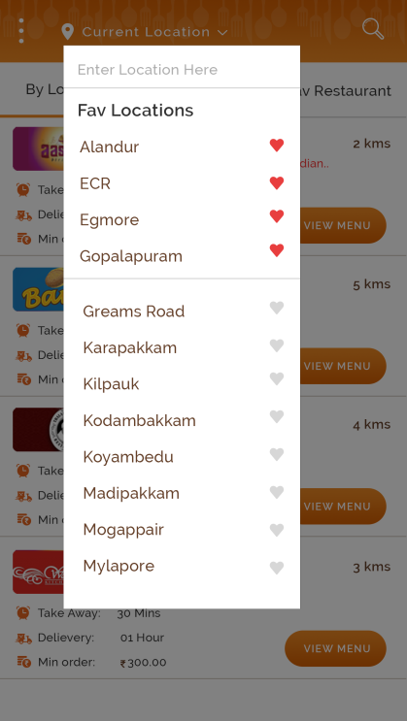

HO-UI-10

HO-UI-09

HO-UI-08

HO-UI-07

HO-UI-06

HO-UI-05

HO-UI-04

HO 2 HO 3

|  |  |  |  |  |  |
| --- | --- | --- | --- | --- | --- |
| ID | User Interface Specifications | Specs | Date | Prio | Rel |
| HO-UI-01 | Display the offers available in restaurants in general | 0.1 | 23/10/2015 | H | 1 |
| HO-UI-02 | When user click on New arrivals display the list of newly added restaurants | 0.1 | 23/10/2015 | H | 1 |
| HO-UI-03 | On Click Goto HO 2 | 0.1 | 23/10/2015 | H | 1 |
| HO-UI-04 | Search restaurants by location Goto HO 3  Display users favourite location first and display the other location below in the drop down list | 0.1 | 23/10/2015 | H | 1 |
| HO-UI-05 | Dsiplay list of favorite restaurants | 0.1 | 23/10/2015 | H | 1 |
| HO-UI-06 | Display list by sorting according to cuisine Goto HO 3 In dropdown display Veg and Nonveg List separately | 0.1 | 23/10/2015 | H | 1 |
| HO-UI-07 | Display list of restaurants by location goto HO 3 | 0.1 | 23/10/2015 | H | 1 |
| HO-UI-08 | Display image of the restaurant with the restaurant details   1. Name 2. Cuisine types 3. Distance from user current location 4. Min time required for the delivery 5. Min order value for the restaurant   On Click display a menu for the particular restaurant Goto | 0.1 | 23/10/2015 | H | 1 |
| HO-UI-09 | Clicking the heart icon add the selection as user favourite | 0.1 | 23/10/2015 | H | 1 |
| HO-UI-10 | When user selects the location sort the restaurants as per the selection and display in HO 2 | 0.1 | 23/10/2015 | H | 1 |

## **Restaurant System (RS)**

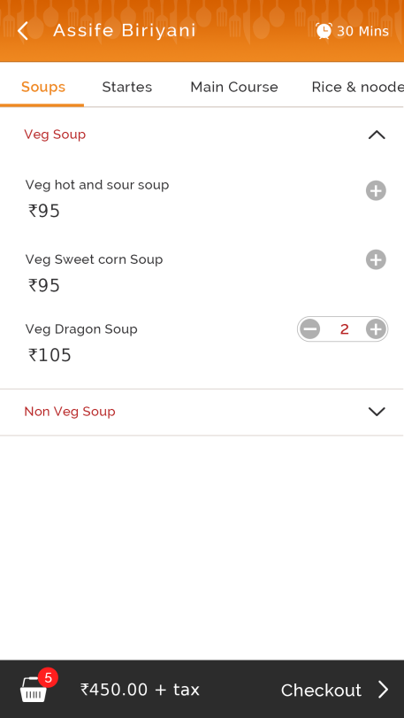 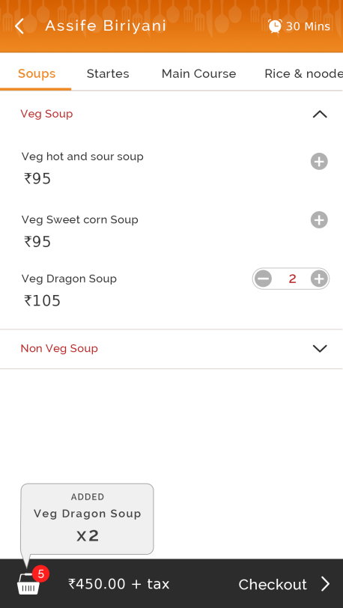

RS-UI-09

RS-UI-08

RS-UI-07

RS-UI-06

RS-UI-05

RS-UI-04

RS-UI-03

RS-UI-01

RS-UI-02

RS 1 RS 2

RS-UI-10

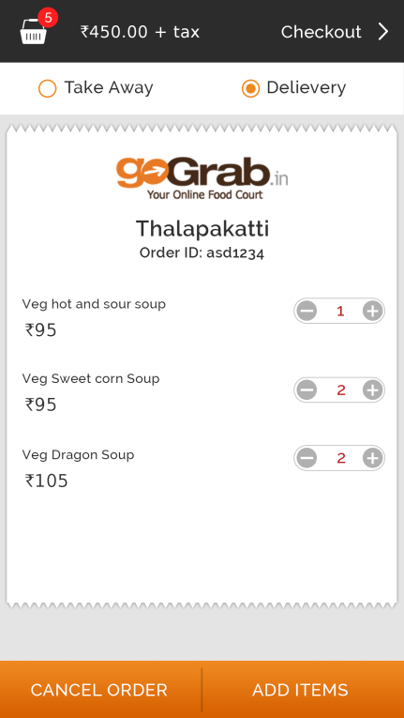 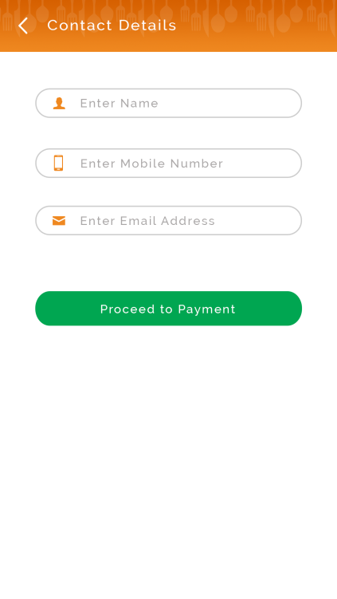

RS-UI-17

RS-UI-16

RS-UI-15

RS-UI-14

RS-UI-13

RS-UI-12

RS-UI-11

RS 3 RS 4

|  |  |  |  |  |  |
| --- | --- | --- | --- | --- | --- |
| ID | User Interface Specifications | Specs | Date | Prio | Rel |
| RS-UI-01 | Display minimum order time of the restaurant | 0.1 | 09/10/2015 | H | 1 |
| RS-UI-02 | Goto HO 2 | 0.1 | 23/10/2015 | H | 1 |
| RS-UI-03 | Horizontal scrolling for menu varieties | 0.1 | 23/10/2015 | H | 1 |
| RS-UI-04 | Clicking on “+” to add the menu item in the “Foodbox” | 0.1 | 23/10/2015 | H | 1 |
| RS-UI-05 | Hide and unhide the menu | 0.1 | 23/10/2015 | H | 1 |
| RS-UI-06 | “Foodbox” Display the count number of items added. | 0.1 | 23/10/2015 | H | 1 |
| RS-UI-07 | Calculate total bill value and display | 0.1 | 23/10/2015 | H | 1 |
| RS-UI-08 | On click go to RS 3 display the bill | 0.1 | 23/10/2015 | H | 1 |
| RS-UI-09 | Create a small animation when the item is added to the foodbox. | 0.1 | 23/10/2015 | H | 1 |
| RS-UI-10 | Goto RS 4 to get user contact details if they are not a registered user. Else redirect to payment gateway. | 0.1 | 23/10/2015 | H | 1 |
| RS-UI-11 | Display a radio button to select Takeaway or Delivery | 0.1 | 23/10/2015 | H | 1 |
| RS-UI-12 | Add or remove from the “Foodbox” | 0.1 | 23/10/2015 | H | 1 |
| RS-UI-13 | Cancel the complete order | 0.1 | 23/10/2015 | H | 1 |
| RS-UI-14 | Goto RS 1 to add new items | 0.1 | 23/10/2015 | H | 1 |
| RS-UI-15 | Goto RS 3 | 0.1 | 23/10/2015 | H | 1 |
| RS-UI-16 | Text field to input the Name, Mobile number and email id. | 0.1 | 23/10/2015 | H | 1 |
| RS-UI-17 | Redirect user to payment gateway. | 0.1 | 23/10/2015 | H | 1 |

## **My Profile System (MP)**

MP-UI-01

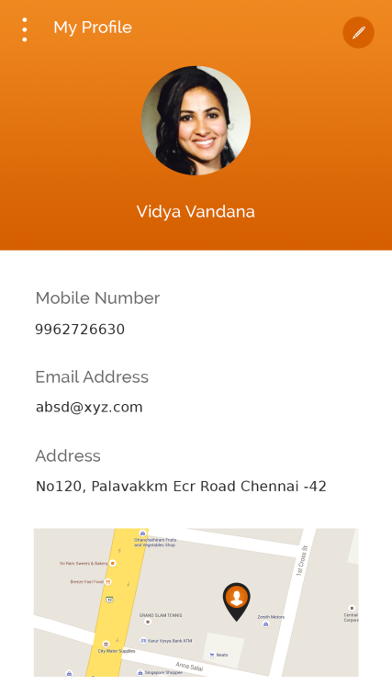 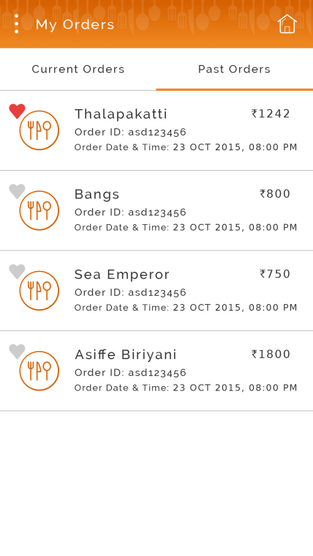

MP-UI-06

MP-UI-05

MP-UI-04

MP-UI-03

MP-UI-02

MP 1

MP 2

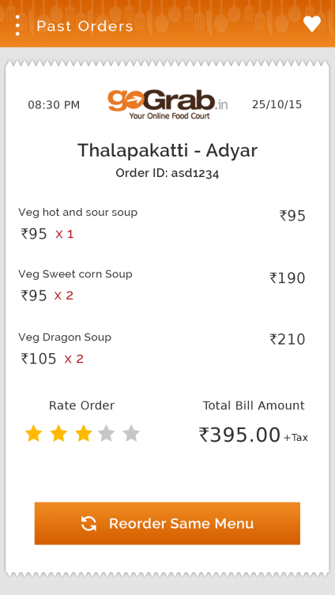 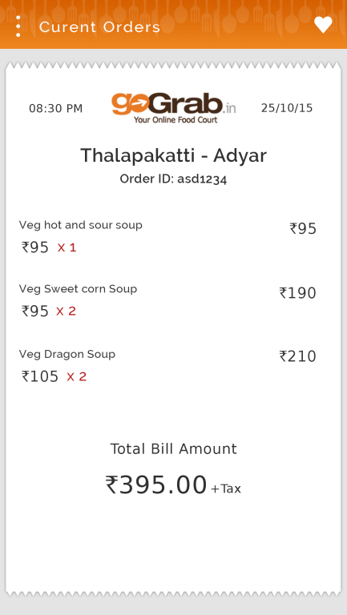

MP 3 MP 4

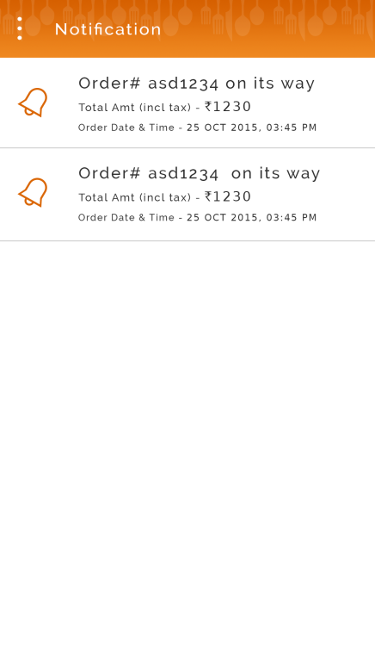 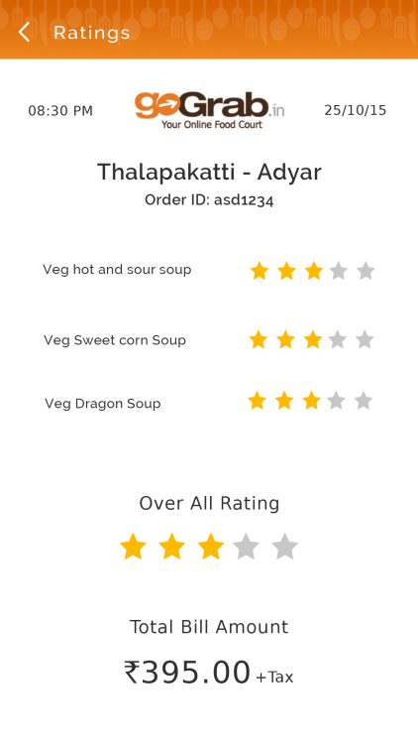

MP-UI-09

MP-UI-08

MP-UI-07

MP 5 MP 6

|  |  |  |  |  |  |
| --- | --- | --- | --- | --- | --- |
| ID | User Interface Specifications | Specs | Date | Prio | Rel |
| MP-UI-01 | Goto SB 1 | 0.1 | 23/10/2015 | H | 1 |
| MP-UI-02 | Open a popup to add picture from gallery or take a picture | 0.1 | 23/10/2015 | H | 1 |
| MP-UI-03 | Display user mobile number, email id, and address. | 0.1 | 23/10/2015 | H | 1 |
| MP-UI-04 | Goto HO 1 | 0.1 | 23/10/2015 | H | 1 |
| MP-UI-05 | Display current orders and past orders | 0.1 | 23/10/2015 | H | 1 |
| MP-UI-06 | Display a detailed bill for current past order  Goto MP 3 for past orders and MP 4 for current order details | 0.1 | 23/10/2015 | H | 1 |
| MP-UI-07 | Display status of the current order as notification | 0.1 | 23/10/2015 | H | 1 |
| MP-UI-08 | Allow user to click on the star and shade the stars accordingly and automatically calculate the overall rating | 0.1 | 23/10/2015 | H | 1 |
| MP-UI-09 | When user click on overall rating automatically fill the menu star rating | 0.1 | 23/10/2015 | H | 1 |