## [Calendar](https://donjon.bin.sh/fantasy/calendar/)

Bellsburgundian  
Year: 424  
Month: Undesmire 29th +15

### Morgith 31 days



### Kilgire 28 days



### Fair Haver 31 days

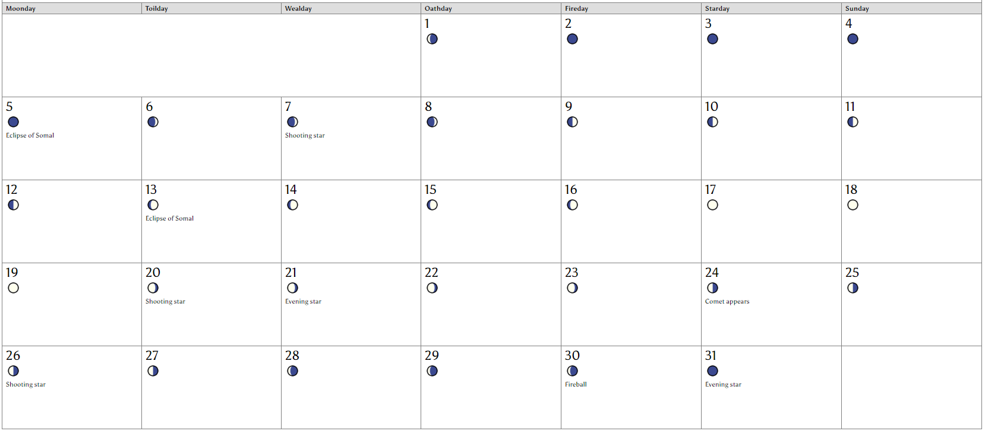

### Jilrive 30 days

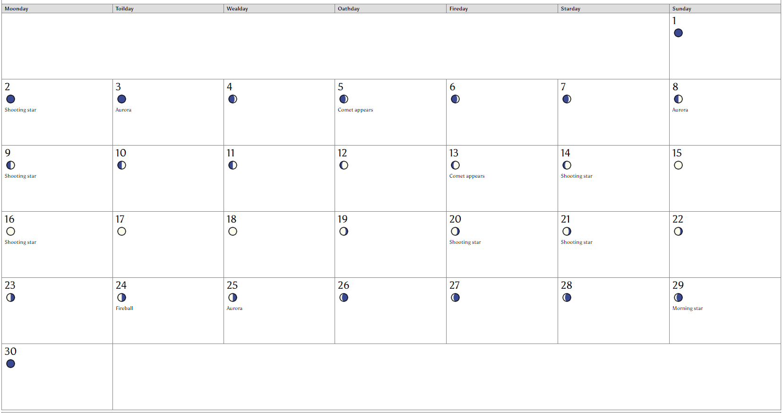

### Undesmire 31 days

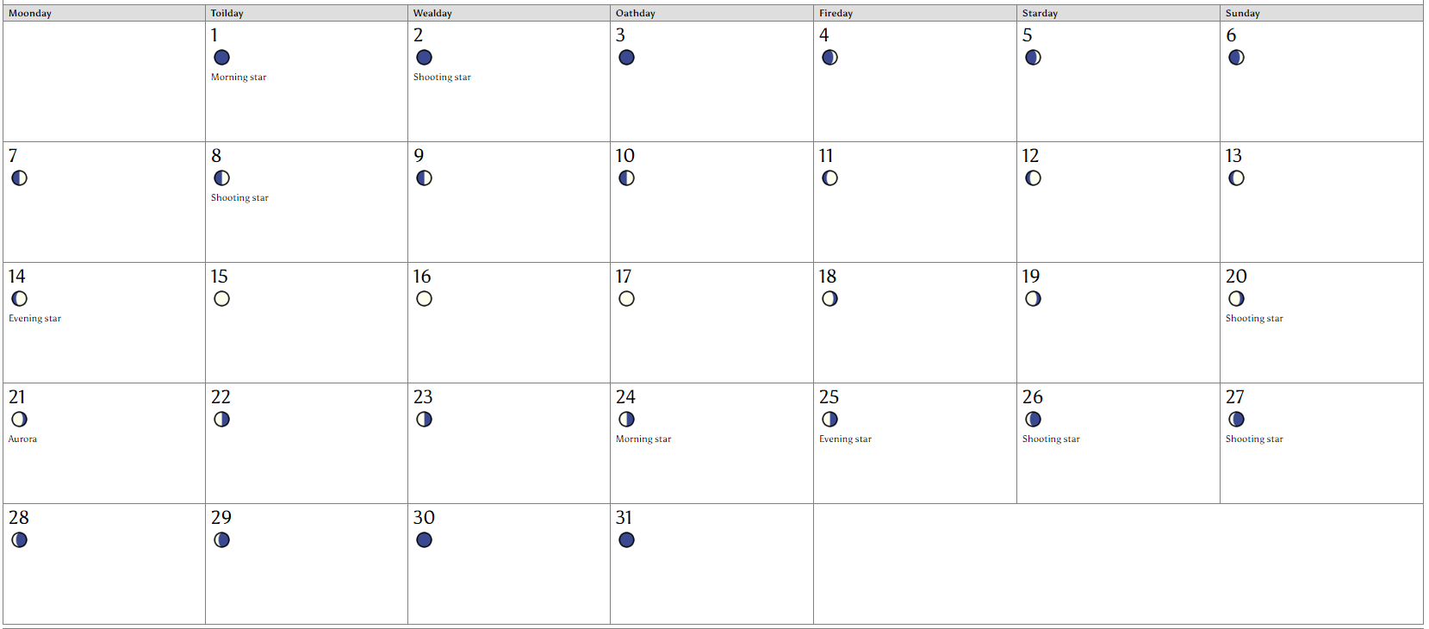

### Infid 30 days

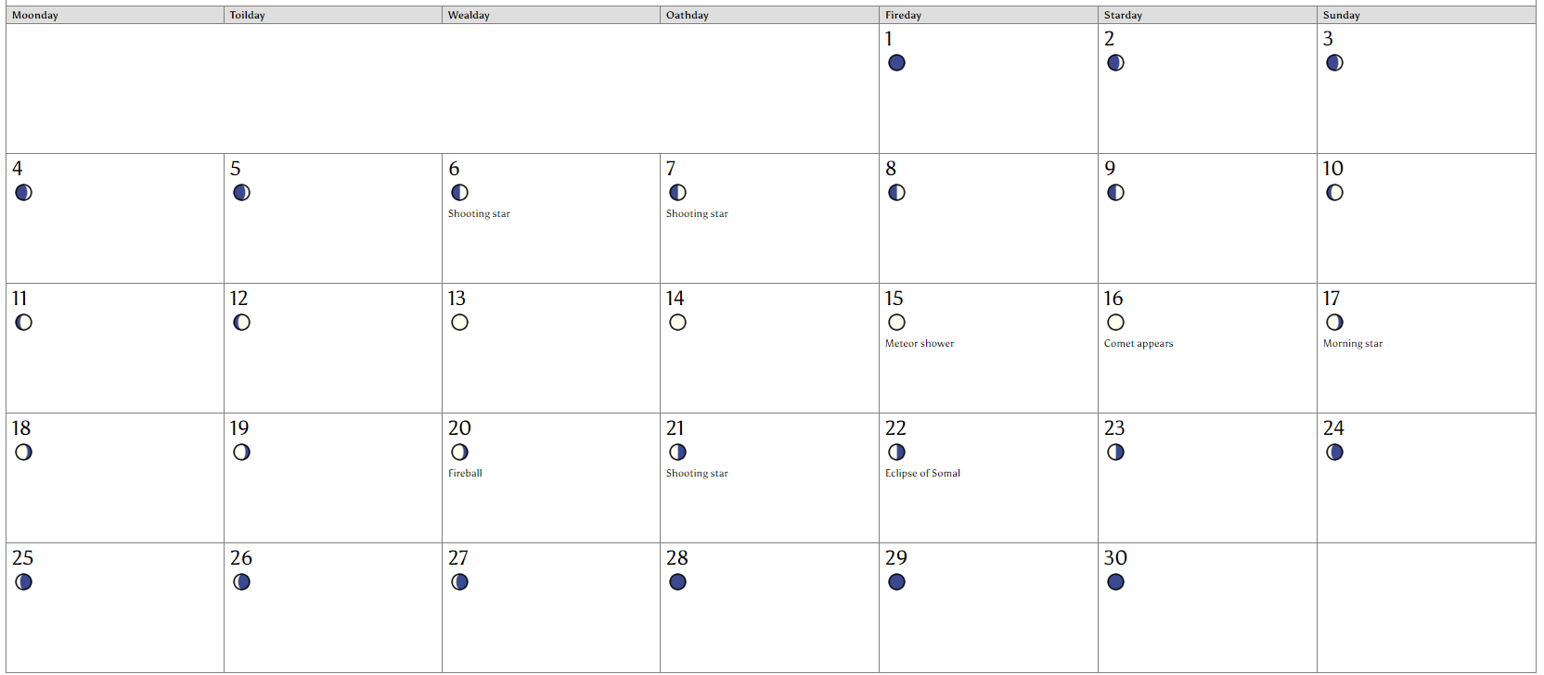

### Ebustes 31 days



### Pulrie 31 days

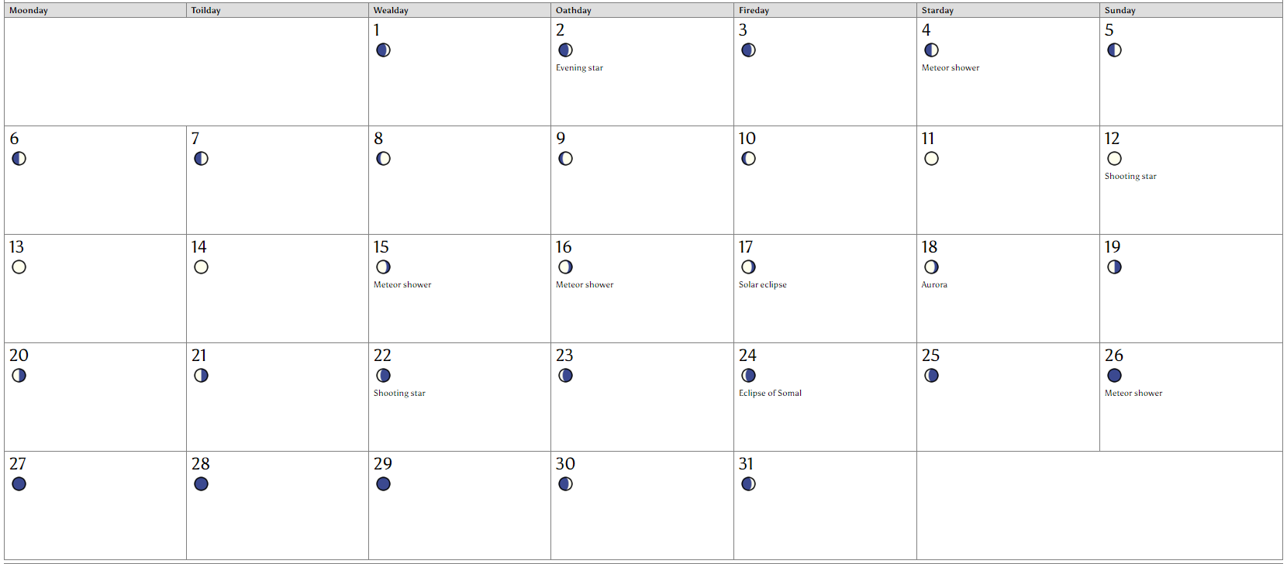

### Rosa 30 days



### Lebanos 31 days

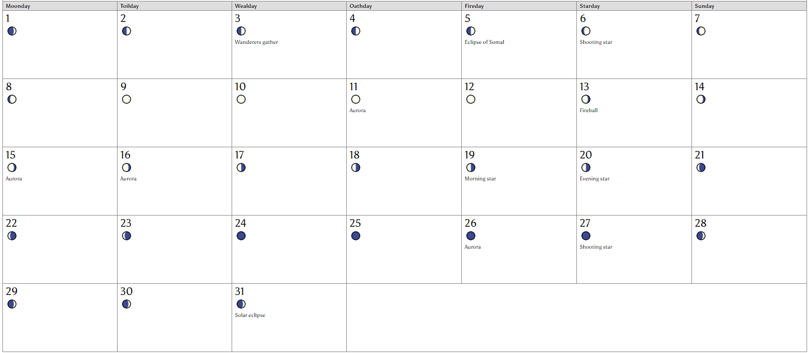

### Trimire 30



### Perth 31 days

