**PIC 18F4550 Installation & Programming**

1. Install MPLAB
2. Install c18 compiler (mplabc18-v3.46-windows-lite-installer.exe)
3. Install from the folder NET/ NETCFS Driver
4. Start MPLAB
5. Project->Projectwizard->select device (PIC 18F4550)->select language tool set-> select mpasmwin, mplink,mccc18,mplib

provide path of all four like C:\Program Files\Microchip\mplabc18\v3.46\bin\mcc18.exe

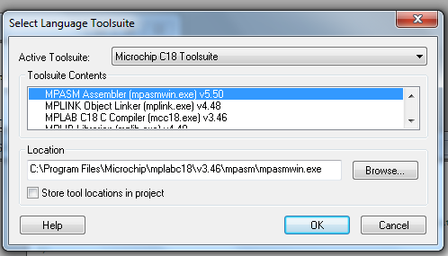

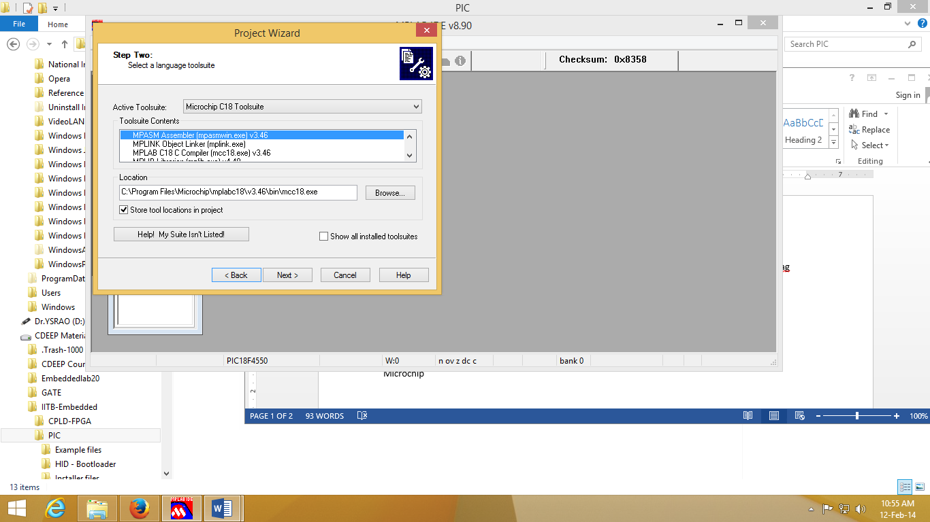

1. Create example folder
2. add rm184550.lkr file to the project file (use rm184550lkr while compiling the programs to avoid boot loader overwriting

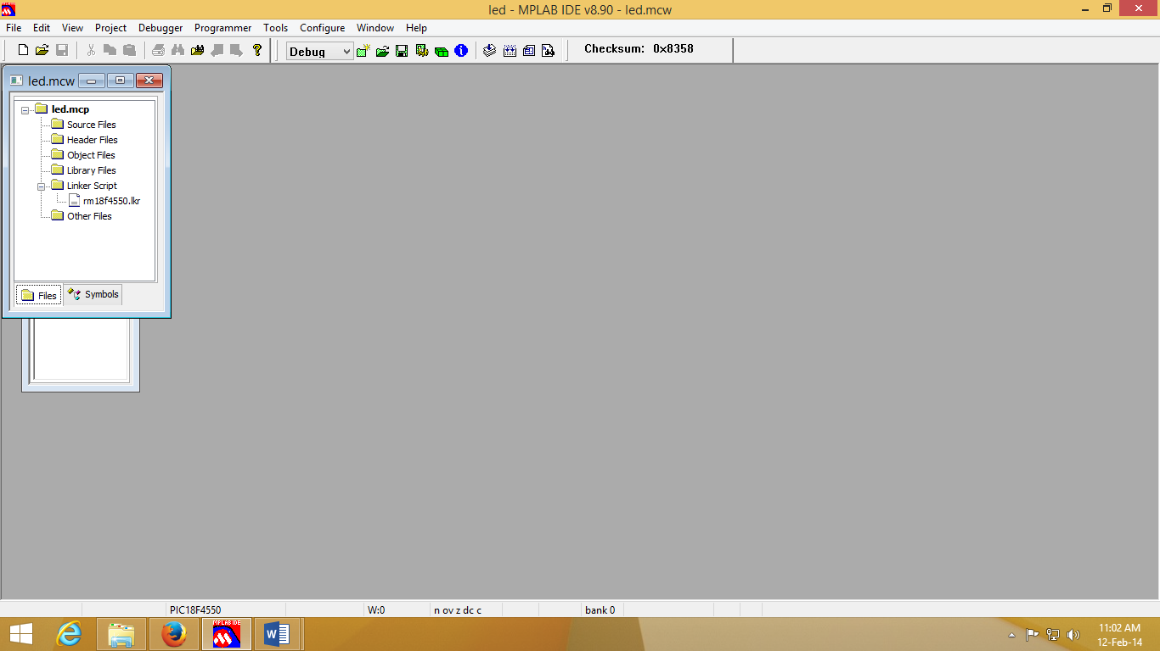

1. add source file (.c)
2. locate header files: Project -> built options -> project->
3. show directories for -> include search path -> New : C:\Program Files\Microchip\mplabc18\v3.46\h
4. Library search path path -> New : C:\Program Files\Microchip\mplabc18\v3.46\lib
5. Linker search path-> C:\Program Files\Microchip\mplabc18\v3.46\bin\LKR
6. configure -> select device->PIC18F4550
7. Debugger -> select tool-> MPLABSIM (for simulations)
8. Build the file.
9. use HID-BootLoader for programming
10. **For Programming Press fist BOOT- then RESET release RESET & then BOOT switches**

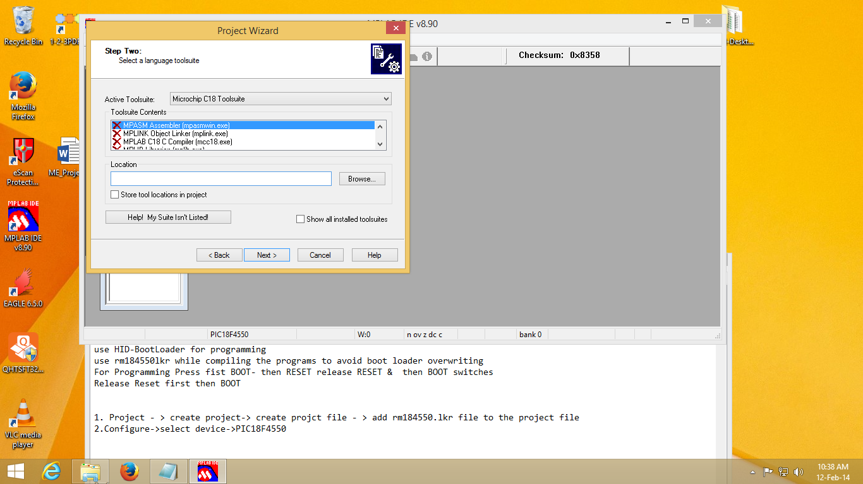

1. **In case the board is not detected verify : In Windows -> Control Panel -> Device Manager->**

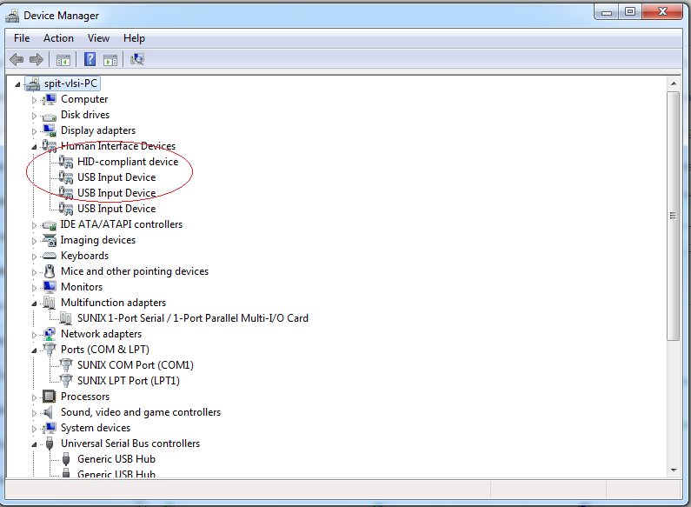

16: Open Hex File -> select .HEX file -> Program/Verify-> Reset Device

Repeat this step every time.

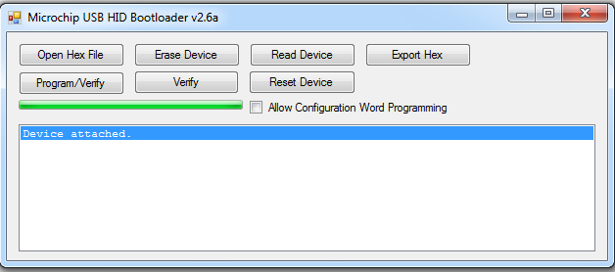

Bootloader is required to make USB enable (programming it using PICKIT3 Programmer through Jtag Port)

Reference:

http://www.microchip.com/stellent/idcplg?IdcService=SS_GET_PAGE&nodeId=1406&dDocName=en010014

For Existing Project:

1. to modify device: Configure-> Select Device

PICKIT3: Start MPLAB IDE: Directly load Hex File

1. Programmer-> Select PICKIT3->Debugger-> Connect it
2. File-> import-> LED.Hex file
3. Programmer-> Program

PICKIT3: Start MPLAB IDE : HID bootloader

1. configure -> select device->PIC18F4550
2. Programmer-> Select PICKIT3->Debugger-> Connect it
3. File-> import-> USB Device - HID - HID Bootloader - C18 - PIC18F4550.Hex file
4. Programmer-> Program

To automatically load Program from Pickit for mass Programming: repeat above steps except step 3

3.Automatic Programmer-> Settings-> Programmer to go -> Send Image in Memory (Select)

For PIC & MPLAB videos:

-------------------------------------

https://www.youtube.com/watch?v=aMK8zkWn7I8&list=PL0F54805E3165D763