**RESUME**

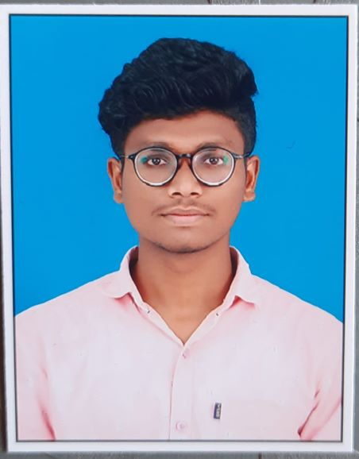

**GOGULA AVINASH KUMAR**

**PHONE NO:9398472038**

**G-MAIL:** [**gogulaavinash22@gmail.com**](mailto:gogulaavinash22@gmail.com)

**­­­­­­ --------------------------------------------------------------------------------------------------------**

**OBJECTIVE**

Aspiring to built a career with commitment and willing to accept the challenges and enhance my skills according to corporate environment and organization needs

**EDUCATION**

* Pursuing “MCA” from “CHAITANYA-DEEMED TO BE UNIVERSITY”, HANAMKONDA.
* BACHELOR OF SCIENCE(MPCS) from “AURORA DEGREE COLLEGE”(KAKATIYA UNIVERSITY) in the year of 2018-21 with 7.86 (CGPA),HANAMKONDA.
* INTERMEDIATE(MPC) from “SR JUNIOR COLLEGE”(TSBIE) in the year of 2016-18 with 84.8%,KARIMNAGAR.
* SSC from “SAI MANIKANTA MODERN HIGH SCHOOL” in the year of 2015-16 with 90%,PEDDAPALLI.

**TECHNICAL SKILLS**

* MS OFFICE
* C PROGRAMMING
* PYTHON
* SQL

**PERSONAL SKILLS**

* Time Management
* Hard Worker
* Quick learner

**SOFT SKILLS**

* Good communication skills,ability to interact with others.
* Ability to work as a part of a team and lead.

**PERSONAL DETAILS**

* NAME : Gogula Avinash Kumar
* DATE OF BIRTH : 13-04-2001
* NATIONALITY : Indian
* GENDER : male
* MARITAL STATUS : unmarried
* HOBBIES : listening music ,Playing Chess
* LANGUAGES KNOWN : English , Telugu
* FATHERS NAME : Gogula Vidya Sagar
* ADDRESS : h.no:1-72,

Buttapur (vil)

Dasturabad (mdl)

Nirmal (dist)

TELANGANA-504202

**DECLARATION**

I here by declare that above mentioned information is accurate to the best of my knowledge.

PLACE: SIGNATURE/E-SIGNATURE:

DATE: GOGULA AVINASH KUMAR

|  |
| --- |
|  |