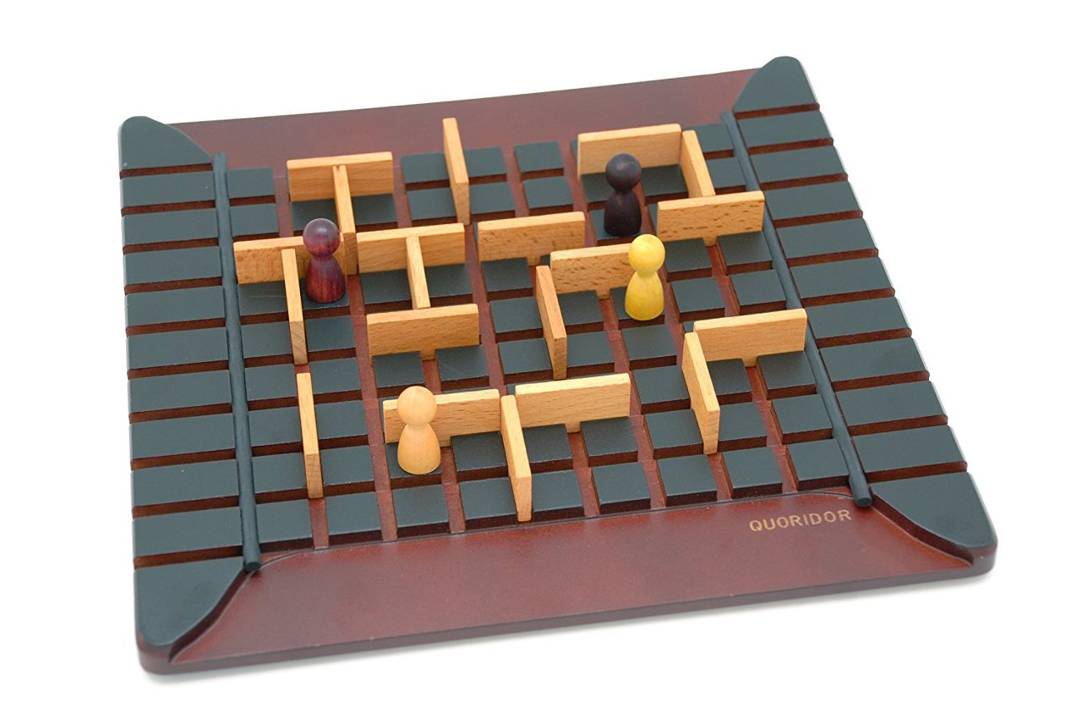

## ANIDO

Document version number *(v1.0.0)*

Written by *Team GOGUMA*

Point of contact *(goguma1000@ajou.ac.kr)*

Date of publishing

2023.03.28

## Group members

| **Name** | **Role** | **Main contributions** |
| --- | --- | --- |
| Dae Yong Kim | Game Server | Game server development |
| Dong Ho Choi | Game Client | Game client development |
| Seung Woo Lee | Game Server | Game server development |
| Song Heon Han | Game Client | Game client development |

## Document history

| **Revision** | **Date** | **Name** | **Comment** |
| --- | --- | --- | --- |
|  | 23.03.28 | GOGUMA | GDD First version |

# Table of contents

Game overview 4

Game controls 5

Technological requirements 5

Title/Start screen (Updated) 6

Game flowchart 7

Loading Screen 7

Game camera(s) 7

HUD system 7

Player character(s) 7

Player metrics 8

Other Objects 8

Stage theme 9

Universal game mechanics(Updated) 9

Music and SFX(Updated) 9

# Game overview

* Summary
* Genre : Casual, Strategy Board game
* Platform : PC
* Ages : Everyone
* Number of players : 2 or 4
* Anido is a casual strategy board game that can be enjoyed by anyone.
* Anido is PC platform version of Quoridor game, the popular board game worldwide. While Quoridor is classic and formal, Anido uses a variety of cute animal characters and casual themes to create a friendly image to users.
* Rule
* 17x17 main board with 10 obstacles each player.
* Each player places their character in the middle of the first row in front of player’s side.
* It is turn-based format. In each turn, players can choose to perform one of two actions.

1. The first action is to move characters one space on the game board, which can help players get closer to their destination.
2. The second action is to block the opponent’s path by placing obstacles on the game board.

* The winning condition
* If player’s character reaches destination (the opposite side of the board) before opponents’ characters.
* The key point of the game
* By strategically blocking the opponent’s path, players can prevent opponents from reaching the destination before they do.
* Making smart choices and select the right strategy at the right time. Since each decision can have a significant impact on the outcome of the game, players must plan carefully and develop a winning strategy.
* The selling point
* The game rule and control are simple to make anyone accessible to play it.
* The players can experience a wide range of difficulty and playability according to the strategies of the players.

# Game controls

* Mouse Clicks
* Click on specific tiles to move characters
* Click on specific tiles to set up obstacles

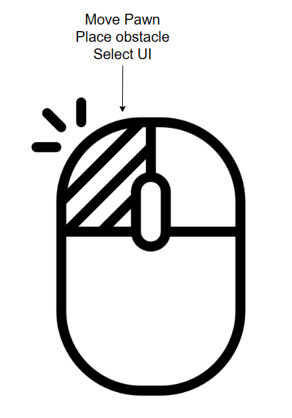

# Technological requirements

* Development tools
* Git
* Unity
* Spring Tool suite 4
* Visual studio
* Jira
* IntelliJ
* Target platform
* PC(OS : window 10)
* Design tools (Level creation and scripting tools)
* Photoshop
* Illustrator
* Unity Asset Store
* Tools for cheats (Controls for level, invulnerability, camera, and other gameplay related cheats)
* Managing coordinate information between players on the server
* Target specs of the device

# Title/Start screen (Updated)

**What is the first impression of the actual game? Include the following:**

* An image of the title/start screen and any associated animation and graphics.
* A list of what selection options are available to the player.
* Save/load file - Describe how a game file is saved and loaded and naming conventions for the player. Player options - Include image, sound and music, and player interface details. Include details on connecting links to options: Video, audio, music, and subtitle settings; contrast tool; and alternate control settings (airplane controls, feedback on/off, and so on)

# 

# Game flowchart

# Loading Screen

* Some background images with each player’s status with player profile

# Game camera(s)

* Third person perspective
* Fixed View
* Top-down view (Slightly Angled)

# HUD system

* Number of available obstacles (remaining walls), time left on player’s or opponent’s turn
* When a player attempts to move a character, the space where the character can move lights up
* If a player attempts to place an obstacle, the space where the obstacle cannot be placed will light up

# Player character(s)

* Animal characters
* Players can choose their own character before starting game.
* Characters are used for board game pieces of players in the game.
* Characters move by being placed on the tiles of board according to player’s mouse click.

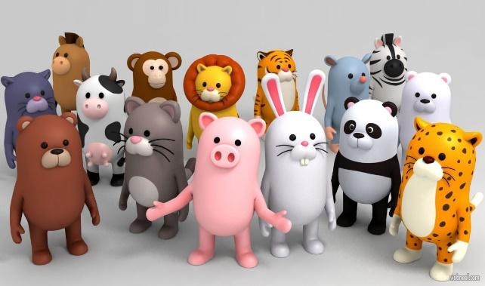

# Player metrics

* Each character has movements that match their unique animal traits.
* Each character has obstacles that match their unique animal traits.
* Characters have animation (Idle, movement, setting obstacles)

# Other Objects

* Main Board
* Composed by 17x17 tiles
* The main space for game (space where characters move and obstacles are set up)
* Obstacle
* Objects that blocking the path of the opponent’s character
* Set up vertically or horizontally by players
* Timer
* Showing the remaining time of the player’s turn

# Stage theme

* Season
* Spring
* Fall

# Universal game mechanics(Updated)

**Universal game mechanics** - List mechanics that will be found throughout the game. Always include images of each mechanic. List each platform, portal, breakable, hazard, interactable object, and puzzle element and how the player interacts with them.

# Music and SFX(Updated)

**Music and SFX** - List all music needs. List on what levels the music is needed, and don't forget the menu, pause, and option screens as well as the end credits.

List all sound effects and describe when they are used in the gameplay.

**Story overview(Not applicable)**

**Story overview** - keep this description short and frame it in the context of the gameplay.

* How does the player start the game?
* How are you presenting the story? Movies? Cut-scenes? In-game?
* How the player gets from one location to the next? (List all locations and how they relate to the narrative)
* What is the ending? What is the player expected to be/have done by the end of the game?

**Player skills(Not applicable)**

**Player skills** - List the player's skills and provide a list of skill upgrades.

**Player inventory tools(Not applicable)**

**Player inventory tools (equipment, spells, buffs, and so on)** - List all tools and inventory items - things the player will use and how to use them. Describe or illustrate the inventory screen and how the player will access items.

**Combat(Not applicable)**

**Combat** - Describe and/or illustrate all combat moves and reactions including combo moves; different weapon types (melee and ranged); weapon tech tree; ranges; how the player equips, reloads, and changes weapons; lock-ons; and targeting systems.

**Power-ups/state modifiers(Not applicable)**

**Power-ups/state modifiers** - List power-ups and state modifiers. Show images and list what their effect and duration are.

**Health(Not applicable)**

**Health** - Describe how the player’s (or another game object’s, like car’s) health is tracked on HUD and how players can lose and replenish health. Describe how players can tell when health is low.

* Alternate states - Describe how alternate states (stunned, poisoned, turned into a baby, etc.) the player can get into and how it might affect controls.
* Lives (if applicable) - Explain how lives are earned or lost and what happens when the player runs out.
* Death (if applicable) - Describe what happens when death occurs. List situations requiring unique animations (fire, drowning, and so on). What happens when the game is over? What does the game-over screen look like? Is there a penalty for dying?
* Checkpoint system - Describe the in-game checkpoint system. How does the autosave system work?

**Scoring(Not applicable)**

**Scoring (if applicable)** - Assign point values to actions and explain what happens when players reach them. How do players earn bonuses in the game (like chaining or combos)?

* Leader board setup - What does it look like? What stats are being tracked?
* Achievements - What achievements are available and how are they earned? List them and provide images for badges if applicable.

**Rewards and economy(Not applicable)**

**Rewards and economy** - Describe the game's monetary system including how money is earned, spent, and saved (if applicable). List purchasable items and cost. Describe how the shopping interface works.

**Collectibles/object sets(Not applicable)**

**Collectibles/object sets** - Provide a list of all items in the game, where they can be found, and what they do. Provide images.

**Vehicles(Not applicable)**

**Vehicles** - What vehicles are used? Provide visuals. How does a vehicle interact with the world, enemies, objects, and so on? How does it control? Does it require a different camera system? How does the player enter or exit the vehicle? What abilities does the vehicle have?

**Game progression outline(Not applicable)**

**Game progression outline** - Provide an overview of all game levels. You can do this with a Beat chart (<https://www.gamasutra.com/blogs/NickFilatov/20150623/246758/Beatchart__game_designers_best_friend.php>). Show how game play and story intertwines. Indicate introduction of major elements such as enemies, bosses, rewards, items, puzzles, or twists to the story.

**World overview/level select/navigation screen**

**World overview/level select/navigation screen** - Provide images and a control scheme showing how the player will navigate. List locations and where they lead to. Provide sound and music requirements.

**Game levels(Not applicable)**

**Game levels** - List each of the levels mentioned in the world overview including name, short description, major gameplay, enemies, and items found in the level. Describe how the level relates to the story if applicable. Include a list of time of day, color guide, and music needs. You may even describe the level’s atmosphere, ambiance and provide a layout sketch, if applicable.

**General enemy rules(Not applicable)**

**General enemy rules** - List behavior types (shooter, patroller, flyer, and so on) and how the behavior type AI operates. Describe spawn and defeat parameters. List reward rules.

**Level specific enemies(Not applicable)**

**Level specific enemies** - Provide an image and description of the enemy and where it appears in the game. List all movement and attack patterns and ways the player can defeat the enemy. Describe any combination attacks or encounters between different types of enemies. Describe what happens when the enemy is defeated and what the player gets for doing so. Describe also how much damage each enemy causes to the player and how much HP they have (e.g. in a table), if applicable.

**Bosses(Not applicable)**

**Bosses** - Provide an image (sketch) and description of each boss and its environment. Describe the encounter and what it will be like to play it. List all movement, attack patterns, and ways the player can defeat the boss. Describe what happens when the boss is defeated and what the player gets for doing so.

**NPCs(Not applicable)**

**NPCs** (non-player characters) - List characters in the game. Provide descriptions, images, and where they appear. List what functions they serve in the overall context of the game. List what rewards or items they are associated with.

**Mini games(Not applicable)**

**Mini games** - List the types of mini games and provide illustrations showing each game type. Describe how to play and use control schemes. List what original and repurposed game elements the mini games require. List what levels the games are found on and what rewards they yield.

**Monetization(Not applicable)**

**Monetization** - Describe how monetization will work over the course of the game. Show the interface for purchasing content. List purchasable items and estimated cost.