**RollPaper Documentation**

1. MapRollDoubleSided Shader

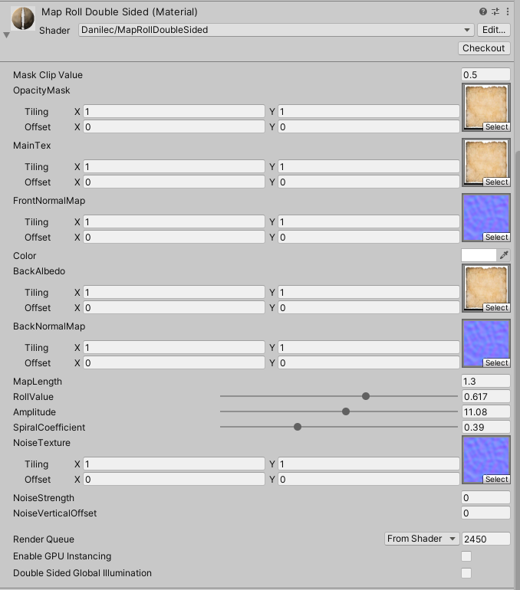

Properties of interest:

* **MapLength**:

Map length value is a middle length of the mesh:

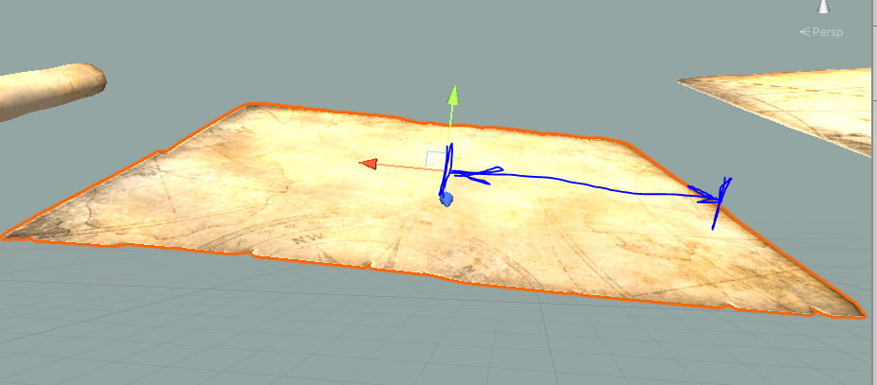

For a mesh MapPlane in the Demo folder this length is 1.3.

For a Plane (standard Unity 3d object Plane) this length is 5-5.2.

You can play with this value:

**Set the property RollValue to 1 and increase the value MapLength till the paper will be plain.**

* **RollValue:**

With this property you control how the paper is rolled. If 0 - rolled fully. If 1 - the paper is plain.

* **Amplitude:**

With this property you can control the curvature of rolling.

* **SpiralCoefficient:**

This property controls the spiral effect.

**Noise properties** let you add some noise for a map plain.

1. MapRollDoubleSidedOneDirection Shader

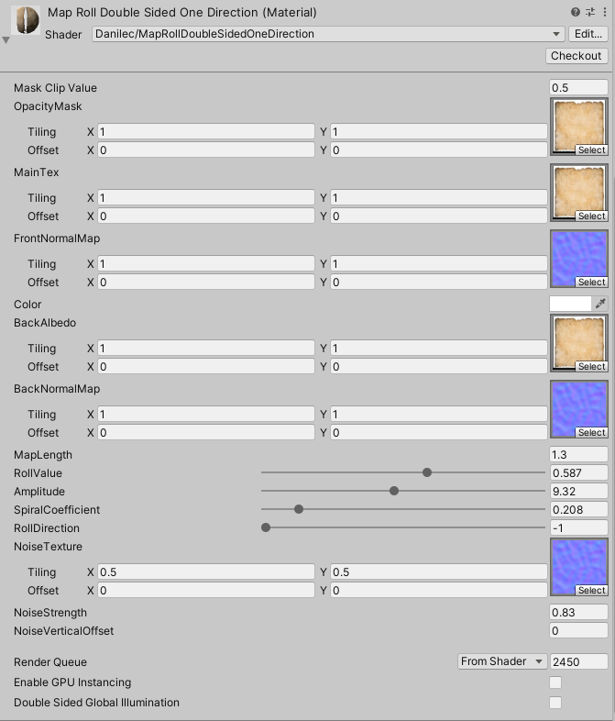

Properties of interest:

The same as in the first shader. And one additional:

* **RollDirection:**

This property controls in which direction the roll is going. From the left to the right or vice versa. If is > 0 - one direction, If is < 0 - opposite direction.

**Also you can check a video: https://youtu.be/DWNdlAcm62Q**