Business Requirement Document for Aasaan Skill Learning Platform (LMS)
Learning Management System

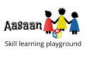

MangoesOrange Agritech India Pvt. Ltd.
Version 0.3 – Draft
Project Manager: Mr. Imran Ahmad
Prepared by:
- Atul Raj
- Himanshu Bhatt
- Aakash Sagar
- Shivam Sharma
- Ritik Chhimwal
- Abhinav Singh Sengar

Date: 21-July-2023
Table of Contents
1. Introduction 3
1.1 Purpose 3
1.2 Problem statement 3
1.3 Proposed solution 3
1.4 Target age group 5
2. Tradition Education System 5
2.1 Role of our Platform 6
3. Identify Skills Training Programs 7
3.1 Briefly defined Skills / Concept that we have added in our curriculum - 8
3.1.1 Introduction to basic programming – 9
3.1.2 Mathematics – 9
3.1.3 Critical Thinking – 9
3.1.4 Problem Solving Skills – 9
3.1.5 Health and Fitness – 9
3.1.6 Digital Literacy – 9
3.1.7 Arts and crafts – 10
3.1.8 Literacy and communication skills – 10
3.1.9 Personal and First Aid Skills – 10
3.1.10 Nature and environment Skills – 10
3.1.11 Pet Caring – 11
4. Platform Overview 11
4.1 Modules 11
4.1.1 The Website 11
4.1.2 The Web Application 12
4.1.2.1 Demo Web Application section 12
4.1.2.2 Complete Web Application 12
4.1.3 Skill Course Module 13
5. Student Assessment System – 13
6. Scholarship Program – 14
6.1 Support provided by Scholarship program – 15

Introduction

1.1 Purpose
The purpose of this document is to define what Aasaan Skill Learning Platform(LMS) is and to gather the complete requirements for this project.
This document will provide an overview layout of the complete project. Explain all the aspects of this platform.

1.2 Problem statement
In India, there are almost 36 Crores students currently going to school from different State and center boards, and most of these schools follows conventional pattern of teaching which lacks adequate professional skills need in 21st Century.
The questions arise here is, as to what extent student are actually getting practical knowledge and skills that are crucial for their future education and professional development.

1.3 Proposed solution
In 2020 a new education policy is passed where the way of learning shifted from traditional learning to skill-based learning. And while taking a reference from it we aspire to create a platform where our skilled and professional teachers designing a curriculum for each grade and different age group. Edit here

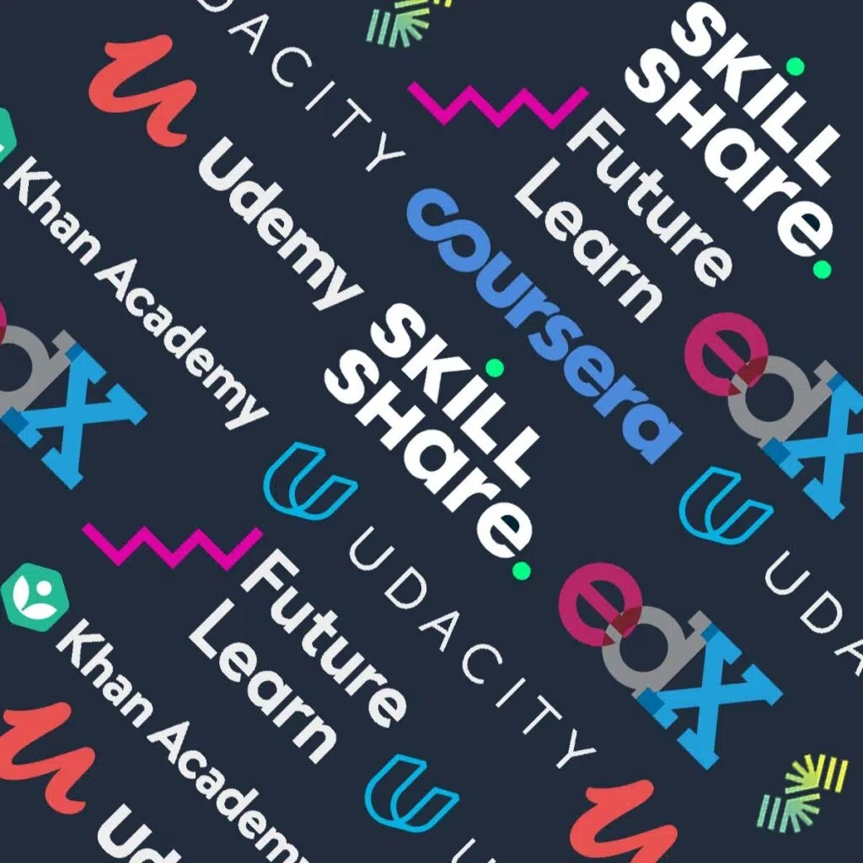

Today there are ample amount of platforms for learning and exploring. We would like to propose a platform which is closely integrated with new National Education Policy and helps the student acquire all the basic and professional skill that they want.
A platform which will there with every student with each every part of his/her learning phase.
Highlight NEP – what it wants – outcomes
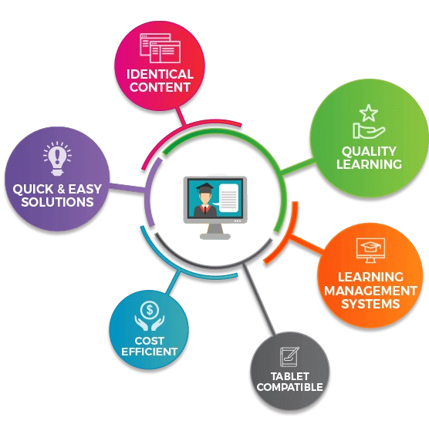

1.4 Target age group
Our target age group are from 3rd to 5th grade. But in later stage we certainly going to include other age group as well.
Define reason -

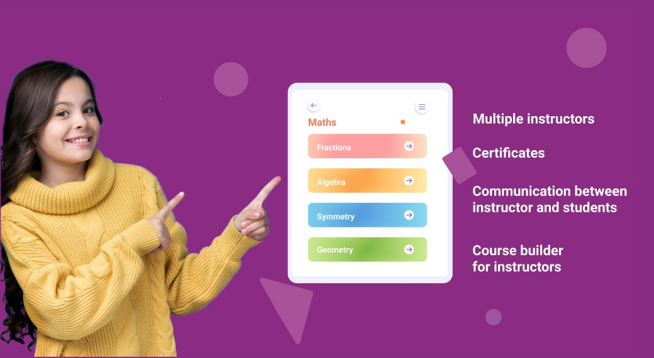

Traditional Education System
The traditional education system in India, which having some strengths, also had some certain limitation where it considered to be lacking in this digital age.
Here are some point out where traditional education system fall behind –

- Memorization is a very important part of the old education system, where a student has to memorize information necessarily without understanding the underlying concepts. While this approach may be effective in short term but in future it doesn’t give any benefits.

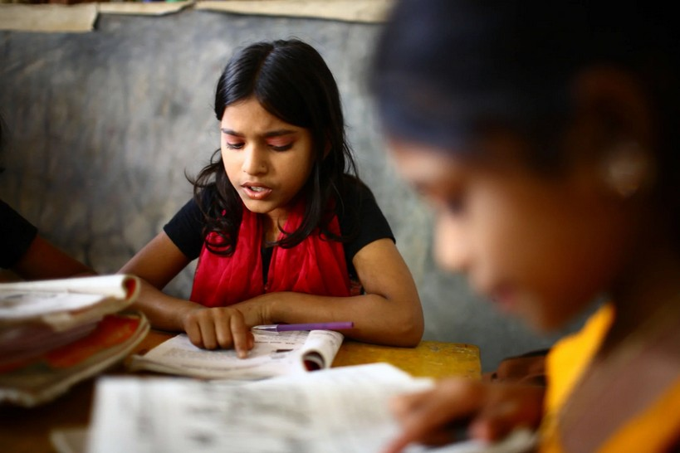

- Lack of practical knowledge is another negative point of current education system. Where most of the time studying of the theoretical aspects give more importance them applying knowledge in practical scenarios.
- Primary focus on only academic subject often neglected the development of other important skills such as communication, team work, critical thinking. And this lack of emphasis on skills left students ill prepared for the modern workforce.

2.1 Role of our Platform
We will provide skills that are beneficial for today's generation. Our platform will provide a collaborative environment for students, teachers and parents.
As a teaching platform curriculum is a very vital part of our system. And we believe in creating a syllabus that not only build skills in students but also make them future ready.

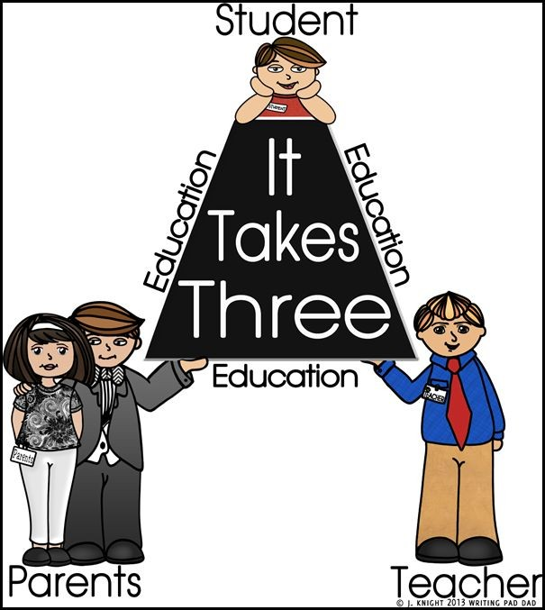

And to do that our team has carefully crafted a syllabus that revolve around some core concepts for every grade student. But at the same time, we change the methodology of teaching and interaction according to age groups.
And some of these core concepts are. How to channelize creativity, Know about internet and its component, Critical thinking and analysis and a very basic introduction to programming. So, from a very early age students can have an idea about what programming is about.

Identify Skills Training Programs
As a teaching platform curriculum is a very vital part of our system. And we believe in creating a syllabus that not only build skills in students but also make them future ready and to do that our team has carefully crafted a syllabus that revolve around some core concepts for every grade student. But at the same time, we change the methodology of teaching and interaction according to age groups.
Some of these core concepts are. How to channelize creativity, Know about internet and its component, Critical thinking and analysis and a very basic introduction to programming. So, from a very early age students can have an idea about what programming is about.
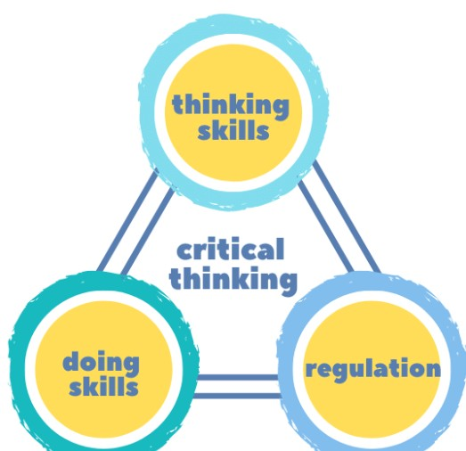

3.1 Briefly defined Skills / Concept that we have added in our curriculum -
- Introduction to basic programming
- Mathematics Number crunching
- Critical Thinking
- Problem Solving Skills
- Health and Fitness
- Art and crafts
- Internet Safety
- Application Use
- Digital literacy
- Typing Classes
- Communication and literature
- Personal Skills
- First Aid Skills
- Nature and environment skills
- Pet Caring

3.1.1 Introduction to basic programming –
Teaching and introducing programming to students is an essential feature of our platform. And as of now we are targeting students who are in their 1st grade to 5th grade. And for that we created a curriculum that will introduce kids to programming and problem solving in a very fun and interactive way.

3.1.2 Mathematics –
It is recognized that mathematics and mathematical thinking will be very important for student future.

3.1.3 Critical Thinking –
Developing critical thinking skills is crucial for kids as it helps them analyze information, make informed decisions, solve problems, and think independently.

3.1.4 Problem Solving Skills –
Another essential life skill that the children need to develop is problem-solving. This skill will come in handy when they encounter challenges in their lives. Teaching children how to identify the root cause of a problem and brainstorm possible solutions. Also, encourage them to think critically and creatively to come up with the best solution.

3.1.5 Health and Fitness –
Teaching children about healthy eating habits and providing them with the necessary skills to make nutritious food choices is crucial for their overall well-being.

3.1.6 Digital Literacy –
To keep a view of increasing internet consumption and exposure to technology in daily life, we think it is a best time to introduce a course that actually teach kids how internet works and how to use it safely.
Teaching cyber security to kids help them develop a strong foundation of digital literacy and online safety.
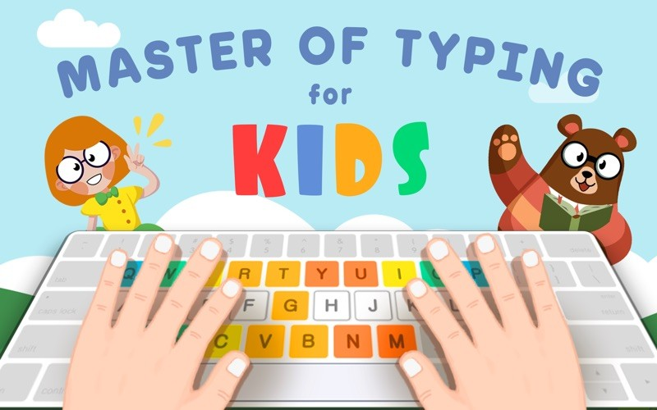

Teaching kids about different applications, can help them to develop a knowledge about digital world while enhancing their learning experience.

3.1.7 Arts and crafts –
Arts and crafts activities help kids to develop or express their creativity, imagination, and cognitive abilities while teaching them how to channelize their creative side.

3.1.8 Literacy and communication skills –
Literacy and Communication skills are crucial for children as it forms the foundation for their academic success and lifelong learning. We can sharp these skills in the students using various strategies and techniques.

3.1.9 Personal and First Aid Skills –
Personal skills include teaching children’s how to take care of the body of our own. Helping children to understand what are the different situation that can occur in the household and in school related to emergency and how to react on these situations.

3.1.10 Nature and environment Skills –
Engaging children in nature-related activities can foster a deep connection with the natural world and promote environmental stewardship. Teaching children about agriculture and farming can help them develop an understanding and appreciation for where their food comes from, the importance of sustainable practices, and the value of nature.


3.1.11 Pet Caring –
To teach kids a sense of responsibility, empathy, and compassion pet caring is a great task that we can teach a kid.
NEP Syllabus – defined skills

Platform Overview

In previous section we listed some skills on which we will be focusing on. This section describes how are going to build the platform so that we can provide the skill learning platform to our users.
Mobile first

4.1 Modules

4.1.1 The Website
The first module that user will encounter is the Website of our platform.
Here we will be providing the following:
- Introduction to the actors involved in our platform.
  - Students
  - Instructors
  - Parents
- Live demo, where users interact with the platform.
- Registration section, for Sign Up and Sign In.
- Catalog all the skills students will be learning in our platform.
- Catalog all the projects create by existing students of our platform.
- Grades and their activities introduction.
- Catalog of all the benefits for above mentioned actors.
- Section of our blog for updates.
- Complete curriculum section, describing all the course material.
- Testimonial section, where existing students and parents provides reviews.
- About us section, where we brief about our platform.

Website will the gateway to our other modules.

4.1.2 The Web Application
After completing the registration process, user will direct to our web application, which is cross platform and provide ease of user experience. Students can login to the web application and start learning.

4.1.2.1 Demo Web Application section
In this section we will provide demo lessons, where students can explore how the platform will look and feel. After completing the basic demo lesson student will be re-directed to registration section. After registering the student will have complete access to the platform.
Monitor Demo Application – feedback mechanism of usage and user details(section)

4.1.2.2 Complete Web Application
Web application will provide interface to:
- Catalog of all the Skill Course Modules (Described in section 4.1.3).
- Student dashboard
  - Profile
  - Achievements
  - Assignments
  - Projects
  - Badges (Reward system)
- Instructor dashboard
  - Profile
  - Skill teaching
Cred

4.1.3 Skill Course Module
Skill Course Module is a complete course which a user can enroll into, perform activities inside course and get marks accordingly.
Student can buy multiple modules.
Skill Course Module attributes:
- Module name
- Module instructor name
- Complete duration
- Prerequisite modules
- Provoke to complete module positively

Student Assessment System –
As part of providing better education and learning, our platform will implement a student assessment system. And the main motive of this system will be to analyse and evaluate student performance to ensure their effective learning outcomes. As well as assess how students are responding to our course and identifying areas where improvement may be needed. And to apply this assessment process, we will be introducing a review system within our platform, and this system will be designed to evaluate students’ performance based on regular testes conducted by our faculty. Upon completion of each test, students will assign points based on their performance. And while assigning these grade points we will take account on various factors to determine the points allocating to each student. Also, the points earned by students are prominently displayed in their profile, provide them the transparent representation of their progress and achievements. Again, the performance data collected through the assessment will not valuable for students but it will help us too, to create personalized learning paths for each student and to recognize where we have to work more. After the assessment the reward system will also be going to introduce where student can earn virtual badges, certification or other forms of recognition based on their point and achievements. Transparency is very important int this reviews system and to keep in mind we also have to understand the crucial role of parents in their child journey. And that's why we encourage parents to actively involve to monitor student progress. Parents can also access their child assessment data, progress report, and can communicate with teachers to discuss performance and feedback. And as we continue to move forward in our journey, The student assessment system will also undergo continuously by open feedback and by our learning.

Scholarship Program –
Scholarship program is another import aspect of our project, and we know how important it is to keep students motivate and help them to stay on track with their courses and education. That’s why our platform has an incredible scholarship program that reward students for their hard work and dedication, Our program is carefully designed to be directly linked to student performance in their sessions and assessment reviews. And this makes the value of weekly and monthly test more important. While giving us a clear overview of how well students are grasping the concepts and applying them. So, how does it all work? And for that we crunch all the numbers and analyse the overall grades of the students. We closely inspect at their performance, consistency throughout their learning journey. And finally based on this analysis, we pick a selected group of students who have truly stood out with their outstanding performance and dedication. And here is another part of the program: the chosen students will receive a well -deserved scholarship for their future education. Because we believe in supporting our student beyond their time in our platform. And that is why we understand that, it is our responsibility to give them a head start in their academic pursuits, and help them achieve even greater things in life.

6.1 Support provided by Scholarship program – (Need discussion and more thinking)
Once we select the recipients, we’ll provide them with opportunity to pursue their future education. And this support could be financial support for their tuition fees, access to advanced coding courses, mentorship program, or partnership with well settled educational institutions.

