

Makes it easy for you to learn and explore new Skills!

Business Requirement Document for Aasaan Skill Learning Platform

Version 0.4 – Draft
MangoesOrange Agritech India Pvt. Ltd.
Date: 15-August-2023

Project Leads:
Mr. Ravi Rautela
Mr. Praveen Prajapati
Mr. Imran Ahmad

Team Members

Atul Raj
Himanshu Bhatt
Aakash Sagar
Shivam Sharma
Ritik Chhimwal
Abhinav Singh Sengar

Table of Contents
1. Introduction 6
1.1 Purpose 6
1.2 Problem statement 6
1.2 National Education Policy 7
1.3 Proposed solution 7
1.4 Minimum Viable Product 8
1.5 Targeted audience 8
1.5.1 Students 8
1.5.2 Parents 8
2. Identify Skills 9
2.1 Briefly defined Skills / Concept that we have added in our curriculum - 9
2.1.1 Introduction to basic programming – 10
2.1.2 Mathematics – 10
2.1.3 Critical Thinking – 10
2.1.4 Problem Solving Skills – 10
2.1.5 Health and Fitness – 11
2.1.6 Digital Literacy – 11
2.1.7 Arts and crafts – 11
2.1.8 Literacy and communication skills – 11
2.1.9 Personal and First Aid Skills – 12
2.1.10 Nature and environment Skills – 12
3. Members of Platform 12
3.1 Students 12
3.2 Instructors 13
3.3 Parents 13
4. Mapping Activities to Skills 14
4.1 Skills 14
5. Platform Overview 15
5.1 Modules 15
5.1.1 The Website 15
5.1.2 The Web Application 15
5.1.2.1 Demo Web Application section 16
5.1.2.2 Complete Web Application 16
5.1.3 Skill Course Module 16
6. Student Assessment System – 17
7. Scholarship Program – 17
7.1 Support provided by Scholarship program – (Need discussion and more thinking) 18

Introduction

1.1 Purpose
The purpose of this document is to define what Aasaan Skill Learning Platform is and to gather the complete requirements for this project.
This document will provide an overview layout of the complete project. Explain all the aspects of this platform.

1.2 Problem statement
India will have the highest population of young people in the world over the next decade, and our ability to provide high-quality educational opportunities to them will determine the future of our country. There are almost 36 Crore students currently going to school from different state and center board and most of these schools follows conventional pattern of teaching which lacks adequate professional skills need in 21st Century.
The questions arise here is, as to what extent students are actually getting practical knowledge and skills that are crucial for their future education and professional development. How our education system is ensuring that the students are getting adequate amount of exposure towards skills that will shape their future?
As our dependency over technology increases the way we educate student must include new structure for education too. We can see the huge missing piece in the education system that is the lack of actual implementation of how skills to be taught to students.

1.2 National Education Policy

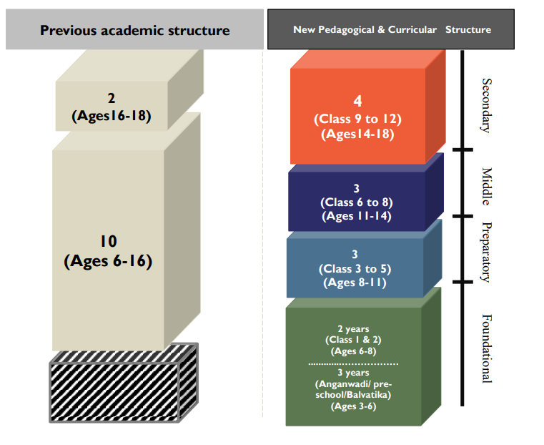

Highlight NEP – what it wants – outcomes?

1.3 Proposed solution
We aspire to develop an Online Skill Learning Platform where all students of any age group or class can enroll and learn to sharpen their Skills in which ever field they like. We believe that every student has skills embedded in them already, of course they are not all same. We will provide the resources as fun and playful games by which students can learn any skills they prefer.

In 2020 a new education policy was passed where the way of learning shifted from traditional learning to skill-based learning. And while taking a reference from it our platform will follows the new curricular structure and provide skills accordingly.

A platform which will be there with every student with each and every part of their learning phase.

1.4 Minimum Viable Product
The eduction system comprises of all the students of age 3 – 18 and classes pre-nursery – 12th grade.
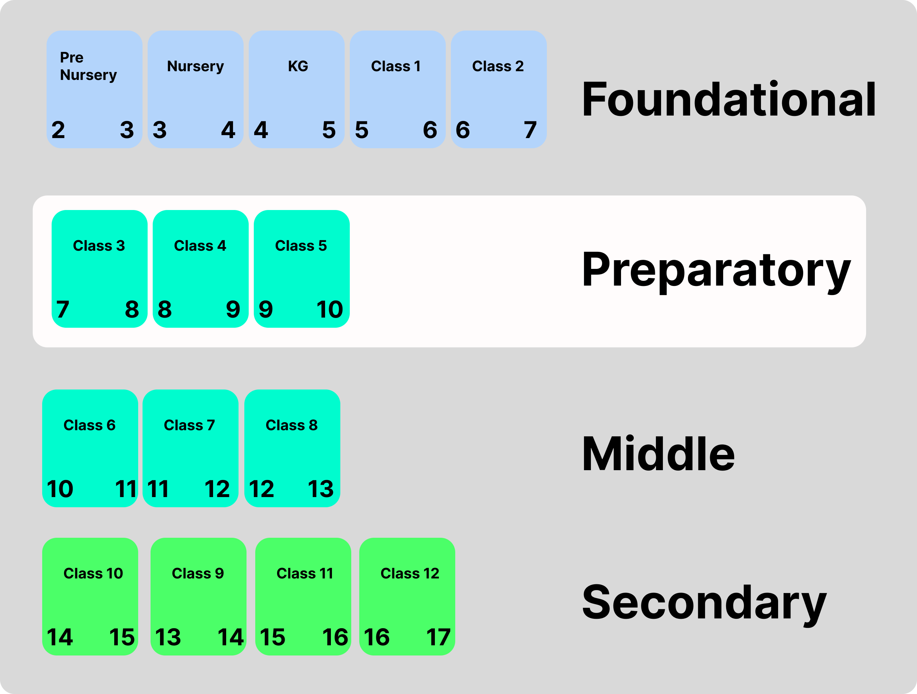

For our MVP we are focusing on Preparatory level which includes
Class: 3 – 5

1.5 Targeted audience

1.5.1 Students
Students studying at 3rd to 5th grade with age group of 7 – 11 year old. Students of this level are very efficient in grasping new skills. The learning ability is high at this stage, we want these student to recognize their skills and be perfect at it.

1.5.2 Parents
Parent of all the students of 3rd to 5th grade. It is said that, when a child is born, parents are also born. We understand nourishing a child is a heavy task as its own. We want to make it simple (Aasaan) for parents to understand the psychology of their child and provide resources and activities for them too.

Identify Skills
As a teaching platform curriculum is a very vital part of our system. And we believe in creating a syllabus that not only build skills in students but also make them future ready and to do that our team has carefully crafted a syllabus that revolve around some core concepts for every grade student. But at the same time, we change the methodology of teaching and interaction according to age groups.
Some of these core concepts are. How to channelize creativity, Know about internet and its component, Critical thinking and analysis and a very basic introduction to programming. So, from a very early age students can have an idea about what programming is about.
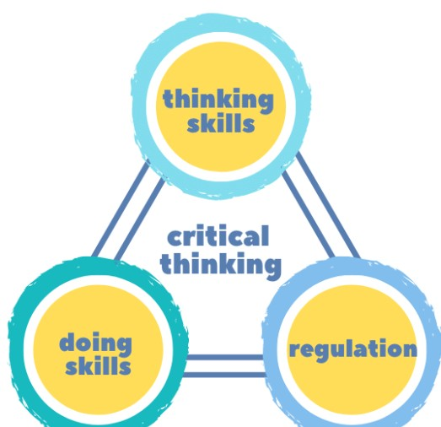

2.1 Briefly defined Skills / Concept that we have added in our curriculum -
- Introduction to basic programming
- Mathematics Number crunching
- Critical Thinking
- Problem Solving Skills
- Health and Fitness
- Art and crafts
- Internet Safety
- Application Use
- Digital literacy
- Typing Classes
- Communication and literature
- Personal Skills
- First Aid Skills
- Nature and environment skills
- Pet Caring

2.1.1 Introduction to basic programming –
Teaching and introducing programming to students is an essential feature of our platform. And as of now we are targeting students who are in their 1st grade to 5th grade. And for that we created a curriculum that will introduce kids to programming and problem solving in a very fun and interactive way.

2.1.2 Mathematics –
It is recognized that mathematics and mathematical thinking will be very important for student future.

2.1.3 Critical Thinking –
Developing critical thinking skills is crucial for kids as it helps them analyze information, make informed decisions, solve problems, and think independently.

2.1.4 Problem Solving Skills –
Another essential life skill that the children need to develop is problem-solving. This skill will come in handy when they encounter challenges in their lives. Teaching children how to identify the root cause of a problem and brainstorm possible solutions. Also, encourage them to think critically and creatively to come up with the best solution.

2.1.5 Health and Fitness –
Teaching children about healthy eating habits and providing them with the necessary skills to make nutritious food choices is crucial for their overall well-being.

2.1.6 Digital Literacy –
To keep a view of increasing internet consumption and exposure to technology in daily life, we think it is a best time to introduce a course that actually teach kids how internet works and how to use it safely.
Teaching cyber security to kids help them develop a strong foundation of digital literacy and online safety.
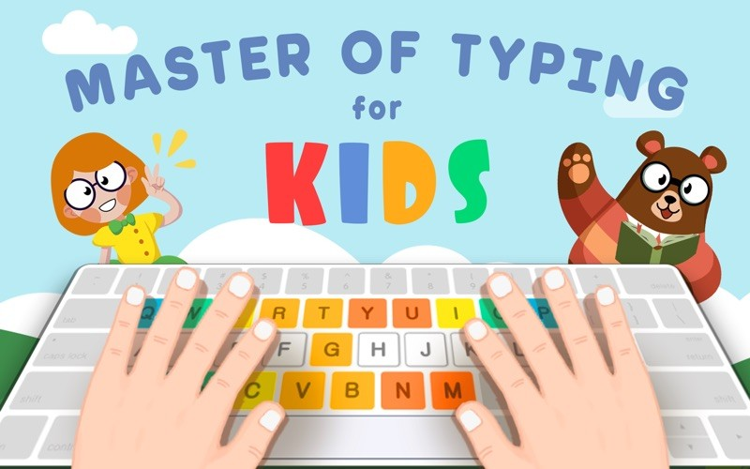

Teaching kids about different applications, can help them to develop a knowledge about digital world while enhancing their learning experience.

2.1.7 Arts and crafts –
Arts and crafts activities help kids to develop or express their creativity, imagination, and cognitive abilities while teaching them how to channelize their creative side.

2.1.8 Literacy and communication skills –
Literacy and Communication skills are crucial for children as it forms the foundation for their academic success and lifelong learning. We can sharp these skills in the students using various strategies and techniques.

2.1.9 Personal and First Aid Skills –
Personal skills include teaching children’s how to take care of the body of our own. Helping children to understand what are the different situation that can occur in the household and in school related to emergency and how to react on these situations.

2.1.10 Nature and environment Skills –
Engaging children in nature-related activities can foster a deep connection with the natural world and promote environmental stewardship. Teaching children about agriculture and farming can help them develop an understanding and appreciation for where their food comes from, the importance of sustainable practices, and the value of nature.
Also teach kids a sense of responsibility, empathy, and compassion pet caring is a great task that we can teach a kid.


Members of Platform

3.1 Students
Student is an entity which will perform the task of learning. Student will interact with our platform, perform activity and get results out of their engagement.
Student is the main actor of focus.
Properties:
Name, Grade, Parents Information, Skill Bundle, Result Dashboard, Social Engagement
Skill bundle: A set of skills which are accessible by the student.
Result Dashboard: Student performing any task will generate results these results will further determine the performance of them.
Social Engagement: Public appearance of student.

3.2 Instructors
Instructor is an entity which will create the activity resources of student. Instructor will be of special domain(s). They will decide what activity has to be taught and assess the activity.
For example:
Ankita is an artist, she paints beautiful portraits.
She enrolls at Aasaan as a drawing instructor.
To create an activity first she selects:
Level/Grade of activity
Requirements and prerequisites
Instructions for the activities
Properties:
Name, Skill teaching, Activities created, number of students learning.
Skill teaching: Will define what skills the instructor can teach.

3.3 Parents
Parents of student enrolled in our platform. As our website it targeted towards parents, these parents wants their child to grow skills and ace them.
Properties:
Name, Details for child enrolled, Monitor results, Skills taken
Monitor results: Parents will be able to track the progress of their child. They can see what does their child like and provide more exposure towards it.
Skills taken: We will provide skills for parents, where we will define how to treat their child, what is the psychology of child at different age.

Mapping Activities to Skills

4.1 Skills
Section 2 above mentions about the what skills we will be focusing on.
Skills must related to what student is studying in class.
Skills must enhance the existing knowledge of student.
Skills should help students to score good in exams.
Skills must focus on complete development of student in all aspects.
Our skills must cover all these subjects and provide more skills for overall development of student.

Basic subjects we found to be common in grade 3 -5
- Mathematics
- English
- Hindi
- Environmental Science

The complete Excel sheet can be found in Project’s Git at “School_Project/Documentations/Identifying_Skills.xlsx”

List of Skills we gathered:
1. Mathematics (Mathematics subject)
2. Digital literacy
3. Introduction to programming
4. Communication and literature skills(English and Hindi subjects)
5. Arts and crafts
6. Entertainment
7. Health and Fitness
8. Personal skills
9. Nature and environment skills(EVS subject)
10. Moral Skills

Every grade from 3 - 5 will have exactly same skills but with different level.

Platform Overview

In previous section we listed some skills on which we will be focusing on. This section describes how are we going to build the platform so that we can provide the platform to our users.

5.1 Modules

5.1.1 The Website
The first module that user will encounter is the Website of our platform.
Here we will be providing the following:
- Live demo, where users interact with the platform.
- Registration section, for Sign Up and Sign In.
- Catalog all the skills students will be learning in our platform.
- Catalog all the projects create by existing students of our platform.
- Grades and their activities introduction.
- Catalog of all the benefits for above mentioned actors.
- Section of our blog for updates.
- Complete curriculum section, describing all the course material.
- Testimonial section, where existing students and parents provides reviews.
- About us section, where we brief about our platform.

Website will be the gateway to our other modules.

5.1.2 The Web Application
After completing the registration process, user will direct to our web application, which is cross platform and provide ease of user experience. Students can login to the web application and start learning.

5.1.2.1 Demo Web Application section
In this section we will provide demo lessons, where students can explore how the platform will look and feel. After completing the basic demo lesson student will be re-directed to registration section. After registering the student will have complete access to the platform.
Monitor Demo Application – feedback mechanism of usage and user details(section)

5.1.2.2 Complete Web Application
Web application will provide interface to:
- Catalog of all the Skill Course Modules (Described in section 4.1.3).
- Student dashboard
  - Profile
  - Achievements
  - Assignments
  - Projects
  - Badges (Reward system)
- Instructor dashboard
  - Profile
  - Skill teaching

5.1.3 Skill Course Module
Skill Course Module is a complete course which a user can enroll into, perform activities inside course and get marks accordingly.
Student can buy multiple modules.
Skill Course Module attributes:
- Module name
- Module instructor name
- Complete duration
- Prerequisite modules
- Provoke to complete module positively

Student Assessment System –
As part of providing better education and learning, our platform will implement a student assessment system. And the main motive of this system will be to analyse and evaluate student performance to ensure their effective learning outcomes. As well as assess how students are responding to our course and identifying areas where improvement may be needed. And to apply this assessment process, we will be introducing a review system within our platform, and this system will be designed to evaluate students’ performance based on regular testes conducted by our faculty. Upon completion of each test, students will assign points based on their performance. And while assigning these grade points we will take account on various factors to determine the points allocating to each student. Also, the points earned by students are prominently displayed in their profile, provide them the transparent representation of their progress and achievements. Again, the performance data collected through the assessment will not valuable for students but it will help us too, to create personalized learning paths for each student and to recognize where we have to work more. After the assessment the reward system will also be going to introduce where student can earn virtual badges, certification or other forms of recognition based on their point and achievements. Transparency is very important int this reviews system and to keep in mind we also have to understand the crucial role of parents in their child journey. And that's why we encourage parents to actively involve to monitor student progress. Parents can also access their child assessment data, progress report, and can communicate with teachers to discuss performance and feedback. And as we continue to move forward in our journey, The student assessment system will also undergo continuously by open feedback and by our learning.

Scholarship Program –
Scholarship program is another import aspect of our project, and we know how important it is to keep students motivate and help them to stay on track with their courses and education. That’s why our platform has an incredible scholarship program that reward students for their hard work and dedication, Our program is carefully designed to be directly linked to student performance in their sessions and assessment reviews. And this makes the value of weekly and monthly test more important. While giving us a clear overview of how well students are grasping the concepts and applying them. So, how does it all work? And for that we crunch all the numbers and analyze the overall grades of the students. We closely inspect at their performance, consistency throughout their learning journey. And finally based on this analysis, we pick a selected group of students who have truly stood out with their outstanding performance and dedication. And here is another part of the program: the chosen students will receive a well -deserved scholarship for their future education. Because we believe in supporting our student beyond their time in our platform. And that is why we understand that, it is our responsibility to give them a head start in their academic pursuits, and help them achieve even greater things in life.

7.1 Support provided by Scholarship program – (Need discussion and more thinking)
Once we select the recipients, we’ll provide them with opportunity to pursue their future education. And this support could be financial support for their tuition fees, access to advanced coding courses, mentorship program, or partnership with well settled educational institutions.

