

|  |  |
| --- | --- |
|  | **FPT ACADEMY INTERNATIONAL FPT – APTECH COMPUTER EDUCATION** |

32 SMILES EPROJECT-SEMESTER 1

|  |  |  |  |
| --- | --- | --- | --- |
| **Center Name** | | ACE-HCMC-2-FPT  Address: 590 Cach Mang Thang Tam, District 3, Ho Chi  Minh City | |
| **Instructor** | | Mr. Nguyen Ngo Phuoc | |
| **Class** | | T1.2005.E1 | |
| **Group** | | 2 | |
| **Group members** | | **Name** | **Student ID** |
| Nguyen Thanh Trung | Student1266450 |
| Phan Thi Tuyet Nhung | Student1241103 |
| Le Hoan Vu | Student1233872 |
| Pham Khac Van | Student1225546 |
| **Duration** | **Start**  **date** | 01st August 2020 | |
| **End**  **date** | 01st September 2020 | |

## This is to certify that

**Mr./Ms.:**

Nguyen Thanh Trung

Phan Thi Tuyet Nhung

Le Hoan Vu

Pham Khac Van

**has successfully designed & developed**

eProject: 32 SMILES

**Submitted by:**

Nguyen Thanh Trung

**Date of issue:** August 11th 2020

## Authorized Signature:

**Table of Contents**

ACKNOWLEDGEMENT 4

SYNOPSIS…………………………………………………………………………………………………………….. 4

PROBLEM STATEMENT 5

REQUIREMENT SPECIFICATION 6

HARDWARE/ SOFTWARE REQUIREMENTS 6

SCOPE OF THE WORK (IN BRIEF) 7

ARCHITECTURE AND DESIGN OF THE SYSTEM………………………………………………………. 7

DIAGRAM OF THE WEBSITE 8

TASK SHEET REVIEW 1 9

SITE MAP 10

MOCK OF THE WEBSITE 11

1. Homepage 11
2. Dental Education 12
3. Health Treatment 13
4. Our experts 14
5. Our products 15

TASK SHEET REVIEW 2 16

**ACKNOWLEDGEMENT**

First, we would like to express our appreciation to our teacher, Mr. Nguyen Ngo Phuoc, FPT-Aptech Department, and FPT Academy International, for giving us this opportunity to do the first project of this course and providing invaluable guidance throughout this project.

Once again, a special gratitude to our teacher, for his helpful contributions and suggestions. Beside that, his guidance and encouragement helped us to complete our project in the best way.

Next, we would like to thank FPT Academy International for giving us the great opportunity to practice what we have learnt into reality. It is also a chance for us to increase our experience and confidence when we have to face an interview as we have worked on a project.

Finally, we are so thankful to our teammates for their support and hard work. Our deepest thanks and appreciations also go to our friends, who helped us out with their abilities to complete this project directly or indirectly.

**SYNOPSIS**

32 Smiles Website is a website created to provide information, courses and news related to dental health care. Beside that, it also helps many people increase the awareness about dental problems and how to improve their oral health.

When the customers log on to 32 Smiles Website, they can find many courses about this field. Furthermore, this Website has an expert team who are ready to answer questions for the customers about the problems they are in. And the patients can know their therapeutic process through health treatment.

In addition, this Website also provides the services and products that are in terms of dental health.

If they are not satisfied with their experiences at our website, they can give us the feedback in the Contact Us section at the end of this website.

**PROBLEM STATEMENT**

Dental or oral health is concerned with your teeth, gumsand mouth. The goal is to prevent complications such as tooth decay (cavities) and gum disease and to maintain the overall health of your mouth.

​​​​​​​​​​​​​​​​​​​​​​​​​​​​​​​​​​​​​​​​​​​​​​A healthy mouth, free of infections, injuries and other problems with teeth and gums, is important in maintaining your overall health.

Although a different set of medical professionals focuses on dental health, they are still part of your regular health care team.

Disease and other conditions can affect your dental health and dental problems can affect other parts of your body. Failing to properly care for your oral health may lead to other health problems.

You can help prevent or minimize many oral health problems by regular preventive steps (brushing, flossing and so on) and regular visits to dental health professionals.

Hence to increase awareness and provide all information about dental care, we are looking for developing a website “32smiles.com” based on the requirements mentioned below.

The website is to be developed for the Windows Platform using HTML5, JavaScript and Geolocation. The site should work well in all leading browsers including Chrome, IE, Firefox etc.

**REQUIREMENT SPECIFICATION**

The Web site is to be created based on the following requirements:

1. The Homepage should display the images that related and some latest information/researches in the  field.
2. In addition, there should be a classified menu with related sub menus.
3. Sample list of pages/menu options are as described below:
   1. Professional education: This principally includes the education assistance for students and practitioners. This can have further categories such as finding related courses, help documents, faculty resources, student resources, case studies etc, …
   2. Patient education: Including general and necessary information for the patients suffering from any of the oral/dental issues.
   3. Research: This should have the latest research in this field. Necessary documents, videos etc (media library) is expected here.
   4. Products: As the name indicates, this should have all the related products. Here sub categories can be done based on numerous types of products like tooth pastes, brushes, special products for kids, electrical accessories etc.
4. There should be site map.
5. Contact us page: contact us page here should list various dental expert’s contact details for further treatment / assistance/ guidance. Their location should be displayed by using GeoLocation API (eg: Google Maps).
6. Overall website should be simple for people to use.

**HARDWARE/SOFTWARE REQUIREMENTS**

### For webmaster Hardware

* Intel Pentium 4 processor or higher
* 1 Gigabytes of RAM or higher

### Software

* Windows 7 OS or higher
* Sublime Text 3, Visual Studio Code
* Bootstrap 4, jQuery, AngularJS, AOS, SweetAleart 2
* HTML5 and Javascript supporting web browsers such as IE, Chrome, Firefox, Opera…

### For web users Hardware

* Intel Pentium 4 processor or higher
* 512 Megabytes of RAM or higher

### Software

* Windows XP OS or higher
* HTML5 and Javascript supporting web browsers such as IE, Chrome, Firefox,

Opera… *(Website best running on Chrome browser).*

**SCOPE OF THE WORK (IN BRIEF)**

Webpage request

**WEB SERVER**

**WEB BROWSER**

Having carefully reviewed all requirements, our team agreed that 32 SMILES Project should have the following pages:

1. HOME: Display some related images and the latest information/research in the field. Provides brief information about our information dental experts and services.

2. Dental Education: This mainly provides some detailed dental education

assistance, such as related courses, document, study materials or in-depth training courses, ... for students and practitioners

3. Health treatment: provide useful and general information for patients suffering from any of common oral/dental issues.

4. Our experts: This represents 32 SMILES line-up of doctors who are experts in dental field.

5. Services: This included related products, such as: toothpastes. brushes, accessories and other services currently being offered.

6. Contact us: This provides user contact details in case of further treatment/assistance/guidance .

7. About us: Display information about team members: Full names, images, contact information.

**ARCHITECTURE AND DESIGN OF THE SYSTEM**

**SERVER**

**CLIENT**

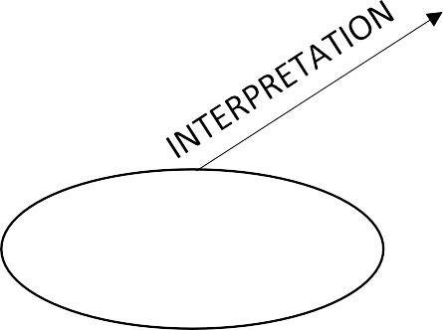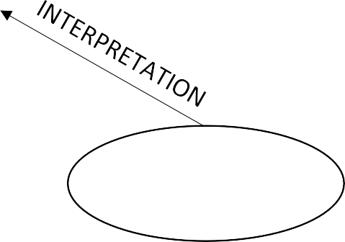

Requested Page

**RENDERING**

**ENGINE**

**CSS CODE**

**HTML CODE**

# DIAGRAM OF THE WEBSITE

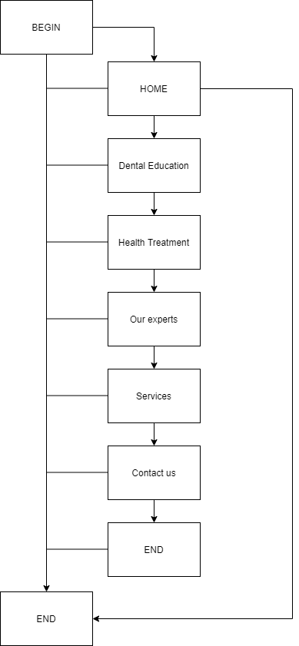

# TASK SHEET REVIEW 1

|  |  |  |  |  |  |  |  |
| --- | --- | --- | --- | --- | --- | --- | --- |
| **Project Ref. No.:**  **eP/Advertisement Portal Management System/01** | | **Project Title:** | **Activity Plan Prepared By:** | **Date of Preparation of Activity Plan:** | | | |
| **Sr.**  **No.** | **Task** | **Actual Start Date** | **Actual Days** | **Team Mate Names** | **Status** |
| 1 | Problem Statement | 32 Smiles | Trung | 03/08/2020 | 1 | Nhung | Completed |
| 2 | Analysis of 32 Smiles requirements about the website | 03/08/2020 | 1 | Nhung | Completed |
| 3 | The scope of the work (in brief) | 03/08/2020 | 1 | Trung | Completed |
| 4 | Architecture and design of the system | 03/08/2020 | 1 | Nhung | Completed |
| 5 | Diagram of the website | 03/08/2020 | 1 | Trung | Completed |
| 6 | Task Sheet | 03/08/2020 | 1 | Trung | Completed |
|  | | | | | | | |
| **Date:** | | | | | | | |
| Signature of Instructor:  **Mr. Nguyen Ngo Phuoc** | | | | Signature of Team Leader:  **Nguyen Thanh Trung** | | | |

**SITE MAP**

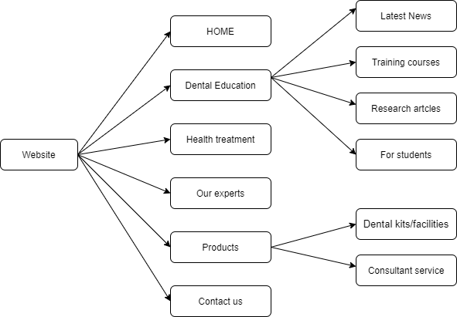

**MOCK OF THE WEBSITE**

**1. Homepage**

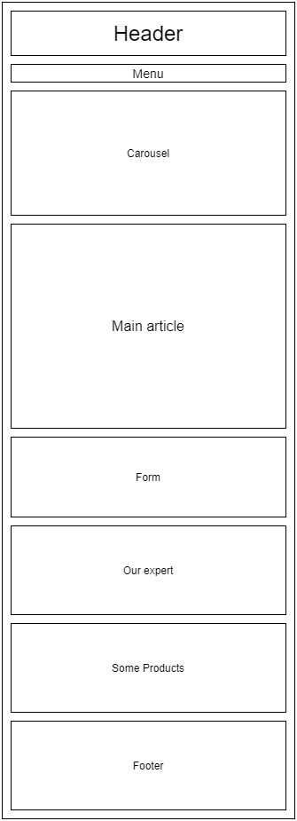

* 1. **Dental Education**

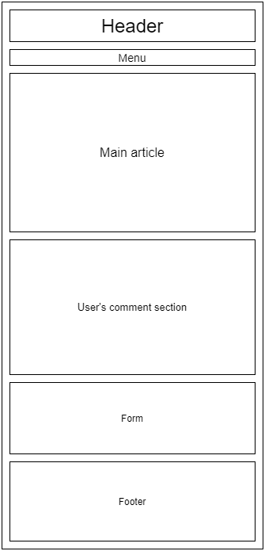

**3. Health Treatment**

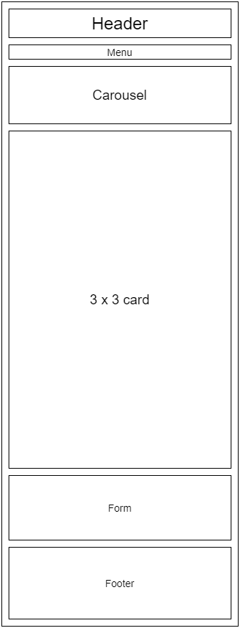

**4. Our Experts**

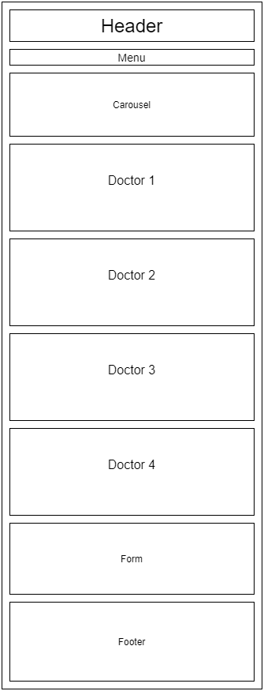

**5. Our Products**

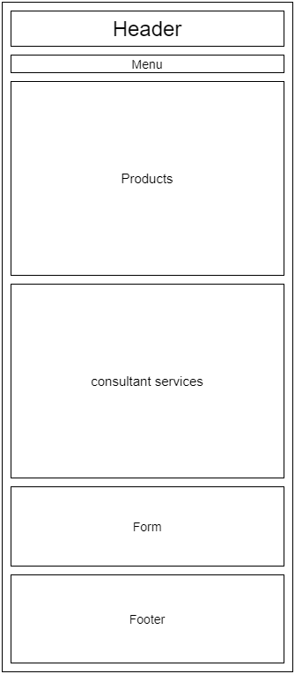

**6. Contact us**

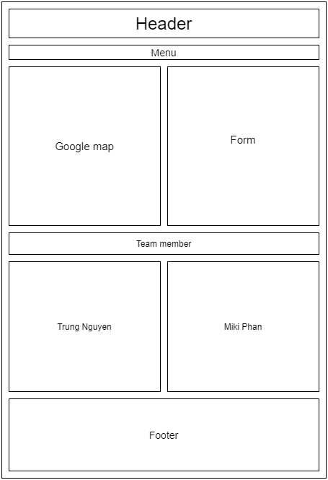

**TASK SHEET REVIEW 2**

|  |  |  |  |  |  |  |  |
| --- | --- | --- | --- | --- | --- | --- | --- |
| **Project Ref. No.:**  **eP/Advertisement Portal Management System/01** | | **Project Title:** | **Activity Plan Prepared By:** | **Date of Preparation of Activity Plan:** | | | |
| **Sr.**  **No.** | **Task** | **Actual Start Date** | **Actual Days** | **Team Mate Names** | **Status** |
| 1 | Site Map | 32  Smiles | Trung | 9/8/2020 | 1 | Nhung | Completed |
| 2 | Mock of the website | 9/8/2020 | 1 | Trung | Completed |
| 3 | Task Sheet | 9/8/2020 | 1 | Nhung | Completed |
|  | | | | | | | |
| **Date:** | | | | | | | |
| Signature of Instructor:  **Mr. Nguyen Ngo Phuoc** | | | | Signature of Team Leader:  **Nguyen Thanh Trung** | | | |