
GitHub Repository:
https://github.com/gohary72/C--Scanner-project.git
Compiler Practical Task Documentation
Name | Mostafa Magdy | ID | 200017736
Course | Compiler Construction | Project | C- Scanner using Flex

1. Project idea
The project is based on the original TINY scanner. The same project structure was kept, and the needed files were updated to recognize the required C- scanner tokens. The main changes were made in TINY.flex, GLOBALS.H, UTIL.C, and tiny.txt. The header files were kept with the same interface so the project structure stays complete.
2. Files included in the project
File | Purpose in the project
GLOBALS.H | Contains the updated TokenType enum and scanner-related declarations.
TINY.flex | Contains the lexical rules used to recognize C- keywords, operators, delimiters, identifiers, numbers, and comments.
UTIL.C | Contains printToken, which prints each detected token in result.txt.
SCAN.H / UTIL.H | Header files used by the scanner and utility functions.
tiny.txt | Input test program used to run the scanner.
result.txt | Output file generated after scanning tiny.txt.
3. Required tasks and the exact changes made
The following table follows the same order written in the task sheet.
Requirement | Original TINY scanner | Final C- update
Task 1: Add New Keywords | The original scanner had TINY reserved words such as if, then, else, end, repeat, until, read, and write. | The scanner now recognizes int, void, if, else, while, return. read and write are also kept because the test program uses read() and write(...).
Task 2: Add Operators | The original scanner used TINY operators such as :=, =, <, +, -, *, /. | The C- scanner uses = for assignment and supports ==, !=, <, <=, >, >=, +, -, *, /. Two-character operators are written before one-character operators.
Task 3: Add Delimiters | The original scanner mainly recognized ;, (, and ). | The scanner now recognizes ; , ( ) [ ] { } as C- delimiters.
Task 4: Identifiers and Numbers | The original identifier rule accepted letters only. Numbers were already integer values. | Identifiers now start with a letter and can be followed by letters or digits. Numbers are still handled as integers only.
Task 5: Comments | The original scanner skipped comments written between { and }. | The scanner now handles C-style comments using /* ... */ with a COMMENT state.
Task 6: Update Token Types | The old TokenType enum did not include all C- tokens. | GLOBALS.H was updated to include INT, VOID, WHILE, RETURN, NEQ, LE, GE, GT, LBRACE, RBRACE, LBRACKET, RBRACKET, COMMA, and the rest of the required tokens.
4. Line-by-line link with the real code
File | Code part | Reason for change
GLOBALS.H | MAXRESERVED | Kept as 8 because the scanner recognizes int, void, if, else, while, return, read, and write as reserved words.
GLOBALS.H | TokenType enum | Updated to include the C- keywords, identifiers, numbers, operators, and delimiters.
GLOBALS.H | StmtKind enum | Updated to include WhileK and ReturnK instead of keeping only the old TINY statement types.
TINY.flex | identifier rule | Changed to {letter}({letter}|{digit})* so identifiers like x1 are accepted.
TINY.flex | keyword rules | Added int, void, while, and return, while keeping if, else, read, and write.
TINY.flex | operator rules | Added ==, !=, <=, >=, >, and changed assignment to =.
TINY.flex | delimiter rules | Added comma, brackets, and braces as returned tokens.
TINY.flex | comment rules | Added a COMMENT state for /* ... */ comments.
UTIL.C | printToken switch | Added cases for all new tokens so they can be printed clearly in result.txt.
tiny.txt | test input | Changed to the C- factorial example used to test the scanner.
5. Updated TINY.flex source code
/******************************/
/* File: tiny.flex */
/* Flex scanner for C- */
/* Modified from TINY scanner */
/******************************/
%{
#include "globals.h"
#include "util.h"
#include "scan.h"
#include "util.c"
char tokenString[MAXTOKENLEN+1];
%}
digit [0-9]
number {digit}+
letter [a-zA-Z]
identifier {letter}({letter}|{digit})*
newline \n
%option noyywrap
%x COMMENT
%%
"int" {return INT;}
"void" {return VOID;}
"if" {return IF;}
"else" {return ELSE;}
"while" {return WHILE;}
"return" {return RETURN;}
"read" {return READ;}
"write" {return WRITE;}
"==" {return EQ;}
"!=" {return NEQ;}
"<=" {return LE;}
">=" {return GE;}
"<" {return LT;}
">" {return GT;}
"=" {return ASSIGN;}
"+" {return PLUS;}
"-" {return MINUS;}
"*" {return TIMES;}
"/" {return OVER;}
";" {return SEMI;}
"," {return COMMA;}
"(" {return LPAREN;}
")" {return RPAREN;}
"[" {return LBRACKET;}
"]" {return RBRACKET;}
"{" {return LBRACE;}
"}" {return RBRACE;}
{number} {return NUM;}
{identifier} {return ID;}
"/*" {BEGIN(COMMENT);}
<COMMENT>"*/" {BEGIN(INITIAL);}
<COMMENT>{newline} {lineno++;}
<COMMENT>. {/* skip comment content */}
{newline} {lineno++;}
[ \t\r]+ {/* skip whitespace */}
. {return ERROR;}
%%
TokenType getToken(void)
{ static int firstTime = TRUE;
TokenType currentToken;
if (firstTime)
{ firstTime = FALSE;
lineno++;
yyin = fopen("tiny.txt", "r+");
yyout = fopen("result.txt", "w+");
listing = yyout;
}
currentToken = yylex();
strncpy(tokenString, yytext, MAXTOKENLEN);
fprintf(listing, "\t%d: ", lineno);
printToken(currentToken, tokenString);
return currentToken;
}
int main()
{
printf("welcome to the flex scanner: ");
while(getToken())
{
printf("a new token has been detected...\n");
}
return 1;
}
6. Updated GLOBALS.H source code
/****************************************************/
/* File: globals.h */
/* Global types and vars for the C- scanner */
/* Based on the original TINY scanner files */
/****************************************************/
#ifndef _GLOBALS_H_
#define _GLOBALS_H_
#include <stdio.h>
#include <stdlib.h>
#include <ctype.h>
#include <string.h>
#ifndef FALSE
#define FALSE 0
#endif
#ifndef TRUE
#define TRUE 1
#endif
/* Number of reserved words used by the scanner */
#define MAXRESERVED 8
typedef enum
{ENDFILE,ERROR,
/* reserved words */
INT,VOID,IF,ELSE,WHILE,RETURN,READ,WRITE,
/* identifiers and numbers */
ID,NUM,
/* operators */
ASSIGN,EQ,NEQ,LT,LE,GT,GE,PLUS,MINUS,TIMES,OVER,
/* delimiters */
LPAREN,RPAREN,LBRACKET,RBRACKET,LBRACE,RBRACE,SEMI,COMMA
} TokenType;
FILE* source;
FILE* listing;
extern FILE* code;
int lineno;
/**************************************************/
/*********** Syntax tree for parsing ************/
/**************************************************/
typedef enum {StmtK,ExpK} NodeKind;
typedef enum {IfK,WhileK,ReturnK,AssignK,ReadK,WriteK} StmtKind;
typedef enum {OpK,ConstK,IdK} ExpKind;
typedef enum {Void,Integer,Boolean} ExpType;
#define MAXCHILDREN 3
typedef struct treeNode
{ struct treeNode * child[MAXCHILDREN];
struct treeNode * sibling;
int lineno;
NodeKind nodekind;
union { StmtKind stmt; ExpKind exp;} kind;
union { TokenType op;
int val;
char * name; } attr;
ExpType type;
} TreeNode;
extern int EchoSource;
int TraceScan;
extern int TraceParse;
extern int TraceAnalyze;
extern int TraceCode;
extern int Error;
#endif
7. Updated UTIL.C source code
/****************************************************/
/* File: util.c */
/* Utility function implementation for C- scanner */
/* Modified from the original TINY utility file */
/****************************************************/
#include "globals.h"
#include "util.h"
void printToken(TokenType token, const char* tokenString)
{ switch (token)
{ case INT:
case VOID:
case IF:
case ELSE:
case WHILE:
case RETURN:
case READ:
case WRITE:
fprintf(listing,"reserved word: %s\n", tokenString);
break;
case ASSIGN: fprintf(listing,"=\n"); break;
case EQ: fprintf(listing,"==\n"); break;
case NEQ: fprintf(listing,"!=\n"); break;
case LT: fprintf(listing,"<\n"); break;
case LE: fprintf(listing,"<=\n"); break;
case GT: fprintf(listing,">\n"); break;
case GE: fprintf(listing,">=\n"); break;
case PLUS: fprintf(listing,"+\n"); break;
case MINUS: fprintf(listing,"-\n"); break;
case TIMES: fprintf(listing,"*\n"); break;
case OVER: fprintf(listing,"/\n"); break;
case LPAREN: fprintf(listing,"(\n"); break;
case RPAREN: fprintf(listing,")\n"); break;
case LBRACKET: fprintf(listing,"[\n"); break;
case RBRACKET: fprintf(listing,"]\n"); break;
case LBRACE: fprintf(listing,"{\n"); break;
case RBRACE: fprintf(listing,"}\n"); break;
case SEMI: fprintf(listing,";\n"); break;
case COMMA: fprintf(listing,",\n"); break;
case ENDFILE: fprintf(listing,"EOF\n"); break;
case NUM:
fprintf(listing,"NUM, val= %s\n", tokenString);
break;
case ID:
fprintf(listing,"ID, name= %s\n", tokenString);
break;
case ERROR:
fprintf(listing,"ERROR: %s\n", tokenString);
break;
default:
fprintf(listing,"Unknown token: %d\n", token);
}
}
TreeNode * newStmtNode(StmtKind kind)
{ TreeNode * t = (TreeNode *) malloc(sizeof(TreeNode));
int i;
if (t==NULL)
fprintf(listing,"Out of memory error at line %d\n",lineno);
else {
for (i=0;i<MAXCHILDREN;i++) t->child[i] = NULL;
t->sibling = NULL;
t->nodekind = StmtK;
t->kind.stmt = kind;
t->lineno = lineno;
}
return t;
}
TreeNode * newExpNode(ExpKind kind)
{ TreeNode * t = (TreeNode *) malloc(sizeof(TreeNode));
int i;
if (t==NULL)
fprintf(listing,"Out of memory error at line %d\n",lineno);
else {
for (i=0;i<MAXCHILDREN;i++) t->child[i] = NULL;
t->sibling = NULL;
t->nodekind = ExpK;
t->kind.exp = kind;
t->lineno = lineno;
t->type = Void;
}
return t;
}
char * copyString(char * s)
{ int n;
char * t;
if (s==NULL) return NULL;
n = strlen(s)+1;
t = malloc(n);
if (t==NULL)
fprintf(listing,"Out of memory error at line %d\n",lineno);
else strcpy(t,s);
return t;
}
static int indentno = 0;
#define INDENT indentno+=2
#define UNINDENT indentno-=2
static void printSpaces(void)
{ int i;
for (i=0;i<indentno;i++)
fprintf(listing," ");
}
void printTree(TreeNode * tree)
{ int i;
INDENT;
while (tree != NULL) {
printSpaces();
if (tree->nodekind==StmtK)
{ switch (tree->kind.stmt) {
case IfK: fprintf(listing,"If\n"); break;
case WhileK: fprintf(listing,"While\n"); break;
case ReturnK: fprintf(listing,"Return\n"); break;
case AssignK: fprintf(listing,"Assign to: %s\n",tree->attr.name); break;
case ReadK: fprintf(listing,"Read: %s\n",tree->attr.name); break;
case WriteK: fprintf(listing,"Write\n"); break;
default: fprintf(listing,"Unknown StmtNode kind\n"); break;
}
}
else if (tree->nodekind==ExpK)
{ switch (tree->kind.exp) {
case OpK:
fprintf(listing,"Op: ");
printToken(tree->attr.op,"\0");
break;
case ConstK:
fprintf(listing,"Const: %d\n",tree->attr.val);
break;
case IdK:
fprintf(listing,"Id: %s\n",tree->attr.name);
break;
default:
fprintf(listing,"Unknown ExpNode kind\n");
break;
}
}
else fprintf(listing,"Unknown node kind\n");
for (i=0;i<MAXCHILDREN;i++)
printTree(tree->child[i]);
tree = tree->sibling;
}
UNINDENT;
}
8. Header files used in the project
SCAN.H
/****************************************************/
/* File: scan.h */
/* The scanner interface for the TINY compiler */
/* Compiler Construction: Principles and Practice */
/* Kenneth C. Louden */
/****************************************************/
#ifndef _SCAN_H_
#define _SCAN_H_
/* MAXTOKENLEN is the maximum size of a token */
#define MAXTOKENLEN 40
/* tokenString array stores the lexeme of each token */
extern char tokenString[MAXTOKENLEN+1];
/* function getToken returns the
* next token in source file
*/
TokenType getToken(void);
#endif
UTIL.H
/****************************************************/
/* File: util.h */
/* Utility functions for the TINY compiler */
/* Compiler Construction: Principles and Practice */
/* Kenneth C. Louden */
/****************************************************/
#ifndef _UTIL_H_
#define _UTIL_H_
/* Procedure printToken prints a token
* and its lexeme to the listing file
*/
void printToken( TokenType, const char* );
/* Function newStmtNode creates a new statement
* node for syntax tree construction
*/
TreeNode * newStmtNode(StmtKind);
/* Function newExpNode creates a new expression
* node for syntax tree construction
*/
TreeNode * newExpNode(ExpKind);
/* Function copyString allocates and makes a new
* copy of an existing string
*/
char * copyString( char * );
/* procedure printTree prints a syntax tree to the
* listing file using indentation to indicate subtrees
*/
void printTree( TreeNode * );
#endif
9. Test program used as input
The input program below is saved in tiny.txt and is used to test the scanner.
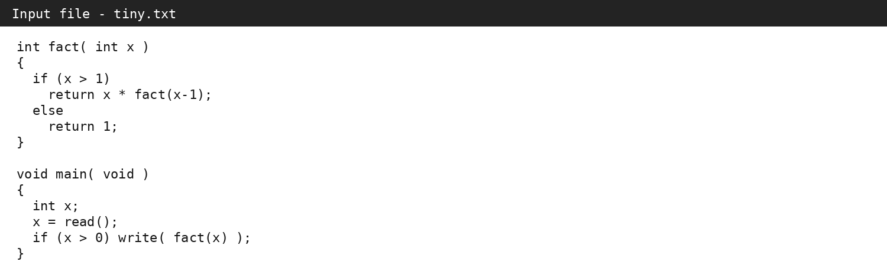
10. Sample scanner output
The following output shows the tokens recognized by the scanner after reading tiny.txt. This is the output from result.txt.
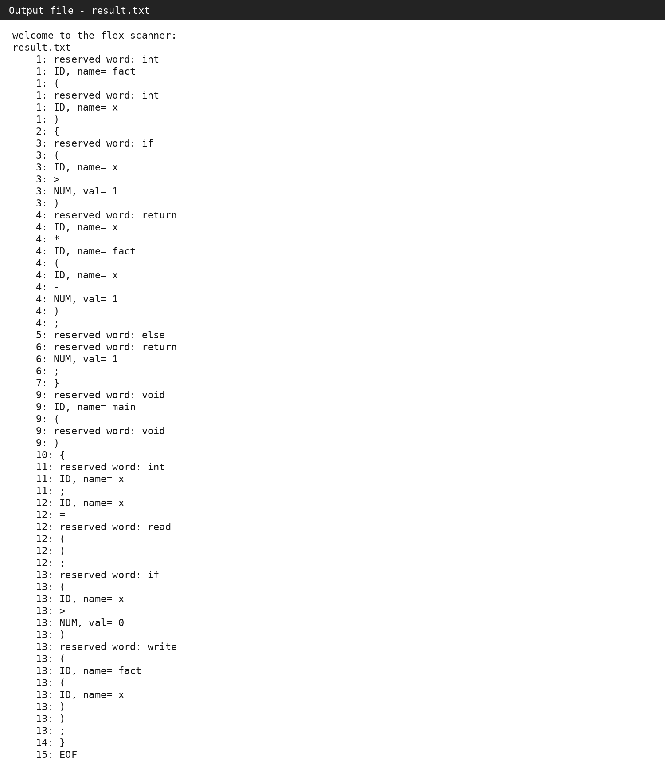
11. Conclusion
The scanner documentation shows that the original TINY project structure was kept while the scanner was updated to support the required C- tokens. The input and output screenshots also show that the test program is scanned and printed correctly.

