
GitHub Link:
https://github.com/gohary72/Compiler-Task2-LL1-Bison-Flex
Compiler Practical Task #2
Name | Mostafa Magdy | ID | 200017736
Course | Compiler Design | Project | Task 2

1. Project idea
This task applies syntax analysis on the given grammar. The work includes grammar checking, FIRST and FOLLOW sets, LL(1) parsing table, stack parsing trace, manual tree, Graphviz tree, and a small Flex/Bison implementation that builds the tree and exports a DOT file.
2. Given grammar and input
S -> P S'
S' -> ; P S' | epsilon
P -> id R
R -> ^ id R | epsilon
Input string: id ^ id ^ id ; id ^ id
3. Required tasks and the exact work done
Requirement | What was checked | Final work
Task 1: Grammar analysis | Checked left recursion, ambiguity, and LL(1) conflicts. | The grammar has no direct or indirect left recursion. It is not ambiguous for the given form because every id-chain and semicolon-separated part has one clear derivation.
Task 2: Grammar transformation | Checked if any changes were needed before parsing. | No real transformation was needed. The grammar is already written in right-recursive LL(1) form.
Task 3: FIRST & FOLLOW | Computed FIRST and FOLLOW sets for S, S', P, and R. | FIRST and FOLLOW sets were calculated and used to build the parsing table.
Task 4: LL(1) parsing table | Used FIRST/FOLLOW rules to fill the predictive table. | The LL(1) table has no multiple entries, so the grammar can be parsed predictively.
Task 5: Parsing trace | Parsed the string with a stack. | A full stack trace is shown with no skipped steps.
Task 6: Manual parse tree | Built the parse tree before visualization. | A hand-drawn style tree image is included.
Task 7: Graphviz visualization | Converted the tree to DOT. | tree.dot and tree.png were generated.
Task 8: Flex scanner | Scanner supports id, ^, and ;. | scanner.l returns ID, POWER, and SEMI tokens.
Task 9: Bison grammar | Implemented the grammar in Bison. | parser.y contains the grammar productions and semantic actions.
Task 10: Node structure | Used the required Node structure. | node.h defines label, left, and right fields.
Task 11: Export to DOT | Added DOT export function. | The parser writes tree.dot automatically.
Task 12: Visualization | Generated the final PNG. | Graphviz command: dot -Tpng tree.dot -o tree.png.
4. Task 1 - Grammar analysis
The grammar is already right-recursive. There is no left recursion because no non-terminal derives itself as the first symbol. The grammar is also not ambiguous for this input pattern. The sequence before and after the semicolon is parsed using P, and repeated exponent parts are parsed using R.
5. Task 2 - Grammar transformation
No transformation was required. The given grammar is already suitable for LL(1) parsing because alternatives can be selected using one lookahead token.
6. Task 3 - FIRST and FOLLOW sets
Non-terminal | FIRST | FOLLOW
S | { id } | { $ }
S' | { ;, epsilon } | { $ }
P | { id } | { ;, $ }
R | { ^, epsilon } | { ;, $ }
Short calculation notes: FIRST(S) comes from P, and FIRST(P) starts with id. S' can start with ; or become epsilon. R can start with ^ or become epsilon. Since S is the start symbol, $ is in FOLLOW(S). P and R can be followed by either ; or end of input.
7. Task 4 - LL(1) parsing table
Non-terminal | id | ^ | ; | $
S | S -> P S' | error | error | error
S' | error | error | S' -> ; P S' | S' -> epsilon
P | P -> id R | error | error | error
R | error | R -> ^ id R | R -> epsilon | R -> epsilon
Additional LR(0) item-set check
Because the task description mentions LR(0), this check was added beside the LL(1) work. It shows that pure LR(0) has epsilon-related shift/reduce situations, while the LL(1) table and the Bison implementation use lookahead and parse the input correctly.
Augmented grammar:
S0 -> S
S -> P S'
S' -> ; P S' | epsilon
P -> id R
R -> ^ id R | epsilon
LR(0) item sets (short form):
I0: S0 -> . S, S -> . P S', P -> . id R
I1: S0 -> S .
I2: S -> P . S', S' -> . ; P S', S' -> . epsilon
I3: P -> id . R, R -> . ^ id R, R -> . epsilon
I4: S -> P S' .
I5: S' -> ; . P S', P -> . id R
I6: P -> id R .
I7: R -> ^ . id R
I8: S' -> ; P . S', S' -> . ; P S', S' -> . epsilon
I9: R -> ^ id . R, R -> . ^ id R, R -> . epsilon
I10: S' -> ; P S' .
I11: R -> ^ id R .
Note:
The epsilon productions create LR(0) shift/reduce situations if no lookahead is used.
With FOLLOW-based lookahead (as in LL(1)/SLR idea), the grammar parses the given string correctly.
Bison uses lookahead, so the implementation is still suitable for this task.
8. Task 5 - LL(1) parsing trace using stack
Stack | Input | Action
$ S | id ^ id ^ id ; id ^ id $ | S -> P S'
$ S' P | id ^ id ^ id ; id ^ id $ | P -> id R
$ S' R id | id ^ id ^ id ; id ^ id $ | match id
$ S' R | ^ id ^ id ; id ^ id $ | R -> ^ id R
$ S' R id ^ | ^ id ^ id ; id ^ id $ | match ^
$ S' R id | id ^ id ; id ^ id $ | match id
$ S' R | ^ id ; id ^ id $ | R -> ^ id R
$ S' R id ^ | ^ id ; id ^ id $ | match ^
$ S' R id | id ; id ^ id $ | match id
$ S' R | ; id ^ id $ | R -> epsilon
$ S' | ; id ^ id $ | S' -> ; P S'
$ S' P ; | ; id ^ id $ | match ;
$ S' P | id ^ id $ | P -> id R
$ S' R id | id ^ id $ | match id
$ S' R | ^ id $ | R -> ^ id R
$ S' R id ^ | ^ id $ | match ^
$ S' R id | id $ | match id
$ S' R | $ | R -> epsilon
$ S' | $ | S' -> epsilon
$ | $ | accept
9. Task 6 - Manual parse tree
The following tree was drawn first in a manual style to show the full derivation clearly.
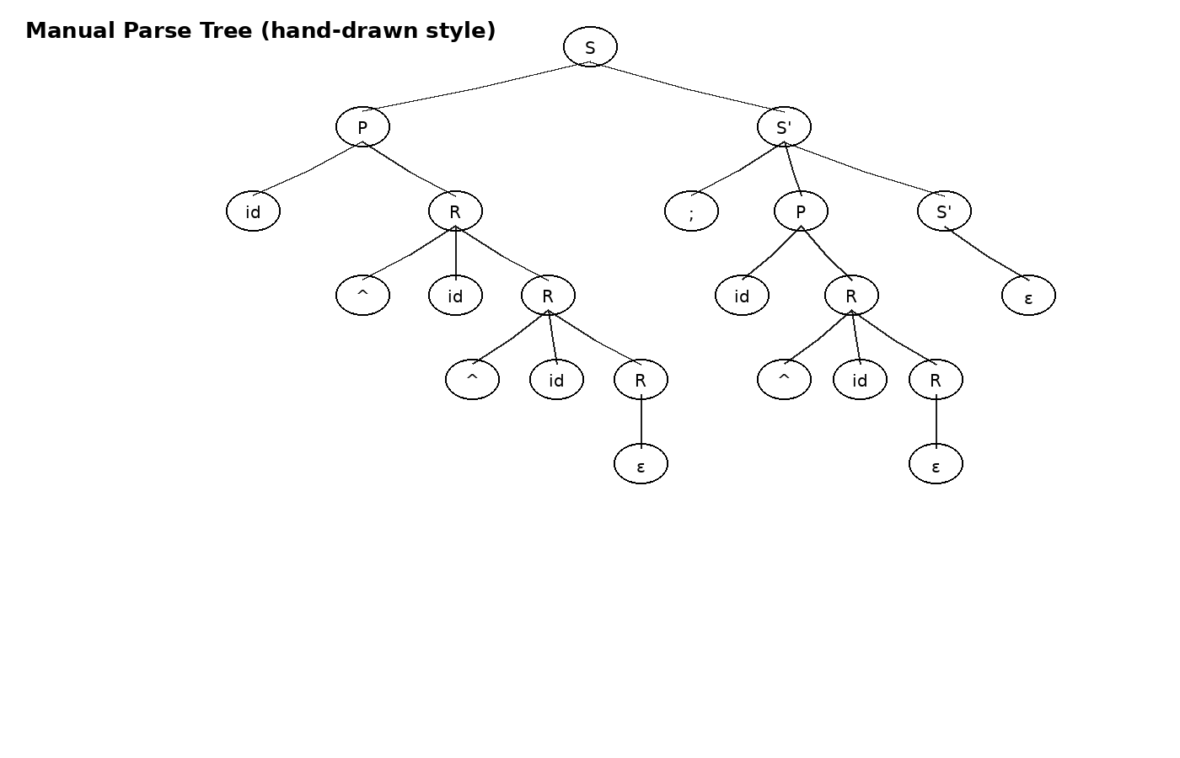
10. Task 7 - Graphviz tree
The DOT file was written for the same parse tree, then Graphviz was used to generate the PNG image.
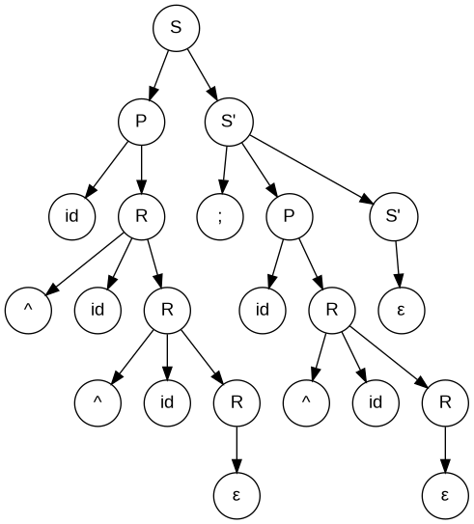
11. DOT file code
digraph ParseTree {
graph [rankdir=TB];
node [shape=circle, fontname="Arial"];
S0 [label="S"];
P1 [label="P"];
SP1 [label="S'"];
id1 [label="id"];
R1 [label="R"];
pow1 [label="^"];
id2 [label="id"];
R2 [label="R"];
pow2 [label="^"];
id3 [label="id"];
R3 [label="R"];
eps1 [label="ε"];
semi [label=";"];
P2 [label="P"];
SP2 [label="S'"];
id4 [label="id"];
R4 [label="R"];
pow3 [label="^"];
id5 [label="id"];
R5 [label="R"];
eps2 [label="ε"];
eps3 [label="ε"];
S0 -> P1;
S0 -> SP1;
P1 -> id1;
P1 -> R1;
R1 -> pow1;
R1 -> id2;
R1 -> R2;
R2 -> pow2;
R2 -> id3;
R2 -> R3;
R3 -> eps1;
SP1 -> semi;
SP1 -> P2;
SP1 -> SP2;
P2 -> id4;
P2 -> R4;
R4 -> pow3;
R4 -> id5;
R4 -> R5;
R5 -> eps2;
SP2 -> eps3;
}
12. Task 8 - Flex scanner file
%{
#include "parser.tab.h"
%}
%%
"id" { return ID; }
"^" { return POWER; }
";" { return SEMI; }
[ \t\r\n]+ { /* skip whitespace */ }
. { return yytext[0]; }
%%
int yywrap(void)
{
return 1;
}
13. Task 9 and Task 10 - Bison grammar and Node structure
The required Node structure was placed in node.h, and the Bison grammar uses it to build the parse tree during parsing.
#ifndef NODE_H
#define NODE_H
#include <stdio.h>
#include <stdlib.h>
#include <string.h>
typedef struct Node {
char* label;
struct Node* left;
struct Node* right;
} Node;
Node* createNode(const char* label, Node* left, Node* right);
void exportDot(Node* root, const char* filename);
#endif
%{
#include <stdio.h>
#include <stdlib.h>
#include "node.h"
int yylex(void);
void yyerror(const char* s);
Node* root = NULL;
static int nodeCounter = 0;
Node* createNode(const char* label, Node* left, Node* right)
{
Node* n = (Node*) malloc(sizeof(Node));
n->label = strdup(label);
n->left = left;
n->right = right;
return n;
}
void writeDot(Node* n, FILE* out)
{
if (n == NULL) return;
int current = nodeCounter++;
fprintf(out, " node%d [label=\"%s\"];\n", current, n->label);
if (n->left != NULL)
{
int child = nodeCounter;
writeDot(n->left, out);
fprintf(out, " node%d -> node%d;\n", current, child);
}
if (n->right != NULL)
{
int child = nodeCounter;
writeDot(n->right, out);
fprintf(out, " node%d -> node%d;\n", current, child);
}
}
void exportDot(Node* root, const char* filename)
{
FILE* out = fopen(filename, "w");
fprintf(out, "digraph ParseTree {\n");
fprintf(out, " node [shape=circle, fontname=\"Arial\"];\n");
nodeCounter = 0;
writeDot(root, out);
fprintf(out, "}\n");
fclose(out);
}
%}
%union {
Node* node;
}
%token ID POWER SEMI
%type <node> S Sprime P R
%%
program:
S { root = $1; }
;
S:
P Sprime { $$ = createNode("S", $1, $2); }
;
Sprime:
SEMI P Sprime { $$ = createNode("S'", createNode(";", NULL, NULL), createNode("P S'", $2, $3)); }
| /* empty */ { $$ = createNode("epsilon", NULL, NULL); }
;
P:
ID R { $$ = createNode("P", createNode("id", NULL, NULL), $2); }
;
R:
POWER ID R { $$ = createNode("R", createNode("^ id", NULL, NULL), $3); }
| /* empty */ { $$ = createNode("epsilon", NULL, NULL); }
;
%%
void yyerror(const char* s)
{
printf("Parse error: %s\n", s);
}
int main(void)
{
if (yyparse() == 0)
{
printf("Input accepted.\n");
exportDot(root, "tree.dot");
printf("tree.dot generated.\n");
}
return 0;
}
14. Task 11 and Task 12 - Export and visualization
The Bison code exports the generated tree to tree.dot. The final image is generated with this command:
dot -Tpng tree.dot -o tree.png
15. Input screenshot
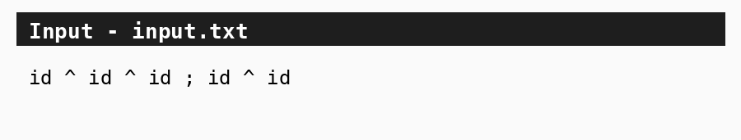
16. Output screenshot
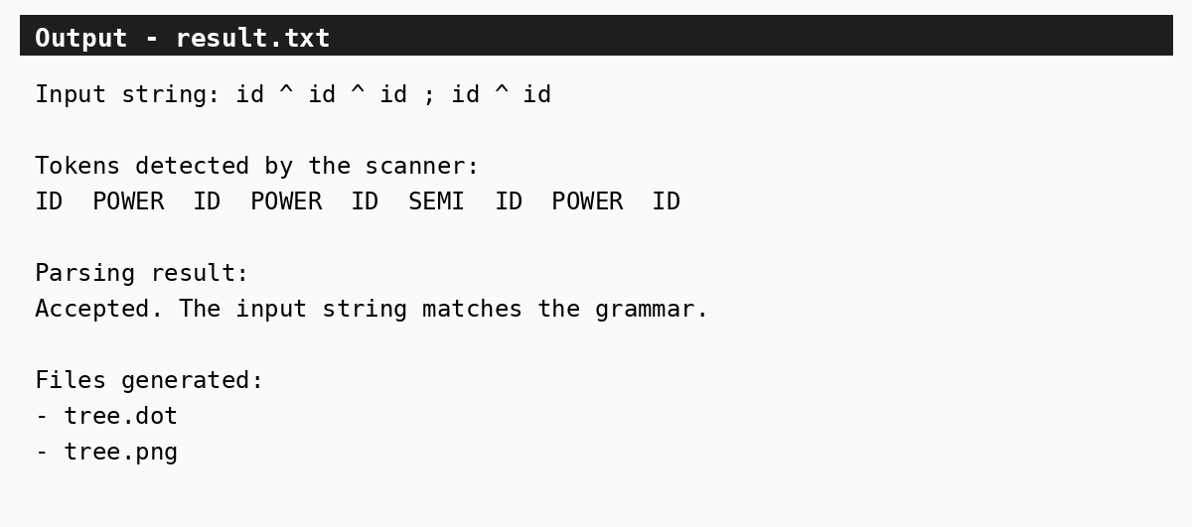
17. Conclusion
The grammar was analyzed, the FIRST/FOLLOW sets were calculated, and the LL(1) table and parsing trace were completed. The same parse tree was then drawn manually and visualized using Graphviz. Finally, Flex and Bison files were prepared to scan the input, parse it, build the tree, and export the DOT file.

