**Task 1: Simulating SDE**

1. **Simulating Geometric Brownian Motion**

Calculate the expectation value of S(3)

The last column of the matrix is S(3), since 0 < t < 3, by using the build in function numpy.mean, the expectation value can be easily find. The theoretical expected value of S3 is 48.7153513878.

Calculate the variance of S(3)

The variance can also be easily find by using another build in function numpy.var. Thw theoretical value of the variance for S(3) is 165.922170963.

Calculate P[S(3)> 39]

By filtering out the number which is greater than 39 from the last column of the matrix, calculate the length of the number which fulfills this condition and then divide by the length of the column, then the probability can be get. P[S(3)> 39] = 0.766.

Calculate E[S(3) | S(3) > 39]

By summing up all the number which is greater than 39 form the last column of the matrix and dividing it by the length of the number which fulfills this condition, the expectation value can be get. E[S(3) | S(3) > 39] = 53.1413612054.

Plot 5 realizations of Geometric Brownian Motion simulation

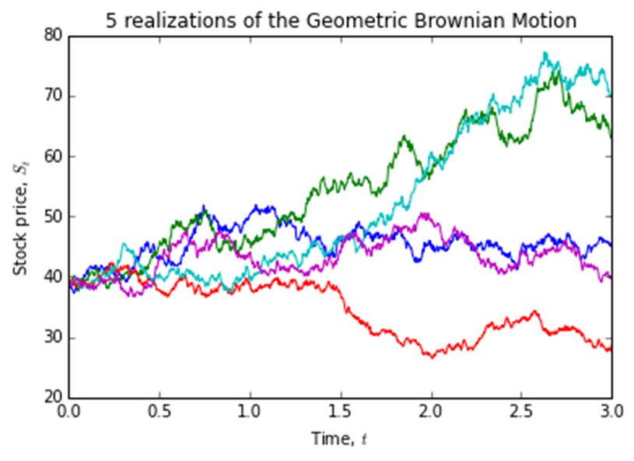

1. **Simulating mean reversal process**

Plot 5 realizations of mean reversal process simulations

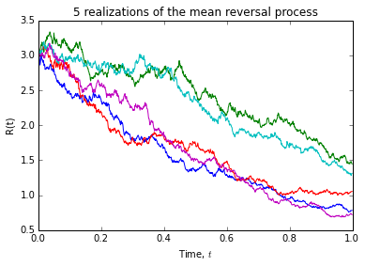

Calculate the expectation value of R(1)

The last column of the matrix is R(1), since 0 < t < 1, by using the build in function numpy.mean, the expectation value can be easily find. The expectation value of R(1) is 1.13642600091.

Calculate P[R(1)> 2]

By filtering out the number which is greater than 2 from the last column of the matrix, calculate the length of the number which fulfills this condition and then divide by the length of the column, then the probability can be get. P[R(1)> 2] = 0.01.

**Task 2: Downloading and manipulating stock data**

How many components stocks are there?

There are 30 components stocks listed in the FTSE Bursa Malaysia KLCI Index.

Create a table list the following information for all the component stocks: Stock Name, Stock Code, Stock Sector, Weightage in FTSEKLCI, PE Ratio, Net Market Capital.

|  |  |  |  |  |  |  |
| --- | --- | --- | --- | --- | --- | --- |
| No. | Stock Name | Stock Code | Stock Sector | Weightage (%) | PE Ratio | Net Market Capital (RM in billion) |
| 1 | AMMB Holdings Berhad | 1015 | Finance | 2.38 | 8.82 | 16.92 |
| 2 | Astro Malaysia Holdings Berhad | 6399 | Trading-Services | 1.22 | 28.32 | 15.76 |
| 3 | Axiata Group Berhad | 6888 | Trading-Services | 5.62 | 24.27 | 55.35 |
| 4 | British American Tobacco Malaysia Bhd | 4162 | Consumer Products | 1.7 | 20.05 | 18.45 |
| 5 | CIMB Group Holdings Berhad | 1023 | Finance | 5.76 | 17.57 | 46.69 |
| 6 | DiGi.Com Berhad | 6947 | IPC | 4.16 | 21.02 | 41.83 |
| 7 | Genting Malaysia Berhad | 4715 | Trading-Services | 2.5 | 20.24 | 24.10 |
| 8 | Genting Berhad | 3182 | Trading-Services | 3.68 | 16.44 | 30.75 |
| 9 | Hong Leong Bank Berhad | 5819 | Finance | 1.67 | 11.19 | 24.05 |
| 10 | Hong Leong Financial Group Berhad | 1082 | Finance | 0.64 | 9.96 | 16.22 |
| 11 | IHH Healthcare Berhad | 5225 | Trading-Services | 3.28 | 63.76 | 48.76 |
| 12 | IOI Corp.Bhd | 1961 | Plantation | 2.99 | 64.92 | 26.67 |
| 13 | KLCC Real Estate Investment Trust | 5235SS | REITS | 0.63 | 26.60 | 12.73 |
| 14 | Kuala Lumpur Kepong Berhad | 2445 | Plantation | 2.28 | 29.21 | 23.98 |
| 15 | Maxis Berhad | 6012 | Trading-Services | 3.45 | 30.18 | 49.41 |
| 16 | Malayan Banking Berhad | 1155 | Finance | 9.32 | 12.42 | 88.04 |
| 17 | MISC Berhad | 3816 | Trading-Services | 2.45 | 15.99 | 35.26 |
| 18 | Public Bank Berhad | 1295 | Finance | 11.6 | 15.21 | 73.37 |
| 19 | Petronas Chemicals Group Berhad | 5183 | Industrial Products | 3.55 | 21.83 | 50.64 |
| 20 | Petronas Dagangan Bhd | 5681 | Trading-Services | 1.21 | 36.83 | 20.37 |
| 21 | Petronas Gas Bhd | 6033 | Industrial Products | 3.4 | 22.81 | 42.74 |
| 22 | PPB Group Berhad | 4065 | Consumer Products | 1.8 | 17.85 | 17.95 |
| 23 | RHB Capital Berhad | 1066 | Finance | 1.06 | 9.08 | 18.78 |
| 24 | Sime Darby Berhad | 4197 | Trading-Services | 5.51 | 20.53 | 51.42 |
| 25 | SapuraKencana Petroleum Berhad | 5218 | Trading-Services | 1.98 | 11.97 | 14.15 |
| 26 | Tenaga Nasional Berhad | 5347 | Trading-Services | 9.28 | 9.24 | 69.19 |
| 27 | Telekom Malaysia Berhad | 4863 | Trading-Services | 2.96 | 32.40 | 24.59 |
| 28 | UMW Holdings Bhd | 4588 | Consumer Products | 1.37 | 20.52 | 11.94 |
| 29 | Westports Holdings Berhad | 5246 | Trading-Services | 0.93 | 26.60 | 13.90 |
| 30 | YTL Corporation Berhad | 4677 | Trading-Services | 1.63 | 14.72 | 16.57 |

Plot FTSEKLCI 5-day moving average

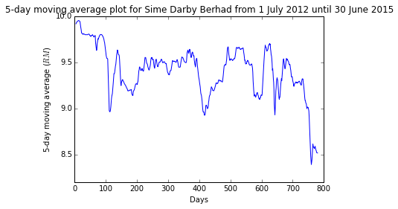

Compute the correlation of Sime Darby Berhad with FTSEKLCI

The correlation of Sime Darby Berhad with FTSEKLCI is -0.084914.