**Assignment 2 Output:**

**Frame 1:**

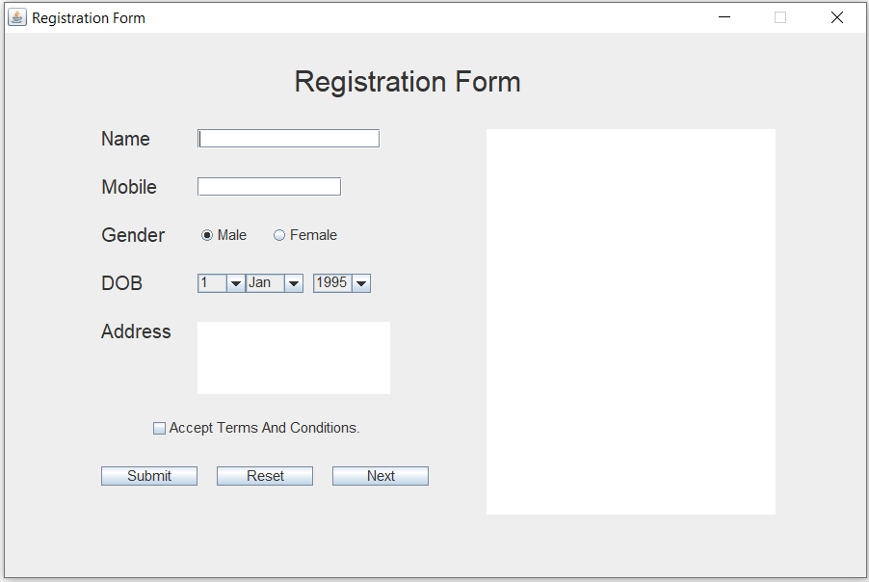

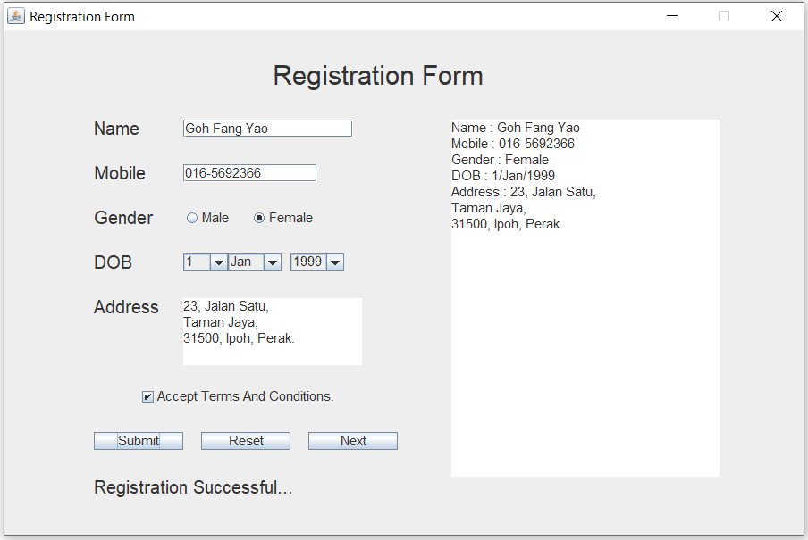

**After press “Next” Button from Register form:**

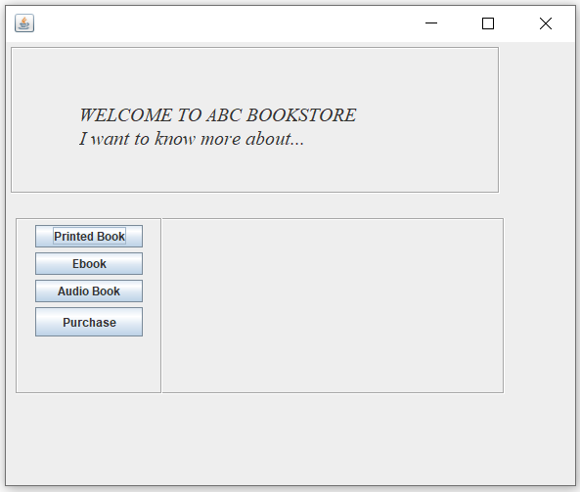

**Frame 2**

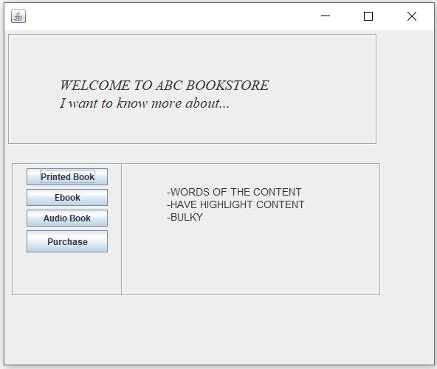

**Information of Printed Book appear when press “Printed Book” button.**

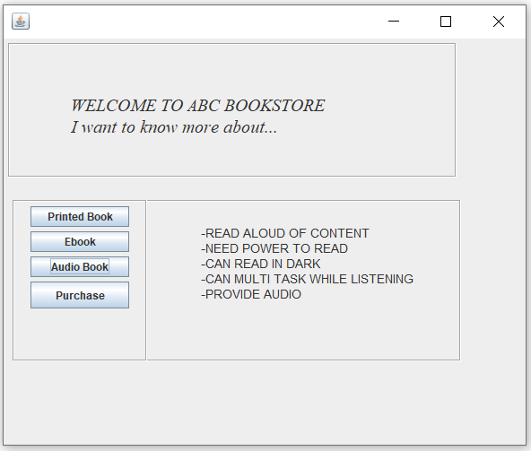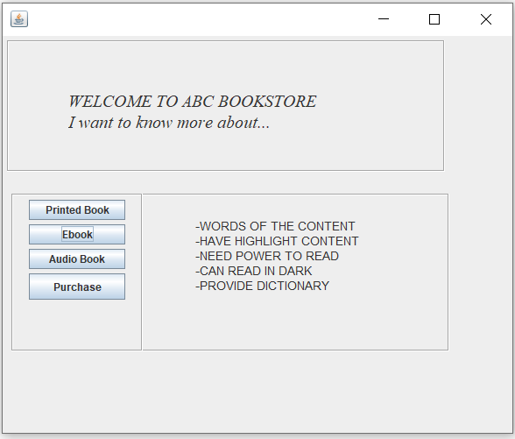

**Information of EBook appear when press “EBook” button.**

**Information of Audio Book appear when press “Audio Book” button.**

**After press “Purchase” Button, will come to Frame 3:**

