Studıo bıllıon

ADB Wifi Build – Editor
ADB Wifi Build is a tool for connecting an Android device to the Android Debug Bridge (ADB) over a wireless connection.
Setup:
Import the package via Unity Asset Store.
Usage:

- Be sure your PC and Android device is connected to same wireless internet.
- Connect your Android device to PC via USB cable.
- Open Wifi Build Window from StudioBillion->ADB Wifi Build and Click “Refresh Device List”.
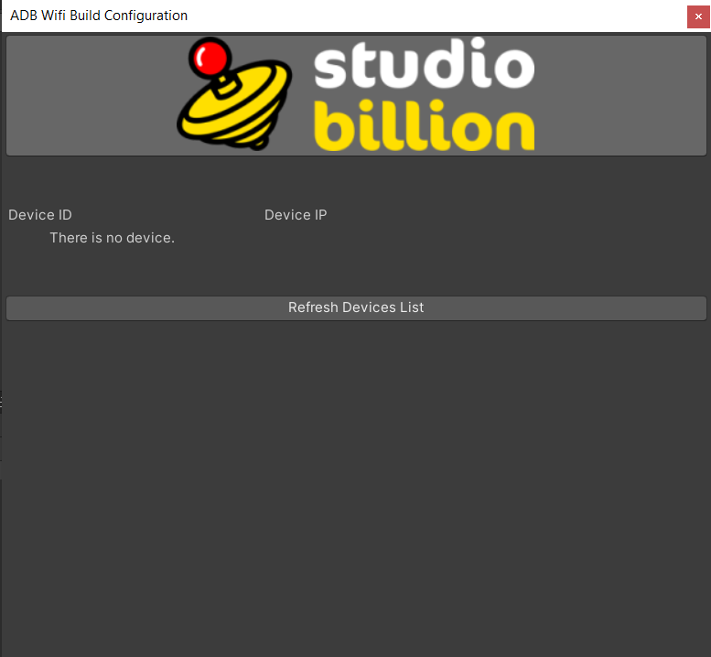

- You will see your connected devices. Click “Try to Find IP Address” button.

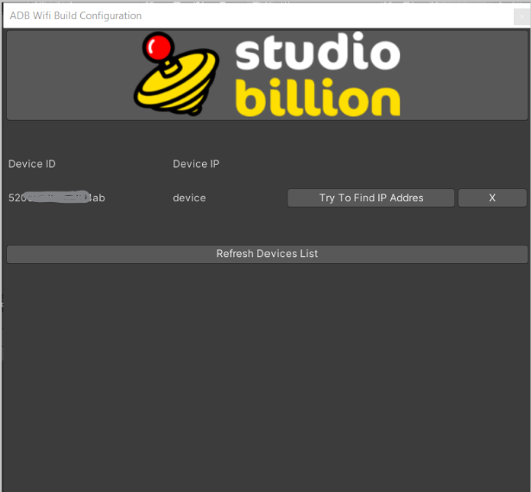

- After IP configuration you can unplug device cable connection. Then Click “Connect to Device” button

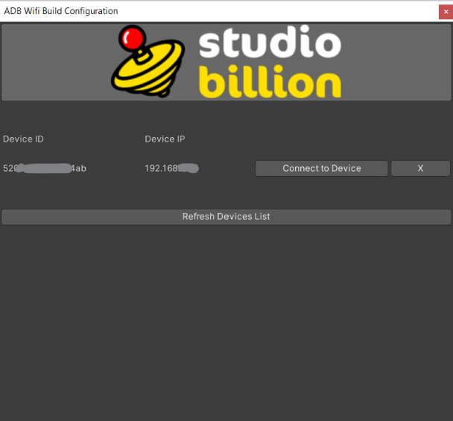

- You will see a connection report after connection process.
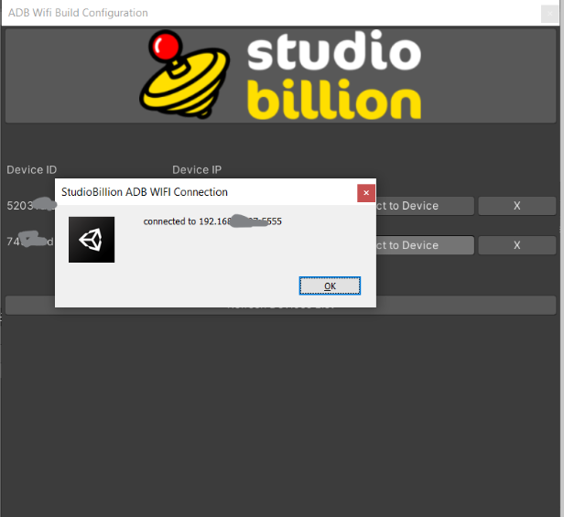

- You can save and connect multiple devices.
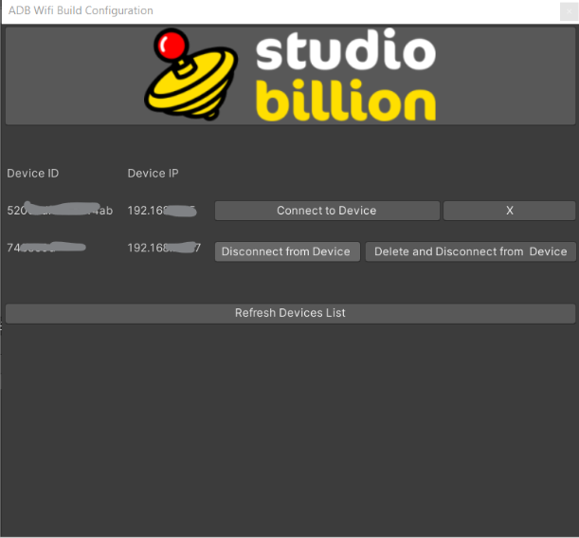
Support:
info@studiobillion.com

