🔹 1. GENERAL / BEHAVIORAL INTERVIEW QUESTIONS

❓ Q1: Tell me about yourself and your experience with DevOps practices.
✅ Answer:
"I have over [X years] of experience working in DevOps, focusing on automating and optimizing cloud-based deployments. My expertise spans setting up CI/CD pipelines, managing infrastructure on AWS, containerization using Docker, and automating deployments for Power Platform apps using Azure DevOps. I’ve worked in cross-functional teams, collaborating with developers, testers, and infrastructure teams to enable efficient release cycles and infrastructure scalability. Recently, I’ve been heavily involved in implementing Infrastructure as Code using Terraform and managing AWS services including RDS and DynamoDB."

❓ Q2: Describe a challenging DevOps project and how you handled it.
✅ Answer:
"At my previous job, we had a monolithic application that we needed to break down into containerized microservices and deploy on AWS. The challenge was balancing migration while maintaining uptime. I introduced Docker for containerization, created CI/CD pipelines using Jenkins, and used Terraform for provisioning AWS resources. We implemented phased rollouts using blue-green deployments. It helped us reduce downtime to near-zero while moving from a legacy to a microservices architecture."

Blue-Green Deployments
¹

Blue-green deployment is a software release management strategy that involves maintaining two separate environments, typically referred to as "blue" and "green." At any given time, one environment is live and handling production traffic, while the other is idle and used for staging and testing.
Key Principles
In a blue-green deployment, the live environment (e.g., blue) serves all incoming requests. When a new version of the application is ready, it is deployed to the idle environment (e.g., green). This new version is thoroughly tested in the green environment to ensure it works as expected. Once verified, traffic is switched from the blue environment to the green environment, making the new version live.
Benefits
- Reduced Downtime: Since traffic is switched instantly between environments, there is minimal to no downtime during deployment.
- Quick Rollback: If any issues arise with the new version, traffic can be quickly routed back to the previous environment, ensuring a swift rollback.
- Improved Testing: The idle environment allows for thorough testing of the new version before it goes live, reducing the risk of introducing defects into production.

🔹 2. TECHNICAL QUESTIONS

⚙️ POWER PLATFORM & AZURE DEVOPS

❓ Q3: How do you set up CI/CD pipelines for Power Platform solutions?
✅ Answer:
"I use the Power Platform Build Tools for Azure DevOps. The process involves exporting unmanaged solutions, checking them into source control, and deploying managed solutions to target environments. I configure tasks like 'Export Solution', 'Unpack Solution', 'Publish Customizations', and 'Import Solution' in a YAML-based pipeline or classic release pipeline. This ensures repeatable and automated deployments across environments like Dev, Test, and Production."

❓ Q4: What are the challenges in automating Power Platform deployments?
✅ Answer:
- Managing dependencies between multiple solutions
- Ensuring environment variables are set correctly
- Handling data loss risks in managed vs. unmanaged solutions
- Managing service principals or app registrations for authentication
- Versioning and rollback strategies for Power Apps and Flows

🐳 DOCKER & CONTAINERIZATION

❓ Q5: How do you manage Docker images for multiple environments?
✅ Answer:
"I maintain different Dockerfile configurations or use ARG variables for environment-specific parameters. Images are tagged properly (e.g., app:dev, app:prod) and pushed to a secure container registry (like Amazon ECR). I use environment variables or mounted secrets for runtime configs, ensuring that the same image behaves differently based on the target environment."

❓ Q6: What security practices do you follow when managing Docker containers?
✅ Answer:
- Use minimal base images (e.g., alpine)
- Regularly scan images for vulnerabilities (using tools like Trivy or Clair)
- Avoid running containers as root
- Keep images updated and signed
- Restrict container-to-host access with proper network/volume isolation
- Use Docker secrets for managing credentials

☁️ AWS INFRASTRUCTURE & DATABASE MANAGEMENT

❓ Q7: How do you manage RDS in production?
✅ Answer:
- Enable multi-AZ deployments for high availability
- Schedule automatic backups and enable point-in-time recovery
- Set monitoring and alerts with CloudWatch
- Apply parameter groups for tuning
- Secure RDS instances using IAM roles, security groups, and KMS encryption
- Perform regular snapshots and failover testing

❓ Q8: How do you secure and optimize DynamoDB?
✅ Answer:
- Use on-demand capacity mode for unpredictable traffic
- Implement read/write capacity planning for known workloads
- Secure using IAM policies
- Use DAX (DynamoDB Accelerator) for performance
- Monitor using CloudWatch metrics (e.g., ThrottledRequests)
- Apply partition key design to prevent hot partitions

🔁 CI/CD AUTOMATION TOOLS

❓ Q9: Describe a robust CI/CD pipeline you’ve implemented.
✅ Answer:
"In a recent project, we used GitLab CI to build, test, and deploy a microservices app. The pipeline was triggered by merges to specific branches. We had build stages for containerization, test stages for unit/integration testing using Pytest, and deploy stages using Helm charts to AWS EKS. We used GitLab runners, integrated SonarQube for code quality, and Slack for notifications."

❓ Q10: How do you implement blue-green or canary deployments in AWS?
✅ Answer:
Using AWS CodeDeploy with Elastic Beanstalk or EC2, I define deployment groups and use traffic shifting. For ECS or EKS, I configure target groups in Application Load Balancers, and incrementally shift traffic from the old to the new version while monitoring metrics to detect anomalies.

🛠 INFRASTRUCTURE AS CODE (IaC)

❓ Q11: Terraform vs CloudFormation – what’s your preference and why?
✅ Answer:
I prefer Terraform for its cloud-agnostic nature and more concise syntax. It has a large module ecosystem, better state management with remote backends, and supports providers beyond AWS. However, for purely AWS environments, CloudFormation integrates deeply with AWS services, especially StackSets and Change Sets.

❓ Q12: How do you manage Terraform state securely?
✅ Answer:
- Store state in remote backends like AWS S3 with versioning enabled
- Use DynamoDB for state locking
- Encrypt the state file using SSE-KMS
- Restrict access using IAM policies
- Avoid storing sensitive values in plaintext (use sensitive = true or external secret managers)

🧾 SCRIPTING (Python, Bash)

❓ Q13: Describe a script you've written to automate DevOps tasks.
✅ Answer:
"I wrote a Python script to automate RDS snapshot cleanup. It used boto3 to list and delete snapshots older than 30 days across multiple accounts. The script was deployed as a Lambda function triggered daily by CloudWatch Events, saving storage costs and ensuring compliance."

📊 MONITORING & LOGGING

❓ Q14: How do you implement observability for a production app?
✅ Answer:
- Use CloudWatch Logs and Metrics for AWS services
- Set up Prometheus and Grafana for container metrics
- Use ELK stack or OpenSearch for log aggregation
- Set alarms and thresholds for CPU, memory, DB connections
- Use distributed tracing tools like AWS X-Ray or Jaeger
- Alerting integrated with Slack/Teams for real-time responses

🔹 3. SCENARIO-BASED / PROBLEM-SOLVING

❓ Q15: A pipeline fails after deploying to production. What steps do you take?
✅ Answer:
- Check logs of the failed job for errors
- Use monitoring tools to identify anomalies in performance or logs
- Trigger rollback (via Terraform or CodeDeploy)
- Alert the team and implement a hotfix if needed
- Perform root cause analysis
- Add regression tests or monitoring to catch it earlier next time

❓ Q16: Your Power Platform pipeline is failing during import. How do you debug?
✅ Answer:
- Check if the solution version is compatible
- Validate connection references and environment variables
- Ensure proper service principal permissions
- Review logs in Azure DevOps and Power Platform Admin Center
- Attempt manual import to isolate if it’s a pipeline or solution issue

🔹 4. QUESTIONS TO ASK THE INTERVIEWER

- How mature is the current DevOps implementation at Infosys?
- What DevOps tools and cloud environments are most commonly used by teams?
- Is the DevOps team centralized or embedded within product teams?
- How much autonomy do engineers have in choosing tools or proposing improvements?
- Are there opportunities to work on Kubernetes or expand into multi-cloud?

✅ Tips for Final Prep:
- Review Power Platform Build Tools documentation
- Practice scripting (Python, Bash)
- Brush up on Terraform syntax and state management
- Understand AWS networking basics (VPC, security groups)
- Prepare project stories with measurable outcomes

Terraform
2014-2017--open source---ppl created own terraform
2023--business source license---open source but ppl can't create own terraform
2025---taken by IBM--terraform

Cloudformation---AWS ka terraform

AWS---EC2
Azure--VM
GCP---Compute engine
AWS_---eks
Azure---AKS
GCP---gke

visual studio code
Terraform HCL--HashiCorp Configuration language

python---.py
java---.java
c----.cpp
terraform--.tf

Block ---resources creation, output print-output and variable creation-variable block
Parameters---type and name n all,
Arguments---{instance_typee==____, key pair}

vim main.tf

now in same folder
write terraform init

to initialize

ls -a--hidden files

now in same folder write terraform validate

now------terraform plan

arguments-- writing before execution
attributes---after execution

terraform init
terraform validate
terraform plan
terraform apply
terraform destroy---
after apply it is asking yes no
so you write terraform apply -auto-approve---same for destroy
init---used for whatever you have written in tf file--like--local, aws , etc
in provider folder it will be visible
aws cli---to connect aws account to your sentence
aws configure
Access key--provide-------you can creare in AWS

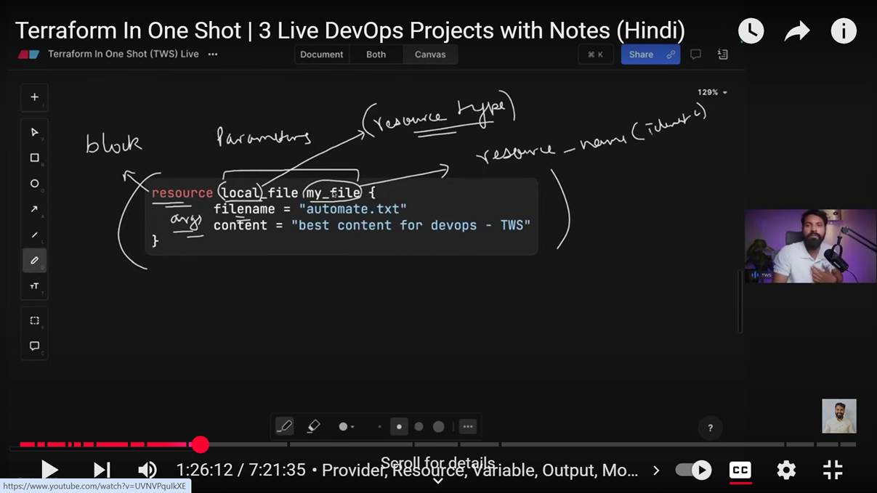

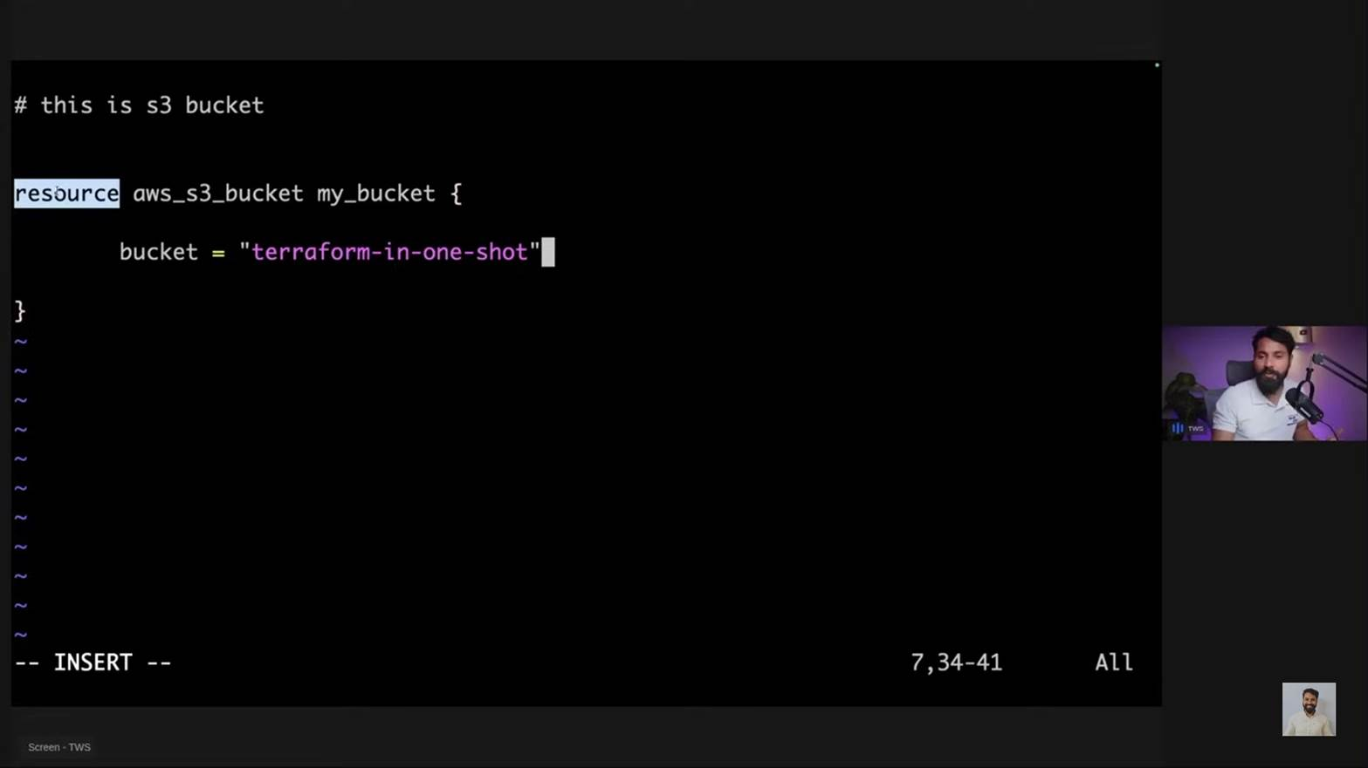

Regards,
Heena Gohil

Ansible

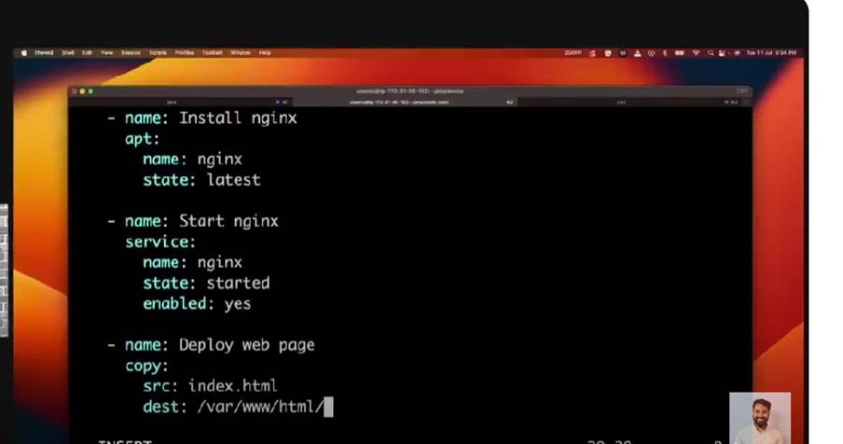

From: Heena Gohil
Sent: 31 July 2025 04:09 PM
To: Heena Gohil <Heena.Gohil@ril.com>
Subject: RE: ansible playbooks

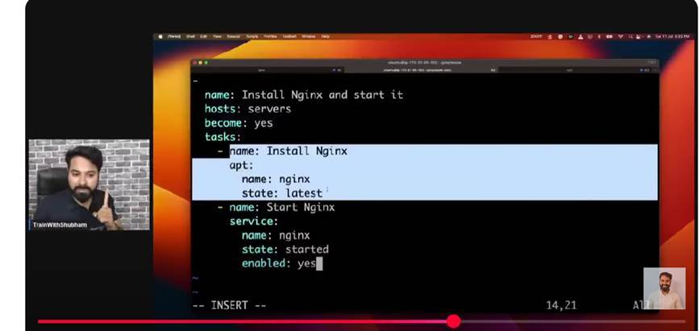

From: Heena Gohil
Sent: 31 July 2025 04:07 PM
To: Heena Gohil <Heena.Gohil@ril.com>
Subject: RE: ansible playbooks

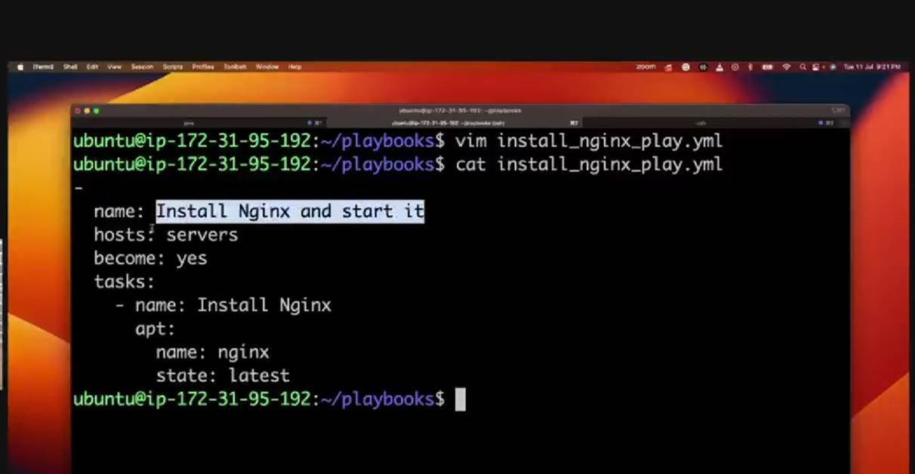

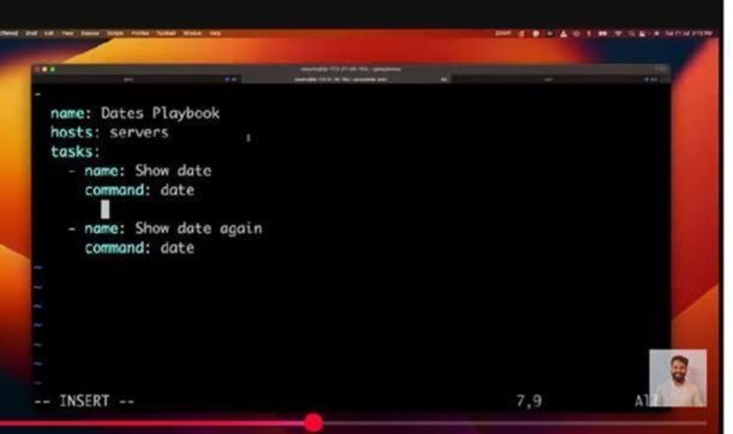

From: Heena Gohil
Sent: 31 July 2025 12:52 PM
To: Heena Gohil <Heena.Gohil@ril.com>
Subject: RE: ansible playbooks

Module
Ansible modules are units of code that can control system resoureces or execute system commands
Ansible servers -m ping

Adhoc
Are great for tasks you repeat rarely
Ansible servers -a “free -h”

From: Heena Gohil
Sent: 02 May 2025 04:01 PM
To: Heena Gohil <Heena.Gohil@ril.com>
Subject: RE: ansible playbooks

Vi new

[G1]
10.32.200.87

[G1:vars]
ansible_ssh_user=root
ansible_ssh_pass= rancore@123

user.yml

- hosts: G1
tasks:
- name: create group
group:
name: domo
state: present
- name: adding
user:
name: paso
state: present
group: domo

ansible-playbook -i new user.yml

- hosts: G1
tasks:
- name: install httpd
yum:
name: httpd
state: present
- name: start service
service:
name: httpd
state: started

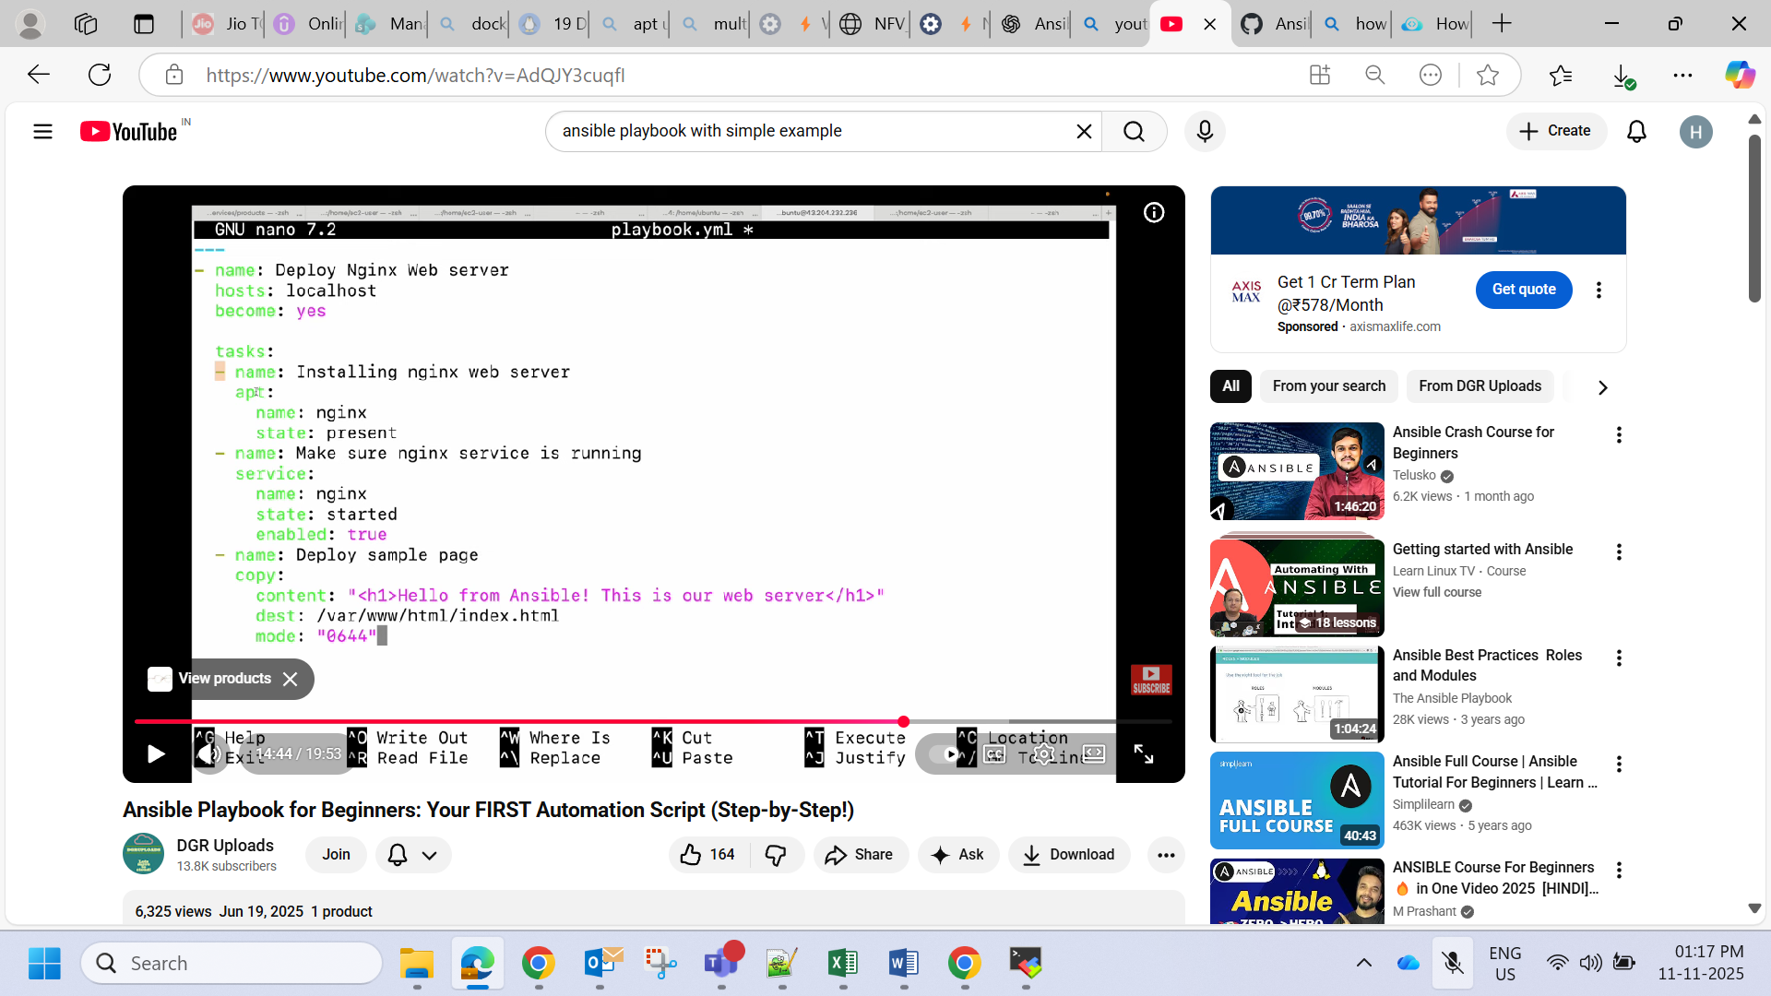
---
- name: Copying files to remote
hosts: all

tasks:
- name: Copy files
copy:
src: /root/myfile.txt
dest: /tmp/
owner: paul
group: paul
mode: ugo=rw
backup: true

- name: change permissions
hosts: all

tasks:
- name: change perm
file:
path: /tmp/myfile.txt
mode: u=r,g=rw

---
- name: Set Password
hosts: all

tasks:
- name: Set passwd
user:
name: nick
update_password: always
password: "{{'abcd12345' | password_hash('sha512', 'mysecretcode')}}"
---------------------

From: Heena Gohil
Sent: 02 May 2025 02:01 PM
To: Heena Gohil <Heena.Gohil@ril.com>
Subject: ansible playbooks

- hosts: g1
tasks:
- name: keerthan
copy:
src: /etc/ansible/{{filename}}.yml
dest: /root/ksn/
vars:
filename: demo

- hosts: G1
tasks:
- name: create file
shell:
docker ps && docker images && hostname
register: r3
- debug: var=r3.stdout_lines

[root@10-32-200-87 ~]# cat user.yml
- hosts: all
tasks:
- name: create group
group:
name: domo
state: present
- name: adding
user:
name: paso
state: present
group: demo
[root@10-32-200-87 ~]# ansible all -m shell -a "id paso"
localhost | CHANGED | rc=0 >>
uid=1034(paso) gid=5075(demo) groups=5075(demo)
[root@10-32-200-87 ~]#

Regards,
Heena Gohil

Jenkins
Stages{

stage("Code")
steps{
echo "This is cloning the code"
git url: "https:// ", branch:"main"
}
}
stage("Build"){
steps{
echo "This is building the code"
sh "whoami"
sh "docker build -t notes-app:latest ."
}
}
stage("Test"){
steps{
echo "This is testing the code"
}
}
stage("Deploy"){
steps{
echo "This is deploying the code"
sh "docker run -d -p 8000:8000 notes-app:latest"
}
}

From: Heena Gohil <Heena.Gohil@ril.com>
Sent: 10 July 2025 04:25 PM
To: Heena Gohil <Heena.Gohil@ril.com>
Subject: RE: jenkins

Stages{

stage("Code")
steps{
echo "This is cloning the code"
git url: "https:// ", branch:"main"
}
}
stage("Build"){
steps{
echo "This is building the code"
sh "whoami"
sh "docker build -t notes-app:latest ."
}
}
stage("Test"){
steps{
echo "This is testing the code"
}
}
stage("Deploy"){
steps{
echo "This is deploying the code"
sh "docker compose up -d"
}
}

From: Heena Gohil
Sent: 09 July 2025 11:58 AM
To: Heena Gohil <Heena.Gohil@ril.com>
Subject: jenkins

Installation steps

http://13.232.215.173:8080/

sudo apt update
sudo apt install fontconfig openjdk-21-jre
java -version

sudo wget -O /etc/apt/keyrings/jenkins-keyring.asc \
https://pkg.jenkins.io/debian-stable/jenkins.io-2023.key
echo "deb [signed-by=/etc/apt/keyrings/jenkins-keyring.asc]" \
https://pkg.jenkins.io/debian-stable binary/ | sudo tee \
/etc/apt/sources.list.d/jenkins.list > /dev/null
sudo apt-get update
sudo apt-get install jenkins
systemctl status jenkins
sudo systemctl enable jenkins
instance--security group me 8080port add--firwall

sudo cat /var/lib/jenkins/secrets/initialAdminPassword
enter password initial

Regards,
Heena Gohil

EC2
If you want to check if port 80 is open on your EC2 instance, you can:
- First, check the security group rules to ensure port 80 is allowed for inbound traffic.
- Then, connect to your instance and run netstat -tulnp to see if any process is listening on port 80.
- You can also use nmap -p 80 <Instance Public IP-address> to scan for the port from outside.
- Finally, you can use telnet <Instance Private IP> 80 to check if you can connect to the instance on that port.

From: Heena Gohil
Sent: 08 July 2025 04:01 PM
To: Heena Gohil <Heena.Gohil@ril.com>
Subject: important

The idle timeout for an AWS load balancer, which defines how long a connection can be idle before the load balancer closes it, is 60 seconds by default. This applies to both Application Load Balancers and Classic Load Balancers. You can adjust this timeout value within a range of 1 to 4000 seconds.

An "EBC" can refer to different things, and whether it can connect to multiple other things depends on the specific context. For example, an Amazon EBS volume can be connected to multiple EC2 instances using Multi-Attach, while an Equipotential Bonding Connector (EBC) can connect multiple grounding wires. On the other hand, an EBC in Oracle's Siebel system is a type of business component that has certain limitations and doesn't support multiple connections in the same way as the other examples.

You can attach an available EBS volume to one or more of your instances that is in the same Availability Zone as the volume.

No, you cannot directly change the primary private IP address of an existing EC2 instance. The primary private IP address is automatically assigned when the instance is launched and remains associated with the instance's network interface until termination. You can, however, add and manage secondary private IP addresses for an instance.

You can connect to an instance in several ways, including SSH, Remote Desktop (RDP), and through a bastion host. SSH and RDP are standard methods for connecting to Linux and Windows instances respectively, while bastion hosts are used to access instances in private subnets. Additionally, EC2 Instance Connect and Session Manager offer alternative connection methods within AWS.

There are four methods for connecting to Amazon EC2 Linux instances:
- Secure Shell (SSH)
- EC2 serial console for Linux instances.
- Session Manager, a capability of AWS Systems Manager.
- Amazon EC2 Instance Connect.

You can associate a security group with one or more instances. Open the Amazon EC2 console at https://console.aws.amazon.com/ec2/. In the navigation pane, choose Instances. Select your instance, and then choose Actions, Security, Change security groups.

By creating an AWS Load Balancer, you can let the load balancer listen on port 80 or 443 and have it route traffic to another port on your EC2 instance.

Clients can connect to the Network Load Balancer using both IPv4 addresses (for example, 192.0.2.1) and IPv6 addresses (for example, 2001:0db8:85a3:0:0:8a2e:0370:7334). The Network Load Balancer communicates with targets based on the IP address type of the target group.

Regards,
Heena Gohil

Jenkins installation

Installation steps

http://13.232.215.173:8080/

sudo apt update
sudo apt install fontconfig openjdk-21-jre
java -version

sudo wget -O /etc/apt/keyrings/jenkins-keyring.asc \
https://pkg.jenkins.io/debian-stable/jenkins.io-2023.key
echo "deb [signed-by=/etc/apt/keyrings/jenkins-keyring.asc]" \
https://pkg.jenkins.io/debian-stable binary/ | sudo tee \
/etc/apt/sources.list.d/jenkins.list > /dev/null
sudo apt-get update
sudo apt-get install jenkins
systemctl status jenkins
sudo systemctl enable jenkins
instance--security group me 8080port add--firwall

sudo cat /var/lib/jenkins/secrets/initialAdminPassword
enter password initial

Regards,
Heena Gohil

Jenkins Basic Interview Questions (Freshers/Junior Level)
Q1. What is Jenkins?
A: Jenkins is an open-source automation server used for Continuous Integration/Continuous Deployment (CI/CD). It automates building, testing, and deploying applications.
Q2. What are the features of Jenkins?
- Open-source and community-driven
- Easy installation and configuration
- Supports plugins for extended functionality
- Distributed builds
- Integration with version control tools like Git
Q3. What is Continuous Integration (CI)?
A: CI is a development practice where developers integrate code into a shared repository several times a day, and each integration is verified by automated builds and tests.
Q4. What are Jenkins Pipelines?
A: Jenkins Pipeline is a suite of plugins that supports building, testing, and deploying code using a DSL (Domain Specific Language). It defines the stages of a CI/CD process in a Jenkinsfile.

🔹 2. Intermediate Jenkins Interview Questions (2-4 Years Experience)
Q5. What is a Jenkinsfile?
A: A Jenkinsfile is a text file that contains the definition of a Jenkins Pipeline and is checked into source control. It allows versioning of the build process.
Q6. Difference between Declarative and Scripted Pipelines?
Feature | Declarative Pipeline | Scripted Pipeline
Syntax | Structured & limited DSL | Full Groovy-based DSL
Error handling | Built-in | Manual try-catch
Readability | Easier to read | More flexible
Q7. How do you trigger a Jenkins job?
- Manually from UI
- Via SCM changes (e.g., Git hooks)
- Scheduled (CRON jobs)
- API call
- Trigger from another job
Q8. What is a Jenkins Agent/Node?
A: Agents (or nodes) are machines connected to the Jenkins Master that run the jobs. It allows distributing the workload.
Q9. What is the use of Jenkins plugins?
A: Plugins extend Jenkins functionality, e.g., Git plugin for source control, Slack plugin for notifications, Docker plugin for container builds.

🔹 3. Advanced Jenkins Interview Questions (5+ Years Experience)
Q10. How do you secure Jenkins?
- Enable security with user authentication
- Use role-based access control
- Use HTTPS
- Limit access to sensitive plugins
- Audit logging
Q11. How do you implement parallel stages in Jenkins Pipeline?
groovy
CopyEdit
stage('Parallel Tasks') {
parallel {
stage('Task 1') {
steps {
echo 'Running Task 1'
}
}
stage('Task 2') {
steps {
echo 'Running Task 2'
}
}
}
}
Q12. Explain how you integrate Jenkins with Docker.
- Install Docker on Jenkins agents
- Use the Docker plugin
- Build and publish Docker images in pipelines using docker.build() or shell scripts
Q13. How do you manage secrets in Jenkins?
- Use Credentials Plugin
- Store secrets (API tokens, passwords) securely
- Access them using withCredentials block in pipeline
Q14. Describe how you handle failed builds.
- Email/Slack notification on failure
- Retain console output for analysis
- Use post block in pipeline for cleanup or alerts
- Enable automatic retries using retry {}

🔹 4. DevOps Scenario-Based Questions
Q15. What steps would you take to migrate Jenkins to a new server?
- Backup JENKINS_HOME
- Install Jenkins on the new server
- Restore plugins and job configurations
- Copy credentials and security settings
- Test build jobs before switching DNS
Q16. CI/CD use-case: How do you deploy to staging and production using Jenkins?
- Use stages in pipeline: Build → Test → Staging → Approval → Production
- Use input step to manually approve production deployment
- Parameterize the environment and control flow using conditionals

Regards,
Heena Gohil

Git
Heena.Gohil@LT0152453 MINGW64 /c/repo (master)
$ mv ~/.ssh/id_rsa ~/.ssh/id_rsa.bak
mv ~/.ssh/id_rsa.pub ~/.ssh/id_rsa.pub.bak

Heena.Gohil@LT0152453 MINGW64 /c/repo (master)
$ ssh-keygen -t ed25519 -C "heena.gohil@ril.com"
Generating public/private ed25519 key pair.
Enter file in which to save the key (/c/Users/Heena.Gohil/.ssh/id_ed25519):
Enter passphrase for "/c/Users/Heena.Gohil/.ssh/id_ed25519" (empty for no passphrase):
Enter same passphrase again:
Your identification has been saved in /c/Users/Heena.Gohil/.ssh/id_ed25519
Your public key has been saved in /c/Users/Heena.Gohil/.ssh/id_ed25519.pub
The key fingerprint is:
SHA256:D1xT6G73MyCiTWH5irjRlWjmKhEx8gS9PAmFiio7EMg heena.gohil@ril.com
The key's randomart image is:
+--[ED25519 256]--+
|.=. .. |
|+ = .. |
|=* = oo |
|=EB o+o.. |
|.. o +.S+ |
|+ . = .oo= o |
|o. ...o= +.o o |
|o . .oo o + |
| . .o. o |
+----[SHA256]-----+

Heena.Gohil@LT0152453 MINGW64 /c/repo (master)
$ eval "$(ssh-agent -s)"
ssh-add ~/.ssh/id_ed25519
Agent pid 1796
Identity added: /c/Users/Heena.Gohil/.ssh/id_ed25519 (heena.gohil@ril.com)

Heena.Gohil@LT0152453 MINGW64 /c/repo (master)
$ cat ~/.ssh/id_ed25519.pub
ssh-ed25519 AAAAC3NzaC1lZDI1NTE5AAAAIP1WBGSplW5bgCDQlPeS5Zam4sJpWlAiEU+0eRyGdlTe heena.gohil@ril.com

Heena.Gohil@LT0152453 MINGW64 /c/repo (master)
$ /home/vcs-user/.ssh/authorized_keys
bash: /home/vcs-user/.ssh/authorized_keys: No such file or directory

Heena.Gohil@LT0152453 MINGW64 /c/repo (master)
$ ^C

Heena.Gohil@LT0152453 MINGW64 /c/repo (master)
$ ^C

Heena.Gohil@LT0152453 MINGW64 /c/repo (master)
$ cat ~/.ssh/id_ed25519.pub
essh-ed25519 AAAAC3NzaC1lZDI1NTE5AAAAIP1WBGSplW5bgCDQlPeS5Zam4sJpWlAiEU+0eRyGdlTe heena.gohil@ril.com
xit
Heena.Gohil@LT0152453 MINGW64 /c/repo (master)
$

Heena.Gohil@LT0152453 MINGW64 /c/repo (master)
$

Heena.Gohil@LT0152453 MINGW64 /c/repo (master)
$ ssh -p 2222 vcs-user@10.64.111.61
vcs-user@10.64.111.61: Permission denied (publickey).

Heena.Gohil@LT0152453 MINGW64 /c/repo (master)
$ git clone ssh://vcs-user@10.64.111.61:2222/source/rjionfvsdnplatformdocuments.git
Cloning into 'rjionfvsdnplatformdocuments'...
vcs-user@10.64.111.61: Permission denied (publickey).
fatal: Could not read from remote repository.

Please make sure you have the correct access rights
and the repository exists.

Heena.Gohil@LT0152453 MINGW64 /c/repo (master)
$ cat ~/.ssh/id_ed25519.pub
ssh-ed25519 AAAAC3NzaC1lZDI1NTE5AAAAIP1WBGSplW5bgCDQlPeS5Zam4sJpWlAiEU+0eRyGdlTe heena.gohil@ril.com

Heena.Gohil@LT0152453 MINGW64 /c/repo (master)
$ ssh -p 2222 vcs-user@10.64.111.61
PTY allocation request failed on channel 0
phabricator-ssh-exec: Welcome to Phabricator.

You are logged in as Heena.Gohil.

You haven't specified a command to run. This means you're requesting an interactive shell, but Phabricator does not provide an interactive shell over SSH.

Usually, you should run a command like `git clone` or `hg push` rather than connecting directly with SSH.

Supported commands are: conduit, git-lfs-authenticate, git-receive-pack, git-upload-pack, hg, svnserve.
Connection to 10.64.111.61 closed.

Heena.Gohil@LT0152453 MINGW64 /c/repo (master)
$ git clone ssh://vcs-user@10.64.111.61:2222/source/rjionfvsdnplatformdocuments.git
Cloning into 'rjionfvsdnplatformdocuments'...
remote: Counting objects: 16789, done.
remote: Compressing objects: 87% (9756/11180)

upload public key

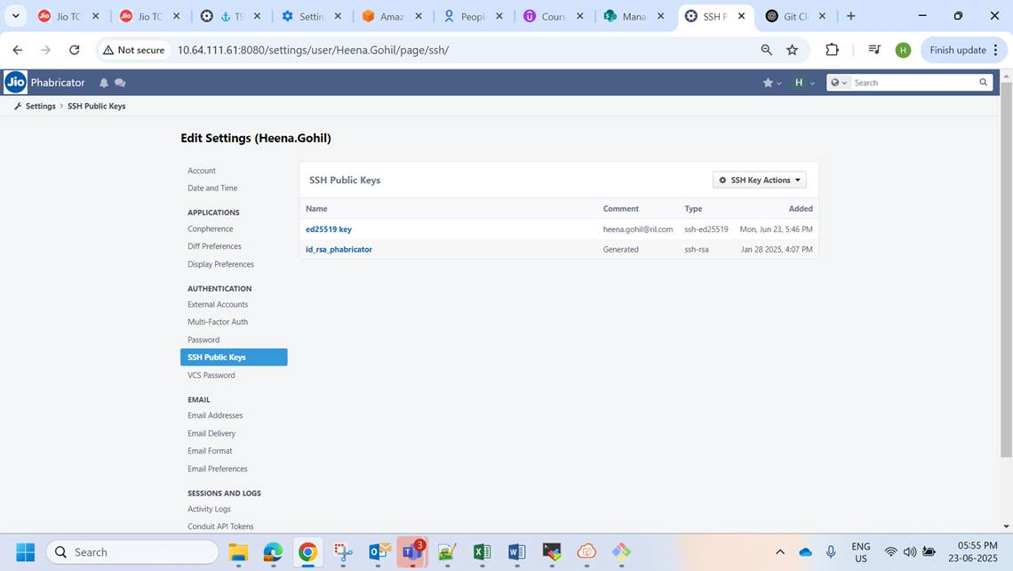
ssh-ed25519 AAAAC3NzaC1lZDI1NTE5AAAAIP1WBGSplW5bgCDQlPeS5Zam4sJpWlAiEU+0eRyGdlTe heena.gohil@ril.com

Linux

Docker file
FROM docker-repo-iot.jio.com:5000/ubuntutest12

# LABEL about the custom image
LABEL maintainer="admin@howtoforge.com"
LABEL version="0.1"
LABEL description="This is a custom Docker Image for PHP-FPM and Nginx."

RUN echo 'we are running some # of cool things'
RUN echo hello \
world

WORKDIR /home
COPY new2.txt /home

ENV abc=hello

#ENTRYPOINT ["/bin/bash", "-c", "echo hello"]
EXPOSE 80
RUN mkdir /myvol
VOLUME /myvol
USER root
ARG user1
SHELL ["sleep", "infinity"]
Docker compose

version: "3.9"

services:
web:
build: ./web
ports:
- "8080:80"
depends_on:
- app
restart: always

app:
build: ./app
environment:
- DATABASE_URL=postgresql://user:password@db:5432/mydatabase
volumes:
- ./app:/usr/src/app
depends_on:
- db
restart: always

db:
image: postgres:15
environment:
- POSTGRES_USER=user
- POSTGRES_PASSWORD=password
- POSTGRES_DB=mydatabase
volumes:
- db_data:/var/lib/postgresql/data
restart: always

volumes:
db_data:
docker multi stage

# -----------------------------
# Stage 1 — Build the frontend
# -----------------------------
FROM node:20 AS builder

WORKDIR /app

# Copy dependency files
COPY package*.json ./

# Install dependencies
RUN npm ci

# Copy all source files
COPY . .

# Build the production version
RUN npm run build

# -----------------------------
# Stage 2 — Run the app
# -----------------------------
FROM nginx:stable-alpine

# Copy build output from the previous stage
COPY --from=builder /app/build /usr/share/nginx/html

# Expose port 80 for the web server
EXPOSE 80

# Start Nginx
CMD ["nginx", "-g", "daemon off;"]

Ansible playbook
---
- name: My first simple Ansible playbook
hosts: all
become: true # use sudo (optional)
tasks:
- name: Create a file
ansible.builtin.file:
path: /tmp/hello.txt
state: touch

- name: Write a message inside the file
ansible.builtin.copy:
dest: /tmp/hello.txt
content: "Hello from Ansible!\n"

- name: Print a message
ansible.builtin.debug:
msg: "File /tmp/hello.txt has been created!"
🧩 Inventory File (hosts.ini)
ini
Copy code
[all]
localhost
(You can replace localhost with a remote server’s IP if needed.)

▶️ Run the Playbook
bash
Copy code
ansible-playbook -i hosts.ini simple_playbook.yml
✅ What It Does
Connects to the target host(s).

Creates a file /tmp/hello.txt.

Writes “Hello from Ansible!” into it.

Prints a confirmation message.
---
- name: Set Password
hosts: all

tasks:
- name: Set passwd
user:
name: nick
update_password: always
password: "{{'abcd12345' | password_hash('sha512', 'mysecretcode')}}"

terraform

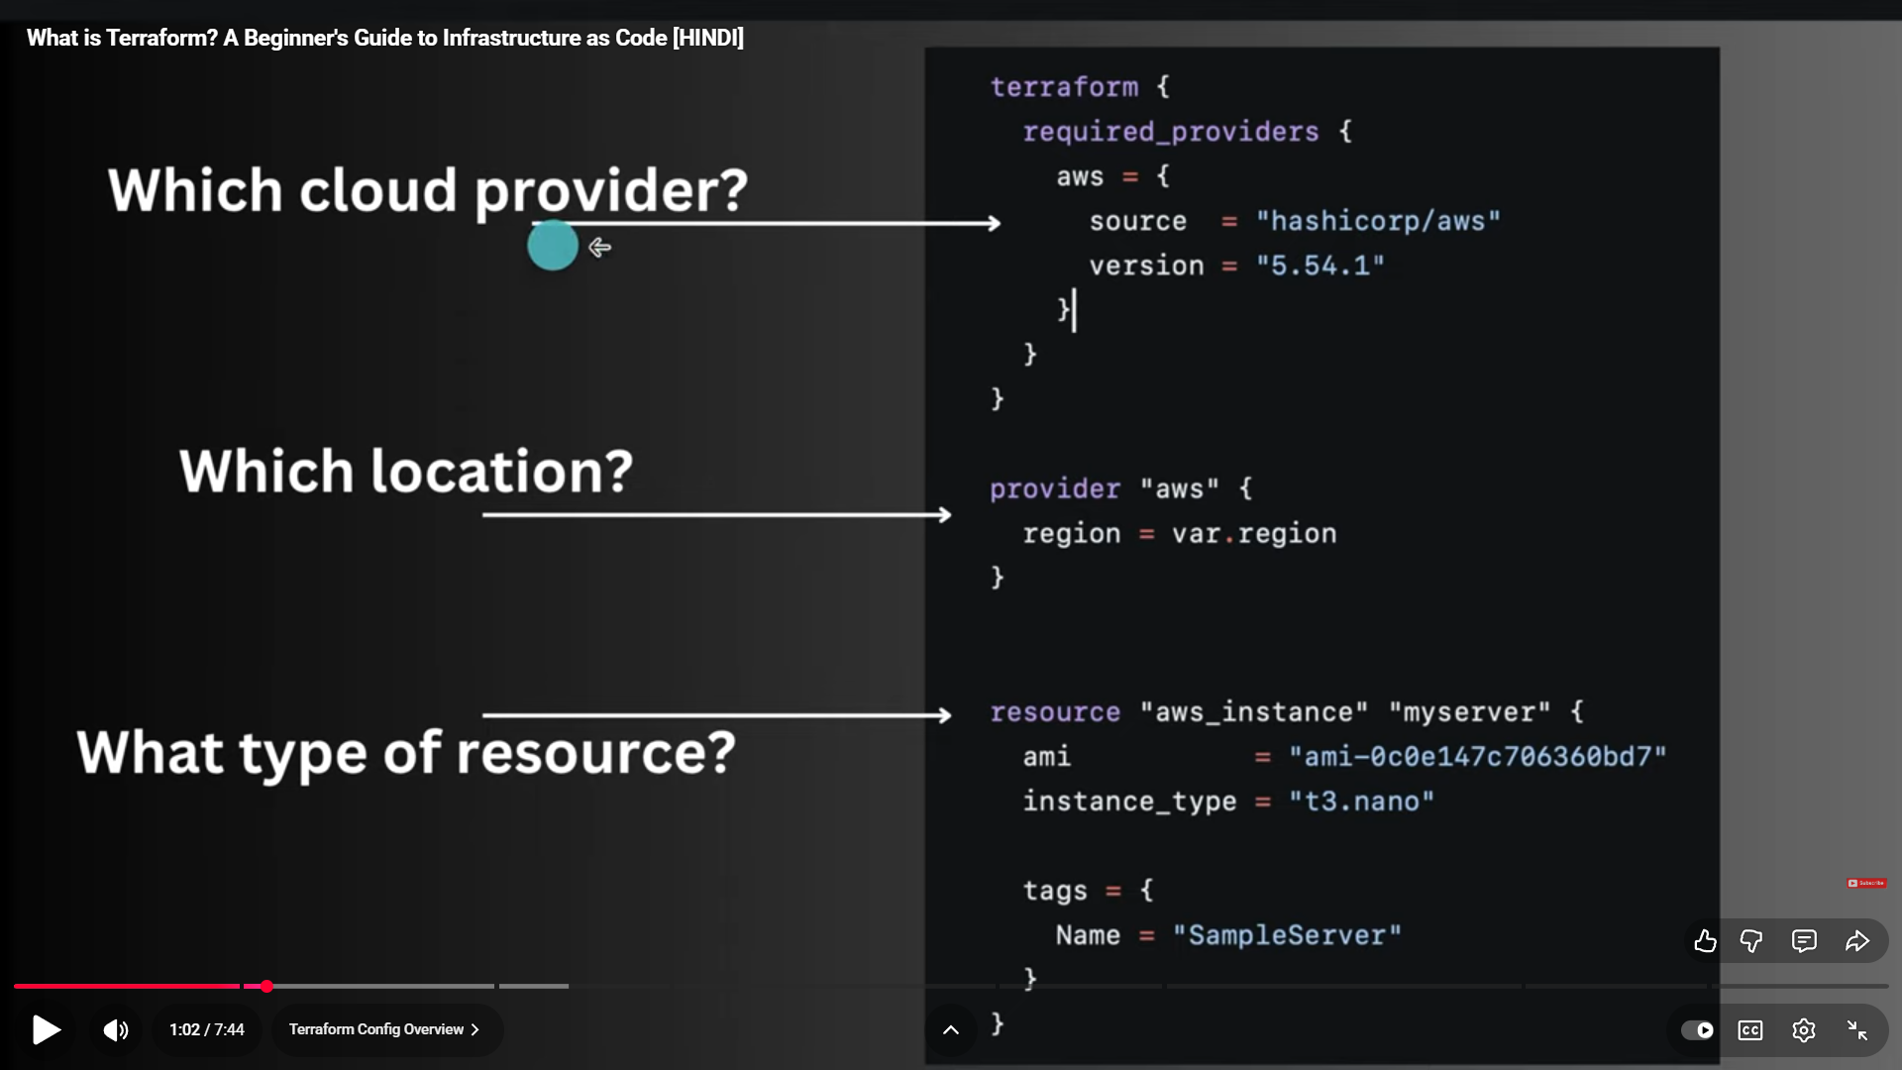
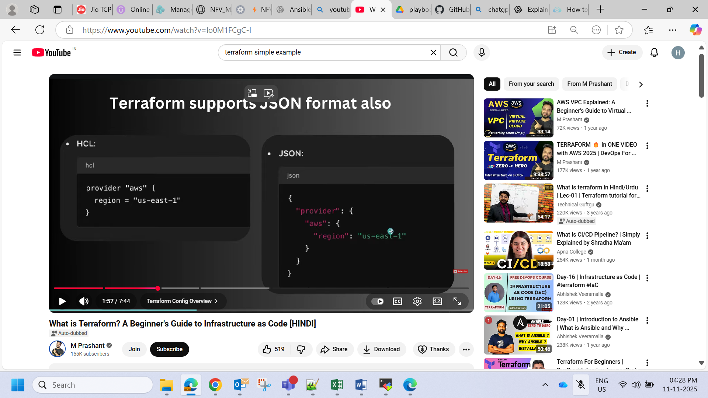
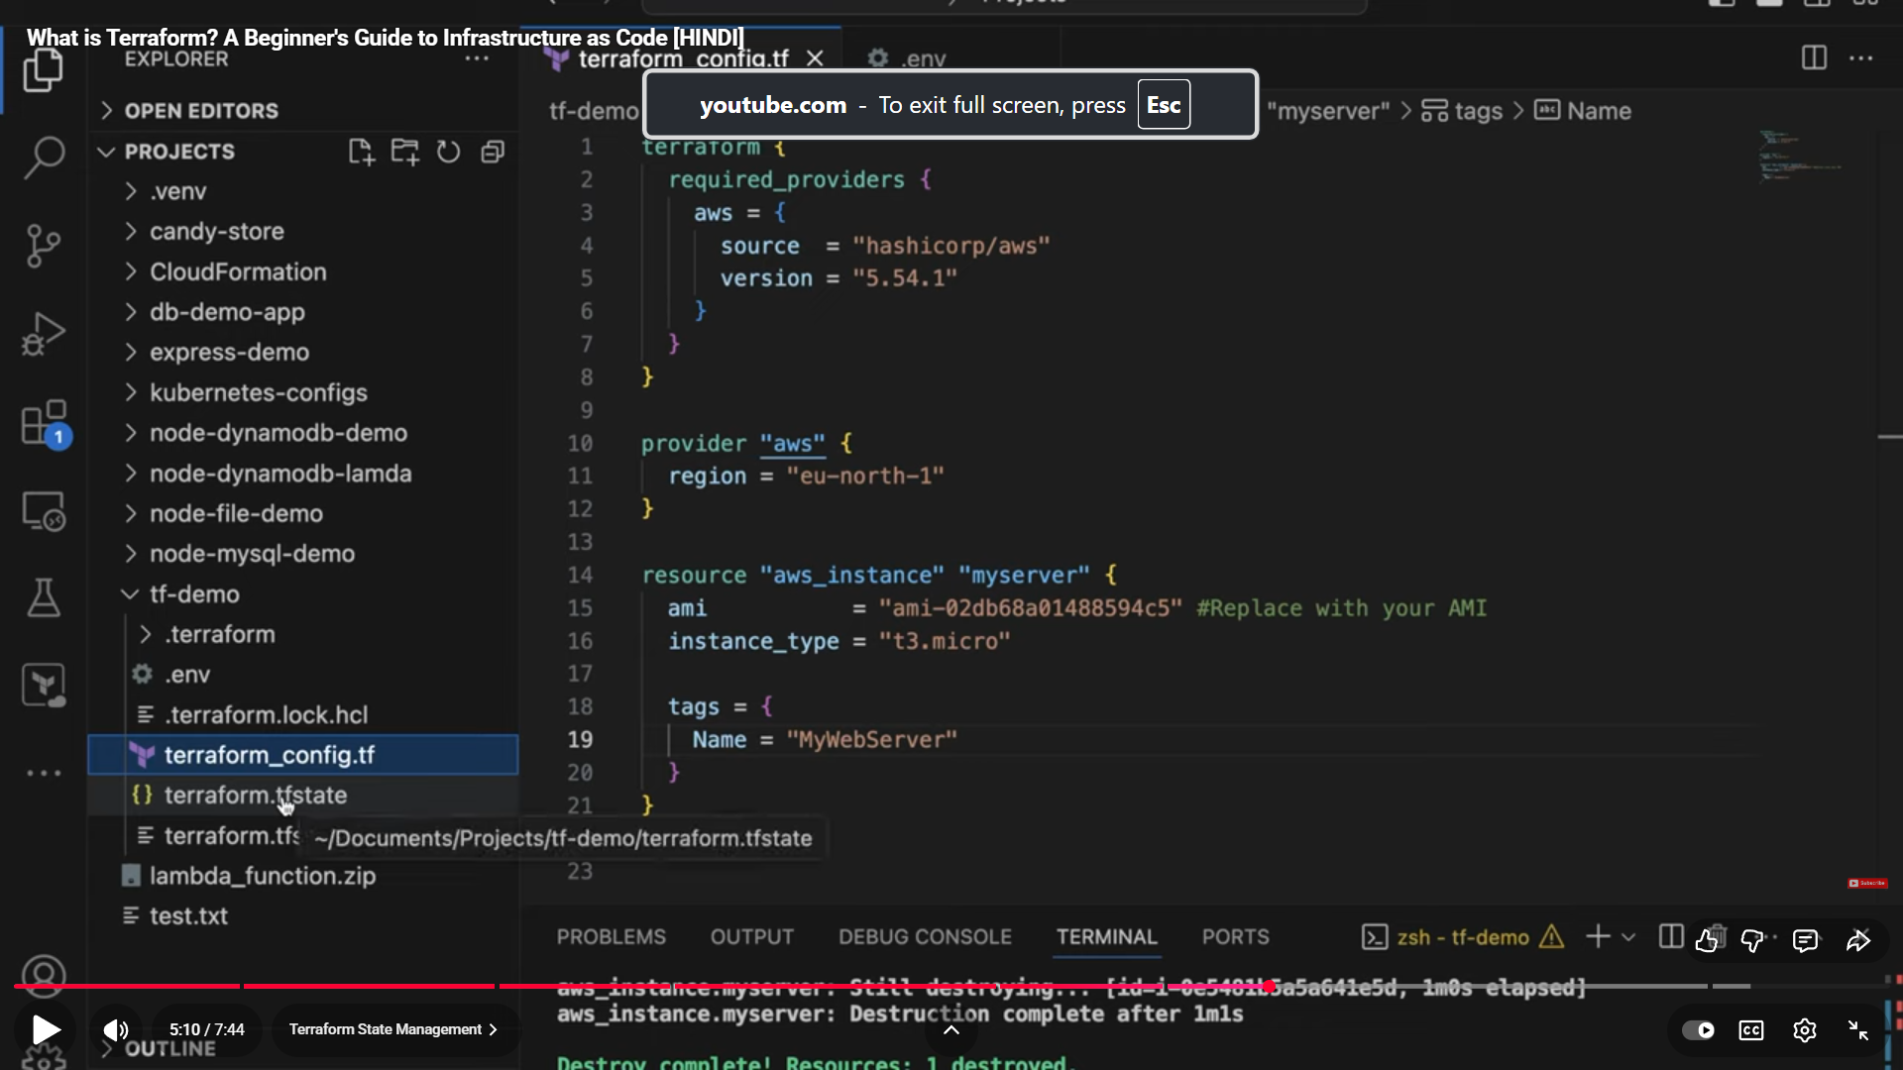

1st add provider
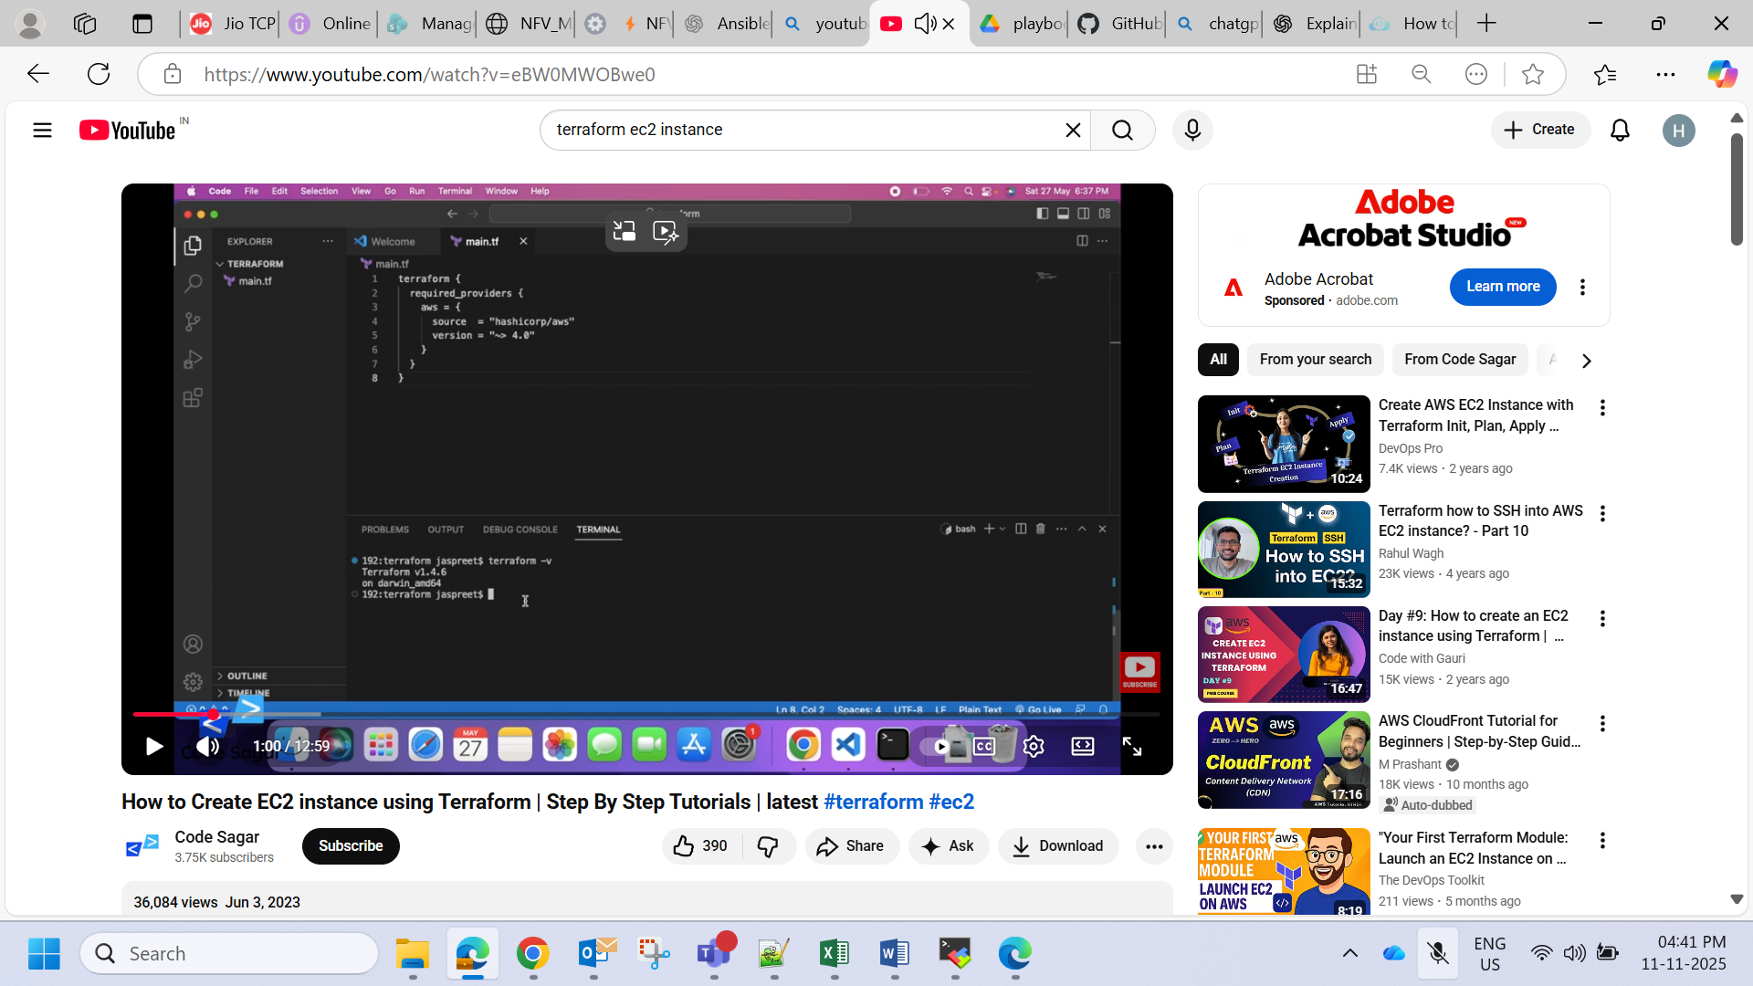
How to get keys
Go to aws and create IAM user and then give permission administrator and u will get access and secret key

Initialise AWS provider
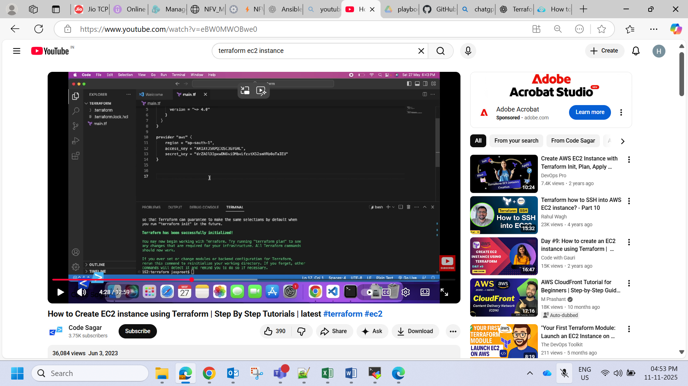
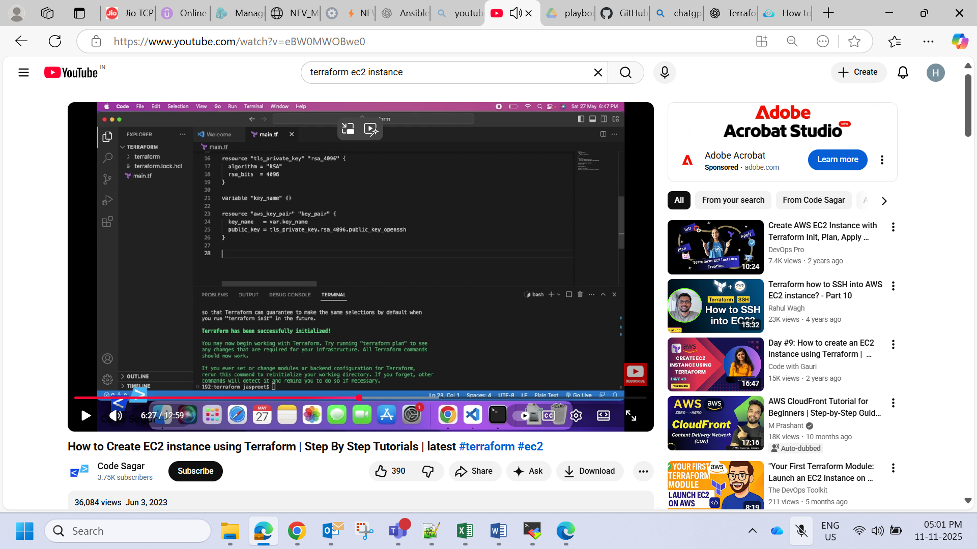
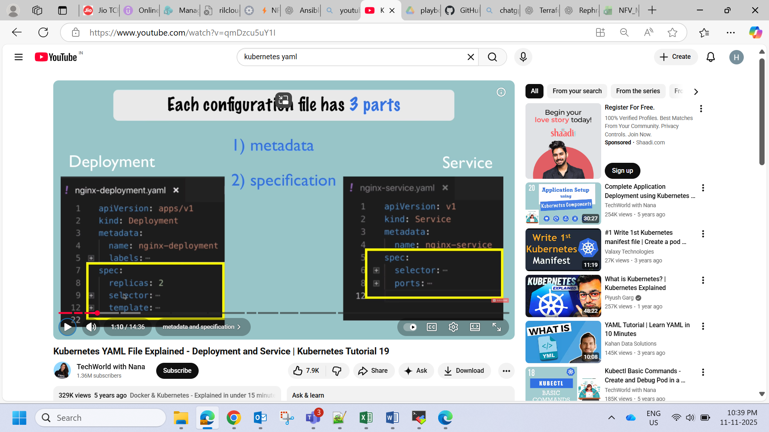
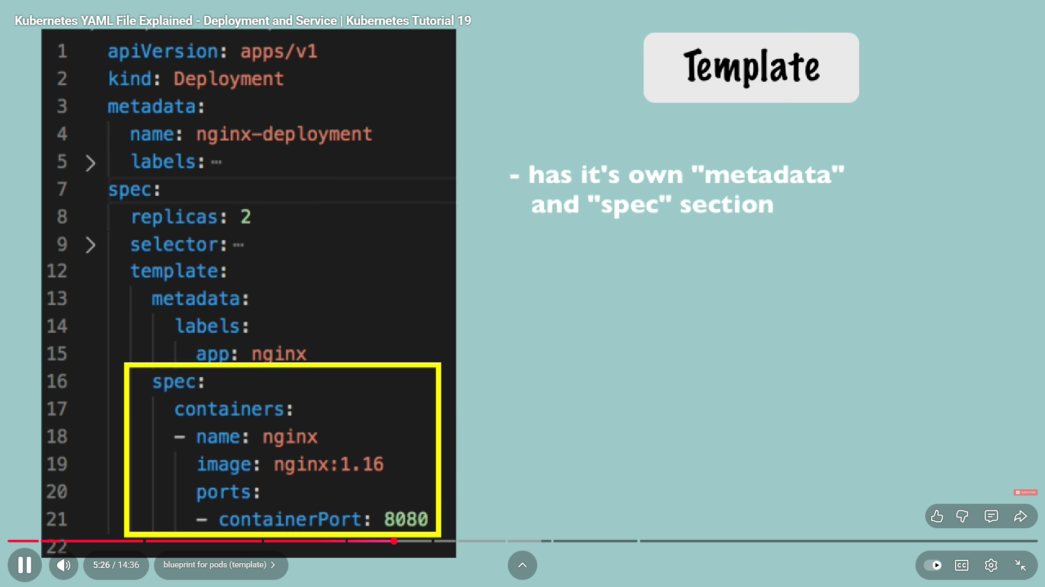
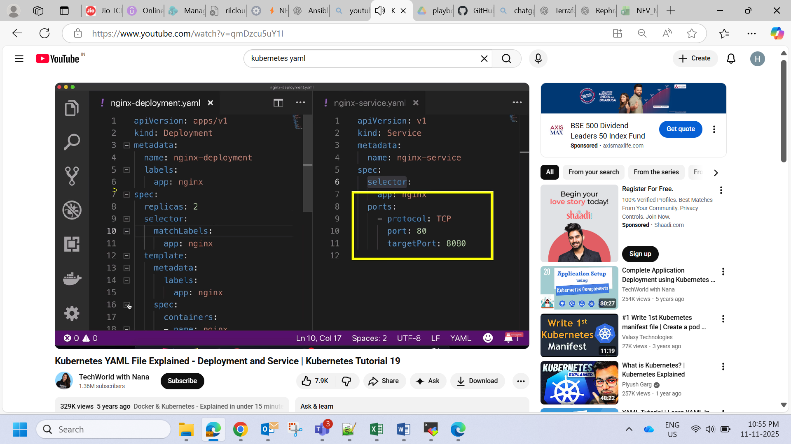
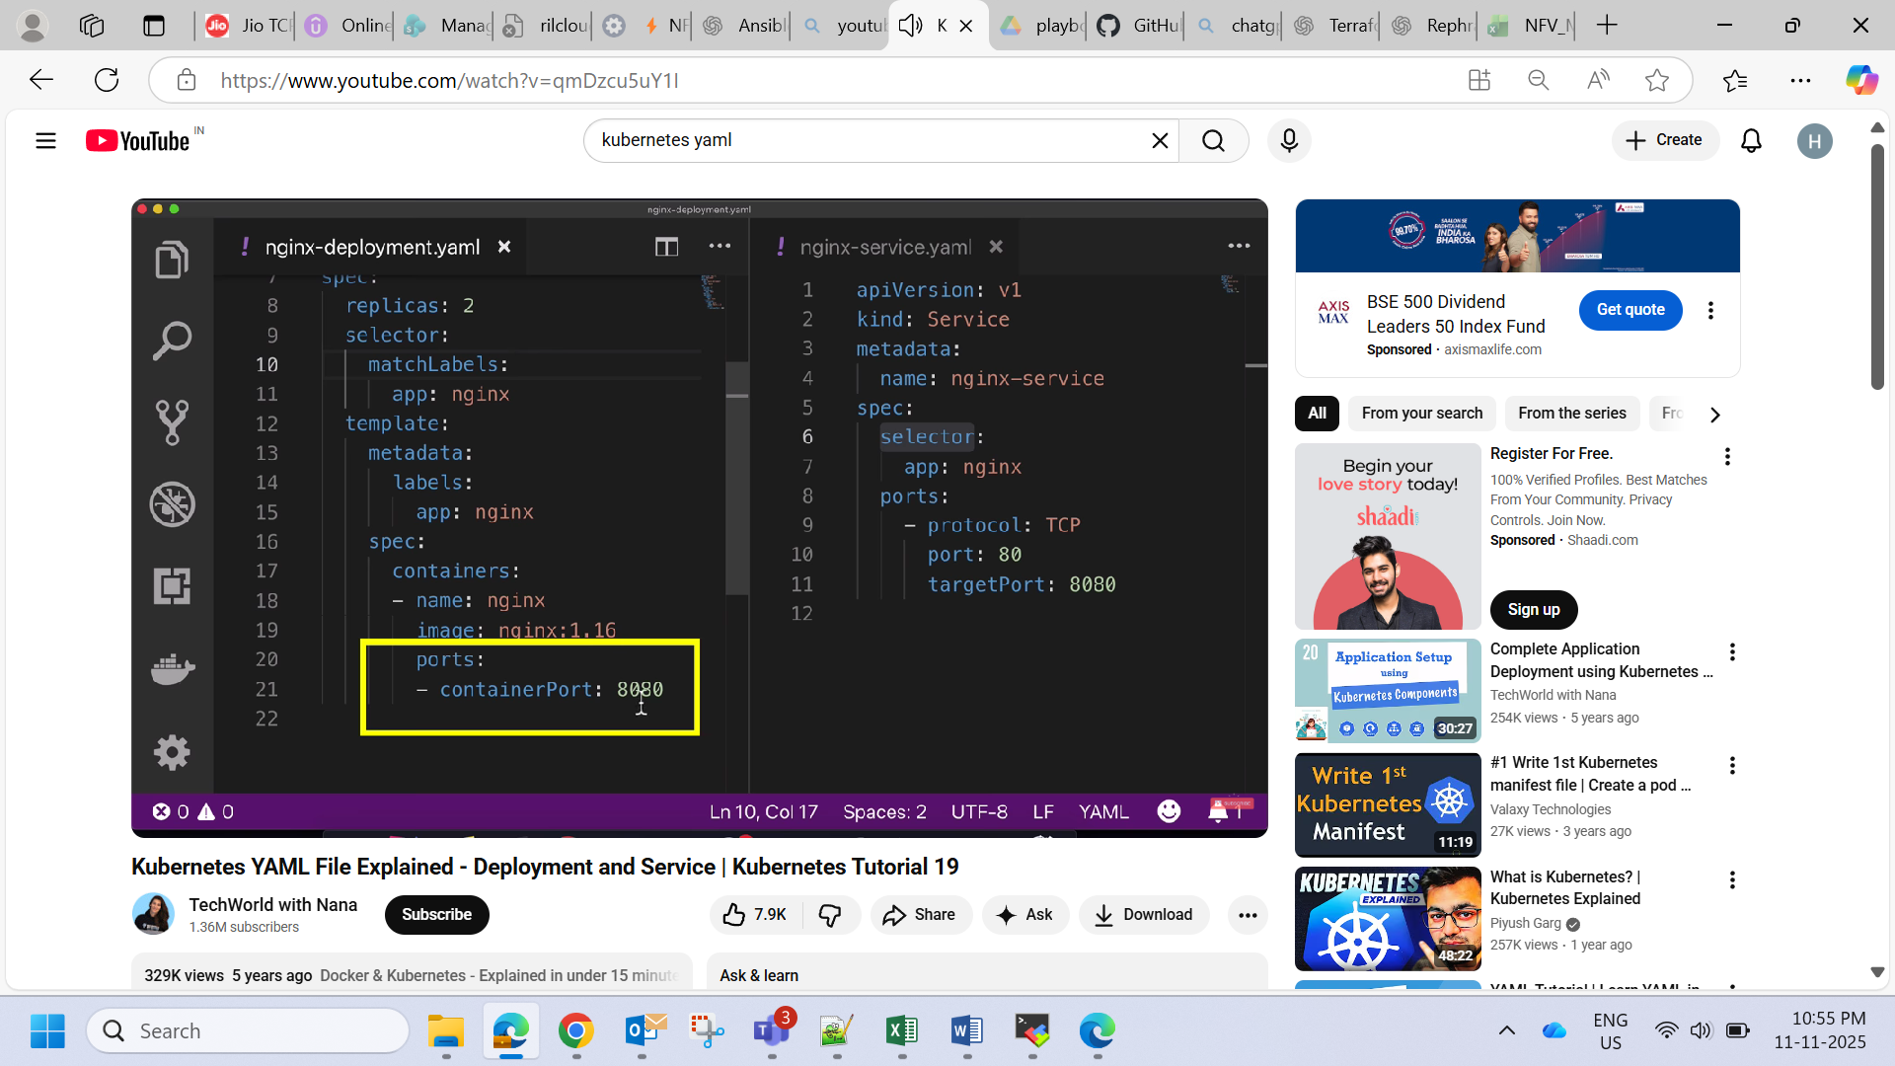
Node exporter check

http://10.63.85.11:9100/metrics
http://10.64.213.42:9100/metrics

Prometheus

http://10.63.85.15:9090/targets?search=

grafana

http://10.63.85.15:3000/dashboards

how to integrate nodes

cat /etc/prometheus/prometheus.yml

- job_name: "node_exporter"

# metrics_path defaults to '/metrics'
# scheme defaults to 'http'.

static_configs:
- targets: ['10.63.85.11:9100', '10.64.213.42:9100']

sudo systemctl restart Prometheus

check on Prometheus if it is not up

Node Exporter is running | curl http://<node>:9100/metrics

Prometheus sees the node | http://<prometheus>:9090/targets

Grafana shows data | Dashboard should display metrics for each node

Check a specific port (e.g., 9100 for Node Exporter)

sudo nano /etc/systemd/system/node_exporter.service

sudo systemctl daemon-reload
sudo systemctl restart node_exporter

sudo netstat -tulnp | grep :9100

error on Prometheus

Get "http://10.64.213.42:9100/metrics": dial tcp 10.64.213.42:9100: connect: no route to host

Check routing/connectivity from Prometheus server
Run this from the Prometheus server:
a) Can it ping the node?
bash
CopyEdit
ping 10.64.213.42
b) Can it connect to port 9100?
bash
CopyEdit
telnet 10.64.213.42 9100

again error

telnet 10.64.213.42 9100 Trying 10.64.213.42... telnet: connect to address 10.64.213.42: No route to host

. Check firewall on 10.64.213.42

sudo firewall-cmd --list-all
sudo firewall-cmd --permanent --add-port=9100/tcp
sudo firewall-cmd --reload
IMP questions and answers

Basic Definitions

RUN
- Executes a command at build time (when you build the image with docker build).
- The results are baked into the image as a new layer.
- Used for installing packages, creating files, changing configuration, etc.
- Does not run when the container starts — only during image creation.

ENTRYPOINT
- Defines the default executable that runs when the container starts (runtime).
- You can think of it as the “main command” of the container.
- Used for containers that act like executables — e.g., nginx, python, etc.

⚙️ 2. Example
Here’s a simple Dockerfile to illustrate:
# Base image
FROM python:3.9-slim

# RUN happens during build time
RUN pip install flask

# Copy app files
COPY app.py /app/app.py

# ENTRYPOINT happens during container run time
ENTRYPOINT ["python", "/app/app.py"]

Build:
docker build -t myflaskapp .

Run:
docker run myflaskapp

What happens:
- RUN pip install flask executes while building → Flask gets installed into the image.
- ENTRYPOINT ["python", "/app/app.py"] executes when you start the container → Flask app starts running.

🧠 3. Key Conceptual Difference
Aspect | RUN | ENTRYPOINT
When it runs | During image build | During container startup
Purpose | Configure image, install software, prepare environment | Define container’s main process
Effect | Creates new image layer | Defines runtime behavior
Example command | RUN apt-get install nginx | ENTRYPOINT ["nginx", "-g", "daemon off;"]

🚀 4. Optional: Adding CMD
Often, you’ll see ENTRYPOINT used with CMD — they complement each other.
ENTRYPOINT ["python"]
CMD ["app.py"]
Running:
docker run mypython
→ executes python app.py
Running:
docker run mypython script.py
→ executes python script.py
So:
- ENTRYPOINT = fixed command
- CMD = default arguments (can be overridden)

🔍 5. Summary
Command | When It Runs | Common Use
RUN | Build time | Install software, modify filesystem
ENTRYPOINT | Run time | Define main container process
CMD | Run time | Default arguments to ENTRYPOINT

Quick Analogy
Think of a restaurant:
- RUN = preparing the kitchen (buying ingredients, setting up equipment)
- ENTRYPOINT = the chef who starts cooking when an order comes in
- CMD = the default dish to cook (can be changed per customer)
Command | What It Does | Result
git merge | Combines the histories of two branches by creating a new “merge commit.” | Keeps the original branch history intact.
git rebase | Rewrites commit history so that your commits appear on top of another branch. | Produces a cleaner, linear history.

⚙️ 2. Scenario Setup
Let’s say you have this:
main: A --- B --- C
\
feature: D --- E
Here:
- main has commits A, B, C
- feature has commits D, E (branched off after B)
Now, you want to bring the latest main changes (commit C) into your feature branch.

🔀 3. Using git merge
git checkout feature
git merge main

Resulting history:
A --- B --- C
\ \
D --- E --- M
- A new merge commit (M) is created.
- The history shows exactly how the branches diverged and then merged.
- You preserve all history, but it looks more complex.
🟢 Pros
- Safe: preserves all commits.
- Good for shared/team branches (e.g., main, develop).
🔴 Cons
- Can clutter history with many merge commits.

🔁 4. Using git rebase
git checkout feature
git rebase main

Resulting history:
A --- B --- C --- D' --- E'
- Commits D and E are rebased (rebuilt) on top of commit C.
- No merge commit is created — you get a straight, linear history.
- Git internally replays your branch’s commits (D, E) as new commits (D’, E’).
🟢 Pros
- Cleaner, linear history (good for reviewing or feature branches).
- Easier to follow chronological development.
🔴 Cons
- Rewrites commit history — not safe on branches that others are using.
- Can cause conflicts that need to be resolved one by one.

Example
First, let’s create a new Git repo with a main branch and a feature branch.
# Create a test repo
mkdir git-demo
cd git-demo
git init

# Create a file and make the first commit
echo "Initial version" > app.txt
git add app.txt
git commit -m "A: initial commit"

# Add another commit on main
echo "Add main change" >> app.txt
git commit -am "B: update on main"

# Create and switch to a feature branch
git checkout -b feature

# Make a few commits in feature branch
echo "Feature line 1" >> app.txt
git commit -am "D: first feature commit"

echo "Feature line 2" >> app.txt
git commit -am "E: second feature commit"
Now your branches look like this:
main: A --- B
\
feature: D --- E

🔀 Example 1: git merge
Let’s simulate new work on main, then merge it into feature.
# Switch to main and add a new commit
git checkout main
echo "Another main update" >> app.txt
git commit -am "C: main branch update"

# Switch back to feature and merge main
git checkout feature
git merge main
If there are no conflicts, Git creates a merge commit:
A --- B --- C
\ \
D --- E --- M
✅ Result:
- feature now includes the latest changes from main
- A new merge commit M was created
- The full history (branches + merge point) is visible

🔁 Example 2: git rebase
We’ll reset and try again, this time using rebase.
# Reset feature branch to before the merge
git checkout feature
git reset --hard E # removes merge commit if any

# Rebase feature onto the updated main
git rebase main
Git will replay your feature commits (D, E) on top of the latest main commit (C).
The new history:
A --- B --- C --- D' --- E'
✅ Result:
- No merge commit
- Linear history (cleaner timeline)
- Commits D and E were rewritten as D' and E'

🔍 View the Difference
To visualize:
git log --oneline --graph --all
- After merge: you’ll see branches joining with a merge commit.
- After rebase: you’ll see a single straight line of commits.

⚠️ Important Note
- Never rebase public/shared branches — it rewrites commit history.
- Safe to rebase your own local feature branches before merging into main.

✅ Summary
Command | Creates Merge Commit? | Changes History? | Typical Use
git merge main | ✅ Yes | ❌ No | Combine branches safely
git rebase main | ❌ No | ✅ Yes | Clean up feature branch before merging

🧠 5. When to Use What
Use Case | Recommended Command
Working alone on a feature branch, want clean history | ✅ git rebase
Collaborating on shared branches (e.g. main/dev) | ✅ git merge
You want to preserve exact historical record | git merge
You want a linear “story” of commits | git rebase

🧩 6. Example Summary
Action | Command | History Style
Merge main into feature | git merge main | Keeps branch graph, adds merge commit
Rebase feature onto main | git rebase main | Linear history, rewrites commits

💡 7. Simple Analogy
Imagine you and a friend are writing a book:
- merge: You combine both your chapters as they are, adding a note that says “merged our work here.”
- rebase: You rewrite your chapters as if you had written them after your friend finished theirs — looks cleaner, but you’ve changed the “timeline.”
git commit -am "D: first feature commit"
🧩 1. git commit
This tells Git to create a new commit — basically, a saved snapshot of your changes in the repository.

Each commit includes:

The changes you made

Metadata (who made the commit, when)

A message describing the change

🧩 2. -a
The -a flag stands for “all”.

It automatically stages all modified and deleted files that are already tracked by Git (i.e., files Git already knows about).

👉 In other words:

You don’t need to run git add for tracked files — -a handles that for you.

But new files (untracked ones) still need to be added manually with git add.

🧩 3. -m "D: first feature commit"
The -m flag lets you specify the commit message inline, instead of opening a text editor.

Here, the message is:

sql
Copy code
D: first feature commit
This is a short description of what this commit does.
The D: prefix might be your team’s convention (e.g., "D" for “Development” or “Deployment”).

🧠 So putting it all together
The command:

bash
Copy code
git commit -am "D: first feature commit"
Does the following:

Stages all tracked files that have been changed or deleted.

Creates a new commit with those changes.

Adds the message “D: first feature commit”.
Command | What It Does | Does It Update Local Files?
git fetch | Downloads new commits, branches, and tags from the remote repository into your local .git database. | ❌ No — it only updates remote tracking branches (like origin/main).
git pull | Does a git fetch + git merge (or git rebase, depending on config). | ✅ Yes — it updates your working directory to match the remote branch.

⚙️ 2. Example Scenario
Imagine your repository looks like this:
Local main: A --- B
Remote main: A --- B --- C --- D
The remote (origin/main) has two new commits (C, D) that you don’t have locally.

🔹 Using git fetch
git fetch origin
Result:
- Git downloads commits C and D from the remote.
- Your local remote-tracking branch (origin/main) is updated.
- But your current branch (main) still points to B.
main: A --- B
origin/main: A --- B --- C --- D
✅ No change to your working files yet.
You just have the new commits stored locally, ready to inspect or merge manually.
You can check:
git log main..origin/main
(to see what’s new on remote)

🔹 Using git pull
git pull origin main
Result:
- Git first fetches remote changes.
- Then it merges (or rebases) them into your local branch.
After pull:
main (local) now → A --- B --- C --- D
✅ Your local files are updated.
✅ You’re now in sync with origin/main.

🧠 3. Summary of Behavior
Action | git fetch | git pull
Downloads commits from remote | ✅ | ✅
Updates remote-tracking branches | ✅ | ✅
Merges changes into current branch | ❌ | ✅
Updates working directory | ❌ | ✅
Risk of merge conflicts | ❌ | ✅ (possible)

🔍 4. When to Use Which
Situation | Use This Command | Why
You just want to see what changed remotely before merging | git fetch | Safe — doesn’t modify local work
You’re ready to update your branch with remote changes | git pull | Brings your branch fully up to date
You want to review incoming changes before merging | git fetch + git log origin/main | Lets you inspect first

⚙️ 5. Advanced Tip: Configure Pull Behavior
You can configure pull to rebase instead of merge (for cleaner history):
git config --global pull.rebase true
Then git pull will do:
fetch + rebase
instead of:
fetch + merge

🧩 6. Simple Analogy
Imagine your Git repo as a book:
- git fetch = You get the latest chapters from the publisher, but don’t put them in your copy yet.
- git pull = You insert those new chapters into your copy, merging them with your notes.

✅ TL;DR
Command | Fetches remote data | Merges into current branch | Updates working files | Safe to run anytime
git fetch | ✅ | ❌ | ❌ | ✅
git pull | ✅ | ✅ | ✅ | ⚠️ (can cause merge conflicts)

Git branch types

ChatGPT said:
Sure! Git has several types of branches, each serving a different purpose in development workflows. Let’s break them down clearly.

1. Main/Primary Branch
- Name: Usually main or master
- Purpose: The primary, stable branch representing the production-ready code.
- Characteristics:
  - All major releases eventually get merged here.
  - Typically protected in shared repositories to avoid accidental changes.

2. Feature Branches
- Purpose: Used to develop new features or improvements.
- Naming convention: Often feature/<feature-name> (e.g., feature/login-page)
- Characteristics:
  - Branched off from main or develop.
  - Merged back when the feature is complete.
  - Keeps development isolated until ready.
Example:
git checkout -b feature/user-auth

3. Release Branches
- Purpose: Prepares code for an upcoming release.
- Naming convention: release/<version> (e.g., release/1.0.0)
- Characteristics:
  - Allows for final testing, bug fixes, and documentation before release.
  - Merged into main and often back into develop (or feature branches) after release.
Example:
git checkout -b release/1.0.0

4. Hotfix Branches
- Purpose: Quickly fix critical bugs in production.
- Naming convention: hotfix/<issue> (e.g., hotfix/login-bug)
- Characteristics:
  - Branched from main (or production branch).
  - Changes merged back into both main and develop to keep history consistent.
Example:
git checkout -b hotfix/critical-bug

5. Develop/Integration Branch (Optional)
- Purpose: Serves as an integration branch for features before merging into main.
- Naming convention: Usually develop
- Characteristics:
  - Common in Git Flow workflow.
  - Acts as a pre-production branch where QA/testing happens.

6. Remote Branches
- Purpose: Represent branches on a remote repository.
- Naming convention: origin/<branch-name>
- Characteristics:
  - Cannot be directly checked out; must be tracked locally first.
  - Example: origin/main, origin/feature/login-page

7. Tracking Branches
- Purpose: Local branches that track a remote branch.
- Characteristics:
  - Syncs changes with the remote.
  - Example: You create a local branch main that tracks origin/main.
git checkout -b main origin/main

8. Experimental/Topic Branches
- Purpose: Short-lived branches for experiments or testing ideas.
- Characteristics:
  - Usually not merged into main or develop.
  - Helps keep main history clean while experimenting.

Visual Summary of Git Branch Types
main/master -> production-ready branch
develop -> integration/testing branch (optional)
feature/* -> new feature branch
release/* -> prepare for release
hotfix/* -> urgent fixes to production
origin/* -> remote-tracking branches
topic/experiment -> short-lived experimental branches

triggers in jenkins

ChatGPT said:
Sure! Let’s break down triggers in Jenkins clearly. Triggers define when and how a Jenkins job should run automatically without manual intervention.

1. What is a Trigger in Jenkins?
A trigger is a mechanism that tells Jenkins when to start a job/build.
Triggers can be time-based, event-based, or remote-triggered.

2. Common Types of Jenkins Triggers

A. Poll SCM (Source Code Management)
- Jenkins checks the version control system (e.g., Git, SVN) at regular intervals.
- If it detects changes, it triggers a build.
- Configuration:
  - Go to Job → Build Triggers → Poll SCM
  - Use a cron-like syntax:
  - H/5 * * * * # Checks every 5 minutes
- ✅ Good for periodic automatic builds without a webhook.

B. Build Periodically
- Time-based trigger that runs the job at a fixed schedule, regardless of code changes.
- Configuration:
  - Job → Build Triggers → Build periodically
  - Use cron syntax:
  - H 2 * * * # Run daily at 2 AM
- ✅ Useful for nightly builds, reports, backups, etc.

C. GitHub / GitLab / Bitbucket Webhooks
- Event-based trigger — the repository sends a webhook to Jenkins when a commit is pushed.
- Jenkins immediately starts the job without polling.
- Configuration:
  - Install the relevant plugin (GitHub, GitLab, Bitbucket).
  - Configure the webhook in the repository.
  - In Jenkins Job → Build Triggers → GitHub hook trigger for GITScm polling
✅ Efficient, reduces unnecessary polling.

D. Trigger Builds Remotely
- Allows a job to be started via an HTTP request.
- Configuration:
  - Job → Build Triggers → Trigger builds remotely (e.g., from scripts)
  - Provide an authentication token.
  - Example curl command:
  - curl -X POST JENKINS_URL/job/JOB_NAME/build?token=TOKEN_NAME
✅ Useful for integrating Jenkins with external systems.

E. Upstream / Downstream Projects
- Trigger jobs based on the completion of other jobs.
- Upstream: Job A finishes → triggers Job B.
- Downstream: Job B is triggered when Job A completes.
- Configuration:
  - Job A → Post-build Actions → Build other projects
  - Job B → Build Triggers → Build after other projects are built
✅ Useful for pipelines or chained jobs.

F. SCM Polling + Ignore Certain Changes
- Advanced polling where Jenkins triggers builds only if specific paths/files changed.
- Reduces unnecessary builds for unrelated file changes.

G. Manual Trigger
- Not really automatic, but you can manually click Build Now.
- Can be combined with other triggers for testing.

3. Trigger Syntax Examples (Cron Style)
Cron Expression | Meaning
H/15 * * * * | Every 15 minutes
0 2 * * * | Every day at 2 AM
H 0 * * 0 | Every Sunday at midnight
H 0 1 * * | First day of every month
Note: H is used in Jenkins to avoid all jobs running at the exact same time (hash-based scheduling).

4. Summary Table
Trigger Type | Event | Typical Use Case
Poll SCM | Detect changes in repo | Automatic builds on commit
Build Periodically | Scheduled | Nightly builds, backups
Webhook (GitHub/GitLab) | Push/PR event | Instant CI/CD triggers
Trigger remotely | HTTP request | External system integration
Upstream / Downstream | Completion of other jobs | Pipelines, chained builds
Manual | User clicks | Testing or one-time runs

Jenkins Trigger / Cron Syntax Overview
In Jenkins, triggers like “Build periodically” or “Poll SCM” use cron-like syntax to define when a job should run.
The format is:
MINUTE HOUR DOM MONTH DOW
Where:
Field | Allowed Values | Meaning
MINUTE | 0-59 | Minute of the hour
HOUR | 0-23 | Hour of the day
DOM | 1-31 | Day of the month
MONTH | 1-12 or JAN-DEC | Month
DOW | 0-7 or SUN-SAT | Day of the week (0 and 7 both Sunday)
Special in Jenkins:
- H = Hash-based value (to distribute load across minutes)
  - Example: H * * * * → runs once per hour at a pseudo-random minute.

2. Basic Examples

A. Run every 5 minutes
H/5 * * * *
- H/5 → Jenkins chooses a hash-based starting minute, then runs every 5 minutes.
- * in other fields → every hour, day, month, day-of-week.

B. Run at midnight every day
0 0 * * *
- 0 minute, 0 hour → 12:00 AM daily.
- DOM, MONTH, DOW = * → every day/month/weekday.

C. Run at 2:30 AM on weekdays
30 2 * * 1-5
- 30 minute, 2 hour → 2:30 AM
- 1-5 → Monday to Friday

D. Run on the first day of every month at 1 AM
0 1 1 * *
- 0 minute, 1 hour, 1 DOM → 1:00 AM on the first day
- * for month and DOW → every month

E. Run every Sunday at 11 PM
0 23 * * 0
- 0 minute, 23 hour → 11 PM
- 0 DOW → Sunday

F. Run every 15 minutes
H/15 * * * *
- Similar to example A, H/15 avoids all jobs firing at the same exact time.

3. Using Multiple Values
You can also specify multiple minutes, hours, or days:
- Run at 10 AM and 6 PM every day:
0 10,18 * * *
- Run every 5th and 20th of the month at 3 AM:
0 3 5,20 * *

4. Using Ranges
- Run every hour from 9 AM to 5 PM:
0 9-17 * * *
- Run every Monday to Friday:
H H * * 1-5

5. Hash H in Jenkins
- Jenkins uses H to avoid all jobs starting at the exact same minute when multiple jobs are scheduled.
- Example: H 2 * * * → the job runs at some minute between 0–59 in the 2nd hour, unique per job.

6. Examples in Jenkins UI

Poll SCM
- Poll Git repo every 10 minutes:
H/10 * * * *

Build Periodically
- Nightly build at 1 AM:
0 1 * * *
- Every 15 minutes during work hours (9 AM – 5 PM):
H/15 9-17 * * 1-5

7. Tips
- Always use H for minutes when scheduling frequent jobs → avoids load spikes.
- Test cron expressions using crontab.guru or similar tools.
- Day-of-week vs Day-of-month: if both are specified, Jenkins uses OR logic (runs if either matches).

how to connect git in jenkins and build

ChatGPT said:
Absolutely! Let’s go step by step on how to connect a Git repository to Jenkins and configure a build. I’ll cover both freestyle jobs and pipeline jobs.

1. Prerequisites
- Jenkins installed and running.
- Git installed on the Jenkins server and added to the system PATH.
- Jenkins Git plugin installed (usually installed by default).
- Access to a Git repository (GitHub, GitLab, Bitbucket, etc.).

2. Configure Jenkins Credentials (Optional but Recommended)
If your Git repo is private, you’ll need credentials:
- Go to Jenkins → Manage Jenkins → Credentials → System → Global credentials → Add Credentials.
- Choose credential type:
  - Username with password (Git username & password or token)
  - SSH Username with private key (for SSH access)
- Give it an ID (e.g., git-creds) — you’ll use it in the job configuration.

3. Creating a Freestyle Job with Git

Step 1: Create a New Job
- Jenkins → New Item → Enter name → Freestyle project → OK

Step 2: Configure Source Code Management
- Select Git
- Enter the Repository URL (HTTPS or SSH)
- Add credentials if required
Example:
Repository URL: https://github.com/user/demo.git
Credentials: git-creds

Step 3: Configure Branches
- Usually */main or */master
- Can be any branch you want Jenkins to build.

Step 4: Configure Build Triggers (Optional)
- Poll SCM: Jenkins checks for changes periodically (H/5 * * * *)
- GitHub hook trigger: build automatically on push

Step 5: Add Build Step
- Add build step → Execute shell (Linux) or Execute Windows batch command (Windows)
- Example shell command:
echo "Building project..."
ls -la
# or run build commands like
mvn clean install

Step 6: Save and Build
- Click Save → Build Now
- Check the console output to see Git being cloned and the build executed.

4. Using a Pipeline Job with Git
Pipeline jobs are recommended for CI/CD workflows.

Step 1: Create Pipeline Job
- Jenkins → New Item → Name → Pipeline → OK

Step 2: Define Pipeline Script
pipeline {
agent any

stages {
stage('Checkout') {
steps {
// Clone Git repo
git branch: 'main',
url: 'https://github.com/user/demo.git',
credentialsId: 'git-creds'
}
}

stage('Build') {
steps {
// Example build command
sh 'echo "Building project..."'
sh 'ls -la'
}
}

stage('Test') {
steps {
sh 'echo "Running tests..."'
}
}
}
}
- credentialsId refers to the Git credentials you saved earlier.

Step 3: Save and Run
- Click Save → Build Now
- Console output will show:
  - Git clone
  - Build steps executed
  - Test steps executed

5. Webhook Integration (Optional but Recommended)
- On GitHub/GitLab/Bitbucket, configure a webhook pointing to Jenkins:
http://<jenkins-url>/github-webhook/
- In Jenkins, enable GitHub hook trigger for GITScm polling.
- Now, pushes to the repo automatically trigger a Jenkins build.

6. Summary
Step | Freestyle Job | Pipeline Job
Create job | ✔️ | ✔️
Configure Git repo | ✔️ | ✔️ (via git step)
Add credentials | ✔️ | ✔️ (via credentialsId)
Add build commands | ✔️ (Execute shell) | ✔️ (Groovy sh step)
Automatic trigger | Poll SCM / Webhook | Same, can integrate in pipeline
Pros | Simple to configure | CI/CD friendly, versionable Jenkinsfile

kubernetes deployment strategies

ChatGPT said:
Excellent question 👏 — understanding Kubernetes Deployment Strategies is essential for rolling out updates safely and efficiently.
Let’s go step by step 👇

🧩 1. What Are Deployment Strategies in Kubernetes?
A deployment strategy defines how new versions of an application are released (or rolled out) to users — whether you replace, gradually update, or run both old and new versions together.
Kubernetes uses these strategies to ensure:
- High availability
- Zero downtime (ideally)
- Safe rollouts and easy rollbacks

🚀 2. Main Kubernetes Deployment Strategies
Strategy | Downtime | Speed | Risk | Description
Recreate | ✅ Yes | Fast | High | Stop old version, then start new one
Rolling Update | ❌ No | Medium | Low | Gradually replace pods with new version
Blue-Green | ❌ No | Fast | Low | Run two environments (old = blue, new = green) and switch traffic
Canary | ❌ No | Slow | Very Low | Roll out to a small subset of users first
A/B Testing | ❌ No | Slow | Very Low | Route traffic based on user segments
Shadow | ❌ No | Slow | Very Low | Mirror traffic to new version (not user-visible)
Let’s understand each in detail 👇

⚙️ 3. Recreate Strategy
Process:
- Stop all existing Pods.
- Deploy the new version.
Manifest Example:
strategy:
type: Recreate
Pros:
- Simple and fast.
Cons:
- Downtime between stopping old Pods and starting new ones.
✅ Use when downtime is acceptable or environment is non-production.

⚙️ 4. Rolling Update Strategy (Default)
Process:
- Gradually replace old Pods with new ones.
- Ensures that some instances are always up.
Manifest Example:
strategy:
type: RollingUpdate
rollingUpdate:
maxUnavailable: 1
maxSurge: 1
Explanation:
- maxUnavailable: How many pods can be down during the update.
- maxSurge: How many extra pods can be created temporarily.
Pros:
- No downtime.
- Easy rollback.
Cons:
- Harder to test both versions simultaneously.
✅ Default and safest strategy for most use cases.

⚙️ 5. Blue-Green Deployment
Process:
- Run two separate environments:
  - Blue = current version
  - Green = new version
- Switch traffic (via Service or Ingress) from blue → green.
Steps:
- Deploy new version alongside old one.
- Test the new environment.
- Update the Service selector to point to the green pods.
Pros:
- Zero downtime.
- Easy rollback (switch traffic back).
Cons:
- Requires double resources temporarily.
✅ Ideal for production environments needing zero downtime.

⚙️ 6. Canary Deployment
Process:
- Deploy a small number of new version pods.
- Gradually increase traffic to them while monitoring performance.
Example:
- 90% traffic → old version
- 10% traffic → new version
- If stable, gradually shift more traffic.
Pros:
- Minimizes risk.
- Allows real-world testing before full rollout.
Cons:
- Requires traffic splitting setup (Ingress, Istio, etc.).
✅ Common in progressive delivery and cloud-native CI/CD setups.

⚙️ 7. A/B Testing
Process:
- Route users to different versions based on specific rules (e.g., headers, cookies, user IDs).
Example:
- Version A → users in India
- Version B → users in the US
Pros:
- Great for testing user experience and business metrics.
- Fine-grained control.
Cons:
- Complex setup (usually needs a service mesh like Istio or NGINX Ingress).
✅ Used for experimentation and UX validation.

⚙️ 8. Shadow (Mirroring) Deployment
Process:
- All production traffic is duplicated to the new version (without affecting users).
Use case:
- Validate new app performance and behavior with real data.
Pros:
- Real traffic testing.
- No user impact.
Cons:
- Complex setup.
- Consumes more resources.
✅ Excellent for load testing or pre-production validation.

🧠 9. Quick Summary Table
Strategy | Downtime | Rollback | Resources Needed | Ideal Use Case
Recreate | ✅ | ✅ | Low | Non-critical apps
Rolling Update | ❌ | ✅ | Medium | Standard updates
Blue-Green | ❌ | ✅ | High | Production apps
Canary | ❌ | ✅ | Medium | Gradual safe rollout
A/B Testing | ❌ | ✅ | High | UX/feature testing
Shadow | ❌ | ✅ | High | Performance validation

💡 10. Common Tools Used
- Kubernetes Deployments → Built-in RollingUpdate
- Argo Rollouts → Advanced Canary & Blue-Green strategies
- Flagger (with Istio, Linkerd, NGINX) → Progressive delivery
- Helm → Manage deployment templates
Difference between deployment and service

1. Kubernetes Deployment
A Deployment is responsible for managing Pods (your application instances).

What it does:
- Creates and manages ReplicaSets
- Ensures the desired number of Pods are running
- Supports rolling updates and rollbacks
- Handles scaling (up/down)
- Ensures Pods restart if they fail

Think of Deployment as:
“How my application should run”

Example responsibilities of Deployment:
- Run 3 replicas of your app
- Update pods with new images (rolling update)
- Replace crashed pods

Sample YAML:
apiVersion: apps/v1
kind: Deployment
metadata:
name: my-app
spec:
replicas: 3
selector:
matchLabels:
app: my-app
template:
metadata:
labels:
app: my-app
spec:
containers:
- name: my-app
image: my-image:v1

2. Kubernetes Service
A Service provides a stable network endpoint to access Pods.

What it does:
- Gives a fixed IP and DNS name (pods may change)
- Distributes traffic across Pods (load balancing)
- Enables communication inside or outside the cluster
- Automatically tracks Pods using labels

Think of Service as:
“How to access my application”

Service Types:
- ClusterIP → internal access inside cluster
- NodePort → exposes app on node IP and port
- LoadBalancer → exposes app externally (cloud LB)
- Headless Service → direct pod-to-pod communication

Sample YAML:
apiVersion: v1
kind: Service
metadata:
name: my-app-service
spec:
selector:
app: my-app
ports:
- port: 80
targetPort: 8080
type: ClusterIP

✅ Quick Summary Table
Feature | Deployment | Service
Purpose | Run and manage Pods | Provide network access to Pods
Handles scaling | Yes | No
Load balancing | No | Yes
Has stable IP/DNS | No | Yes
Supports rolling updates | Yes | No
Manages Pod lifecycle | Yes | No
Used for internal/external traffic | No | Yes

Type of services

Service Types:
- ClusterIP → internal access inside cluster
- NodePort → exposes app on node IP and port
- LoadBalancer → exposes app externally (cloud LB)
- Headless Service → direct pod-to-pod communication

Kubernetes Service Types Explained

1. ClusterIP (Default)
Use case: Access service inside the cluster only.
- A stable internal IP is assigned.
- Not accessible from outside the cluster.
- Used for communication between microservices.

Example
type: ClusterIP

When to use
- Backend services
- DB connections
- Internal API communication

2. NodePort
Use case: Expose the application outside the cluster using the node’s IP address.
- Opens a port (30000–32767) on every worker node.
- Traffic → NodePort → Service → Pods.
- Static but limited external access.

Example
type: NodePort
ports:
- port: 80
targetPort: 8080
nodePort: 32000

When to use
- Simple external access without a cloud load balancer
- Local clusters (Minikube, on-prem, dev environment)

3. LoadBalancer
Use case: Expose service to the internet via cloud provider Load Balancer.
- Available in AWS, Azure, GCP, DigitalOcean, etc.
- Automatically creates an external Load Balancer → routes traffic to NodePort → Pods.

Example
type: LoadBalancer
ports:
- port: 80
targetPort: 8080

When to use
- Public-facing applications
- Production services on cloud
- Needs high availability + external access

4. Headless Service
Use case: Direct access to individual pod IPs — no load balancing, no ClusterIP.
- Service does not assign a cluster IP.
- DNS responds with pod IPs directly.
- Useful for stateful apps that need direct pod identity.

Example
type: ClusterIP
clusterIP: None

When to use
- StatefulSets
- Databases like Cassandra, MongoDB, Kafka
- Applications needing pod-to-pod communication

✅ Quick Comparison Table
Service Type | Internal Access | External Access | Load Balancing | Use Case
ClusterIP | ✔️ | ❌ | ✔️ | Internal microservice communication
NodePort | ✔️ | ✔️ (limited) | ✔️ | Simple external access
LoadBalancer | ✔️ | ✔️ (via LB) | ✔️ | Cloud production apps
Headless | ✔️ | ❌ | ❌ | Stateful apps, direct pod discovery

For building what you are using

✅ Short and direct answer
I am using Jenkins for building the project.

✅ Slightly detailed answer
For the build process, I use Jenkins. It helps automate the build, testing, and deployment pipelines.

✅ Professional detailed answer
I am using Jenkins as my CI/CD tool for building the application. Jenkins automatically triggers builds, pulls the latest code from Git, executes the build steps, runs tests, and prepares the artifacts for deployment.

✅ If they want tool + reason
I use Jenkins for building because it allows automated builds, integrates well with Git, supports pipeline-as-code, and provides flexibility through plugins.

Version control tool u are using
I am using Git as the version control tool.

✅ Slightly detailed answer
I use Git as my version control tool for managing the source code and tracking changes.

✅ Professional detailed answer
I am using Git as the version control tool. It helps in tracking changes, branching, merging, and collaborating with the team efficiently. We use Git along with a remote repository platform like GitHub/GitLab/Bitbucket for centralized code management.

Optional additions (if asked further):
- Branching strategy: Git Flow / Feature branching
- Repository platform: GitHub / GitLab / Bitbucket
- Workflow: Pull requests, code reviews, merges

Dockerfile
A Dockerfile is a text file that contains a set of instructions used to build a Docker image.
It defines what goes inside the image, such as the base OS, application code, dependencies, and commands to run.

✅ Basic Dockerfile Example
# Base image
FROM python:3.9-slim

# Set working directory inside the container
WORKDIR /app

# Copy application files into the image
COPY . /app

# Install dependencies
RUN pip install -r requirements.txt

# Expose port
EXPOSE 5000

# Command to run the application
CMD ["python", "app.py"]

Which parameter that

🔍 Common Dockerfile Instructions

1. FROM
Specifies the base image.
FROM ubuntu:20.04

2. WORKDIR
Sets the working directory in the container.
WORKDIR /app

3. COPY
Copies files from your machine to the image.
COPY . /app

4. RUN
Executes commands at build time.
RUN apt-get update && apt-get install -y curl

5. EXPOSE
Indicates the port the container listens on.
EXPOSE 8080

6. CMD
Command to run when the container starts.
CMD ["python", "app.py"]

7. ENTRYPOINT
Defines the main executable for the container.
ENTRYPOINT ["python"]

🚀 How to Build and Run a Docker Image

Build the image
docker build -t myapp:1.0 .

Run the container
docker run -p 5000:5000 myapp:1.0

🎯 In simple terms
A Dockerfile = recipe
A Docker image = cake
A Container = running cake slice 😄
Add copy difference

Difference Between COPY and ADD in Dockerfile
Both COPY and ADD are used to transfer files from your local machine into the Docker image, but they behave differently.

✅ 1. COPY (Preferred Command)
Purpose:
Copies files or directories as-is from local machine to the image.

✔️ Simple

✔️ Predictable

✔️ Recommended for most cases

Syntax:
COPY <src> <dest>

Example:
COPY . /app

🚀 2. ADD (More Powerful)
Purpose:
Performs everything COPY does plus extra features:

✔️ Can extract compressed files (.tar, .gz)

✔️ Can download remote URLs directly into the image

✔️ Can copy local files same as COPY

Syntax:
ADD <src> <dest>

📌 Key Differences Table
Feature | COPY | ADD
Copy local files | ✔️ Yes | ✔️ Yes
Extract tar archives automatically | ❌ No | ✔️ Yes
Download from URL | ❌ No | ✔️ Yes
Security / Predictability | ✔️ More secure & predictable | ⚠️ Less predictable (auto extraction)
Recommended use | ✔️ Yes | ❌ Use only when needed

Entry point cmd difference
Entry point cmd difference

ChatGPT said:
Here is the clear, simple, and interview-ready explanation of the difference between ENTRYPOINT and CMD in Dockerfile, with examples 👇

🚀 ENTRYPOINT vs CMD in Dockerfile
Both ENTRYPOINT and CMD define what command runs inside a container.
But they serve different purposes.

✅ 1. CMD

Purpose:
Provides default arguments or default command for the container.

Behavior:
- Can be overridden when running docker run
- If multiple CMD instructions exist → last one wins

Example:
CMD ["python", "app.py"]

Override example:
docker run myimage python test.py # overrides CMD

✅ 2. ENTRYPOINT

Purpose:
Defines the main command that will always run.

Behavior:
- Cannot be overridden easily
- Arguments passed in docker run append to the ENTRYPOINT

Example:
ENTRYPOINT ["python"]
CMD ["app.py"]
When container runs → becomes:
python app.py

Override example:
docker run myimage test.py
This becomes:
python test.py # app.py replaced because CMD replaced

📌 Key Difference Table
Feature | CMD | ENTRYPOINT
Defines default command | ✔️ Yes | ✔️ Yes
Acts as the main command | ❌ No | ✔️ Yes
Can be overridden during docker run | ✔️ Yes | ❌ Harder
Arguments appended | ❌ No | ✔️ Yes
Best used for | Default args | Main executable

💡 Simple Analogy
- ENTRYPOINT = vehicle (always used)
- CMD = destination (can change anytime)

🎯 Real-World Examples

Example 1: ENTRYPOINT as main command
ENTRYPOINT ["python"]
CMD ["app.py"]
Running container:
python app.py
Running with override:
docker run myimage test.py
Result:
python test.py

Example 2: Only CMD
CMD ["echo", "Hello World"]
Running container:
echo Hello World
Override:
docker run myimage echo Bye
Result:
echo Bye

Example 3: Only ENTRYPOINT
ENTRYPOINT ["curl"]
Running:
docker run myimage https://google.com
Result:
curl https://google.com

🏁 Final Summary

ENTRYPOINT
- Defines the main executable
- Arguments from docker run are appended

CMD
- Provides default arguments
- Can override ENTRYPOINT parameters
- Easily replaced during docker run
Which deployment strategies u arr using

✅ Short & Simple Answer
I am using the Rolling Update deployment strategy.

✅ Slightly Detailed Answer
I mostly use the Rolling Update strategy, where pods are updated gradually without downtime.

✅ Professional Detailed Answer
I primarily use the Rolling Update deployment strategy in Kubernetes. It gradually replaces old pods with new ones, ensuring zero downtime. I also have experience with Blue-Green and Canary deployments, especially for production workloads where safer rollouts are required.

✅ Expert-Level Answer (if they expect strong Kubernetes knowledge)
For deployments, I mainly use Rolling Updates as the default Kubernetes strategy.
In some environments, we also implement Blue-Green deployments for zero-downtime releases and easy rollbacks.
For critical services, I use Canary deployments to roll out changes to a small percentage of users before full rollout.

📝 Optional Add-Ons (if interviewer asks “Why?”)

Rolling Update
- Zero downtime
- Safe gradual rollout
- Easy rollback

Blue-Green
- Fast rollback
- Allows full testing of new version before switching traffic

Canary
- Low-risk rollout
- Good for testing in production
- ------------

can we connect ebs to multiple ec2 instance
Short answer: No, a standard Amazon EBS volume cannot be attached to multiple EC2 instances at the same time.

Why?
- EBS is designed for single-instance attachment
- It behaves like a network-attached disk with exclusive access to avoid data corruption

The one exception: EBS Multi-Attach
Amazon does support attaching one EBS volume to multiple EC2 instances, but only under strict conditions:

EBS Multi-Attach requirements
- Volume type: io1 or io2 only
- Instances must be:
  - In the same Availability Zone
  - Nitro-based EC2 instances
- File system must be cluster-aware (for example):
  - GFS2
  - OCFS2
- Not supported for:
  - Root volumes
  - Boot volumes
  - Most traditional file systems like ext4 or xfs (unless carefully managed)

Common alternatives (often better)
If your goal is shared storage, these are usually the right choices:
Use case | Recommended service
Shared file system | Amazon EFS
Shared object storage | Amazon S3
High-performance shared POSIX FS | Amazon FSx
Block storage for one instance | Amazon EBS

Summary
- ❌ Standard EBS → one EC2 only
- ⚠️ EBS Multi-Attach → Yes, but advanced & limited
- ✅ For most shared storage needs → EFS or FSx
can we attach multiple public ip to ec2 instance
Yes — you can attach multiple public IP addresses to a single EC2 instance, but not directly in the way many people expect. Here’s the clear breakdown 👇

✅ Supported ways

1. Multiple Elastic IPs (EIPs) via multiple network interfaces
This is the correct and recommended approach.
- An EC2 instance can have multiple ENIs (Elastic Network Interfaces)
- Each ENI can have:
  - One primary private IP
  - Multiple secondary private IPs
- Each private IP can be associated with an Elastic IP
✔ Result: Multiple public IPs on one EC2 instance
Limits depend on instance type (number of ENIs and IPs per ENI).

2. Multiple public IPs on a single ENI
Indirectly possible:
- Add multiple secondary private IPs to the ENI
- Associate a separate Elastic IP with each private IP
This still counts as multiple public IPs.

❌ Not supported

Auto-assigned public IPs
- You cannot assign multiple auto-assigned public IPv4 addresses
- Auto-assigned public IP:
  - Only one per instance
  - Lost on stop/start

Example use cases
- Hosting multiple SSL websites (different IPs)
- Running multiple NAT services
- Network appliances / firewalls
- IP-based routing or whitelisting

Key notes
- The OS must be configured to:
  - Bind services to multiple IPs
  - Handle routing correctly
- Security Groups apply per ENI
- Elastic IPs are region-scoped and billable when unused

Summary
Method | Multiple public IPs? | Persistent?
Auto-assigned public IP | ❌ No | ❌ No
Multiple EIPs + ENIs | ✅ Yes | ✅ Yes
Multiple EIPs + secondary private IPs | ✅ Yes | ✅ Yes

can we use cpu command for check disk
Short answer: No — CPU commands cannot be used to check disks.
CPU and disk are different system components, and each has its own set of commands.

What you can use to check disks (Linux)

✅ Disk usage
df -h
Shows filesystem space usage.
du -sh /path
Shows disk usage of a directory.

✅ Disk devices & partitions
lsblk
fdisk -l

✅ Disk performance / health
iostat
iotop
smartctl -a /dev/xvda
(SMART health info — if supported)

What CPU commands are for

CPU usage / info
top
htop
mpstat
lscpu
These do not provide disk information.

Why people get confused
Some commands show both CPU and disk I/O:
top
→ shows CPU usage and I/O wait (wa)
vmstat
→ shows CPU, memory, and disk I/O together
⚠️ But these are system performance monitors, not disk check tools.

Summary
Task | Use CPU  command? | Correct command
Check disk space | ❌ | df -h
Check disk I/O | ❌ | iostat, iotop
Check disk health | ❌ | smartctl
Check CPU usage | ✅ | top, mpstat

Bottom of Form

can we use ip config command to check ip on linux
No — ipconfig is not used on Linux.
ipconfig is a Windows-only command.

✅ Correct Linux commands to check IP address

Recommended (modern)
ip addr
or
ip a
To show only IPs:
ip -br addr

Older (still works on many systems)
ifconfig
⚠️ Not installed by default on many modern Linux distros.

Check specific interface
ip addr show eth0

Public IP (from internet)
curl ifconfig.me
or
curl ipinfo.io/ip

❌ Commands that do NOT work on Linux
ipconfig # Windows only

Command comparison
OS | Command
Windows | ipconfig
Linux | ip addr
Linux (legacy) | ifconfig

Quick tip
If you ever forget:
- Windows → ipconfig
- Linux → ip

can we use ps command to check current process or all process
Yes 👍 — the ps command can be used to check both current processes and all processes, depending on the options you use.

🔹 Common ps usages

1. Current user’s processes (basic)
ps
Shows processes running in the current terminal.

2. All processes (most common)
ps -ef
or
ps aux
Both show all running processes, just in different formats.

3. Process tree (parent/child view)
ps -ef --forest
or
ps auxf

4. Processes for a specific user
ps -u username

5. Find a specific process
ps -ef | grep nginx

🔹 ps option meanings

ps -ef (UNIX style)
- -e → all processes
- -f → full format

ps aux (BSD style)
- a → all users
- u → user-oriented format
- x → include processes without a terminal

Summary
Command | What it shows
ps | Current terminal processes
ps -ef | All system processes
ps aux | All system processes
ps -u user | User-specific processes

Pro tip
For live monitoring, use:
top
or
htop

through which exporter we can get data to promethus
Prometheus does not collect data directly from most systems — it pulls (scrapes) metrics through exporters.
An exporter exposes metrics in a Prometheus-readable format (/metrics endpoint).

🔹 Common Prometheus Exporters

System / OS
Exporter | What it collects
node_exporter | CPU, memory, disk, network, filesystem
windows_exporter | Windows OS metrics
👉 Most commonly used exporter

Containers / Kubernetes
Exporter | Purpose
kube-state-metrics | Kubernetes object states
cAdvisor | Container CPU, memory, network
kubelet | Pod & node metrics

Databases
Exporter | Database
mysqld_exporter | MySQL
postgres_exporter | PostgreSQL
mongodb_exporter | MongoDB
redis_exporter | Redis

Web / Application Servers
Exporter | Service
nginx_exporter | NGINX
apache_exporter | Apache
haproxy_exporter | HAProxy

Messaging & Streaming
Exporter | Service
kafka_exporter | Kafka
rabbitmq_exporter | RabbitMQ

Cloud & Infrastructure
Exporter | Purpose
blackbox_exporter | Endpoint checks (HTTP, TCP, ICMP)
snmp_exporter | Network devices
cloudwatch_exporter | AWS CloudWatch metrics

Custom Applications
- Client libraries (no exporter needed):
  - Go
  - Java
  - Python
  - Node.js
- App exposes /metrics endpoint directly

🔹 Example Prometheus scrape config
scrape_configs:
- job_name: "node"
static_configs:
- targets: ["server1:9100"]
(9100 is default port for node_exporter)

🔹 Summary
Source | How Prometheus gets data
Linux server | node_exporter
Kubernetes | kube-state-metrics, cAdvisor
Database | DB-specific exporter
Network device | snmp_exporter
URL / service | blackbox_exporter
Custom app | Prometheus client library

which port is there for es
For Elasticsearch (ES), the commonly used ports are:

🔹 Elasticsearch Ports

1. HTTP / REST API
Port: 9200
- Used by:
  - Clients (curl, Kibana, apps)
  - Browsers
  - Monitoring tools (Prometheus exporters, Beats)
- Example:
curl http://localhost:9200

2. Transport / Cluster communication
Port: 9300
- Used for:
  - Node-to-node communication
  - Cluster discovery
- ❌ Not used by external clients

🔹 Quick summary
Port | Purpose
9200 | REST API / client access
9300 | Internal cluster communication

🔹 Related services (for reference)
Service | Default Port
Kibana | 5601
Logstash | 5044 (Beats input)

⚠️ Security note
- Do NOT expose port 9200 publicly without authentication
- Always restrict via:
  - Firewall
  - Security Groups
  - Authentication (x-pack / OpenSearch security)

If you’re asking this for:
- AWS OpenSearch
- Elasticsearch exporter for Prometheus
- Firewall / security group setup
do we need to disable root for linux server through ssh
Yes — it is strongly recommended to disable root login over SSH on Linux servers.
This is a security best practice, not a strict requirement.

✅ Why disable root SSH access?
- Prevents brute-force attacks
  - Attackers always target the root user first
- Enforces accountability
  - Users log in with their own accounts
  - Actions are traceable via sudo
- Reduces blast radius
  - Compromised user ≠ full system takeover
- Compliance requirement
  - CIS, ISO 27001, SOC2 recommend it

🔹 Best practice approach
✔ Disable root login
✔ Use a normal user
✔ Grant sudo access
✔ Use SSH keys (not passwords)

🔧 How to disable root SSH login
Edit SSH config:
sudo vi /etc/ssh/sshd_config
Set:
PermitRootLogin no
Reload SSH:
sudo systemctl reload sshd

⚠️ Important (don’t lock yourself out!)
Before disabling root:
- Create a normal user
- Add user to sudoers:
usermod -aG wheel username # RHEL/CentOS/Amazon Linux
usermod -aG sudo username # Ubuntu/Debian
- Confirm SSH login works for that user

🔹 When root SSH might be allowed
🚨 Only in very limited cases:
- Temporary break-glass access
- Isolated lab or non-production systems
- With:
  - Key-based auth only
  - IP restrictions
  - MFA / bastion host

Summary
Question | Answer
Disable root SSH login? | ✅ Yes (recommended)
Use sudo instead? | ✅ Yes
Production servers? | 🚫 Never allow root SSH
Temporary exceptions? | ⚠️ Rare & controlled

mutiple open files in linux will lead to disk utilization full
Short answer: Not directly.
Having multiple open files in Linux does NOT by itself make disk utilization full, but it can indirectly cause disk space issues in certain situations.

How open files normally work
- Opening a file does not consume disk space
- Disk space is consumed only when data is written
- You can have thousands of open files with no disk usage increase

⚠️ When multiple open files can cause disk to fill up

1. Deleted but still open files (most common issue)
- A file is deleted, but a process is still using it
- Linux keeps the disk space until the process closes the file
- Disk looks full, but file is invisible
Check with:
lsof | grep deleted
🔴 Very common with:
- Log files
- Java applications
- Databases
Fix:
systemctl restart service_name
(or restart the process)

2. Applications writing to many files
- If applications are actively writing data
- Disk fills because of actual writes, not open files
Check:
du -sh /path

3. Too many file descriptors (FD limit)
- Hitting ulimit -n
- Causes app failures, not disk full
Check:
ulimit -n

4. Temporary files not cleaned
- Apps open many temp files in /tmp
- Disk fills due to leftover files
Check:
df -h /tmp

What does NOT cause disk full
❌ Just opening files
❌ High number of file descriptors
❌ File reads only

Quick troubleshooting checklist
df -h # Disk usage
du -sh /* # Directory usage
lsof | grep deleted # Hidden disk usage

Summary
Scenario | Disk full?
Many open files (no writes) | ❌ No
Deleted but open files | ✅ Yes
Heavy logging / writes | ✅ Yes
FD limit exceeded | ❌ No (app error)

If you’re seeing disk full but can’t find large files, tell me:
- Output of df -h
- Filesystem type
- Application running

can Prometheus used for apache application for monitoring
Yes ✅ — Prometheus can absolutely be used to monitor an Apache (HTTPD) application, but it needs an exporter.

How Prometheus monitors Apache
Prometheus cannot scrape Apache directly.
You must use Apache Exporter (also called apache_exporter or apache_httpd_exporter).

🔹 Required components

1. Apache HTTPD
Enable server-status module.
Edit Apache config:
LoadModule status_module modules/mod_status.so

<Location /server-status>
SetHandler server-status
Require all granted
</Location>
Restart Apache:
systemctl restart httpd
Test:
curl http://localhost/server-status?auto

2. Apache Exporter
- Reads metrics from /server-status
- Exposes metrics for Prometheus
Default port: 9117
Example run:
./apache_exporter \
--scrape_uri="http://localhost/server-status?auto"
Metrics endpoint:
http://localhost:9117/metrics

3. Prometheus scrape config
scrape_configs:
- job_name: "apache"
static_configs:
- targets: ["server-ip:9117"]

🔹 Metrics you get
- Requests per second
- Total requests
- Worker states
- Busy / idle workers
- Uptime
- Bytes served

🔹 Alternatives
- Telegraf (with InfluxDB)
- Datadog agent
- Elastic Metricbeat

Summary
Question | Answer
Monitor Apache with Prometheus? | ✅ Yes
Exporter required? | ✅ apache_exporter
Apache port | 80 / 443
Exporter port | 9117

If you want, tell me:
- Linux distro
- Apache version
- Bare metal / VM / Kubernetes
I can give you a step-by-step setup or Grafana dashboard for Apache monitoring 📊
yes
Great! Since you want to monitor Apache with Prometheus, here’s a step-by-step guide for setting it up on a Linux server. I’ll assume a standard Apache HTTPD setup.

Step 1: Enable Apache server-status
- Open Apache configuration:
sudo vi /etc/httpd/conf/httpd.conf # RHEL/CentOS/Amazon Linux
sudo vi /etc/apache2/apache2.conf # Ubuntu/Debian
- Add or enable the mod_status module and the server-status location:
LoadModule status_module modules/mod_status.so # Usually already loaded

<Location /server-status>
SetHandler server-status
Require local # Change to 'Require all granted' for remote access
</Location>

ExtendedStatus On
- Restart Apache:
sudo systemctl restart httpd # RHEL/CentOS/Amazon Linux
sudo systemctl restart apache2 # Ubuntu/Debian
- Test the endpoint locally:
curl http://localhost/server-status?auto
You should see metrics in a simple key-value format.

Step 2: Install Apache Exporter
- Download the exporter (example using Prometheus official exporter):
wget https://github.com/Lusitaniae/apache_exporter/releases/download/v0.12.0/apache_exporter-0.12.0.linux-amd64.tar.gz
tar xvf apache_exporter-0.12.0.linux-amd64.tar.gz
cd apache_exporter-0.12.0.linux-amd64
- Run the exporter:
./apache_exporter --scrape_uri="http://localhost/server-status?auto"
- By default, it exposes metrics at port 9117:
http://localhost:9117/metrics

Step 3: Configure Prometheus to scrape Apache Exporter
Edit prometheus.yml:
scrape_configs:
- job_name: 'apache'
static_configs:
- targets: ['<server-ip>:9117']
Reload Prometheus:
sudo systemctl reload prometheus

Step 4: Verify metrics
Open Prometheus UI:
http://<prometheus-server-ip>:9090
Check for metrics like:
- apache_up
- apache_requests_total
- apache_workers_busy
- apache_bytes_total

Step 5 (Optional): Grafana Dashboard
- Add Prometheus as a data source in Grafana.
- Import a ready-made Apache dashboard from Grafana Dashboards.
load balancer timout timing in aws
In AWS, the load balancer timeout depends on the type of load balancer you are using: Classic Load Balancer (CLB), Application Load Balancer (ALB), or Network Load Balancer (NLB). Here's a clear breakdown:

1. Application Load Balancer (ALB)
- Idle timeout: the maximum time the load balancer waits for data on a connection before closing it.
- Default: 60 seconds
- Configurable range: 1 – 4000 seconds
- Where to set:
  - In ALB settings → Attributes → Idle timeout
- Notes:
  - Applies to HTTP/HTTPS connections between client and ALB.
  - If your backend takes longer than the timeout to respond, ALB will close the connection.

2. Classic Load Balancer (CLB)
- Idle timeout: similar to ALB
- Default: 60 seconds
- Configurable range: 1 – 3600 seconds
- Where to set:
  - CLB → Description tab → Idle timeout
- Notes:
  - Applies to both front-end (client → LB) and back-end (LB → instance) connections.

3. Network Load Balancer (NLB)
- TCP connections only
- Idle timeout: NLB does not have a configurable idle timeout.
  - TCP connections are kept alive by default (long-lived connections supported)
  - OS-level or application-level TCP keepalive applies.

4. Key points
LB Type | Default Idle Timeout | Configurable? | Notes
ALB | 60 sec | ✅ 1–4000 sec | HTTP/HTTPS only
CLB | 60 sec | ✅ 1–3600 sec | HTTP/HTTPS/TCP
NLB | No fixed timeout | ❌ | TCP only; use OS/app keepalive
- If your backend takes longer than the timeout, you may need to increase idle timeout.
- For WebSocket or long-polling apps, increasing ALB timeout is important.

can we attach multiple security group to single ec2 instance
Yes ✅ — you can attach multiple security groups to a single EC2 instance in AWS.
Here’s how it works and what you need to know:

1. Rules
- An EC2 instance must have at least one security group.
- You can attach up to 5 security groups per network interface (default limit, can be increased).
- Each EC2 instance has at least one network interface (ENI), usually called eth0.
- Rules from all attached security groups are cumulative:
  - Inbound rules: combined using logical OR
  - Outbound rules: combined using logical OR

2. Example
- Security Group A: allows HTTP (port 80)
- Security Group B: allows SSH (port 22)
If attached both to the instance:
Port | Access
22 | allowed (from B)
80 | allowed (from A)
443 | blocked (no rule)

3. How to attach multiple SGs

Console
- Go to EC2 → Instances → Select instance
- Actions → Security → Change Security Groups
- Select multiple security groups
- Save

CLI
aws ec2 modify-instance-attribute \
--instance-id i-0123456789abcdef0 \
--groups sg-11111111 sg-22222222

4. Important notes
- Inbound traffic: allowed if any SG permits it
- Outbound traffic: allowed if any SG permits it
- Removing a security group: rules from that group no longer apply immediately
- Each ENI can have multiple SGs, so an instance with multiple ENIs can have even more SGs attached cumulatively

✅ Summary
Feature | Allowed?
Multiple SGs per EC2 | ✅ Yes
Multiple SGs per ENI | ✅ Yes
Rule combination | Cumulative (OR)

how to connect vpc to external environment
To connect an AWS VPC to an external environment (on-premises data center, another cloud, or the Internet), there are several options depending on your use case. Here’s a detailed breakdown:

1. Connecting to the Internet

Use Internet Gateway (IGW)
- Public subnets can reach the Internet.
- Steps:
  - Create an Internet Gateway in your VPC.
  - Attach the IGW to your VPC.
  - Update route tables:
    - Destination 0.0.0.0/0 → target IGW
  - Ensure EC2 instances have:
    - Public IP or Elastic IP
    - Security group allowing outbound/inbound traffic
- Example use case: public web servers

2. Connecting to On-Premises (Private) Network

Option A: AWS Site-to-Site VPN
- Encrypted IPsec VPN connection over the Internet.
- Steps:
  - Create Customer Gateway (your on-prem router info)
  - Create Virtual Private Gateway (VGW) attached to VPC
  - Create VPN connection between VGW and Customer Gateway
  - Update route tables to send traffic to VGW
- Pros: Secure, quick to deploy, low cost
- Cons: Internet bandwidth, latency

Option B: AWS Direct Connect
- Dedicated private connection between your data center and AWS.
- Steps:
  - Set up a Direct Connect link at a DX location
  - Create Virtual Interface (VIF):
    - Private VIF → VPC
    - Public VIF → AWS public services
  - Connect to VPC via VGW
- Pros: High bandwidth, low latency, more reliable
- Cons: Higher cost, setup time

Option C: Transit Gateway (TGW)
- For connecting multiple VPCs and on-premises networks
- Acts as a hub for routing between networks
- Can integrate with VPN and Direct Connect

3. Connecting to another VPC (AWS or external cloud)

Option A: VPC Peering
- Direct routing between two VPCs
- Private IP only, no public Internet
- Steps:
  - Request peering connection
  - Accept connection in peer VPC
  - Update route tables

Option B: Transit Gateway
- Central hub for multiple VPCs and on-premises networks
- Easier to manage at scale

4. Connecting to external cloud via VPN
- Create IPsec VPN from external cloud (Azure, GCP, etc.) to VPC VGW or TGW
- Similar setup to Site-to-Site VPN

5. Key Components Summary
Use case | AWS Component | Notes
Internet access | IGW | Public subnets
On-prem secure | VGW + Site-to-Site VPN | Encrypted, over Internet
On-prem high BW | Direct Connect | Dedicated line
Multi-VPC + on-prem | Transit Gateway | Hub-and-spoke model
Another VPC | VPC Peering / TGW | Private connectivity

🔹 Security & Routing Tips
- Always update route tables for the destination network.
- Configure security groups and NACLs properly.
- Consider BGP for dynamic routing in VPN/Direct Connect.

If you want, I can draw a diagram showing VPC connected to Internet, on-prem, and another VPC — it makes understanding the paths much easier. Do you want me to do that?
what is use of map gateway
I want to clarify first: by “map gateway”, do you mean NAT Gateway in AWS, or are you asking about mapping routes in a gateway (like in routing tables or Transit Gateway)? The term isn’t standard, so I want to make sure I answer correctly.
Assuming you mean NAT Gateway (common in AWS VPC context), here’s the explanation:

Use of NAT Gateway in AWS
A NAT Gateway (Network Address Translation Gateway) allows instances in private subnets to access the Internet without exposing them to inbound Internet traffic.

1. Purpose
- Private EC2 instances cannot have public IPs.
- They need to:
  - Download updates (yum update, apt-get update)
  - Access external APIs
- NAT Gateway enables outbound Internet access while keeping the instance private.

2. How it works
- Launch NAT Gateway in a public subnet.
- Attach an Elastic IP to the NAT Gateway.
- Update route table for the private subnet:
- Destination: 0.0.0.0/0 → Target: NAT Gateway
- Traffic from private instances goes to NAT Gateway → Internet → Response comes back.

3. Key Features
Feature | Notes
Outbound access | Allowed for private instances
Inbound access | Not allowed from Internet (secure)
Scalability | Managed by AWS, highly available in AZ
Cost | Charged per hour + data processed

4. Alternatives
Alternative | Pros | Cons
NAT Instance | Cheaper for small workloads | Manual scaling, maintenance
NAT Gateway | Fully managed, scalable | Costlier

5. Example Use Case
- You have a private database server in a private subnet.
- It needs software updates from the Internet.
- Attach NAT Gateway in the public subnet and update private subnet route table.
- Database stays private; only outbound traffic goes through NAT.

A NAT Gateway is used to enable outbound Internet access from private subnets without exposing private instances to the Internet. It’s a security best practice for AWS VPC architecture.

how to connect mutiple vpc
You can connect multiple VPCs in AWS using several methods depending on your architecture, scale, and whether the VPCs are in the same account or different accounts/regions. Here’s a detailed breakdown:

1. VPC Peering

Overview
- Direct private connectivity between two VPCs.
- Traffic stays on AWS network.
- Supports IPv4 and IPv6.

Pros
- Simple to set up
- Low latency
- No additional cost (data transfer charges may apply)

Cons
- Peer-to-peer → does not scale well for many VPCs
- Transitive routing not supported:
  - If VPC A peers with B, and B peers with C, A cannot reach C through B

Setup Steps
- Create peering connection in the AWS console or CLI.
- Accept peering in the peer VPC.
- Update route tables to point traffic to the peer VPC CIDR via the peering connection.
- Update security groups to allow traffic.

2. Transit Gateway (TGW)

Overview
- Central hub connecting multiple VPCs and on-premises networks.
- Supports transitive routing.
- Scales to hundreds of VPCs.

Pros
- Hub-and-spoke model → easier to manage at scale
- Supports VPCs across accounts and regions (with inter-region TGW peering)
- Can connect to VPN and Direct Connect as well

Cons
- Additional cost
- Slightly more complex to configure initially

Setup Steps
- Create a Transit Gateway.
- Attach VPCs to the TGW.
- Update VPC route tables to route traffic via TGW.
- Update security groups/NACLs as needed.

3. AWS PrivateLink (Interface VPC Endpoint)

Overview
- Connect services in one VPC to other VPCs privately via Elastic Network Interfaces (ENIs).
- Typically used for service consumption, not full network connectivity.

Pros
- Secure service-level access
- Traffic does not traverse the Internet

Cons
- Not suitable for full VPC-to-VPC routing
- Each service needs an endpoint

4. VPN Connection (Optional)
- Can connect multiple VPCs over IPsec VPN, especially if peering or TGW is not feasible.
- Usually slower and used for hybrid connections (on-premises + VPCs).

5. Comparison Table
Method | Transitive Routing | Scale | Cost | Use Case
VPC Peering | ❌ | 2–10 VPCs | Low | Simple connectivity, same or different account
Transit Gateway | ✅ | 100s+ VPCs | Medium | Large-scale hub-and-spoke architecture
PrivateLink | Limited | Service-level | Medium | Expose services privately
VPN | ❌ | 2–10 VPCs | Medium | Hybrid cloud, temporary solution

Best Practices
- Small number of VPCs (≤ 5–10): VPC Peering is simplest.
- Many VPCs or multi-account: Transit Gateway is recommended.
- Service-specific access: Use PrivateLink.
- Hybrid cloud: Use VPN or Direct Connect + TGW.

can we share excrypted Ec2 instance data to outside through AMI
Yes, you can share an encrypted EC2 instance AMI, but there are some important limitations and steps you need to be aware of.
Here’s a detailed explanation:

1. Understanding AMI and Encryption
- An AMI (Amazon Machine Image) includes:
  - Root volume snapshot (EBS)
  - Launch permissions
- If the AMI uses EBS encryption, the snapshot is encrypted with a KMS key.

2. Sharing Encrypted AMIs

Limitations
- Same AWS account only by default
  - Encrypted AMIs cannot be shared publicly directly.
  - You can share with specific AWS accounts.
- KMS key must allow access
  - The KMS key policy must allow the target account to use the key.
  - Otherwise, the recipient cannot launch the AMI.
- Cross-region sharing requires copy
  - Encrypted AMIs must be copied to the destination region.
  - The KMS key in the destination region must allow usage.

Steps to Share Encrypted AMI
- Modify KMS key policy
{
"Sid": "AllowUseOfKeyInOtherAccount",
"Effect": "Allow",
"Principal": {
"AWS": "arn:aws:iam::<target-account-id>:root"
},
"Action": [
"kms:DescribeKey",
"kms:Decrypt",
"kms:ReEncrypt*",
"kms:GenerateDataKey*"
],
"Resource": "*"
}
- Share the AMI
aws ec2 modify-image-attribute \
--image-id ami-xxxxxxxx \
--launch-permission "Add=[{UserId=<target-account-id>}]"
- Share the snapshots
aws ec2 modify-snapshot-attribute \
--snapshot-id snap-xxxxxxxx \
--attribute createVolumePermission \
--operation-type add \
--user-ids <target-account-id>
- Recipient can launch AMI
- They need access to the KMS key used for encryption.

3. Notes
- Public sharing: AWS does not allow encrypted AMIs to be made public.
- Data security: The encryption ensures that only authorized accounts can access the AMI data.
- Alternative: Create an unencrypted copy (if security policies allow) and share that instead.

✅ Summary Table
Feature | Supported? | Notes
Share encrypted AMI to another account | ✅ | Must grant KMS permissions
Make encrypted AMI public | ❌ | AWS does not allow this
Cross-region | ✅ | Copy AMI & ensure KMS key access in target region

explain for differnet region can we share
Yes ✅ — you can share an encrypted EC2 AMI across different AWS regions, but it requires some additional steps compared to same-region sharing. Here’s a detailed explanation:

1. Key Concepts
- Encrypted AMI uses an EBS snapshot encrypted with a KMS key.
- KMS keys are region-specific:
  - A key in us-east-1 cannot be used in us-west-2.
- Therefore, you cannot directly share an encrypted AMI to another region.
- Instead, you must copy the AMI to the target region and manage the encryption key there.

2. Steps to Share Encrypted AMI Across Regions

Step 1: Ensure KMS Key Access
- If using a custom KMS key, make sure the target AWS account has permission to use it in the destination region.
- If you use the default AWS managed key, AWS handles it automatically.

Step 2: Copy the Encrypted AMI
- Use the copy-image command:
aws ec2 copy-image \
--source-region us-east-1 \
--source-image-id ami-xxxxxxxx \
--region us-west-2 \
--name "MyCopiedEncryptedAMI" \
--encrypted \
--kms-key-id arn:aws:kms:us-west-2:<account-id>:key/<key-id>
Notes:
- --encrypted ensures the copy remains encrypted.
- --kms-key-id specifies the key in the destination region.
- The copy process creates a new snapshot in the destination region.

Step 3: Share the Copied AMI with Another Account
- Once the AMI is copied to the target region, you can share it with a specific AWS account:
aws ec2 modify-image-attribute \
--image-id ami-xxxxxxxx \
--region us-west-2 \
--launch-permission "Add=[{UserId=<target-account-id>}]"
- Also, share the underlying snapshot:
aws ec2 modify-snapshot-attribute \
--snapshot-id snap-xxxxxxxx \
--region us-west-2 \
--attribute createVolumePermission \
--operation-type add \
--user-ids <target-account-id>

Step 4: Recipient Launches the AMI
- The target account can now launch the AMI in the destination region.
- They must have permissions to use the KMS key in that region.

3. Important Notes
Item | Notes
Encrypted AMI | Cannot be shared publicly across regions
KMS key | Must exist in target region; permissions must allow target account
Default key | AWS handles automatically if using AWS-managed keys
Data transfer | Copying across regions incurs inter-region data transfer charges

4. Summary
- Encrypted AMIs are region-specific due to KMS.
- To share to another region:
  - Copy the AMI to the destination region.
  - Use an encryption key in the destination region.
  - Grant launch permission to the target account.
- The recipient can launch the AMI only if they have KMS key access.

which command we can used for taking printscreen for linux server
On a Linux server, the command depends on whether you have a GUI (desktop environment) or you are working purely in the terminal (SSH).

1️⃣ Linux server without GUI (most common – SSH)
There is no print screen like on a desktop. Instead, you usually:

🔹 Capture terminal output
command > output.txt
Example:
df -h > disk_usage.txt

🔹 Capture everything shown in terminal
script screenlog.txt
Press Ctrl + D to stop recording.

🔹 Copy screen manually (SSH clients)
- PuTTY: Select text → right-click → Paste into editor
- MobaXterm: Right-click → Save terminal text
- Terminal (Linux/Mac): Select → Copy

2️⃣ Linux server with GUI
If your server has a desktop environment (GNOME, KDE, etc.):

🔹 Using keyboard
- Print Screen → Full screen
- Alt + Print Screen → Active window
- Shift + Print Screen → Select area

3️⃣ Command-line screenshot tools (GUI required)

🔹 gnome-screenshot
gnome-screenshot
Save to file:
gnome-screenshot -f screenshot.png

🔹 scrot
scrot screenshot.png
Install if missing:
sudo apt install scrot # Debian/Ubuntu
sudo yum install scrot # RHEL/CentOS

4️⃣ Screenshot over SSH with X11 forwarding (advanced)
If X11 is enabled:
ssh -X user@server
scrot

✅ Summary
Server Type | Best Option
SSH only | script, redirect output, copy terminal
GUI server | Print Screen, gnome-screenshot, scrot
AMI used cases in AWS
In AWS, an AMI (Amazon Machine Image) is a template used to create EC2 instances. Below are the most common and practical AMI use cases, especially relevant for real-world cloud and DevOps work.

🔹 Key Use Cases of AMI in AWS

1️⃣ Launching EC2 Instances
- AMI provides:
  - Operating system (Amazon Linux, Ubuntu, Windows, etc.)
  - Preinstalled software
  - Configuration settings
- Used every time you launch an EC2 instance.
📌 Example: Launch 100 EC2 instances from the same AMI for consistency.

2️⃣ Golden Image / Standardized Environment
- Create a custom AMI with:
  - Security patches
  - Monitoring agents
  - Company-required software
- Ensures all instances are identical and compliant.
📌 Used in enterprises to meet security and audit requirements.

3️⃣ Auto Scaling
- Auto Scaling Groups use AMIs to:
  - Automatically launch instances during traffic spikes
  - Replace unhealthy instances
📌 AMI ensures every new instance has the same configuration.

4️⃣ Backup and Disaster Recovery
- Create AMI from a running EC2 instance
- Can relaunch instance if:
  - Instance fails
  - Data is corrupted
  - Region outage (with AMI copy)
📌 Faster recovery compared to manual rebuild.

5️⃣ Application Deployment
- Bake application + dependencies into an AMI
- Faster deployments (no install at launch time)
📌 Common in CI/CD pipelines (immutable infrastructure).

6️⃣ Cross-Region & Cross-Account Sharing
- Copy AMIs:
  - Between regions
  - Across AWS accounts
📌 Used for multi-region deployments and disaster recovery.

7️⃣ Security & Hardening
- Create hardened AMIs with:
  - CIS benchmarks
  - Custom firewall rules
  - Disabled unnecessary services
📌 Reduces attack surface.

8️⃣ Testing & Staging Environments
- Clone production environment using same AMI
- Ensures environment parity
📌 Prevents “works on my machine” issues.

9️⃣ Marketplace AMIs
- Use AMIs from AWS Marketplace:
  - Databases
  - Web servers
  - Security tools
📌 Saves setup time and speeds deployment.

🔟 Cost & Performance Optimization
- Preinstalled software reduces:
  - Boot time
  - Configuration time
📌 Ideal for high-traffic and latency-sensitive workloads.

✅ Summary Table
Use Case | Benefit
EC2 launch | Quick instance creation
Golden image | Consistency & compliance
Auto Scaling | Reliable scaling
Backup & DR | Fast recovery
CI/CD | Immutable infrastructure
Cross-region | High availability
Security | Hardened systems
Testing | Environment parity

⭐ Interview One-Line Answer
AMI is used as a reusable template to create EC2 instances with preconfigured OS, software, and settings, enabling fast, consistent, and scalable deployments.

how to check current process running in linux
To check currently running processes in Linux, here are the most commonly used commands, from basic to advanced.

1️⃣ ps – Snapshot of current processes

🔹 Show all running processes
ps -ef
or
ps aux
Key columns:
- PID – Process ID
- USER – Owner
- %CPU / %MEM – Resource usage
- CMD – Command

2️⃣ top – Real-time process monitoring
top
Useful keys inside top:
- P → sort by CPU
- M → sort by memory
- k → kill process
- q → quit

3️⃣ htop – User-friendly (if installed)
htop
Install if missing:
sudo apt install htop # Ubuntu/Debian
sudo yum install htop # RHEL/CentOS

4️⃣ pstree – Process hierarchy
pstree
With PIDs:
pstree -p

5️⃣ pgrep – Find process by name
pgrep nginx
With full details:
ps -ef | grep nginx

6️⃣ watch – Monitor repeatedly
watch -n 2 "ps -ef | grep java"

7️⃣ Processes by a specific user
ps -u username

8️⃣ Check a specific PID
ps -p 1234

✅ Quick Summary
Purpose | Command
All processes | ps -ef
Real-time view | top
Friendly UI | htop
Tree view | pstree
Search process | pgrep
User-specific | ps -u user

can we increase disk data for the ec2 instance without down time
Yes, in most cases you can increase disk size for an EC2 instance without downtime, but it depends on the volume type and OS steps.
Below is the clear interview-ready explanation 👇

✅ When can you increase disk without downtime?

✔ EBS volumes (most common)
- gp2 / gp3 / io1 / io2 volumes support online resize
- EC2 instance can stay running

🔹 High-Level Steps (No Downtime)

1️⃣ Modify EBS volume size
- AWS Console → EC2 → Volumes → Modify Volume
OR
aws ec2 modify-volume --volume-id vol-xxxx --size 100
➡ This step does NOT require stopping the instance

2️⃣ Extend the partition (inside OS)

For Linux:
lsblk
growpart /dev/xvda 1
resize2fs /dev/xvda1 # ext4
# OR
xfs_growfs / # xfs

For Amazon Linux 2 (easy):
sudo growpart /dev/xvda 1
sudo resize2fs /dev/xvda1

3️⃣ Verify
df -h

❌ When downtime may be required
- Instance store volumes (cannot be resized)
- Root volume on very old EC2 types
- Unsupported file systems
- Encrypted volume with legacy OS

🔹 Windows EC2 (No Downtime)
- Modify volume size in AWS
- Open Disk Management
- Extend volume

🎯 Interview One-Line Answer
Yes, we can increase EBS volume size without downtime by modifying the volume and resizing the file system while the instance is running.

can you encrypt ec2 disk data without down time
Short answer (interview-ready):
➡️ Directly encrypting an existing unencrypted EBS volume without downtime is NOT possible.
But you can achieve encryption with near-zero or minimal downtime using the supported AWS method.

✅ Why it’s not possible directly
- AWS does not allow in-place encryption of an attached, unencrypted EBS volume
- You must create a new encrypted volume and replace the old one

✅ Supported Method (Minimal / Near-Zero Downtime)

🔹 High-Level Steps
1️⃣ Create snapshot of unencrypted volume
2️⃣ Copy snapshot with encryption enabled
3️⃣ Create encrypted EBS volume from encrypted snapshot
4️⃣ Detach old volume and attach encrypted volume
⚠️ A brief stop/start or detach/attach window is required (seconds–minutes)

🛠 Step-by-Step (Linux / Root Volume Example)

1️⃣ Take snapshot
aws ec2 create-snapshot --volume-id vol-123

2️⃣ Copy snapshot with encryption
aws ec2 copy-snapshot \
--source-snapshot-id snap-123 \
--source-region us-east-1 \
--encrypted

3️⃣ Create encrypted volume
aws ec2 create-volume \
--snapshot-id snap-encrypted \
--availability-zone us-east-1a

4️⃣ Replace volume
- Stop instance (recommended for root volume)
- Detach old volume
- Attach encrypted volume
- Start instance

🟡 For Data Volumes (Minimal Downtime)
- Can often be done without stopping the instance
- Just unmount → detach → attach → mount

🔐 Best Practice (Avoid This Situation)
- Enable EBS encryption by default
- Use encrypted AMIs
- Use KMS CMK if required

🎯 Interview Answer (Perfect)
Existing unencrypted EBS volumes cannot be encrypted in place. We must create an encrypted copy via snapshot and replace the volume, which causes minimal downtime.

• Can root volume be encrypted? → Yes, via snapshot method
• Can we encrypt without snapshot? → No
• Is EBS encryption performance impacted? → No noticeable impact
• Can KMS keys be rotated? → Yes

can you provide AWS related question and answers for the interview
Absolutely 🙂
Below are commonly asked AWS interview questions with clear answers, grouped from basic → intermediate → advanced. These are very useful for Cloud / DevOps / SysAdmin roles.

🔹 AWS Basic Interview Questions & Answers

1️⃣ What is AWS?
AWS (Amazon Web Services) is a cloud platform that provides on-demand computing resources like servers, storage, databases, networking, and more on a pay-as-you-go basis.

2️⃣ What are the main AWS services?
- EC2 – Virtual servers
- S3 – Object storage
- RDS – Managed databases
- VPC – Networking
- IAM – Identity & access management
- CloudWatch – Monitoring

3️⃣ What is an EC2 instance?
An EC2 instance is a virtual server in AWS used to run applications.

4️⃣ What is an AMI?
An AMI (Amazon Machine Image) is a template that contains OS, software, and configuration used to launch EC2 instances.

5️⃣ What is S3?
Amazon S3 is object storage used to store and retrieve any amount of data with high durability (99.999999999%).

6️⃣ What is IAM?
IAM controls access to AWS resources using users, roles, policies, and groups.

🔹 AWS Intermediate Interview Questions & Answers

7️⃣ Difference between Security Group and NACL?
Security Group | NACL
Instance level | Subnet level
Stateful | Stateless
Allow rules only | Allow + deny rules

8️⃣ What is Auto Scaling?
Auto Scaling automatically increases or decreases EC2 instances based on traffic or load.

9️⃣ What is Load Balancer?
A Load Balancer distributes incoming traffic across multiple EC2 instances for high availability.
Types:
- ALB
- NLB
- Classic LB

🔟 Difference between EBS and S3?
EBS | S3
Block storage | Object storage
Attached to EC2 | Independent
Used for OS | Used for backups

1️⃣1️⃣ What is VPC?
A VPC (Virtual Private Cloud) is a logically isolated network in AWS where you launch resources.

1️⃣2️⃣ Public vs Private Subnet?
- Public subnet → Has Internet Gateway
- Private subnet → No direct internet access

1️⃣3️⃣ What is an Elastic IP?
A static IPv4 address that can be attached to an EC2 instance.

1️⃣4️⃣ What is CloudWatch?
Used to monitor metrics, logs, and set alarms for AWS resources.

🔹 AWS Advanced Interview Questions & Answers

1️⃣5️⃣ What is High Availability in AWS?
Using multiple Availability Zones to ensure applications stay online during failures.

1️⃣6️⃣ What is Disaster Recovery?
Strategies to recover systems after failure:
- Backup & Restore
- Pilot Light
- Warm Standby
- Multi-site

1️⃣7️⃣ Difference between Role and User?
- User → Human access
- Role → Used by AWS services (EC2, Lambda)

1️⃣8️⃣ What is Route 53?
AWS DNS service used for domain registration, routing, and health checks.

1️⃣9️⃣ What is NAT Gateway?
Allows private subnet instances to access the internet without inbound access.

2️⃣0️⃣ What is Lambda?
AWS Lambda runs code without managing servers (serverless).

🔹 Scenario-Based Interview Questions

2️⃣1️⃣ How do you host a highly available website?
- EC2 in multiple AZs
- Load Balancer
- Auto Scaling
- S3 for static content
- Route 53

2️⃣2️⃣ How do you secure AWS resources?
- IAM least privilege
- Security Groups
- NACLs
- Encryption
- MFA

2️⃣3️⃣ How do you reduce AWS costs?
- Right-size EC2
- Use Reserved Instances
- Auto Scaling
- S3 lifecycle policies

⭐ One-Line Interview Tip
AWS provides scalable, secure, and cost-effective cloud services using a global infrastructure.

AWS interview questions for 4 years experience
Below are AWS interview questions & answers tailored for ~4 years of experience.
These focus on architecture, security, networking, cost optimization, and real-world scenarios—exactly what interviewers expect at this level.

🔹 Core AWS Architecture (4 Yrs Experience)

1️⃣ How do you design a highly available application in AWS?
Answer:
- Deploy EC2 instances across multiple AZs
- Use Application Load Balancer
- Enable Auto Scaling
- Store static content in S3
- Use RDS Multi-AZ
- Route traffic using Route 53

2️⃣ Difference between Multi-AZ and Multi-Region?
Multi-AZ | Multi-Region
Within one region | Across regions
High availability | Disaster recovery
Low latency | Higher latency

3️⃣ When do you use ALB vs NLB?
- ALB → HTTP/HTTPS, path-based routing
- NLB → TCP/UDP, high performance, static IP

4️⃣ Explain Auto Scaling lifecycle.
- Launch instance
- Attach to Load Balancer
- Health checks
- Scale in/out
- Termination

🔹 AWS Networking (Very Important)

5️⃣ What happens when you launch an EC2 in a public subnet?
- Gets private IP
- Can get public IP
- Route table points to Internet Gateway
- Security Group allows inbound traffic

6️⃣ Difference between NAT Gateway and NAT Instance?
NAT Gateway | NAT Instance
Managed | Self-managed
Highly available | Single point of failure
Auto scaling | Manual scaling

7️⃣ How does VPC peering work?
Allows private communication between VPCs using private IPs.
No transitive routing allowed.

🔹 IAM & Security (High Weightage)

8️⃣ What is IAM role and why is it preferred?
- Provides temporary credentials
- No hard-coded keys
- Used by EC2, Lambda, ECS

9️⃣ How do you secure S3?
- Bucket policy
- Block public access
- Enable encryption
- Versioning
- MFA delete

🔟 Security Group vs NACL (Interview Favorite)
- SG → Stateful, instance-level
- NACL → Stateless, subnet-level

🔹 Storage & Database

1️⃣1️⃣ Difference between EBS, EFS, and S3?
Service | Use Case
EBS | EC2 OS & apps
EFS | Shared file system
S3 | Object storage

1️⃣2️⃣ How do you back up EC2 instances?
- AMIs
- EBS snapshots
- AWS Backup

1️⃣3️⃣ RDS vs DynamoDB?
- RDS → Relational, SQL
- DynamoDB → NoSQL, serverless, high scale

🔹 Monitoring, Logging & Troubleshooting

1️⃣4️⃣ How do you monitor AWS resources?
- CloudWatch metrics
- CloudWatch alarms
- CloudWatch logs
- CloudTrail for auditing

1️⃣5️⃣ What is CloudTrail?
Records API calls for security and compliance.

1️⃣6️⃣ EC2 is not reachable — how do you troubleshoot?
- Check Security Group
- Check NACL
- Route table
- Instance status checks
- Key pair & disk space

🔹 Cost Optimization (Must Know)

1️⃣7️⃣ How do you reduce AWS costs?
- Right-size instances
- Use Reserved Instances / Savings Plans
- Auto Scaling
- S3 lifecycle policies
- Spot instances

🔹 DevOps & Automation (Expected at 4 Years)

1️⃣8️⃣ What is Infrastructure as Code?
Using tools like CloudFormation / Terraform to provision AWS resources.

1️⃣9️⃣ What is immutable infrastructure?
Replacing servers instead of modifying them using AMIs.

2️⃣0️⃣ CI/CD in AWS?
- CodeCommit
- CodeBuild
- CodeDeploy
- CodePipeline

🔹 Scenario-Based Questions (Very Common)

2️⃣1️⃣ How do you host a static website?
- S3
- CloudFront
- Route 53

2️⃣2️⃣ How do you migrate on-prem apps to AWS?
- Rehost (Lift & Shift)
- Re-platform
- Refactor

2️⃣3️⃣ How do you handle disaster recovery?
- Multi-AZ
- Cross-region backups
- AMI copy
- RDS snapshots
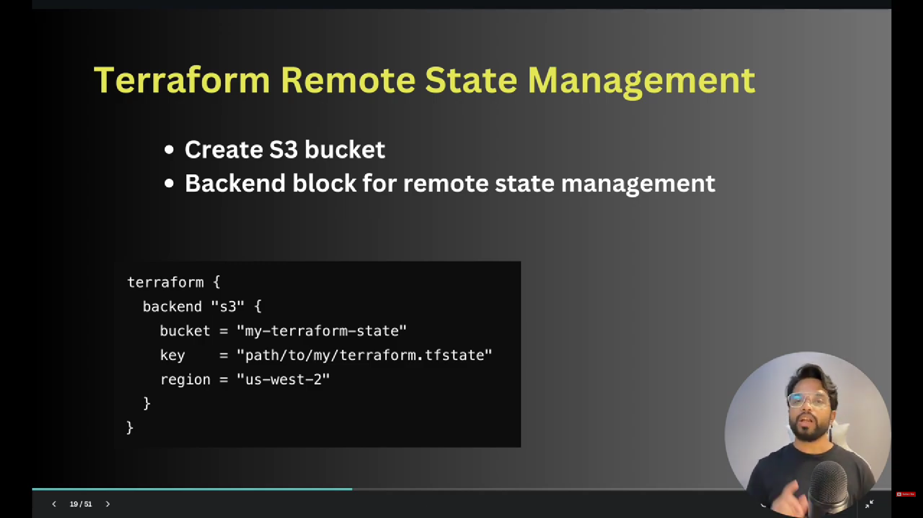
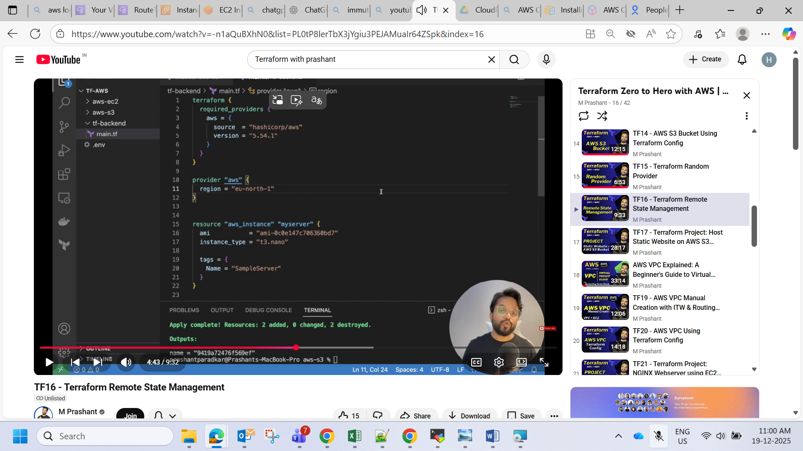
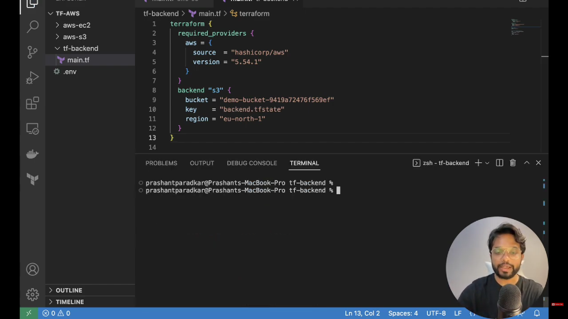
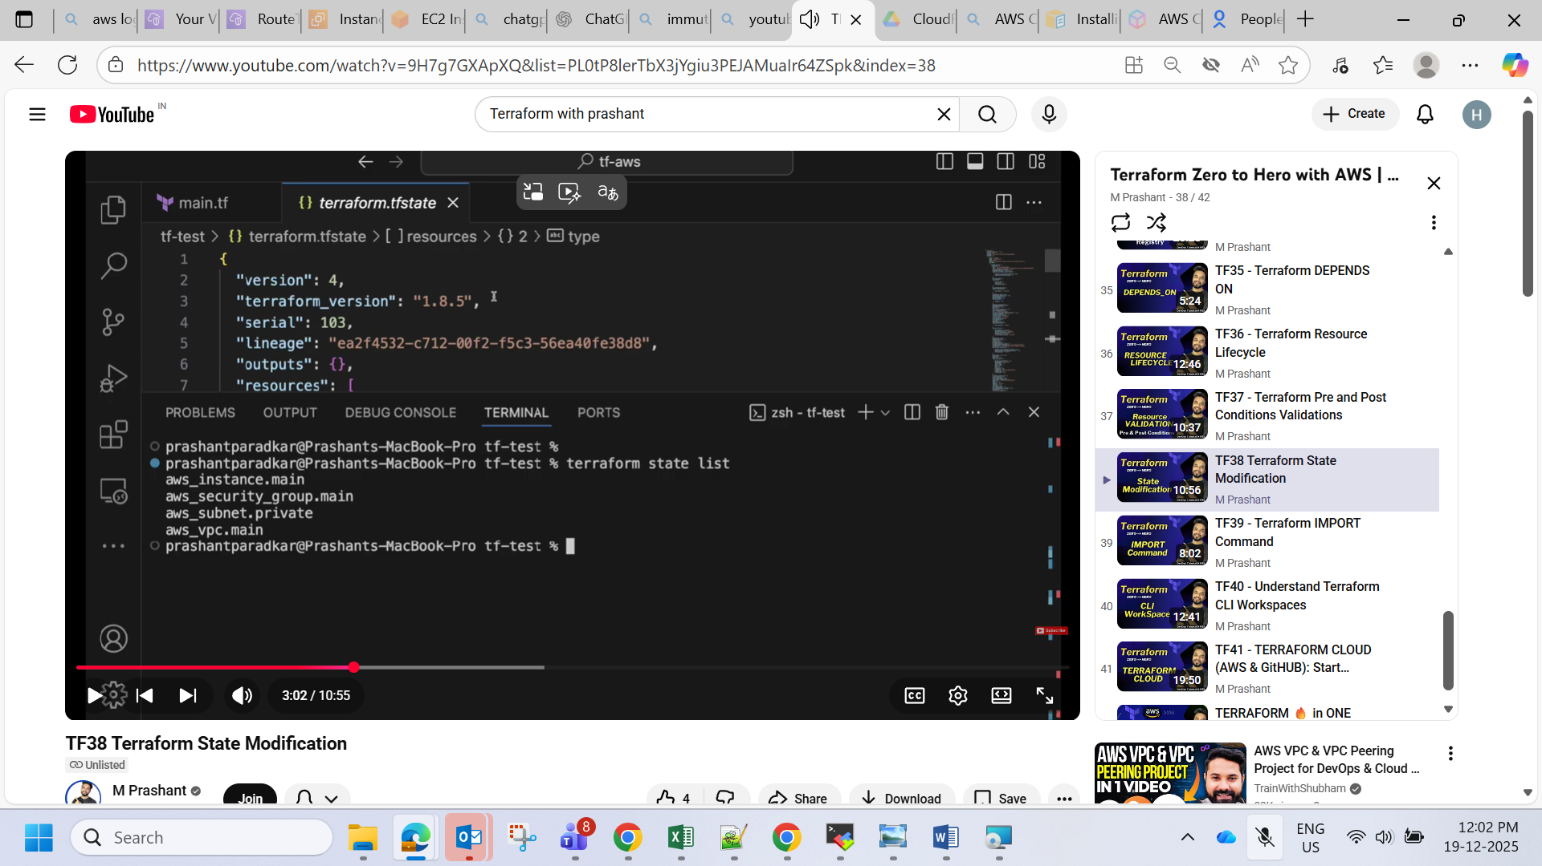
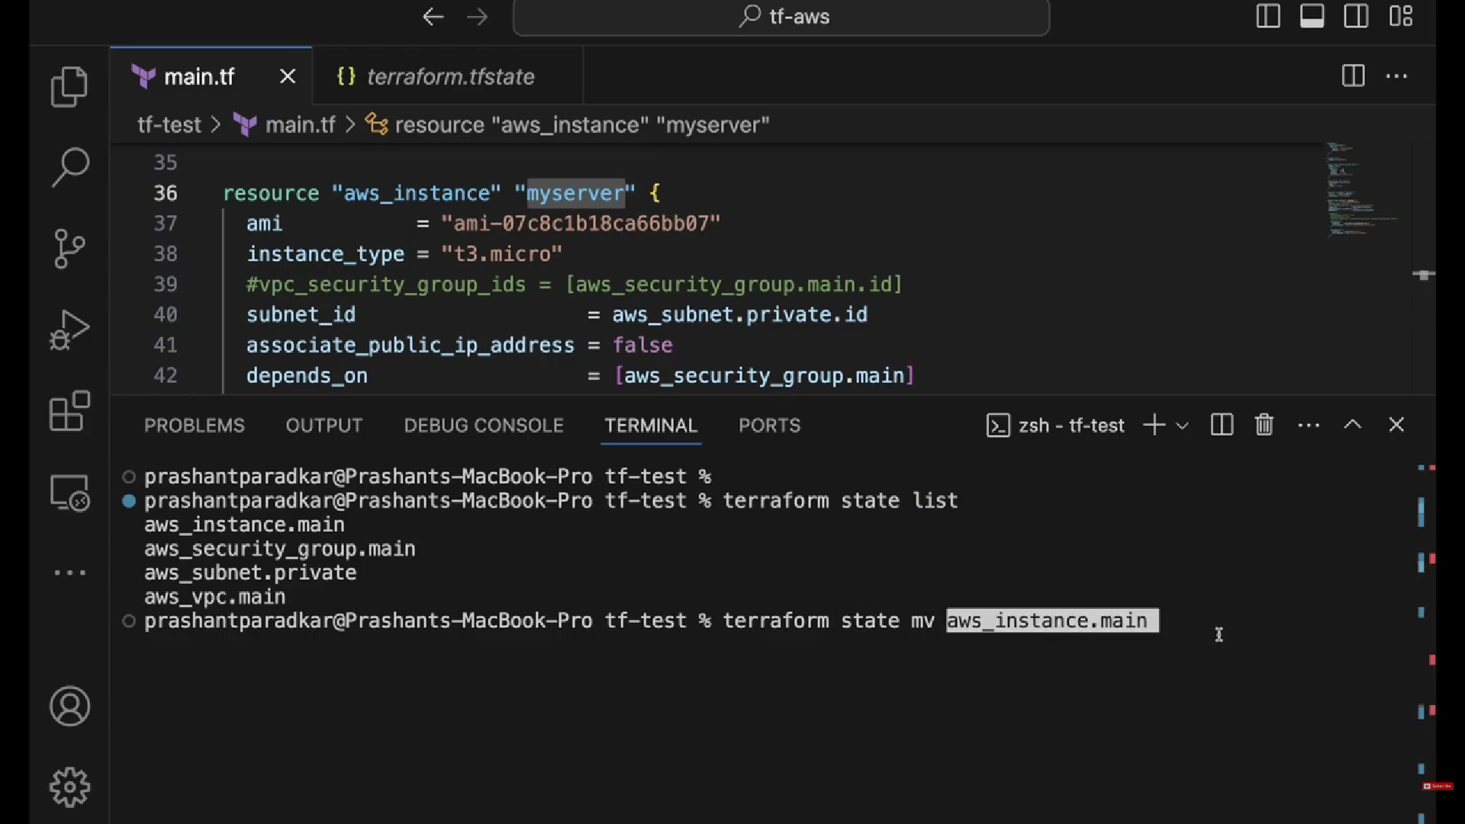
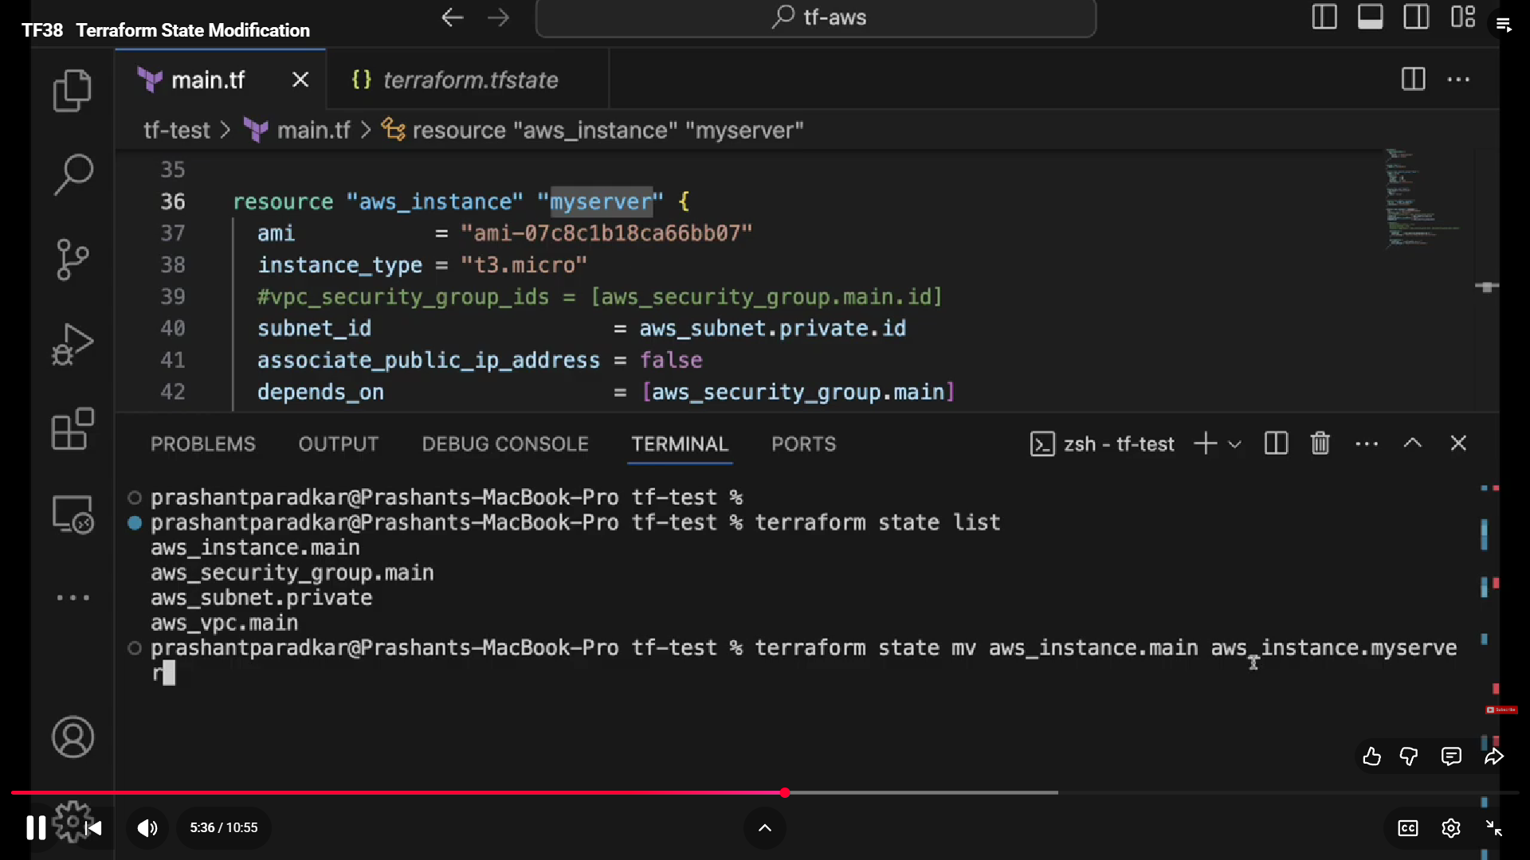
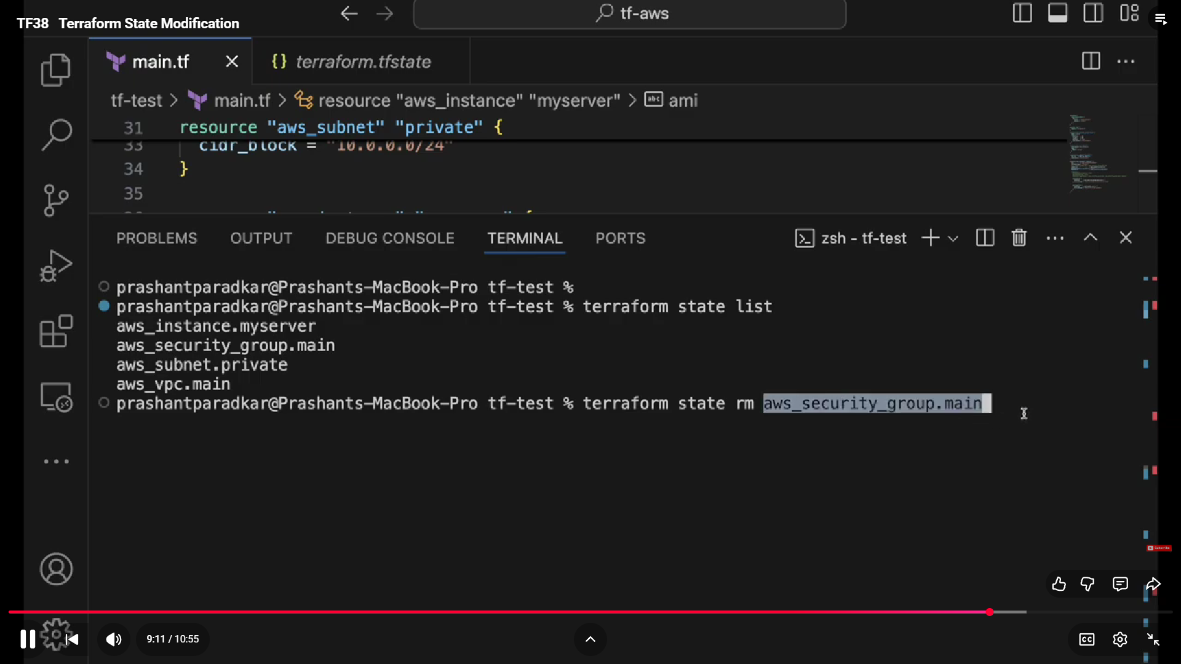
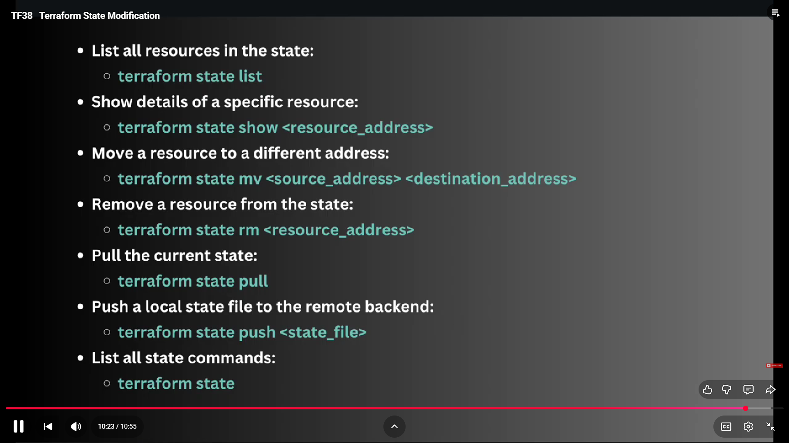
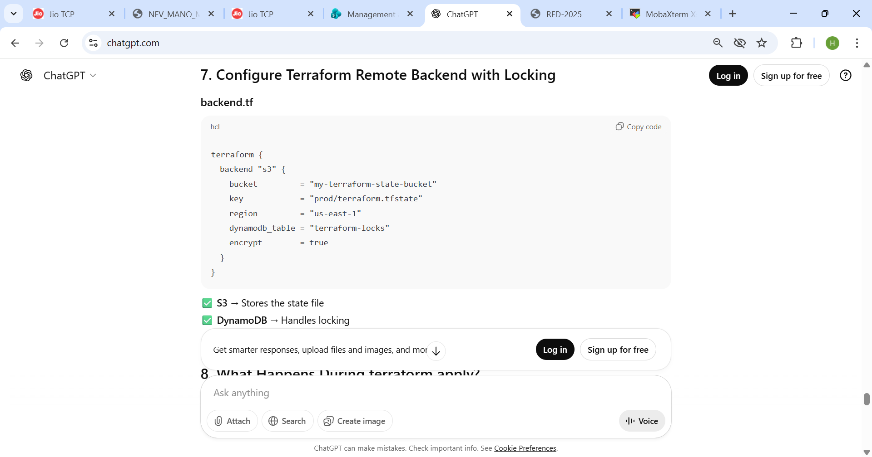
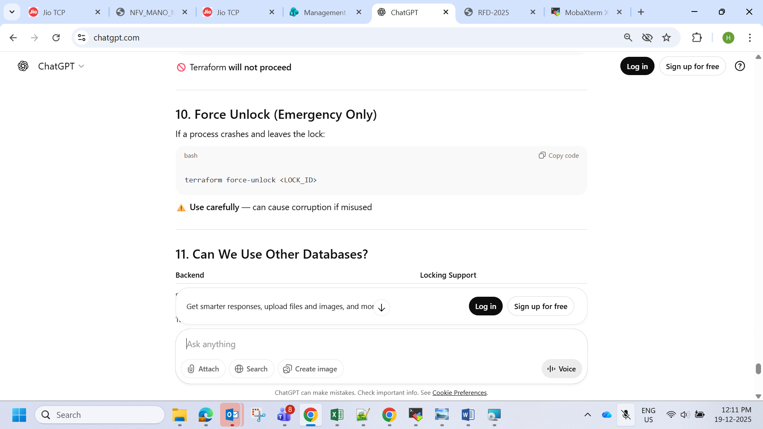
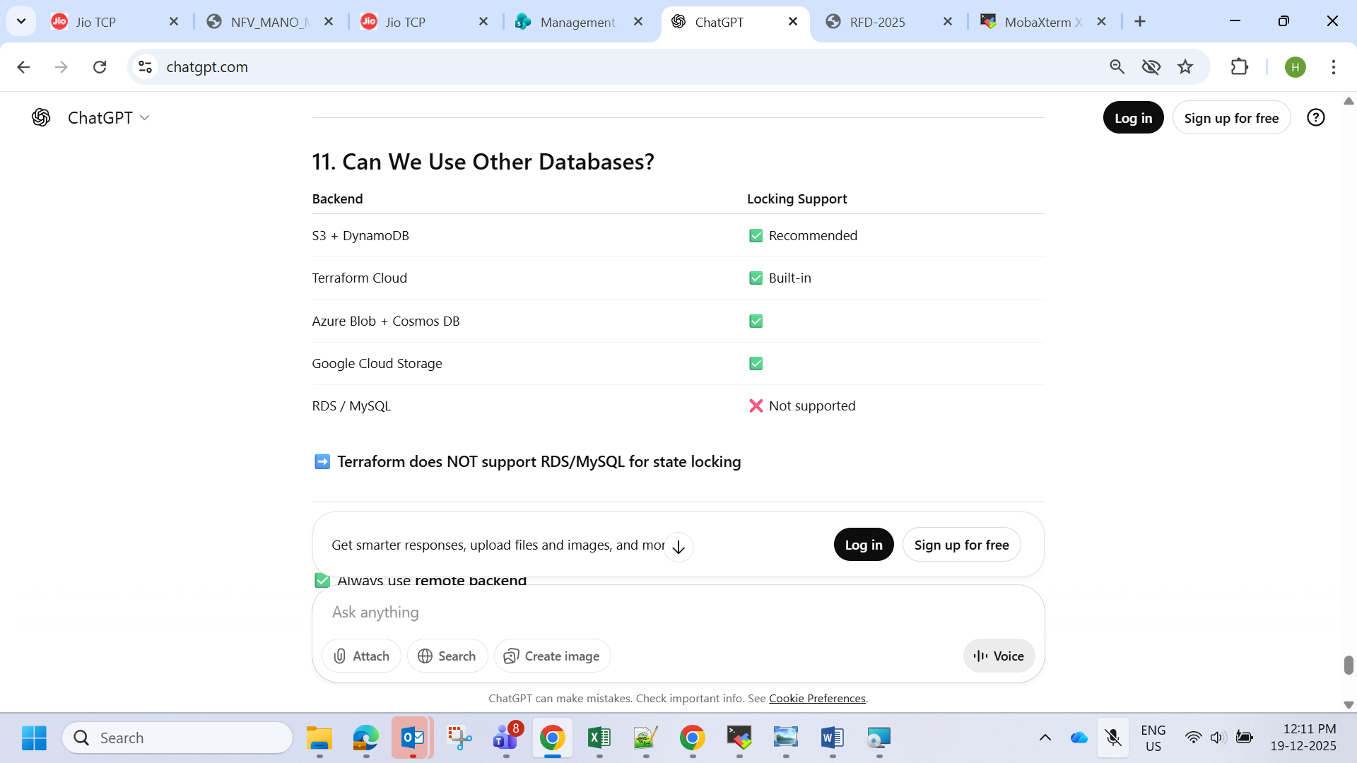

🧱 What is Docker Swarm?
Docker Swarm is Docker’s native clustering tool. It turns multiple Docker hosts into a single virtual cluster.

🖥️ Example Setup
Node Type | Hostname | IP Address
Manager | manager1 | 192.168.1.10
Worker | worker1 | 192.168.1.11
Worker | worker2 | 192.168.1.12

✅ STEP 1 — Install Docker (If Not Installed)
On all nodes:

Ubuntu/Debian:
sudo apt update
sudo apt install docker.io -y

RHEL/CentOS:
sudo yum install docker -y
Start Docker:
sudo systemctl start docker
sudo systemctl enable docker
Verify:
docker --version

✅ STEP 2 — Initialize Swarm (On Manager Node)
Login to your manager node.
Run:
docker swarm init --advertise-addr 192.168.1.10
Replace 192.168.1.10 with your manager's IP.
You will see output like:
Swarm initialized: current node is now a manager.

To add a worker to this swarm, run:

docker swarm join --token SWMTKN-1-xxxxx 192.168.1.10:2377
👉 Copy this join command.

✅ STEP 3 — Join Worker Nodes
Go to each worker node and run the join command:
docker swarm join --token SWMTKN-1-xxxxx 192.168.1.10:2377
You should see:
This node joined a swarm as a worker.

✅ STEP 4 — Verify Swarm Cluster
On the manager node:
docker node ls
Example output:
ID HOSTNAME STATUS AVAILABILITY MANAGER STATUS
xxxx manager1 Ready Active Leader
yyyy worker1 Ready Active
zzzz worker2 Ready Active

✅ STEP 5 — Create a Service in Swarm
Let’s deploy nginx as an example:
docker service create --name web --replicas 3 -p 8080:80 nginx
This:
- Creates service named web
- Runs 3 containers
- Exposes port 8080
Check services:
docker service ls
Check tasks:
docker service ps web

✅ STEP 6 — Scale the Service
Increase replicas:
docker service scale web=5

✅ STEP 7 — Test Load Balancing
Access from browser:
http://192.168.1.10:8080
Swarm automatically load balances across replicas.

🔁 Important Swarm Commands

View nodes
docker node ls

Inspect node
docker node inspect <node-id>

Remove worker
docker node rm <node-id>

Leave swarm (worker)
docker swarm leave

Force manager leave
docker swarm leave --force

👑 Add Another Manager (High Availability)
On manager:
docker swarm join-token manager
Run the provided command on another node.

🌐 Networking Ports Required
Make sure these ports are open between nodes:
Port | Purpose
2377 | Cluster management
7946 TCP/UDP | Node communication
4789 UDP | Overlay network

🧠 How Swarm Works Internally
- Manager nodes handle cluster state
- Worker nodes run containers
- Raft consensus maintains cluster consistency
- Built-in load balancing
- Overlay networking

🧪 Optional: Deploy Using Docker Stack (Production Style)
Create docker-compose.yml:
version: "3.8"
services:
web:
image: nginx
deploy:
replicas: 3
ports:
- "8080:80"
Deploy stack:
docker stack deploy -c docker-compose.yml mystack

can explain answers for below question detail as this was asked me in interview How to identify private or public subnet How u are different from Ai if ai is there then how u are special then that New server how to check ram cpu If so many open files showing erroe then how to debug and resolve Autoscalling which entity is there between instance and autoscalling that u will know it is exceed and it should scale Ecr u have worked on Jenkins job which u have made Y elb needs to deploy if u have load balancer Which pipeline u used freestyle or pipeline Which data base u have worked on How u installed kibana How u made es cluster up On aws database u have worked on How to access private subnet instance Have you observed 300% full on your server disk and how to debug Which type of application u have created on ec2 How u are deciding which type of ec2 u want select examplae t2 micro how u decide Have you created vpc Have you created ecs ers eks how to
Below are detailed, interview-style answers you can use. I’ll keep them practical and real-world focused (DevOps / AWS perspective).

1️⃣ How to identify private or public subnet?
In AWS, subnet type depends on route table configuration, not the name.

✅ Public Subnet:
- Route table has a route to Internet Gateway (IGW)
Example:
0.0.0.0/0 → igw-xxxx
- Instance has public IP / Elastic IP.
- Used for: Bastion, Load Balancer, Web servers.

✅ Private Subnet:
- No route to IGW.
- Usually route goes to NAT Gateway:
0.0.0.0/0 → nat-xxxx
- No public IP assigned.
- Used for: DB, backend apps.
👉 So I check:
- Route Table
- Internet Gateway attached?
- Public IP assigned?

2️⃣ How are you different from AI?
You can answer diplomatically:
AI provides automated answers and suggestions. But I bring real production experience, troubleshooting skills, decision-making ability, and understanding of business impact. I can design, implement, debug, and optimize systems based on real scenarios, which AI alone cannot execute.
AI assists. Engineers implement.

3️⃣ New server – how to check RAM & CPU?

Linux commands:
free -h # RAM usage
top # CPU usage live
htop # Better view
lscpu # CPU details
nproc # Number of cores
cat /proc/cpuinfo
Disk:
df -h

4️⃣ Too many open files error – how to debug & resolve?
Error:
Too many open files

Step 1: Check limit
ulimit -n

Step 2: Check open files
lsof | wc -l
lsof -u username

Step 3: Increase limit
Temporary:
ulimit -n 65535
Permanent:
Edit:
/etc/security/limits.conf
Add:
* soft nofile 65535
* hard nofile 65535
Restart service.
Also check application file descriptor leak.

5️⃣ Auto Scaling – what monitors instance?
Between instance and Auto Scaling, the key component is:

👉 CloudWatch
Specifically:
Amazon CloudWatch
It monitors:
- CPU
- Memory (via custom metrics)
- Network
- Custom metrics
Auto Scaling triggers based on CloudWatch Alarms.

6️⃣ ECR – Have you worked on it?
Yes.
Amazon Elastic Container Registry
Used for:
- Storing Docker images
- Integrated with ECS / EKS
Steps:
- Build Docker image
- Tag image
- Push to ECR
- ECS pulls image during deployment

7️⃣ Jenkins jobs you created?
Jenkins
Created:
- CI pipeline for Java app
- Docker build & push
- SonarQube scan
- Deployment to EC2 / ECS
Stages:
- Git pull
- Build (Maven)
- Test
- Docker build
- Push to ECR
- Deploy

8️⃣ Why ELB is needed?
Elastic Load Balancing
Purpose:
- Distributes traffic across multiple EC2 instances
- High availability
- Health checks
- SSL termination
Without ELB:
- Single point of failure

9️⃣ Which pipeline used – freestyle or pipeline?
Used:
- Freestyle (basic jobs)
- Mostly Declarative Pipeline (Jenkinsfile)
Pipeline is better because:
- Code versioning
- Reusable
- Scalable

🔟 Which databases worked on?
- MySQL
- PostgreSQL
- MongoDB
On AWS:
- Amazon RDS
- Amazon DynamoDB

11️⃣ How did you install Kibana?
Kibana
Steps:
- Install Elasticsearch
- Add Elastic repo
- Install:
yum install kibana
- Configure:
/etc/kibana/kibana.yml
- Start service:
systemctl start kibana

12️⃣ How did you make Elasticsearch cluster up?
Elasticsearch
Steps:
- Install on multiple nodes
- Configure:
cluster.name
node.name
network.host
discovery.seed_hosts
- Start services
- Verify:
curl localhost:9200/_cluster/health

13️⃣ AWS DB worked on?
- Amazon RDS (MySQL, PostgreSQL)
- DynamoDB
- Aurora

14️⃣ How to access private subnet instance?
Options:
- Bastion Host (Jump Server)
- VPN
- AWS SSM (Session Manager)
Best modern way:
Use AWS Systems Manager Session Manager (no SSH key needed).

15️⃣ Disk showing 300% full – how to debug?
First:
df -h
Check large files:
du -sh /*
Check logs:
/var/log
Check deleted files still open:
lsof | grep deleted
Clear:
- Old logs
- Rotate logs
- Remove temp files
If inode issue:
df -i

16️⃣ What type of application deployed on EC2?
- Java Spring Boot app
- Node.js app
- Nginx reverse proxy
- Dockerized microservices

17️⃣ How do you decide EC2 type? Example t2.micro?
Amazon EC2
I check:
- Application requirement (CPU, RAM)
- Traffic expectation
- Benchmark testing
- Cost optimization
- Burst vs steady workload
Example:
- Low traffic → t2.micro
- Production high load → m5.large or c5.large

18️⃣ Have you created VPC?
Yes.
Steps:
- Create VPC (CIDR block)
- Create Public & Private Subnets
- Attach IGW
- Create NAT Gateway
- Configure Route Tables
- Security Groups
- NACL

19️⃣ Have you created ECS / EKS?

ECS:
Amazon ECS
Steps:
- Create cluster
- Create task definition
- Attach IAM role
- Create service
- Attach ALB
- Auto Scaling config

EKS:
Amazon EKS
Steps:
- Create cluster
- Create worker nodes
- Configure kubectl
- Deploy YAML
- Service + Ingress

In AWS, **ALB** and **NLB** are both types of Elastic Load Balancers provided by entity["company","Amazon Web Services","cloud computing company"] under the entity["product","Elastic Load Balancing","aws service"] service.

They serve different purposes depending on your application needs.

---

# 1️⃣ What is ALB (Application Load Balancer)?

entity["product","Application Load Balancer","aws load balancer type"] operates at **Layer 7 (Application Layer)** of the OSI model.

It understands **HTTP and HTTPS traffic** and can make routing decisions based on:

- URL path (`/api`, `/images`)
- Hostname (`app.example.com`)
- HTTP headers
- Query strings

---

## ✅ When to Use ALB

Use ALB when:

- You are running **web applications**
- You need **path-based routing**
- You need **host-based routing**
- You are using **microservices architecture**
- You want **WebSocket support**
- You need **integration with Kubernetes (EKS)**
- You need authentication (OIDC, Cognito)
- You want HTTP → HTTPS redirection

---

## 🔹 ALB Example

Imagine you have:

- `example.com/api` → API servers
- `example.com/images` → Image servers
- `example.com/admin` → Admin app

ALB can route traffic like this:

| Request | Target Group |
|----------|--------------|
| `/api/*` | API EC2 instances |
| `/images/*` | Image EC2 instances |
| `/admin/*` | Admin servers |

This is called **content-based routing**.

---

## 🔹 Real-World Example

E-commerce website:

- Frontend service
- Payment service
- Order service
- Authentication service

ALB routes traffic to different microservices based on URL paths.

---

## 🔹 ALB Supports

- HTTP
- HTTPS
- WebSockets
- gRPC
- WAF integration
- Sticky sessions (via cookies)

---

# 2️⃣ What is NLB (Network Load Balancer)?

entity["product","Network Load Balancer","aws load balancer type"] operates at **Layer 4 (Transport Layer)**.

It handles:

- TCP
- UDP
- TLS

It does NOT understand HTTP paths or headers.

It just forwards traffic based on:

- IP address
- Port number

---

## ✅ When to Use NLB

Use NLB when:

- You need **extreme performance**
- You need **very low latency**
- You handle **millions of requests per second**
- You use **non-HTTP protocols**
- You need **static IP addresses**
- You need to preserve client IP
- You are running **real-time systems**
- You use TCP/UDP applications

---

## 🔹 NLB Example

Imagine you run:

- A gaming server (UDP)
- A financial trading app (TCP)
- A custom TCP protocol
- VoIP system

NLB can forward traffic directly to backend servers without inspecting HTTP.

---

## 🔹 Real-World Example

High-frequency trading platform:

- Needs microsecond latency
- Uses raw TCP connections
- Cannot tolerate overhead of Layer 7 inspection

NLB is best choice.

---

# 🔥 ALB vs NLB — Detailed Comparison

| Feature | ALB | NLB |
|----------|------|------|
| OSI Layer | Layer 7 | Layer 4 |
| Protocols | HTTP, HTTPS, WebSocket, gRPC | TCP, UDP, TLS |
| Path-based routing | ✅ Yes | ❌ No |
| Host-based routing | ✅ Yes | ❌ No |
| Static IP | ❌ No | ✅ Yes |
| Performance | High | Ultra High |
| Latency | Low | Ultra Low |
| Best For | Web apps, microservices | Gaming, IoT, TCP apps |
| WAF support | ✅ Yes | ❌ No |
| SSL termination | Yes | Yes (TLS pass-through or termination) |
| Preserve Client IP | No (by default uses X-Forwarded-For) | Yes (native) |

---

# 🧠 Architecture-Level Decision Guide

## 👉 Choose ALB If:

- You're building:
- SaaS app
- REST APIs
- Microservices
- Kubernetes workloads
- You need smart routing rules
- You need WAF
- You need authentication at load balancer

## 👉 Choose NLB If:

- You’re building:
- Gaming backend
- IoT platform
- TCP-based system
- VoIP
- Financial systems
- You need static IP
- You need extreme throughput
- You need to preserve client IP

---

# 🔥 Advanced AWS Scenario Comparison

### Scenario 1: Microservices on ECS

Use ALB
Why? You can route `/user` → User Service, `/orders` → Order Service.

---

### Scenario 2: Kubernetes on EKS

Use ALB
Integrated with Ingress Controller.

---

### Scenario 3: MQTT IoT Platform

Use NLB
Because MQTT runs over TCP.

---

### Scenario 4: Real-time multiplayer game

Use NLB
Because UDP + low latency required.

---

# 💡 Can You Use Both Together?

Yes!

Example architecture:

```
CloudFront
↓
ALB (Web traffic)
↓
Microservices

NLB (TCP traffic)
↓
Gaming / Real-time servers
```

Many large systems use both.

---

# 🚀 Simple Rule to Remember

If it’s **HTTP/HTTPS and needs smart routing → ALB**

If it’s **TCP/UDP and needs performance → NLB**

---

If you'd like, I can also explain:

- ALB vs NLB vs Classic Load Balancer
- Pricing differences
- Interview-focused explanation
- Architecture diagram explanation
- Real production case study

Just tell me 😊
RDS

admin
abcd123456
how to connect database with container creation on ec2
docker run --rm -p 80:3000 -e DB_HOST="database-1.c9ki0coq6mb2.ap-south-1.rds.amazonaws.com" -e DB_USER="admin" -e DB_PASSWORD="" -d philippaul/node-mysql-app:02
how to logged in to data base

docker run -it --rm mysql:8.0 mysql -h database-1.c9ki0coq6mb2.ap-south-1.rds.amazonaws.com -u admin -p

ec2 snaps
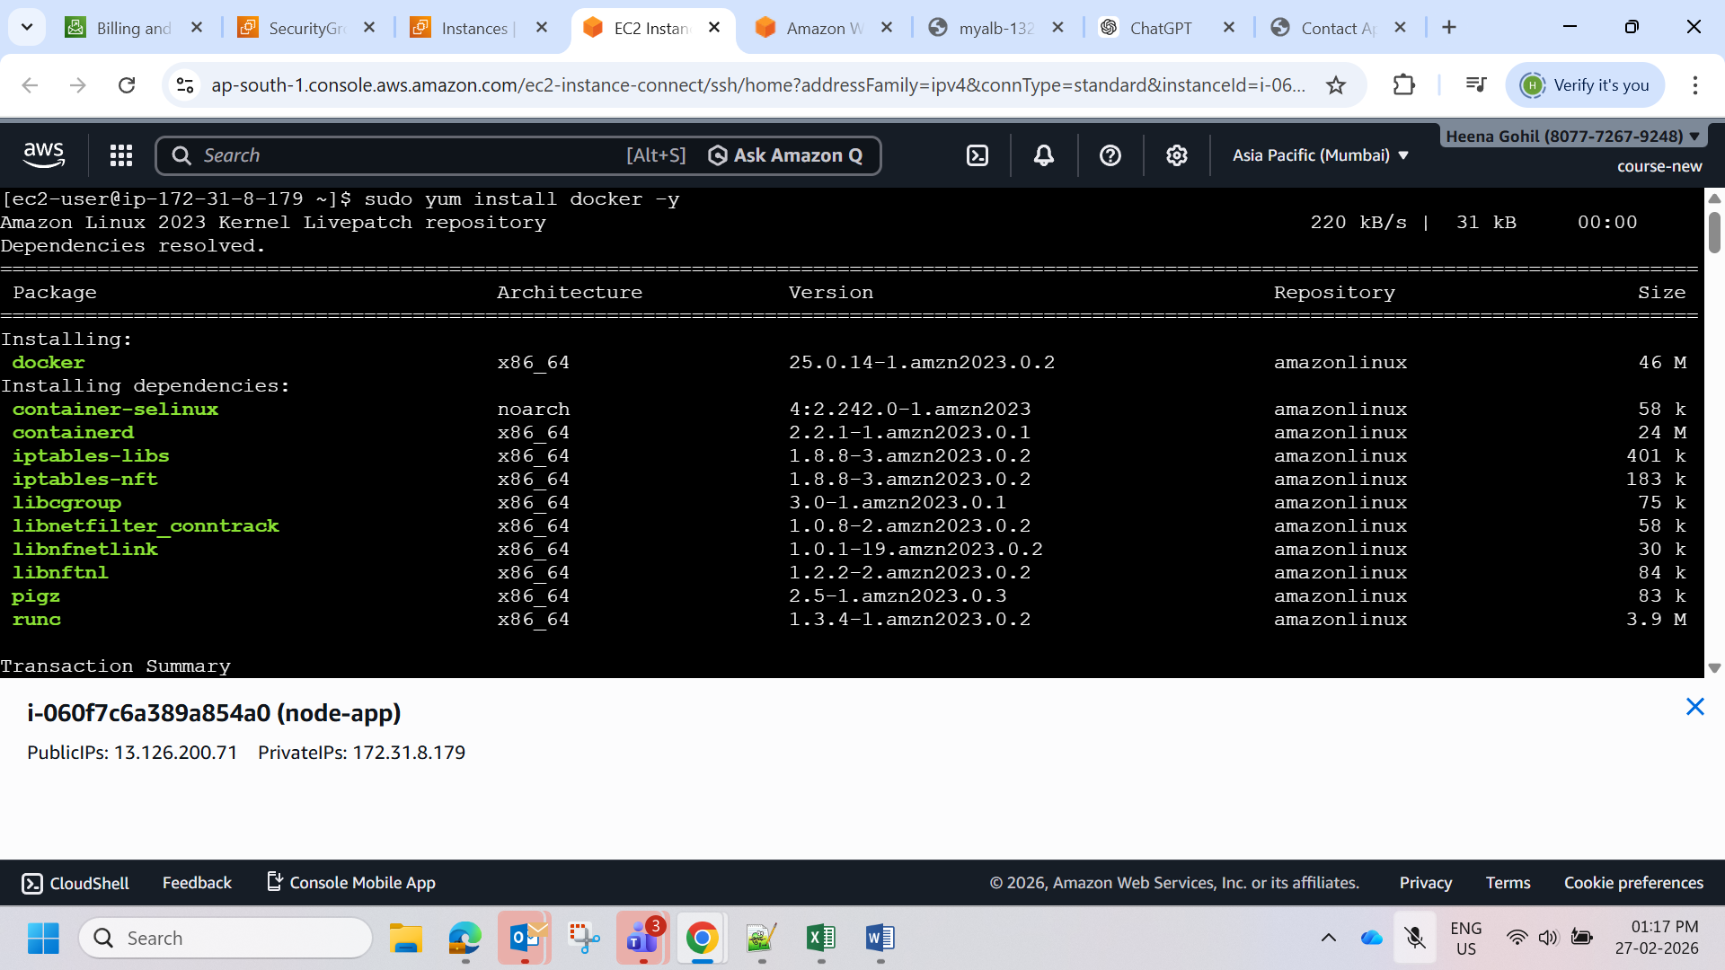
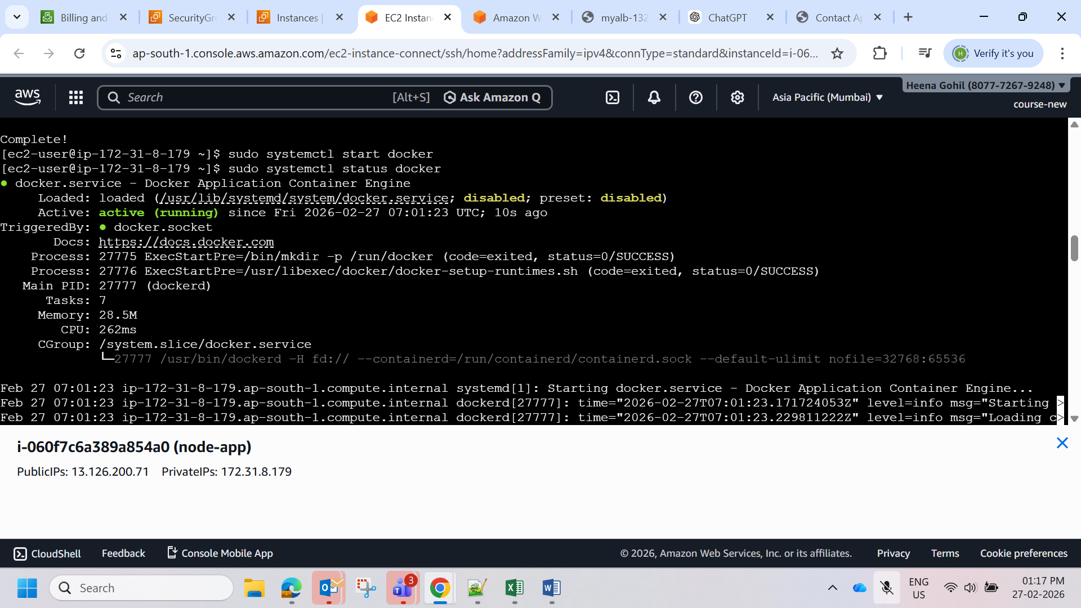

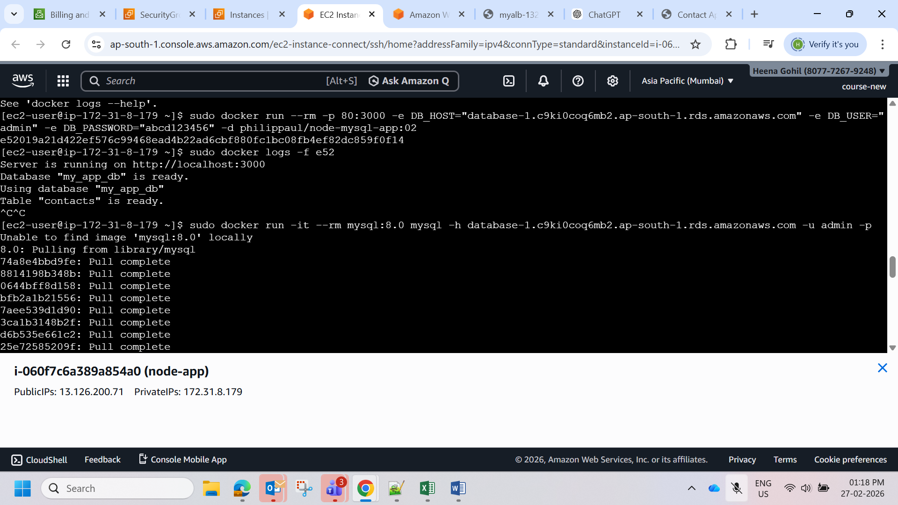
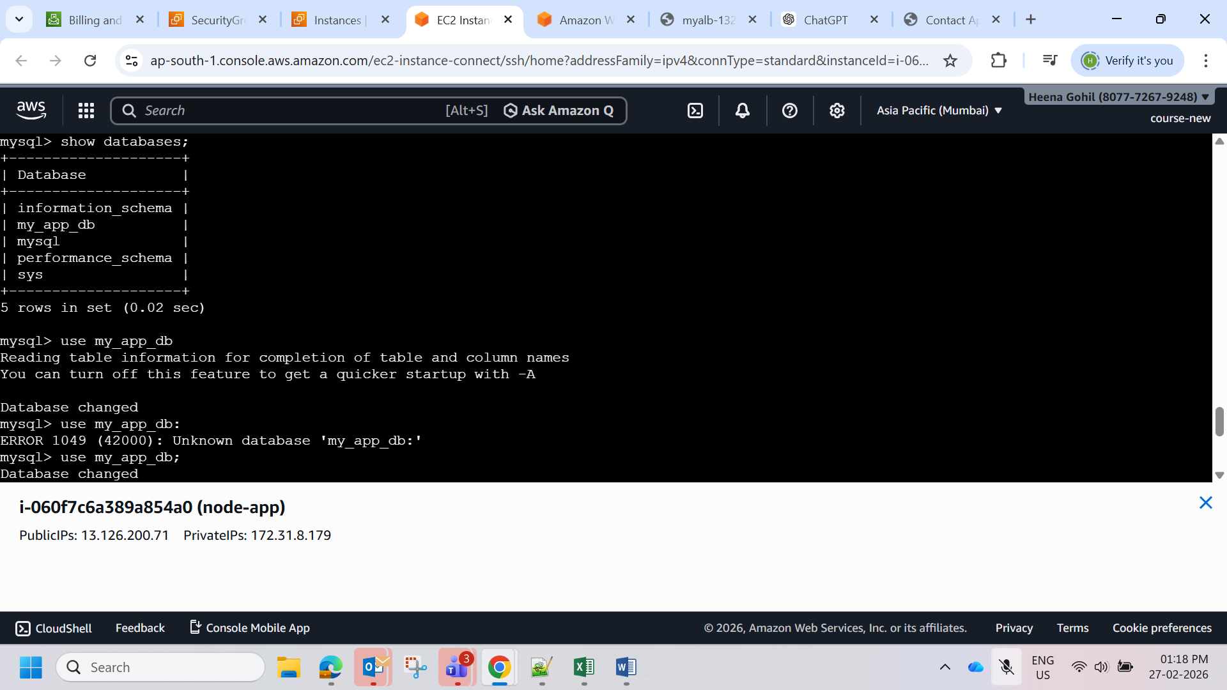
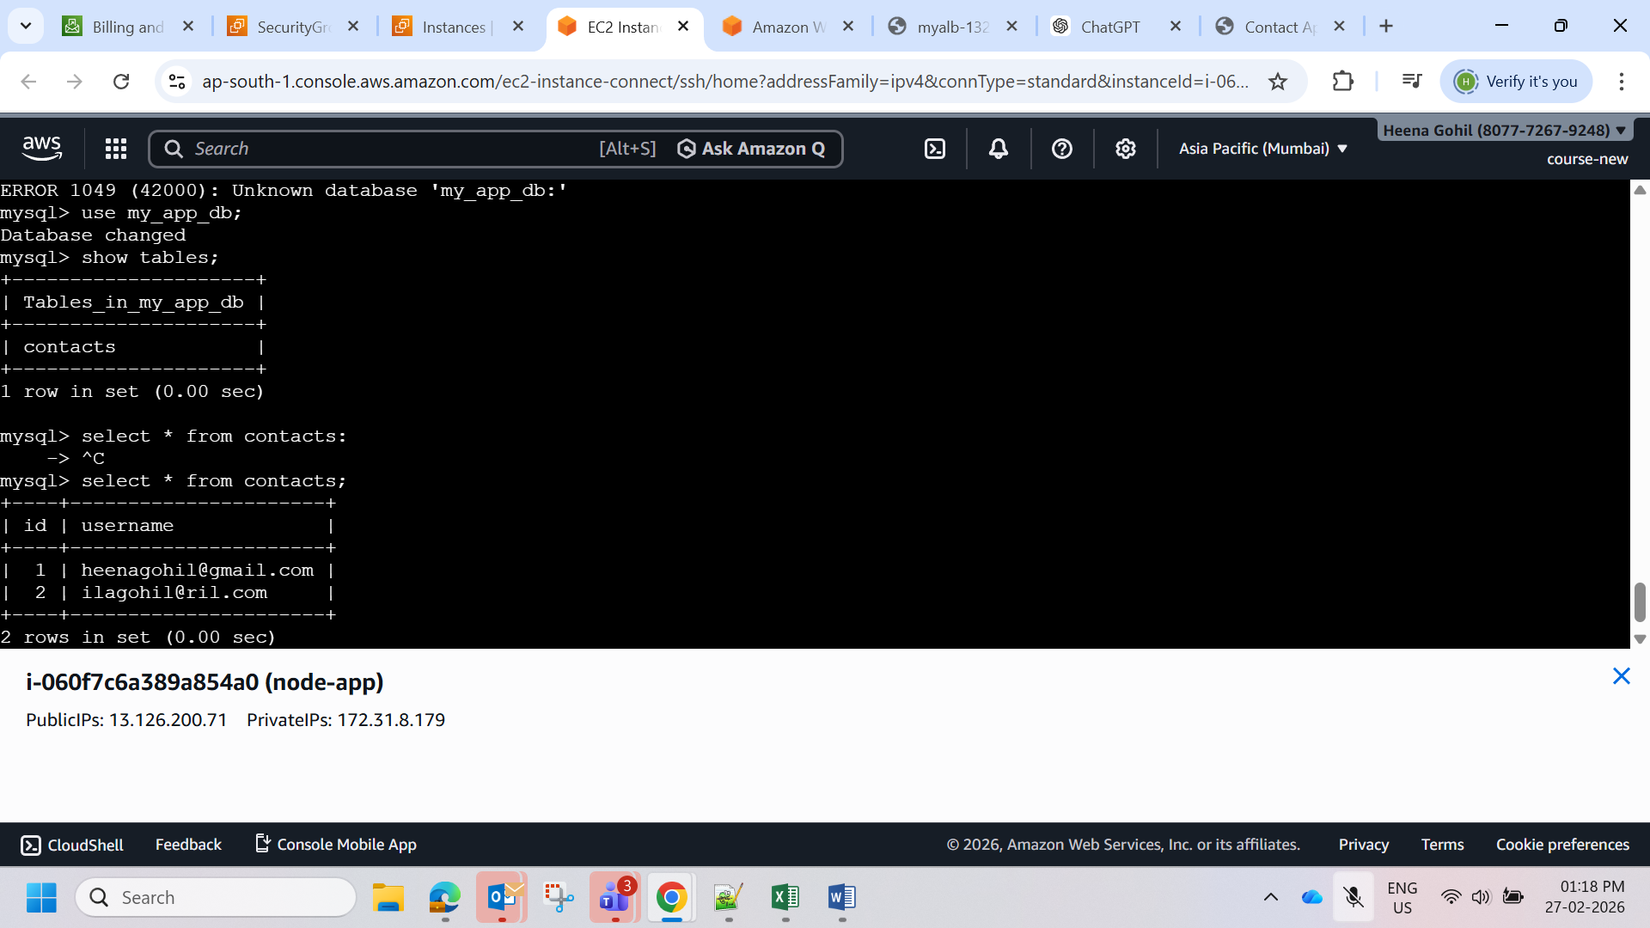
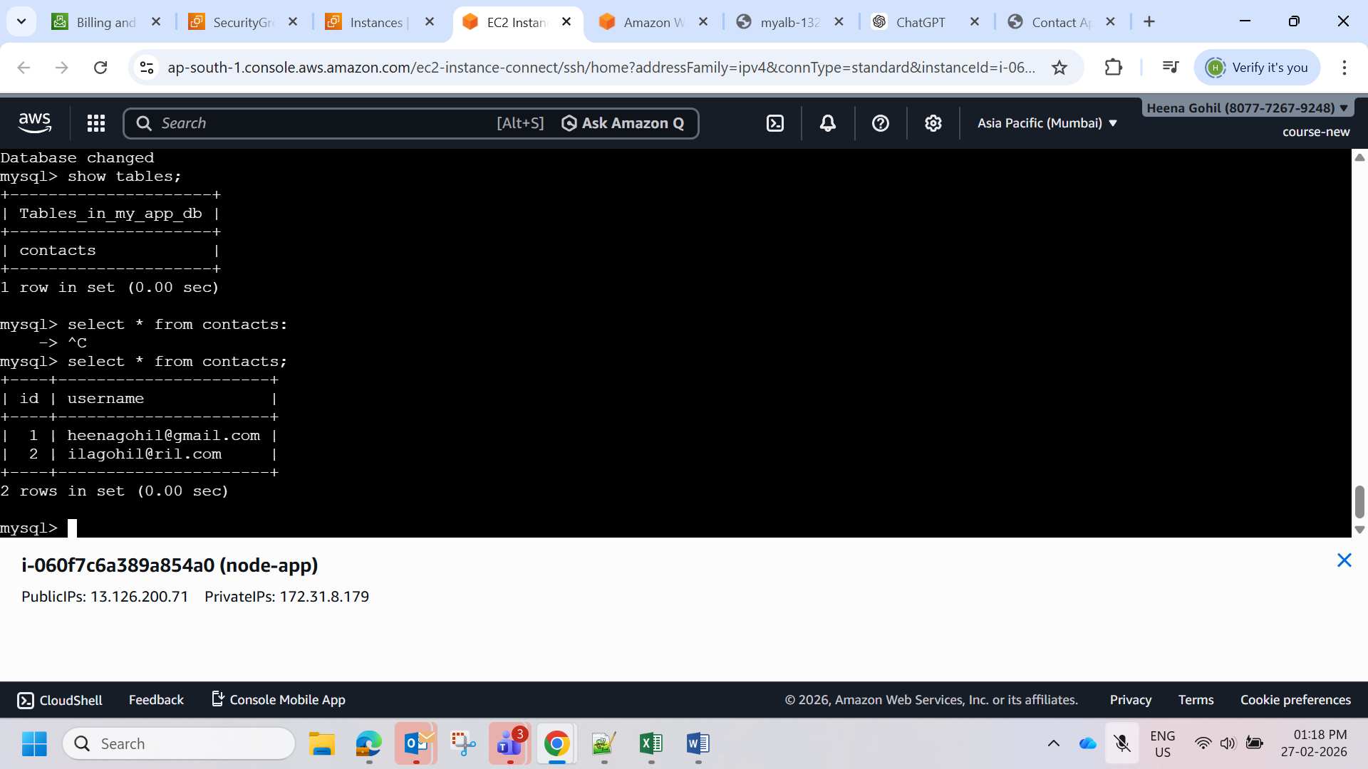

Below is a detailed explanation for the 20 Terraform scenario interview questions. These explanations are written the way you can answer in an L1/L2 DevOps interview using Terraform with cloud platforms like Amazon Web Services.

1️⃣ Terraform state file deleted. What happens?

The Terraform state file (terraform.tfstate) keeps track of all infrastructure resources created by Terraform.

If it is deleted:

• Terraform loses track of existing resources.

• On the next terraform apply, Terraform may try to recreate resources because it thinks they do not exist.

• This can cause duplicate infrastructure or conflicts.

Best practice

• Store state remotely (S3, Terraform Cloud).

• Enable state backups.

2️⃣ Multiple engineers running Terraform. How to avoid conflict?

If multiple engineers run Terraform at the same time, the state file may get corrupted.

Solution Use remote backend with state locking.

Example architecture:

• S3 bucket → store state file

• DynamoDB → lock state file

Example configuration:

terraform {

backend "s3" {

bucket = "terraform-state-bucket"

key = "project/terraform.tfstate"

region = "us-east-1"

dynamodb_table = "terraform-lock"

}

}

State locking prevents multiple users modifying infrastructure simultaneously.

3️⃣ Infrastructure drift detected. What to do?

Infrastructure drift occurs when resources are changed manually outside Terraform.

Example: Someone modifies EC2 configuration directly in AWS console.

To detect drift:

terraform plan

Terraform compares:

• Current infrastructure

• Terraform configuration

It shows the differences.

Fix

• Update Terraform code

• Run terraform apply

4️⃣ Terraform apply failed halfway. What happens?

If terraform apply fails in the middle:

• Some resources may be created

• Others may not

But Terraform still records successful resources in the state file.

Example:

EC2 created

RDS failed

Load balancer not created

Next step

Run again:

terraform apply

Terraform will continue from where it stopped.

5️⃣ How to reuse Terraform code?

Terraform code reuse is done using modules.

Modules allow you to reuse infrastructure templates.

Example module structure:

modules/

vpc/

ec2/

rds/

Example usage:

module "vpc" {

source = "./modules/vpc"

cidr = "10.0.0.0/16"

}

Benefits:

• Reusability

• Standardization

• Cleaner code

6️⃣ How to manage multiple environments?

Organizations usually have environments like:

• Dev

• Staging

• Production

There are two main methods.

Method 1 – Workspaces

terraform workspace new dev

terraform workspace new prod

Each workspace has its own state file.

Method 2 – Separate directories

envs/

dev/

staging/

prod/

7️⃣ How to store secrets in Terraform?

Never store secrets directly in Terraform code.

Bad example:

password = "mypassword"

Best methods:

• Environment variables

• AWS Secrets Manager

• HashiCorp Vault

• Encrypted variables

Example:

export TF_VAR_db_password=secret

8️⃣ How to store Terraform state remotely?

Remote state allows teams to collaborate safely.

Common remote storage options:

• S3

• Terraform Cloud

• Azure Storage

• Google Cloud Storage

Example S3 backend:

terraform {

backend "s3" {

bucket = "terraform-state"

key = "prod/terraform.tfstate"

region = "us-east-1"

}

}

Benefits:

• Shared access

• State locking

• Backup

9️⃣ What is Terraform locking?

State locking prevents multiple Terraform operations simultaneously.

Without locking:

Engineer A → terraform apply

Engineer B → terraform apply

This may corrupt the state file.

Locking ensures:

Only one operation allowed

Tools used:

• DynamoDB (AWS)

• Terraform Cloud

🔟 Terraform plan vs apply?

Command Purpose

terraform plan Shows what changes will happen

terraform apply Executes the changes

Example workflow:

terraform init

terraform plan

terraform apply

Plan helps detect errors before applying changes.

11️⃣ How to destroy infrastructure?

Terraform can delete all resources using:

terraform destroy

Terraform reads the state file and removes all managed resources.

Example:

• EC2

• VPC

• Load balancer

Everything created by Terraform will be removed.

12️⃣ How to debug Terraform errors?

Use these commands.

Validate syntax

terraform validate

Check execution plan

terraform plan

Enable debug logs

TF_LOG=DEBUG terraform apply

13️⃣ What is a provider?

A provider is a plugin that allows Terraform to interact with cloud services.

Example providers:

• AWS

• Azure

• Google Cloud

Example configuration:

provider "aws" {

region = "us-east-1"

}

Providers translate Terraform code into API calls.

14️⃣ What is a variable?

Variables make Terraform configurations flexible and reusable.

Example:

variable "instance_type" {

default = "t2.micro"

}

Usage:

instance_type = var.instance_type

Benefits:

• Reusability

• Environment customization

15️⃣ What is output variable?

Output variables display important information after deployment.

Example:

output "instance_ip" {

value = aws_instance.web.public_ip

}

After terraform apply:

instance_ip = 52.10.12.45

16️⃣ What is Terraform module?

A module is a reusable Terraform configuration.

Example resources inside module:

module/

main.tf

variables.tf

outputs.tf

Benefits:

• Code reuse

• Standard infrastructure

17️⃣ What is state locking?

State locking prevents simultaneous modifications to Terraform state.

Example with AWS:

• State file → S3

• Locking → DynamoDB

If someone runs Terraform:

State locked by user

Other users must wait.

18️⃣ How to upgrade Terraform provider?

Providers can be upgraded using:

terraform init -upgrade

This downloads the latest compatible provider version.

Example:

hashicorp/aws v4 → v5

19️⃣ What is dependency in Terraform?

Terraform automatically understands dependencies between resources.

Example:

EC2 depends on VPC

Terraform creates resources in correct order.

Manual dependency example:

depends_on = [aws_vpc.main]

20️⃣ What is Terraform backend?

Backend defines where the state file is stored.

Types:

• Local backend

• Remote backend

Example:

terraform {

backend "s3" {

bucket = "terraform-state"

}

}

Benefits:

• Collaboration

• State locking

• Backup

🎯 Most Important Terraform Interview Topics

If your role requires Terraform with Amazon Web Services, interviewers usually focus on:

• State file

• Remote backend

• Modules

• Workspaces

• Terraform lifecycle

• Infrastructure drift

• Terraform debugging

✅ If you want, I can also give you very powerful DevOps interview topics like:

• 25 Terraform real production scenarios

• 30 AWS DevOps architecture questions

• 40 Kubernetes troubleshooting scenarios

• Complete DevOps interview preparation roadmap

These are very commonly asked in senior DevOps interviews. 🚀

Great 👍 Below is the advanced preparation set interviewers often ask for DevOps L1/L2 rounds based on tools like Kubernetes, Terraform, Jenkins, and Amazon Web Services.

🔧 Top 30 Kubernetes Troubleshooting Interview Questions

1. Pod is not starting. What will you check?

Steps

1. Check pod status

2. Describe pod

3. Check logs

kubectl get pods

kubectl describe pod

kubectl logs

2. Pod is in CrashLoopBackOff. Why?

Possible reasons:

• Application error

• Wrong environment variables

• Port conflict

• Dependency service not running

3. ImagePullBackOff error?

Reasons:

• Wrong image name

• Private registry authentication failure

• Image does not exist

4. Pod stuck in Pending state?

Reasons:

• No available resources

• Node selector mismatch

• Persistent volume not available

5. Service not accessible?

Check:

• Service type

• Endpoints

• Pod labels

kubectl get svc

kubectl get endpoints

6. How to check cluster nodes?

kubectl get nodes

7. Pod logs not showing?

Check:

• Correct container name

• Multiple containers in pod

kubectl logs -c

8. Pod restarting frequently?

Check:

• Application errors

• Liveness probe failures

9. Node is NotReady. What to check?

• Node resources

• Kubelet service

• Network issues

10. How to debug inside a pod?

kubectl exec -it -- /bin/bash

11. Deployment failed?

Check rollout status:

kubectl rollout status deployment

12. How to rollback deployment?

kubectl rollout undo deployment

13. How to scale pods?

kubectl scale deployment app --replicas=5

14. How to check events?

kubectl get events

15. How to check pod resource usage?

kubectl top pods

16. Container not responding?

Check:

• Health probes

• Application logs

17. Service DNS not resolving?

Check:

• CoreDNS

• Service name

18. PVC not binding?

Check:

• Storage class

• Persistent volume availability

19. Node memory issue?

Check:

kubectl top nodes

20. Network issue between pods?

Check:

• Network policy

• Pod IP connectivity

21. ConfigMap not updated?

Pods must be restarted.

22. Secret not loading?

Check volume mount or environment variable configuration.

23. Pod scheduling issue?

Check:

• Node selectors

• Taints and tolerations

24. Cluster slow?

Check:

• CPU

• Memory

• Pod count

25. How to check pod IP?

kubectl get pods -o wide

26. How to restart a pod?

kubectl delete pod

27. How to check deployment history?

kubectl rollout history deployment app

28. How to debug network?

kubectl exec -it pod -- ping service-name

29. How to see container logs of previous crash?

kubectl logs --previous

30. How to check cluster information?

kubectl cluster-info

🌍 20 Terraform Scenario Interview Questions

Using Terraform

1. Terraform state file deleted. What happens?

Terraform will lose track of existing resources.

2. Multiple engineers running Terraform. How to avoid conflict?

Use remote state with locking (S3 + DynamoDB).

3. Infrastructure drift detected. What to do?

Run:

terraform plan

4. Terraform apply failed halfway. What happens?

State file will contain partial resources.

5. How to reuse Terraform code?

Use modules.

6. How to manage multiple environments?

Use:

• Workspaces

• Separate state files

7. How to store secrets?

Use:

• AWS Secrets Manager

• Environment variables

8. How to store state remotely?

Use:

• S3 bucket

9. What is Terraform locking?

Prevents multiple users modifying state simultaneously.

10. Terraform plan vs apply?

Plan Apply

Preview changes Execute changes

11. How to destroy infrastructure?

terraform destroy

12. How to debug Terraform error?

terraform validate

terraform plan

13. What is provider?

Plugin that connects Terraform to cloud platforms.

14. What is variable?

Used to make configurations reusable.

15. What is output variable?

Displays information after deployment.

16. What is Terraform module?

Reusable Terraform configuration.

17. What is state locking?

Prevents concurrent operations.

18. How to upgrade Terraform provider?

terraform init -upgrade

19. What is dependency in Terraform?

Resources depend on other resources.

20. What is Terraform backend?

Where state file is stored.

⚙️ 15 Jenkins Pipeline Interview Questions

Using Jenkins

1. What is Jenkins pipeline?

Automated CI/CD workflow defined as code.

2. What is Jenkinsfile?

File containing pipeline configuration.

3. What are pipeline stages?

Example:

• Build

• Test

• Deploy

4. Declarative vs Scripted pipeline?

Declarative Scripted

Simple Flexible

5. Example Jenkins pipeline

pipeline {

agent any

stages {

stage('Build') {

steps {

echo "Build stage"

}

}

}

}

6. What is Jenkins agent?

Worker machine executing jobs.

7. What are Jenkins plugins?

Extensions that add functionality.

8. How to trigger Jenkins pipeline?

• Git push

• Schedule

• Manual trigger

9. What is webhook?

Automatically triggers pipeline on code commit.

10. How to store secrets in Jenkins?

Use Credentials Manager.

11. What is pipeline parallel stage?

Multiple stages run simultaneously.

12. What is Jenkins workspace?

Directory where builds execute.

13. What is artifact?

Output files produced by build.

14. What is pipeline failure handling?

Use retry or rollback.

15. How to integrate Jenkins with Docker?

Build and push Docker images in pipeline.

🚨 Real DevOps Production Troubleshooting Cases

Case 1 – Website Down

Steps:

1. Check load balancer

2. Check server health

3. Check logs

4. Rollback deployment

Case 2 – High CPU on servers

Steps:

• Identify process

• Scale instances

• Optimize application

Case 3 – Deployment failed

Steps:

• Check CI/CD logs

• Verify configuration

• Redeploy previous version

Case 4 – Kubernetes pods not scaling

Check:

• HPA configuration

• Metrics server

Case 5 – Terraform infrastructure mismatch

Steps:

• Run terraform plan

• Fix configuration drift

🎯 Final Interview Tip

If your interview includes tools like:

• Kubernetes

• Terraform

• Jenkins

• Amazon Web Services

You should prepare:

✅ Kubernetes troubleshooting ✅ Terraform infrastructure scenarios ✅ CI/CD pipeline design ✅ Production debugging

💡 If you want, I can also give you something extremely useful for interviews:

• DevOps 100 most asked interview questions

• 15 real Kubernetes production failures

• AWS DevOps architecture interview questions

• Complete DevOps interview cheat sheet (1-day revision)

These are very commonly asked in companies like TCS, Infosys, Accenture, Capgemini, Cognizant, and product companies. 🚀

Below are the 50 DevOps L1 Interview Questions with simple answers based on your job description (AWS, Terraform, Jenkins, Kubernetes, CI/CD, SRE). These are short L1 answers that interviewers expect.

1️⃣ DevOps Fundamentals

1. What is DevOps?

DevOps is a culture and practice that combines development and operations teams to automate software delivery, improve collaboration, and release applications faster and more reliably.

2. What are the benefits of DevOps?

• Faster software delivery

• Better collaboration between teams

• Improved reliability

• Faster issue resolution

• Automation of manual tasks

3. What is CI/CD?

CI/CD stands for Continuous Integration and Continuous Delivery/Deployment. It automates building, testing, and deploying applications.

4. Difference between Continuous Delivery and Continuous Deployment?

Continuous Delivery Continuous Deployment

Manual approval before production Automatic deployment to production

Safer for critical systems Fully automated release

5. What is Infrastructure as Code?

Infrastructure as Code (IaC) means managing infrastructure using code instead of manual configuration. Example tool: Terraform

6. What is version control?

Version control tracks changes in code over time and allows multiple developers to collaborate.

7. What is Git branching strategy?

It defines how branches are created and merged in Git. Common strategies:

• Git Flow

• Feature branching

• Trunk-based development

8. What is a pipeline in DevOps?

A pipeline is an automated workflow that builds, tests, and deploys code.

9. What is configuration management?

Configuration management ensures systems remain consistent and properly configured. Examples: Ansible, Chef, Puppet.

10. What are microservices?

Microservices are an architecture where an application is split into small independent services that communicate via APIs.

2️⃣ CI/CD – Jenkins

11. What is Jenkins?

Jenkins is an open-source automation server used to build, test, and deploy applications.

12. What is Jenkins pipeline?

A Jenkins pipeline defines automated stages of software delivery using code (Jenkinsfile).

13. Difference between freestyle job and pipeline job?

Freestyle Job Pipeline Job

GUI configuration Code-based

Limited flexibility Highly flexible

14. What is Jenkinsfile?

A Jenkinsfile is a script that defines CI/CD pipeline stages.

Example:

pipeline {

stages {

stage('Build') { steps { echo 'Building' } }

}

}

15. What are Jenkins stages?

Stages represent steps in the pipeline such as:

• Build

• Test

• Deploy

16. What are Jenkins plugins?

Plugins extend Jenkins functionality such as:

• Git plugin

• Docker plugin

• Kubernetes plugin

17. What is Blue/Green deployment?

Two environments are maintained:

• Blue → current production

• Green → new version

Traffic switches to Green after testing.

18. What is Canary deployment?

A small percentage of users get the new version first before full rollout.

19. What is rollback in CI/CD?

Rollback means reverting to the previous stable version if deployment fails.

20. How do you secure Jenkins?

• Use authentication

• Role-based access

• Secure credentials

• Enable HTTPS

3️⃣ Containers – Docker

21. What is Docker?

Docker is a container platform used to package applications with dependencies.

22. Difference between Docker and Virtual Machine?

Docker VM

Lightweight Heavy

Shares host OS Separate OS

23. What is Docker image?

A Docker image is a template used to create containers.

24. What is Docker container?

A container is a running instance of a Docker image.

25. What is Dockerfile?

A Dockerfile contains instructions to build a Docker image.

Example:

FROM ubuntu

RUN apt update

26. What is Docker registry?

A registry stores Docker images.

Example: Docker Hub

27. What is Docker Hub?

Docker Hub is a public repository for Docker images.

28. What is containerization?

Containerization packages applications with all dependencies so they run consistently in any environment.

29. What is multi-stage Docker build?

Multi-stage builds reduce image size by using multiple build stages.

30. How do you reduce Docker image size?

• Use smaller base images (Alpine)

• Remove unnecessary files

• Use multi-stage builds

4️⃣ Kubernetes – Kubernetes

31. What is Kubernetes?

Kubernetes is a container orchestration platform used to deploy, scale, and manage containers.

32. What is a Pod?

A Pod is the smallest deployable unit containing one or more containers.

33. What is a Deployment?

Deployment manages pods and ensures desired number of replicas are running.

34. What is a Service?

A service exposes pods to internal or external network traffic.

35. What is Namespace?

Namespace is used to logically separate resources inside a cluster.

36. What is ConfigMap?

ConfigMap stores application configuration data.

37. What is Secret?

Secrets store sensitive data like passwords or tokens.

38. What is Ingress?

Ingress manages external access to services in Kubernetes.

39. What is a Node?

A node is a worker machine where pods run.

40. What is a Cluster?

A cluster is a group of nodes managed by Kubernetes.

5️⃣ Cloud – Amazon Web Services

41. What is EC2?

EC2 (Elastic Compute Cloud) provides virtual servers in the cloud.

42. What is S3?

S3 is an object storage service used to store files and backups.

43. What is IAM?

IAM (Identity and Access Management) controls user access and permissions in AWS.

44. What is VPC?

VPC is a virtual network in AWS where resources are deployed.

45. What is Load Balancing?

Load balancing distributes traffic across multiple servers.

Example: AWS Application Load Balancer.

46. What is Auto Scaling?

Auto Scaling automatically increases or decreases servers based on traffic.

47. What is CloudWatch?

Amazon CloudWatch is used for monitoring logs, metrics, and alarms in AWS.

48. What is an Availability Zone?

An Availability Zone is a separate data center inside an AWS region.

49. What is an AMI?

AMI (Amazon Machine Image) is a template used to launch EC2 instances.

50. Difference between Public and Private Subnet?

Public Subnet Private Subnet

Internet access No direct internet access

Used for web servers Used for databases

✅ Tip for your interview: For L1 DevOps interviews, interviewers mainly check:

• Basic DevOps concepts

• AWS fundamentals

• Kubernetes basics

• Terraform understanding

• CI/CD pipelines

⭐ If you want, I can also give you very powerful preparation materials like:

• Top 30 Kubernetes troubleshooting questions (very commonly asked)

• 20 Terraform scenario interview questions

• 15 Jenkins pipeline interview questions

• Real DevOps production troubleshooting cases

These are extremely useful for cracking DevOps interviews. 🚀

Below is a structured interview preparation guide based on the job description (AWS + Terraform + Jenkins + Kubernetes + SRE + scripting). These are commonly asked L1 DevOps interview questions.

1️⃣ 50 DevOps L1 Interview Questions

DevOps Fundamentals

1. What is DevOps?

2. What are the benefits of DevOps?

3. What is CI/CD?

4. Difference between Continuous Delivery and Continuous Deployment?

5. What is Infrastructure as Code?

6. What is version control?

7. What is Git branching strategy?

8. What is a pipeline in DevOps?

9. What is configuration management?

10. What are microservices?

CI/CD – Jenkins

11. What is Jenkins?

12. What is Jenkins pipeline?

13. Difference between freestyle job and pipeline job?

14. What is Jenkinsfile?

15. What are Jenkins stages?

16. What are Jenkins plugins?

17. What is Blue/Green deployment?

18. What is Canary deployment?

19. What is rollback in CI/CD?

20. How do you secure Jenkins?

Containers – Docker

21. What is Docker?

22. Difference between Docker and Virtual Machine?

23. What is Docker image?

24. What is Docker container?

25. What is Dockerfile?

26. What is Docker registry?

27. What is Docker Hub?

28. What is containerization?

29. What is multi-stage Docker build?

30. How do you reduce Docker image size?

Container Orchestration – Kubernetes

31. What is Kubernetes?

32. What is a pod?

33. What is a deployment?

34. What is a service?

35. What is a namespace?

36. What is ConfigMap?

37. What is Secret?

38. What is ingress?

39. What is a node?

40. What is a cluster?

Cloud – Amazon Web Services

41. What is EC2?

42. What is S3?

43. What is IAM?

44. What is VPC?

45. What is load balancing?

46. What is Auto Scaling?

47. What is CloudWatch?

48. What is an availability zone?

49. What is an AMI?

50. Difference between public and private subnet?

2️⃣ Terraform Interview Questions

Basics – Terraform

1. What is Terraform? Terraform is an Infrastructure as Code tool used to create and manage infrastructure using configuration files.

2. What are Terraform providers? Providers are plugins that allow Terraform to interact with cloud platforms like AWS, Azure, or GCP.

3. What is Terraform state? Terraform state keeps track of infrastructure resources created by Terraform.

4. What is Terraform plan? It shows the changes Terraform will make before applying them.

5. What is Terraform apply? It creates or updates infrastructure based on the configuration.

6. What is Terraform init? It initializes the Terraform working directory and downloads providers.

7. What is Terraform module? Modules are reusable Terraform configurations.

8. What is remote state? Remote state stores the Terraform state file in remote storage like S3.

9. What is Terraform workspace? Workspaces allow managing multiple environments (dev, staging, prod).

10. What is Terraform destroy? It deletes all resources created by Terraform.

3️⃣ Kubernetes Interview Questions

Basics – Kubernetes

1. What is Kubernetes? Kubernetes is a container orchestration system used to deploy, manage, and scale containerized applications.

2. What is a Pod? A Pod is the smallest deployable unit in Kubernetes containing one or more containers.

3. What is a Node? A node is a machine (physical or virtual) where Kubernetes runs pods.

4. What is a Deployment? A deployment manages replica sets and ensures the desired number of pods are running.

5. What is a Service? A service exposes a set of pods to the network.

6. Types of Kubernetes services

• ClusterIP

• NodePort

• LoadBalancer

• ExternalName

7. What is ConfigMap? ConfigMap stores configuration data separately from container images.

8. What are Secrets? Secrets store sensitive data like passwords and API keys.

9. What is Ingress? Ingress manages external access to services in a cluster.

10. What is ReplicaSet? ReplicaSet ensures a specific number of pod replicas are running.

4️⃣ Real DevOps Scenario Questions (Very Important)

These are commonly asked in DevOps interviews.

Scenario 1

Application is down in production. What will you do?

Answer:

1. Check monitoring alerts (CloudWatch).

2. Check server health.

3. Check logs.

4. Check recent deployment.

5. Rollback if necessary.

Scenario 2

Your website suddenly gets high traffic.

Answer:

• Enable Auto Scaling

• Use Load Balancer

• Scale Kubernetes pods

• Monitor with CloudWatch

Scenario 3

Deployment failed in Jenkins pipeline.

Steps:

• Check Jenkins logs

• Check build stage

• Verify dependencies

• Fix error and redeploy

Scenario 4

Pod is not starting in Kubernetes.

Steps:

1. Check pod status

kubectl get pods

2. Describe pod

kubectl describe pod

3. Check logs

kubectl logs

Scenario 5

Terraform failed during apply.

Steps:

• Check error logs

• Run terraform plan

• Verify provider credentials

• Fix configuration

⭐ Bonus: Commands They May Ask

Kubernetes

kubectl get pods

kubectl describe pod

kubectl get nodes

kubectl apply -f file.yaml

kubectl delete pod

Terraform

terraform init

terraform plan

terraform apply

terraform destroy

Docker

docker build

docker run

docker ps

docker images

🔥 Most Important Tools From Your JD

You should focus on these:

• Amazon Web Services

• Terraform

• Jenkins

• Kubernetes

• Docker

• Shell scripting

• Monitoring with Amazon CloudWatch

✅ If you want, I can also give you:

• 100 DevOps interview questions (most asked in companies)

• 10 real DevOps troubleshooting scenarios

• Complete AWS DevOps interview guide

• Kubernetes troubleshooting interview questions

These are extremely useful for clearing DevOps interviews. 🚀

----------
Automation on that you have worked on
In deployment what stage you have added in that
If pod is going in to terminated state again and again then what you have to do
How to check which port it is using for that app or service
Load balancer u know and if it is showing unhealthy nodes then what you will check and how
I have given url in that I am getting error like 400 then what you will check
Which k8 cluster you have used
EKS used or not
Day to day activity what u doing
Crashbackloop and Imagebackoff
Which monitoring tool you have used and which metrics
Time
IP
Hostname
nodeType
Uptime
Total_Mem
CPU_Cores
Load(5m)
CPU used% [3m]
Min CPU% [24hr]
Avg CPU% [24hr]
Max CPU% [24hr]
Mem used%
Disk Used%
system_vendor
NTP_Deviaton
Network_Link_Status
Current CRC
CRC_increase[24hr]

On which server you have made up Jenkins up and agent
Which API u have used RESTAPI
If deployment is taking so much time 40 minutes then what you will do in that case
Image size is very much high then how u will reduce and whats your images size
Case 1 – Website Down

Steps:

1. Check load balancer

2. Check server health

3. Check logs

4. Rollback deployment
Capgemini questions
Explain below interview questions with answer in detail
Automation on that you have worked on
In deployment what stage you have added in that
If pod is going in to terminated state again and again then what you have to do
How to check which port it is using for that app or service
Load balancer u know and if it is showing unhealthy nodes then what you will check and how
I have given url in that I am getting error like 400 then what you will check
Which k8 cluster you have used
EKS used or not
Day to day activity what u doing
Crashbackloop and Imagebackoff
Which monitoring tool you have used and which metrics
Time
IP
Hostname
nodeType
Uptime
Total_Mem
CPU_Cores
Load(5m)
CPU used% [3m]
Min CPU% [24hr]
Avg CPU% [24hr]
Max CPU% [24hr]
Mem used%
Disk Used%
system_vendor
NTP_Deviaton
Network_Link_Status
Current CRC
CRC_increase[24hr]

On which server you have made up Jenkins up and agent
Which API u have used RESTAPI
If deployment is taking so much time 40 minutes then what you will do in that case
Image size is very much high then how u will reduce and whats your images size
Case 1 – Website Down

Steps:

1. Check load balancer

2. Check server health

3. Check logs

- Rollback deployment
in pod liveness is happening in that you are facing problem then what you will do
Below is a detailed explanation with sample answers for each of these DevOps / Kubernetes / CI-CD interview questions. These answers are written in a way you can speak in interviews.

1. Automation you have worked on

What interviewer expects
They want to know what tasks you automated and which tools you used.

Sample Answer
In my project, I worked on automation mainly for CI/CD pipeline and infrastructure provisioning.
We automated:
1. Build Automation
- Used Jenkins pipelines.
- Whenever a developer pushes code to Git repository, Jenkins automatically triggers a build.
2. Containerization
- Application is packaged using Docker images.
3. Deployment Automation
- Deployment to Kubernetes cluster is automated through Jenkins pipeline.
4. Infrastructure Automation
- Used Terraform for provisioning infrastructure in Amazon Web Services.
Pipeline flow
Code Commit → Jenkins Build → Docker Image Build → Push to Registry → Deploy to Kubernetes
This automation reduced manual work and deployment time.

2. In deployment what stage you have added

Sample Answer
In Jenkins pipeline I created multiple stages:
Typical CI/CD pipeline stages
- Checkout
  - Pull code from Git repository.
- Build
  - Build application using Maven or Gradle
- Unit Testing
  - Run automated tests.
- Docker Build
  - Create Docker image.
- Push Image
  - Push image to Docker Hub or Amazon Elastic Container Registry.
- Deployment
  - Deploy image to Kubernetes cluster.
- Verification
  - Check deployment status and pod health.

3. Pod going to terminated state repeatedly

What to check
Steps:
- Check pod logs
kubectl logs <pod-name>
- Describe pod
kubectl describe pod <pod-name>
- Check events
Look for errors like:
- OOMKilled
- ImagePull error
- Application crash
- Check resource limits
Maybe CPU or memory limits are too low.
- Check readiness and liveness probes
- Check node resources
kubectl top nodes

4. How to check which port app/service is using

Step 1: Check service
kubectl get svc

Step 2: Describe service
kubectl describe svc <service-name>
Example output:
Port: 80/TCP
TargetPort: 8080
Meaning:
- Service port → 80
- Application port → 8080

Step 3: Check inside container
netstat -tulnp
or
ss -tulnp

5. Load balancer unhealthy nodes – what to check
Example in Amazon Elastic Load Balancing
Steps:
- Check health check configuration
  - Path
  - Port
  - Timeout
- Check application status
systemctl status nginx
- Check security group
Make sure load balancer can access instance.
- Check instance health
curl localhost:port
- Check logs
Example:
/var/log/nginx/access.log

6. URL returning 400 error
HTTP 400 = Bad Request
Steps to check:
- Verify URL format
- Check request headers
- Check API parameters
- Check application logs
- Verify web server configuration
Example servers:
- Nginx
- Apache HTTP Server

7. Which Kubernetes cluster you used
Example Answer
In my project we used Amazon Elastic Kubernetes Service.
Reasons:
- Managed Kubernetes service
- Automatic control plane management
- Easy integration with AWS services
We deployed applications using:
- Deployments
- Services
- Ingress

8. EKS used or not
Example answer:
Yes, I worked with Amazon Elastic Kubernetes Service.
Tasks I performed:
- Cluster deployment
- Node group configuration
- Application deployment
- Monitoring
- Troubleshooting pods

9. Day-to-day activities (DevOps)
Typical daily tasks:
- Monitor CI/CD pipelines in Jenkins
- Deploy applications to Kubernetes
- Monitor infrastructure using Prometheus
- Troubleshoot failed deployments
- Manage Docker images
- Handle incidents and alerts
- Work with development team for deployment issues

10. CrashLoopBackOff and ImagePullBackOff

CrashLoopBackOff
Meaning:
Container starts → crashes → restarts repeatedly.
Reasons:
- Application error
- Wrong configuration
- Missing dependency
- Port conflict
Check logs:
kubectl logs <pod>

ImagePullBackOff
Meaning:
Kubernetes cannot pull Docker image.
Reasons:
- Wrong image name
- Private repository authentication issue
- Image does not exist
Check:
kubectl describe pod <pod>

11. Monitoring tools and metrics
Monitoring tool used:
- Prometheus
- Grafana
Metrics monitored:

System Metrics
CPU
- CPU cores
- CPU usage %
Memory
- Total memory
- Memory used %
Disk
- Disk usage %
Network
- Network status
- Packet errors

Infrastructure Metrics
- Node uptime
- Hostname
- IP address
- Node type

Performance Metrics
- Load average (5 minutes)
- Min CPU (24h)
- Max CPU (24h)
- Avg CPU (24h)

12. Jenkins server and agent setup
Example Answer
Jenkins master was installed on Linux EC2 server.
Agents were configured on separate build servers.
Master responsibilities:
- Manage pipelines
- Schedule builds
Agent responsibilities:
- Execute build jobs
- Run Docker builds
- Run testing
Communication happens through SSH.

13. Which API used
Example answer:
We used REST API for application communication.
Common methods used:
- GET
- POST
- PUT
- DELETE
Example:
GET /api/users
POST /api/login

14. Deployment taking 40 minutes
Steps to troubleshoot:
- Check pipeline logs in Jenkins
- Check Docker image build time
- Check Kubernetes deployment rollout
kubectl rollout status deployment app
- Check cluster resources
kubectl top nodes
- Check container image size
Large images increase deployment time.

15. Image size too large – how to reduce
Ways to reduce Docker image size:
- Use Alpine base image
Example:
node:alpine
- Use multi-stage build
- Remove unnecessary packages
- Clean cache
Example:
apt-get clean
- Compress artifacts
Typical optimized image size:
- 100MB – 300MB

16. Website Down – troubleshooting

Step 1: Check Load Balancer
Verify:
- health check
- target instances
Example service:
Amazon Elastic Load Balancing

Step 2: Check server health
Check CPU / memory
top
Check services:
systemctl status nginx

Step 3: Check logs
Application logs
Example:
/var/log/nginx/error.log

Step 4: Rollback deployment
If issue caused by new deployment:
kubectl rollout undo deployment app
Rollback restores previous working version.

Pro Interview Tip ⭐
Always answer in structured troubleshooting order:
1. Identify issue
2. Check logs
3. Check configuration
4. Check resources
5. Fix or rollback
Interviewers like logical debugging process.

If you want, I can also give you:
✔ 50 DevOps Interview Questions with Answers
✔ Real-time Kubernetes troubleshooting scenarios
✔ Jenkins pipeline interview answers
These are very commonly asked in 3–5 year DevOps interviews. 🚀

If Liveness Probe is causing issues in Pod – What will you do?
First understand what Kubernetes Liveness Probe does.
Liveness probe checks whether the application inside the container is still running or stuck.
If the probe fails multiple times, Kubernetes restarts the container automatically.
If there is a problem with the liveness probe, the pod may go into CrashLoopBackOff state.

Steps to Troubleshoot Liveness Probe Issues

1. Check Pod Status
First check the pod status.
kubectl get pods
If the pod keeps restarting, you may see:
CrashLoopBackOff

2. Describe the Pod
This shows probe failures and events.
kubectl describe pod <pod-name>
Example output:
Liveness probe failed: HTTP probe failed with statuscode: 500
This means Kubernetes health check failed.

3. Check Pod Logs
Check application logs to see why the container is failing.
kubectl logs <pod-name>
If pod restarted multiple times:
kubectl logs <pod-name> --previous
This shows logs of the previous crashed container.

4. Check Liveness Probe Configuration
Example configuration:
livenessProbe:
httpGet:
path: /health
port: 8080
initialDelaySeconds: 30
periodSeconds: 10
Verify:
- Correct path
- Correct port
- Application responding correctly

5. Check Application Health Endpoint
Login into the container and test manually.
kubectl exec -it <pod-name> -- /bin/bash
Then test the health endpoint:
curl localhost:8080/health
If it fails → application problem.

6. Increase Probe Timing
Sometimes application takes longer to start.
Adjust probe settings.
Example:
initialDelaySeconds: 60
timeoutSeconds: 10
periodSeconds: 15
failureThreshold: 5
This prevents unnecessary restarts.

7. Check Resource Issues
Sometimes container fails because of low CPU or memory.
Check:
kubectl top pod
If memory is exceeded → container restarts.

8. Temporarily Disable Liveness Probe (for debugging)
Comment it in deployment YAML.
# livenessProbe:
# httpGet:
# path: /health
# port: 8080
Then redeploy.

Example Interview Answer (Best Way to Say)
You can answer like this:
In Kubernetes, if the liveness probe is causing issues and the pod keeps restarting, first I check the pod status using kubectl get pods. Then I run kubectl describe pod to see probe failure events. After that I check container logs using kubectl logs to identify application errors. I verify the liveness probe configuration like path, port, and timing parameters. I also test the health endpoint manually using curl inside the container. If the issue is due to slow startup, I increase initialDelaySeconds and timeoutSeconds. If needed, I temporarily disable the liveness probe for debugging and redeploy the application.

Difference Between Liveness Probe and Readiness Probe
Feature | Liveness Probe | Readiness Probe
Purpose | Checks if the container is alive or stuck | Checks if the container is ready to receive traffic
Action on Failure | Container is restarted | Pod is removed from service endpoints
Impact | Fixes application crash or deadlock | Prevents sending traffic to unready pod
Use Case | Detects application hang or crash | Ensures app is fully initialized before serving requests

1. Liveness Probe
A Liveness Probe checks whether the container is still running properly.
If it fails multiple times, Kubernetes restarts the container automatically.

Example Situation
Application is running but stuck in infinite loop or deadlock.
The probe fails → Kubernetes restarts container.

Example YAML
livenessProbe:
httpGet:
path: /health
port: 8080
initialDelaySeconds: 30
periodSeconds: 10

Example Interview Explanation
You can say:
In Kubernetes, a Liveness Probe checks whether the application inside the container is alive. If the probe fails repeatedly, Kubernetes automatically restarts the container to recover from failures like application crashes or deadlocks.

2. Readiness Probe
A Readiness Probe checks whether the container is ready to serve traffic.
If it fails:
- Pod will not receive traffic
- Pod remains running

Example Situation
Application is still starting up or loading configuration.
It should not receive requests yet.

Example YAML
readinessProbe:
httpGet:
path: /ready
port: 8080
initialDelaySeconds: 10
periodSeconds: 5

Example Interview Explanation
A Readiness Probe checks whether the application is ready to handle requests. If the readiness probe fails, Kubernetes removes the pod from the service load balancer but does not restart the container.

Real-World Example
Imagine a web application deployed in Kubernetes.

Startup Flow
- Pod starts
- Application loads configuration
- Database connection initializes
During this time:
- Readiness probe = FAIL
- Pod does not receive traffic
Once initialization finishes:
- Readiness probe = PASS
- Pod starts receiving requests
If later the application hangs:
- Liveness probe fails
- Container restarts

Simple Way to Remember (Interview Trick)
Think like this:
Liveness = Alive
Readiness = Ready
Example statement you can use:
Liveness probe checks whether the container is alive and restarts it if it fails. Readiness probe checks whether the container is ready to serve traffic, and if it fails Kubernetes temporarily removes the pod from the load balancer without restarting it.

Bonus: One More Probe (Sometimes Asked)
There is also a third probe in Kubernetes:

Startup Probe
Purpose:
Used for slow starting applications.
It prevents liveness probe from killing the container during startup.
Example:
startupProbe:
httpGet:
path: /health
port: 8080
failureThreshold: 30
periodSeconds: 10

✅ If you want, I can also explain a very famous Kubernetes interview scenario:
"Pod is running but application is not accessible – how will you troubleshoot?"
IMP

1. Automation you have worked on

Example Answer
In my project I automated the CI/CD pipeline using Jenkins and Kubernetes.
Typical pipeline stages:
- Code Commit
  - Developers push code to Git or GitHub.
- Build Stage
  - Jenkins triggers build automatically.
  - Compile application.
- Unit Testing
  - Run automated tests.
- Docker Build
  - Build container using Docker.
- Image Push
  - Push image to registry like Amazon Elastic Container Registry.
- Deployment
  - Deploy container to Kubernetes cluster.
- Monitoring
  - Monitor using tools like Prometheus and Grafana.
Automation reduces manual deployment errors and speeds up releases.

2. In deployment what stages you added
Typical CI/CD stages:
- Source (Git)
- Build
- Unit Testing
- Static Code Analysis (SonarQube)
- Docker Build
- Image Scan
- Push Image
- Deploy to Kubernetes
- Smoke Testing
- Production Deployment

3. Pod going to Terminated state again and again
This is a Kubernetes troubleshooting question.
Steps:
- Check pod status
kubectl get pods
- Describe pod
kubectl describe pod <pod-name>
- Check logs
kubectl logs <pod-name>
Possible reasons:
- Application crash
- Memory limit exceeded
- Liveness probe failure
- Container startup error
- Configuration issue
Fix based on root cause.

4. How to check which port application is using
Commands:
Check service:
kubectl get svc
Describe service:
kubectl describe svc <service-name>
Check pod port:
kubectl describe pod <pod-name>
Or inside container:
netstat -tulpn

5. Load balancer unhealthy nodes troubleshooting
If nodes are unhealthy in AWS Elastic Load Balancing:
Check:
- Instance health
- Security groups
- Target group health checks
- Application status
- Network connectivity
- Port mismatch
- CPU or memory overload
Commands:
curl localhost:8080
Check if application responds.

6. If URL returns 400 error
HTTP 400 = Bad Request
Check:
- Incorrect URL
- Missing headers
- Wrong API request
- Load balancer routing issue
- Backend service configuration
Example:
curl -v https://example.com
Check logs on server.

7. Which Kubernetes cluster used
Typical answer:
"I have worked with **Amazon Elastic Kubernetes Service cluster where we deployed containerized applications."
Explain:
- Worker nodes
- Control plane managed by AWS
- Autoscaling
- Load balancing

8. Day to day activities in DevOps
Typical tasks:
- Monitor CI/CD pipelines
- Manage deployments
- Troubleshoot build failures
- Kubernetes pod monitoring
- Infrastructure automation
- Log monitoring
- Security patching
- Incident handling
- Scaling applications

9. CrashLoopBackOff vs ImagePullBackOff

CrashLoopBackOff
Container starts then crashes repeatedly.
Causes:
- App crash
- Config issue
- Dependency missing
- Memory limit
Check logs:
kubectl logs <pod>

ImagePullBackOff
Kubernetes cannot pull Docker image.
Causes:
- Wrong image name
- Private registry authentication
- Image not found
Fix:
kubectl describe pod <pod>

10. Monitoring metrics explanation
Metrics monitored using tools like Prometheus and Grafana.
Important metrics:

CPU metrics
- CPU cores
- CPU usage %
- Avg CPU usage
- Max CPU usage

Memory metrics
- Total memory
- Memory usage %

Disk
- Disk usage %

Network
- Network link status
- CRC errors

System info
- Hostname
- IP
- Node type
- System vendor
- Uptime

Time synchronization
- NTP deviation
Monitoring helps identify performance issues and resource bottlenecks.

11. Jenkins master and agent setup
Example answer:
Jenkins Master:
- Installed on EC2 instance
Agents:
- Installed on worker nodes
- Connected via SSH
- Used for distributed builds
Benefits:
- Faster builds
- Parallel execution
- Resource isolation

12. Which API used
Most services use **REST API.
Characteristics:
- HTTP methods
- Stateless
- JSON responses
Methods:
- GET
- POST
- PUT
- DELETE
Example:
curl -X GET https://api.example.com/users

13. Deployment taking 40 minutes
Steps to troubleshoot:
- Check build time
- Check Docker build time
- Check image size
- Parallel stages in Jenkins
- Optimize pipeline
- Use caching
- Optimize Kubernetes deployment

14. Image size high – how to reduce
Use Docker optimization:
- Use smaller base image
Example:
alpine
- Multi-stage builds
- Remove unnecessary packages
- Use .dockerignore
- Compress layers
- Avoid installing build tools in final image
Example:
FROM node:18-alpine
Typical optimized image size:
200MB → 50MB.

15. Website down troubleshooting
Steps:
- Check Load Balancer
- Check EC2 instances
- Check Kubernetes pods
- Check logs
- Check database
- Check recent deployment
- Rollback deployment
Rollback example:
kubectl rollout undo deployment my-app

16. Liveness probe issue
If liveness probe failing:
Check:
- Wrong path
- Port mismatch
- Application slow startup
- Timeout too small
Fix example:
livenessProbe:
httpGet:
path: /health
port: 8080
initialDelaySeconds: 30
periodSeconds: 10

What to Expect in 2nd Round
Second round will likely include:

1. Scenario based troubleshooting
Examples:
- Pod not starting
- Node NotReady
- High CPU usage
- Jenkins pipeline failing
- Load balancer issues

2. Architecture design
Example question:
Design architecture using:
- Amazon EC2
- Amazon S3
- Amazon RDS
- Amazon Elastic Kubernetes Service
- AWS Auto Scaling

3. Deep AWS Questions
Examples:
- Difference between ALB and NLB
- IAM roles
- VPC architecture
- Security groups vs NACL

4. Kubernetes Deep Questions
- Pod lifecycle
- DaemonSet vs Deployment
- HPA
- Node failure handling

My Advice for Your 2nd Round
Prepare these topics well:
✅ AWS core services
✅ Kubernetes troubleshooting
✅ Jenkins pipelines
✅ Docker optimization
✅ Networking basics
✅ Monitoring and logging
✅ Real production incidents

Below are **clear DevOps interview answers** for the questions you listed. I’ve kept them **structured and practical**, which is how interviewers usually expect them.

---

# DevOps / Kubernetes / Jenkins Interview Answers

## 1. SSH is slow – Why? How will you troubleshoot?

Possible reasons:

1. **DNS lookup delay**
2. **Network latency**
3. **High CPU or memory on server**
4. **Too many authentication methods**
5. **Reverse DNS lookup enabled**

Troubleshooting steps:

* Check server load

```bash
top
```

* Check network latency

```bash
ping server_ip
```

* Disable DNS lookup in ssh config

Edit:

```
/etc/ssh/sshd_config
```

Add

```
UseDNS no
```

Restart ssh

* Check login time

```bash
ssh -vvv user@server
```

---

# 2. Jenkins job – Explain a job you created

Example answer:

"I created a Jenkins pipeline job for CI/CD of our application. The job pulls code from Git, builds the application using Maven, runs unit tests, builds a Docker image, pushes it to Docker registry, and deploys it to Kubernetes using Helm."

Typical pipeline stages:

1. Git checkout
2. Build
3. Test
4. Docker build
5. Push image
6. Deploy to Kubernetes

---

# 3. Jenkins job fails – What will you do?

Steps:

1. Check **Console Output**
2. Verify **build logs**
3. Check **plugin issues**
4. Verify **credentials**
5. Check **agent availability**
6. Check **dependency or build errors**

Example:

```
Build → Console Output
```

Look for errors like:

* permission denied
* docker login failed
* build failure

---

# 4. Jenkins agent not running (multiple slaves configured)

Steps to troubleshoot:

1. Check agent status in Jenkins UI

```
Manage Jenkins → Nodes
```

2. Check agent logs.

3. Verify agent connection method:

* SSH
* JNLP
* Kubernetes agent

4. Check network connectivity.

```
ping agent_ip
ssh agent_ip
```

5. Restart agent service.

6. Verify Java installed on agent.

---

# 5. Kubernetes Architecture

Kubernetes has **two main components**:

### Control Plane (Master)

Components:

1. **API Server** – entry point
2. **Scheduler** – schedules pods
3. **Controller Manager** – manages cluster state
4. **etcd** – key value store for cluster data

### Worker Nodes

Components:

1. **Kubelet** – communicates with control plane
2. **Container Runtime** – Docker / containerd
3. **Kube-proxy** – networking

Flow:

User → API Server → Scheduler → Node → Pod

---

# 6. Application not accessible but Pod running

Possible reasons:

1. Service not configured
2. Wrong port mapping
3. Ingress issue
4. Network policy blocking
5. Application inside pod not listening

Debug steps:

Check pods

```
kubectl get pods
```

Check service

```
kubectl get svc
```

Check logs

```
kubectl logs pod_name
```

Check port

```
kubectl exec -it pod_name -- netstat -tulnp
```

Test inside pod

```
curl localhost:port
```

---

# 7. Pod restarting – How to debug?

Steps:

Check pod status

```
kubectl get pods
```

Describe pod

```
kubectl describe pod pod_name
```

Check logs

```
kubectl logs pod_name
```

Check previous logs

```
kubectl logs pod_name --previous
```

Look for:

* memory issue
* application crash
* config error

---

# 8. CrashLoopBackOff – What is it?

CrashLoopBackOff means the **container repeatedly crashes and Kubernetes tries to restart it.**

Common causes:

* Application crash
* Missing environment variables
* Wrong configuration
* Port conflict
* Memory limit exceeded

Debug:

```
kubectl describe pod
kubectl logs pod_name --previous
```

---

# 9. Pod CPU usage very high – What will you do?

First check:

```
kubectl top pod
```

Solutions:

1. Increase CPU limits
2. Optimize application
3. Scale pods using **HPA (Horizontal Pod Autoscaler)**

Example:

```
kubectl autoscale deployment myapp --cpu-percent=70 --min=2 --max=10
```

HPA automatically scales pods based on CPU usage.

---

# 10. Monitoring tool – Which tool? How installed?

Common monitoring tools:

* **Prometheus**
* **Grafana**

Installation using Helm:

```
helm repo add prometheus-community https://prometheus-community.github.io/helm-charts

helm install prometheus prometheus-community/kube-prometheus-stack
```

This installs:

* Prometheus
* Grafana
* Alertmanager
* Node exporter

---

# 11. Prometheus metrics not showing – Why?

Possible reasons:

1. Target not added
2. ServiceMonitor missing
3. Endpoint incorrect
4. Application not exposing metrics
5. Firewall/network issue

Check:

```
Prometheus → Targets
```

Verify:

* target status
* scrape endpoint

---

# 12. Grafana integration with Prometheus

Steps:

1. Install Grafana
2. Login Grafana UI

```
http://grafana_ip:3000
```

3. Go to

```
Settings → Data Sources
```

4. Add

```
Prometheus
```

URL:

```
http://prometheus:9090
```

Then create dashboards.

---

# 13. CPU / RAM trigger alert configuration

Use **Prometheus Alertmanager**.

Example rule:

```
alert: HighCPUUsage
expr: node_cpu_seconds_total > 80
for: 1m
labels:
severity: warning
annotations:
description: CPU usage high
```

Alert can be sent to:

* Email
* Slack
* PagerDuty

---

# 14. Application log monitoring – Kibana

Log monitoring stack:

**ELK Stack**

* Elasticsearch
* Logstash
* Kibana

Flow:

Application logs → Logstash / Filebeat → Elasticsearch → Kibana Dashboard

Kibana is used for:

* log visualization
* searching logs
* monitoring errors

---

# 15. Which database used?

Common DevOps environments use:

* MySQL
* PostgreSQL
* MongoDB
* Redis
* Cassandra

Example answer:

"Our application uses **PostgreSQL** for relational data and **Redis** for caching."

---

# 16. Script to delete logs every 7 days

Use **cron job**.

Example script:

```
find /var/log/myapp -type f -mtime +7 -delete
```

Cron job:

```
crontab -e
```

Add:

```
0 2 * * * find /var/log/myapp -type f -mtime +7 -delete
```

This deletes logs older than **7 days at 2 AM daily**.

---
If **secrets get exposed while building a Jenkins job**, the interviewer expects you to explain **cause + impact + mitigation steps**. A good answer should show **security awareness and remediation**.

---

## Interview Answer: Secrets exposed during Jenkins build – What will you do?

If secrets are exposed during a Jenkins job build, it usually happens when **credentials are printed in console logs, stored in plain text in pipeline scripts, or pushed into Git repositories**. This is a serious **security risk** because anyone with access to the logs or repository can misuse those credentials.

### Immediate Actions

1. **Revoke or Rotate the exposed credentials immediately**

* Change passwords, tokens, or API keys.

2. **Remove secrets from logs**

* Delete or restrict access to Jenkins build logs containing sensitive information.

3. **Check where the secret was exposed**

* Pipeline script
* Environment variables
* Console output
* Source code repository

---

### Preventive Measures

#### 1. Use Jenkins Credentials Manager

Instead of hardcoding secrets:

```
Manage Jenkins → Credentials
```

Store credentials securely and reference them in the pipeline.

Example:

```groovy
withCredentials([string(credentialsId: 'docker-password', variable: 'PASS')]) {
sh 'docker login -u user -p $PASS'
}
```

Jenkins will **mask the password in logs**.

---

#### 2. Use Secret Masking

Enable **Mask Passwords Plugin** or Jenkins built-in masking to hide secrets in logs.

Example output:

```
Password: ******
```

---

#### 3. Use Environment Variables Securely

Example:

```groovy
environment {
DB_PASSWORD = credentials('db-pass')
}
```

---

#### 4. Do Not Store Secrets in Git

Never commit:

* passwords
* API keys
* tokens

Instead use:

* Jenkins credentials
* Vault
* Kubernetes secrets

---

#### 5. Use Secret Management Tools

Best practice:

* **HashiCorp Vault**
* **Kubernetes Secrets**
* **AWS Secrets Manager**

Example flow:

```
Jenkins → Vault → Inject secret → Run pipeline
```

---

### Additional Security Steps

* Audit Jenkins logs
* Check if secrets were used maliciously
* Limit Jenkins access with **RBAC**
* Use **least privilege principle**

---

### Short Interview Version (Best)

"First I would immediately rotate the exposed credentials and restrict access to the Jenkins logs. Then I would identify where the secret was exposed, such as pipeline scripts or environment variables. To prevent this, I would store secrets in Jenkins Credentials Manager and use the `withCredentials` block so Jenkins masks them in logs. Additionally, I would avoid storing secrets in Git and use a secret management solution like Vault or Kubernetes Secrets."

---

If you want, I can also give **15 real DevOps troubleshooting interview scenarios** like:

* Jenkins pipeline stuck
* Kubernetes pod pending
* Node not ready
* Docker image build failure
* Production deployment rollback

This is a **very common Kubernetes interview question**.

---

# Interview Answer: ConfigMap changed but Pod still using old configuration

If a **ConfigMap is updated but the pod is still using the old configuration**, it usually happens because **pods do not automatically restart when a ConfigMap changes** (especially when used as environment variables).

### Reason

Kubernetes **does not restart running pods automatically when ConfigMap values are updated**.
The pod will continue using the **old configuration loaded at startup**.

---

# How to Fix

### 1. Restart the Pod / Deployment

Restart the deployment so the pod loads the updated ConfigMap.

```bash
kubectl rollout restart deployment <deployment-name>
```

or

```bash
kubectl delete pod <pod-name>
```

Kubernetes will recreate the pod with the **new ConfigMap values**.

---

### 2. Check if ConfigMap is Mounted as Volume

If ConfigMap is mounted as **volume**, Kubernetes updates the file automatically (usually within ~1 minute). But the **application must reload the config**.

Check:

```bash
kubectl describe pod <pod-name>
```

---

### 3. Use Annotation Trick (Best Practice)

Add a **checksum or annotation in deployment** so pods restart when ConfigMap changes.

Example:

```yaml
annotations:
configmap-version: "v2"
```

Updating this forces a **new rollout**.

---

### 4. Use Tools like Reloader

Tools like **Stakater Reloader** automatically restart pods when ConfigMap or Secret changes.

---

# Troubleshooting Steps

Check ConfigMap:

```bash
kubectl get configmap
kubectl describe configmap <name>
```

Check pod configuration:

```bash
kubectl describe pod <pod-name>
```

Verify environment variables:

```bash
kubectl exec -it <pod-name> -- env
```

---

# Short Interview Answer (Best)

"If a ConfigMap is updated but the pod is still using the old configuration, it is because Kubernetes does not automatically restart pods when ConfigMaps change. The pod loads the configuration only at startup. To apply the new configuration, I would restart the pod or rollout the deployment using `kubectl rollout restart deployment`. In production environments, we can also use tools like Reloader or annotations to trigger automatic pod restarts when ConfigMaps are updated."

---

If you want, I can also give **25 Kubernetes troubleshooting interview questions** like:

* Pod stuck in Pending
* ImagePullBackOff
* Node Not Ready
* Service not reachable
* Ingress not working

## Interview Answer: How to check Kubernetes logs for a specific Pod

To view logs of a **specific pod in Kubernetes**, we use the `kubectl logs` command.

### 1. Get the Pod Name

First list the pods:

```bash
kubectl get pods
```

---

### 2. View Logs of a Specific Pod

```bash
kubectl logs <pod-name>
```

Example:

```bash
kubectl logs myapp-pod-7d8f9c6
```

This shows the **application logs from the container inside that pod**.

---

### 3. Pod with Multiple Containers

If the pod has multiple containers, specify the container name.

```bash
kubectl logs <pod-name> -c <container-name>
```

Example:

```bash
kubectl logs myapp-pod -c nginx
```

---

### 4. View Previous Container Logs (If Pod Restarted)

If the container restarted:

```bash
kubectl logs <pod-name> --previous
```

Useful for debugging **CrashLoopBackOff issues**.

---

### 5. Stream Logs in Real Time

```bash
kubectl logs -f <pod-name>
```

Example:

```bash
kubectl logs -f myapp-pod
```

This works like **tail -f**.

---

### 6. Logs for Pods in Specific Namespace

```bash
kubectl logs <pod-name> -n <namespace>
```

Example:

```bash
kubectl logs myapp-pod -n production
```

---

### 7. Logs for Last Few Lines

```bash
kubectl logs --tail=50 <pod-name>
```

Shows **last 50 log lines**.

---

## Short Interview Answer (Best)

"To check logs for a specific pod in Kubernetes, I use `kubectl logs <pod-name>`. If the pod has multiple containers, I specify the container name using `-c`. For debugging restarted containers, I use `--previous`. To monitor logs in real time, I use `kubectl logs -f <pod-name>`."

---

## Cron Job – Meaning (Interview Answer)

A **Cron Job** is a **scheduled task in Linux/Unix systems** used to automatically run scripts or commands at specific times or intervals.

It is commonly used for **automation tasks** like:

* Backup jobs
* Log cleanup
* Database maintenance
* Sending reports
* Running scripts periodically

The cron scheduler runs based on a **time-based configuration called a crontab**.

---

## Cron Job Time Format

A cron expression has **5 fields**:

```
* * * * *
| | | | |
| | | | └── Day of week (0–7)
| | | └──── Month (1–12)
| | └────── Day of month (1–31)
| └──────── Hour (0–23)
└────────── Minute (0–59)
```

Example:

```bash
0 2 * * *
```

Meaning: **Run at 2:00 AM every day**

---

## Example Cron Job

Delete logs older than 7 days:

```bash
0 2 * * * find /var/log/myapp -type f -mtime +7 -delete
```

This runs **daily at 2 AM**.

---

## How to Create a Cron Job

Open cron editor:

```bash
crontab -e
```

Add the job:

```bash
0 1 * * * /home/user/backup.sh
```

This runs **backup script every day at 1 AM**.

---

## Kubernetes CronJob

In **Kubernetes**, a CronJob runs a **containerized job on a schedule**.

Example:

```yaml
apiVersion: batch/v1
kind: CronJob
metadata:
name: log-cleanup
spec:
schedule: "0 2 * * *"
```

This runs **every day at 2 AM**.

---

## Short Interview Answer (Best)

"A Cron Job is a time-based scheduler used in Linux to run scripts or commands automatically at specific intervals like hourly, daily, or weekly. It is configured using crontab and commonly used for tasks such as backups, log rotation, and maintenance scripts."

---

In Kubernetes, **deployment strategies** define **how new versions of an application are released while the system is running**. They help ensure **minimal downtime, safe updates, and easy rollback**.

---

# Kubernetes Deployment Strategies

## 1. Rolling Update (Default Strategy)

In **Rolling Update**, old pods are gradually replaced with new pods.

Process:

* New pod starts
* Old pod terminates
* Repeat until all pods updated

Benefits:

* **No downtime**
* Smooth transition
* Easy rollback

Example configuration:

```yaml
strategy:
type: RollingUpdate
rollingUpdate:
maxUnavailable: 1
maxSurge: 1
```

Explanation:

* **maxUnavailable** → number of pods that can be unavailable during update
* **maxSurge** → extra pods created during update

---

## 2. Recreate Strategy

In **Recreate**, all existing pods are terminated first, then new pods are created.

Process:

1. Stop all old pods
2. Start new pods

Downside:

* **Downtime occurs**

Example:

```yaml
strategy:
type: Recreate
```

Used when:

* Application cannot run multiple versions simultaneously.

---

## 3. Blue-Green Deployment

Two environments exist:

* **Blue** → current version
* **Green** → new version

Steps:

1. Deploy new version (Green)
2. Test it
3. Switch traffic to Green

Benefits:

* **Zero downtime**
* Easy rollback

Rollback simply switches traffic back to Blue.

Usually implemented using:

* Service switch
* Ingress change

---

## 4. Canary Deployment

In **Canary**, the new version is released to **a small percentage of users first**.

Example rollout:

* 10% traffic → new version
* 90% traffic → old version

If stable → gradually increase traffic.

Benefits:

* Detect issues early
* Lower risk

Often implemented with:

* Ingress controller
* Service mesh (like Istio)

---

# Summary Table

| Strategy | Downtime | Risk | Usage |
| -------------- | -------- | -------- | --------------------------- |
| Rolling Update | No | Low | Default Kubernetes strategy |
| Recreate | Yes | Medium | Apps needing single version |
| Blue-Green | No | Very Low | Safe production releases |
| Canary | No | Very Low | Gradual feature rollout |

---

# Short Interview Answer (Best)

"In Kubernetes, deployment strategies define how application updates are rolled out. The common strategies are Rolling Update, Recreate, Blue-Green, and Canary. Rolling Update is the default strategy where pods are updated gradually without downtime. Blue-Green uses two environments for safe switching, and Canary releases the new version to a small percentage of users before full rollout."

---
This is a typical Kubernetes troubleshooting interview question. The interviewer expects a systematic debugging approach.
Interview Answer
If the Load Balancer is working and the Pod is running but the backend application is not accessible, I would troubleshoot step-by-step from outside to inside the cluster.
1. Check the Service Configuration
First verify the Kubernetes service.
kubectl get svc
kubectl describe svc <service-name>
Things to verify:
Correct service type (LoadBalancer / NodePort)
Correct port and targetPort mapping
Service pointing to the correct selector labels
2. Verify Endpoints
Check whether the service is actually connected to the pods.
kubectl get endpoints <service-name>
If endpoints are empty → service selector is wrong.
3. Verify Pod Labels
Check whether the pod labels match the service selector.
kubectl get pods --show-labels
Example issue:
Service selector:
app: backend
Pod label:
app: api
Then the service will not route traffic.
4. Check Application Port Inside Pod
Sometimes the container application is not listening on the expected port.
kubectl exec -it <pod-name> -- netstat -tulnp
Or test locally:
kubectl exec -it <pod-name> -- curl localhost:<port>
5. Check Pod Logs
Application might be running but failing internally.
kubectl logs <pod-name>
Look for errors like:
database connection failure
configuration issues
port binding errors
6. Check Network Policies
If NetworkPolicy is enabled, traffic may be blocked.
kubectl get networkpolicy
7. Check Ingress (If Used)
If traffic goes through an Ingress controller, verify routing rules.
kubectl get ingress
kubectl describe ingress <name>
Short Interview Answer (Best)
"If the load balancer and pod are running but the backend is not accessible, I would first check the Kubernetes service configuration and verify port mapping. Then I would check the service endpoints to ensure it is pointing to the correct pods. Next, I would verify pod labels and service selectors. I would also check whether the application inside the pod is listening on the correct port and review the pod logs for errors. Finally, I would check network policies or ingress configuration if they are being used."
✅ If you want, I can also give you 15 advanced Kubernetes troubleshooting interview scenarios like:
Pod running but service not reachable
Pod stuck in Pending
Node Not Ready
ImagePullBackOff
High CPU usage in cluster
These are very frequently asked in DevOps interviews.
This is a **typical Kubernetes troubleshooting interview question**. The interviewer expects a **systematic debugging approach**.
---
## Interview Answer
If the **Load Balancer is working and the Pod is running but the backend application is not accessible**, I would troubleshoot step-by-step from **outside to inside the cluster**.
### 1. Check the Service Configuration
First verify the Kubernetes service.
```bash
kubectl get svc
kubectl describe svc <service-name>
```
Things to verify:
* Correct **service type** (LoadBalancer / NodePort)
* Correct **port and targetPort mapping**
* Service pointing to the correct **selector labels**
---
### 2. Verify Endpoints
Check whether the service is actually connected to the pods.
```bash
kubectl get endpoints <service-name>
```
If endpoints are empty → service selector is wrong.
---
### 3. Verify Pod Labels
Check whether the pod labels match the service selector.
```bash
kubectl get pods --show-labels
```
Example issue:
Service selector:
```
app: backend
```
Pod label:
```
app: api
```
Then the service will not route traffic.
---
### 4. Check Application Port Inside Pod
Sometimes the container application is not listening on the expected port.
```bash
kubectl exec -it <pod-name> -- netstat -tulnp
```
Or test locally:
```bash
kubectl exec -it <pod-name> -- curl localhost:<port>
```
---
### 5. Check Pod Logs
Application might be running but failing internally.
```bash
kubectl logs <pod-name>
```
Look for errors like:
* database connection failure
* configuration issues
* port binding errors
---
### 6. Check Network Policies
If **NetworkPolicy** is enabled, traffic may be blocked.
```bash
kubectl get networkpolicy
```
---
### 7. Check Ingress (If Used)
If traffic goes through an Ingress controller, verify routing rules.
```bash
kubectl get ingress
kubectl describe ingress <name>
```
---
## Short Interview Answer (Best)
"If the load balancer and pod are running but the backend is not accessible, I would first check the Kubernetes service configuration and verify port mapping. Then I would check the service endpoints to ensure it is pointing to the correct pods. Next, I would verify pod labels and service selectors. I would also check whether the application inside the pod is listening on the correct port and review the pod logs for errors. Finally, I would check network policies or ingress configuration if they are being used."
---
✅ If you want, I can also give you **15 advanced Kubernetes troubleshooting interview scenarios** like:
* Pod running but service not reachable
* Pod stuck in Pending
* Node Not Ready
* ImagePullBackOff
* High CPU usage in cluster
These are **very frequently asked in DevOps interviews**.

