**ST. JOHN'S COLLEGE PALAYAMKOTTAI**

**TIRUNELVELI-627002**

**NAAN MUDHALVAN SCHEME**

**REPORT ON**

**THE TRAGEDY OF FLIGHT: A COMPREHENSIVE**

**CRASH ANALYSIS**

**TEAM MEMBERS**

**GHOUL.H**

**RAHUL DEVA.K**

**ESWARAPANDI.R**

**RAKESH.S**

***Introduction***

**Overview**

Airplane crashes are catastrophic events that result in the loss of human life and property damage. They can be caused by a variety of factors, including mechanical failure, human error, weather conditions, and terrorism. In order to prevent future accidents and improve aviation safety, it is important to study the causes and patterns of airplane crashes.

One way to do this is through data analytics. By analyzing data from past airplane crashes, researchers and analysts can identify common factors and trends, as well as areas where improvements can be made in airplane design, maintenance, and pilot training.

our project involves collecting and analyzing data from a variety of sources related to airplane crashes, including accident reports, flight data, maintenance records, and weather reports. The data is then cleaned, processed, and analyzed using various statistical and machine learning techniques to identify patterns and trends.

The insights gained from the data analysis can be used to inform decision-making in the aviation industry, including improving airplane design and maintenance practices, developing better pilot training programs, and implementing new safety regulations.

Overall, the airplane crash data analytics project plays a critical role in improving aviation safety and preventing future accidents

***PURPOSE***

The purpose of the project could be to improve aviation safety by identifying the causes and contributing factors of airplane crashes. By analyzing historical data on airplane crashes, the project aims to identify patterns, correlations, and factors that are associated with airplane accidents.

The insights gained from the analysis can be used to develop new safety protocols, improve pilot training programs, and design new aircraft that are more resistant to certain types of weather conditions or technical faults. Ultimately, the goal of the project is to reduce the number of airplane crashes and improve aviation safety for passengers and crew members.

In addition, the project could also have implications for the aviation industry as a whole. The insights gained from the analysis could be used to inform regulatory bodies and airlines about potential areas of improvement in safety protocols and aircraft design. This could help to shape policies and regulations in the industry, ultimately leading to safer skies for everyone.

***PROBLEM DEFINITION AND DESIGN THINKING***

**EMPATHY MAP**

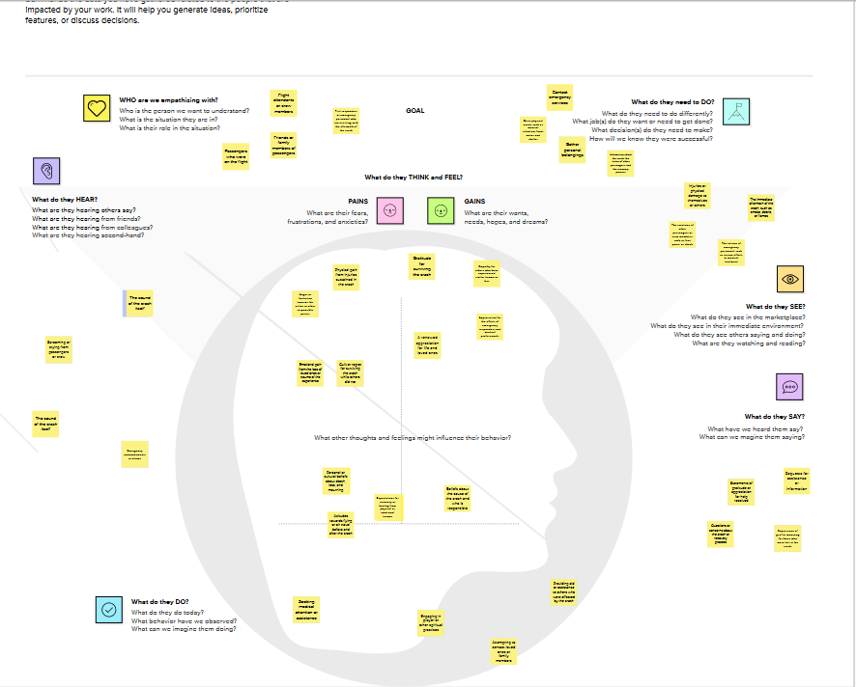

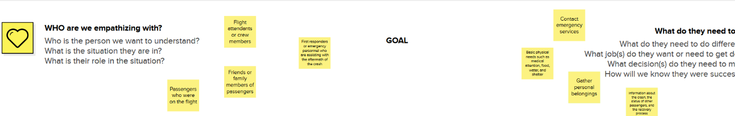

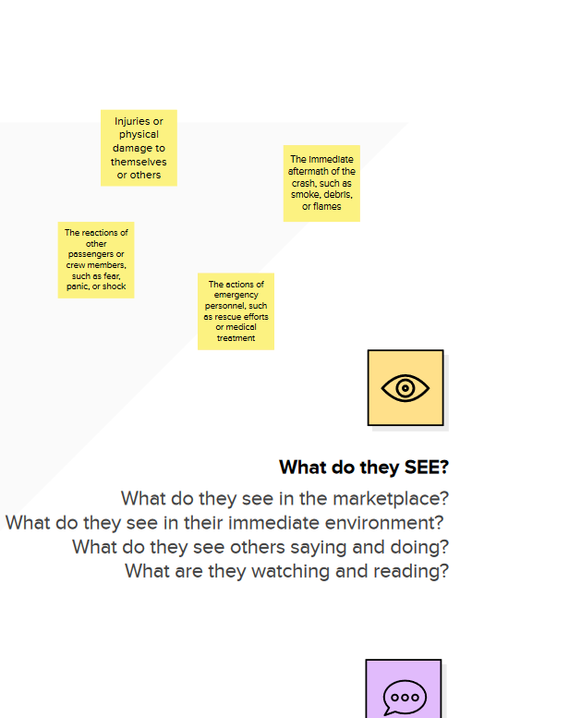

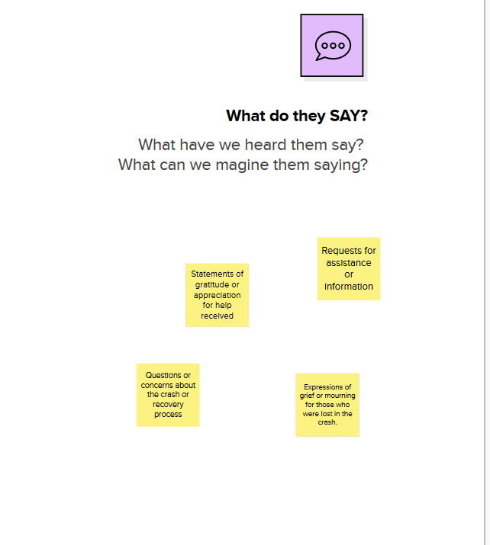

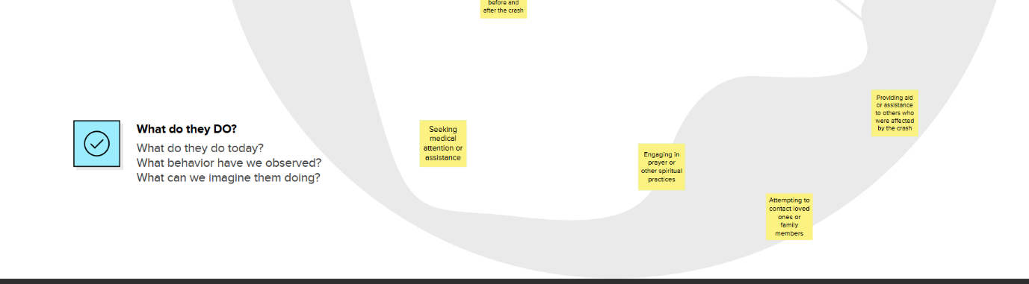

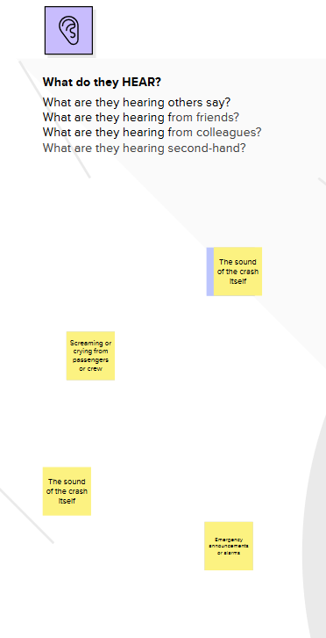

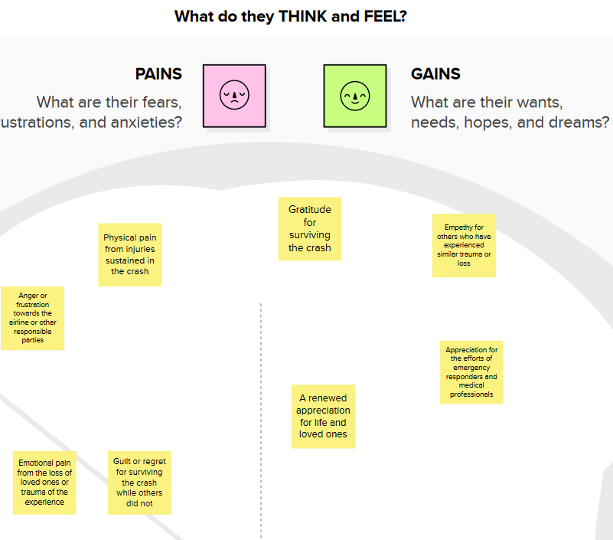

**IDEATION AND BRAINSTORMING MAP**

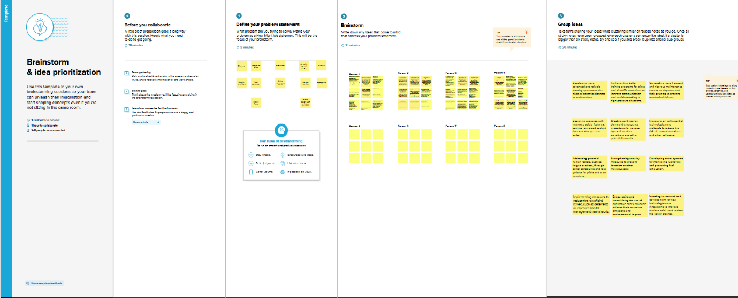

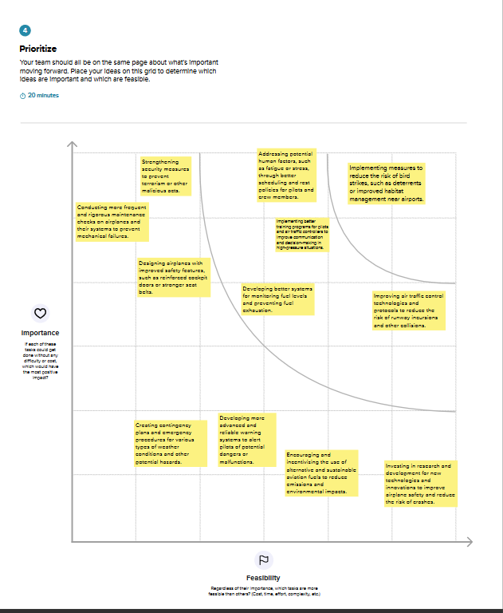

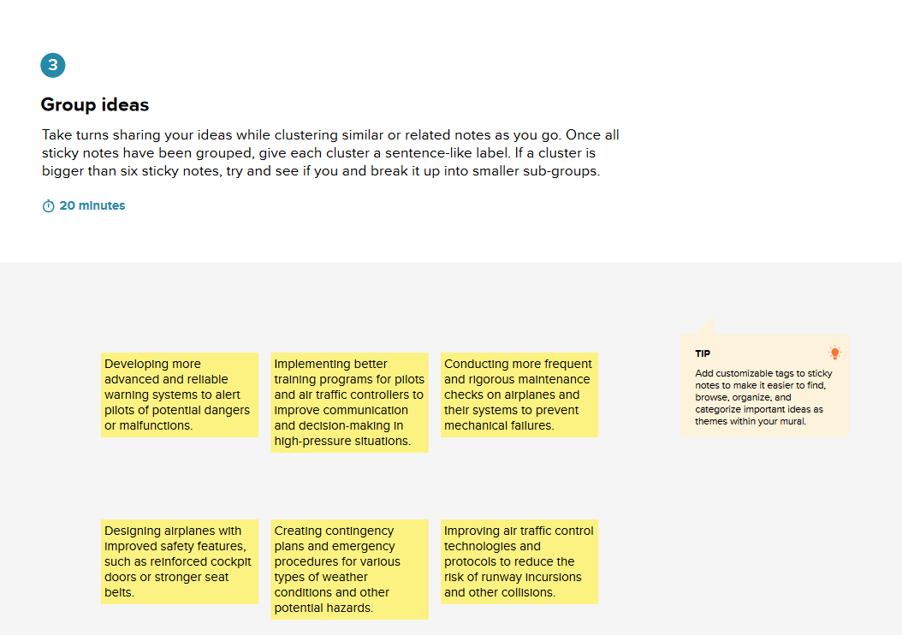

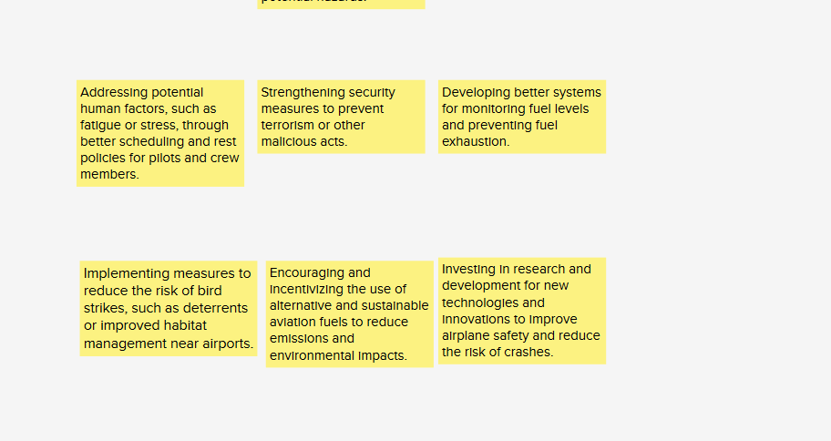

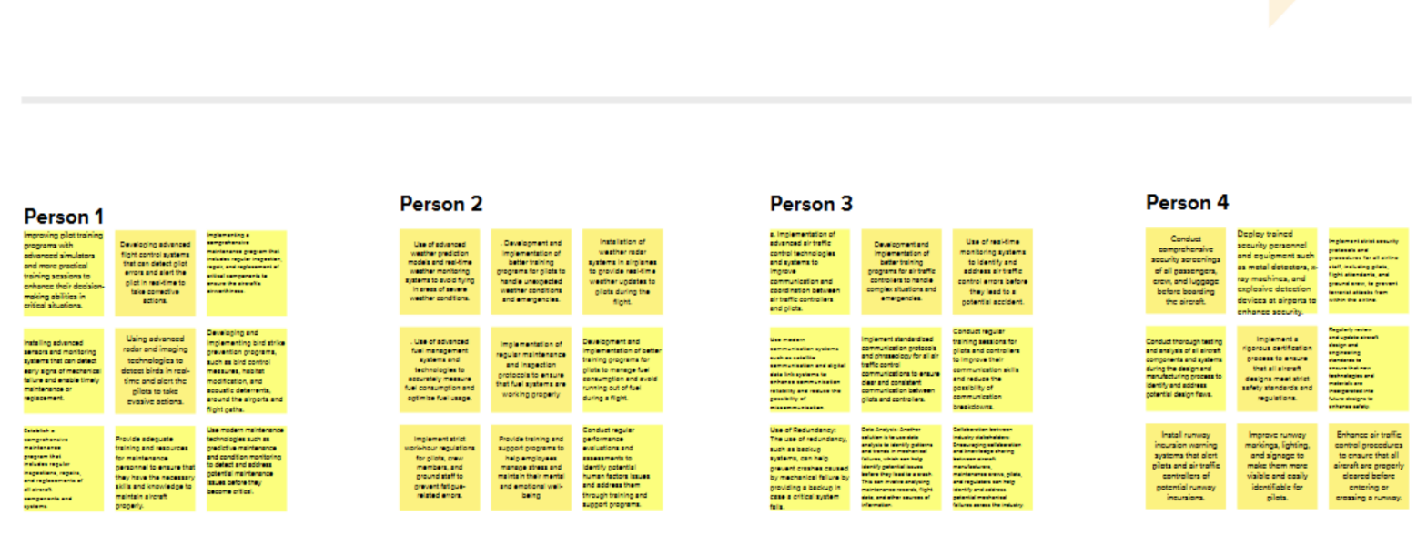

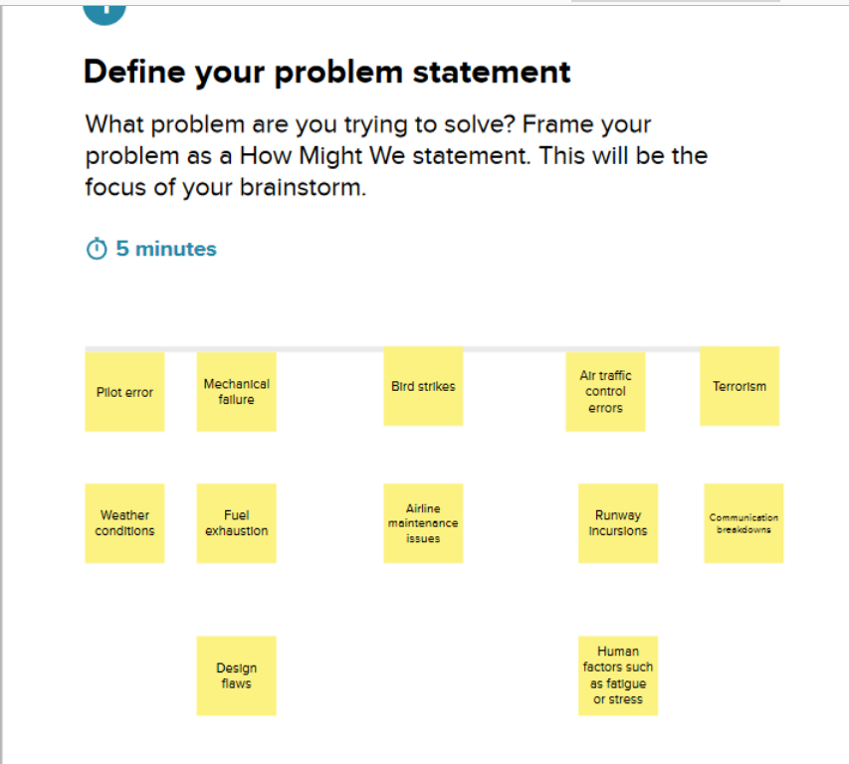

***RESULT***

**DASHBOARD**

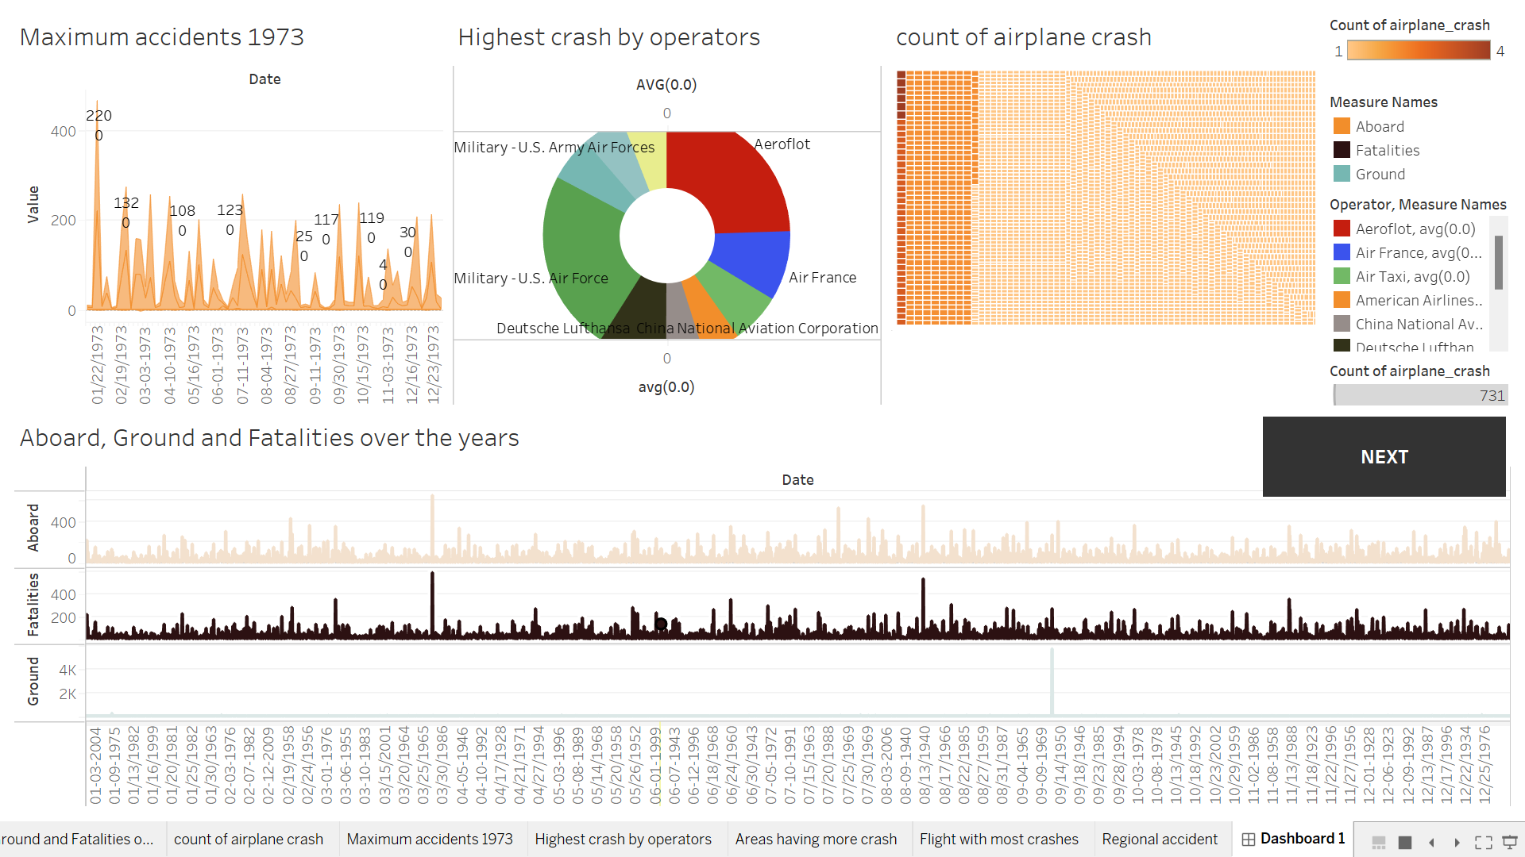

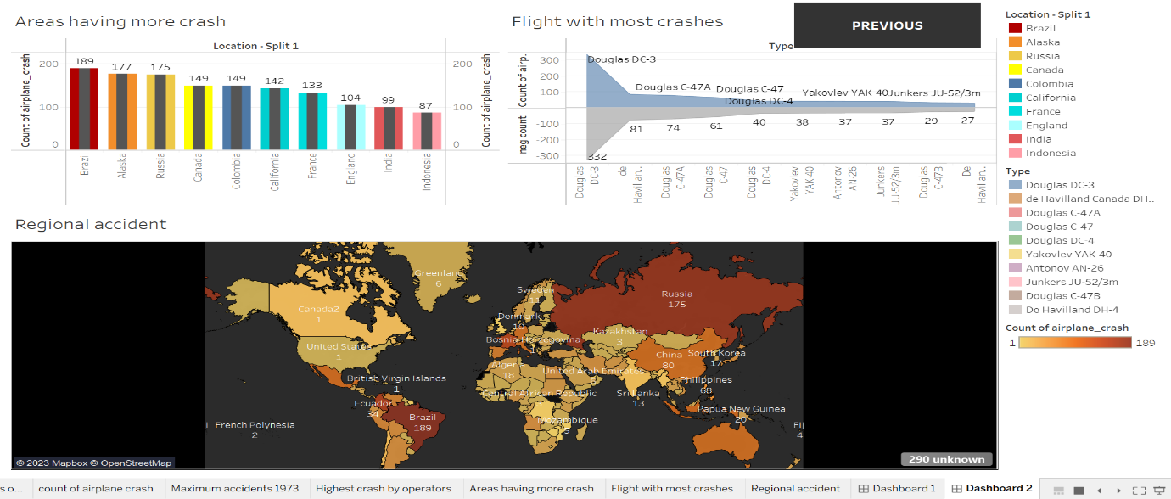

**STORY**

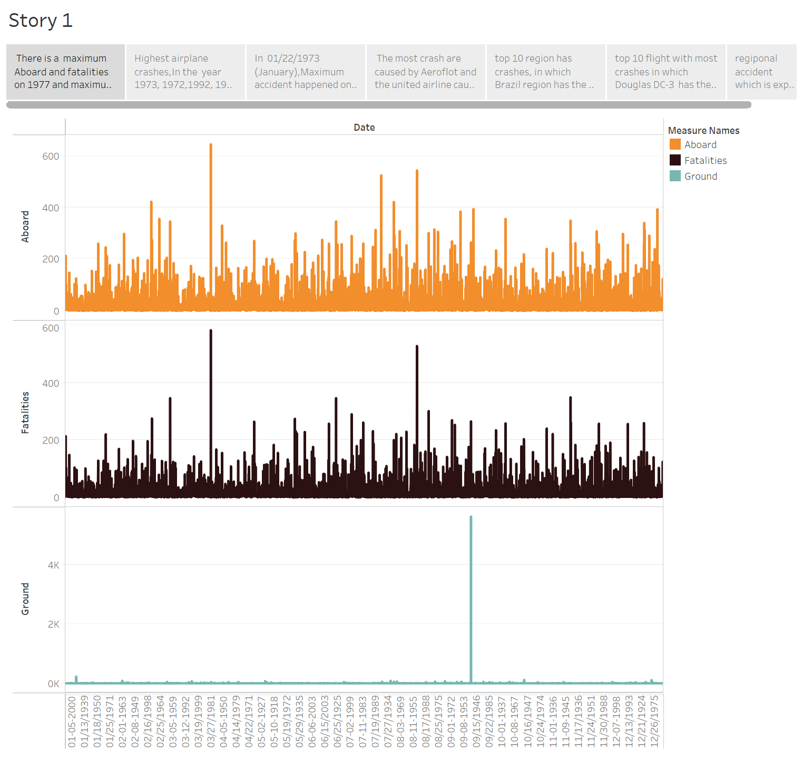

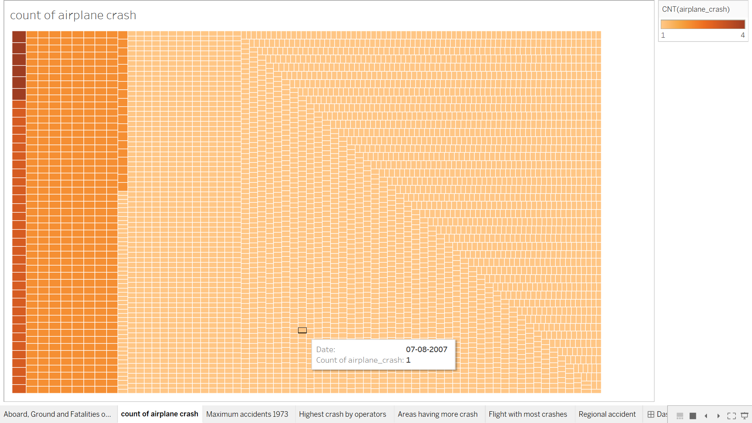

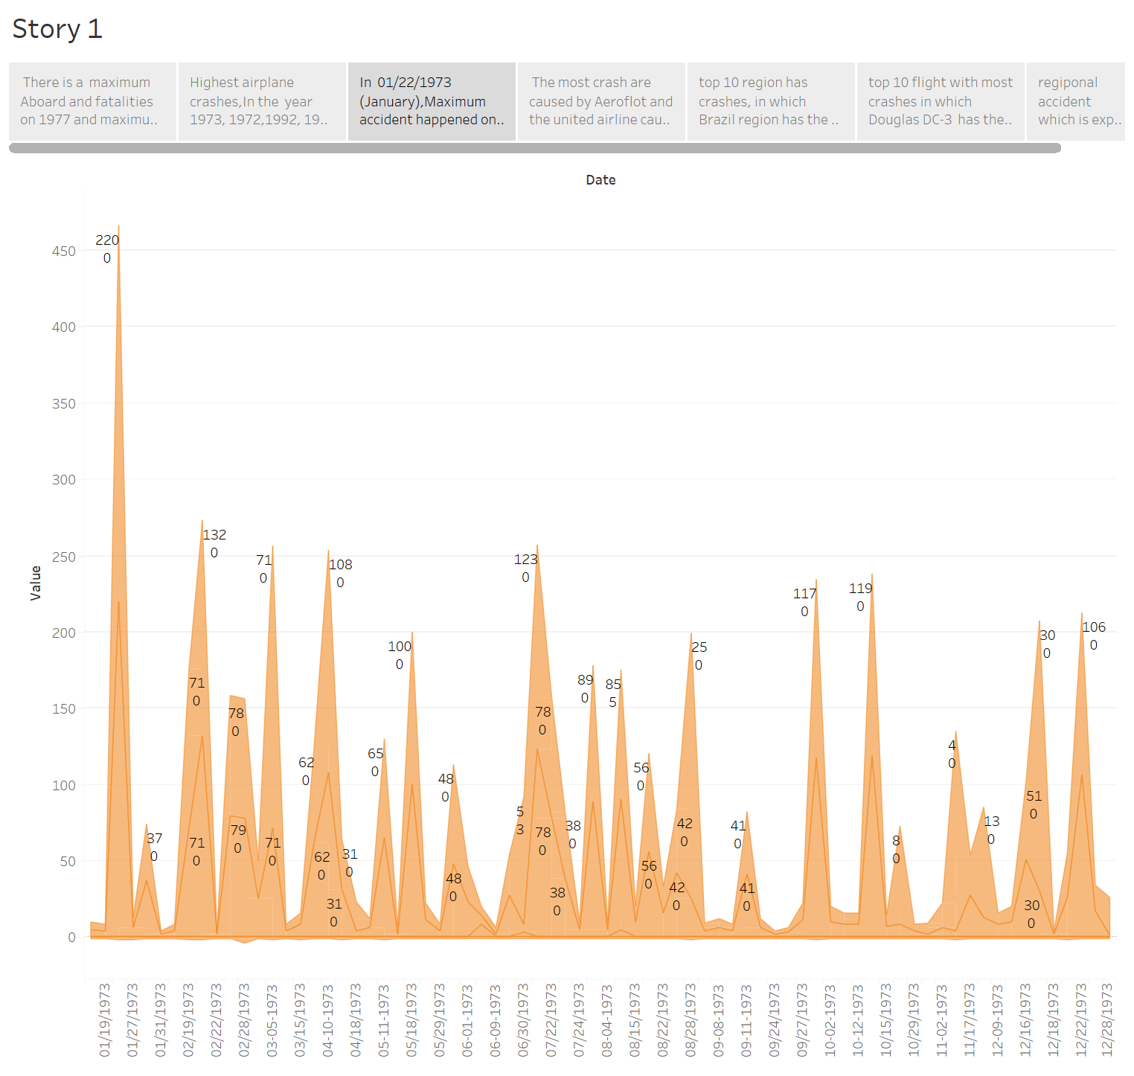

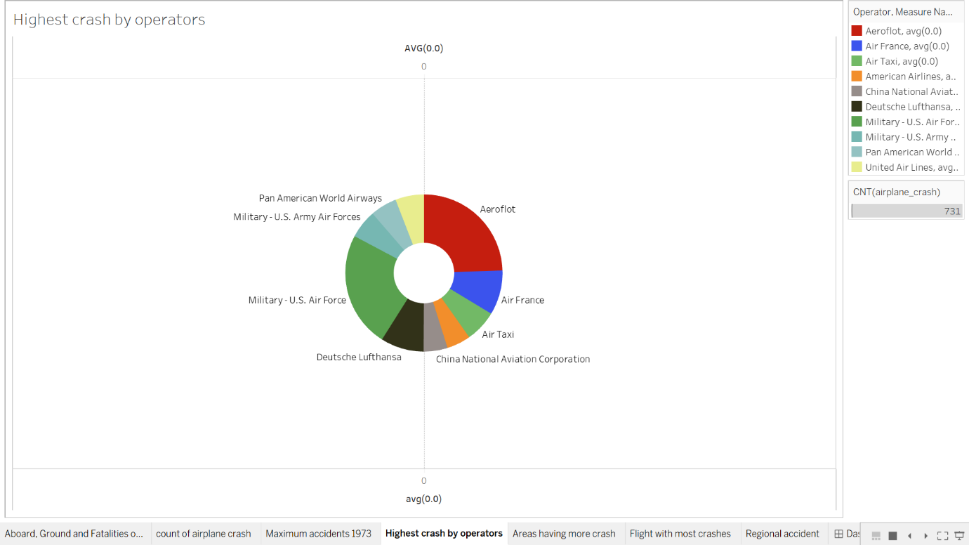

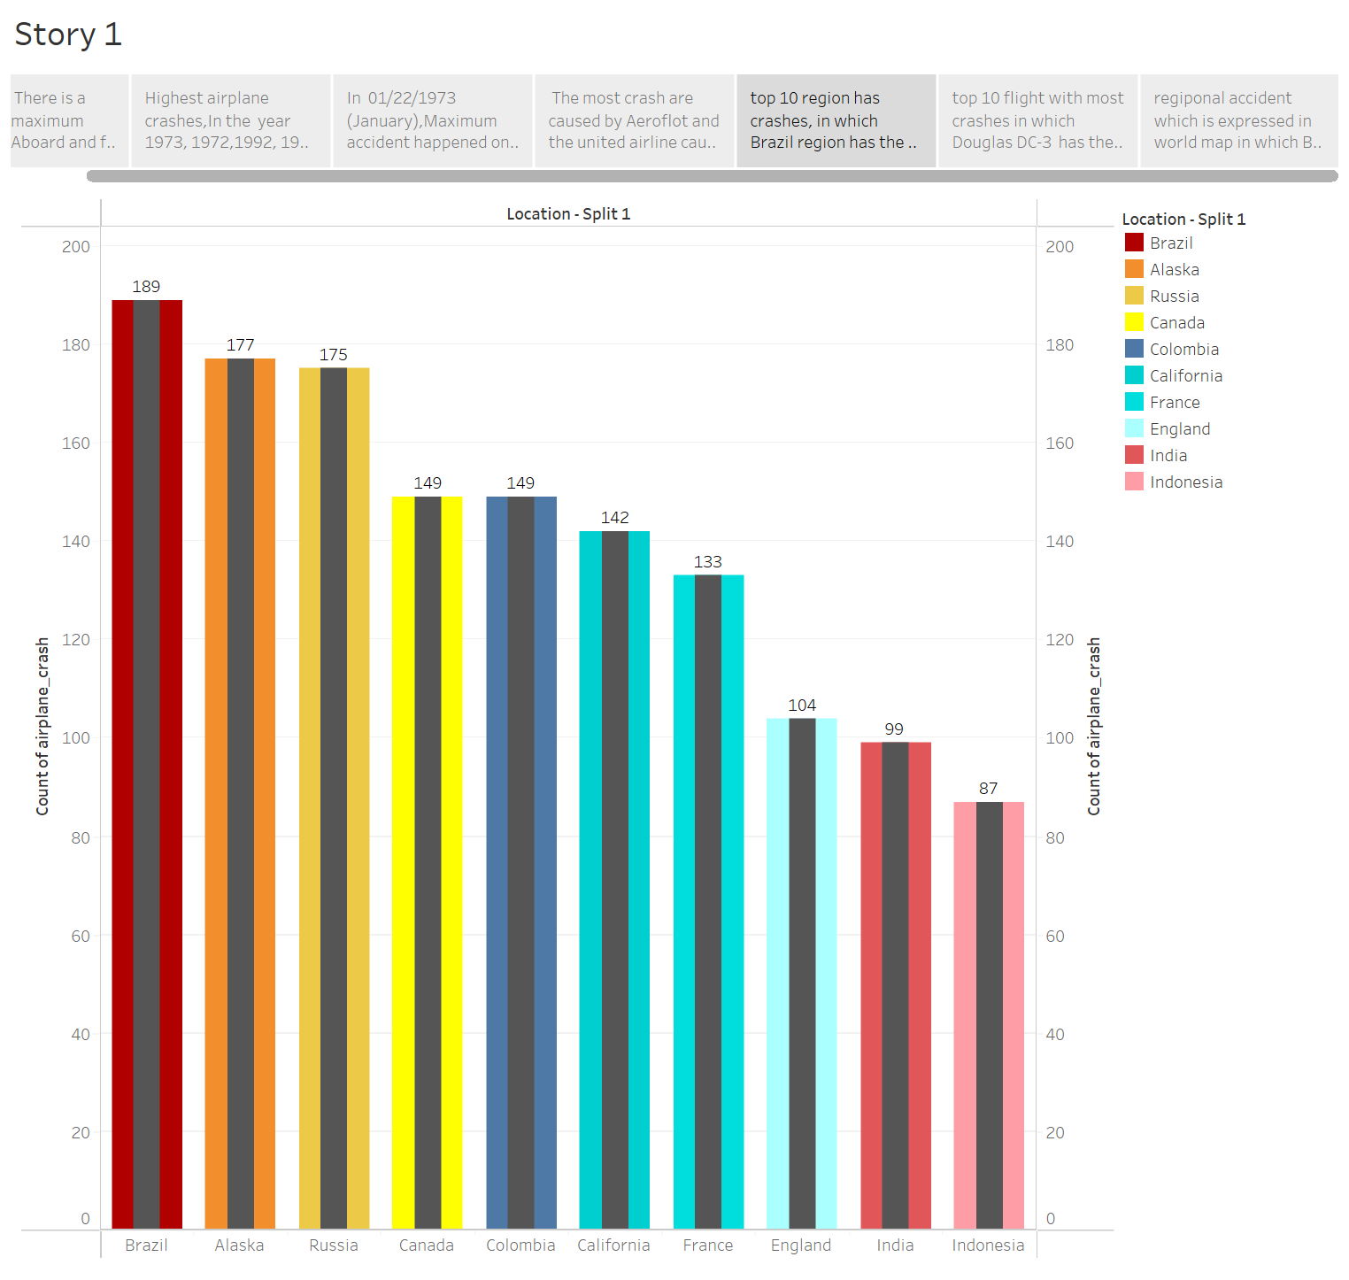

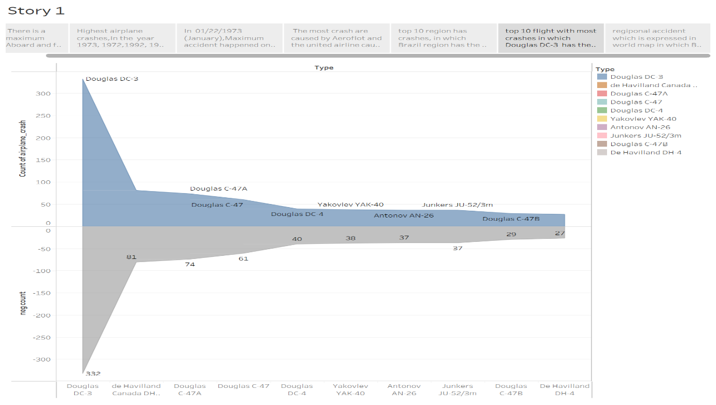

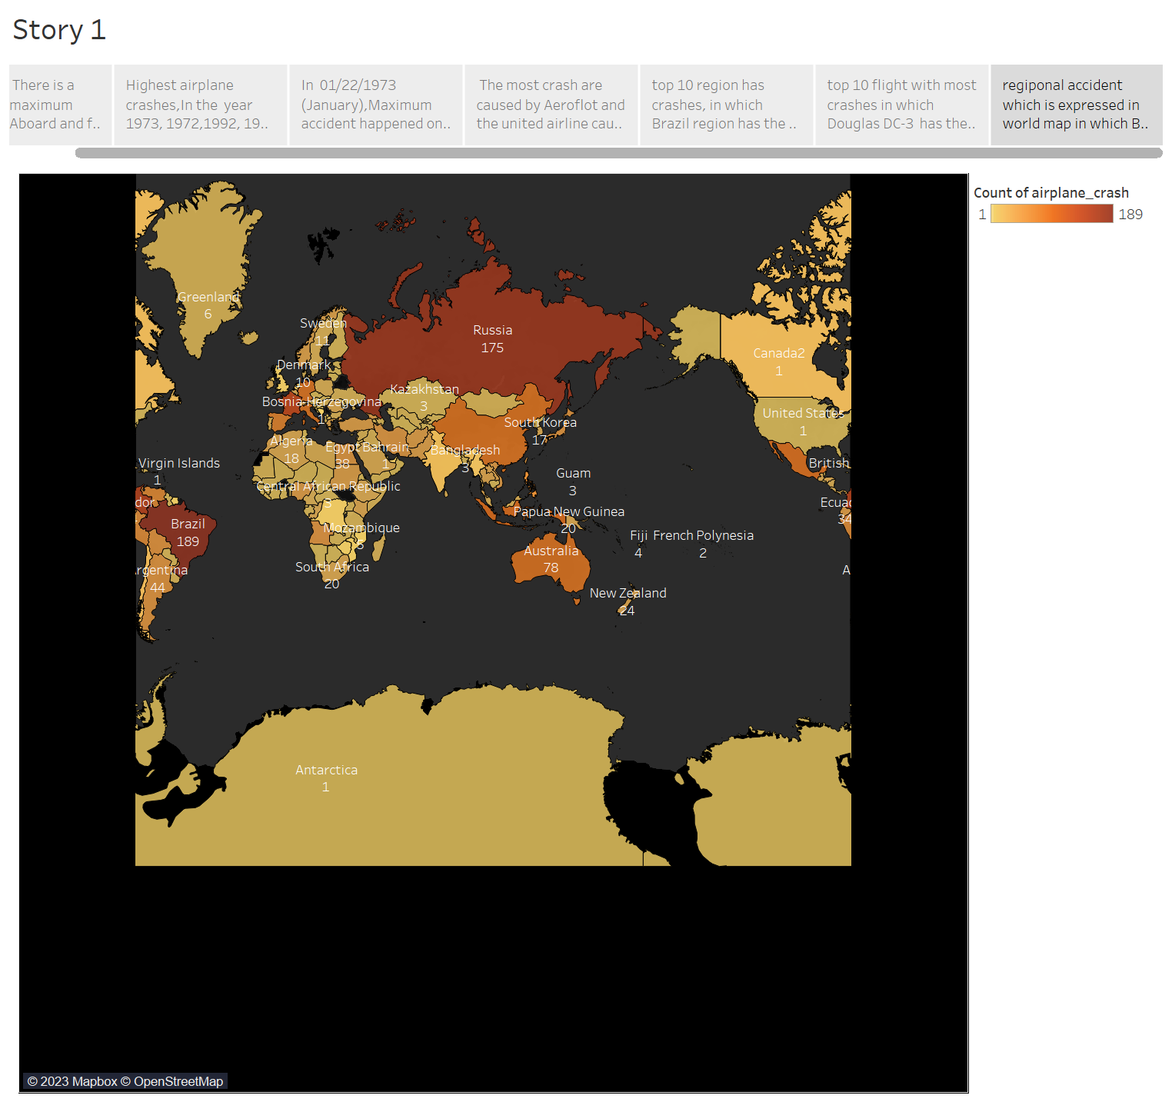

**WEBPAGE**

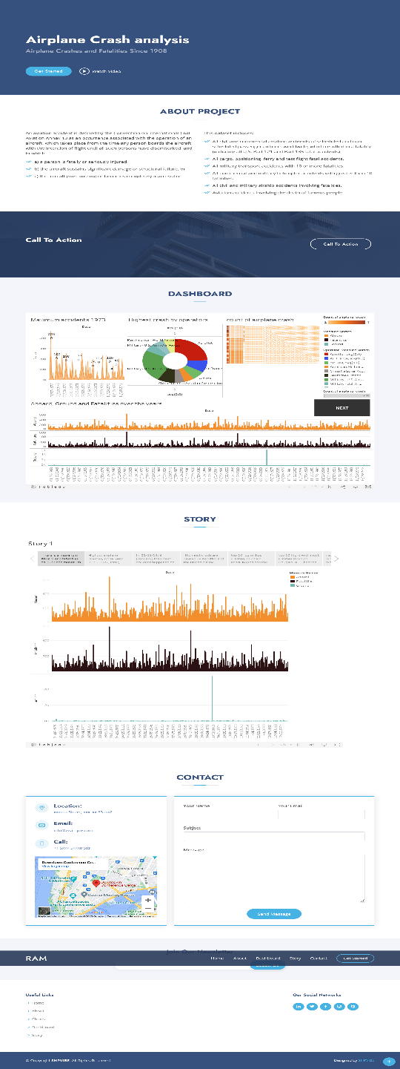

***ADVANTAGE AND DISADVANTAGE***

**ADVANTAGES:**

Improved safety: The solutions listed can improve the safety of air travel, reducing the risk of crashes and fatalities.

Increased reliability: The use of more advanced warning systems, better training programs, and more rigorous maintenance checks can improve the reliability of airplanes and their systems.

Better communication: Improved training programs and air traffic control technologies can improve communication between pilots and air traffic controllers, reducing the risk of accidents due to miscommunication or confusion.

Environmental benefits: Encouraging and incentivizing the use of alternative and sustainable aviation fuels can reduce emissions and the environmental impact of air travel.

**DISADVANTAGES:**

Increased cost: Implementing many of these solutions may require significant investment and can increase the cost of air travel for consumers.

Technical challenges: Developing and implementing new technologies can be challenging, and there may be technical obstacles that need to be overcome.

Resistance to change: There may be resistance from the aviation industry or other stakeholders to implement some of these solutions.

Limitations of technology: While advanced warning systems and improved safety features can help reduce the risk of crashes, there are limitations to what technology can do, and accidents may still occur due to unforeseen circumstances.

***APPLICATION:***

The solutions for improving airplane safety can be applied in various areas of the aviation industry. Here are some examples:

Airplane manufacturing: Airplane manufacturers can incorporate improved safety features into their aircraft designs, such as reinforced cockpit doors or stronger seat belts. They can also invest in research and development for new technologies to improve airplane safety.

Maintenance and repair: Airlines and maintenance providers can conduct more frequent and rigorous maintenance checks on airplanes and their systems to prevent mechanical failures. They can also develop better systems for monitoring fuel levels and preventing fuel exhaustion.

Training and education: Pilots and air traffic controllers can undergo better training programs to improve communication and decision-making in high-pressure situations. Crew members can also be trained in emergency procedures for various types of weather conditions and other potential hazards.

Air traffic control: Air traffic control technologies and protocols can be improved to reduce the risk of runway incursions and other collisions. This can include implementing new technologies such as satellite-based navigation systems.

Security measures: Security measures can be strengthened to prevent terrorism or other malicious acts. This can include implementing stricter screening procedures for passengers and cargo, as well as improving the security of airport perimeters.

Environmental impact: The aviation industry can invest in research and development for alternative and sustainable aviation fuels to reduce emissions and environmental impacts.

Overall, these solutions can be applied across all aspects of the aviation industry, from airplane manufacturing to air traffic control to environmental impact. By implementing these solutions, the aviation industry can improve airplane safety and reduce the risk of crashes.

***CONCLUSION***

By analysing the given dataset using the tableau I making the conclusion I founded that maximum aboard and fatalities where happened in 1973, Highest airplane crash where happened in 1973, 1972, 1992, 1972, 1988 and 2002, In 01/02/1973 (January)maximum accident happened on 1973, The most crash are caused by Aeroflot and the united airline ,top ten region has crashes, In which Brazil region has the highest airplane crash, Douglas D-3 which has the most crashes and finally Brazil which has the highest airplane crash on their region

***FUTURE SCOPE***

Improving the safety features of airplanes, such as stronger seat belts and reinforced cockpit doors, to prevent fatalities and injuries during crashes.

Developing more advanced and reliable warning systems to alert pilots of potential dangers or malfunctions, and conducting more frequent and rigorous maintenance checks on airplanes and their systems to prevent mechanical failures.

Implementing better training programs for pilots and air traffic controllers to improve communication and decision-making in high-pressure situations.

Addressing potential human factors, such as fatigue or stress, through better scheduling and rest policies for pilots and crew members.

Strengthening security measures to prevent terrorism or other malicious acts.

Implementing measures to reduce the risk of bird strikes, such as deterrents or improved habitat management near airports.

Encouraging and incentivizing the use of alternative and sustainable aviation fuels to reduce emissions and environmental impacts.

Investing in research and development for new technologies and innovations to improve airplane safety and reduce the risk of crashes.

By implementing these enhancements, the aviation industry can work towards making air travel safer and more reliable for passengers and crew members alike.

***APPENDIX***

<!DOCTYPE html>

<html lang="en">

<head>

  <meta charset="utf-8">

  <meta content="width=device-width, initial-scale=1.0" name="viewport">

  <title> RAM - Airplane Crash</title>

  <meta content="" name="description">

  <meta content="" name="keywords">

  <!-- Favicons -->

  <link href="img/favicon.png" rel="icon">

  <link href="img/apple-touch-icon.png" rel="apple-touch-icon">

  <!-- Google Fonts -->

  <link href="https://fonts.googleapis.com/css?family=Open+Sans:300,300i,400,400i,600,600i,700,700i|Jost:300,300i,400,400i,500,500i,600,600i,700,700i|Poppins:300,300i,400,400i,500,500i,600,600i,700,700i" rel="stylesheet">

  <!-- Vendor CSS Files -->

  <link href="vendor/aos/aos.css" rel="stylesheet">

  <link href="vendor/bootstrap/css/bootstrap.min.css" rel="stylesheet">

  <link href="vendor/bootstrap-icons/bootstrap-icons.css" rel="stylesheet">

  <link href="vendor/boxicons/css/boxicons.min.css" rel="stylesheet">

  <link href="vendor/glightbox/css/glightbox.min.css" rel="stylesheet">

  <link href="vendor/remixicon/remixicon.css" rel="stylesheet">

  <link href="vendor/swiper/swiper-bundle.min.css" rel="stylesheet">

  <!-- Template Main CSS File -->

  <link href="css/style.css" rel="stylesheet">

  <!-- =======================================================

  * Template Name: Arsha - v4.9.1

  * Template URL: https://bootstrapmade.com/arsha-free-bootstrap-html-template-corporate/

  * Author: BootstrapMade.com

  * License: https://bootstrapmade.com/license/

  ======================================================== -->

</head>

<body>

  <!-- ======= Header ======= -->

  <header id="header" class="fixed-top ">

    <div class="container d-flex align-items-center">

      <h1 class="logo me-auto"><a href="index.html">RAM</a></h1>

      <!-- Uncomment below if you prefer to use an image logo -->

      <!-- <a href="index.html" class="logo me-auto"><img src="assets/img/logo.png" alt="" class="img-fluid"></a>-->

      <nav id="navbar" class="navbar">

        <ul>

          <li><a class="nav-link scrollto active" href="#hero">Home</a></li>

          <li><a class="nav-link scrollto" href="#about">About</a></li>

          <li><a class="nav-link scrollto" href="#team">Dashboard</a></li>

          <li><a class="nav-link scrollto" href="#pricing">Story</a></li>

          <li><a class="nav-link scrollto" href="#contact">Contact</a></li>

          <li><a class="getstarted scrollto" href="#about">Get Started</a></li>

        </ul>

        <i class="bi bi-list mobile-nav-toggle"></i>

      </nav><!-- .navbar -->

    </div>

  </header><!-- End Header -->

  <!-- ======= Hero Section ======= -->

  <section id="hero" class="d-flex align-items-center">

    <div class="container">

      <div class="row">

        <div class="col-lg-6 d-flex flex-column justify-content-center pt-4 pt-lg-0 order-2 order-lg-1" data-aos="fade-up" data-aos-delay="200">

          <h1>Airplane Crash analysis</h1>

          <h2>Airplane Crashes and Fatalities Since 1908</h2>

          <div class="d-flex justify-content-center justify-content-lg-start">

            <a href="#about" class="btn-get-started scrollto">Get Started</a>

            <a href="https://www.youtube.com/@thesmartbridge/videos" class="glightbox btn-watch-video"><i class="bi bi-play-circle"></i><span>Watch Video</span></a>

          </div>

        </div>

        <div class="col-lg-6 order-1 order-lg-2 hero-img" data-aos="zoom-in" data-aos-delay="200">

          <img src="assets/img/a1.jpg" class="img-fluid animated" alt="">

        </div>

      </div>

    </div>

  </section><!-- End Hero -->

  <main id="main">

        <!-- ======= About Us Section ======= -->

    <section id="about" class="about">

      <div class="container" data-aos="fade-up">

        <div class="section-title">

          <h2>About Project</h2>

        </div>

        <div class="row content">

          <div class="col-lg-6">

            <p>

              An aviation accident is defined by the Convention on International Civil Aviation Annex 13 as an occurrence associated with the operation of an aircraft, which takes place from the time any person boards the aircraft with the intention of flight until all such persons have disembarked, and in which

            </p>

            <ul>

              <li><i class="ri-check-double-line"></i> a) a person is fatally or seriously injured, </li>

              <li><i class="ri-check-double-line"></i> b) the aircraft sustains significant damage or structural failure, or </li>

              <li><i class="ri-check-double-line"></i> c) the aircraft goes missing or becomes completely inaccessible.</li>

            </ul>

          </div>

          <div class="col-lg-6 pt-4 pt-lg-0">

            <p>

              This dataset includes:

            <ul>

              <li><i class="ri-check-double-line"></i> All civil and commercial aviation accidents of scheduled and non-scheduled passenger airliners worldwide, which resulted in a fatality (including all U.S. Part 121 and Part 135 fatal accidents)</li>

              <li><i class="ri-check-double-line"></i> All cargo, positioning, ferry and test flight fatal accidents.</li>

              <li><i class="ri-check-double-line"></i> All military transport accidents with 10 or more fatalities.</li>

              <li><i class="ri-check-double-line"></i> All commercial and military helicopter accidents with greater than 10 fatalities.</li>

              <li><i class="ri-check-double-line"></i> All civil and military airship accidents involving fatalities.</li>

              <li><i class="ri-check-double-line"></i> Aviation accidents involving the death of famous people.</li>

               </ul>

            </p>

             </div>

        </div>

      </div>

    </section><!-- End About Us Section -->

    <!-- ======= Cta Section ======= -->

    <section id="cta" class="cta">

      <div class="container" data-aos="zoom-in">

        <div class="row">

          <div class="col-lg-9 text-center text-lg-start">

            <h3>Call To Action</h3>

            </div>

          <div class="col-lg-3 cta-btn-container text-center">

            <a class="cta-btn align-middle" href="#">Call To Action</a>

          </div>

        </div>

      </div>

    </section><!-- End Cta Section -->

    <!-- ======= Team Section ======= -->

    <section id="team" class="team section-bg">

      <div class="container" data-aos="fade-up">

        <div class="section-title">

          <h2>Dashboard</h2>

           </div>

           <div class='tableauPlaceholder' id='viz1681410618827' style='position: relative'><noscript><a href='#'><img alt='Dashboard 1 ' src='https:&#47;&#47;public.tableau.com&#47;static&#47;images&#47;ta&#47;tableauairplanecrash&#47;Dashboard1&#47;1_rss.png' style='border: none' /></a></noscript><object class='tableauViz'  style='display:none;'><param name='host_url' value='https%3A%2F%2Fpublic.tableau.com%2F' /> <param name='embed_code_version' value='3' /> <param name='site_root' value='' /><param name='name' value='tableauairplanecrash&#47;Dashboard1' /><param name='tabs' value='no' /><param name='toolbar' value='yes' /><param name='static_image' value='https:&#47;&#47;public.tableau.com&#47;static&#47;images&#47;ta&#47;tableauairplanecrash&#47;Dashboard1&#47;1.png' /> <param name='animate_transition' value='yes' /><param name='display_static_image' value='yes' /><param name='display_spinner' value='yes' /><param name='display_overlay' value='yes' /><param name='display_count' value='yes' /><param name='language' value='en-US' /><param name='filter' value='publish=yes' /></object></div>                <script type='text/javascript'>                    var divElement = document.getElementById('viz1681410618827');                    var vizElement = divElement.getElementsByTagName('object')[0];                    if ( divElement.offsetWidth > 800 ) { vizElement.style.width='100%';vizElement.style.height=(divElement.offsetWidth*0.75)+'px';} else if ( divElement.offsetWidth > 500 ) { vizElement.style.width='100%';vizElement.style.height=(divElement.offsetWidth*0.75)+'px';} else { vizElement.style.width='100%';vizElement.style.height='1527px';}                     var scriptElement = document.createElement('script');                    scriptElement.src = 'https://public.tableau.com/javascripts/api/viz_v1.js';                    vizElement.parentNode.insertBefore(scriptElement, vizElement);                </script>

      </div>

    </section><!-- End Team Section -->

    <!-- ======= Pricing Section ======= -->

    <section id="pricing" class="pricing">

      <div class="container" data-aos="fade-up">

        <div class="section-title">

          <h2>Story</h2>

          </div>

          <div class='tableauPlaceholder' id='viz1681410849602' style='position: relative'><noscript><a href='#'><img alt='Story 1 ' src='https:&#47;&#47;public.tableau.com&#47;static&#47;images&#47;st&#47;story1_16813848595470&#47;Story1&#47;1_rss.png' style='border: none' /></a></noscript><object class='tableauViz'  style='display:none;'><param name='host_url' value='https%3A%2F%2Fpublic.tableau.com%2F' /> <param name='embed_code_version' value='3' /> <param name='site_root' value='' /><param name='name' value='story1_16813848595470&#47;Story1' /><param name='tabs' value='no' /><param name='toolbar' value='yes' /><param name='static_image' value='https:&#47;&#47;public.tableau.com&#47;static&#47;images&#47;st&#47;story1_16813848595470&#47;Story1&#47;1.png' /> <param name='animate_transition' value='yes' /><param name='display_static_image' value='yes' /><param name='display_spinner' value='yes' /><param name='display_overlay' value='yes' /><param name='display_count' value='yes' /><param name='language' value='en-US' /></object></div>                <script type='text/javascript'>                    var divElement = document.getElementById('viz1681410849602');                    var vizElement = divElement.getElementsByTagName('object')[0];                    vizElement.style.width='1016px';vizElement.style.height='991px';                    var scriptElement = document.createElement('script');                    scriptElement.src = 'https://public.tableau.com/javascripts/api/viz_v1.js';                    vizElement.parentNode.insertBefore(scriptElement, vizElement);                </script>

      </div>

    </section><!-- End Pricing Section -->

    <!-- ======= Contact Section ======= -->

    <section id="contact" class="contact">

      <div class="container" data-aos="fade-up">

        <div class="section-title">

          <h2>Contact</h2>

          </div>

        <div class="row">

          <div class="col-lg-5 d-flex align-items-stretch">

            <div class="info">

              <div class="address">

                <i class="bi bi-geo-alt"></i>

                <h4>Location:</h4>

                <p>xxxxxx Street, xxx, xx 53xxx2</p>

              </div>

              <div class="email">

                <i class="bi bi-envelope"></i>

                <h4>Email:</h4>

                <p>info@example.com</p>

              </div>

              <div class="phone">

                <i class="bi bi-phone"></i>

                <h4>Call:</h4>

                <p>+1 5xxx 5xxx8 5xs</p>

              </div>

              <iframe src="https://www.google.com/maps/embed?pb=!1m14!1m8!1m3!1d12097.433213460943!2d-74.0062269!3d40.7101282!3m2!1i1024!2i768!4f13.1!3m3!1m2!1s0x0%3A0xb89d1fe6bc499443!2sDowntown+Conference+Center!5e0!3m2!1smk!2sbg!4v1539943755621" frameborder="0" style="border:0; width: 100%; height: 290px;" allowfullscreen></iframe>

            </div>

          </div>

          <div class="col-lg-7 mt-5 mt-lg-0 d-flex align-items-stretch">

            <form action="forms/contact.php" method="post" role="form" class="php-email-form">

              <div class="row">

                <div class="form-group col-md-6">

                  <label for="name">Your Name</label>

                  <input type="text" name="name" class="form-control" id="name" required>

                </div>

                <div class="form-group col-md-6">

                  <label for="name">Your Email</label>

                  <input type="email" class="form-control" name="email" id="email" required>

                </div>

              </div>

              <div class="form-group">

                <label for="name">Subject</label>

                <input type="text" class="form-control" name="subject" id="subject" required>

              </div>

              <div class="form-group">

                <label for="name">Message</label>

                <textarea class="form-control" name="message" rows="10" required></textarea>

              </div>

              <div class="my-3">

                <div class="loading">Loading</div>

                <div class="error-message"></div>

                <div class="sent-message">Your message has been sent. Thank you!</div>

              </div>

              <div class="text-center"><button type="submit">Send Message</button></div>

            </form>

          </div>

        </div>

      </div>

    </section><!-- End Contact Section -->

  </main><!-- End #main -->

  <!-- ======= Footer ======= -->

  <footer id="footer">

    <div class="footer-newsletter">

      <div class="container">

        <div class="row justify-content-center">

          <div class="col-lg-6">

            <h4>Join Our Newsletter</h4>

            <form action="" method="post">

              <input type="email" name="email"><input type="submit" value="Subscribe">

            </form>

          </div>

        </div>

      </div>

    </div>

    <div class="footer-top">

      <div class="container">

        <div class="row">

          <div class="col-lg-3 col-md-6 footer-links">

            <h4>Useful Links</h4>

            <ul>

              <li><i class="bx bx-chevron-right"></i> <a href="#hero">Home</a></li>

              <li><i class="bx bx-chevron-right"></i> <a href="#about">About</a></li>

              <li><i class="bx bx-chevron-right"></i> <a href="#portfolio">Charts</a></li>

              <li><i class="bx bx-chevron-right"></i> <a href="#team">Dashboard</a></li>

              <li><i class="bx bx-chevron-right"></i> <a href="#pricing">Story</a></li>

            </ul>

          </div>

          <div class="col-lg-3 col-md-6 footer-links">

            <h4></h4>

            <ul>

            </ul>

          </div>

          <div class="col-lg-3 col-md-6 footer-links">

            <h4></h4>

            <ul>

            </ul>

          </div>

          <div class="col-lg-3 col-md-6 footer-links">

            <h4>Our Social Networks</h4>

            <div class="social-links mt-3">

              <a href="https://www.linkedin.com/in/hariprabu741/" class="linkedin"><i class="bx bxl-linkedin"></i></a>

              <a href="#" class="twitter"><i class="bx bxl-twitter"></i></a>

              <a href="#" class="facebook"><i class="bx bxl-facebook"></i></a>

              <a href="#" class="instagram"><i class="bx bxl-instagram"></i></a>

              <a href="#" class="google-plus"><i class="bx bxl-skype"></i></a>

            </div>

          </div>

        </div>

      </div>

    </div>

    <div class="container footer-bottom clearfix">

      <div class="copyright">

        &copy; Copyright <strong><span>SHPVIBE</span></strong>. All Rights Reserved

      </div>

      <div class="credits">

        <!-- All the links in the footer should remain intact. -->

        <!-- You can delete the links only if you purchased the pro version. -->

        <!-- Licensing information: https://bootstrapmade.com/license/ -->

        <!-- Purchase the pro version with working PHP/AJAX contact form: https://bootstrapmade.com/arsha-free-bootstrap-html-template-corporate/ -->

        Designed by <a href="https://bootstrapmade.com/">SHPVIBE</a>

      </div>

    </div>

  </footer><!-- End Footer -->

  <div id="preloader"></div>

  <a href="#" class="back-to-top d-flex align-items-center justify-content-center"><i class="bi bi-arrow-up-short"></i></a>

  <!-- Vendor JS Files -->

  <script src="vendor/aos/aos.js"></script>

  <script src="vendor/bootstrap/js/bootstrap.bundle.min.js"></script>

  <script src="vendor/glightbox/js/glightbox.min.js"></script>

  <script src="vendor/isotope-layout/isotope.pkgd.min.js"></script>

  <script src="vendor/swiper/swiper-bundle.min.js"></script>

  <script src="vendor/waypoints/noframework.waypoints.js"></script>

  <script src="vendor/php-email-form/validate.js"></script>

  <!-- Template Main JS File -->

  <script src="js/main.js"></script>

</body>

</html>