**Introduction**

Nowadays, people tend to rely more and more on the internet. This is due to the fact that internet has provided people with the convenience of discovering new things and reaching out to new people around the world. Besides opening a shop to start their business or to sell their services, people are starting to see the internet as a more economical and convenient alternative to start their business. However, creating such an online platform is not an easy task and requires professional skills.

**Architectural Design**

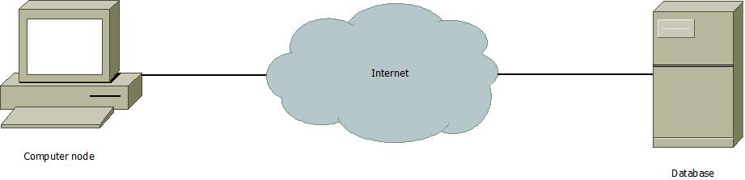

There are three major components required for the system to work. Firstly, the website interface will be displayed by the computer node which allows interact with the system such as receiving data or input data. The system requires internet to use so the computer node needs to be connected to the internet where it is to be connected to the database where the system data is stored. The database will manage the traffic of the data going in or out requested by the user.

**Design Class Diagram**

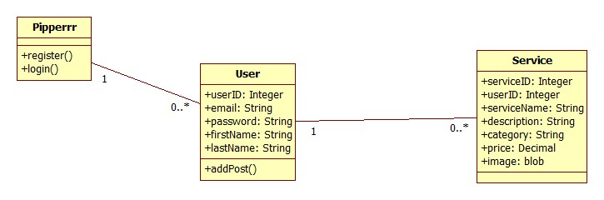

**Sequence Diagram**

**Use case 1: Register and Log in**

**Database Design**



Pipperrr contains two database tables which are user table and the service table. The user table stores the data of the users registered by the users. It has five attributes. The first attribute is the “userID” which is the primary key is the unique identification number for the user, the “email” is the text used to identify the user when logging in, the “password” is the security code for the user to log in, “firstName” holds the first name of the user, and “lastName” holds the last name of the user.



The service table stores the data of the services posted by the users. It has seven attributes. The first attribute is the “serviceID” which is the primary key is the unique identification number of the service, the “userID” is the foreign key of the service table that references the user table, “serviceName” is a text that holds the service name, “description” is the text that describes the service, “category” is used as a tag for easy search, “price” is the decimal that indicates the cost of the service, “image” is a blob that holds the images that are uploaded by the users.

**Generic User Interface**