COMP 464 – Homework 1
Bruno Correa – bcorrea@luc.edu

Part 1

(1) Screen output:

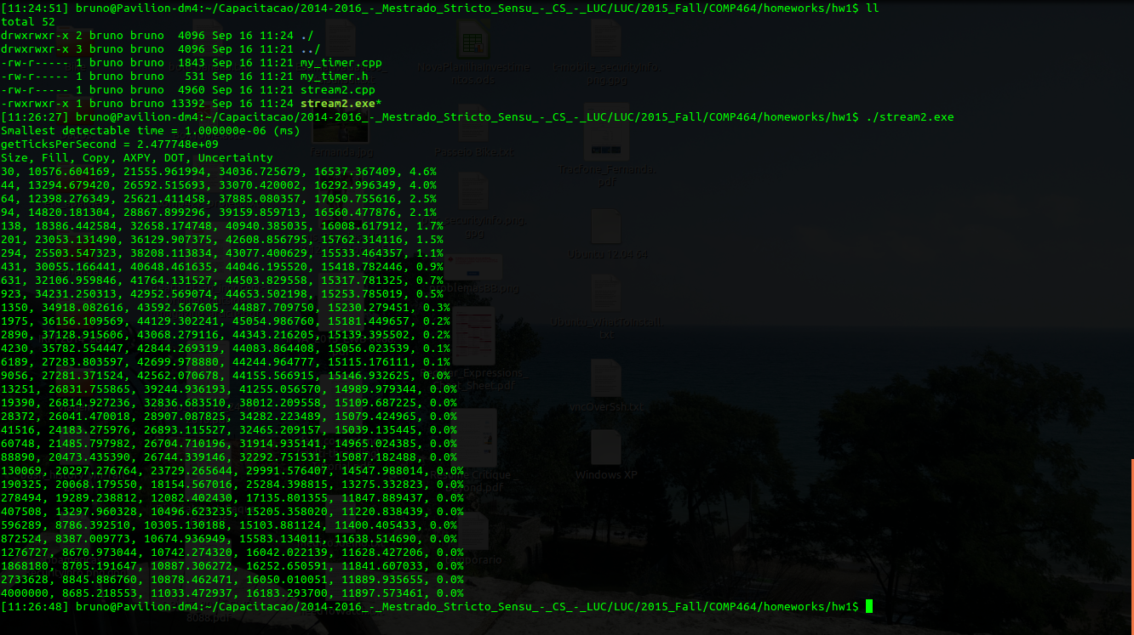
(2) Machine properties:

CPU:
Intel(R) Core(TM) i5-2430M CPU @ 2.40GHz
Cache L1:
2 x 32 KB 8-way set associative instruction caches
2 x 32 KB 8-way set associative data caches
Cache L2:
2 x 256 KB 8-way set associative caches
Cache L3:
3072 KB 12-way set associative shared cache

Main Memory:
DDR3 – 1333 MHz – 2 x 4096 MB (8 GB Total)

OS:
Ubuntu 15.04 (vivid) x86_64 – kernel 3.19.0-28-generic

Compiler:
g++ (Ubuntu 4.9.2-10ubuntu13) 4.9.2
Part 2

Plot the bandwidth for the four tests as a function of array size. Also plot the uncertainty. Write a brief summary of your results discussing the bandwidth as a function of size. Explain how you would predict where the bandwidth should change.

Considering the information gathered in the part 1 of the homework we can predict at which moment a drastic bandwidth change would happen. As learned in the previous classes, this change should happen when the data used cannot fit in the current memory cache level. Considering the fact that the size of each element of the array used in the benchmark is 8B, we can create the following table:

Cache Level | Size (KB) | # of array elements
L1 | 64 | 8192
L2 | 512 | 65536
L3 | 3072 | 393216

From the information shown in the table we could say, for instance, that a drastic change in the bandwidth would happen when the array size reach around 65536 elements. At this moment the array elements would not fit into the L2 cache level, forcing the use of L3 cache level that is slower than the previous one.

The chart shows that a drastic bandwidth drop happens for all four kernels when the array size reach around 150000 elements. At this moment the array probably cannot be fully contained in the L3 cache and therefore the use of ram memory starts, decreasing the bandwidth.

For some reason the values shown in the table and those seen in the graph does not accurately match. It could be a result of cpu optimizations or a misunderstanding of the problem by myself.
Data gathered

