Shiru Sun

A99044353

HW 4 Beyond Relational Data Models

Problem 1.

Find everything about the country whose name is Afghanistan

in language English (\everything" means all properties of the country)

SELECT DISTINCT ?p, ?property WHERE {

?object rdf:type dbo:Country .

?object rdfs:label “Afghanistan"@en.

?object ?p ?property .

FILTER (LANG(?property) = “” || langMatches(lang(?property), "en"))

}

This will give us a table with following result with all the properties of country called Afghanistan

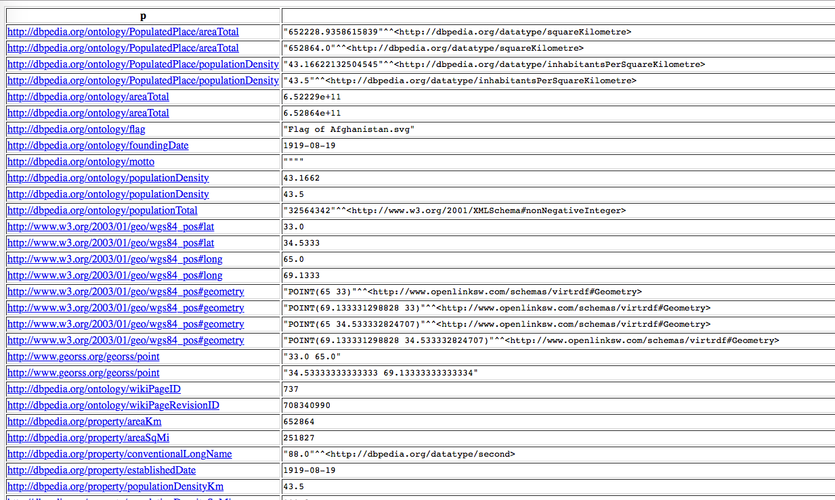

Problem 2.

Who is Barak Obama?

select ?title, ?abstract where{

?object a dbo:Person.

?object rdfs:label "Barack Obama”@en.

?object dbp:title ?title.

?object dbo:abstract ?abstract.

}

This will return a table with two column, one for the title of Obama, and one for details of Obama. In multiple languages.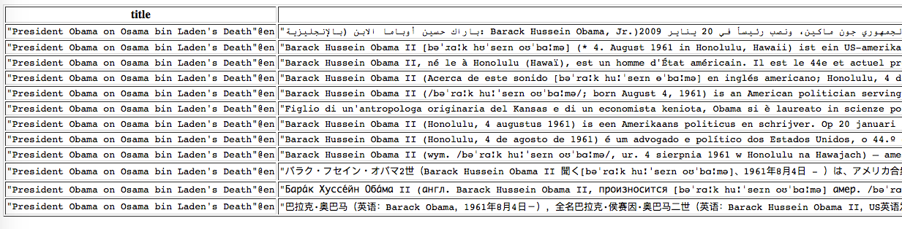

Problem 3. Where is Greece

SELECT ?longitude ?latitude WHERE {

?object rdf:type dbo:Country .

?object rdfs:label "Greece"@en .

?object geo:lat ?latitude .

?object geo:long ?longitude

}

This will return a table which contains the latitude and the longitude of the location of Greece. It has multiple result because the round given by every website is different.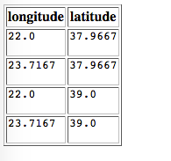

Problem 4.

What is the capital of Nepal?

SELECT ?capital WHERE {

?object rdf:type dbo:Country .

?object rdfs:label "Nepal"@en .

?object dbo:capital [dbp:name ?capital ]

}

result: this will return the name of the capital of Nepal.

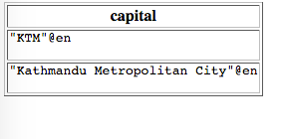

Problem 5.

What is the area of work of Albert Einstein?

SELECT ?area WHERE {

dbr:Albert_Einstein dbp:fields [rdfs:label ?area]

FILTER langMatches(lang(?area), “en")

}

This returns the area of study of person named “Albert Einstein”

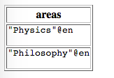

Problem 6.

How is India related to “Indira Gandhi"? (no need to find all existing relationships, but nd at least an interesting one)

SELECT ?a WHERE {

dbr:Indira_Gandhi dbo:office ?a

FILTER regex(?a, "India")

}

result: