WRF Domain Wizard: User Guide
How to go from an empty map to namelist.wps and namelist.input using index.html.
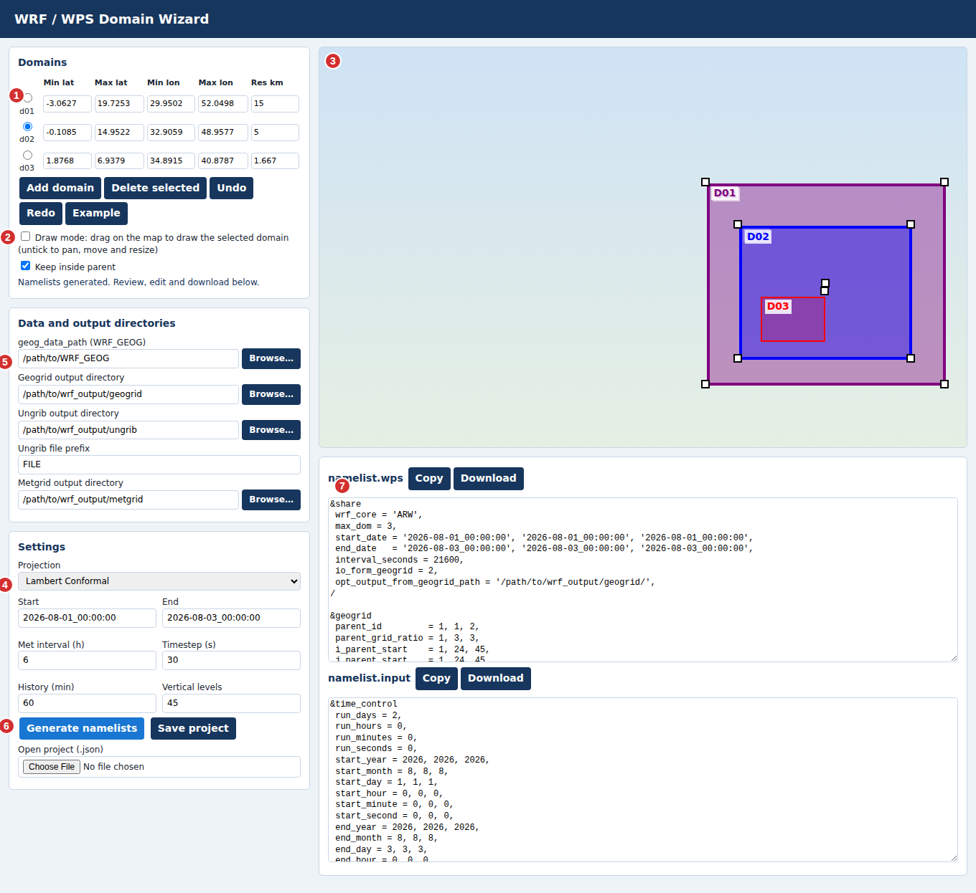
Numbers in the picture match the areas named in the steps. In this image the real map tiles are replaced by a plain background; in the app you see the Carto or ESRI basemap.

Before you start
- Open the live page, or open index.html in a browser (Chrome or Edge recommended).
- An internet connection is needed for the map and tiles.
- Click Example at any time to load a 3-domain sample and see how the tool behaves.

Step 1. Draw the outer domain (d01)
- Make sure Draw mode is ticked (area 2). The cursor becomes a crosshair.
- On the map (area 3), press and hold the mouse button at one corner of your area, drag to the opposite corner, and release.
- To place a corner outside the visible map, keep holding and move the pointer close to the map edge. The map scrolls by itself. You can also release outside the map.
- The extents appear in the Domains table (area 1).
You can also type Min lat, Max lat, Min lon, Max lon and the resolution (km) directly into the table.

Step 2. Add nested domains (d02, d03, ...)
- Click Add domain. The new row gets one third of the previous resolution. Change it if you need another ratio.
- Draw the nest with the mouse inside its parent. With Keep inside parent ticked, the box cannot leave the parent.
- Repeat for each nest, up to 9 domains.

Step 3. Adjust boxes
- Untick Draw mode (area 2). Now dragging the map pans it.
- Select a domain by clicking it on the map or choosing its radio button (area 1). It gets a thicker outline and white squares.
- Drag the centre square to move it, or a corner square to resize it.
- Use Undo and Redo to step back and forward.
- Use Delete selected to remove the chosen domain. Later domains are renumbered.
The basemap switcher (top right of the map) changes between Carto Voyager, ESRI World Topo and ESRI World Imagery. Scroll to zoom.

Step 4. Choose the projection
In Settings (area 4), pick Lambert Conformal, Mercator, Polar Stereographic or Latitude-Longitude. The reference point and true latitudes are computed from d01.

Step 5. Set timing and run options
- Start and End, in YYYY-MM-DD_HH:MM:SS format.
- Met interval (h), how often your input data arrives (for example 6).
- Timestep (s), History (min) and Vertical levels.

Step 6. Set data and output directories
In Data and output directories (area 5) enter:
Box | Used for
geog_data_path | Your WRF_GEOG folder
Geogrid output directory | Where geo_em files are written
Ungrib output directory and file prefix | Intermediate files, written as <directory>/<prefix>
Metgrid output directory | Where met_em files are written
Browse opens a folder picker. Browsers do not reveal full paths, so only the folder name is inserted after the existing parent path. Check the start of each path afterwards.

Step 7. Generate and export
- Click Generate namelists (area 6).
- Read the message under the table. A warning appears if a nest does not fit inside its parent.
- Check namelist.wps and namelist.input in the editors (area 7). You can edit the text there.
- Click Copy to copy a file's text, or Download to save it.
- Use Save project to keep your domains and settings as a .json file, and Open project to load it later.

Checking before a real run
- The grid sizes and parent start positions are estimated from the boxes you draw. Run geogrid.exe and plot the result to confirm the domains.
- e_we - 1 and e_sn - 1 of each nest must divide by its parent ratio. The tool aligns them, and warns about problems.
- The physics and dynamics values are general defaults. Adjust them for your case.

Troubleshooting
Problem | What to do
Map is blank | Check your internet connection, then hard-refresh with Ctrl+Shift+R.
Cannot drag the map | Untick Draw mode.
Cannot move or resize a box | Untick Draw mode and select the domain first.
"Cannot generate" message | Make sure every domain has numeric extents and a resolution, and that End is after Start.
Browse shows an upload prompt | Your browser lacks the folder picker. Nothing is uploaded; you can type the path instead.

