INDEX
- Flutter CI/CD Concept……………………………………………………2
- Flutter CI/CD Flow………………………………………………………….4

Flutter CI (Continuous Integration) / CD (Continuous Deployment) Concept:
# Traditional backend CI/CD is:
Push code build test deploy to server
# But Flutter CI/CD is:
Push code build APK/AAB test upload to store release to users
# CI/CD for Flutter is necessary too just the “deployment target” is the app store instead of a server.

What Actually Happens in Flutter CI/CD:
# Step-1, code pushed to GitHub. Example, we push to the main branch
# Step-2, CI/CD pipeline triggers, using tools like:
- GitHub Actions
- Codemagic
- Bitrise
- # Step-3, Automated steps run:
- Install Flutter SDK
- Run tests
- Build app:
  - APK (debug/testing)
  - AAB (production)
# Step-4, Auto-upload to Play Store, using Google Play Console API. The pipeline CAN automatically upload our app bundle (AAB)

About Updates (Important):
# We need to rebuild app bundle every time for every update or feature. Every update requires:
- New version code
- New build (AAB)
- Upload again
# But CI/CD can automate this

How Updates Reach Users:
# After upload to Play Store. We control rollout:
- Internal testing
- Closed testing
- Open beta
- Production rollout
# Users get updates via:
- Auto-update (Play Store)
- Manual update

Fully automated pipeline (real workflow):
# We can set up this flow:
- Push code to GitHub
- CI/CD builds AAB
- Uploads to Play Store (internal track)
- (Optional) auto-promote to production
# No manual build needed.

Example real setup:
# Using Codemagic:
- Connect GitHub repo
- Add Play Store API key
- Configure workflow
# Then:
git push → app builds → uploaded to Play Store automatically

Importance of CI/CD in Flutter:
- No manual build errors
- Faster releases
- Automated testing
- Team collaboration
- One-click deployment

Break

Flutter CI/CD Flow:
# When we push the code to GitHub/GitLab using git push then:
- When PR is opened (CI):
# GitHub Actions runs our defined commands like flutter pub get, dart run build_runner build, flutter test specified in project_root/.github/workflows/ YML files. To get the dependencies and test our Flutter project (Like Firebase Hosting doc)

- When merged with main (CD):
# After testing and verifying GitHub Action runs flutter build apk --release or futter build appBundle depending on the workflow. Also specified in the .github folder. Then deploys automatically to staging or production.

# Flow:
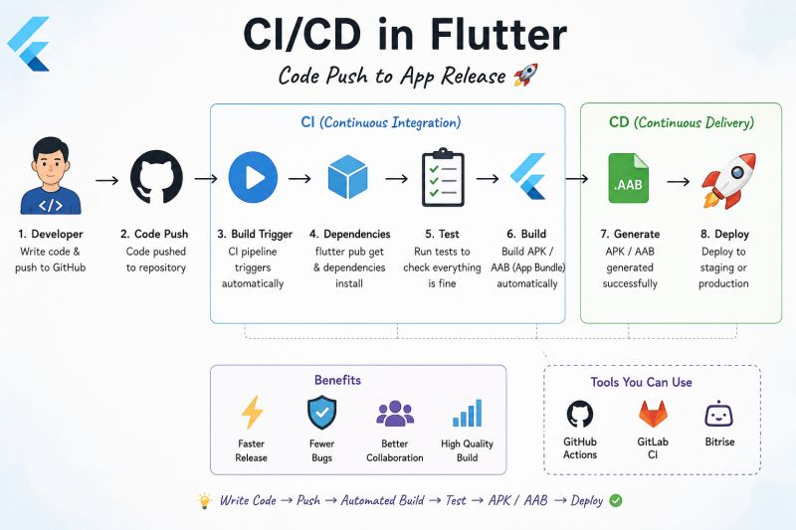

Break

