# **C#/.NET Project Proposal – Inventory Management System**

Andrew Morrison (200463770)

Marcos de Gois Borges (200445501)

Department of Computer Studies: Georgian College - Barrie

COMP1098: C#/.NET

Professor Radhika Sharma

20 March 2021

# **C#/.NET Project Proposal – Inventory Management System**

**Project Overview**. We plan on creating an inventory management system using C#/.NET and Microsoft Access. The application will be a stand-alone application meant to run on a single system. The application will contain customers, suppliers, products, and orders. When orders are completed the product quantity on hand will be updated in the database. We will be developing the application using Visual Studio 2019 (for the C#/.NET portion) and MS Access (for the database portion). We will be using github to assist with version control.

**Functional Requirements**.

F1. The application must be able to run as a stand-alone application on a windows machine.

F2. The application must allow the user to add/edit/suspend customers.

F3. The application must allow the user to add/edit/suspend suppliers.

F4. The application must allow the user to add/edit/discontinue products.

F5. The application will allow the user to classify products into categories and will be able to add/edit/suspend categories.

F6. The application will allow the user to generate an order tied to a specific customer, where the order will contain 1 or more products.

F7. When an order is submitted by the user, the product quantities will be updated.

F8. The user will not be able to order more than the product quantity available.

F9. Order history will be saved.

**Use Cases**.

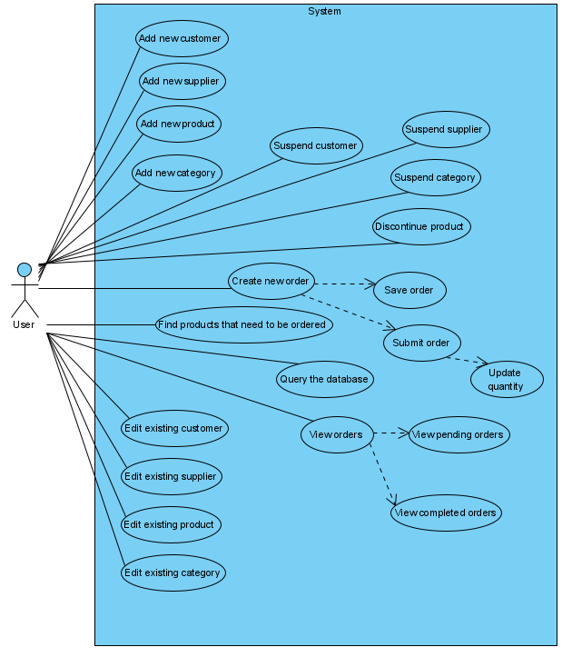

**Project Design**.

**iControl Database**

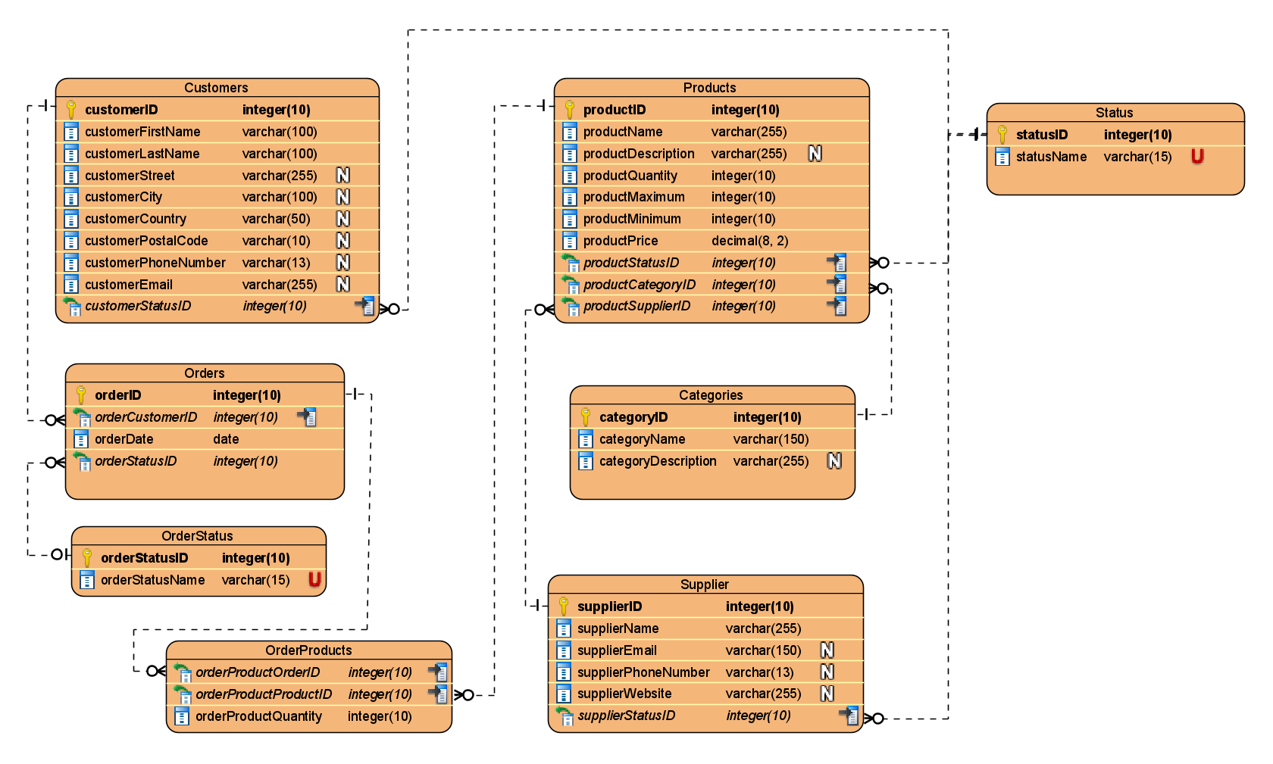

**iControl GUIs**

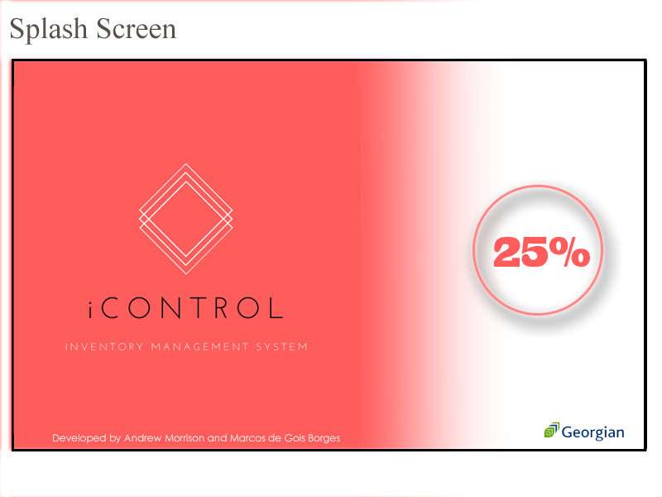

The splash screen is an optional feature, but if implemented, would be the first interaction the user will have with the application. It will show the logo, name, and a loading bar with percentage. As soon as the percentage reaches 100% the main screen appears.

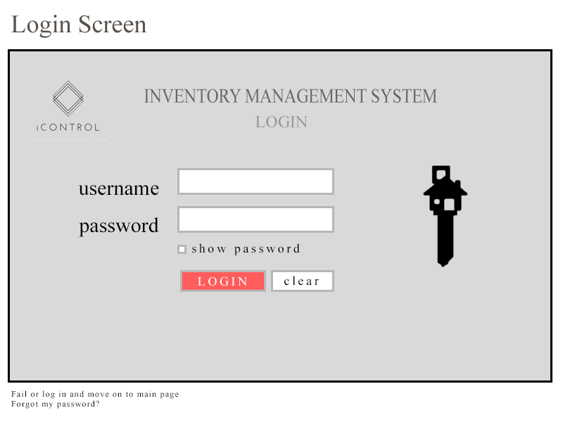

The login screen is an optional feature, and if implemented, would show up once the program is loaded. Having a login screen will add more security to the application.

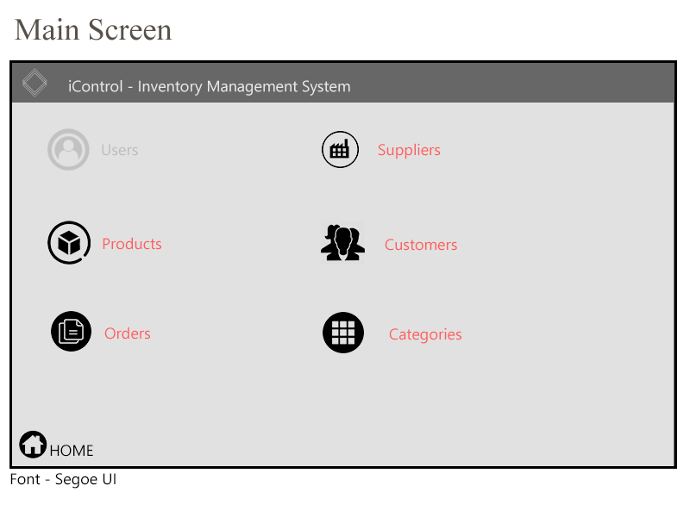

The main screen contains the links to the application features that will be shown and explained next. It guides the user through the 5 main features: products, suppliers, orders, customers, and categories. The user manager will be needed if we activate the login window and we need to create and manage the users. 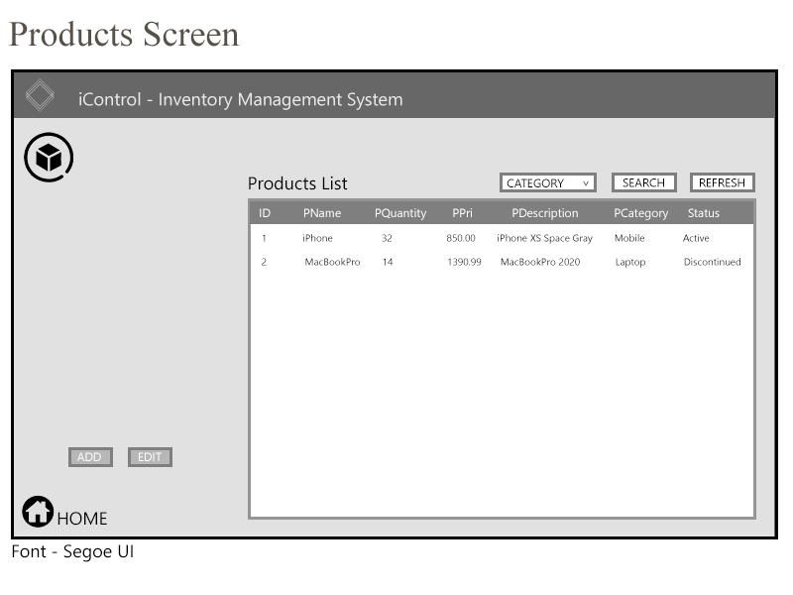

The products screen displays a list of products that are retrieved from the database. The user can add new products or edit the existing ones. Moreover, the user can filter the products by category and check and modify the status of the products (active or discontinued).

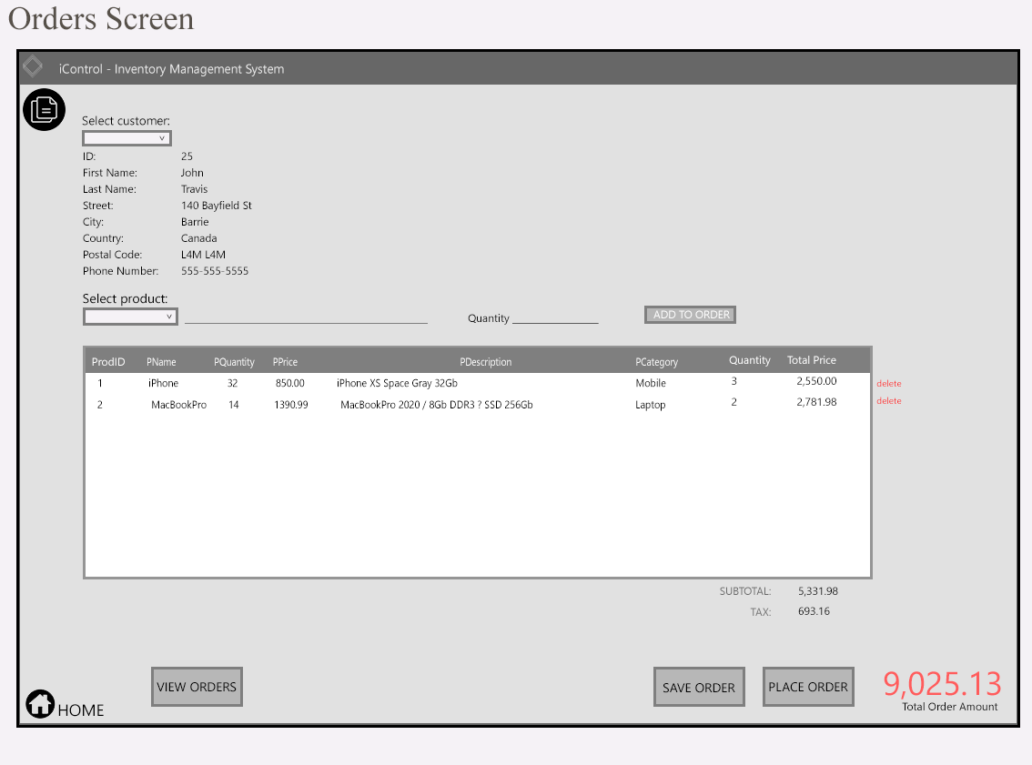

The orders screen offers the user the ability to place the orders. Here we can select the customer that is placing the order using a combo box. The application should retrieve the customer’s information and fill the page with it. Then the user can select the product from a combo box and choose the desired quantity. After clicking on the “add to order”, the list displays the product information with unit price and total price. The user can select how many products they want unless there are not enough in stock. If this happens, the application should notify the user. Furthermore, it displays the subtotal, tax amount and total order amount automatically.

From here, the user will then save or place the order. Saving the order will add it to the orders list and set the status as “pending”. Placing the order will add it to the orders list and set the status to “completed”.

The “view orders” button will open a new screen that shows a complete list of the orders. The user can filter the orders by pending or completed.

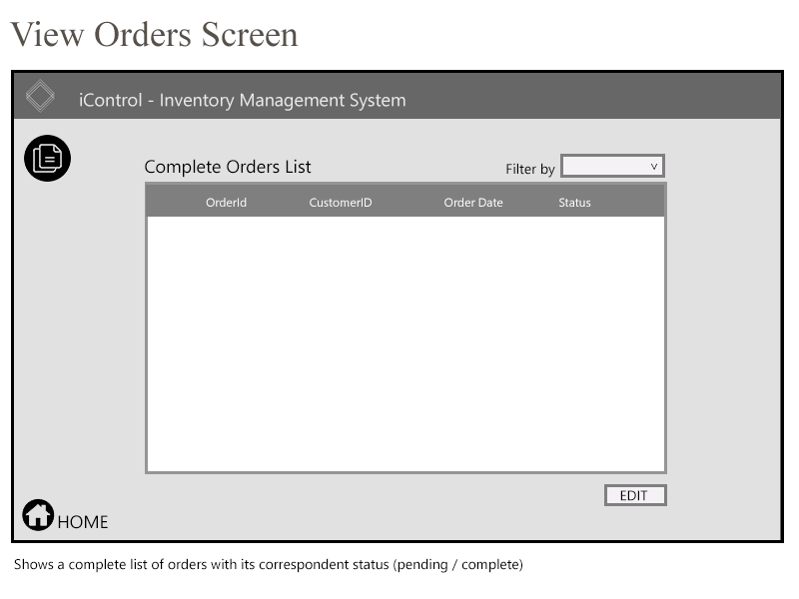

Representation of the View Orders screen. From this screen, the user should be able to see all the orders, completed or pending, and modify the status of the pending ones to completed.

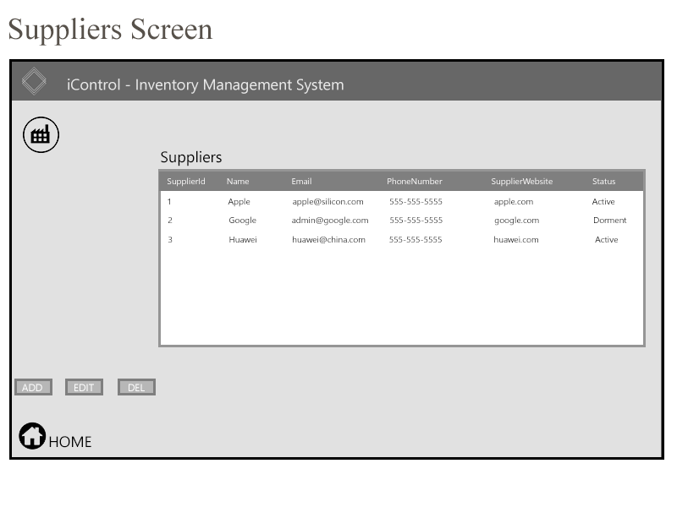

The suppliers screen displays the list with all the supplier’s information. The user can add more suppliers or edit existing ones. The supplier information consists of id, name, email, phone number, website and status (active / dorment).

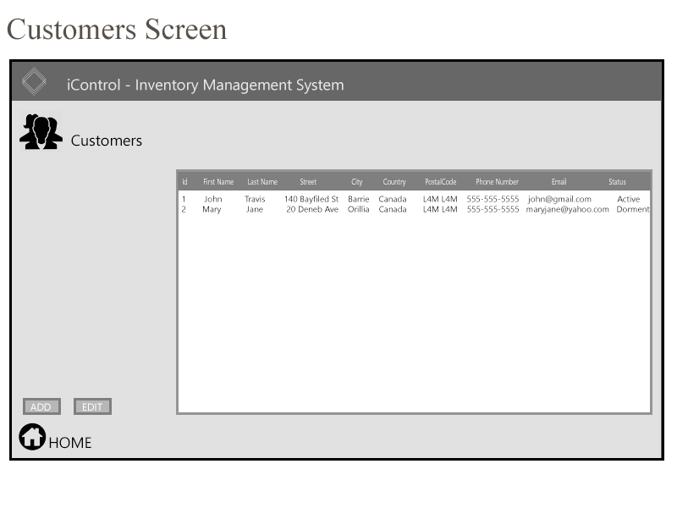

The customers screen displays the list with all the customer’s information. The user can add more customers or edit existing ones. When adding a new customer, a form with all fields will be available containing the following fields: id, first name, last name, street, city, country, postal code, phone number, email, and status (active/dorment).

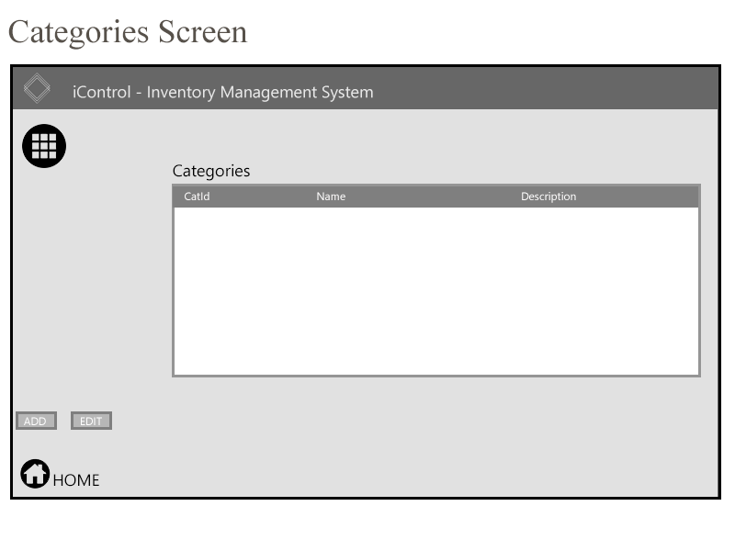

The categories screen displays the list with all the categories’ information. The categories can be set to the products and facilitate the process of filtering and finding products. The user can add more categories or edit existing ones.

**Work Assignments**.

Andrew – Will work with the Products and Orders, associated database, program logic, and GUI.

Marcos – Will work with the Customers, Suppliers, Categories, Home screen, associated database, programming logic, and GUI.

Time/capacity permitting we will also investigate a splash loading screen and different Users and associated login credentials as well as additional search and supplier order functionality.