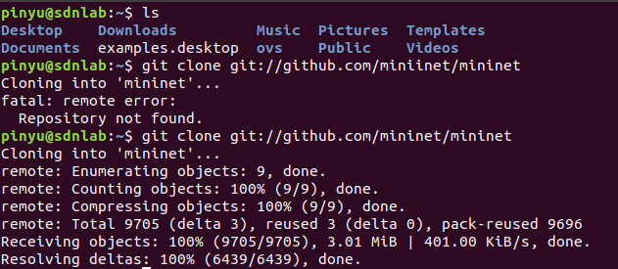



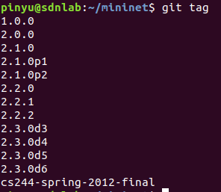

Ovs > mininet (X)

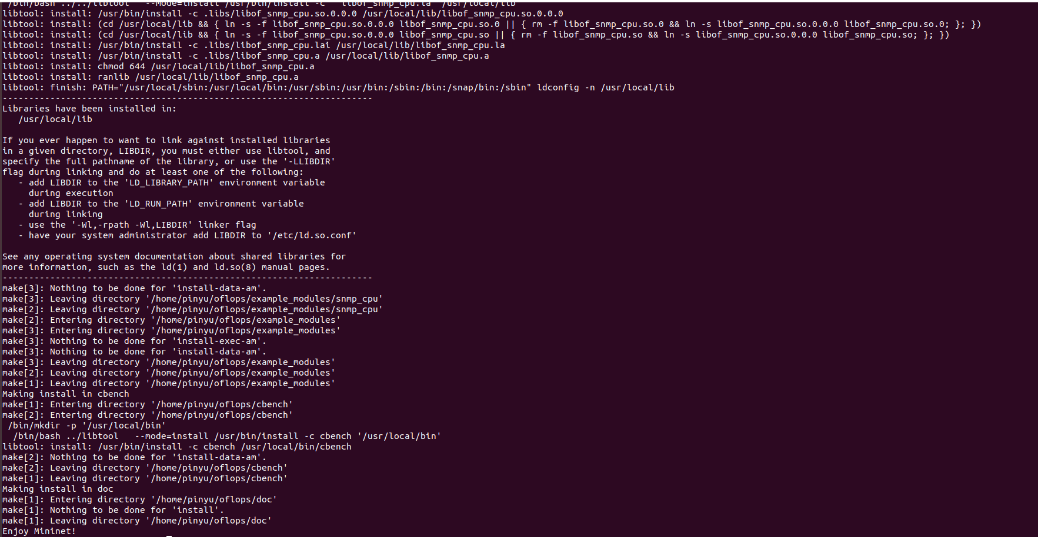

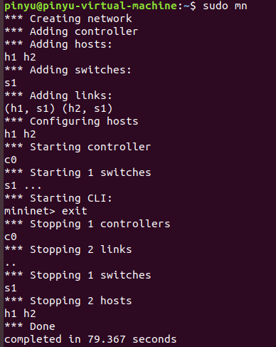

<https://github.com/mininet/mininet/issues/812>

<https://ting-kuan.blog/2017/11/09/%E3%80%90mininet%E6%8C%87%E4%BB%A4%E4%BB%8B%E7%B4%B9%E3%80%91/>