**Part 1**

[ARP packet capture program]

需要以root權限執行

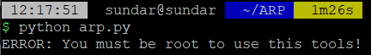

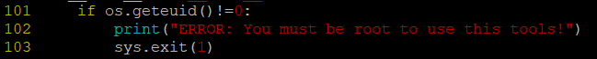

以 python arp.py -help 進行命令參數查詢

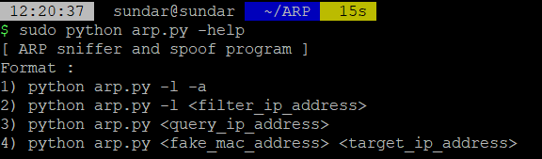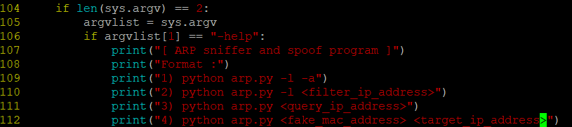

以 python arp.py -l -a 查看 所有的 ARP packets.

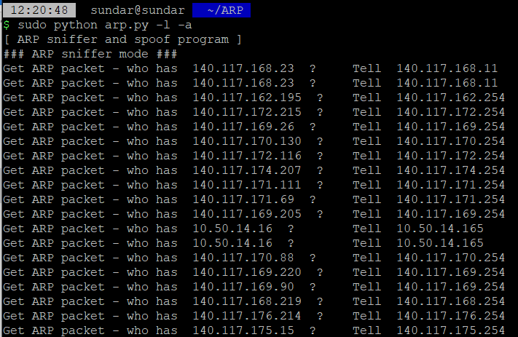

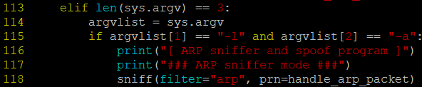

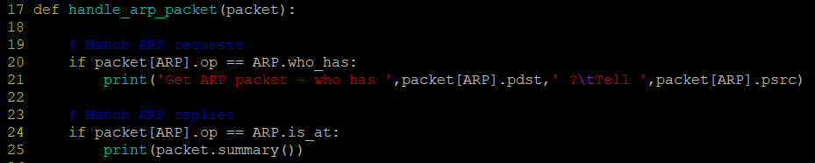

以 python arp.py -l 140.117.168.23 查看 特定IP (ex: 140.117.168.23) 的 arp packet.

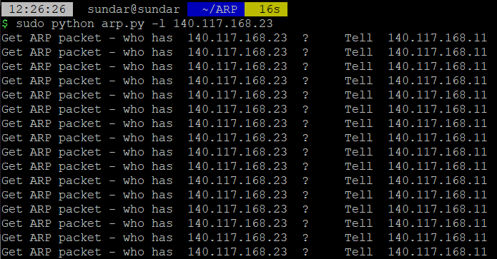

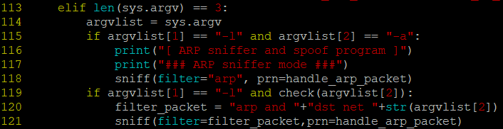



**Part 2**

Send an ARP request and receive the ARP reply to analyze the packet and find the MAC address of the specific IP.

詢問實驗室同學(ip:140.117.172.87) 的 mac address。

發送 60 個 arp query packets。

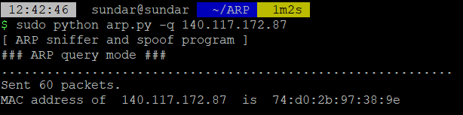

[驗證1 by my ARP capture program]

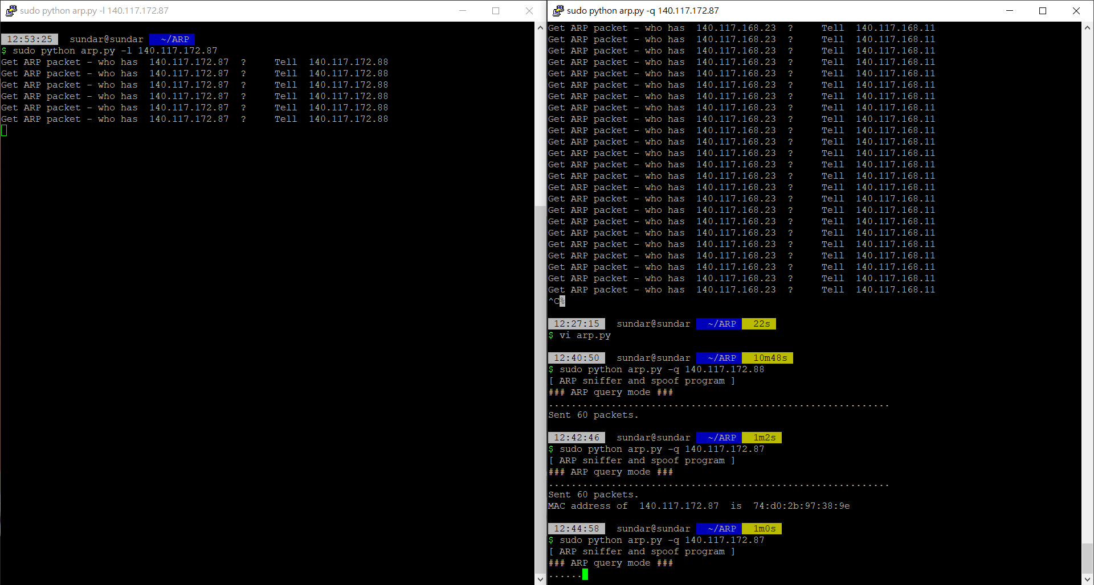

[驗證2 by Wireshark]

[send]

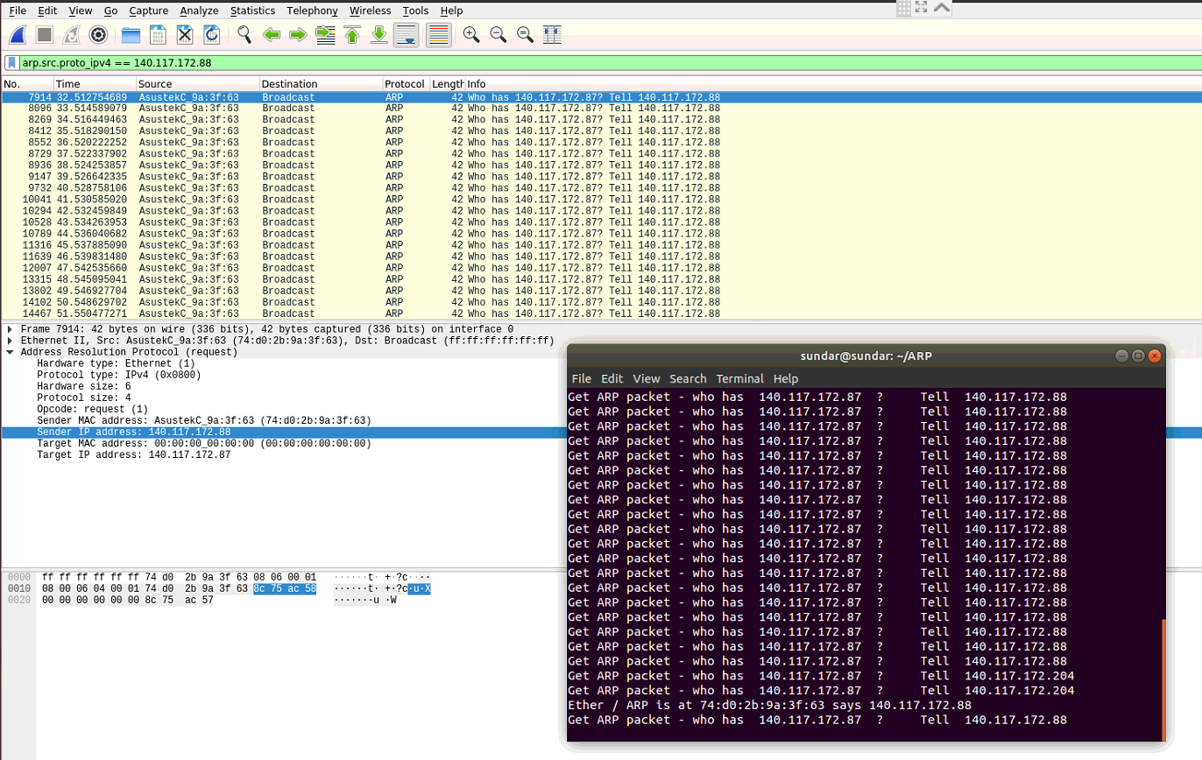

[receive]

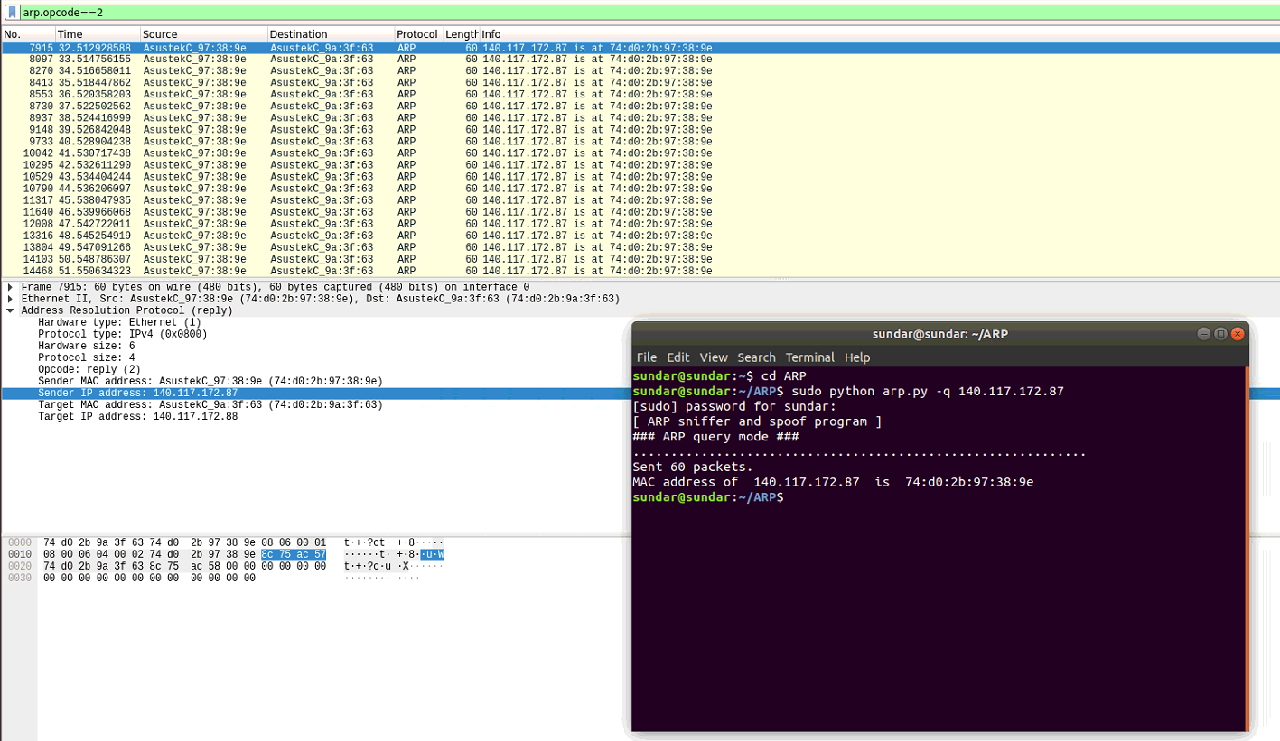

[Code]

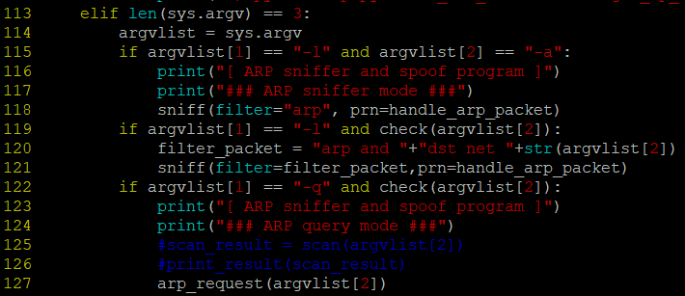

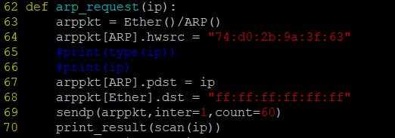



**Part 3**

Make an ARP daemon, it can reply a MAC address when it receive specific IP address.

