**Project Overview**

This project involves creating a digital dice using an Arduino microcontroller and a 7-segment display. The digital dice simulates the roll of a traditional six-sided die, displaying the result on a 7-segment display when a button is pressed.

**Components**

* **Solderless Breadboard**: A reusable platform for prototyping electronic circuits without soldering.
* **Arduino Uno**: A microcontroller board based on the ATmega328P, used for building digital devices and interactive objects.
* **7-Segment Display Common Anode**: A display device with seven LEDs arranged in a pattern to represent numbers, sharing a common positive terminal.
* **Push Button**: A momentary switch used to input a signal to the Arduino when pressed.
* **100R Resistor**: A 100-ohm resistor used to limit current and protect components like LEDs and the display.
* **Buzzer**: An audio signaling device that produces sound when activated by an electrical signal.
* **Male to Male Jumper Wires**: Wires with pins on both ends for making connections between components on a breadboard.
* **Battery Clip**: A connector used to attach a 9V battery to the circuit.
* **Battery 9V**: A power source providing 9 volts of electrical energy for the project.

**Circuit Diagram**

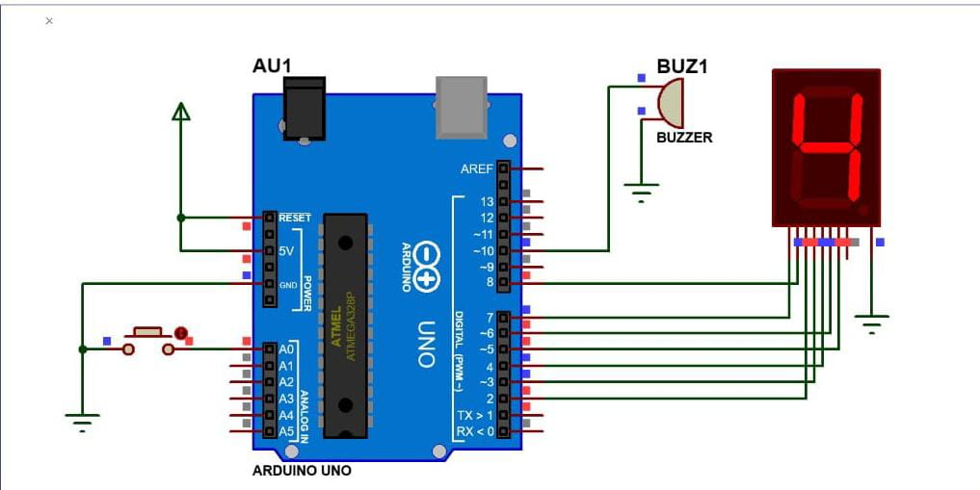

**Assembly Instructions**

**Mounting the Components:**

· Place the 7-segment display on the breadboard.

· Insert the push button into the breadboard.

· Position the Arduino Uno for easy access to its pins.

· Insert the buzzer into the breadboard.

**Wiring:**

· **Connect the 7-Segment Display**:

* Connect the common anode of the display to the 5V pin on the Arduino Uno.
* Connect each segment pin (a-g) of the 7-segment display to digital pins 2 to 8 on the Arduino Uno through 100-ohm resistors to limit the current.
  + Pin a: Digital Pin 2
  + Pin b: Digital Pin 3
  + Pin c: Digital Pin 4
  + Pin d: Digital Pin 5
  + Pin e: Digital Pin 6
  + Pin f: Digital Pin 7
  + Pin g: Digital Pin 8

· **Push Button**:

* One terminal to Digital Pin 9.
* Other terminal to GND.
* 10k ohm pull-down resistor between Digital Pin 9 and GND.

**Buzzer**:

* Positive terminal to Digital Pin 10
* Negative terminal to GND.

**Power Connections**:

* GND pins of the Arduino to the ground rail.
* 5V pin of the Arduino to the positive rail.

**Power Supply**

**Connect the Battery**:

* Attach the battery clip to a 9V battery.
* Connect the positive wire of the battery clip to the VIN pin on the Arduino Uno.
* Connect the negative wire of the battery clip to one of the GND pins on the Arduino Uno.

**Usage**

* Press the push button to simulate rolling a dice.
* The Arduino generates a random number between 1 and 6.
* The result is displayed on the 7-segment display.
* The buzzer sounds briefly to indicate the dice roll.
* This setup mimics rolling a physical dice, useful for digital games and educational purposes.

**Troubleshooting**

**Display does not show numbers:**

* Check the connections between the Arduino Uno and the 7-segment display.
* Ensure the resistors are correctly connected to each segment.
* Verify that the common anode is properly connected to the 5V pin.

**Button press not registering:**

* Confirm the push button connections, ensuring one terminal is connected to digital pin 9 and the other to GND.
* Check the 10k ohm pull-down resistor between digital pin 9 and GND.
* Test the button with a multimeter to ensure it is functioning correctly.

**Buzzer does not sound:**

* Verify the connections of the buzzer, ensuring the positive terminal is connected to digital pin 10 and the negative terminal to GND.
* Check the code to ensure the buzzer is triggered correctly.

**Random number generation seems incorrect:**

* Ensure the randomSeed() function is used correctly in the setup() function.
* Verify the analogRead() function is used to provide a good random seed.